Testahil · Independent Valuation Study — Educational Analysis Not investment advice

Independent Valuation Study — Educational Analysis
Silver (XAG/USD)
Fundamental analysis · Technical analysis · Monte Carlo simulation — one integrated read
Anchor: $62.425/oz (03 Jul 2026 close) · gold $4,020 → gold-silver ratio ~64.4× · the industrial-and-monetary precious metal, priced in US dollars per troy ounce · prices and probabilities computed 03 Jul 2026 from the attached daily history (01 Jan 2021 – 03 Jul 2026, 1432 sessions) · primary fundamental lenses: the gold-silver ratio and the analyst-consensus forward anchor, cross-checked against the structural supply/demand deficit, a non-binding cost floor and real-rate carry · this study combines the 1-month, 3-month and 12-month horizons in one document. The swing factors are the Fed real-rate path, the gold-silver ratio, and whether the sixth-straight supply deficit outlasts solar thrifting.
READ FIRST — what this document is, and is not. This study is a valuation exercise and an expression of personal analytical opinion, published free of charge for educational purposes: it shows how one analyst applies fundamental, technical and probabilistic methods to a commodity, and invites scrutiny of that methodology. It is NOT investment advice, NOT a recommendation or solicitation to buy, sell or hold silver or any related instrument, and NOT directed at the circumstances of any reader. The preparer is not licensed by any securities or commodities regulator in any jurisdiction, provides no financial consultancy, manages no money, and accepts no fees, funds or clients. All values are model outputs presented as ranges and probability distributions because no single number should be relied on. A commodity has no balance sheet, shares or cash flows, so the fundamental section rests on fair-value anchors — the gold-silver ratio, the analyst consensus, the supply/demand balance, a cost floor and real-rate carry — not a discounted-cash-flow of a business; the company-style items in the standard template are therefore replaced by their metal analogues and flagged as such. Market figures are drawn from the World Silver Survey 2026 (Silver Institute / Metals Focus, 15 April 2026) and published analyst research; forward-looking inputs — the factor probabilities, the fair-value zone and the drift — are the preparer's judgments and are flagged throughout. See the Disclosure & Disclaimer at the end. The preparer may hold, and may in the future take or dispose of, a position in the instrument discussed. Consult a licensed financial advisor before any investment decision.

Headline
The model's read: a wide, two-sided distribution centred near spot over one and three months and tilting modestly higher over twelve, as silver consolidates a violent boom-and-bust inside a fair-value zone that spans roughly $58–78. Silver closed $62.42 after the most dramatic year in its modern history — a run from the high-$30s to an intraday all-time high near $121–122 in late January 2026 (a $117 daily close), then a halving back to the low-$60s as the Iran/Hormuz war premium unwound and the Fed pivoted from cuts toward hikes. The fundamental lens — for a commodity, fair-value anchors rather than cash flows — puts a fair-value ZONE (what an ounce is worth now, undated) of $58–78 (centre ≈ $68), with spot in its lower half. The gold-silver ratio, silver's signature lens, sits at ~64.4× against gold's $4,020: at the long-run average ratio (~62×) silver is worth ~$65 — essentially spot — while ratio compression toward 50–55× (the bull case) implies $73–80 and a drift back toward the 2-year-average 80× implies ~$50. The published analyst consensus clusters near $70–86 (Reuters 30-analyst median ~$79.5, J.P. Morgan $81, BofA $86), but — critically — every one of those targets was set when silver traded $78–90, and the metal now sits $62, below all of them: the crux is whether price reverts up to consensus or consensus is cut down to price. The structural picture is genuinely tight — a sixth consecutive annual deficit (~70 Moz in 2026e) has drawn ~808 Moz from above-ground stocks since 2021 — but 2025's solar-driven demand fell as high prices forced record thrifting, and that is the swing factor.
A 50,000-path Monte Carlo sized by the YZ-HAR engine (Step-0-validated) carries a forward volatility of ~47% over three months — roughly twice gold's — so the cone is wide. Read the 50% band first: over one month the interquartile range is $58–68, over three months $56–72, over twelve $52–86; the predicted median sits at spot at 1 and 3 months and lifts to ~$67 predicted at 12 months on a mild +7% net factor drift (structural deficit plus expected 2027 Fed easing plus the gold anchor, tempered by an overvaluation flag). Technically the tape is corrective — price ~11% below both the 50- and 200-day averages, RSI 44 recovering from oversold, MACD negative but its histogram just turned up. Net: silver has round-tripped a speculative mania and now trades in the lower half of a fair-value zone that a tight physical market underwrites and a hawkish Fed and solar thrifting cap. The right tail belongs to ratio compression, a Fed-easing re-pricing and the deficit reasserting; the left tail to a positioning unwind (J.P. Morgan flags $50) and demand destruction. This study estimates a distribution, not an action.

Valuation summary — every read at a glance
One table for the four reads that follow — what the metal is worth (fundamental anchors), what the tape is doing (technical), where price could travel over one, three and twelve months (Monte Carlo), and how three independent expert methods land. Every row is developed in the sections and appendices below.
Two kinds of number, kept distinct throughout. A fair value is what an ounce is worth today (the fundamental anchors and the expert estimates — a “fair value now”), and it does not carry a date. A prediction is where the price could actually be at a future moment (the Monte Carlo medians and bands — labelled “predicted at 1 / 3 / 12 months”). The two answer different questions: fair value asks “is it cheap or dear right now?”; the prediction asks “where might it trade by then?” Wherever a dollar figure appears below it is tagged as one or the other.
Lens / read | What it measures | Output | Takeaway
FUNDAMENTAL — what an ounce is worth TODAY (fair value now, not a forecast)
Gold-silver ratio (primary) | Gold ÷ ratio, reverting toward avg | $65 | Long-run ratio ≈ spot
Analyst-consensus forward | 2026 published target cluster | $78 | +25% (targets set at $78–90)
Supply/demand deficit | 6th deficit, stock drawdown | $50–72 support | Firm floor, not $120
Cost floor (AISC) | Primary-producer all-in cost | $25–31 | Non-binding (spot ~2× cost)
Fair-value zone (synthesis) | Anchors reconciled at gold $4,020 | $58–78 | centre $68 · spot in lower half
TECHNICAL — what the tape is doing (timing, not value)
Trend & momentum | Price vs 20/50/100/200-day | Below all four | Weak, corrective
Momentum / range | RSI · MACD · 52-wk | RSI 44 · MACD -3.4 · $37–117 | Oversold, stabilising
MONTE CARLO — PREDICTED price distribution at 1 / 3 / 12 months (from spot)
T+21 (1 month) | 50k paths · 16 factors | p5 50 · p50 63 · p95 79 | Median ≈ spot
T+63 (3 months) | same engine, longer horizon | p5 44 · p50 63 · p95 92 | Wide, two-sided
T+252 (12 months) | annual horizon | p5 34 · p50 67 · p95 135 | Very wide, right-skewed
EXPERT PANEL — three fair-value-today estimates (Appendix D)
Expert 1 — real-rate / opportunity cost | Carry vs real yields | $60 | Near-term cautious
Expert 2 — industrial supply/demand | Deficit & cost curve | $72 | Structural bull
Expert 3 — investment flows / ratio | ETF, positioning, G/S ratio | $66 | The swing vote
Panel range | Spread = the demand question | $60–72 | centres ~$66
Bottom line. The anchors agree that silver is neither cheap nor dear at $62: the long-run gold-silver ratio puts fair value at ~$65, the structural deficit underwrites a floor well above the cost curve, and the published consensus sits higher (~$78) but was written before the metal fell to its current level. The three experts span $60–72 and each turns on one question — whether industrial demand holds against solar thrifting. The technical tape is the near-term dissenter, corrective and below trend, which is why the one- and three-month distributions centre near spot with wide two-sided tails rather than already at the zone's centre, and only the twelve-month view tilts up.

Market overview — silver at a glance
Item | Value
Instrument | Silver spot (XAG/USD), US$ per troy ounce
Spot / date | $62.425 · 03 Jul 2026 close
Gold / ratio | gold $4,020 · gold-silver ratio 64.4×
52-week range | $36.77 – $116.61 (intraday ATH ~$121–122, 29 Jan 2026)
Demand profile | Dual: ~58% industrial (electronics, solar/PV, EVs), ~42% investment + jewellery + silverware
2026e total demand | ~1,116 Moz (−2% YoY)
2026e mine supply | ~850 Moz (~70% by-product of other metals; inelastic)
2026e balance | −70 Moz deficit — 6th consecutive; ~808 Moz drawn from stocks since 2021
Solar / PV demand | ~151 Moz in 2026e (−19% YoY, record thrifting) — the swing segment
ETF holdings | ~794 Moz; net speculative futures ~100 Moz
Cost floor (AISC) | ~$25–31/oz for primary producers (rising; non-binding at spot)
Realized volatility | ~64% (trailing 12m) — roughly twice gold's
Source: World Silver Survey 2026 (Silver Institute / Metals Focus, 15 Apr 2026), LBMA, published analyst research, exchange data. Values rounded.

1 Fundamental valuation
How a commodity is valued. Silver pays nothing and has no cash flows, so there is no sum-of-the-parts, no discounted-cash-flow of a business and no earnings multiple; the standard template’s company items are replaced by their metal analogues. Every figure in this section is a fair value NOW — an estimate of what an ounce is worth today, undated — not a price forecast; the dated 1 / 3 / 12-month price predictions live in §3. But silver is not gold: it is the junior precious metal and a major industrial input at once, so it can be — and primarily is — valued relative to gold through the gold-silver ratio, a lens gold itself does not have. Five anchors bound a fair-value ZONE: (1) the gold-silver ratio, the primary lens; (2) the published analyst-consensus forward anchor; (3) the structural supply/demand balance; (4) a mining cost floor (far below spot, non-binding); and (5) real-rate carry. The synthesis and football field are in §1.5; the swing factor — industrial demand versus solar thrifting — is dissected in §1.7 and the sensitivity grid in §1.9.

1.1 The gold-silver ratio — the primary lens
Silver’s most defensible reference is its price relative to gold, because the two metals share the monetary bid and their ratio mean-reverts over cycles. The ratio — how many ounces of silver buy one ounce of gold — sits at ~64.4× today (gold $4,020 ÷ silver $62.42). Its long-run average is ~60–65× and silver’s own multi-decade average is closer to 50–60×; over the past two years it averaged ~80×, spiking to 107× in April 2025 (silver historically cheap) and compressing to 55× by December 2025 (silver historically dear). At the current gold price, the ratio maps directly to a silver fair value:
Gold-silver ratio | Implied silver (gold $4,020) | Interpretation
50× (bull compression, BofA/Citi thesis) | $80 | silver richly re-rated vs gold
55× (Dec-2025 trough) | $73 | top of the reasonable range
62× (long-run average) | $65 | ≈ spot — the neutral anchor
70× | $57 | mild silver underperformance
80× (2-yr avg / UBS drift-to target) | $50 | silver lags gold materially
Ratio statistic | Level | Silver-cheap or dear
Current | 64.4× | roughly fair (near long-run avg)
Long-run average | ~62× | the neutral anchor
Silver multi-decade average | ~50–60× | silver structurally cheaper vs gold
2-year average | ~80× | silver was cheap on this window
April 2025 peak | 107× | silver historically cheapest
December 2025 trough | 55× | silver historically dearest
Read. At the neutral long-run ratio silver is worth ~$65 — within a rounding error of spot — so on this lens silver is fairly valued today, neither the historically-cheap metal it was at 107× nor the historically-dear one it was at 55×. The lens has a second dimension the others lack: it moves with gold. If gold reverts toward its own consensus zone (~$4,600–5,000 over 12 months, per the companion gold study) and the ratio holds ~62×, silver is dragged to ~$74–81 with no change in silver’s own story. That gold linkage — not a silver-specific catalyst — is the single largest source of silver’s upside, and it is why UBS, even while cutting its silver deficit estimate, kept a constructive silver view “anchored by rising gold.”

1.2 Analyst-consensus forward anchor — the market-implied fair value
With no cash flows, the published professional consensus is a second market-implied fair value. The spread is the widest of any major commodity — itself a signal that the market genuinely does not know — but it clusters. Targets, all set in the first half of 2026 when silver traded $78–90:
Source / scenario | 2026 target | View
World Bank / Metals Focus / TD (2027) | $70 | the cautious cluster
ING (2026 avg) | $78 | conservative bank
Reuters 30-analyst median | $79.5 | the neutral consensus anchor
UBS (year-end 2026, cut from $85) | $80 | demand-destruction call
J.P. Morgan (2026 avg; 2027 ~$85) | $81 | repricing “largely complete”
Bank of America (2026 avg) | $86 | structural bull (outlier scenario $135–309)
Citigroup (H2 2026) | $110 | acute-shortage thesis
Consensus cluster | $70–86 (centre $78) | spot sits ~20–35% BELOW it
Read. The consensus centre (~$78) sits ~25% above spot — but the important fact is that silver has fallen below every single target on the sheet. Two readings follow, and they define the whole debate: either price mean-reverts up toward the consensus over 6–18 months (the bull case, and why the 12-month distribution tilts higher), or the consensus is progressively cut down to the price (the bear case — UBS has already moved, halving its deficit estimate and trimming targets). The LBMA poll captures the uncertainty: an average forecast of $79.6 with a range of $42–165. J.P. Morgan’s Marko Kolanovic flags the downside explicitly — $50 if speculative positioning unwinds faster than fundamentals support.

1.3 The supply/demand balance — the structural support
Silver has run a physical deficit for six straight years — the structural case beneath the price. 2026e demand of ~1,116 Moz exceeds mine-plus-recycled supply by ~70 Moz, and cumulative deficits since 2021 have drawn ~808 Moz from above-ground stocks — close to a full year of mine output. Mine supply (~850 Moz) is inelastic because ~70% of silver is a by-product of gold, copper, lead and zinc mines, so it does not respond to the silver price. The balance (the metal’s “financial statements,” detailed in Appendix A):
Year | Total demand (Moz) | Mine supply | Recycling | Balance
2024 | 1,162 | 820 | 193 | −149
2025 | 1,135 | 819 | 198 | −118
2026e | 1,116 | 850 | 196 | −70
Read. The deficit is real and the tightest silver market in a generation — but two cautions keep it from being a $120 story. First, at ~4% of demand it is a firm floor, not a moon-shot; the price ran far ahead of the deficit in 2025 and paid for it in the 2026 halving. Second, 2025 recycling hit a 13-year high as high prices pulled scrap out of drawers, and industrial demand is now falling (see §1.7). The honest read: the deficit underwrites a structurally higher floor — in the $50–60 region, well above the cost curve — and elevated volatility as thin stocks amplify every demand swing, but it does not by itself justify the consensus’s $80.

1.4 Cost floor and real-rate carry
Two bounding anchors. The mining cost floor: primary silver producers report all-in sustaining costs of ~$25–31/oz (Endeavour ~$25–26, Pan American / Hecla ~$26–28, some Peru producers >$30), rising with grades and energy. At $62 spot is ~2× the cost curve, so the floor is non-binding — like gold, silver’s price is demand- and investment-driven with a wide margin over cost — but it marks the deep-bear boundary (~$30) below which primary supply would be cut. Real-rate carry: silver yields nothing, so the opportunity cost of holding it is the real interest rate. A hawkish Fed (cut odds for the next meeting collapsed after a hot CPI print; markets now price hikes) and a firm dollar are the near-term headwind. Over a full year it flips: easing is expected to resume in 2027, and each easing leg historically pulls investment flows back toward the complex. Neither anchor pins a level; they bound the zone — cost near $30 at the bottom, carry as the timing switch.

1.5 Synthesis — five anchors and the fair-value zone
No single anchor is decisive, so we weight them. The gold-silver ratio and the consensus carry the most weight because they are market-implied and silver-specific; the deficit and cost floor bound the downside; real-rate carry sets the near-term tilt.
Anchor | Weight | Range | Centre | Note
Gold-silver ratio (at gold $4,020) | 35% | $50–80 | $65 | neutral ratio ≈ spot; gold linkage is the upside
Analyst-consensus forward | 25% | $70–110 | $78 | above spot, but written at higher prices
Supply/demand deficit | 20% | $50–72 | $60 | firm floor, sixth straight deficit
Real-rate carry | 12% | − | tilt | near-term headwind, 2027 tailwind
Cost floor (AISC) | 8% | $25–31 | $30 | non-binding; deep-bear boundary
Weighted zone | 100% | $58–78 | $68 | spot in the lower half
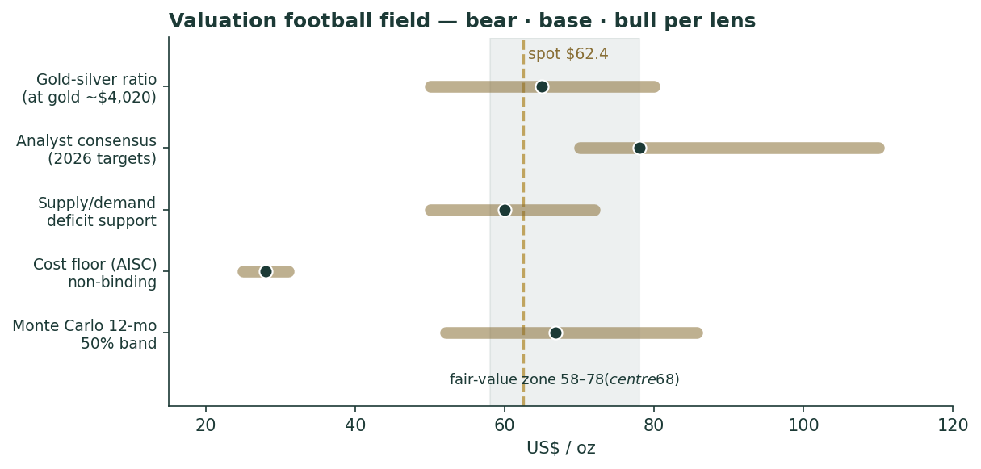
Figure 1. Valuation football field. Bars span the bear–bull range per anchor; dots mark the base case; the dashed line is spot $62.4; the shaded band is the $58–78 fair-value zone. Spot sits in the lower half.
The zone is $58–78, centre ~$68, with spot $62 in its lower half. That is the honest fundamental statement: silver has round-tripped a mania and now trades slightly below a fair-value centre that a tight physical market and the gold anchor support, while a hawkish Fed, record thrifting and an overvaluation flag (HSBC called silver “fundamentally overvalued” at higher levels) keep it from re-rating immediately. The width of the zone is not vagueness — it is the widest analyst spread of any commodity, faithfully reproduced.

1.6 Demand segments — a deeper look
Silver’s dual identity means its demand splits across four very different segments, each with its own driver. The scorecard:
Segment | Share of demand | Scale / 2026e | Read
Industrial (ex-PV) | ~35% | electronics, brazing, EVs | Firm; AI/data-centre and vehicle electrification
Solar / photovoltaics | ~14% | ~151 Moz 2026e (−19%) | THE swing — thrifting cut use per cell (see §1.7)
Investment (bars/coins/ETF) | ~25% | ETF ~794 Moz | Price-sensitive; the mania’s marginal buyer
Jewellery + silverware | ~16% | ~178 Moz (−9%) | Falling to multi-year lows on high prices
Recycling (supply offset) | — | ~198 Moz (13-yr high) | High prices pull scrap; caps the deficit
Read. The investment leg is what took silver to $121 and back — the price-sensitive, sentiment-driven marginal buyer. The industrial leg is the structural story, roughly 58% of demand and anchored in electrification and AI power infrastructure. Jewellery and silverware are in retreat at these prices. But the segment that decides the deficit’s durability is solar — and it is falling.

1.7 The crux — solar thrifting versus the structural deficit
The swing factor, stated in real units. Photovoltaic silver demand fell ~19% in 2026e to ~151 Moz (from ~187 Moz) — the largest single-year cut on record. Crucially, this is thrifting, not yet substitution: solar installations kept growing, but manufacturers cut the milligrams of silver per cell as the metal’s price surged, and are researching copper-metallization TOPCon cells that would remove silver entirely. The bull case: thrifting has physical limits, mass copper substitution is a 2028–2030 event not a 2026 one, and every other industrial use is growing — so the deficit persists and the floor holds. The bear case: high prices have permanently accelerated the engineering that designs silver out, so peak silver intensity is behind us and the deficit narrows structurally (UBS already cut its 2026 deficit estimate by ~80%). The number to watch is silver grams per watt of new solar capacity: if it keeps falling faster than installations grow, the strongest pillar of the bull case erodes. This is silver’s equivalent of a “swing in real units” — not an abstract margin, but milligrams of metal per cell.

1.8 Macro — the Fed, the dollar, and geopolitics
Three macro forces set the near-term tilt. The Fed and real rates: the single biggest swing factor. The 2026 regime turned hawkish — a hot CPI print (inflation revived partly by the Iran/oil shock) collapsed rate-cut odds and pushed the market to price hikes — which lifts the real yield and the opportunity cost of a non-yielding metal. The consensus assumes easing resumes in 2027; if it does, the whole complex re-rates, and if it does not, silver stays capped. The dollar: silver is priced in dollars, so a firm DXY is a headwind; the dollar strengthened through 2026 on the rate re-pricing. Geopolitics and policy: the Iran/Hormuz war drove the January safe-haven spike and its ceasefire drove the unwind — a reminder that silver carries a haven premium that comes and goes violently. Two structural policy shifts are worth flagging: China tightened silver export licences in January 2026, and Russia added silver to its state reserve programme for the first time in the modern era — a nascent official-sector bid that, if it broadens, would be a genuinely new source of demand.

1.9 Sensitivity — fair value versus gold and the ratio
Because silver’s primary lens is two-dimensional, the sensitivity grid is silver fair value as a function of the gold price and the gold-silver ratio — the two variables that, between them, explain most of silver’s moves.
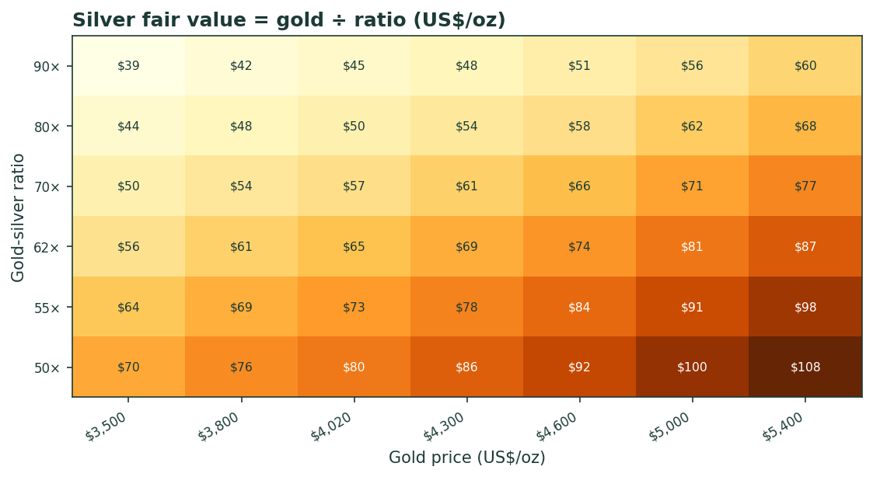
Figure 2. Silver fair value = gold price ÷ gold-silver ratio (US$/oz). Columns are gold scenarios; rows are ratio scenarios. Today’s cell (gold ~$4,020, ratio ~64×) sits near $63 — spot. The upside is a joint move: gold higher and the ratio compressing.
Read. The grid makes the bull and bear cases concrete. Bull: gold rises to $5,000 and the ratio compresses to 55× → silver ~$91. Bear: gold slips to $3,800 and the ratio drifts to 80× → silver ~$48. The base — gold roughly stable and the ratio near its long-run average — leaves silver near spot. Notice what dominates: a one-tier move in gold (~$400) moves silver about as much as a one-tier move in the ratio, so silver’s fate is roughly half its own story (the ratio) and half gold’s (the level). That is the defining feature of valuing the junior metal.

2 Technical and price structure
Computed from the attached XAG/USD daily history (01 Jan 2021 – 03 Jul 2026, 1432 sessions).
Indicator | Reading | Signal
Close | $62.42 | —
SMA 20 / 50 | $63.15 / $71.04 | price -12.1% vs SMA50
SMA 100 / 200 | $74.78 / $70.33 | price -11.2% vs SMA200
SMA50 vs SMA200 | +1.0% | 50-day fractionally above 200 (golden cross fading)
MACD (12·26·9) | -3.37 / -3.67 / +0.30 | negative, but histogram just turned up
RSI-14 | 43.6 | neutral, recovering from oversold
ATR-14 | $3.48 (5.6%) | very wide daily range — high volatility
52-week range | $36.77 – $116.61 | intraday ATH ~$121–122 (29 Jan 2026)
Read. Near-term momentum is corrective: price sits ~11% below both the 50- and 200-day averages, having fallen ~16% over three months, but RSI at 44 is off its oversold low and the MACD histogram has just crossed positive — a tentative stabilisation, not a reversal. The longer-term structure is a curiosity: the 50-day average is still fractionally above the 200-day, so this is technically a golden-cross configuration — but with price well below both and the halving so recent, the 50-day is falling toward the 200-day and a death-cross is the more likely next structural event. Support runs $60 → $55 → $50 → the 52-week low near $37; resistance runs $71 (SMA50) → $78 (consensus floor) → $85 → the prior peak. For a metal this volatile, the tape says ‘consolidating after a crash,’ which is exactly why the near-term distribution centres on spot with wide two-sided tails.
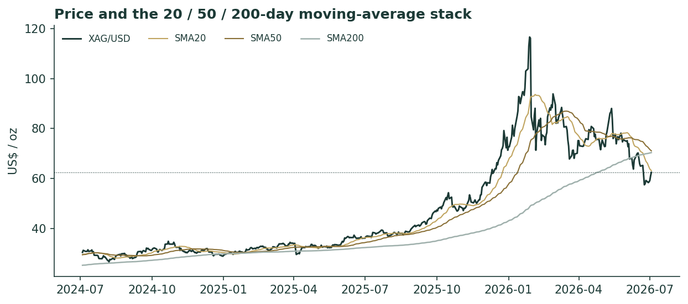
Figure 3. Price and the 20 / 50 / 200-day moving-average stack (last ~2 years). The 2025 melt-up, the January 2026 spike to ~$121 and the halving back to the low-$60s — now below all averages, which are beginning to roll over.
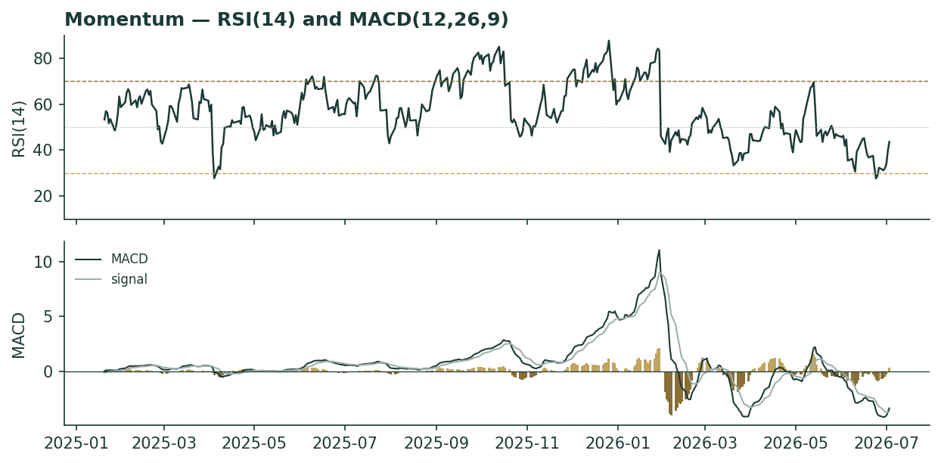
Figure 4. Momentum — RSI(14) and MACD(12,26,9). RSI recovering from oversold toward neutral; MACD negative but its histogram has just turned up.

3 Monte Carlo — a probabilistic price map
Volatility width is sized by the YZ-HAR engine — a pooled log-HAR cascade (variance lags 1/5/22) on a gap-aware Yang-Zhang variance proxy (overnight-return² + Rogers-Satchell), projecting the average daily variance over the forecast window — not trailing close-to-close vol. Innovations are unit-variance Student-t(5), implemented as a per-path chi-square mixture so the aggregate keeps honest fat tails without a fat body. Drift is asset-class-conditional and here set OFF for the diffusion (metal) — the Step 0 backtest confirmed that adding a secular drift degrades skill and does not fix the mild bull-period PIT tilt. Sixteen factors — seven continuous, nine discrete — layer on top; the §1 fair-value gap is deliberately kept out of the drift, so the fundamental and probabilistic lenses stay independent. 50,000 paths, seed 42, anchored at spot; horizons T+21 (1 month), T+63 (3 months) and T+252 (12 months) in one run. Everything in this section is a dated prediction — where the price could actually trade at each horizon — as distinct from the undated fair-value-now anchors in §1.
Read the 50% band first. The engine’s annualised forward width is ~47% over three months, mean-reverting from a trailing ~64% (the post-spike extreme) toward ~44% over the year — roughly twice gold’s width, which is why the cone is wide. The net factor contribution is a near-flat +1.7% at three months (a hawkish Fed offsetting the structural bid) rising to +7% at twelve (structural deficit, expected 2027 easing, the gold anchor), tempered by an overvaluation flag and a fat left tail (positioning unwind). Lead with the interquartile band: at T+63 the middle 50% of outcomes spans $56–72, and the 5–95% cone spans $44–92.
Horizon | p5 | p25 | p50 | p75 | p95 | mean
T+21 (1 month) | 49.9 | 57.8 | 62.8 | 68.2 | 79.0 | 63.4
T+63 (3 months) | 43.8 | 55.6 | 63.5 | 72.5 | 91.8 | 65.3
T+252 (12 months) | 33.5 | 52.1 | 66.8 | 85.7 | 134.7 | 74.3
Percentile map (US$/oz). The mean sits above the median at every horizon — the lognormal-plus-t5 right skew, far wider than gold’s because silver’s volatility is roughly double. At T+21 the band width is ≈ the T+63 width ÷ √3.
The three horizons side by side — the combined read this document is built around:
Measure | 1 month (T+21) | 3 months (T+63) | 12 months (T+252)
Median | $62.8 | $63.5 | $66.8
50% band (IQR) | $58–68 | $56–72 | $52–86
90% band | $50–79 | $44–92 | $34–135
P(below spot) | ~49% | 46% | 42%
Net factor drift | +0.6% | +1.7% | +7%
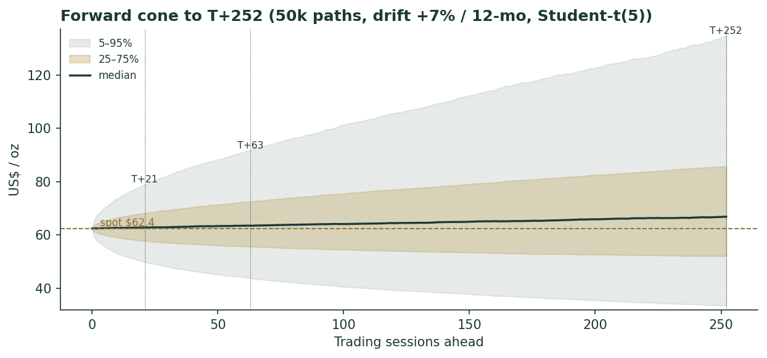
Figure 5. Forward cone to T+252 (50k paths, diffusion drift OFF, +7%/12-mo factor tilt, Student-t(5)). Median (dark) barely rises near-term and lifts modestly over the year; the fan widens with a fat right tail. Dynamic y-axis.
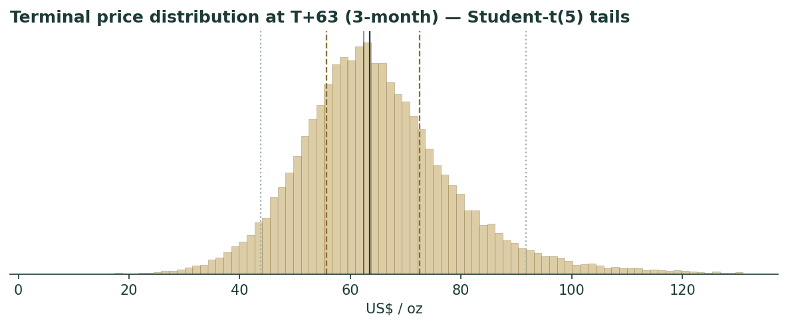
Figure 6. Terminal price distribution at T+63 (3 months). Student-t(5) tails; median near spot, right-skewed.
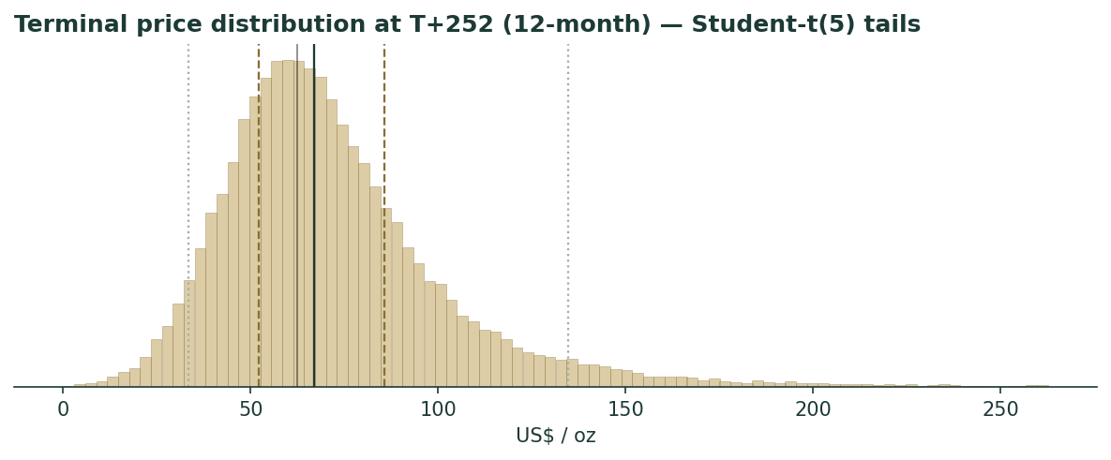
Figure 7. Terminal price distribution at T+252 (12 months) — the same shape stretched, with a pronounced right tail toward the consensus zone.
Outcome zones (probability the terminal price lands in each band vs spot):
Zone (vs spot) | T+63 probability | T+252 probability
< -20% | 12.4% | 21.8%
-20..-10% | 14.2% | 10.0%
-10..-5% | 9.7% | 5.4%
-5..+5% | 20.4% | 10.7%
+5..+10% | 9.0% | 5.2%
+10..+20% | 14.1% | 9.4%
> +20% | 20.3% | 37.6%
The modal three-month outcome is ‘within ±5% of spot’ but it holds only ~20% of the mass — this is a high-dispersion instrument where the tails carry the weight. About 46% of three-month paths finish below spot and 42% of twelve-month paths — a genuinely two-sided distribution with a slight upward lean over the year.
Level-touch probabilities (path touches the level at least once within the window; running max for upside, running min for downside):
Level | Touch by T+63 | Touch by T+252
$85 | 14.8% | 44.8%
$78 (consensus floor) | 27.1% | 57.9%
$72 | 45.9% | 71.8%
$68 (fair-value centre) | 63.7% | 82.2%
$55 | 44.9% | 64.9%
$50 | 23.2% | 46.5%
$45 | 11.0% | 31.6%
$40 (deep-bear / cost zone) | 4.9% | 20.1%

4 Comparison of the lenses, and a verdict
The fundamental anchors, the technical tape and the probabilistic map tell a consistent story with different emphases. The fundamental zone ($58–78, centre $68) says silver is fairly-to-modestly-cheaply valued at $62, underwritten by a tight physical market and the gold anchor. The technical tape says ‘corrective, consolidating a crash’ — below trend but stabilising. The Monte Carlo reconciles the two: a near-term median at spot (the tape’s caution) with wide two-sided tails (the metal’s volatility) and a twelve-month median lifting toward the fair-value centre (the anchors’ pull). The three experts span $60–72 and disagree only on how durable industrial demand is. Verdict: this is a distribution centred on a fair-value zone, not a directional call — the honest statement is a $58–78 zone with spot in its lower half, a wide quarter-ahead cone, and a modest twelve-month upward tilt contingent on the deficit outlasting solar thrifting and the Fed easing on schedule.

5 Catalysts to watch
Catalyst | Materiality | Why it matters
Fed real-rate path | Very high | The dominant swing — a resumption of 2027 easing re-rates the whole complex; stronger-for-longer caps it
Gold price direction | High | Silver is dragged by gold via the ratio — gold toward $4,600–5,000 pulls silver to $74–81 at a stable ratio
Gold-silver ratio | High | Compression toward 55–50× is the bull case ($73–80); drift to 80× is the bear ($50)
Solar/PV silver intensity | High | Grams-per-watt: continued thrifting erodes the deficit; copper substitution (2028–30) is the tail risk
World Silver Survey revisions | Medium | Deficit revisions (UBS already cut ~80%) move the structural floor
Positioning / ETF flows | Medium | A COMEX/ETF unwind is the fast downside (J.P. Morgan flags $50); a physical squeeze is the fast upside
Official-sector / policy | Low–rising | Russia’s reserve buying and China’s export-licence tightening are nascent new demand/supply frictions

6 Reading the probability zones
The distribution is best read as zones, not a point. The lower-$50s-to-lower-$70s is the ‘fair-value core’ — the 50% interquartile band at three months ($56–72) and the region the anchors cluster in. Below ~$50 is the ‘positioning-unwind / demand-destruction’ zone — a 23% touch by three months and 46% by twelve — where the cost floor (~$30) and the deficit eventually arrest the fall. Above ~$78 is the ‘consensus-reversion / ratio-compression’ zone — a 27% touch by three months and 58% by twelve — which needs either gold materially higher or the ratio compressing. The $68 fair-value centre carries a 82% touch over the year. Lead with the interquartile band: the residual cone width is silver’s genuine quarter-ahead uncertainty at ~47% volatility, not padding.

7 Caveats and what would change our mind
This is a distribution, not a target, and several things would move it materially:
- T
- T
- S
- P
- C
- D

Appendix A The silver balance — a commodity’s financial statements
A commodity has no income statement, balance sheet, cash-flow statement or per-share metrics, so the standard template’s Appendix A items (A.1 income statement, A.2 balance sheet, A.3 cash flow) and the company DCF are a justified N/A here. Their metal analogue — the object that plays the role financial statements play for a firm — is the physical supply/demand balance: three years of history plus the current-year forecast, the ledger that determines whether the market draws down or builds inventory. Figures from the World Silver Survey 2026 (Silver Institute / Metals Focus).

A.1 Supply and demand balance (million ounces)
Line | 2024 | 2025 | 2026e
Supply
Mine production | 820 | 819 | 850
Recycling | 193 | 198 | 196
Total supply | 1,013 | 1,017 | 1,046
Demand
Industrial (total) | 681 | 657 | 640
of which photovoltaics | 198 | 187 | 151
Investment (bars, coins, ETP) | 168 | 169 | 171
Jewellery | 203 | 196 | 178
Silverware + other | 110 | 113 | 127
Total demand | 1,162 | 1,135 | 1,116
Balance (deficit) | −149 | −118 | −70
Cumulative deficit since 2021 |  |  | ~808 Moz
The balance is the metal’s bottom line: six consecutive years in deficit, ~808 Moz drawn from above-ground stocks since 2021 — roughly a full year of mine output removed from the visible market. Investment demand is the balancing swing (bars, coins and ETP flows), mine supply barely moves (inelastic by-product), recycling rises with price (a partial safety valve), and the demand-side swing is photovoltaics, down ~19% in 2026e. Supply minus demand equals the deficit on every column. This table is the single most important ‘financial statement’ silver has.

Appendix B Step 0 — calibration backtest
Before valuing the metal we test the forecasting engine on silver’s own history: a rolling backtest, horizon 60 sessions, scoring each realised close against the distribution the YZ-HAR engine (diffusion drift OFF) would have produced using only prior data. The grade is CRPS skill against a zero-drift random-walk cone (spot, trailing realised vol); the Winkler interval score is the second gate; band coverage and PIT are diagnostics only. The sample spans the full available history, 2021-01-01 to 2026-07-03; scored origins run 2022-02-25 to 2026-04-13 (1,072 origins, each with 60 sessions of realised future).
Metric | Result
CRPS skill vs random walk (non-overlapping, mean across 60 phasings) | +0.0153 (pass, >0)
CRPS skill (dense origins, n=1,072) | +0.0150 · block-bootstrap 95% CI [+0.002, +0.025]
Fraction of non-overlapping phasings with skill > 0 | 93%
Winkler interval skill (90% PI, model vs RW) | +0.067 (model tighter and better-scored)
Interval coverage 50 / 80 / 90% (diagnostic) | 0.50 / 0.83 / 0.89 (targets 0.50 / 0.80 / 0.90)
PIT mean / std (diagnostic) | 0.60 / 0.29 (mildly right-skewed)
Secular-drift test (×0 / ×0.5 / ×1.0) | drift degrades skill (0.0150→0.0071) — zero-drift confirmed
Passes: positive CRPS skill with the dense-origin confidence interval entirely above zero and 93% of non-overlapping phasings positive; the model interval score beats the benchmark; coverage lands on target. The one blemish is a mildly right-skewed PIT (mean 0.60) — realised silver landed above the zero-drift median more often than not, the honest signature of an historic 2022–26 bull run. We tested the obvious fix and rejected it: adding a secular drift (×0.5, ×1.0) does not improve the PIT and actively degrades CRPS skill, because silver’s up-bias comes from episodic spikes (the 2025 doubling, the run to $121), not a smooth trend a constant drift can capture, while the drift hurts every flat and down window including the crash. Zero diffusion drift is therefore both the house metals rule and the empirically better choice here.
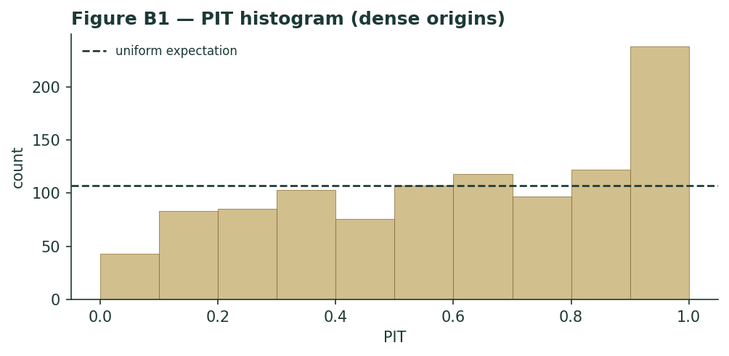
Figure B1. PIT histogram (dense origins). Roughly uniform with a mild right lean — no material U-shape; the elevated top bin is the episodic-spike signature discussed above.
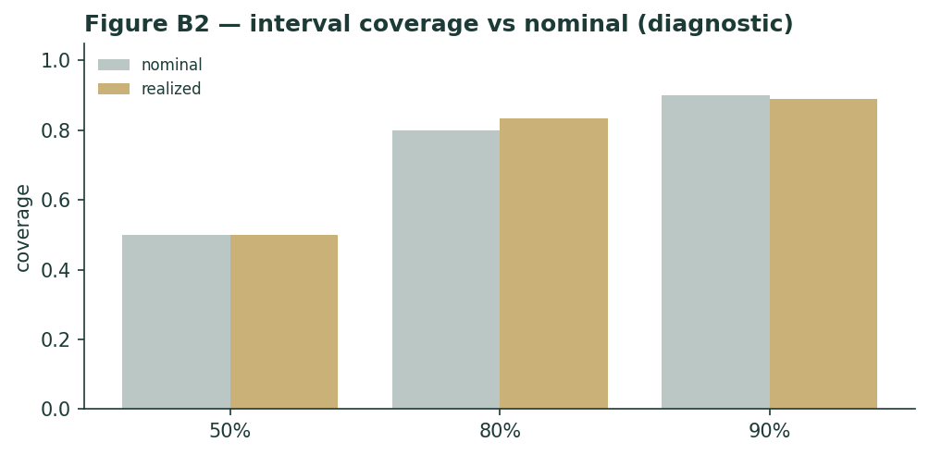
Figure B2. Interval coverage vs nominal (diagnostic only; band-containment is never the grade).

Appendix C Peer set, sector structure, and risks
Silver has no ‘comparable companies’ — it is the underlying — but the investable silver complex spans several vehicles with different exposures, useful for context and for reading what the equity market implies about the metal.
Cohort | Names | Character
Primary silver miners | Fresnillo, Pan American, Hecla, First Majestic, Endeavour | Levered to spot; AISC ~$25–31; operating leverage cuts both ways
Diversified / by-product | Glencore, BHP, Newmont, KGHM | Silver is a minor by-product; little pure-play read
Streamers / royalty | Wheaton Precious Metals, Franco-Nevada | Fixed-cost silver streams; lower-risk metal exposure
Physical ETFs | iShares SLV, abrdn SIVR, Sprott PSLV | Direct bullion; PSLV allocated/redeemable
Silver (this study) | — | The metal itself — no operating leverage, no counterparty
Risks, in order of materiality: the Fed real-rate path and the dollar (the dominant macro driver of a non-yielding asset); the gold price (silver is dragged via the ratio); solar/PV demand and thrifting/substitution (the swing on the industrial leg); speculative positioning in a thin market (the fast-downside tail); and consensus staleness (targets set above the current price). The mitigants are structural: a sixth-straight physical deficit, thin above-ground stocks, inelastic by-product mine supply, and a cost floor well below spot that would eventually arrest a deep fall. Unlike the miners, the metal itself carries no operating leverage, no balance-sheet risk and no counterparty — the trade-off is that it also pays nothing, which is precisely the real-rate cost Expert 1 will press.

Appendix D The expert valuation panel
Three independent methods, cast by the instrument class: for a precious/industrial metal the library pairs a real-rates macro valuer, an industrial supply/demand (cost-curve) valuer, and an investment-flows/gold-silver-ratio valuer. This substitutes an industrial-demand seat for the official-sector seat used on gold — a deliberate, flagged choice, because central banks do not hold silver in meaningful size, whereas silver’s industrial leg (~58% of demand) is its defining difference from gold. Each expert runs a genuinely different method, shows workings, and states a falsification condition. They are labelled Expert 1 / 2 / 3. Every expert fair value below is a fair value NOW (what an ounce is worth today), not a dated price prediction.

D.1 Expert 1 — the real-rate / opportunity-cost valuer
Worldview and tradition. This expert values silver as a zero-yield monetary asset whose fair price is set by the real interest rate and the dollar. Holding an ounce of silver forgoes the real return available on cash; the metal is ‘worth it’ only if expected appreciation compensates that carry. In this tradition silver is a long-duration zero-coupon claim on debasement — its price falls when real yields rise (the discount rate on that claim goes up) and rises when they fall.
When it works / fails. It works over the medium term and at turning points in the rate cycle — the 2013 taper and the 2022 hiking cycle both crushed silver as real yields jumped, exactly as the model says. It fails when a physical squeeze or an industrial-demand shock overwhelms the macro (the model is blind to the deficit), and it says nothing about the gold-silver ratio.
Standard workings. (1) Take the real 10-year yield and the dollar as the discount-rate proxies. (2) Anchor to a neutral silver level consistent with a neutral real rate. (3) Adjust for the deviation of the current real rate from neutral, using silver’s historical real-rate beta (~−$8–12/oz per 100bp of real yield in the recent regime). (4) Overlay the dollar. The result is a carry-fair level, deliberately ignoring the physical balance.
Real-rate scenario | Real 10-yr yield | Carry-fair silver
Easing resumes (2027 base) | ~1.2% | $68
Neutral / current | ~1.8% | $60
Higher-for-longer | ~2.4% | $50
Worked example. At today’s ~1.8% real 10-year and a firm dollar, the carry-fair level is ~$60 — essentially spot. The metal is priced for the current hawkish regime; it is neither discounting the 2027 easing (which would lift the claim to ~$68) nor a higher-for-longer shock (which would cut it to ~$50). Expert 1’s base case is therefore ‘silver is fairly priced for a hawkish Fed, and the upside is a rate-cut option not yet in the price.’
Sensitivity on the swing input. The swing is the real yield: each 50bp move is worth ~$5–6/oz. A return to the 2021 real-rate regime (deeply negative) would justify a far higher silver, but that is not the base case. Falsification: if silver rises materially while real yields also rise, the carry model is not the operative driver — the physical or flow story has taken over.
Cross-examination. To Expert 2: ‘Your deficit is real but silver ran to $121 and halved — the physical balance did not save it, the rate cycle broke it. The cost floor is $30; do not confuse a floor with a fair value.’ To Expert 3: ‘The ratio is just the relative real-rate sensitivity of two metals; you are pricing my variable twice.’
Verdict. Fair value ~$60, with the upside a Fed-easing option. What the price implies: at $62 the market agrees with a hawkish Fed and assigns little value to near-term easing. Falsification condition: sustained silver strength alongside rising real yields.
Bull / base / bear. Bull ~$68: the market begins to discount the 2027 easing cycle early, the real 10-year drifts back toward 1.2% and the dollar softens, lifting the discounted value of the zero-coupon debasement claim. Base ~$60: the current ~1.8% real yield and firm dollar persist through the near term; silver is fairly priced for a hawkish regime and moves sideways. Bear ~$50: inflation proves stickier than expected, the Fed delivers the hikes the market now prices, the real yield pushes toward 2.4% and the opportunity cost of a non-yielding metal rises — the discount rate on the claim goes up and silver de-rates. The asymmetry Expert 1 sees is that the base and bull are close together while the bear is a full $10 below, so the near-term risk-reward is only mildly positive until the rate cycle actually turns.

D.2 Expert 2 — the industrial supply/demand (cost-curve) valuer
Worldview and tradition. This expert values silver as an industrial commodity in structural deficit: fair value is the marginal cost of the supply needed to clear demand, plus a scarcity premium that widens as above-ground stocks are drawn down. Silver is ~58% an industrial metal, so its price should ultimately reflect the physical balance and the cost curve, not just the macro mood.
When it works / fails. It works over multi-year horizons and in genuine shortages — the cumulative 808 Moz drawdown since 2021 is the kind of structural tightening that eventually forces price higher. It fails over short horizons (physical tightness can persist for years without a price response while stocks last) and it is exposed to demand-destruction it cannot see coming — precisely the solar thrifting now underway.
Standard workings. (1) Build the balance (Appendix A). (2) Identify the marginal cost of primary supply (AISC ~$28, rising). (3) Add a scarcity premium scaled to the pace of stock drawdown and the years-of-cover remaining. (4) Cross-check against the level at which recycling and thrifting rebalance the market.
Balance scenario | Deficit / cover | Cost-plus-scarcity fair value
Deficit widens (PV holds) | ~60 Moz, stocks thinning | $78
Base (thrifting continues) | ~46 Moz | $72
Deficit narrows (substitution) | <20 Moz | $55
Worked example. At a ~46 Moz deficit and AISC ~$28, the cost-plus-scarcity fair value is ~$72 — a ~$44 scarcity premium over the marginal cost, justified by six years of drawdown and thin cover. If thrifting deepens and the deficit narrows below 20 Moz, the premium compresses and fair value falls toward $55; if PV demand stabilises and the deficit widens, $78+ is justified.
Sensitivity on the swing input. The swing is solar silver intensity in grams per watt: the single variable that decides whether the deficit persists. A 10% further cut in intensity roughly halves the PV demand growth that underpins the premium. Falsification: two consecutive annual surpluses, or a sustained rise in visible LBMA/COMEX stocks, would break the scarcity thesis.
Cross-examination. To Expert 1: ‘Real rates set the mood, not the price of a physical metal in shortage — you have had a deficit for six years and been wrong about the floor the whole time.’ To Expert 3: ‘The ratio is a trading heuristic, not a valuation; silver’s fair value is set in the physical market, and gold is a sideshow to a solar-cell manufacturer.’
Verdict. Fair value ~$72, the top of the fundamental cluster. What the price implies: at $62 the market prices only a modest scarcity premium — it does not believe the deficit will persist, i.e. it expects thrifting to win. Falsification condition: a return to sustained physical surplus.
Bull / base / bear. Bull ~$78: photovoltaic demand stabilises as thrifting hits its physical floor, every other industrial use keeps growing (AI/data-centre power, vehicle electrification, brazing), the deficit widens back toward 60 Moz and above-ground cover keeps thinning — the scarcity premium over the ~$28 cost curve expands. Base ~$72: thrifting continues at its recent pace, the deficit holds near 46 Moz, and the premium is stable. Bear ~$55: copper-metallization TOPCon cells scale faster than the 2028–30 timetable, per-cell silver intensity falls sharply, and the deficit narrows below 20 Moz on its way toward balance — the scarcity premium compresses toward the cost curve. Expert 2’s whole case is that stocks cannot be drawn down indefinitely: at some point cover runs thin enough that price must ration demand, and the only question is whether that reckoning arrives before or after copper substitution removes the need for it.

D.3 Expert 3 — the investment-flows / gold-silver-ratio valuer
Worldview and tradition. This expert values silver relative to gold and through the flows that actually move a small market — the gold-silver ratio, ETF holdings and futures positioning. Silver is the high-beta junior to gold: it lags in the early innings of a precious-metals move and outperforms late as the ratio compresses. Fair value is gold × the ratio the flows justify.
When it works / fails. It works in precious-metals bull and bear phases, when silver reliably amplifies gold and the ratio mean-reverts — the January 2026 spike (ratio to 55×) and the halving (ratio back toward 65×) both tracked the flows. It fails in industrially-driven moves decoupled from gold, and positioning signals are noisy and can persist longer than solvency.
Standard workings. (1) Take gold’s level (~$4,020 spot; consensus ~$4,600–5,000 over 12 months). (2) Take the ratio the flows justify (long-run 60–65×; compression to 50–55× in a strong bull). (3) Silver = gold ÷ ratio. (4) Overlay positioning: extended net-long is a downside risk, washed-out positioning an upside one.
Gold × ratio scenario | Assumption | Implied silver
Gold $4,600, ratio 58× (bull) | gold reverts up, mild compression | $79
Gold $4,020, ratio 61× (base) | gold flat, neutral ratio | $66
Gold $3,800, ratio 78× (bear) | gold slips, silver lags | $49
Worked example. At gold ~$4,020 and a neutral 61× ratio, silver is ~$66 — modestly above spot, the pull of the neutral ratio. The upside case is not silver-specific: it is gold reverting toward its own $4,600–5,000 consensus while the ratio holds or compresses, which carries silver to $79. The downside is a gold reversal that drags silver via the ratio to ~$49 — near J.P. Morgan’s $50 unwind flag.
Sensitivity on the swing input. Two swings, roughly equal: a $400 move in gold and a 5× move in the ratio each shift silver ~$5–6. Falsification: silver and gold decoupling — silver moving hard while the ratio and gold do not — would mean the industrial leg, not the flow/ratio, is driving, and the method is off-duty.
Cross-examination. To Expert 1: ‘Real rates drive gold, and I already capture gold — so I price your variable, plus the relative flows you ignore.’ To Expert 2: ‘Your deficit has been intact for six years while the price went from $25 to $121 to $62; clearly flows and the ratio, not the balance, set the actual price path.’
Verdict. Fair value ~$66, the swing vote between the cautious macro read and the structural-bull read. What the price implies: at $62 the market sits just below the neutral-ratio level, pricing neither compression nor a gold reversion. Falsification condition: a sustained silver/gold decoupling.
Bull / base / bear. Bull ~$79: gold reverts toward its own $4,600–5,000 consensus zone as the precious-metals bid resumes, and the ratio compresses toward 55–58× as silver does what it always does late in a metals rally — outperform. Base ~$66: gold holds near $4,020 and the ratio sits at a neutral ~61×; silver drifts just above spot. Bear ~$49: a gold reversal (a stronger dollar, a real-rate spike, a haven unwind) drags silver down through the ratio, and stretched speculative positioning accelerates the move — the $50 unwind J.P. Morgan warns about. Expert 3’s distinctive point is that silver’s marginal buyer is a leveraged futures and ETF speculator, so silver overshoots gold in both directions: it is the metal’s beta, not its alpha, and the ratio is the cleanest way to price that beta.

D.5 The three in one room
A short exchange on the single question they most disagree on — whether silver is cheap at $62.
Expert 2: ‘Six years of deficit, 808 million ounces gone from stocks, and you are calling $62 fair? This is the tightest silver market in a generation. The cost curve is $28 and rising; the scarcity premium alone is worth $70-plus.’
Expert 1: ‘And it ran to $121 on that same deficit and halved — because the Fed turned hawkish and the real yield rose. Your deficit did not defend $80. Silver is a zero-yield asset; at a 1.8% real rate it is worth about $60, and the deficit is a slow tailwind, not a floor under any particular price.’
Expert 3: ‘You are both half right. The price is gold times a ratio the flows set. Gold at $4,020 and a neutral ratio is $66 — just above spot. The deficit (Expert 2) is why the ratio should compress over time; the real rate (Expert 1) is why gold — and therefore silver — is capped until 2027. The answer is a wide zone, and the swing is whether solar thrifting lets the deficit keep compressing that ratio.’

D.6 Reading the divergence

Figure D1. Expert and anchor fair values on one field. The spread ($60–72) is narrow relative to the Monte Carlo cone — the experts agree on the zone and disagree on where in it silver sits.
Expert | Method | Fair value | The one assumption driving it
Expert 1 | Real-rate / opportunity cost | $60 | The real 10-year yield (~1.8%, hawkish Fed)
Expert 2 | Industrial supply/demand | $72 | Solar silver intensity (does the deficit persist?)
Expert 3 | Flows / gold-silver ratio | $66 | Gold’s level × the ratio the flows justify
Panel | Spread = the demand question | $60–72 | centres ~$66, just above spot
What the spread measures. The $60–72 range is unusually narrow for silver — the experts agree the metal is fairly-to-modestly-cheaply valued and disagree only on magnitude. The spread is, precisely, the industrial-demand question: Expert 2’s $72 is the deficit persisting, Expert 1’s $60 is the macro capping it, and Expert 3’s $66 is the ratio splitting the difference. Every one of them turns on the same real-unit variable the crux (§1.7) isolates — grams of silver per solar watt. That the panel is tight while the Monte Carlo cone ($44–92 at three months) is enormous is the honest picture: the fair value is knowable within a zone, but the quarter-ahead price is not, because silver is twice as volatile as gold and its marginal buyer is a leveraged speculator.

About this series
Each instrument in the Testahil series follows the same standing format — Headline → Valuation summary → 1. Fundamental → 2. Technical → 3. Monte Carlo → 4. Comparison → 5. Catalysts → 6. Probability map → 7. Caveats → Appendices (A financial statements or their metal analogue, B Step 0 calibration, C peer set, D expert panel) → Disclosure. A Step 0 calibration backtest gates every study: the forecasting engine must beat a zero-drift random-walk benchmark on CRPS skill before the metal is valued. The method is deliberately transparent and open to scrutiny; the aim is education in how fundamental, technical and probabilistic lenses combine, not a recommendation. For a commodity the fundamental section is adapted to fair-value anchors rather than company cash flows, and the company-specific template items are flagged as justified N/A and replaced by their metal analogues.

Disclosure & Disclaimer
Not investment advice. This document is an educational valuation exercise and an expression of personal analytical opinion. It is not investment advice, not a recommendation or solicitation to buy, sell or hold silver or any related instrument, and not directed at the objectives, financial situation or needs of any reader.
No licence, no clients. The preparer is not licensed or registered with any securities or commodities regulator in any jurisdiction, provides no financial consultancy, manages no money, solicits no funds and accepts no fees or clients.
Model outputs, not certainties. All figures are model outputs presented as ranges and probability distributions. No single number is a forecast or a price target; the Monte Carlo describes a distribution of possible outcomes, not an expected path.
Sources and estimates. Market data are drawn from the World Silver Survey 2026 (Silver Institute / Metals Focus), the LBMA, published analyst research and exchange data; forward-looking inputs are the preparer’s own judgments and are flagged as estimates throughout. Errors and omissions are possible.
Risk warning. Silver is a highly volatile asset (realised volatility roughly twice gold’s); prices can move sharply and past behaviour does not indicate future results. Anyone acting on their own view should consult a licensed financial advisor first.
Position disclosure. The preparer may hold, and may in the future take or dispose of, a position in the security discussed in this report.
Testahil · Independent Valuation Study — Educational Analysis · Silver (XAG/USD) · combined 1/3/12-month edition · 03 Jul 2026

