Independent Valuation Study — Educational Analysis
Gold (Spot · XAU/USD) — 12-Month Forecast
Fundamental analysis · Technical analysis · Monte Carlo simulation — one integrated read
Anchor: $3,989.85 / oz (25 Jun 2026 close) · USD per troy ounce · analyst-consensus anchor ~$4,800 (Reuters 30-analyst 2026 median) · horizon 252 sessions (~12 months) · σ = 27% (Step-0-validated) · 50,000 paths, seed 42 · computed 25 Jun 2026 from the attached XAUUSD history (01 Jan 2010 – 25 Jun 2026).
Read this as a scenario distribution. The 12-month forecast is materially weaker than the 3-month one: 16.5 years of data contain only ~16 independent year-long windows, so coverage carries ±8–12% error. Every figure here is a wide scenario distribution, not a precise forecast.

Headline
The model’s read: a wide, right-skewed 12-month distribution centred — on both mean and median — above spot, inside the lower half of fair value, as gold reverts toward consensus over the year. Gold closed $3,989.85 after a violent year (a $5,595 all-time high in January, a ~29% correction back below $4,000, and a fresh death-cross). The fundamental lens — for a commodity, the analyst consensus plus structural demand rather than cash flows — puts a fair-value ZONE of $4,200–$5,000 (centre ≈ $4,600); the Reuters poll of 30 analysts puts the 2026 median near $4,800, ~17% above spot, and the structural picture is the strongest in gold’s modern history (record 2025 demand above 5,000 tonnes, central-bank buying of 863 tonnes, gold now the largest reserve asset by value). A 50,000-path Monte Carlo at the annual horizon (σ = 27%, Step-0-validated; net +12.0% factor drift on the mean) yields a mean of ~$4,487 — at the consensus centre — and a median of $4,295, in the lower consensus zone; the gap between them is the lognormal skew, far milder than silver’s because gold’s volatility is roughly half. Only 40% of paths finish below spot, and the 90% band spans $2,624 to $7,026. Technically the tape is broken and oversold near-term (RSI 30, price ~11% below both moving averages, a fresh 50/200 death-cross); for a one-year view the pivotal level is the $4,500 consensus-zone test (a 73% touch probability over the horizon). Net: over twelve months the structural central-bank/debasement bid and the resumption of Fed easing in 2027 outweigh the fading near-term rate/dollar headwind, pulling gold up toward the consensus zone — but the distribution is wide and the calibration weakly identified, so the honest statement is a scenario range, not a target. The right tail belongs to a Fed-cut re-pricing, a haven bid and a debasement/central-bank surge; the left tail to a stronger-for-longer dollar, a positioning unwind and a deeper correction. This study estimates a distribution, not an action.

Market overview — gold at a glance
Gold (XAU/USD) is the senior monetary/precious metal, priced in US dollars per troy ounce; demand is investment- and central-bank-led, with jewellery now a minority and falling. 2025 was a record year — total demand (including OTC) exceeded 5,000 tonnes across a year of 53 all-time-high prints, central banks bought 863 tonnes (the fourth-largest annual total on record), US-listed ETFs added 437 tonnes to a record 2,019t, and late in the year gold overtook US Treasuries to become the world’s largest reserve asset by value. Supply rose only ~1% to 5,002t. A commodity has no balance sheet, shares or cash flows, so the valuation rests on the analyst-consensus forward anchor, the structural supply/demand balance, a non-binding cost floor, and real-rate carry — a fair-value zone that, over a 12-month horizon, becomes the primary anchor because consensus mean-reversion plays out over 6–18 months.

1. Fundamental analysis
How a commodity is valued at the 12-month horizon. Gold pays nothing and has no cash flows, so there is no SOTP, DCF or multiple — and because it is the senior monetary metal, it cannot be valued relative to a higher metal the way silver is. Four lenses bound a fair-value ZONE: (1) the analyst-consensus forward anchor — the published professional consensus as a market-implied fair value; (2) the structural supply/demand balance, dominated by central-bank and investment demand; (3) a mining cost floor (far below spot, non-binding); and (4) real-rate carry. Over twelve months the consensus zone is the dominant anchor, because mean-reversion toward it plays out over 6–18 months — longer than a quarter but well within a year.

1.1 Method 1 — Analyst-consensus forward anchor (primary)
With no cash flows and no senior metal to anchor against, gold’s most defensible level reference is the published professional consensus. The Reuters poll of 30–31 analysts puts the 2026 median near $4,800 (~17% above spot); 2027 views run higher still. Year-end-2026 targets vs spot $3,989.85:
Source / scenario | 2026 target | vs spot | 12-month view
Morgan Stanley / Deutsche | $4,425 | +11% | conservative cluster
Reuters 30-analyst median | $4,800 | +20% | the neutral consensus anchor
Goldman Sachs (cut 20-Jun) | $4,900 | +23% | 2026 cuts removed; easing to 2027
Citi / BofA | $5,000 | +25% | mid-cluster
UBS / JPM (Q4) | $5,700–6,100 | +43% to +53% | structurally bullish; $6,300 possible
Year-end-2026 targets vs spot. A reversion toward the ~$4,800 consensus median over the year — the heart of the fundamental zone — is the central expectation if real rates stabilise.

1.2 Method 2 — Structural demand (the 12-month-plus support)
Record investment- and central-bank-led demand is the floor under the medium term. 2025 demand exceeded 5,000 tonnes, central banks bought 863 tonnes (fourth-largest on record, well above the 2010–21 average), and gold overtook US Treasuries as the largest reserve asset by value; mine supply grows only modestly and recycling stayed muted despite a 67% price rise. The WGC expects 2026 central-bank buying near 2025 levels. This is a 12-month-plus force — the debasement and de-dollarization trade — and underpins the fundamental read.

1.3 Methods 3 & 4 — cost floor and real-rate carry
Industry all-in sustaining cost is ~$1,400–$1,600/oz, far below spot — the cost floor is non-binding, and the price is monetary/investment-driven. Real-rate carry (a hawkish Fed, no 2026 cuts, the dollar index above 100) is the near-term headwind, but over a full year it flips supportive: easing is expected to resume in 2027 (Goldman has pencilled June and December 2027 cuts), and each cut historically adds roughly 60 tonnes of ETF demand.

1.4 Fundamental synthesis — the 12-month zone
Fair-value zone $4,200–$5,000, centre ≈ $4,600, bracketed by the conservative bank cluster (~$4,400) and the Goldman/Citi/BofA cluster (~$4,900–5,000), with the Reuters median (~$4,800) the neutral anchor. Spot $3,989.85 sits ~5% below the zone floor, having overshot to the downside in the ~29% correction from the January all-time high. Over twelve months gold is expected to revert toward the zone as real rates stabilise and the structural bid reasserts; the Fed path is the dominant swing factor — a stronger-for-longer regime caps the move, while the 2027 easing that the consensus assumes re-rates the whole zone.

2. Technical analysis
Computed from the attached XAUUSD daily history (01 Jan 2010 – 25 Jun 2026).
Indicator | Reading | Signal
Close | $3,989.85 | —
SMA 50 / SMA 200 | $4,469.81 / $4,486.99 | price −10.7% / −11.1% below
SMA50 vs SMA200 | −0.4% | fresh death-cross (structure flipped)
MACD (12·26·9) | −121.3 / −105.0 / −16.3 | bearish
RSI-14 | 30.2 | oversold
ATR-14 | $107.98 (2.7%) | contained daily range
52-week range | $3,268 – $5,595 | —
Read. Near-term momentum is firmly down and oversold, and — unlike the companion silver study — the longer-term structure has just flipped: the 50-day has crossed beneath the 200-day for the first time this cycle, a fresh death-cross. For a 12-month view the question is whether gold reverts up into the $4,200–5,000 consensus zone: the $4,500 line carries a 73% touch probability over the horizon. Support runs $3,800 → $3,500 → the 52-week low $3,268; resistance runs $4,487 (SMA200) → $5,000 → the prior peak $5,595. Whether the death-cross resolves as a regime change or a failed signal is the single biggest technical question for the year.
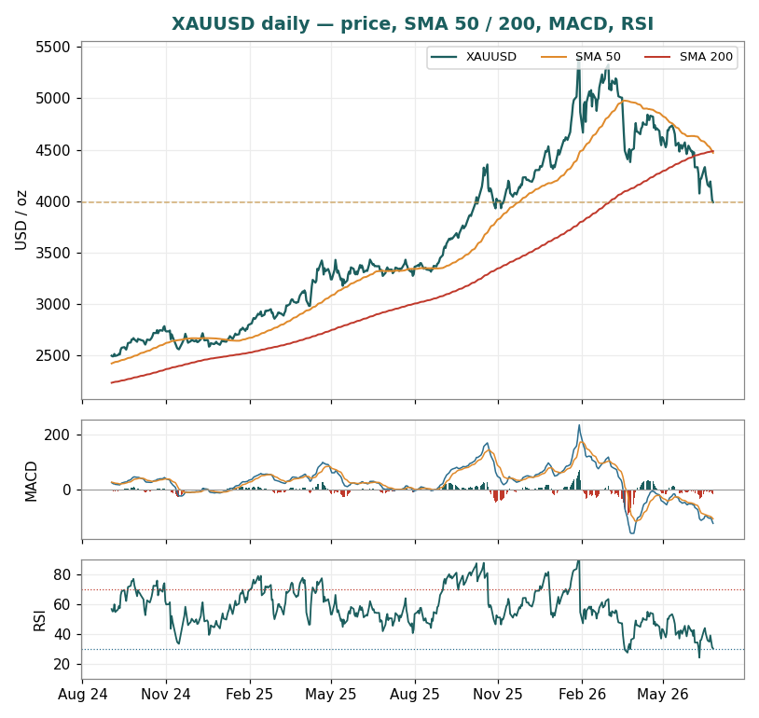
Figure 1. XAUUSD daily, SMA 50 / 200, MACD and RSI. The 2025 melt-up to the $5,595 all-time high, the ~29% correction back below $4,000, and the fresh death-cross — now below both averages with RSI 30. The $4,200–5,000 consensus zone above is the 12-month reversion target.

3. Monte Carlo simulation — 12-month factor model
Method. 50,000 daily paths to T+252, seed 42, anchored at $3,989.85. Five continuous factors contribute a forward drift; six discrete events each fire at most once on a random session as a level shift. Diffusion volatility is σ = 27% (the annualized realized vol = the natural 12-month dispersion, Step-0-validated) — roughly half silver’s 64%. The factor set is recalibrated from the 3-month study to the annual horizon: drifts scaled to a year, the structural central-bank bid given more weight, the Fed-path factor flipped to a tailwind as 2027 easing resumes, and event probabilities raised because there is more time for them to fire.

3.1 The eleven external factors — calibration
All eleven external drivers are set out in one table below, recalibrated to the 12-month horizon. Continuous factors each contribute a 12-month drift to the mean (the 12M-vol entry is informational — the diffusion used is σ = 27%, which already embeds factor-driven volatility); each discrete event fires at most once as a level shift of impact ~ Normal(mean, ± s.d.). The factor table IS the model: every value is an editable judgment, flagged blue in the companion Excel.
Factor (11 external drivers) | Type | 12M drift / prob. | 12M vol / impact | Channel
1. Real US 10-year yield | continuous | −2.0% | 10% | headwind early, fades as 2027 easing nears
2. DXY (US dollar index) | continuous | −1.5% | 9% | dollar headwind may persist over the year
3. Fed-path / real-rate expectations | continuous | +2.0% | 10% | easing resumes 2027 (Goldman Jun & Dec); ~60t ETF/cut
4. Central-bank / official-sector demand | continuous | +6.0% | 10% | structural multi-year bid; debasement / de-dollarization
5. Investment / ETF-flow momentum | continuous | +1.0% | 12% | ETF re-acceleration H2-26/2027 as rates ease
6. Geopolitical / safe-haven shock | event | p = 45% | +6% (±7%) | more time for a shock over 12m
7. Central-bank buying surprise | event | p = 50% | +6% (±5%) | structural; very likely over a year
8. Monetary-policy surprise | event | p = 45% | −4% (±7%) | two-sided; hawkish-tilted early
9. Fiscal / debasement / sovereign stress | event | p = 40% | +6% (±6%) | US fiscal trajectory; debasement catalyst
10. Large COT / ETF positioning unwind | event | p = 40% | −7% (±8%) | deep liquidation a live left-tail
11. ETF / investment-flow resurgence | event | p = 50% | +6% (±5%) | 2027 Fed-cut re-pricing reignites ETF
Net continuous 12-month drift +5.5%; net event expectation (Σ prob × impact) +6.5%; net expected 12-month contribution +12.0% on the mean. The drift lifts the mean to ~$4,487 (the consensus centre); the median sits modestly lower at ~$4,295 because of the volatility — but, unlike silver, both sit above spot.

3.2 Percentile estimates — and why median ≠ mean
Horizon | P5 | P25 | Median | Mean | P75 | P95
T+252 (12m) | $2,624 | $3,515 | $4,295 | $4,487 | $5,246 | $7,026
T+126 (6m) | $2,902 | $3,580 | $4,133 | $4,230 | $4,771 | $5,876
At σ = 27% over a full year the distribution is right-skewed, but median ($4,295) and mean ($4,487) diverge only modestly — about 4.5%, against silver’s ~18% at σ = 64%. The median is the 50/50 level — only 40% of paths finish below spot — dragged below the mean by the lognormal’s −½σ² term (here −0.037 in log space, ≈ −3.6%). Crucially, both sit above spot, reflecting the +12% mean drift as gold reverts toward consensus over the year. The better central anchors are the mean (~$4,487, at the consensus centre) and the fundamental zone ($4,200–5,000); the median ($4,295) marks where the 50/50 line falls, in the lower consensus zone.

3.3 Forward cone to T+252
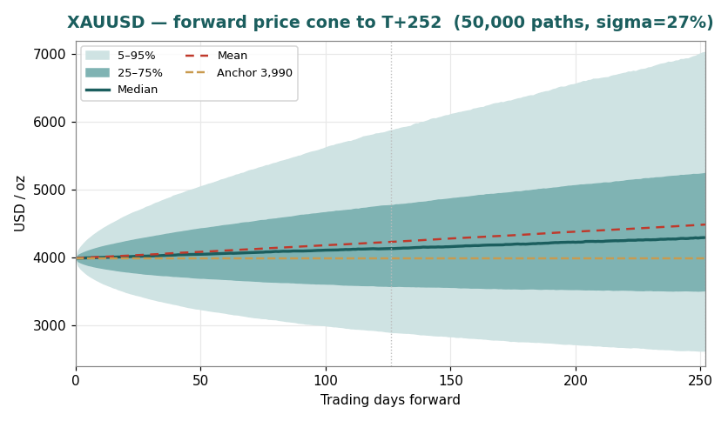
Figure 2. Forward cone to 12 months (median, 25–75%, 5–95%) plus the mean (red dashed). Both median and mean drift above spot toward the consensus zone — the gap between them is the (mild) skew. The 90% band fans to $2,624–$7,026.

3.4 Outcome distributions at 6 and 12 months
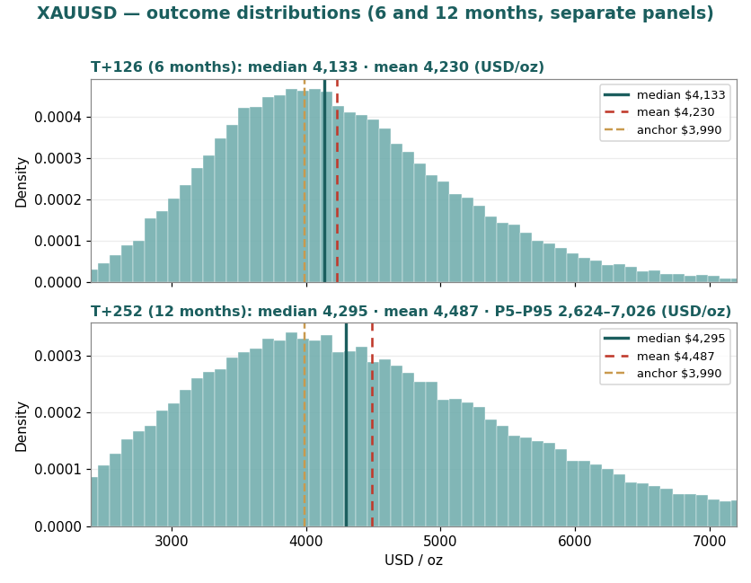
Figure 3. Distributions at 6 months (top) and 12 months (bottom), shown as two separate panels over the same $2,400–$7,200 price range as the cone above (Figure 2), so the two figures read consistently. Median (teal), mean (red dashed) and anchor $3,989.85 (brass dashed) are marked on each. Right-skewed with a long upper tail. T+252 zone probabilities: below $3,500 ≈ 25%, $3,500–4,200 ≈ 23%, $4,200–4,800 ≈ 18%, $4,800–5,600 ≈ 17%, ≥ $5,600 ≈ 19%.

3.5 Level-touch probabilities
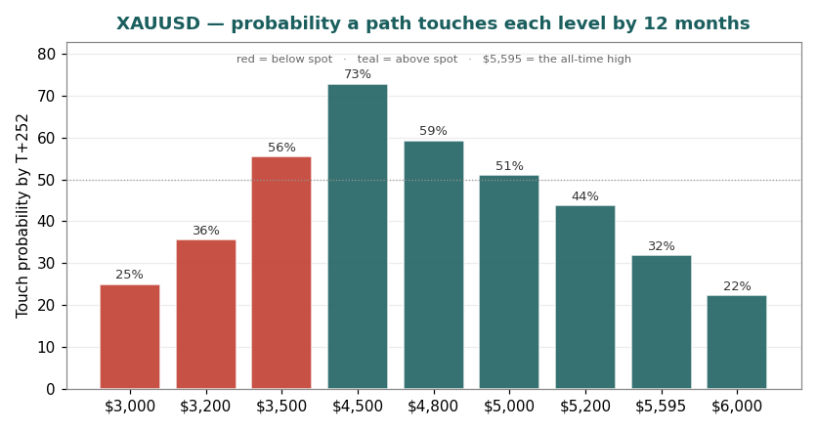
Figure 4. Probability a path touches each level by 12 months: $4,500 ≈ 73%, $4,800 ≈ 59%, $5,000 ≈ 51%, the prior peak $5,595 ≈ 32%, $6,000 ≈ 22% on the upside; $3,500 ≈ 56%, $3,200 ≈ 36%, $3,000 ≈ 25% on the downside. Touch probabilities exceed terminal-zone probabilities (a path may touch a level and retrace).

4. Comparison — fundamental vs technical vs Monte Carlo (12 months)
Lens | 12-month read | Character
Fundamental (consensus anchor) | $4,200–5,000 (≈$4,600) | medium-term magnet; consensus mean-reversion + structural demand; spot ~5% below floor
Technical (structure) | $4,500 zone test | oversold near-term; fresh death-cross; structure has flipped
Monte Carlo | median $4,295 / mean $4,487 / 90% $2,624–7,026 | +12% drift on the mean; mild skew; wide dispersion
Verdict: over twelve months the structural central-bank/debasement bid and the resumption of Fed easing in 2027 outweigh the fading near-term rate and dollar headwind, pulling gold up toward the consensus zone — the mean (~$4,487) at the centre, the median (~$4,295) in the lower zone. The distribution is wide (a 25% tail finishes below $3,500) and the calibration weakly identified, with only ~16 independent year-long observations behind it. The honest 12-month statement is a scenario distribution, not a target: centred above spot near the consensus zone, with the $4,500 reversion as the pivotal level and gold’s own rate-sensitivity as the dominant swing factor. Gold is a less extreme version of the silver setup — the same cheap-versus-anchor logic, but a firmer floor and a far narrower cone.

5. Catalyst calendar (next 12 months)
Window | Catalyst | Why it matters
Jul / Sep 2026 | FOMC meetings (Sep hike decision) | the dominant near-term swing; ~68% market-implied Sep-hike odds
Through 2026–27 | Subsequent FOMC meetings (2027 easing) | the cycle peaks and easing resumes — the upside re-rating; ~60t ETF per cut
Ongoing | US–Iran ceasefire durability | oil and the inflation premium; a breakdown re-arms the haven bid
Apr 2027 | WGC Gold Demand Trends 2026 | confirms whether record central-bank and investment demand persists
Monthly | China gold imports & PBoC purchases | the marginal official buyer; Q1 imports 317t
Ongoing | US fiscal / debt trajectory | the debasement-trade catalyst; the structural reserve bid
Weekly | ETF flows (Western + Asian); CFTC COT | re-acceleration vs further outflow / positioning unwind

6. Reading the probabilities — significant zones (analysis, not guidance)
A map of the 12-month distribution — not a plan, not guidance, not calibrated to any reader’s circumstances.
$3,990 → $4,500 — the consensus-zone reversion. The $4,500 line is the pivotal level: 73% of paths touch it over the year. Reaching it is the constructive base case — gold reverting toward where analysts see it as real rates stabilise and the structural bid reasserts.
$4,200–$5,000 — the fundamental zone. The consensus fair value (centre ≈ $4,600), reached as 2027 easing nears and central-bank demand persists; ~59% of paths touch $4,800 over the year. This is where the discount-to-consensus closes.
$5,000–$7,026 — the upper-distribution zone. The long right tail: 51% touch $5,000, 32% revisit the prior peak near $5,595, 22% touch $6,000. Reached on a Fed-cut re-pricing, a haven bid or a debasement/central-bank surge.
$3,500 / $3,200 / $3,000 — the deeper-correction zone. Below spot, $3,500 (56% touch) and $3,200 (36%) approach mid-2025 levels, and a 25% tail finishes below $3,500. These are the levels at which price-sensitive physical demand and opportunistic central-bank buying have historically re-engaged.

7. Caveats
The 12-month forecast is weakly identified. Only ~16 independent year-long windows exist in the data; coverage carries ±8–12% error (see the calibration appendix). This is a property of the data, not the method — no annual forecast can be calibrated with the confidence of a quarterly one.
Median versus mean. At σ = 27% the median is dragged only ~3.6% below the mean by the lognormal’s −½σ² term — a far milder skew than silver’s ~18% at σ = 64%. Both sit above spot; reading the median as ‘the forecast’ slightly understates the central tendency. The mean and the fundamental zone are the better anchors. Both are shown.
σ is regime-dependent, though gold is calmer than silver. The 27% is the current trailing realized vol; recent realized has ranged 23%–33% and the full-sample figure is 16%. If volatility falls over the year the median lifts and the band narrows (see the Excel sensitivity). Roughly half silver’s σ — the cone is wide but not extreme.
The zone is the analyst consensus, which can re-rate. The fundamental anchor is the Reuters median ~$4,800; banks cut targets in June (Goldman $5,400→$4,900) and the dispersion ($4,400–$6,300) is wide. If the rate regime stays restrictive, the consensus itself can fall — the zone is a forward fair value, not a fixed level.
Direction is not calibrated. The +12% mean drift is the factor overlay’s judgment (defensible range ~0% to +20%); the backtest validates dispersion, not drift, and is where the model is most fallible over a year.
The death-cross is fresh and factors are independent. The 50-day has just crossed beneath the 200-day for the first time this cycle — a regime change that removes the intact-uptrend cushion (it can also resolve as a failed signal). There is no cross-correlation or volatility clustering; the provided series agrees with other feeds within ~0.01%, so there is no basis adjustment.

Appendix — Calibration (Step 0) summary
The 12-month forecast is gated by a Step-0 calibration backtest. Rolling 12-month-ahead forecasts were scored against the realized close across 2010–2026; the verdict is a CONDITIONAL PASS, with the dominant caveat that only ~16 independent windows exist.
Band | Target | Realized (independent, n=16) | Realized (overlap, n=181)
Central 50% | 50% | 50% | 54%
Central 80% | 80% | 62% | 71%
Central 90% | 90% | 75% | 75%
PIT mean 0.64 / 0.62. The 90% band under-covers (fatter-than-lognormal annual tails), widened via the event overlay; centre is within sampling error. The PIT’s upward skew — gold’s secular uptrend — confirms the lognormal median runs low over a year. The PIT histogram and coverage table ship alongside this study in files/.

Appendix — Sources & about this series
Sources. World Gold Council, Gold Demand Trends Full Year 2025 / Metals Focus, 29 Jan 2026 (demand >5,000t, central banks 863t, supply 5,002t, ETF +437t). WGC Q1 2026 Outlook, ~29 Apr 2026. Goldman Sachs Global Research, 20 Jun 2026 (year-end cut to $4,900; easing to 2027). Reuters 30–31 analyst poll (2026 median ~$4,800); bank-target compilations (UBS, J.P. Morgan, Wells Fargo, BNP, Morgan Stanley, Deutsche, Citi, BofA). USAGOLD daily report, 24 Jun 2026 (DXY, Warsh dot plot). Anchor price series: provided OHLC (XAU/USD, 01 Jan 2010 – 25 Jun 2026), cross-checked against TradingView/OANDA ($3,989.55, within ~0.01%). 12-month calibration: Step 0, full 2010–2026 sample.
About this series. Each instrument follows the same standing format — Headline → 1. Fundamental → 2. Technical → 3. Monte Carlo (factor table + percentiles + cone + bells + touch) → 4. Comparison → 5. Catalysts · 6. Probability map · 7. Caveats → Disclosure. A Step-0 calibration backtest gates every study; for the 12-month horizon it carries an explicit small-sample caveat given that only ~16 independent annual windows exist.

Disclosure & Disclaimer — read in full
Nature of this document. This study is an educational valuation exercise and an expression of the preparer’s personal analytical opinion, based exclusively on publicly available information and on stated assumptions. It is published free of charge to demonstrate methodology and to invite scrutiny. No advice, no recommendation, no solicitation. Nothing here constitutes investment advice, financial consultancy, securities or commodities analysis services, a research recommendation, a rating, a price target, an offer, or a solicitation to buy, sell, hold or deal in any security, commodity or financial instrument. No statement is directed at the objectives, financial situation or needs of any person. No licensed activity. The preparer is not licensed or registered with the Egyptian Financial Regulatory Authority (FRA), the U.S. Commodity Futures Trading Commission (CFTC), or any other securities or commodities regulator; carries on no regulated activity; manages no money; and accepts no clients, fees, subscriptions or funds. Commodity-specific risk. Gold is a volatile metal (it corrected ~29% from a $5,595 all-time high in the months to June 2026); where leverage is used, losses can exceed the capital committed. Estimates and uncertainty. All values are model outputs resting on subjective assumptions; they are illustrative, highly uncertain, and likely to prove wrong in material respects — the more so at a 12-month horizon, which the Step-0 calibration shows is weakly identified. The factor calibrations and the analyst-consensus anchor are the preparer’s judgments. Values are presented as ranges and distributions because no single number should be relied on. No liability. To the maximum extent permitted by applicable law, the preparer accepts no liability whatsoever for any decision made or action taken or not taken, or for any loss or damage incurred, by any person in reliance on any part of this document or the accompanying model. Reader’s responsibility. Conduct your own independent assessment and consult an advisor licensed in your jurisdiction. If publication of material of this kind is restricted where you are reading it, do not rely on it. Holdings disclosure. The preparer may hold, and may in the future take or dispose of, a position in the instrument discussed in this report.
25 June 2026

