Independent Valuation Study — Educational Analysis
Gold (Spot · XAU/USD)
Fundamental analysis · Technical analysis · Monte Carlo simulation — one integrated read
Anchor: $3,989.85 / oz (25 Jun 2026 close) · USD per troy ounce · analyst-consensus anchor ~$4,800 (Reuters 30-analyst 2026 median) · prices & probabilities computed 25 Jun 2026 from the attached XAUUSD price history (01 Jan 2010 – 25 Jun 2026) · σ calibrated over the full 2010–2026 sample · independent build, no external target embedded.

Headline
The model’s read: a metal that is cheap on a consensus basis but soft near-term, with a powerful structural bid underneath the medium term. Gold closed $3,989.85 after a violent year — a melt-up to a $5,595 all-time high on 29 January 2026 and a ~29% correction back below $4,000 (its lowest since November 2025) as the Fed turned hawkish. The fundamental lens, which for a commodity rests on consensus and structural demand rather than cash flows, puts a three-month fair-value ZONE of roughly $4,200–$5,000 (centre ≈ $4,600): the Reuters poll of 30 analysts puts the 2026 median near $4,800, and the structural picture is the strongest in gold’s modern history — record 2025 demand above 5,000 tonnes, central-bank buying of 863 tonnes, and gold overtaking US Treasuries as the world’s largest reserve asset by value. Against that, the near-term macro is a headwind: the Fed under Chair Warsh has turned hawkish with no 2026 cuts now expected (Goldman has pushed easing to 2027), the dollar index has broken above 100, the US–Iran ceasefire is unwinding the war’s inflation premium, and ETF demand has “dried to a trickle.” A single factor-based Monte Carlo (five continuous drivers — real rates, the dollar, the Fed path, central-bank demand and ETF flows — plus six discrete events; 50,000 paths, seed 42, σ = 27% calibrated over the full 2010–2026 sample and validated by a rolling backtest) puts the T+20 median at ~$3,975 and the T+60 median at ~$3,944 on a net 0.0% factor drift, with a three-month 90% band of ~$3,064–$5,074. Technically the tape is broken and oversold: price sits ~11% below both its 50- and 200-day averages, MACD is negative, RSI(14) is 30, and the 50-day has just crossed beneath the 200-day — a fresh death-cross. Net: the three lenses run on different clocks — consensus says gold is cheap versus where analysts see it at year-end and a medium-term mean-reversion toward ~$4,600 is plausible if real rates stabilise; momentum and the factor balance say the next one-to-three months are more likely soft, with wide two-sided risk. The right tail belongs to a Fed capitulation, a haven bid and a central-bank/debasement surge; the left tail to further rate-hike pricing, a stronger dollar and an ETF/positioning unwind. This study estimates values and probabilities — it does not recommend actions; the factor calibrations and the consensus anchor are the preparer’s judgments. Unlike the companion silver study, the gold price series agrees with other vendor feeds within ~0.01%.

Market overview — gold at a glance
Gold (XAU/USD) is the senior monetary/precious metal, priced in US dollars per troy ounce. Unlike silver, its demand is investment- and central-bank-led rather than industrial: jewellery is now a minority of demand and falling, while bar-and-coin, ETF and official-sector buying dominate. 2025 was a record year on every axis — total demand (including OTC) exceeded 5,000 tonnes for the first time across a year of 53 all-time-high prints, the value of demand hit $555bn (+45% y/y) with the Q4 average price at $4,135/oz, central banks bought 863 tonnes (the fourth-largest annual total on record, well above the 2010–21 average of 473t), and US-listed ETFs added 437 tonnes to a record 2,019t. Supply barely responded: total supply rose ~1% to 5,002t, with mine production at a record ~3,672t and recycling muted at 1,404t despite a 67% rise in the dollar price. Late in 2025 gold overtook US Treasuries to become the world’s largest reserve asset by value. 2026 has been a sharp correction off the January peak; the World Gold Council’s Q1-2026 outlook expects central-bank buying near 2025 levels, mine supply up modestly, a persistent geopolitical premium, and ETF demand positive but below 2025 as rates stay higher-for-longer.
Company-style disclosure does not apply: a commodity has no balance sheet, no shares and no cash flows. The valuation therefore rests on the analyst-consensus forward anchor, the structural supply/demand balance, a (non-binding) mining cost floor, and real-rate carry — producing a fair-value zone rather than a point. Macro figures here are sourced to the World Gold Council and dated bank research (see Appendix C); the consensus anchor and factor calibrations are the preparer’s judgments, flagged blue in the companion Excel.

1. Fundamental analysis
How a commodity is valued — and how this section is built. A metal is not a cash-flow stream and cannot be valued like a company. There is no SOTP/RNAV, no DCF, no multiple — gold pays no dividend and earns nothing. And because gold is the senior monetary metal, it cannot be valued relative to a higher metal the way silver is valued relative to gold. The defensible approach is to bound a fair-value ZONE from four lenses: (1) the analyst-consensus forward anchor — the published professional consensus taken as a market-implied fair value, not the preparer’s forecast; (2) the structural supply/demand balance, dominated by central-bank and investment demand, which sets directional pressure; (3) a mining cost floor, which in practice is far below spot and non-binding; and (4) real-rate carry, the opportunity cost of holding a non-yielding asset, which sets the near-term tilt. The zone, not a single number, is the output.

1.1 Method 1 — Analyst-consensus forward anchor (primary, neutral)
With no cash flows and no senior metal to anchor against, gold’s most defensible level reference is the published professional consensus, taken as a market-implied fair value. The Reuters poll of 30–31 analysts puts the 2026 median near $4,800. Bank year-end-2026 targets span a wide range — the dispersion is a scenario split over rates and geopolitics, not a fundamental disagreement. Targets vs spot $3,989.85:
Source / scenario | 2026 target | vs spot | Note
Morgan Stanley / Deutsche cluster | $4,425 | +11% | conservative; Deutsche range $3,950–$4,950
Reuters 30-analyst median | $4,800 | +20% | the neutral consensus anchor
Goldman Sachs (cut 20-Jun from $5,400) | $4,900 | +23% | all 2026 cuts removed; easing to 2027
Citi / Commerzbank / BofA | $5,000 | +25% | mid-cluster
UBS (Dec) / BNP avg | $5,700 | +43% | structurally bullish
J.P. Morgan (Q4) / Wells Fargo | $6,100 | +53% | most bullish; $6,300 possible
Year-end-2026 targets vs spot. The conservative-to-mid cluster (~$4,400–$5,000) brackets the consensus median; the wide tail is the rate/geopolitics scenario split. The consensus is a forward fair value, not a near-term forecast.

1.2 Method 2 — Structural supply/demand balance (directional floor)
The structural bid is the through-line. Demand is investment- and central-bank-led and at record levels, while mine supply is roughly flat and recycling muted — a configuration that biases fair value to hold above the correction lows over a three-month-plus horizon. Figures in tonnes unless noted.
Metric (tonnes unless noted) | 2025 | 2026F | Source / as-of
Total demand (incl. OTC) | >5,000 | below 2025 | WGC GDT FY2025, 29-Jan-26
Central-bank buying | 863 | ~2025 levels | WGC — 4th-largest on record
Mine production | 3,672 (record) | up modestly | WGC
Recycling | 1,404 | constrained | WGC — muted vs +67% price
Total supply | 5,002 (+1%) | up modestly | WGC FY2025
US ETF flow | +437 (→2,019) | positive, < 2025 | WGC — $280bn AUM
Demand value (US$bn) | 555 (+45%) | — | WGC — Q4 avg $4,135/oz
Jewellery | falling | weak | WGC — 6th straight quarterly decline
Investment- and central-bank-led demand at record levels; mine supply cannot respond. Gold is now the largest reserve asset by value — a structural floor under the medium-term.

1.3 Method 3 — Cost floor (soft) · Method 4 — Real-rate carry (near-term tilt)
Method 3 — cost floor. Industry all-in sustaining cost is roughly $1,400–$1,600/oz — far below spot. Cost is therefore non-binding in this regime: gold’s price is monetary- and investment-demand-driven, not cost-driven. The floor is noted for completeness only.
Method 4 — real-rate carry. The dominant near-term force is the opportunity cost of holding a non-yielding metal. With the Fed hawkish, no 2026 cuts now expected (Goldman has pushed easing to 2027), and the dollar index above 100, rising real rates are the main reason for the correction off the January high and pull the one-month read toward the lower half of the zone. The World Gold Council’s own scenarios frame the range: mild cooling +5/+15%, recession/geopolitical shock +15/+30%, strong growth and a stronger dollar −5/−20%.

1.4 Fundamental valuation — synthesis
Four lenses, one zone. The consensus anchors the level; the structural demand picture biases it up and underpins it; cost is a distant floor; real-rate carry sets the near-term tilt. The fair-value zone runs roughly $4,200–$5,000 (centre ≈ $4,600), bracketed by the conservative bank cluster (~$4,400) and the Goldman/Citi/BofA cluster (~$4,900–$5,000), with the Reuters median (~$4,800) as the neutral anchor. The one-month tilt is the lower half ($4,200–$4,500) on the rate/dollar headwind; the three-month tilt is the centre/upper half as central-bank demand and the debasement trade reassert if real rates stabilise. Spot $3,989.85 sits ~5% below the zone floor — gold reads mildly-to-moderately cheap versus consensus, having overshot to the downside in a ~29% correction from the $5,595 January all-time high. If real rates stabilise and gold re-rates toward the Reuters median ~$4,800, the discount-to-consensus closes from here.

2. Technical analysis
All technical inputs below are computed directly from the attached XAUUSD daily price history (01 Jan 2010 – 25 Jun 2026).
Indicator | Reading | Signal
Close | $3,989.85 | —
SMA 50 (orange) | $4,469.81 | price −10.7% below
SMA 200 (red) | $4,486.99 | price −11.1% below
SMA50 vs SMA200 | −0.4% | fresh bearish cross (death-cross forming)
MACD (12·26·9) | −121.3 / −105.0 / −16.3 | line < signal; bearish histogram
RSI-14 | 30.2 | oversold (≈30)
ATR-14 | $107.98 (2.7%) | contained daily range
52-week range | $3,268 – $5,595 | —
30-day range | $3,959 – $4,595 | today ≈ 30-day low
Read. Momentum is firmly down and oversold — price has corrected below both moving averages, MACD is negative, and RSI is 30. Crucially, and unlike the companion silver study, the longer-term structure has just flipped: the 50-day has crossed beneath the 200-day for the first time in this cycle, a fresh death-cross and a momentum-regime change rather than a pullback inside an intact uptrend. This reads as an oversold-bounce candidate against a firm structural-demand floor, but with the trend cushion gone and no confirmed reversal. Resistance stacks at $4,200 → $4,470 (SMA50) → $4,487 (SMA200) → $4,600; support at $3,800 → $3,700 → $3,600 → $3,268 (the 52-week low).
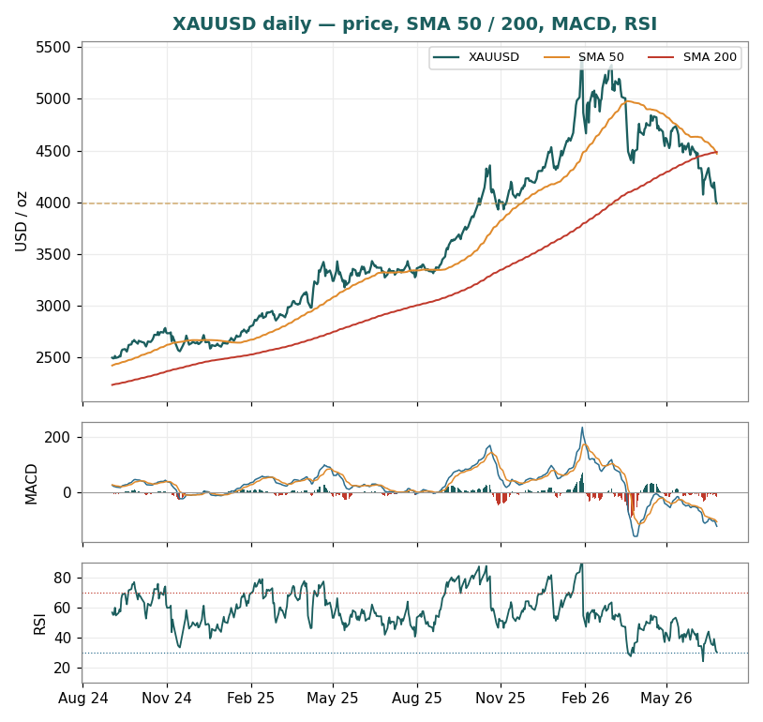
Figure 1. XAUUSD daily with SMA 50 (orange) and SMA 200 (red), MACD (12·26·9) and RSI(14), Sep-2024 → Jun-2026. The 2025 melt-up to the $5,595 all-time high, the ~29% correction back below $4,000, and the fresh death-cross — now below both averages with RSI 30.

3. Monte Carlo simulation — one factor model
Method. One simulation, not a model zoo: 50,000 daily paths to T+60, seed 42, anchored at $3,989.85. Five continuous factors contribute a forward drift (real US 10-year yield, the dollar index, the Fed/real-rate path, central-bank/official-sector demand, and investment/ETF-flow momentum); six discrete events each fire with a stated probability on a random session as a level shift (safe-haven shock, a central-bank buying surprise, a monetary-policy surprise, a fiscal/debasement/sovereign-stress event, a large COT/ETF positioning unwind, and an ETF/investment-flow resurgence). Diffusion volatility is the instrument’s realized σ = 27% (trailing-252d, validated by the Step-0 backtest over the full 2010–2026 sample) — roughly half silver’s 64% — so the historical factor-driven volatility is already embedded and not double-counted. The factors are recalibrated to the June-2026 gold regime: the central-bank-demand driver is the signature structural bid, while the monetary-policy event is hawkish-tilted and ETF-flow momentum is negative as Western and Asian inflows fade.

3.1 The eleven external factors — calibration
All eleven external drivers are set out in one table below, with their full calibration. The factor table IS the model: every value is an editable judgment, flagged blue in the companion Excel and red-pennable before publication. Continuous factors each contribute a 3-month drift to the median (the 3M-vol entry is informational — the diffusion actually used is the realized σ = 27%, which already embeds factor-driven volatility); each discrete event fires at most once on a random session as a level shift of impact ~ Normal(mean, ± s.d.).
Factor (11 external drivers) | Type | 3M drift / prob. | 3M vol / impact | Channel
1. Real US 10-year yield | continuous | −1.5% | 5% | opportunity cost of a non-yielding metal; no 2026 cuts raise carry
2. DXY (US dollar index) | continuous | −1.0% | 4.5% | priced in USD; DXY >100, highest since May-25
3. Fed-path / real-rate expectations | continuous | −1.0% | 5% | forward discounting of carry; hawkish Warsh, easing pushed to 2027
4. Central-bank / official-sector demand | continuous | +2.0% | 5% | structural reserve bid; 863t 2025, OTC-implied strong, debasement trade
5. Investment / ETF-flow momentum | continuous | −0.5% | 6% | first Asian ETF outflow since Aug-25; demand “a trickle”
6. Geopolitical / safe-haven shock | event | p = 25% | +4% (±5%) | haven bid; war premium can re-arm
7. Central-bank buying surprise | event | p = 30% | +4% (±4%) | step-up / mobilisation; China accumulation
8. Monetary-policy surprise | event | p = 30% | −3% (±5%) | hawkish-tilted; energy-inflation hike risk
9. Fiscal / debasement / sovereign stress | event | p = 25% | +4% (±5%) | US fiscal deterioration; the debasement trade
10. Large COT / ETF positioning unwind | event | p = 30% | −5% (±6%) | spec-long / ETF liquidation after the run
11. ETF / investment-flow resurgence | event | p = 30% | +4% (±4%) | Fed-cut re-pricing reignites ETF (~60t per 25bp)
Net continuous 3-month drift −2.0%; net event expectation (Σ prob × impact) +2.0%; net expected three-month contribution 0.0%. Simulated annualized path volatility is 32% — the event impact-spreads add ~5 points over the 27% diffusion. The model is additive, not a weighted blend: each factor’s magnitude is its own weight, and dispersion is set separately by σ together with the impact-spreads. The flat net drift is deliberate — the near-term rate/dollar/ETF headwind roughly balances the structural central-bank-demand bid.

3.2 Percentile estimates (anchor $3,989.85, 50,000 paths)
Horizon | P5 | P25 | Median | P75 | P95
T+20 (1 month) | $3,431 | $3,754 | $3,975 | $4,214 | $4,598
T+60 (3 months) | $3,064 | $3,560 | $3,944 | $4,369 | $5,074
The distribution diffuses from spot and does not embed the fundamental zone — it describes where the factor balance and volatility take the price, not where consensus says it should sit. The median sits essentially at spot on the flat 0.0% drift (modestly below, from the lognormal Itô term); the width is the story. At three months the 90% band spans ~$3,064–$5,074 — honest given gold’s 33%-annualized recent (126-day) volatility and the $5,595→$3,990 swing of the past two quarters. Note the firmer floor than silver: gold’s median holds near spot rather than drifting well below it, because the central-bank-demand bid offsets the rate headwind.

3.3 Forward cone — percentile cone to T+60
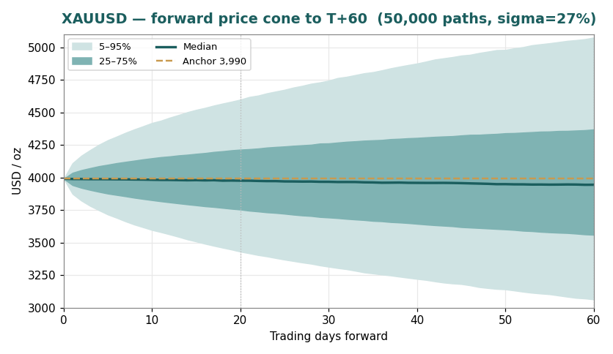
Figure 2. Forward cone (median, 25–75%, 5–95%) from the factor model. The median holds near ~$3,975 by T+20 and ~$3,944 by T+60; the 90% band spans ~$3,431–$4,598 at one month and ~$3,064–$5,074 at three. Dashed: anchor $3,989.85; vertical marks at T+20 and T+60.

3.4 Probability bell curves at T+20 and T+60
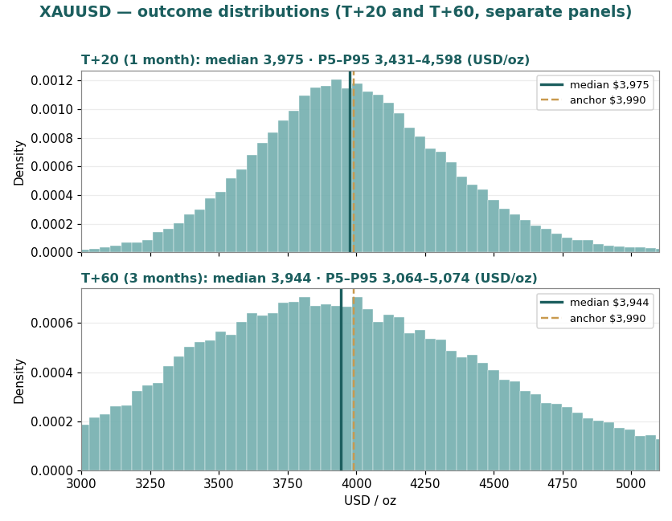
Figure 3. Outcome distributions at T+20 (top) and T+60 (bottom), shown as two separate panels over the same $3,000–$5,100 price range as the cone above (Figure 2), so the two figures read consistently. Median (teal) and anchor $3,989.85 (brass dashed) are marked on each. T+60 zone probabilities: below $3,700 ≈ 34%, $3,700–4,000 ≈ 20%, $4,000–4,300 ≈ 18%, $4,300–4,700 ≈ 16%, ≥ $4,700 ≈ 13%.

3.5 Level-touch probabilities
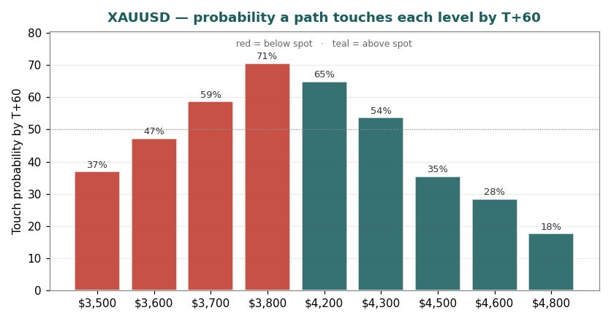
Figure 4. Level-touch probabilities — probability a path touches each level by T+60 (running extrema): downside $3,800 ≈ 71%, $3,700 ≈ 59%, $3,600 ≈ 47%, $3,500 ≈ 37%; upside $4,200 ≈ 65%, $4,300 ≈ 54%, $4,500 ≈ 35%, $4,600 ≈ 28%, $4,800 ≈ 18%. By T+20: $3,800 ≈ 49%, $4,200 ≈ 44%, $4,300 ≈ 30%. Touch probabilities exceed terminal-zone probabilities because a path may touch a level intra-horizon and retrace.

4. Comparison — fundamental vs technical vs Monte Carlo
Lens | 1-month | 3-month | Character
Fundamental (consensus anchor) | ~$4,300–4,600 | $4,200–5,000 (≈$4,600) | cheap vs consensus; structural CB-demand floor
Technical (momentum) | soft / oversold bounce | trend down, fresh death-cross | oversold (RSI 30), below both SMAs
Monte Carlo (factor balance) | median $3,975 | median $3,944 | net drift 0.0%; wide cone, firm floor
Verdict: the three lenses tell one story on different clocks. The consensus says gold is cheap versus where analysts see it at year-end — the Reuters median ~$4,800 is ~20% above spot, and a medium-term mean-reversion toward ~$4,600 is plausible if real rates stabilise, with the record structural demand picture (central banks, the debasement trade, gold as the largest reserve asset by value) a floor under the medium term. Technical and Monte Carlo both say the near-term path is soft and oversold: price is broken below both moving averages, a fresh death-cross has formed, and the factor balance (rising real rates, a stronger dollar, fading ETF flows) nets against the structural bid to a flat-to-soft drift over one-to-three months. The synthesis is a cheap-but-soft picture — wide two-sided risk, a median near spot, the structural demand as the floor and rising real rates as the cap. Gold is a less extreme version of the silver setup: the same cheap-versus-anchor logic, but a firmer floor and a far narrower cone. The disagreement between the lenses is the finding, not a flaw to be averaged away.

5. Catalyst calendar
Window | Catalyst | Why it matters
Late Jul 2026 | FOMC meeting | first read on whether the hawkish September pricing is confirmed or faded
H2 2026 | September FOMC (hike decision) | the dominant catalyst; ~68% market-implied hike odds — a hike pressures, a hold/cut releases
Quarterly | WGC Gold Demand Trends / CB buying data | confirms whether the structural official-sector bid persists at high prices
Monthly | China gold imports & PBoC reported purchases | the marginal official buyer; Q1 imports 317t, PBoC ramping
Ongoing | US–Iran ceasefire durability | oil and the inflation premium; a breakdown re-arms the haven bid
Ongoing | Dollar index trajectory | DXY >100 is a direct headwind; a reversal is a tailwind
Weekly | ETF flows (Western + Asian) & CFTC COT | re-acceleration (upside) or further outflow/positioning unwind (downside)
Ongoing | US fiscal / debt trajectory | the debasement-trade catalyst; sovereign-stress headlines support gold

6. Reading the probabilities — significant zones (analysis, not guidance)
This section translates the simulation into the price zones where the three lenses say something analytically distinct. It is a map of the distribution — not a plan, not guidance, and not calibrated to any reader’s circumstances.
$3,990 → $3,800 — the support test. Spot sits between the recovery zone above and the $3,800/$3,700 supports below. The simulation puts a ~71% chance of touching $3,800 by three months (49% within one) — the downside test is well within reach given the fresh death-cross and the rate headwind.
$4,200–$5,000 — the consensus fair-value zone. This is the fundamental fair-value band (centre ≈ $4,600). Reaching it requires real rates to stabilise and the structural bid to reassert; ~65% of paths touch $4,200 within three months, ~54% touch $4,300 and ~35% touch $4,500. This is where the discount-to-consensus begins to close.
$4,800–$5,074 — the upper-distribution zone. Only ~18% of paths touch $4,800 within the quarter — effectively the ceiling of the three-month cone, reached on a Fed capitulation, a haven bid or a central-bank/debasement surge. The pre-correction $5,000s sit at the top of this band, with the $5,595 all-time high beyond it.
$3,700 / $3,600 / $3,500 — the deeper-correction zone. Below $3,700 (≈59% touch by T+60) the correction extends; $3,500 (≈37%) approaches levels last seen in mid-2025. These are the levels at which price-sensitive physical demand and opportunistic central-bank buying have historically re-engaged — the structural floor in action.

7. Caveats
The fundamental zone is the analyst consensus, and the consensus is a judgment that can be wrong. The consensus-anchor lens rests on the Reuters 30-analyst median (~$4,800) and the bank cluster; banks cut targets in June (Goldman $5,400→$4,900) and the dispersion ($4,400–$6,300) is wide. The zone is a forward fair-value statement, not an absolute near-term forecast — if the rate regime stays restrictive, the consensus itself can re-rate lower.
σ is regime-dependent, though gold is far calmer than silver. The 27% diffusion is the trailing-252d realized volatility; recent realized has ranged from 23% (63-day) to 33% (126-day), and the full-sample figure is 16%. The cone is wide but roughly half the width of the silver study’s. A calmer regime would over-state uncertainty; a more violent one would under-state it.
Monte Carlo factors are independent and judgmental. There is no cross-correlation matrix or volatility clustering — real rates, the dollar and ETF flows are in reality linked. Each factor’s drift, probability and impact is judgment, not estimation; event timing within the window is uniform-random. The flat (0.0%) net drift rests on the call that the near-term rate/dollar/ETF headwind roughly balances the structural central-bank-demand bid — a reasonable analyst could set the drift negative or positive.
The backtest validates dispersion, not direction. Step 0 confirms the bands cover near their stated rates over 2010–2026; the PIT is mildly up-tilted (mean 0.56), reflecting gold’s secular uptrend — a direction effect handled separately by the factor drift, not a band-width fault. The 12-month companion study carries an additional small-sample caveat. Direction is the factor overlay’s judgment, and is where the model is most fallible.
The death-cross is fresh and the structure has just flipped. Unlike many prior corrections — and unlike the companion silver study, whose longer-term golden-cross structure was still intact — the 50-day has crossed beneath the 200-day for the first time in this cycle. That is a momentum-regime change, not just a pullback; it can resolve either way (a failed cross is common after sharp drops), but it removes the ‘intact uptrend’ cushion.
Technical inputs are from the attached vendor history. Moving averages, MACD, RSI and ATR are computed from the provided daily series and not reconciled to exchange tick data. The instrument is spot XAU/USD; futures-basis and roll effects are not modelled. (The provided series agrees with other feeds within ~0.01%, so there is no material basis adjustment here.)

Appendix A — Supply/demand balance (detail)
Source: World Gold Council, Gold Demand Trends Full Year 2025 / Metals Focus, released 29 January 2026; covers full-year 2025 with 2026 outlook. Figures in tonnes unless noted.
Demand segment | 2024 | 2025 | 2026F
Central-bank buying | 1,045 | 863 (−21%) | ~2025 levels
US ETF flow | — | +437 (→2,019) | positive, < 2025
Bar & coin | — | >300/qtr | featured
Jewellery | — | falling (6th qtr) | weak
Total demand (incl. OTC) | ≈4,950 | >5,000 (record) | below 2025
Supply / balance | 2024 | 2025 | 2026F
Mine production | ≈3,661 | 3,672 (record) | up modestly
Recycling | — | 1,404 (+3%) | constrained
Total supply | — | 5,002 (+1%) | up modestly
ETF holdings (tonnes) | — | 2,019 | rising

Appendix B — Calibration (Step 0) and reference
Step 0 — calibration backtest (full 2010–2026 sample). Rolling three-month-ahead forecasts were scored against the realized close across the full history. The diffusion is a lognormal cone with trailing-252d σ re-estimated point-in-time (no lookahead); coverage was tested on non-overlapping windows (n=64) and corroborated on monthly-overlap windows (n=190). The result is a PASS: the bands contain the realized price near their stated rates, and the PIT histogram is mildly up-tilted (mean 0.56) rather than U-shaped — that tilt is gold’s secular uptrend (realized prices land above the random-walk median more often than not), a direction effect the factor drift handles separately, not a dispersion fault. The PIT histogram and coverage table ship alongside this study in files/.
Band | Target | Realized (non-overlap, n=64) | Realized (overlap, n=190)
Central 50% (P25–P75) | 50% | 45% | 52%
Central 80% (P10–P90) | 80% | 75% | 77%
Central 90% (P5–P95) | 90% | 86% | 86%
PIT mean 0.56 (mild upward tilt = the secular uptrend); tail-mass outside [0.1, 0.9] 25% (vs 20% uniform). The 80%/90% bands sit within ~1 binomial standard error of target. Re-estimating σ on a trailing basis is why plain geometric-Brownian survives gold’s vol regimes: the cone widens into each high-volatility regime rather than using one static number. The 12-month companion study is delivered with an explicit small-sample caveat (only ~16 independent annual windows).

Appendix C — Market context, sources and key risks
Sources (primary-preferred, with as-of dates). World Gold Council, Gold Demand Trends Full Year 2025 / Metals Focus, 29 Jan 2026 (demand >5,000t, central banks 863t, supply 5,002t, mine 3,672t, ETF +437t, value $555bn). WGC Gold Demand Trends Q1 2026 / Outlook, ~29 Apr 2026 (2026 outlook). Goldman Sachs Global Research, 20 Jun 2026 (year-end cut $5,400→$4,900; all 2026 cuts removed; ~60t ETF per 25bp). J.P. Morgan Global Research (Q4 ~$6,000, $6,300 possible; avg $5,243; 200-day ~$4,340 / 50-day ~$4,730; China imports 317t Q1). Reuters analyst poll (30–31 analysts, 2026 median ~$4,746–$4,916); bank-target compilations (UBS, Wells Fargo, BNP, Morgan Stanley, Deutsche, Citi, Commerzbank, BofA). USAGOLD daily report, 24 Jun 2026 (DXY >100, Warsh hawkish, ~68% Sept-hike odds). Bloomberg / GBI Direct ($5,595 all-time high 29 Jan 2026; ~$4,728 mid-April). Anchor price series: provided OHLC file (XAU/USD, 01 Jan 2010 – 25 Jun 2026); cross-checked against TradingView/OANDA ($3,989.55, agreeing within ~0.01%).
Key risks. (1) Macro-rate risk — a confirmed September Fed hike and a stronger dollar would deepen the correction. (2) Consensus risk — the fair-value zone is the analyst consensus; if the rate regime stays restrictive, the consensus itself can re-rate lower (as it began to in June). (3) Positioning / ETF risk — after the run, a further spec-long and ETF-outflow unwind is a live left-tail; Western and Asian flows have faded. (4) Geopolitical-premium risk — a durable ceasefire continues to unwind the war premium; a re-escalation is a right-tail. (5) Central-bank-demand risk — the structural floor depends on official buying continuing at high prices; a pause would remove the main support. (6) Death-cross risk — the fresh 50/200 crossover is a momentum-regime change that removes the intact-uptrend cushion.

Appendix — About this series: the standing format
Every instrument (equity or metal) analysed in this educational series follows the same standing format, in order: Headline → 1. Fundamental analysis (cash-flow/asset methods for equities; consensus/supply-demand + cost floor + carry for metals) → 2. Technical analysis → 3. Monte Carlo simulation (one factor model, 50,000 paths: factor table + percentile table + forward cone + bell curves + level-touch probabilities) → 4. Comparison (one table reconciling the three lenses, on different clocks) → 5. Catalyst calendar · 6. Probability map · 7. Caveats → closing Disclosure & Disclaimer. A Step-0 calibration backtest gates every study before publication.

Disclosure & Disclaimer — read in full
Nature of this document. This study is an educational valuation exercise and an expression of the preparer’s personal analytical opinion, based exclusively on publicly available information and on assumptions stated in the text and the accompanying model. It is published free of charge, on a standing periodic schedule, to demonstrate methodology and to invite scrutiny and critique of that methodology. No advice, no recommendation, no solicitation. Nothing in this document constitutes investment advice, financial consultancy, securities or commodities analysis services, a research recommendation, a rating, a price target, an offer, or a solicitation or invitation to buy, sell, hold, subscribe for or otherwise deal in any security, commodity or financial instrument. No statement herein is directed at, or calibrated to, the investment objectives, financial situation, risk tolerance or particular needs of any person. No licensed activity. The preparer is not licensed or registered with the Egyptian Financial Regulatory Authority (FRA), the U.S. Commodity Futures Trading Commission (CFTC), or any other securities or commodities regulator; does not carry on financial consultancy, securities or commodities evaluation or analysis services, portfolio management, brokerage, promotion or any other regulated activity; does not manage money; and does not accept clients, fees, subscriptions or funds of any kind. Commodity-specific risk. Gold is a volatile monetary/precious metal; prices can move sharply (gold corrected ~29% from a $5,595 all-time high in the months to June 2026). Where leverage is used to trade this instrument, losses can exceed the capital committed. Nothing here addresses the suitability of such risk for any person. Publication independence. This study was prepared and published independently, on a pre-set schedule, and is not intended to — and must not be used to — influence the market price of any instrument. Estimates and uncertainty. All valuations, scenarios, probabilities and levels are model outputs resting on explicit, subjective assumptions; they are illustrative, highly uncertain, and likely to prove wrong in material respects. In particular, the factor calibrations and the analyst-consensus anchor underlying the valuation are the preparer’s judgments, not authoritative data. They are deliberately presented as ranges and distributions because no single number should be relied on. Public and vendor-sourced data are believed reliable but are not guaranteed; vendor-derived figures are flagged where used. No liability. To the maximum extent permitted by applicable law, the preparer accepts no liability or responsibility whatsoever for any decision made or action taken or not taken, or for any loss or damage of any kind incurred, by any person in reliance on, or in connection with, any part of this document or the accompanying model. Reader’s responsibility. Any person considering a decision should conduct their own independent assessment and consult an advisor licensed in their jurisdiction. If the publication of material of this kind is restricted where you are reading it, do not rely on it. Holdings disclosure. The preparer may hold, and may in the future take or dispose of, a position in the instrument discussed in this report.
25 June 2026

