Testahil · Independent Valuation Study — Educational Analysis Not investment advice

eXtra — United Electronics Company
Subject: United Electronics Company (Tadawul: 4003)
Fundamental analysis · Technical analysis · Monte Carlo simulation — one integrated read
Spot SAR 68.10 · Close 2026-07-09 · Shares 80m · Mkt cap SAR 5,448m · Split-legs SOTP; a defensive, high-yield retailer + captive lender at a 52-week low.
READ FIRST. This is an educational valuation framework, not investment advice, and not a rating or price target. Fair value is shown as a range and a probability distribution, never a single number.
Primary lens. Split-the-legs sum-of-the-parts — the retail operating company valued by discounted cash flow, and Tasheel, the 68.75%-owned captive consumer-finance subsidiary, valued on its own equity book. The two are never blended.
Near-term path. The Monte Carlo is carry-anchored, so its median is roughly flat: eXtra pays its risk-free carry, and more, out as a ~6.9% dividend. Expected total return ≈ the risk-free rate, delivered as dividend; the price median sits marginally below spot because the dividend yield exceeds the risk-free rate.
Calibration. Step 0 clears the v3 gate at PARITY (CRPS skill -0.050, 90% CI [-0.140, +0.007]) — a calibrated, market-panel-validated distribution with no single-name edge claimed, which is the honest tier for a Saudi carry-only name.
Disclosure. The preparer may hold, and may in the future take or dispose of, a position in the security discussed in this report.

The company
United Electronics Company — trading as eXtra — is Saudi Arabia’s largest specialty retailer of consumer electronics, home appliances and mobile devices, founded in 2002 and headquartered in Al-Khobar. It sells through a national network of big-box stores and its Clix online marketplace (a joint venture with Panda), and it earns money in two distinct ways: a thin-margin but highly cash-generative retail business, and Tasheel, a 68.75%-owned consumer-finance subsidiary that lends to eXtra’s own customers through Sharia-compliant Murabaha, Tawarruq and Islamic-card products. That embedded-finance model is its competitive moat — by owning the credit relationship on its own big-ticket sales, eXtra captures a high-return lending spread on top of retail margins that pure retailers and online marketplaces cannot, which is why the consumer-finance arm, at roughly 7% of revenue, produces close to half of group net income. Majority-owned by United International Holding (69%) and the Al Fozan family (15%) and listed on Tadawul since 2011, it generated FY2025 revenue of about SAR 7.45bn and net income of about SAR 497m. It is a defensive, category-leading, high-dividend name — a ~76% payout and a yield near 7% — whose growth is geared to Saudi consumption, Vision-2030 household spending, and the migration of informal consumer credit into regulated finance.
Company overview — at a glance
Item | Value
Company | United Electronics Company ("eXtra")
Exchange / ticker | Saudi Exchange (Tadawul) : 4003
Sector | Consumer discretionary — electronics & appliances retail + consumer finance
Segments | Sales & Services (retail); Consumer Finance ("Tasheel", 68.75%-owned)
Founded / HQ | 2002 / Al-Khobar, Saudi Arabia
Shares outstanding | 80m (SAR 800m capital, SAR 10 par)
Major holders | United International Holding 69.0%; Al Fozan Holding 15.0%
Spot / market cap | SAR 68.10 / SAR 5,448m
FY2025 revenue / net income | SAR 7,450m / SAR 497m
Dividend (normalized) | ~SAR 4.7/sh; yield ~6.9% on spot; payout ~76%
52-week range | SAR 68.1 – 93.0 (spot at the low)

Headline
At SAR 68.10 the market values eXtra at roughly 11× trailing earnings and a ~6.9% dividend yield, after a slide from the SAR 80–105 range to a fresh 52-week low. Our split-legs sum-of-the-parts centres near SAR 90/share (retail DCF SAR 65 + Tasheel SAR 25), with a weighted central across lenses of ~SAR 81 and a full fair-value band of ~SAR 65–92.
The band is wide by design, and is driven by two swing inputs: the retail discount rate (a low regressed beta of 0.56 on a short window versus a conservative 0.80 base) and the multiple placed on the captive lender. Even the conservative end of the range sits at or a touch above spot, so the read is "modestly-to-clearly undervalued," not a high-conviction call. The near-term price path is modelled as flat around spot, with the return delivered as dividend.
Valuation summary — every read at a glance
Lens / read | SAR / sh | vs spot | Comment
FUNDAMENTAL
Sum-of-the-parts (split legs) | 90 | +33% | Primary lens
Retail DCF component | 65 |  | Net-cash operating company
Tasheel component (68.75%) | 25 |  | Captive consumer-finance lender
Relative multiples (P/E 12×) | 75 | +9% | On group earnings
TECHNICAL
Trend / momentum | 68 | 52-wk low | RSI 27 (oversold); below all MAs
MONTE CARLO (T+60, carry-anchored)
Median | 68 | -1% | Explained-flat (dividend yield > rf)
50% band (25th–75th) | 62–74 |  | Quarter-ahead range
EXPERT PANEL
Expert 1 — Earnings power | 75 |  | P/E on normalized EPS
Expert 2 — Accountant (SOTP) | 90 |  | Split-legs NAV
Expert 3 — Macro-policy | 78 |  | Rate / demand scenario
Weighted central (SOTP 50 / rel 25 / MC 25) | 81 | +19%

Every lens on one page. Fair value is a range, not a point: full band ~SAR 65–92. Spot SAR 68.10. Technical shows a signal, not a fair value.

1 Fundamental valuation
1.1 Primary lens — split-legs sum-of-the-parts
eXtra is two businesses under one listing. The retail arm is a thin-margin, asset-light electronics and appliances retailer (gross margin ~24%, net margin ~4%), highly cash-generative and standalone net-cash. Tasheel, the consumer-finance segment, is a 68.75%-owned subsidiary running Murabaha, Tawarruq and Islamic-card lending — a high-return leveraged lender that, though only ~7% of group revenue, contributes close to half of group net income. Blending the two into a single multiple or a single DCF would misprice both, so the sum-of-the-parts is built from two legs, each valued on its own appropriate method below — the retail operating company by discounted cash flow (§1.1.1), Tasheel by its equity book (§1.1.2) — and then combined at eXtra’s economic share (§1.1.3).
1.1.1 Retail leg — operating-co DCF (FCFF)
The retail leg is a five-year explicit free-cash-flow-to-firm model — it is not a separate corroborating lens, it is one of the two SOTP legs. Because standalone retail carries net cash, we discount at the cost of equity rather than a debt-blended WACC. A lease-payment line offsets the right-of-use depreciation added back, so the free cash flow is sustainable rather than flattered by non-cash add-backs.
SAR mn | FY26 | FY27 | FY28 | FY29 | FY30
Revenue | 7,332 | 7,736 | 8,122 | 8,528 | 8,912
EBIT | 308 | 340 | 366 | 392 | 419
NOPAT = EBIT×(1−t) | 280 | 310 | 333 | 357 | 381
+ D&A | 161 | 170 | 179 | 188 | 196
− Capex | (81) | (85) | (89) | (94) | (98)
− Lease payments | (95) | (101) | (106) | (111) | (116)
− ΔWorking capital | (2) | (2) | (2) | (2) | (2)
Free cash flow to firm | 264 | 293 | 315 | 338 | 362
Discount factor | 0.913 | 0.834 | 0.761 | 0.695 | 0.635
PV of FCFF | 241 | 244 | 240 | 235 | 230

Terminal value SAR 5,726m (g = 3.0%); PV of terminal value SAR 3,636m; enterprise value SAR 4,826m + retail net cash SAR 388m = retail equity SAR 5,214m (SAR 65.2/sh) — the first SOTP leg. Terminal value is 75.3% of enterprise value — disclosed and sensitized in §1.6 (device A-7); this is a stable-cash-flow business, so a high terminal weight is expected, but it makes the discount rate the swing factor.
1.1.2 Tasheel leg — captive consumer-finance book
Tasheel is a lender, not a cash-flow business — its "capex" is loan-book growth funded by debt, so a free-cash-flow DCF is meaningless for it. That is the whole reason the legs are split: keeping the retail cash flow out of Tasheel, and valuing Tasheel the way a lender is valued — equity book × a justified price-to-book of (ROE−g)/(COE−g) — then taking eXtra’s economic 68.75% (the 31.25% minority drops out by construction).
Tasheel P/B build | Value
Equity book (SAR mn, est.) | 1,200
Return on equity | 19.2%
Cost of equity / terminal g | 10.5% / 4.5%
Justified P/B = (ROE−g)/(COE−g) | 2.44×
Tasheel value 100% | 2,933
eXtra 68.75% share | 2,017 (SAR 25.2/sh)

The equity book is a flagged estimate (segment equity is not separately disclosed) — the honest weak point of this leg, sensitized in §1.6.
1.1.3 Sum-of-the-parts
Leg | Method | SAR mn | SAR / share
Retail operating-co (§1.1.1) | 5-yr FCFF DCF at retail Ke (net-cash) | 5,214 | 65.2
Tasheel — eXtra 68.75% (§1.1.2) | Equity book × justified P/B | 2,017 | 25.2
Sum-of-the-parts | Retail equity + Tasheel share | 7,231 | 90.4

Retail cash flow drives 72% of the SOTP (SAR 65 of 90); the captive lender the remaining SAR 25. Because the two legs are on different methods, the split is the point — not a presentational choice.
1.2 Relative multiples — cross-check
The genuine independent cross-check to the sum-of-the-parts is a relative multiple. On group earnings, eXtra trades at 11.0× trailing P/E. A 12× peer multiple on FY2025 EPS of SAR 6.21 gives SAR 75/share (a 10–14× range spans SAR 62–87). EV/EBITDA is deliberately not used as the anchor: with roughly half of group earnings coming from a finance book, group EBITDA is not a clean cash-flow proxy, and the metric is not meaningful for the blended entity.
1.3 Where earnings sit in the cycle
Neither leg is at a cyclical peak. Retail revenue grew ~10% in FY2025 but net income fell, as the consumer-finance segment lifted operating spend and provisions (its net profit declined ~20% year-on-year into 2026). We therefore normalize toward a mid-cycle retail EBIT margin of ~4.3–4.7% and a Tasheel return-on-equity below its recent peak, rather than extrapolating either the 2024 profit spike (which carried a one-off) or the 2025 softness. This is the "peak/mid/trough" discipline in place of a normalized-EPS figure that means little for a two-engine business.
1.4 Synthesis — five lenses and the football field
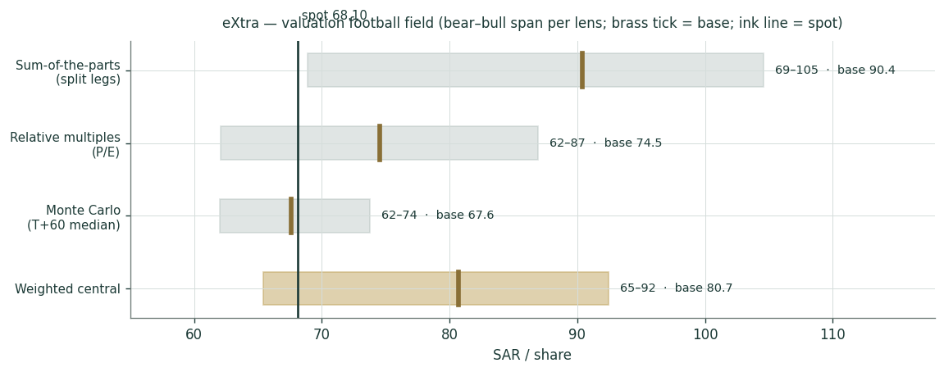
Figure 1. Valuation football field. Bear–bull span per lens; brass tick = base; ink vertical line = spot. The fundamental lenses sit above spot; the near-term Monte Carlo median sits at spot.
Lens | Weight | Base (SAR/sh) | Read
Sum-of-the-parts (split legs) | 50% | 90 | Primary; retail DCF + Tasheel book
Relative multiples (P/E) | 25% | 75 | Cross-check on group earnings
Monte Carlo (T+60 median) | 25% | 68 | Near-term price, carry-anchored (≈ flat)
Weighted central | — | 81 | ≈ +19% vs spot

1.5 Segment scorecard
SAR mn | FY2023 | FY2024 | FY2025
Retail revenue | 5,850 | 6,350 | 6,950
Tasheel revenue | 351 | 431 | 500
Retail net income | 240 | 330 | 267
Tasheel net income | 150 | 205 | 230
Tasheel loan book | 1,850 | 2,407 | 3,036
Tasheel equity (est.) | 900 | 1,050 | 1,200
Group net income | 390 | 534 | 497

Segment split partly estimated where not separately disclosed (flagged in the driver ledger). Consumer finance is ~45–50% of group net income on ~7% of revenue.
1.6 The crux — two swing factors, sensitized in real units
Two inputs move the valuation more than any operating assumption. First, the retail discount rate. A genuine regression of eXtra against the Tadawul index over the available window returns a beta of 0.56 (n=40, R² 9%, SE 0.56) — it passes the usability gate but on a short window, and a beta that low implies an implausibly high value, so we carry a conservative 0.80 in the base case and sensitize the whole 0.55–1.00 range. Second, the multiple on Tasheel: a justified price-to-book of (ROE−g)/(COE−g) on a ~19% return-on-equity and a 10.5% cost of equity gives ~2.4×, but the recent ~20% drop in consumer-finance profit argues for caution.
SOTP (SAR/sh) | g=2% | g=3% | g=4%
Ke 8.26% | 95 | 105 | 120
Ke 9.51% | 84 | 90 | 99
Ke 10.51% | 77 | 82 | 88
Ke 11.22% | 74 | 78 | 82

Retail cost of equity × terminal growth → SOTP per share. Base Ke 9.51% (beta 0.80, rating ERP). Beta grid: SOTP ranges SAR 82 (beta 1.0) to SAR 105 (beta 0.55). Tasheel P/B grid: SAR 82 (1.6×) to SAR 94 (2.8×).
1.7 Macro and country
eXtra is a pure Saudi consumer story. The tailwinds are real household-income growth, Vision-2030 consumption, and the electronics upgrade cycle; the peg to the US dollar keeps import costs stable and imports the US rate path via SAMA. Rate cuts help twice — they lift big-ticket retail demand and lower Tasheel’s funding cost — while rate rises squeeze both. The consumer-finance segment also carries regulatory risk (SAMA finance-company rules, provisioning) that retail does not. The cost of capital is built on Saudi local-currency inputs throughout, never a US-dollar proxy despite the peg.
1.8 Cost of capital — bottom-up, sourced
Input | Value | Basis
Risk-free (SAR 10Y sukuk) | 5.5% | Derived; band 5.4–5.6% (peg ≠ UST). Carry anchor uses SAMA repo 4.2%
ERP — rating-based (primary) | 5.0% | Damodaran Jan-2026, Saudi Aa3 (CRP 0.78 + mature 4.23)
ERP — CDS-based (alternative) | 5.7% | Damodaran Jan-2026, Saudi CDS 0.98 (the higher/"more current")
Beta | 0.80 base (0.55 regressed) | Regression vs TASI n=40, R² 8.8%, gate-passed, short-window
Retail Ke (base, rating) | 9.5% | rf + beta×ERP; net-cash entity → WACC = Ke
Retail Ke (CDS / beta 1.0) | 10.1% / 10.5% | Sensitized alternatives
Tasheel cost of equity | 10.5% | Leveraged consumer-finance lender
Cost of debt Kd (pre-tax) | 6.0% | SAIBOR 3M 4.79% + spread; Tasheel murabaha (flagged)

Both ERP bases are published per house rule. Ke shown explicitly as rf + beta×ERP. Sourced from Cost_of_Capital_Reference.md (Saudi/Tadawul row-set).

2 Technical and price structure
The technical picture is oversold. At SAR 68.10 the stock sits at its 52-week low, below its 20-, 50-, 100- and 200-day averages (SAR 73/77/80/84), with a 14-day RSI of 27 — deep in oversold territory. Momentum is negative (MACD histogram -0.28), consistent with the recent sharp drop from the SAR 80–105 range. For a defensive, high-dividend name, a 52-week low with a sub-30 RSI is the kind of setup where price has often run ahead of any change in fundamentals.
Indicator | Reading | Signal
Spot vs 200-day MA | 68.1 vs 83.9 | Below — bearish trend
MA stack (20/50/100/200) | 73 / 77 / 80 / 84 | Fully inverted (downtrend)
RSI (14-day) | 27 | Oversold (<30)
MACD (12/26/9) | -1.63 / -1.35 / -0.28 | Bearish, histogram negative
52-week range | 68.1 – 93.0 | At the low

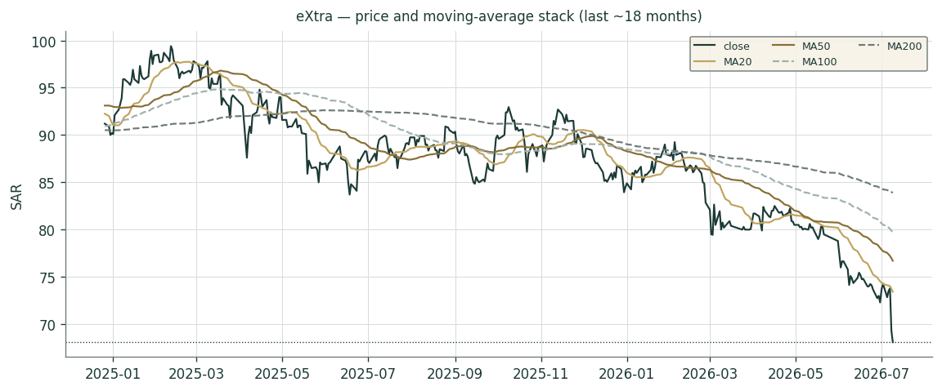
Figure 2. Price and moving-average stack (last ~18 months). The averages are stacked in descending order — a clean downtrend into the 52-week low.

3 Monte Carlo simulation
The paths diffuse from a carry-anchored centre as a near-term price forecast, and deliberately do not embed the fundamental value gap of §1 — the §1 upside is kept out of the drift. The engine is the v3 carry-anchored YZ-HAR-t: a gap-aware Yang-Zhang / log-HAR width, a per-market fitted Student-t shape, and a drift equal only to the carry (risk-free minus dividend yield). 50,000 paths, seed 42.
The probability read
Metric | Reading (T+60)
P(price above spot) | 48%
P(+10%) vs P(−10%) | 22% vs 22% (odds 0.97)
Median level / move | SAR 67.6 (-0.7%)
50% band (25th–75th) | SAR 62.0 – 73.8 (17% of spot)
Touch +10% / −10% (within 60d) | 40% / 39%

Explained-flat median. The median move is -0.7% because eXtra’s dividend yield (~6.9%) exceeds the risk-free rate (~4.25%), so on a price-only basis the median drifts marginally below spot; the expected total return is ≈ the risk-free rate, paid out as dividend. This is a committed, explained number — not an absence of a view, and not a manufactured direction.
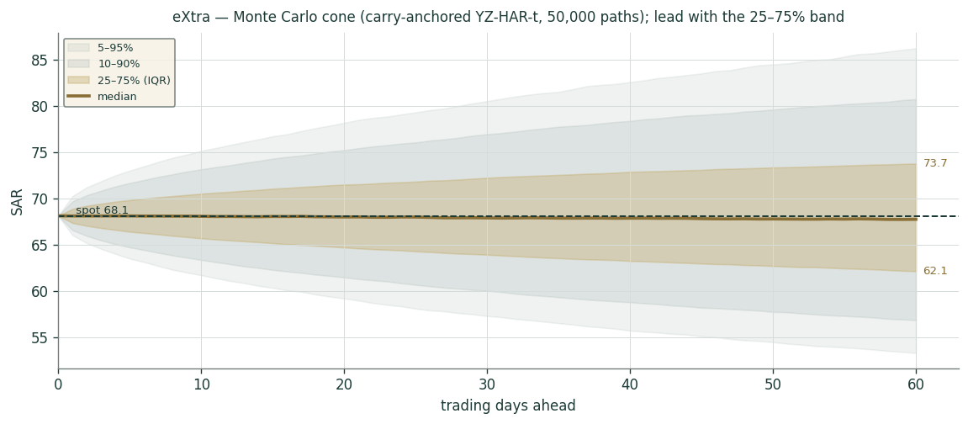
Figure 3. Monte Carlo cone. Lead with the 25–75% interquartile band (gold); the median (brass) is roughly flat. The wide 5–95% band is the instrument’s genuine quarter-ahead uncertainty, not padding.
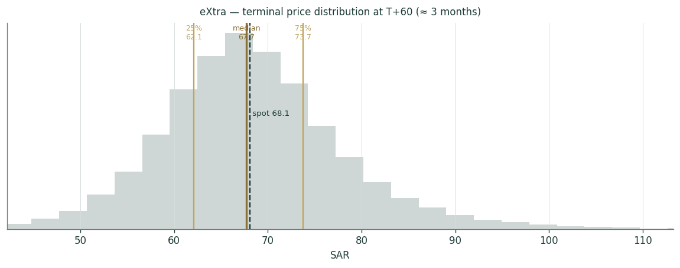
Figure 4. Terminal price distribution at T+60 (≈ 3 months).
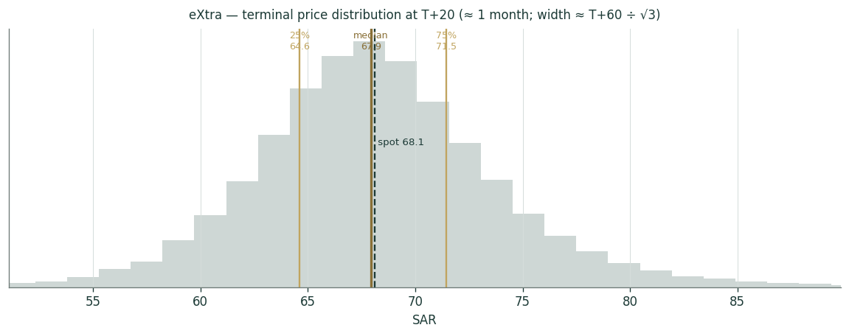
Figure 5. Terminal price distribution at T+20 (≈ 1 month); width ≈ the T+60 width divided by √3.
Percentile | T+20 (SAR) | T+60 (SAR)
5th | 59.2 | 53.2
10th | 61.9 | 57.6
25th | 64.6 | 62.0
50th | 67.9 | 67.6
75th | 71.4 | 73.8
90th | 74.8 | 80.0
95th | 78.2 | 86.2

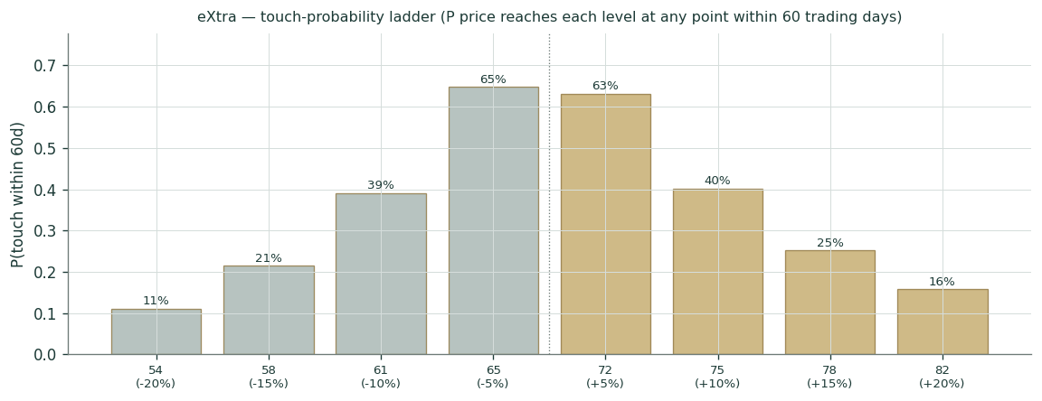
Figure 6. Touch-probability ladder — the chance the price reaches each level at any point within 60 trading days (higher than the terminal-distribution odds, since a path need only touch once).

4 Comparison of the lenses, and a verdict
The three lenses tell a coherent story. The fundamental lenses — split-legs SOTP (~SAR 90) and relative multiples (~SAR 75) — both sit above spot, implying the recent selloff has opened a gap to a conservative estimate of value. The near-term Monte Carlo median sits at spot, because a carry-anchored price forecast for a high-dividend name is flat by construction. The tension is not a contradiction: it says a patient owner is paid to wait (a ~6.9% dividend) while the fundamental gap closes, with no near-term directional edge in the price path itself.
Verdict: on a split-legs basis eXtra looks modestly-to-clearly undervalued at SAR 68.10, with a weighted central of ~SAR 81 (+19%) and a fair-value band of ~SAR 65–92. The conservative end of that band sits at spot, so this is a range with a modest tilt to the upside and a well-covered dividend as the floor — not a high-conviction target. We publish a range and a distribution, never a rating.
5 Catalysts to watch
- Consumer-finance trajectory. Whether Tasheel’s net-profit decline stabilizes; the loan book is still growing double-digits, so the question is margin and provisioning, not volume.
- Rate path. SAMA cuts (tracking the Fed) would lift big-ticket retail demand and cut Tasheel’s funding cost simultaneously — the single biggest external swing.
- Dividend. Confirmation of the ~SAR 4.7 normalized payout; the yield is the anchor of the thesis and is well-covered by retail cash flow plus Tasheel dividend income.
- Quarterly prints. Retail like-for-like growth and gross margin; any read-through from the Clix (Panda) e-commerce venture and the Nowpay fintech investment (upside optionality, not in the base case).
6 Reading the probability zones
The 50% band (SAR 62–74) is where the price spends half its time over the next quarter; the 5–95% band is far wider and reflects genuine uncertainty, not a forecast of direction. The odds of a +10% move (22%) and a −10% move (22%) are close to symmetric, as the flat carry implies. Read the touch ladder (Figure 6) for the chance of reaching a level at any point, which is always higher than the terminal odds.
7 Caveats — what would change our mind
- A higher discount rate. If the true retail beta is nearer 1.0 than the regressed 0.55, retail value falls toward SAR 57/sh and the SOTP compresses to ~SAR 82 — the single largest downside lever.
- Tasheel de-rating. A structural fall in consumer-finance ROE (regulation, provisioning, competition) would pull the justified multiple toward book; at 1.6× the SOTP is ~SAR 82.
- Segment-split estimates. The Tasheel equity book and the retail/finance profit split are partly estimated (flagged in the driver ledger); a materially different split would move both legs.
- Terminal dependence. Terminal value is ~75% of the retail EV; the model is ultimately a Ke-versus-g bet dressed as a 5-year cash-flow forecast, which is why we sensitize both.
- Calibration honesty. Step 0 is PARITY, not PASS — the distribution is calibrated but claims no single-name forecasting edge; the Saudi shape/width are name-fitted pending a fuller market panel.

Appendix A Financial statements
A.1 Income statement (SAR mn)
SAR mn | FY2023 | FY2024 | FY2025 | FY26 | FY27 | FY28 | FY29 | FY30
Revenue | 6,201 | 6,781 | 7,450 | 7,897 | 8,371 | 8,831 | 9,273 | 9,736
Gross profit | 1,362 | 1,559 | 1,781 | 1,911 | 2,026 | 2,137 | 2,244 | 2,356
EBIT | 481 | 639 | 600 | 648 | 686 | 724 | 760 | 798
Net income (incl NCI) | 390 | 534 | 497 | 553 | 586 | 618 | 649 | 682
EPS (SAR) | 4.87 | 6.68 | 6.21 | 6.91 | 7.32 | 7.73 | 8.11 | 8.52
DPS (SAR) | 3.30 | 10.00 | 4.72 | 5.25 | 5.57 | 5.87 | 6.17 | 6.47

A.2 Balance sheet (SAR mn) — 3 historical + 5 forecast
SAR mn | FY2023 | FY2024 | FY2025 | FY26 | FY27 | FY28 | FY29 | FY30
Cash & equivalents | 158 | 476 | 660 | 693 | 728 | 764 | 802 | 842
Other current assets | 2,204 | 2,653 | 2,770 | 2,936 | 3,112 | 3,299 | 3,497 | 3,707
PP&E | 486 | 486 | 504 | 519 | 535 | 551 | 567 | 584
Right-of-use assets | 451 | 463 | 483 | 497 | 512 | 528 | 544 | 560
Other non-current (finance rec.) | 1,142 | 1,324 | 1,763 | 1,975 | 2,212 | 2,477 | 2,774 | 3,107
Total assets | 4,442 | 5,402 | 6,187 | 6,620 | 7,083 | 7,579 | 8,110 | 8,678
Current liabilities | 1,679 | 1,662 | 2,070 | 2,194 | 2,326 | 2,465 | 2,613 | 2,770
Non-current liabilities | 1,478 | 1,697 | 1,947 | 2,083 | 2,229 | 2,385 | 2,552 | 2,731
Total equity (incl NCI) | 1,284 | 2,043 | 2,170 | 2,300 | 2,438 | 2,585 | 2,740 | 2,904

A.3 Cash flow (SAR mn) — 3 historical + 5 forecast
SAR mn | FY2023 | FY2024 | FY2025 | FY26 | FY27 | FY28 | FY29 | FY30
Cash from operations | 300 | 601 | 609 | 639 | 671 | 705 | 740 | 777
Capex | (59) | (56) | (76) | (80) | (84) | (88) | (92) | (97)
Financing (incl dividends) | (232) | (226) | (424) | (445) | (467) | (491) | (515) | (541)

Historical figures from Yahoo Finance / Mubasher / Aljazira Capital / stockanalysis; FY2025 is the reported full year. Forecasts are the house’s own conservative build (group revenue ~6% declining to ~5%, margins held near FY2025). Segment splits partly estimated — flagged in the Fundamental Driver Ledger.

Appendix B Peer set, sector structure, and risks
B.1 Peer set
eXtra’s cleanest comparator is Jarir Marketing (Tadawul: 4190) — the other listed Saudi specialty retailer selling electronics, computing and consumer goods, and, like eXtra, a high-payout dividend name. The contrast is stark: Jarir trades at roughly 18× earnings on a ~5.4% yield and has re-rated ~37% over the past year to near its highs, while eXtra trades at ~11× on a higher ~6.9% yield and sits at a 52-week low. Part of the gap is genuine — Jarir earns a ~9% net margin (a richer books-and-stationery mix) versus eXtra’s ~7% blended (thin retail plus the finance spread) — but a ~40% P/E discount to the closest domestic peer, with a superior yield and an unrecognised captive-finance book, is the core of the value case.
Comparator | Market / ticker | Business | P/E (x) | Div yld | Net mgn
eXtra — subject | Tadawul : 4003 | Electronics retail + captive finance | 11.0 | 6.9% | 7%
Jarir Marketing | Tadawul : 4190 | Office/school/electronics/books retail | ~18.5 | ~5.4% | ~9%
Al Othaim Markets | Tadawul : 4001 | Grocery + consumer retail | ~16 | ~3% | ~3%
Best Buy (approx.) | NYSE : BBY | US electronics retail | ~11–13 | ~4–5% | ~3%
Ceconomy / Currys (approx.) | XETRA / LSE | European electronics retail | ~9–12 | ~2–4% | ~1–2%

Jarir metrics sourced (Tadawul / Argaam / stockanalysis, Jun–Jul 2026): price ~SAR 16.8, ~1,200m shares, FY2025 revenue ~SAR 11.4bn, net income ~SAR 1.05bn. Global peers are approximate current ranges (illustrative), not point quotes. Tasheel (the finance leg) has no clean listed peer — GCC consumer-finance is largely private (Tabby, Tamara) — so it is valued on book × justified P/B rather than a peer multiple.
B.2 Sector structure
Saudi organised electronics and appliances retail is a scale-and-omnichannel business, and eXtra is the category leader by store footprint and assortment. The competitive set is four-cornered: (1) Jarir, which overlaps most in computing, mobile and electronics; (2) online marketplaces — noon and Amazon.sa — which are the structural threat in electronics e-commerce and compress pricing on commoditised SKUs; (3) the informal / grey market and brand mono-stores (Apple, Samsung); and (4) grocery and general retailers extending into electronics. eXtra defends with breadth, after-sales service, exclusive ranges, its Clix marketplace (a JV in which Panda carries the capex), and — decisively — embedded finance.
The embedded-finance layer is the moat and the reason for the two-engine valuation. By financing its own big-ticket sales through Tasheel (68.75%-owned), eXtra earns a high-return lending spread on top of a thin retail margin, and it owns the customer credit relationship that a pure marketplace does not. That is why the consumer-finance segment, at ~7% of revenue, produces close to half of group net income — and why blending the two into one multiple mis-prices the whole.
Dimension | eXtra | Jarir | Online (noon / Amazon.sa)
Electronics breadth | Category leader | Strong | Very broad
Embedded consumer finance | Yes (Tasheel) | Limited | No (third-party BNPL)
Physical + omnichannel | Big-box + Clix | Stores + e-com | Pure online
Blended net margin | ~7% | ~9% | Thin / loss-leading
Pricing power | Service + finance | Brand + mix | Price / selection

Structural demand drivers are favourable: Vision-2030 consumption, real household-income growth, a young and tech-adopting population, rising e-commerce penetration, and — for Tasheel specifically — the migration of informal consumer credit into regulated finance. The binding constraint is the regulatory and rate regime: SAMA licenses and supervises finance companies (capital, provisioning, responsible-lending caps), and the recent ~20% decline in consumer-finance net profit reflects exactly this — rising provisions and operating investment — not a demand problem (the loan book still grew double-digits).
B.3 Risk register
Risk | Channel | Why it matters | Materiality
Discount-rate / beta | Valuation | Short-window beta 0.55–1.0 swings SOTP ~SAR 70–105 | High
Consumer-finance credit & regulation | Tasheel leg | Provisioning cycle + SAMA rules; segment NI already −20% Y/Y | High
Rate path (Fed via peg) | Both legs | Cuts lift demand + spread; rises squeeze both | High
Online / marketplace competition | Retail margin | noon / Amazon.sa pressure electronics pricing and share | Medium
Single-country concentration | Demand | 100% Saudi consumer economy; import cost via the peg | Medium
Disclosure / governance | Modelling | Tasheel equity book estimated; 31.25% NCI; 69% parent stake limits free float | Medium
Dividend sustainability | Total return | ~76% payout — a floor only if retail FCF + Tasheel dividend hold | Low–Med

The top three are all versions of one thing — the discount rate and the rate/regulatory path — and they interact: a higher-for-longer rate world both raises the beta-driven discount rate and squeezes the consumer-finance spread, hitting the valuation from two sides at once. Against that, the ~7% dividend is well covered (retail free cash flow plus Tasheel dividend income comfortably exceed the payout), which is why every lens in this study treats it as the practical downside floor rather than a variable. The most idiosyncratic risk is disclosure: because Tasheel’s equity book and the retail/finance profit split are partly estimated (flagged in the driver ledger), the split-legs value carries genuine model risk that a fuller segment disclosure would resolve in either direction.

Appendix C Expert valuation panel
Three experts, each running a genuinely different method, cast for a capital-heavy operating company: an earnings-power valuer in the Graham–Greenwald tradition, a balance-sheet sum-of-the-parts accountant, and a top-down macro-policy strategist. They are labelled Expert 1–3 (cast by method, not named). Each sets out a worldview, when the method works and fails, its workings with a table, a worked example on eXtra, a sensitivity on its single swing input, a cross-examination of the other two, and a verdict with a falsification condition and what the market price implies. The discipline is that they must genuinely disagree — three methods that agree would be cosmetic.
Expert 1 — Earnings power
Worldview and tradition. In the Graham–Greenwald earnings-power tradition, a business is worth its sustainable, through-cycle earnings capitalised at a justified multiple — you do not pay for growth you cannot underwrite, and you distrust any valuation whose answer hides in a terminal value a decade out. The multiple is not plucked from peers; it is built from the required return and the durability of the franchise.
When it works and fails. It works for stable, branded, cash-generative consumer franchises with durable margins — the retail half of eXtra fits. It fails for businesses mid-transition, for financial businesses whose "earnings" are really a return on a capital base (Tasheel), and when a one-off distorts the base year: eXtra’s FY2024 net income carried a ~SAR 33m one-off, and FY2025 was softened by consumer-finance provisioning — so the base must be normalised, not taken raw.
Workings. (1) Strip one-offs and normalise to a mid-cycle margin; (2) compute normalised group EPS; (3) build the justified P/E up from the required return, then adjust for quality and for the lower quality of the finance-derived earnings; (4) capitalise.
Justified-multiple build | Value
Normalized through-cycle EPS (SAR) | ~6.0 (reported FY2025 6.21)
Required return (retail Ke) | 9.5% → no-growth P/E ≈ 10.5×
+ franchise quality / modest growth | +~2× (category leader, high ROE)
− lower-quality finance earnings, single-country | −~0.5×
Justified P/E | ≈ 12× (range 10–14×)

Worked example. Normalized EPS ~6.0 × 12× = ~SAR 72; on the reported FY2025 EPS of 6.21, 12× = SAR 75. We carry ~SAR 75 as the earnings-power fair value.
Swing — the multiple | 8× | 10× | 12× | 14×
Fair value (SAR/sh) | 50 | 62 | 75 | 87

Cross-examination. To the Accountant: a blended group multiple already prices Tasheel’s profits, so adding Tasheel back as a separate asset at 2.4× book capitalises the same earnings twice — and it levers an equity book that is itself an estimate. To Macro-policy: scenario-weighting a rate path re-introduces the discount rate through the back door; a properly-built normalised multiple already embeds a mid-cycle rate, so the scenario band is double-counting the same uncertainty.
Verdict, falsification, price-implied. Fair ~SAR 75. Falsified if Tasheel’s return-on-equity proves durably far above what a blended retail multiple implies — in which case the lender deserves a separate premium capitalisation and this method is systematically too low. At SAR 68 the market pays ~11× normalized earnings: it is pricing eXtra as a plain cyclical retailer, giving no credit for the finance franchise.
Expert 2 — Accountant (split-legs sum-of-the-parts)
Worldview and tradition. In the sum-of-the-parts / asset-based tradition, a business with genuinely different engines is worth the sum of its parts — each valued on its own appropriate method and its own balance sheet — minus holding-level items. The market’s single blended multiple systematically mis-weights a low-margin retailer bolted to a high-return lender, and that mis-weighting is the opportunity.
When it works and fails. It works precisely for holding-company-like structures where the parts have different economics — which is eXtra. It fails when the balance-sheet marks are stale or estimated (here, Tasheel’s equity book is an estimate), and it can overstate value if minority interests, holding costs, or the practical difficulty of "unlocking" the parts are ignored.
Workings. (1) Retail — a net-cash operating company, so a five-year FCFF DCF discounted at the cost of equity; (2) Tasheel — a lender, so equity book × a justified price-to-book of (ROE−g)/(COE−g); (3) take eXtra’s economic 68.75% of Tasheel (the 31.25% minority is excluded by construction); (4) Nowpay and Clix carry nothing in the base — optionality, not value.
Retail DCF (net-cash op-co) | SAR mn / sh
Enterprise value | 4,826
+ standalone net cash | 388
Retail equity value | 5,214 (65.2/sh)
Terminal value as % of EV | 75%

Tasheel P/B build | Value
Equity book (SAR mn, est.) | 1,200
Return on equity | 19.2%
Cost of equity / terminal g | 10.5% / 4.5%
Justified P/B = (ROE−g)/(COE−g) | 2.44×
Tasheel value 100% → eXtra 68.75% | 2,933 → 2,017 (25.2/sh)

Worked example. Retail SAR 65.2/sh + Tasheel SAR 25.2/sh = SAR 90.4/sh.
Swing — Tasheel P/B | 1.6× | 2.0× | 2.4× | 2.8×
SOTP (SAR/sh) | 82 | 86 | 90 | 94

Cross-examination. To Earnings-power: a single group multiple values a ~4%-net-margin retailer and a ~19%-ROE lender at the same P/E, which is analytically indefensible — the market’s blended ~11× is the mispricing, not an anchor to respect. To Macro-policy: scenarios give direction, but you still have to put a number on each leg’s balance sheet; a top-down demand story does not tell you what Tasheel’s book is worth. Concedes that the estimated equity book is this method’s genuine weak point.
Verdict, falsification, price-implied. Fair ~SAR 90. Falsified if the estimated Tasheel equity book is materially off, or if retail cash conversion is structurally weaker than the DCF assumes. At SAR 68 the market is either applying a single group multiple (Earnings-power’s frame) or heavily discounting the finance leg toward book.
Expert 3 — Macro-policy
Worldview and tradition. In the top-down strategist tradition, a single-country consumer name is a leveraged bet on the household economy and the policy rate; company-specific modelling is second-order to the demand and rate regime. Fair value is a scenario band, and the dividend yield is a floor the bottom-up methods understate.
When it works and fails. It works for reading demand inflection and the dividend-versus-rates relationship. It fails at company-specific mispricings and at pinning a precise number — it deliberately produces a range, not a point.
Workings. (1) Map the SAMA rate path (which tracks the Fed via the riyal peg) to two channels that move the same way — big-ticket retail demand (cuts lift financed purchases) and Tasheel’s net spread (cuts lower funding cost); rates are therefore a double-lever. (2) Overlay Vision-2030 consumption and household-income growth as a structural tailwind. (3) Net the consumer-finance regulatory risk (SAMA finance-company rules, provisioning) as a leg-specific discount. (4) Treat the ~6.9% dividend yield as a valuation floor.
Scenario | Rate / regime | SAR/sh
Bull | Cuts + resilient consumer; Tasheel spread widens | ~95
Base | Gradual / current policy; spread stable | ~78
Bear | Higher-for-longer + tighter CF rules; spread compresses | ~65 (dividend floor)

Worked example. In the base case — gradual policy, retail revenue +5–6%, Tasheel spread broadly held — the demand-plus-dividend read lands at ~SAR 78; the ~6.9% yield stops the bear case falling far below spot.
Swing input. The SAMA rate path. Because it hits both retail demand and Tasheel’s spread in the same direction, a ~100bp move in the policy rate shifts fair value materially — far more than any single operating assumption — which is exactly why a precise bottom-up point can mislead.
Cross-examination. To Earnings-power: a static "normalised" multiple hides that the normal rate environment is itself the variable; capitalising mid-cycle earnings at a fixed multiple buries the rate bet rather than pricing it. To the Accountant: a sum-of-the-parts to the decimal is false precision when the dominant driver can swing the whole valuation ~30%; and 2.4× book on Tasheel quietly assumes a benign rate-and-regulatory path that a strategist would not underwrite without a discount.
Verdict, falsification, price-implied. Fair ~SAR 78. Falsified if rates rise materially from here, or if SAMA tightens consumer-finance provisioning. At SAR 68, a 52-week low, the market is pricing something close to the bear rate/regulation scenario — which the covered dividend floor argues is too pessimistic.
The three in one room
Put them at one table and the argument is entirely about the captive lender.
Accountant: "Tasheel is a distinct 19%-return lender — capitalise it separately at ~2.4× book. The market’s blended multiple hides it, and that’s the mispricing."
Earnings-power: "It’s already inside group EPS. Value it twice and you’ve manufactured ~SAR 25/share of value on an equity book you had to estimate."
Macro-policy: "You’re both assuming a benign rate and regulatory path — that’s the real bet. It’s why I discount the lender and lean on the ~7% dividend as the floor."
The disagreement resolves to one question — is Tasheel a separately-valuable growth asset or a high-return line already inside a retailer? — conditioned on the rate and regulatory path. That single question accounts for almost the entire SAR 75–90 spread between the three fair values.
Reading the divergence
Expert | Method | Fair value (SAR/sh) | The one driving assumption
Expert 1 | Earnings power (P/E) | 75 | Tasheel already inside a single group multiple
Expert 2 | Split-legs SOTP | 90 | Tasheel a separate asset at ~2.4× book
Expert 3 | Macro-policy scenario | 78 | The SAMA rate path; the dividend as a floor

The spread (~SAR 75–90) is not noise — it measures how much of eXtra’s value sits in the captive lender and how it should be capitalised. A buyer who believes Tasheel is a durable, separately-valuable growth business sits with the Accountant near SAR 90; one who treats it as an embedded retail-finance line sits with Earnings-power near SAR 75; the strategist discounts both for the rate path and lands between. Their common ground matters as much as the spread: all three fair values sit above the SAR 68 spot, and all three lean on the same ~7% covered dividend as the downside floor. The debate is how much eXtra is undervalued, not whether.

About this series
Testahil publishes independent, educational valuation studies that integrate a fundamental view, a technical read, and a calibrated Monte Carlo distribution. We publish fair-value ranges and probability distributions, never ratings or price targets. Every study runs the same calibration gate (Step 0), the same bottom-up cost-of-capital discipline, and the same expert panel, so the framework is comparable across names and over time.
Disclosure & Disclaimer
1. This report is prepared by Testahil for educational and informational purposes only. It is not investment advice, an offer, or a solicitation to buy or sell any security.
2. Nothing herein is a personal recommendation. It does not consider the objectives, financial situation, or needs of any specific person. Readers must make their own decisions and seek professional advice.
3. Testahil is not a licensed financial adviser and is not regulated by the Saudi Capital Market Authority or the Egyptian Financial Regulatory Authority. No rating or price target is expressed — fair value is presented only as a range and a probability distribution.
4. Information is drawn from sources believed reliable but is not guaranteed as to accuracy or completeness. Forward estimates are the house’s own and are inherently uncertain; certain inputs are flagged as estimates.
5. Past performance and modelled distributions are not guarantees of future results. Securities can lose value. The Monte Carlo output describes a range of outcomes, not a forecast of any single price.
6. The preparer may hold, and may in the future take or dispose of, a position in the security discussed in this report.
Testahil · Independent Valuation Study · eXtra (Tadawul:4003) · edition 2026-07-09 · educational — not investment advice

