Testahil · Independent Valuation Study — Educational Analysis Not investment advice

Modon Holding PSC
ADX: MODON · Abu Dhabi Securities Exchange · United Arab Emirates dirham (AED)
Independent valuation study · revision 3 · 10 August 2026 · valuation date 30 June 2026 · price anchor AED 2.83 (close 7 August 2026)
READ FIRST. This study is an independent, educational analysis of Modon Holding PSC. It is not investment advice, not a recommendation, and it contains no price target. Every value is a model output presented as a range with its assumptions shown.
Revision 3. One input changed and it changed the answer. Revisions 1 and 2 could not obtain the exchange's official index and measured the stock's market sensitivity against a composite built from this study's own price library, flagged in both editions as a stand-in. The official FTSE ADX General series has since been obtained and the regression re-run against it. Beta rises from 1.03 to 1.28 (like for like on the same five-year window the stand-in read 1.12), the cost of equity from 9.08% to 10.28%, and the weighted central falls from AED 3.38 to AED 2.98 — against a price of AED 2.83, the margin narrows from about 19% to about 5%. Nothing else in the forecast moved. The stand-in flattered the company, and the correction is reported here rather than absorbed quietly.
Revision 2. The first edition (earlier the same day) struck its development drivers on 31-December-2025 disclosures although the company's H1-2026 results release of 29 July 2026 — which this study cites for other figures — had superseded them: the revenue backlog had reached AED 65.4 billion (95% development) and H1 sales AED 26 billion. External audits caught that failure and several others. This edition restrikes the valuation on the 30-June-2026 reviewed balance sheet, rebuilds working capital from components, charges depreciation on the asset base, derives the terminal capital structure from the model's own forecast, bridges on available rather than gross cash, replaces the assumed beta with a regression, and rebuilds the peer table on one attributable basis from the peers' own filings. Each change is marked where it appears.
Sources. Every historical figure comes from the company's own audited statements, reviewed interims and results announcements. Peer figures are cross-checks, labelled. The companion bibliography lists every input with value, source and date.
The one judgement that matters most. Whether the realised 2025–26 development surge normalises-but-sustains (base) or collapses to run-off (now a stress case — the H1 disclosure falsified it as a live central path) moves this valuation more than any other input. Both readings are computed in full and shown side by side, never averaged.

Headline
Fair value AED 1.03–5.34 per share (the envelope of the four lenses' extremes, not a distribution), weighted central AED 2.98, against a market price of AED 2.83 (+5%).
Modon Holding is Abu Dhabi's government-owned city-builder: real-estate development (Hudayriyat Island, Reem Island, Ras El Hekma in Egypt), the ADNEC events platform, a hospitality portfolio and an asset-management leg. The first half of 2026 was the strongest in its history: revenue AED 9.2bn (+40%), profit AED 2.2bn, real-estate sales AED 26.0bn in six months (a single Hudayriyat launch took AED 13bn within days), and a revenue backlog of AED 65.4bn — double a year earlier, 95% of it contracted development.
The cash-flow reading of that backlog is worth AED 4.51 per share on the base path, and AED 3.28 even if launches halve and fade (the run-off stress). The market lenses sit lower: the peer multiple implies about AED 2.20, normalised mid-cycle earnings about AED 1.46, and book value at a justified multiple about AED 2.24. The market prices Modon at 11.5x trailing attributable earnings against 8.1x for Aldar on the same basis. Section 4 prices the gap; section 1.7 shows both sales paths in full.
Over the next three months the price map is symmetric and modest: central band AED 2.64–3.09, 5th–95th percentiles AED 2.32–3.52. A fundamental verdict of this size, if right, plays out over years, not a quarter.
Valuation summary
Lens | Bear | Base | Bull | Weight | vs price
Discounted cash flow (primary) | 3.28 | 4.51 | 5.34 | 40% | +60%
Relative multiples | 1.38 | 2.20 | 2.37 | 20% | -22%
Normalised earnings power | 1.03 | 1.46 | 1.80 | 20% | -48%
Book value & sustainable return | 1.34 | 2.24 | 3.13 | 20% | -21%
Weighted central | 1.03 | 2.98 | 5.34 | 100% | +5%
DCF terminal value share of enterprise value: 74.2%
Market price (7 Aug 2026) |  | 2.83

AED per share. The DCF bear is the run-off stress and the bull the growth-hold scenario of section 1.7 — engine re-runs whose full driver vectors are published on the model's Assumptions sheet. The bear–bull row on the central line is the envelope of lens extremes, labelled as such. The terminal value share is stated beside the lens it belongs to and linked live in the Excel bridge.
The contested judgement, both ways: base path AED 4.51 · run-off stress AED 3.28. Same balance sheet, different sales paths; never averaged. The realised H1-2026 sales of AED 26bn falsified the run-off as a central scenario — it is retained as the stress bound.
Company overview
Modon Holding PSC is the Abu Dhabi government's listed city-development platform. The listed vehicle began as Al Qudra Holding, became Q Holding, and in 2024 absorbed Modon Properties and the ADNEC Group in a share-financed combination that multiplied the balance sheet roughly four-fold and reset the perimeter — FY2024 income carries a AED 9.2bn accounting gain from that combination and is treated as a transition year throughout. On 30 October 2025 IHC and ADQ sold their entire stakes to L'imad Holding Company PJSC, wholly owned by the Abu Dhabi Government — 84.75% of the shares (the arithmetic of the disclosed share count; one company announcement rounds it to 84.76%). The stock trades on ADX's growth market with a correspondingly thin free float.
Four reported segments. Real Estate Development (54% of FY2025 revenue) masterplans and sells land and homes on Hudayriyat Island (>50mn sqm, 40,000 planned units), Reem Island and Al Ain, and leads phase 1 of Ras El Hekma on Egypt's north coast (170.8mn sqm, 500,000+ planned units), alongside La Zagaleta in Spain. Events, Catering & Tourism (36%) is the ADNEC platform: venues in Abu Dhabi and London (ExCeL), event infrastructure (Arena Group), catering and tourism. Hospitality (6%) reported 7,137 keys across 27 hotels including managed properties at end-2025; the H1-2026 release counts 3,613 keys across 16 owned, operated and JV hotels — the narrower perimeter this study's forward driver uses, with the difference (managed-for-others keys) stated. Asset & Investment Management (5%) holds the recurring-income portfolio (96–97% occupancy) and financial investments including 50% of 2 Finsbury Avenue in London. Recurring revenues reached 38% of the group in H1-2026.
Segment | Revenue | Gross profit | Margin | Profit before tax | Assets
Real Estate Development | 7,403 | 3,233 | 43.7% | 2,548 | 55,739
Asset & Investment Mgmt | 655 | 421 | 64.3% | 685 | 11,096
Hospitality | 792 | 211 | 26.6% | -69 | 4,602
Events, Catering & Tourism | 5,009 | 1,325 | 26.5% | 1,062 | 14,118
Group (incl. others/eliminations) | 13,829 | 5,025 | 36.3% | 4,421 | 87,031

FY2025 segments, AED mn, audited. Hospitality's pre-tax loss reflects financing and depreciation on a young portfolio; its gross profit is positive.
1 · Fundamental valuation
1.1 · Cash-flow model — restruck at 30 June 2026
The model values the company from its 30-June-2026 reviewed balance sheet: a half-year 2026 stub, then four full years, then the terminal block. Development revenue converts the disclosed AED 62.1bn development backlog (65.4bn × 95%) at a visible conversion rate anchored to the pace actually recognised in H1 (development revenue ex-land of AED 4.2bn on an opening 42.6bn backlog, ~20% annualised); new launches roll the backlog forward. The other legs are anchored on their H1 actuals with the events-heavy second-half seasonality stated. Fair-value gains, bargain and disposal gains are zero across the forecast by construction.
Working capital is built from components, calibrated at the two balance-sheet dates (31-Dec-2025 and 30-Jun-2026): receivable days on revenue (440 days at both anchors — the related-party collection question in one number), a land-bank roll (new project WIP added per dirham of sales, cost of sales drawn from the existing at-cost bank), and payables-plus-advances cover of direct costs (2.6× at end-2025, 1.86× at 30-Jun-2026, declining — presale advances, not the balance sheet, fund construction). The result is absorption while growth is hot — matching the AED 3.9bn operating outflow the H1 statements actually show — and releases only late, as collections and the land bank catch up. The first edition assumed schedule-based releases; the audits were right to attack it.
AED mn | H2-26E | FY27E | FY28E | FY29E | FY30E
Revenue | 11,046 | 26,019 | 32,007 | 34,928 | 36,189
Gross profit | 4,165 | 9,619 | 11,784 | 12,807 | 13,143
General & administrative | -917 | -2,290 | -2,785 | -3,004 | -3,076
Selling & marketing | -188 | -468 | -544 | -594 | -579
Investment and other income | 80 | 165 | 170 | 175 | 180
EBIT | 3,140 | 7,026 | 8,625 | 9,384 | 9,668
EBITDA margin | 31.5% | 29.7% | 29.2% | 29.1% | 28.9%
Depreciation & amortisation (asset-base) | 341 | 709 | 736 | 765 | 794
EBITDA | 3,481 | 7,734 | 9,361 | 10,149 | 10,462
NOPAT = EBIT × (1 − 15.5%) | 2,653 | 5,937 | 7,288 | 7,930 | 8,170
+ D&A | 341 | 709 | 736 | 765 | 794
− capital expenditure | -700 | -1,500 | -1,550 | -1,600 | -1,650
− Δ working capital (components) | 938 | 3,119 | 1,520 | -313 | -2,109
Free cash flow to firm | 1,357 | 2,027 | 4,955 | 7,408 | 9,423
Discount factor | 0.9565 | 0.8751 | 0.8007 | 0.7325 | 0.6702
PV of FCFF | 1,298 | 1,774 | 3,967 | 5,427 | 6,315

H2-2026E is a half-year stub discounted at 0.5 years; FY2027E–FY2030E at 1.5–4.5 years. Explicit present value AED 18,780mn at the 9.30% cost of capital of section 1.8. The Δ-working-capital row ABSORBS cash through FY2028 — the reversal of the first edition's release schedule.
Working-capital components (AED mn) | H2-26E | FY27E | FY28E | FY29E | FY30E
Receivables incl. related-party (days × revenue) | 24,392 | 30,653 | 35,953 | 37,320 | 36,684
Inventories + development WIP (roll) | 34,435 | 35,239 | 34,923 | 33,972 | 32,687
Payables incl. advances (cover × costs) | 23,935 | 27,881 | 31,346 | 32,075 | 32,263
Net working capital | 34,892 | 38,010 | 39,530 | 39,217 | 37,108
Δ working capital (+ = absorption) | 938 | 3,119 | 1,520 | -313 | -2,109

Terminal block. Terminal growth 2.5%; terminal return on capital 8.5% — deliberately below the model's own forecast path (which reaches ~13% by FY2030E as capital releases while profit grows) and above the FY2025 clean achieved 6.1%, a stated mean-reversion margin of safety. Reinvestment = g/ROIC = 29.4%, derived. The terminal debt weight is no longer assumed: it is DERIVED from the model's own FY2030E balance sheet (8.0%), which puts the terminal rate at 9.82% — ABOVE the explicit-window rate, where the first edition had it below. Terminal value AED 80,726mn, worth AED 54,103mn today — 74.2% of enterprise value, a share the reader should see and judge; the working-capital absorption in the explicit years pushes it up, and section 1.9 prices the terminal-return case both ways.
Enterprise value → equity per share (30-Jun-2026) | AED mn
PV of explicit periods | 18,780
PV of terminal value | 54,103
Enterprise value | 72,884
of which terminal value: 74.2%
+ unrestricted (available) cash — disclosed | 8,600
(excluded: AED 3,703mn of escrow/restricted cash — it funds completion of the very backlog the DCF values; adding it back would double-count)
− debt incl. the related-party loan | -9,542
− lease liabilities | -645
+ associates & joint ventures at book | 2,826
+ financial assets | 393
− non-controlling interests, capitalised at 2% of equity value (book AED 922mn shown as the alternative) | -1,472
Equity attributable, 30 Jun 2026 | 73,045
Per share (16,347mn shares) | 4.47
Rolled 38 days to the 7 Aug 2026 anchor at the cost of equity | 4.51

Gross-cash alternative (first edition's basis): AED 4.74; book-NCI alternative: AED 4.55. Both are shown in the workbook. On the strict all-cash basis the company holds net cash of AED 2,762mn; on its own available-cash definition it reports net debt of AED 912mn — both framings stated.
1.2 · Book value and sustainable return
Attributable equity at 30 June 2026 is AED 56,397mn — AED 3.45 per share, so the market pays 0.82x book. One cleaning, tied to the disclosed line items: FY2025 carried AED 735mn of fair-value and disposal gains; removing them (tax-effected) puts clean attributable return on average equity at 6.6% against 7.8% reported. The 7.5% used here is a forward-sustainable judgement, not that cleaning: it sits between the mechanical clean figure and the model's own forecast path (10.3% rising), and the first edition's conflation of the two — flagged by the audits — is withdrawn. Justified price-to-book = (7.5% − 2.5%) / (10.28% − 2.5%) = 0.64x, worth AED 2.24 per share rolled to the anchor — this lens is now struck on the same date as the others.
1.3 · Relative multiples — rebuilt on one basis
Peer | Spot | Mkt cap, AED mn | FY2025 attributable NP | Trailing P/E (attr.) | Backlog (own disclosure)
Aldar Properties (ADX) | 7.78 | 61,171 | 7,548 | 8.10x | 71,700
Emaar Properties (DFM) | 11.50 | 101,650 | 17,599 | 5.78x | 155,000
Emaar Development (DFM) | 13.38 | 53,520 | 11,316 | 4.73x | 125,200
Modon Holding | 2.83 | 46,262 | 4,020 | 11.51x | 65,400

One basis throughout: attributable profit from each peer's own audited filings and releases; every multiple is the printed market cap over the printed profit (the first edition's table mixed bases and vintages and did not reconcile — rebuilt after the audits). Backlogs: Aldar FY2025 development 71.7bn; Emaar group 155bn; Emaar Development 125.2bn; Modon 30-Jun-2026 group 65.4bn — own disclosure and date per row. On the group-profit basis Modon's trailing multiple is 11.8x (dual-framed; FY2025 NCI was a loss, so attributable exceeds group profit).
The attributable peer set runs 4.7–8.1x trailing. This study applies 7.5x to FY2026E attributable profit (H1 actual plus the H2 model, AED 4,785mn) — parity-minus with the sector leader: the growth and recurring-income premium and the ~15%-float/related-party discount are treated as offsetting, and a forward multiple on a growing base is worth ~8% more than the same trailing multiple, stated. That gives AED 2.20 per share. The EV/EBITDA cross-check (7.0x, a house multiple with no computable peer anchor — peer net debt is not disclosed in reachable form) implies AED 2.82 and is displayed in the workbook but NOT averaged into the lens; the first edition's silent blend of two legs 43% apart is withdrawn.
1.4 · Normalised earnings power
Through a full cycle this study assumes development sales settle near AED 20.0bn a year — raised from the first edition's 18bn because the realised H1-2026 (AED 26bn in six months) lifts any honest cycle average, yet still far below the current pace — with the recurring legs grown moderately: normalised revenue about AED 24.4bn, through-cycle net margin 11.5%, normalised earnings AED 2,809mn (AED 0.172/share), worth AED 1.46 at 8.5x. The harshest lens: it treats 2025–26 as a cycle top.
1.5 · Synthesis — four lenses, one field
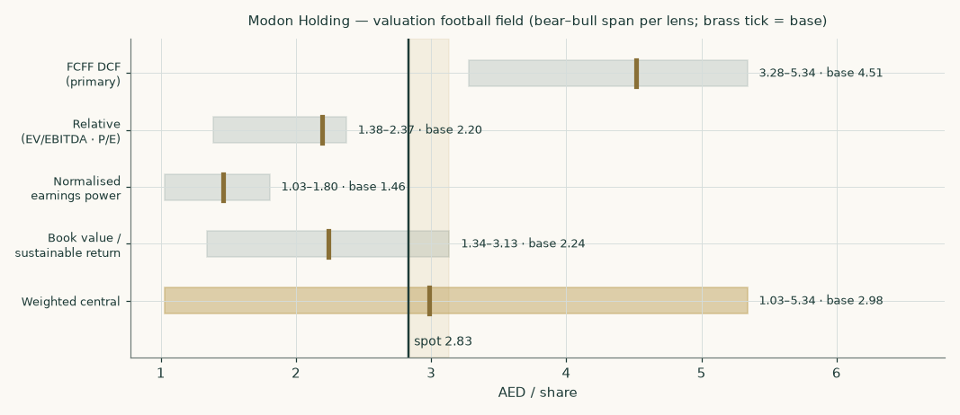
Figure 1 — the four lenses and the weighted central against the market price. The DCF span is the run-off-stress-to-growth-hold spread.
Weights: DCF 40% on backlog visibility; the three market lenses carry 60% jointly — and that structure IS how the float and governance friction is priced. One audit demanded an additional ~30% holding-company discount on top; that would charge the same friction twice, and is rejected with the reasoning stated here — the central already sits 34% below the DCF because of it. Result: AED 2.98, +5% above the market.
1.6 · Drivers — each leg on its own driver
Leg | Driver build | Path
Development | conversion of the disclosed 30-Jun backlog (10.5% half-year stub, then 25%→32%) + land sales; new sales AED 30.0bn→21.0bn/yr — every year below the realised H1 annualised pace | revenue AED 18.3bn→27.3bn
margin | 41.0%→38.0% (H1 actual 41.3%); related-party land mix fades; construction escalator ~4% vs realised-price ~2% | output
Asset & investment mgmt | H1 actual + contracted occupancy (96%); ~8.5%/yr | AED 813→1,029mn
Hospitality | H1 actual + winter seasonality on the 3,613 owned/operated/JV keys; margin recovering to 30% | AED 899→1,081mn
Events, catering & tourism | H1 actual + the H2-weighted events season; ~4%/yr | AED 6.0bn→6.8bn
Working capital | receivable days 440→370; land-bank draw vs new-WIP add; advances cover 1.86×→1.40× | absorbs, then releases late
D&A | 3.4% on the average depreciable base (asset-base charge — the first edition's revenue-driven D&A is withdrawn) | from the base roll
Tax | DMTT floor + foreign uplift (H1 actual 15.4%) | 15.5%

Per-project volumes and prices are not disclosed; the build stops at segment level with unit-level anchors (FY2025: AED 7.0mn/unit realised in Abu Dhabi, 3.1mn internationally — the latter including joint-venture sales, so per-unit division across categories is not closed). That gap is flagged, not papered over.
1.7 · The crux — the sales path, priced both ways
 | Base: normalising-but-sustained | Stress: backlog run-off
New development sales | H2-26 AED 12.0bn, then 30.0→21.0bn/yr | H2-26 AED 8.0bn, then 15.0→8.0bn/yr
Development margin | 41.0%→38.0% | 40.0%→35.0%
FY2030E group revenue | AED 36.2bn | AED 25.4bn
Value per share | AED 4.51 | AED 3.28
Status | central path | stress bound: the disclosed H1-2026 sales (AED 26bn in six months, 2.6× prior year) falsify this as a live central scenario; it prices the question "what if that was the top?"

Even the stress reading values the group +16% against the market price; the growth-hold upper reading (sales held near the realised pace) reaches AED 5.34. All three driver vectors are published in the workbook.
1.8 · Macro and country — the cost of capital, built and priced
Rates are sourced and each risk charged once. The AED government curve gives 4.48% (January-2031 dirham treasury tranche, auctioned July 2026 ~4bp over US Treasuries; the longest liquid AED tenor, ~4.4 years against a perpetual stream — a limitation, stated); netting the UAE's own 0.42% default spread — which already sits inside the equity premium — leaves 4.06%. The equity premium is 4.87% on the rating basis (no sovereign CDS series exists for the UAE, so no CDS-basis alternative can be built; and the spread-basis mix in the first edition — rating-based for the netting, market-based for retiring the conflict premium — is now stated: on a like-for-like basis the two constructions differ by ~6bp).
Beta is measured against the exchange's own index. Earlier editions could not obtain the FTSE ADX General series and used a composite of this study's own UAE price library as a stand-in, flagged as such. The official series has since been obtained — 3,884 sessions from January 2011 to July 2026, screened for data quality before use — and MODON's weekly returns are now regressed against it: beta 1.28 over five years (R² 0.09, n 255), which is the longest window that clears the usability test and is therefore the one adopted. The shorter windows read HIGHER, not lower — 1.80 over three years and 1.58 over two — so the adopted figure is the most favourable of the three and the risk on this input runs against value, not for it. The stand-in was not harmless: the official index is about a third less volatile than the composite at a similar correlation, and because beta divides the stock's volatility by the market's, the true benchmark RAISES beta from 1.12 to 1.28 — worth about AED 1.05 per share on the cash-flow lens. That correction is the single largest change in this edition and it moves against the company. A published industry-average route (emerging-market real-estate development, unlevered ~0.45) was tested and rejected as primary: that average is dominated by highly-levered developers unrepresentative of a state platform, and it is kept only as a lower-bound cross-check. Section 1.9 sensitises beta one standard error either side of the adopted figure rather than around a convention.
Cost of capital | Value | Construction
Risk-free rate, normalised | 4.06% | 4.48% − 0.42% default spread
Cost of equity | 10.28% | rf* + 1.28 × 4.87%
Marginal cost of debt | 5.36% | 6M EIBOR 3.71% (31-Mar-2026 fixing, dated — the official page refused retrieval twice; ~3bp of rate per 25bp of fixing) + 1.65% margin
after tax | 4.53% | × (1 − 15.5%)
Weights | 82.9% / 17.1% | market equity / 30-Jun-2026 book debt. Circularity acknowledged: the market's own weights are used while the study argues the equity is mispriced; at the study's own equity value the rate would be ~30bp higher and the DCF ~1% lower
Cost of capital, explicit window | 9.30% | weighted
Cost of capital, terminal | 9.82% | weights DERIVED from the model's own FY2030E balance sheet (8.0% debt) — above the explicit rate, as a shrinking debt share demands

Cost-of-debt evidence (loan note, FY2025) | Rate | Maturity
Largest new AED tranche (AED 1,415mn) | 6M EIBOR + 0.60% | Jan-2027
AED construction tranches | 3M EIBOR + 0.85% to + 2.5% | 2028–2030
GBP venue debt (ExCeL, hotels) | SONIA + 0.95% to + 2.05% | 2028–2029
USD project tranches | SOFR + margin (to + 4.98%) | 2026–2027
Fixed AED tranches | 3.32% – 4.36% | 2028–2033
Blended marginal rate used | 5.36% | above the 4.48% sovereign, as it must be
Realised effective rate, FY2025 | 5.9% | interest charge over average loan book

Priced stress readings: charging the 17% of revenue earned outside the UAE (the audited geographic split in the revenue note — recognised revenue, not contracted sales) with Egypt's country premium cuts the DCF to AED 3.64; the mid-2026 conflict premium stays retired on the auction evidence, with a +2-point cost-of-equity strip below. Tax at the 15% domestic-minimum floor plus the observed foreign uplift.
1.9 · Sensitivity
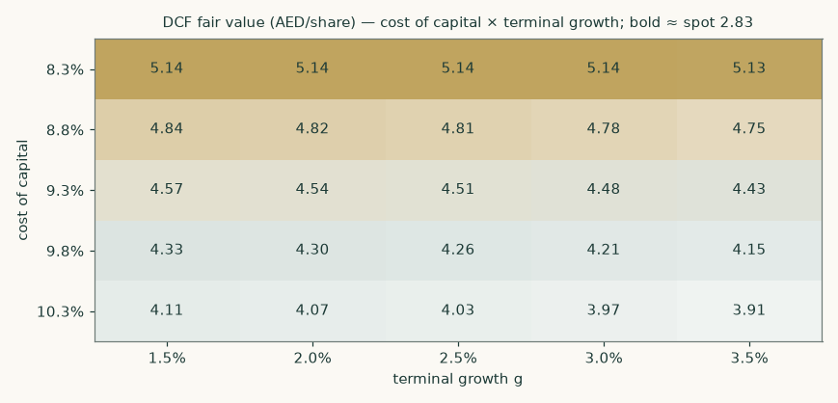
Figure 2 — DCF fair value across cost-of-equity shifts and terminal growth. Rebuilt so the centre cell equals the base case (the first edition's grid used a different terminal convention from its own base — an audit finding). Note the flat rows: with the terminal rate near the terminal return on capital, growth is close to value-neutral.
One-way strip (DCF per share) | −2 | −1 | base | +1 | +2
Beta 0.76 → 1.79 (base 1.28, steps of one standard error) | 6.51 | 5.33 | 4.51 | 3.92 | 3.47
Development margin ±4pts | 4.10 | 4.31 | 4.51 | 4.72 | 4.93
Conversion rate ±6pts | 4.12 | 4.33 | 4.51 | 4.67 | 4.80
New sales 50%→150% of base | 3.53 | 4.02 | 4.51 | 5.00 | 5.49
Working capital ±AED 1bn/yr | 4.27 | 4.39 | 4.51 | 4.64 | 4.76
Receivable days ±60 | 4.83 | 4.67 | 4.51 | 4.35 | 4.19
Cost of equity +0 → +2pts (own axis: 0 at base) | 4.51 | 4.26 | 4.03 | 3.82 | 3.64

Each cell is a complete revaluation; scenario driver vectors are published on the Assumptions sheet. Two mechanisms worth naming: a uniform conversion-rate shift raises value (all five years convert more), while pulling conversion forward only in the first period is nearly value-neutral — it drains the backlog that feeds the terminal year; and the receivable-days strip is the priced form of the related-party collection risk.
2 · Technical and price structure
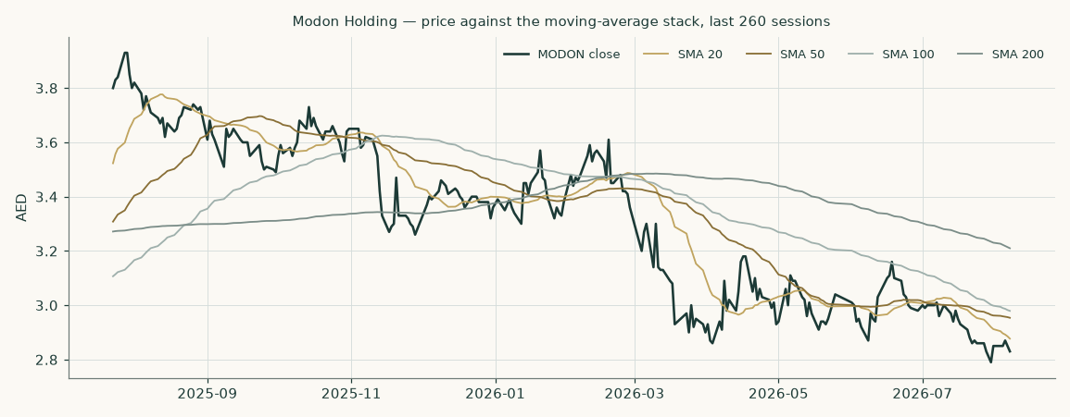
Figure 3 — the last 260 sessions against the 20/50/100/200-day moving averages.
The price closed 2.83 below a falling 20-day (2.88), a falling 50-day (2.95) and a falling 200-day (3.21). Momentum is soft: RSI(14) is ~39 and the daily ATR near 0.05 (~1.8%) points to a normal tape. MACD (12·26·9) is below zero but turning up (−0.04 / −0.04 / +0.00). Over the last year it has ranged 2.76–3.82; the last close sits 26% below that high and 3% above that low. (The MACD histogram is +0.002 — marginally positive; "turning up" rests on that computed sign, shown here at full precision.)
Trading below the whole moving-average stack, under a falling 200-day. A daily close back above 2.88 would clear the nearest resistance and open the 3.57 zone. A close below 2.76 would break the nearest support and open the 2.40 zone.
Nearest levels (computed from swing-point clusters) | AED
Resistance 3 | 3.57
Resistance 2 | 3.30
Resistance 1 (nearest) | 2.88
Last close (7 Aug 2026) | 2.83
Support 1 (nearest) | 2.76
Support 2 | 2.70
Support 3 | 2.40

Levels are recency-weighted swing-point clusters computed from the full price history; the read is computed, not drawn by hand.
3 · Probabilistic price map
Struck from the 7 August 2026 close of AED 2.83 using a volatility model fitted to this market's panel of ADX/DFM names, drift at the short-term dirham rate (no dividend is paid or proposed — a sourced zero), 50,000 paths. Unchanged from the first edition: the price series and anchor did not change.
How much to trust it: tested on 17 non-overlapping three-month windows walked forward over the post-2022 trading regime (earlier windows excluded because the UAE changed its trading week in January 2022 — and, worth stating, part of that history belongs to the smaller predecessor company), the method beat a drift-adjusted random walk by 4.2% on a proper scoring rule, robust across resampling. Coverage runs WIDE: the 80% band contained 94% of outcomes and the 90% band the same 94% — over-coverage, not precision; the bands are, if anything, conservative at this sample size. The forecast percentile of realised prices is statistically indistinguishable from uniform. Calibrated ranges, not promises.
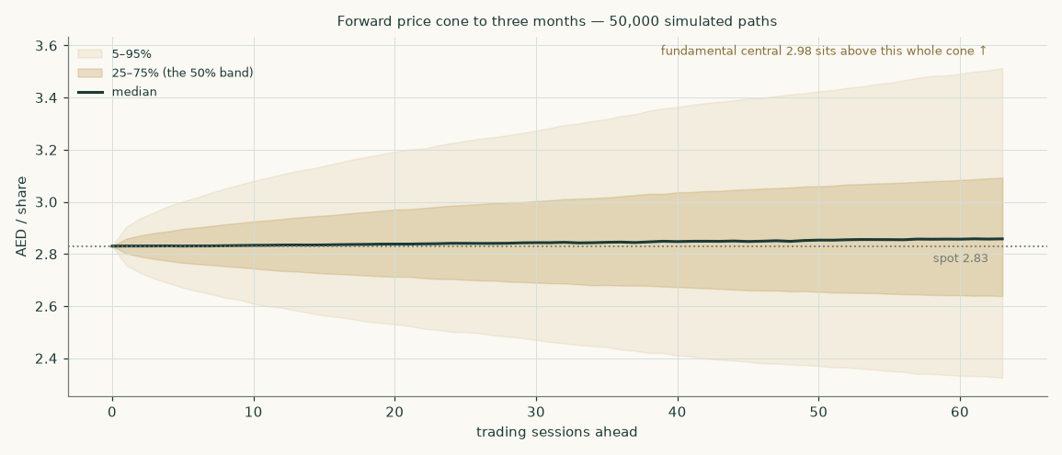
Figure 4 — the three-month cone: median, central 50% band and 5–95% band.
 | 1 month (to 2026-09-07) | 3 months (to 2026-11-09)
5th percentile | 2.54 | 2.32
25th percentile | 2.72 | 2.64
Median | 2.84 | 2.86
75th percentile | 2.96 | 3.09
95th percentile | 3.17 | 3.52
P(finish above spot) | 52% | 53%
P(finish ≥ +10%) | 8% | 23%
P(finish ≤ −10%) | 6% | 17%
P(touch +5% at any point) | 39% | 65%
P(touch −5% at any point) | 35% | 59%
P(touch +10% at any point) | 13% | 41%
P(touch −10% at any point) | 9% | 32%

Calendar-defined windows, settled on the first trading session on or after each date.
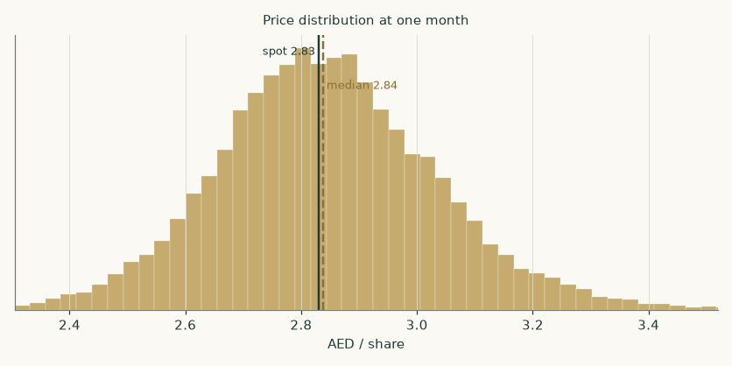
Figure 5 — simulated distribution at one month.
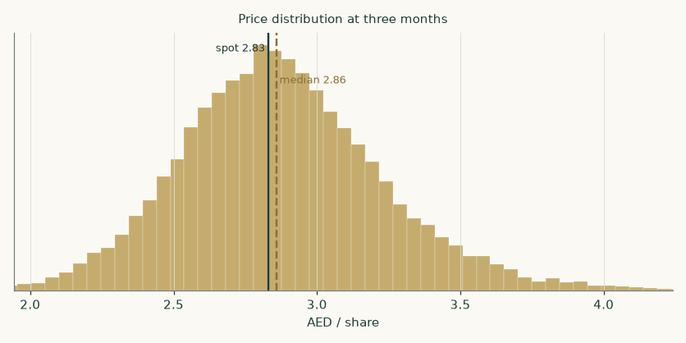
Figure 6 — simulated distribution at three months.
4 · Comparison of the lenses
The gap narrowed but did not close. The cash-flow lenses say AED 3.28–5.34 depending on the sales path; the market lenses say AED 1.46–2.24. Three readings, each priced. First: the market is charging for risk. Making the base cash flows worth AED 2.83 requires a cost of equity of 15.3% — 5.0% above the built-up rate: a hard-currency frontier-credit premium on a AA-sovereign's own developer. Materially less absurd than it sounds, given ~85% state ownership, related-party land sales at 67% gross margins, and a receivable book that consumed AED 5.4bn of cash in six months.
Second: the market is pricing the run-off stress with a further discount — the stress value of AED 3.28 needs a 14% holding-company-style haircut to land on the price. Third: the market lenses anchor on current multiples while the DCF anchors on the contracted backlog — and 74.2% of the DCF's enterprise value is terminal, which is where scepticism belongs; the working-capital honesty of this revision moved cash out of the explicit window and made that share larger, not smaller. The weighted central of AED 2.98 holds these readings in stated proportions rather than pretending they agree.
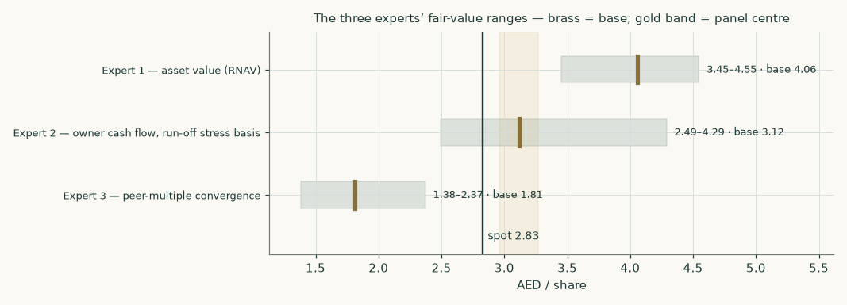
Figure 7 — three expert framings (Appendix C) against the market price.
5 · Catalysts
- Collections. FY2026 results (February 2027): whether H2 shows the receivable build-up collecting — the model requires roughly AED 7.5bn of H2 operating cash inflow on the IFRS basis after H1's AED −3.9bn, and says so.
- Related parties. Every dirham of the ~AED 10.8bn related-party receivable book (Department of Finance the largest counterparty) collected converts a paper claim into cash — the receivable-days strip in section 1.9 is this risk, priced.
- Egypt. Ras El Hekma phase-1 delivery milestones and further precinct launches.
- Capital returns. A maiden dividend policy would force the market to price the cash flows as owner earnings; none has been announced.
- Float. Any placement widening the ~15% free float changes the relative lens directly.
- Rates. The dirham imports US policy: each cut lowers the discount rate and mortgage friction.
6 · Reading the probability zones
The three-month map says: a two-in-three chance the price sits between AED 2.64 and 3.09 on 2026-11-09; 59% odds that AED 2.69 trades at some point (just above the 2.70 support); 65% odds that AED 2.97 trades — just ABOVE the nearest resistance at 2.88, so a touch of it would already be a breakout signal. A reader holding this study's fundamental view should not expect the map to confirm it inside a quarter: the map is calibrated to realised volatility, not to the study's opinion, and a +5% revaluation is a multi-year event, visible first in collections, margins and the dividend decision.
7 · Caveats — what would change our mind
- Related-party pricing. More than half of FY2025 land-sale profit came from related-party transactions at a 67% gross margin; arms-length repricing would cut the margin path and every cash-flow lens. Expert 1's land mark-up is set at exactly half that margin for this reason.
- Collections. H1-2026 consumed AED 3.9bn of operating cash into receivables. The component build now absorbs cash through FY2028; if receivable days do not fall from 440 as assumed, each 30 days is about AED 0.16 per share (section 1.9).
- Short clean history. FY2024 is a perimeter break and FY2023 belongs to a smaller predecessor: exactly two audited years of the modern group exist. Every trend read off this history carries that caveat.
- Beta. Beta is now regressed against the exchange's official index rather than a self-built stand-in, which raised it to 1.28 and cut the central. Two limits remain: the fit is loose (R² 0.09 over five years), and the shorter windows read higher still — 1.80 over three years would take the central to about AED 3.47 on the cash-flow lens. A rising beta is the live risk to this valuation.
- Terminal weight. 74.2% of the DCF's enterprise value is terminal. At the terminal return of 8.5% the block assumes the land bank converts to recognised profit; at FY2025's clean achieved 6.1% the terminal value falls by roughly a sixth and the DCF by about a tenth.
- Liquidity. The probability map is fitted to a market panel more liquid than MODON's float; thin trading can gap.
Appendix A · Financial statements
A.1 · Income statement — audited years, H1-2026 actual, forecast
AED mn | FY2023* | FY2024** | FY2025 | H1-26A | H2-26E | FY27E | FY28E | FY29E | FY30E
Revenue | 994 | 6,511 | 13,829 | 9,188 | 11,046 | 26,019 | 32,007 | 34,928 | 36,189
Gross profit | 600 | 2,317 | 5,025 | 3,201 | 4,165 | 9,619 | 11,784 | 12,807 | 13,143
EBITDA (house basis) | 673 | 9,795 | 4,896 | — | 3,481 | 7,734 | 9,361 | 10,149 | 10,462
Depreciation & amortisation | 28 | 265 | 610 | — | 341 | 709 | 736 | 765 | 794
EBIT | 646 | 9,530 | 4,285 | — | 3,140 | 7,026 | 8,625 | 9,384 | 9,668
Net finance result | 9 | -157 | -127 | — | -69 | -91 | -1 | 189 | 469
Associates & joint ventures | -1 | 115 | 264 | — | 95 | 210 | 227 | 245 | 264
Profit before tax | 653 | 9,488 | 4,421 | 2,601 | 3,166 | 7,144 | 8,851 | 9,818 | 10,401
Income tax | -80 | -99 | -495 | -401 | -491 | -1,107 | -1,372 | -1,522 | -1,612
Profit for the period | 574 | 9,389 | 3,926 | 2,202 | 2,676 | 6,037 | 7,479 | 8,296 | 8,789
Attributable to owners | 461 | 9,423 | 4,020 | 2,163 | 2,622 | 5,916 | 7,329 | 8,130 | 8,613

* Q Holding perimeter. ** Includes the AED 9,192mn bargain gain (ex-gain profit AED 197mn); the FY2024 EBITDA of 9,795 shown here is dominated by it — house basis, labelled, dual-framed. "Profit before tax" includes small discontinued items, as presented. FY2026E full year = H1 actual + the H2-26E stub.
A.2 · Balance sheet
AED mn | FY2024 | FY2025 | 30-Jun-26A | H2-26E | FY27E | FY28E | FY29E | FY30E
Receivables incl. related-party | 12,844 | 16,635 | 22,156 | 24,392 | 30,653 | 35,953 | 37,320 | 36,684
Inventories + development WIP | 32,048 | 33,409 | 34,087 | 34,435 | 35,239 | 34,923 | 33,972 | 32,687
Payables incl. advances + related-party | 18,030 | 23,102 | 22,289 | 23,935 | 27,881 | 31,346 | 32,075 | 32,263
Net working capital | 26,862 | 26,943 | 33,954 | 34,892 | 38,010 | 39,530 | 39,217 | 37,108
Cash and bank balances | 7,010 | 12,642 | 12,303 | 14,345 | 16,462 | 20,581 | 27,210 | 36,089
Debt incl. related-party loan | 5,364 | 6,789 | 9,542 | 10,300 | 10,500 | 9,700 | 8,800 | 7,900
Net debt (− = net cash) | -1,646 | -5,853 | -2,762 | -4,045 | -5,962 | -10,881 | -18,410 | -28,189
Equity attributable to owners | 49,676 | 53,903 | 56,397 | 59,019 | 64,935 | 72,264 | 80,394 | 89,007

Forecast columns roll only the lines the model drives; asset lines it does not forecast are left to the workbook. FY2023 (Q Holding perimeter) appears in A.1; its balance sheet is in the workbook.
A.3 · Cash-flow markers
AED mn | FY2024A | FY2025A | H1-26A | H2-26E | FY27E | FY28E | FY29E | FY30E
IFRS operating cash flow (audited/reviewed) | 3,231 | 3,860 | -3,921 | — | — | — | — | —
Model construct: NOPAT + D&A − ΔWC (a DIFFERENT measure — pre-interest, model tax) | — | — | — | 2,057 | 3,527 | 6,505 | 9,008 | 11,073
Capital expenditure | 1,247 | 1,261 | 312 | 700 | 1,500 | 1,550 | 1,600 | 1,650
Free cash flow to firm | — | — | — | 1,357 | 2,027 | 4,955 | 7,408 | 9,423

The two operating rows are different measures and are no longer presented as one series (an audit finding). The model's FY2026 implies roughly AED 5,978mn of H2 operating inflow on the IFRS basis after H1's outflow — stated in section 5 as the thing to watch.
Appendix B · Peers, risks and research register
B.1 · Peer set
Company | Market | FY2025 revenue | FY2025 attributable NP | Trailing P/E (attr.) | Backlog (own disclosure, dated)
Aldar Properties | ADX | 33,800 | 7,548 | 8.10x | 71,700 (FY25 dev.)
Emaar Properties | DFM | 49,600 | 17,599 | 5.78x | 155,000 (FY25 group)
Emaar Development | DFM | 27,490 | 11,316 | 4.73x | 125,200 (FY25)
Modon Holding | ADX | 13,829 | 4,020 | 11.51x | 65,400 (30-Jun-26 group)

AED mn; one attributable basis; every backlog labelled with its object and date. Peer figures from the peers' own audited filings and releases; prices 7-Aug-2026.
B.2 · Risk register
Risk | Where it bites | How it is priced here
Related-party sales concentration and pricing | development margin, receivables | margin glide; Expert 2 haircut; margin and receivable-day strips
Receivable collection timing | working capital | component build absorbs through FY2028; ±60-day strip
Abu Dhabi residential cycle turns | new sales, pricing | run-off stress priced in full (section 1.7)
Egypt macro and FX on Ras El Hekma | international leg | Egypt-premium stress: AED 3.64 per share
Rates higher for longer | discount rate, demand | +2pt cost-of-equity strip
Free float and index exclusion | the multiple, not the cash | 60% weight on market lenses IS the discount; no second haircut
Execution at masterplan scale | capex, delivery cadence | conversion strip; the terminal return held below the model's own path

B.3 · Research register
Area | What was established | Source | Date
Global | AED is hard-pegged to the USD; CBUAE Base Rate 3.65%, held since 17-Jun-2026, tracks the Fed. The July-2026 AED sovereign auction printed just 4bp over comparable US Treasuries | CBUAE Base Rate (house monetary-policy calendar); UAE MoF/CBUAE July-2026 T-Bond auction (WAM) | 2026-07-30
Global | UAE tender price inflation ~3.3% in 2025, forecast ~2.7-4.5% for 2026 (Turner & Townsend UAEMI 2025), with a post-conflict hawkish tail (one QS house sees 6-9%) as fuel/freight/insurance feed through; materials ~60% of baseline cost | Turner & Townsend UAE Market Intelligence 2025; MEED/Currie & Brown 2026 forecasts | 2026-07-01
Global | Cross-border capital is the marginal buyer of Abu Dhabi residential: foreign buyers drove 62% of the y/y growth in residential sales value in 2025, and Modon booked AED 6.6bn of international sales (Egypt+Spain+JV) across 2,115 units in 2025 | ADREC Abu Dhabi Real Estate Market Report 2025; Modon Annual Report 2025 | 2026-01-31
Global | Negative search — nothing found (UAE sanctions exposure real estate; Modon supply chain disruption; construction materials import restrictions UAE 2026) | negative search | 2026-08-09
Country | UAE rated Aa2 (Damodaran Jan-2026: adjusted default spread 0.42%, CRP 0.64%, total ERP 4.87%); AED T-Bond maturing Jan-2031 auctioned at 4.48% YTM in July-2026; EIBOR 3M 3.66% / 6M 3.71% (31-Mar-2026); AED peg unquestioned | Damodaran ctryprem (Jan-2026); UAE MoF July-2026 auction via WAM; CBUAE EIBOR fixings | 2026-07-30
Country | UAE corporate tax 9% from 2023; Domestic Minimum Top-up Tax (15%) effective 2025 for large groups — Modon's FY2025 charge includes AED 350.4mn of DMTT, and its disclosed effective-rate range is 9%-23.5% across jurisdictions | Income tax note 11, audited FY2025 consolidated financial statements | 2026-02-18
Country | Abu Dhabi government consolidation: on 30-Oct-2025 IHC and ADQ sold their entire stakes to L'imad Holding Company PJSC, wholly owned by the Abu Dhabi Government — Modon is now a majority government-owned entity under IAS 24, embedded in the emirate's development agenda | Note 1 / note 30, audited FY2025 consolidated financial statements | 2026-02-18
Country | Negative search — nothing found (FTSE ADX General Index daily history: stooq (^adx), Yahoo FADGI.FGI / FADX15.FGI (1 point only), investing.com SSR table (~1 month) and api.investing.com (403), TradingEconomics chart API (proxy 502), WSJ/MarketWatch michelangelo (unknown instrument), apigateway.adx.ae + www.adx.ae (Cloudflare challenge)) | negative search | 2026-08-09
Industry | Abu Dhabi 2025: AED 142bn total real-estate transactions (+44% y/y) on 42,814 deals (+52%); residential sales AED 76bn (+67%); off-plan 71% of residential transactions; 56 new projects launched | ADREC (Abu Dhabi Real Estate Centre) 2025 market report | 2026-01-31
Industry | Residential price momentum is buyer-led and cash-led: 87% of residential sales value registered as cash in 2025, with foreign buyers driving 62% of growth; Modon's blended realised price was AED 7.02mn/unit in Abu Dhabi (29.8bn/4,243 units) vs AED 3.12mn/unit internationally (6.6bn/2,115 units) | ADREC 2025 report; Modon Annual Report 2025 sales disclosures | 2026-01-31
Industry | Abu Dhabi development remains a near-duopoly of Aldar and Modon at masterplan scale, with Bloom Holding, Reportage and Q Properties-era mid-tier players below; Dubai majors (Emaar, Emaar Development) compete for the same international buyer but not on Abu Dhabi land | ADREC 2025 report; company disclosures | 2026-01-31
Industry | Negative search — nothing found (modular construction disruption UAE developer margins; proptech substitution of exhibition venues (virtual events share post-2024)) | negative search | 2026-08-09
Industry | Aldar FY2025: revenue AED 33.8bn (+47%), net profit 8.8bn (+36%), EBITDA 11.2bn, group sales 40.6bn, backlog AED 66.5bn Aldar-led (167bn incl. government projects). Emaar FY2025: property sales 80.4bn (+16%), revenue 49.6bn (+40%), backlog 155bn. Emaar Development: UAE sales 71.1bn, backlog 134.3bn | Aldar Q4-FY25 earnings release (aldar.com); Emaar FY2025 press release (emaar.com) | 2026-02-09
Company | Masterplan pipeline: Hudayriyat Island >50mn sqm gross land, 40,000 planned units; Ras El Hekma (Egypt) 170.8mn sqm with Modon lead developer on the 56mn sqm phase 1, 500,000+ planned units, first precinct (Wadi Yemm) launched at AED 5.8bn across 2,109 units; La Zagaleta (Spain) land sales continuing | Modon Annual Report 2025 (masterplan disclosures) | 2026-03-31
Company | H1-2026 reviewed interims: revenue AED 9,188mn (+40% y/y), gross profit 3,201mn, PBT 2,601mn, profit 2,202mn; development backlog converting on schedule; loans and borrowings 8,542mn (+66% since Dec-2025) as construction accelerates | Interim condensed consolidated financial statements, 30-Jun-2026 (reviewed) | 2026-08-07
Company | FY2025 results release: revenue backlog AED 46.0bn (93% development sales), adjusted EBITDA 4.9bn (35.2% margin), net cash 1.8bn on the company's own definition (available cash incl. qualifying escrow, less total debt incl. the related-party loan); real-estate sales 36.3bn across 6,358 units; hospitality 7,137 keys at 71% occupancy; AIM occupancy 97%; 896 events, 6.3mn visitors | Modon FY2025 results announcement, modon.com media centre, 18-Feb-2026 | 2026-02-18
Company | FY2024 is a perimeter break: the Modon Properties/ADNEC combination entered via share issues of AED 27.4bn and a bargain-purchase gain of AED 9,192mn; FY2024 reported profit 9,389mn falls to ~0.2bn excluding the one-off (company's own framing). FY2023 and earlier are the Q Holding perimeter | Note 4 business combinations, audited FY2025/FY2024 statements; FY2025 results release | 2026-02-18
Company | Named transaction: on 30-Oct-2025 IHC and ADQ disposed of their entire shareholding to L'imad Holding Company PJSC (wholly owned by the Abu Dhabi Government); the FY2025 results release states an 84.75% L'imad stake | Note 1, audited FY2025 consolidated financial statements; FY2025 results release | 2026-02-18
Company | No dividend paid to owners in FY2024 or FY2025 (statements of changes in equity show only an AED 243mn NCI dividend in 2025) and none proposed with FY2025 results; no buyback; Group CFO signature changed between the FY2025 filing (Bill O'Regan) and the H1-2026 interim (Matt Matharu) | Audited FY2025 statements; H1-2026 interim; FY2025 results release | 2026-08-07
Company | Four audited fiscal years assembled from the company's own filings: FY2025 (Modon, audited, signed 18-Feb-2026), FY2024 (comparatives in the FY2025 filing + the scanned FY2024 original), FY2023 and FY2022 (Q Holding filings). H1-2026 reviewed interim on top. All retrieved directly from modon.com/investor-relations | Audited consolidated financial statements FY2022-FY2025; H1-2026 interim | 2026-02-18
Company | FY2023 audited consolidated financial statements (Q Holding PSC perimeter): revenue AED 994mn, profit 574mn, total assets 21.3bn | Audited FY2023 consolidated financial statements (Q Holding PSC) | 2024-02-15
Company | FY2022 audited figures via the FY2023 filing's comparative column: revenue AED 720mn, profit 823mn, total assets 19.5bn | Audited FY2023 consolidated financial statements, FY2022 comparatives | 2024-02-15
Company | H1-2026 results release (29-Jul-2026): revenue backlog AED 65.4bn (doubling y/y, +42% vs FY2025), 95% development; H1 real-estate sales AED 26bn incl. 23bn Abu Dhabi (Hudayriyat Golf Estates AED 13bn within days); net debt AED 912mn on the company definition with AED 8.6bn unrestricted cash; adjusted EBITDA AED 3.0bn (32.6%); hospitality 3,613 keys across 16 owned/operated/JV hotels. (added at revision 2 after external audit) | Modon H1-2026 results announcement, modon.com media centre, 29-Jul-2026 | 2026-07-29
Industry | TIER 1 — own-stock weekly regression vs the stock's OWN local index, the official FTSE ADX General (3,884 sessions, 02-Jan-2011 to 24-Jul-2026, screened for data quality before use: 249.7 rows/yr on ADX's own calendar, zero moves beyond the +/-15% constituent limit, zero repairs). Beta 1.278 (5y, SE 0.258, R2 0.089, n 255, clears the usability test) is adopted as the longest window clearing the gate; 3y 1.800 (R2 0.258), 2y 1.581 (R2 0.306) both read HIGHER. The retired revision-2 proxy (equal-weight composite of the 19 house UAE names) re-run on the same weeks reads 1.118 at 5y - it under-read at every window because the official index is 1.30x less volatile than the composite (11.5% vs 14.9% annualised) at a similar correlation (0.298 vs 0.343). Damodaran EM industry route stays rejected as primary (RE Development unlevered 0.45 dominated by highly-levered Chinese developers, D/E 1.97); retained as a lower-bound cross-check (relevered 0.56-0.59) | Official FTSE ADX General daily history (requester-supplied, 10-Aug-2026); house regression beta_official.py; Damodaran betaemerg.xls (07-Jan-2026) | 2026-08-10

Every claim the model rests on, with source and date. The companion bibliography carries the full input-by-input register — now including the corrections adopted from the external audits, each marked.
Appendix C · Three experts, worked in full
Three framings, each taken to a number by a different method, with stated blind spots and falsifiers. Labelled Expert 1, 2 and 3. Expert 2 builds on the study's own run-off scenario — a derived framing with an independent overlay, labelled as such, not a third independent view.
C.1 · Expert 1 — the asset value (revalued net assets)
Worldview: a developer is a warehouse of land bought below market. Works when the land is carried far below realisable value; fails when the buyer of first resort is a related party whose price is the appraisal.
Line | AED mn
Attributable equity, 30 Jun 2026 (reviewed) | 56,397
Land bank at cost (land plots within inventories, FY2025 note) | 26,611
Mark-up: 33.7% — EXACTLY half the realised 67.4% related-party land-sale margin (the first edition said "half" but applied 35%; aligned) | 8,968
Work-in-progress mark-up: 15% on AED 6,488mn | 973
Revalued net asset value | 66,338
Per share (16,347mn shares) | 4.06
Range: appraisal haircut 15% to premium 12% | 3.45–4.55

Named sensitivity: each 10 points of land mark-up is AED 0.16 per share. Falsifier: two consecutive halves of arms-length land sales clearing below 20% gross margin collapses the mark-up toward zero and this value toward book (AED 3.45).
C.2 · Expert 2 — owner cash flow on the run-off stress (derived framing)
Worldview: value only the cash an owner could take out if no new story arrives; treat affiliate receivables as impaired until collected. Works at cycle tops; structurally blind to compounding growth.
Line | Value
Run-off stress DCF (the study's own scenario) | AED 3.28/sh
Related-party receivable book, 30 Jun 2026 | AED 10,756mn
Haircut: 25% for timing and collection | − AED 0.16/sh
Expert 2 value | AED 3.12/sh
Range: deeper haircut, to the base DCF less 5% | 2.49–4.29

Named sensitivity: each 10 points of haircut is AED 0.07 per share. Falsifier: the Department-of-Finance receivable collecting on schedule through FY2026 removes the haircut and moves this expert to AED 3.28.
C.3 · Expert 3 — the market pricer
Worldview: the peer multiple is the verdict of everyone else's money. Works when the peer set is deep; prices inflections only after the fact.
Line | Value
FY2026E attributable profit (H1 actual + H2 model) | AED 4,785mn
Multiple: 6.2x — the arithmetic MEAN of the rebuilt attributable peer set (4.73/5.78/8.10; the first edition claimed "centre" but used 6.5x)
Implied equity value | AED 29,668mn
Per share | AED 1.81
Range: trough 4.73x to leader 8.10x | 1.38–2.37

Named sensitivity: each turn of P/E is AED 0.29 per share. Falsifier: a dividend policy plus a float above 25% would justify migrating toward the cash-flow lenses.
C.4 · Cross-examination
- Expert 1 to Expert 2: your haircut double-counts — the run-off already starves the related-party channel. Expert 2 concedes in part: the haircut stays on the stock of receivables, not the flow. Sustained in part.
- Expert 2 to Expert 1: your mark-up is circular — the margin you halve was set by related-party sales. Expert 1 concedes the circularity; the falsifier (arms-length clearing prices within two reporting periods) is the test. Acknowledged.
- Expert 3 to both: the shares trade at 11.5x attributable earnings against a leader at 8.1x — the market has voted. Experts 1 and 2 reject the inference: a 15% float is not a verdict but the absence of one. Rejected, reason stated.
C.5 · Three in one room
One sentence each. Expert 1: "the land covers the price at AED 4.06." Expert 2: "paid to wait even in run-off — AED 3.12 — if the affiliates pay their bills." Expert 3: "until the float and dividend exist it is worth the peer mean: AED 1.81." Median AED 3.12 — between the study's market lenses and its cash-flow lenses, which is where the disagreement lives.
C.6 · Divergence table
Assumption | Expert 1 | Expert 2 | Expert 3 | Gap it drives
Land bank worth above cost | +34% | 0% | ignored | AED 0.55/sh
Related-party receivables | face value | −25% | face value | AED 0.16/sh
Sales path | irrelevant (assets) | run-off stress | FY2026E only | AED 1.23/sh between base and stress
Multiple regime | n/a | n/a | 6.2x peer mean | AED 0.38/sh vs the study's 7.5x

About this study
Revision 2, produced the same day as the first edition after external audits of that edition. Every number in the study, the Excel model and the bibliography comes from one computed model; the delivered workbook is verified cell by cell against it — 617 formula cells reproduce the model exactly, zero unresolvable, zero unchecked — and a driver test on the delivered file confirms 25 drivers reprice the workbook in the asserted direction with no dead inputs (the published scenario-vector rows are display inputs for the pasted engine re-runs and are inert by design, stated on the sheet). The historical record is built exclusively from the company's own audited statements, reviewed interims and results announcements; where a figure is both disclosed and derivable, the disclosed figure is carried. The audits' accepted findings and this study's own re-audit findings are implemented and marked where they appear; their rejected findings are answered with receipts in the build record.
Disclosure
Educational analysis. Not investment advice, not a recommendation, not an offer. No rating is expressed. The single weighted central is the centre of a stated range of model outputs, not a price target, and the full per-lens ranges are shown wherever it appears. The authors hold no position in MODON. Data as of 9 August 2026; prices as of the 7 August 2026 close. © Testahil 2026.

