Testahil · Independent Valuation Study — Educational Analysis Not investment advice

Riyadh Cables Group Company
Tadawul: 4142 · Capital Goods — Electrical Equipment (wire & cable) · Saudi Arabia
Fair-value range (weighted central) SAR 109 per share · full span SAR 64–198 · spot SAR 104.80 (4% to the central)
READ FIRST. This is an independent, educational valuation study. It is not investment advice, not a recommendation, and not a price target. Every figure is a model output shown as a range, built only from Riyadh Cables’ own audited financial statements and its filed results. A companion workbook carries the full model; a companion bibliography lists every source.
What the number means. The four valuation lenses below place fair value between about SAR 86 and SAR 128 per share; weighting them gives a central of SAR 109, about 4% above the SAR 104.80 market price. The lenses disagree, and that disagreement is the point: the intrinsic cash-flow lens sees clear value, the exit-multiple lens is more cautious.
The one thing to watch. Riyadh Cables is a metal converter — copper and aluminium are about 95% of its cost of sales. Its gross margin is therefore an OUTPUT of the metal price, not a stable input. The study’s central judgement is the margin the business holds now that the 2024–25 metal tailwind has passed; it is anchored on the most recent reviewed half-year (15.3%) and shown both ways against the higher full-year 2025 print.

Headline
Riyadh Cables is the largest Saudi manufacturer of electrical cables and wire. Revenue has grown from SAR 7.8bn in 2023 to SAR 10.7bn in 2025 (a 17% annual pace), and net profit has doubled to SAR 1.08bn, as gross margin climbed from 12.4% to 16.2%. The company is lightly geared — net financial debt of about SAR 385mn is a fraction of its SAR 15.7bn market value — earns a return on equity near 37% and a return on invested capital of about 31% in 2025 (normalising toward the mid-20s in the forecast), and pays out a little over half its earnings.
Our central fair-value estimate is SAR 109 per share, about 4% above the SAR 104.80 price. The intrinsic discounted-cash-flow lens is the most positive at SAR 128; a cautious exit-multiple reading is the least, at SAR 86; the earnings-power and book-value lenses sit in between at SAR 102 and SAR 95. The single most important assumption is the sustained gross margin: at the recent half-year’s 15.3% the cash-flow lens is worth SAR 128; if the 2025 full-year 16.0% holds it is worth SAR 140; if it compresses to 14.5% it is worth SAR 116.
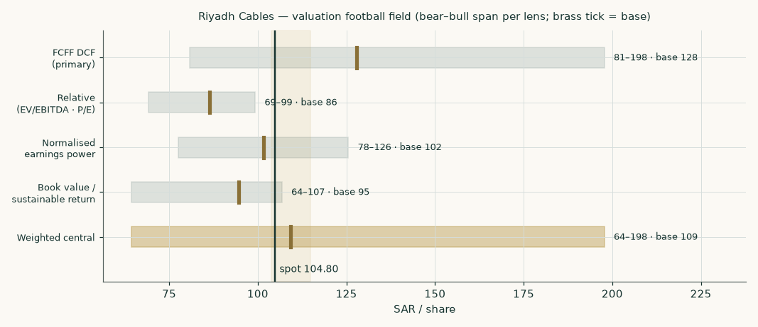
Figure 1. Valuation football field — the bear-to-bull span of each lens; the brass tick is the base case; the vertical line is the market price.
Valuation summary — every read at a glance
Lens | Bear | Base | Bull | Weight | vs spot
Discounted cash flow (primary) | 81 | 128 | 198 | 45% | 22%
Relative multiples | 69 | 86 | 99 | 20% | -18%
Normalised earnings power | 78 | 102 | 126 | 20% | -3%
Book value and sustainable return | 64 | 95 | 107 | 15% | -10%
Weighted central | 64 | 109 | 198 | 100% | 4%
Expert panel median |  | 126 |  |  | 20%
Market price (anchor) |  | 104.80 |  |  | —

Terminal value as a share of the discounted-cash-flow enterprise value: 81%. Enterprise value / EBITDA (on FY2025 EBITDA) 11.9x; price / FY2025 earnings 14.5x. Cost of capital 10.5% today, easing to 9.5% in perpetuity.
The contested judgement, both ways. The sustained gross margin drives the cash-flow lens more than any other input. Anchored on the reviewed H1-2026 actual of 15.3%: SAR 128/share. On the 2025 full-year 16.0%: SAR 140. On a further compression to 14.5%: SAR 116. We publish the three side by side and do not average them into one number.

Company overview
Riyadh Cables Group Company is a Saudi joint-stock company founded in 1984 and listed on the Saudi Exchange (Tadawul) in December 2022. It manufactures low-, medium-, high- and extra-high-voltage power cables, building wire, and telecommunications cable, from plants in Riyadh’s industrial cities. It is the largest cable maker in Saudi Arabia and a significant exporter into the wider Gulf.
Two 2025 acquisitions reshaped the group’s perimeter and explain the balance-sheet step-ups. In April 2025 it bought the remaining 50% of Qatar Cables, taking that subsidiary to full ownership; and with a control date of 28 November 2025 it acquired 51% of Artikul Aziya Kabel in Uzbekistan for SAR 147.7mn. The Uzbek deal added goodwill (group intangibles and goodwill rose from SAR 57mn to SAR 138mn) and brought in the SAR 63mn non-controlling interest now on the balance sheet — both deducted in the valuation bridge.
The business reports three segments. Cables and wire is by far the largest at SAR 10.4bn, 98% of 2025 revenue; high-voltage turnkey projects add SAR 231mn (2.2%); and other products — chiefly telephone cable and services — a further SAR 29mn. By destination, 73% of sales are inside Saudi Arabia and 27% are exports, predominantly to the United Arab Emirates (about SAR 2.2bn in 2025).
The balance sheet is that of a metal converter: inventory of copper and aluminium and a large trade-receivables book (together about 48% of revenue), part-funded by trade payables and a supplier-finance facility, with only modest interest-bearing debt. The company hedges copper, aluminium and lead through commodity forwards. It is not a bank, a developer or a holding company; it is an operating manufacturer, and it is valued as one — a discounted-cash-flow model first, cross-checked against multiples, earnings power and book value.
1 Fundamental valuation
1.1 Cash-flow model — the free-cash-flow waterfall and the value bridge
The primary lens is a five-year discounted cash flow to the firm. Operating profit is taxed at a forward zakat-and-tax rate of 9.5% — just above the 9.0% the group actually paid in 2025, allowing for a rising foreign-profit share — depreciation is added back, and capital expenditure and the investment in working capital are subtracted, to give free cash flow to the firm. Each year is discounted at its own cost of capital (at year-end), gliding from 10.5% to 9.5%.
SAR mn | FY26E | FY27E | FY28E | FY29E | FY30E
Revenue | 11,499 | 12,392 | 13,340 | 14,235 | 15,111
EBITDA | 1,354 | 1,471 | 1,589 | 1,710 | 1,814
EBITDA margin | 11.8% | 11.9% | 11.9% | 12.0% | 12.0%
Depreciation & amortisation | 98 | 105 | 113 | 121 | 128
EBIT | 1,256 | 1,365 | 1,476 | 1,589 | 1,686
NOPAT (EBIT×(1−t)) | 1,137 | 1,236 | 1,336 | 1,438 | 1,526
+ Depreciation & amortisation | 98 | 105 | 113 | 121 | 128
− Capital expenditure | 218 | 223 | 227 | 228 | 242
− Change in working capital | 286 | 250 | 266 | 251 | 245
Free cash flow to firm | 730 | 868 | 957 | 1,080 | 1,167
Discount factor | 0.9052 | 0.8212 | 0.7467 | 0.6805 | 0.6216
PV of FCFF | 660 | 713 | 714 | 735 | 726

Sum of the present values of the five explicit years is SAR 3,548mn; the present value of the terminal value is SAR 15,136mn (81% of enterprise value); together the enterprise value is SAR 18,684mn.
Enterprise value to equity (SAR mn)
Enterprise value | 18,684
of which terminal value (81% of EV) | 15,136
Less: net financial debt | -385
Add: associates + non-operating assets | 52
Less: non-controlling interests | -63
Equity value attributable | 18,288
Value per share at 31-Dec-2025 (SAR) | 122.15
Rolled to the 18-Aug-2026 anchor, net of dividend (SAR) | 127.91

The enterprise-to-equity bridge. The terminal-value share is shown on its own line, and again in the summary table and the companion workbook, where it is a live formula.
1.2 Book value and sustainable return
Equity attributable to shareholders was SAR 3.25bn at end-2025, or SAR 21.68 per share. Trailing return on average equity is about 37% — very high, but flattered by the 2024–25 metal tailwind and a large receivables book. We take a sustainable return of 28%. Capitalised against a terminal cost of equity of 9.7% and 4% growth, that supports a justified price-to-book of 4.2x and a value of SAR 95 per share.
1.3 Relative multiples
Riyadh Cables trades at about 11.9x enterprise value to FY2025 EBITDA and 14.5x FY2025 earnings. Developed-market cable majors (Prysmian, Nexans) trade around 7–9x forward EBITDA; fast-growing emerging-market peers (Polycab, KEI in India) carry a large growth premium at 20–30x. Applying a 9.5x multiple — with the developed majors, a deliberate discount to Riyadh Cables’ own trailing multiple — to 2027 EBITDA of SAR 1,471mn, discounting it, and adding the interim cash flows, gives SAR 86 per share — the most cautious lens, reflecting a single-country base and a market that already prices in quality.
1.4 Normalised earnings power
Stripping cycle from the earnings, a mid-cycle EBITDA margin of 11.9% on current-scale revenue of SAR 11,499mn, after depreciation, financing and tax, yields normalised earnings of about SAR 7.50 per share. At a through-cycle 13x — appropriate for a high-return, low-leverage regional leader with a roughly 11% cost of equity — that is SAR 102 per share.
1.5 Synthesis — four lenses, one field
The four lenses span SAR 86 to SAR 128. We weight the discounted cash flow most (45%) because the company’s cash flows are directly modelled from a disclosed cost structure; the relative and earnings-power lenses each 20%; and book value least (15%), because book understates a business earning a return on equity near 37%. The weighted central is SAR 109.
1.6 The drivers — each segment on its own driver, margin as an output
Revenue is not grown at one rate, and it is not grown as one business. The model is built on the three disclosed reporting segments, each on its own driver, and summed. Cables and wires — 98% of revenue — is the metal converter: a cable-tonnage index priced as metal content (on its own copper-and-aluminium path) plus a conversion cost (on domestic inflation) plus a conversion spread, with volume growing 10.0% in 2026 tapering to 5.0%, anchored on the reviewed half-year statement that 2026 revenue rose 9.5% "due to the increase in the volume of quantities sold." High-voltage turnkey projects — a lumpy project business — grow on their own path at their disclosed 8% segment margin, and the small Other leg likewise. Metal prices are held broadly flat. The group gross margin is then the blended OUTPUT of the three legs — 15.2% in 2026 rising gently to 15.4%, never back to the 2024–25 peak. Along that expected metal path the cable leg’s conversion spread is set to earn the target margin, so the reported margin holds; an unexpected metal move — the one the sensitivity prices — is not repriced in the spread and therefore dilutes the margin, exactly as the first half of 2026 showed. (The cost-by-nature split is disclosed only at group level, so the group metal is carried in the cable leg and the two small legs carry their disclosed segment margins — immaterial at 2.4% of revenue.)
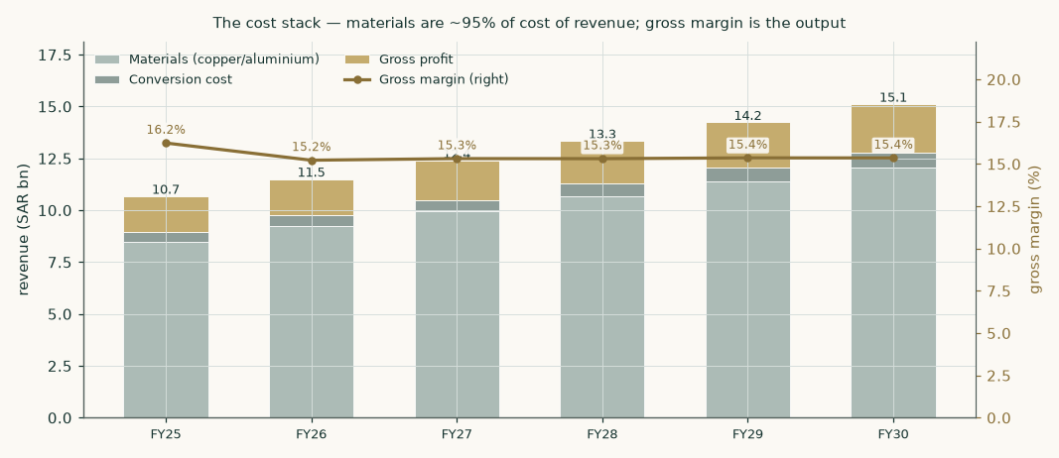
Figure 2. The cost stack. Materials (copper and aluminium) are about 95% of cost of sales; the gross margin, shown on the right axis, is what is left after materials and conversion cost — an output, not an input.
1.7 The crux — the sustained gross margin
The crux is simple to state and consequential. Gross margin rose from 12.4% in 2023 to a 16.2% peak in 2025 as metal prices moved the company’s way. In the first half of 2026, on a 9.5% rise in revenue, gross profit was essentially flat — margin fell to 15.3%, and within the half it was still easing: the second quarter’s 15.0% sat below the first quarter’s 15.6%. That is the metal pass-through working in reverse: volume-led growth at a normalising per-tonne spread. We anchor the forecast on that reviewed half-year (15.3%), not the higher full-year 2025 print, and we show the value both ways.
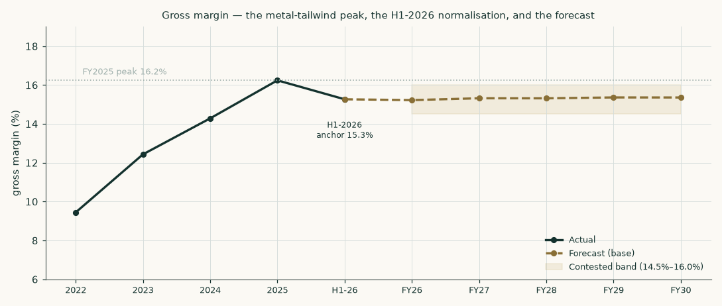
Figure 3. The gross-margin story: the 2024–25 metal-tailwind peak, the first-half-2026 normalisation to 15.3%, and a forecast that recovers only gently and stays below the peak. The shaded band is the contested range carried through the valuation.
1.8 Macro and country — the cost of capital, built up
The cost of capital is built from sourced components. Saudi Arabia is rated Aa3; its adjusted sovereign default spread is 0.48% and its equity risk premium 4.94% (a 4.20% mature-market base plus a 0.74% country premium). We take the ten-year Saudi sukuk yield at 5.50% — re-derived this edition from the published SAR government-sukuk curve after an earlier estimate sat below it — subtract the sovereign’s own default spread to avoid charging country risk twice, and add beta times the premium. Beta is 1.129, from Riyadh Cables’ own weekly returns against the Tadawul All Share Index over its 185-week listed history; it is a noisy estimate (R-squared about 0.15, standard error 0.31, a 90% confidence interval of roughly 0.6 to 1.6), which the sensitivity carries. That gives a cost of equity of 10.6%. Debt is marginal — Islamic Murabaha at about 5.9%, above the sovereign as a same-currency corporate must be — and its weight is struck on NET financial debt (borrowings less cash); with an almost all-equity balance sheet the weighted cost is 10.5%, easing to 9.5% in perpetuity as the country premium narrows and beta reverts toward one.
Cost of capital | Explicit | Terminal
Risk-free rate (SAR 10-year), normalised | 5.02% | 5.02%
Equity risk premium | 4.94% | 4.70%
Beta | 1.129 | 1.00
Cost of equity | 10.60% | 9.72%
Cost of debt (after tax) | 5.34% | 4.98%
Net-debt weight | 2.4% | 5%
Weighted cost of capital | 10.47% | 9.48%

Two terminal conventions are worth flagging. The terminal structure carries a 5% net-debt weight, modestly above today’s 2.4%, to acknowledge the structural working-capital leverage a cable maker runs — a small lever, not a geared structure the company has ever operated. And the terminal risk-free rate is held flat at its normalised current level rather than marked down, so the terminal cost of equity falls only as beta reverts to one and the country premium compresses, never by cutting the risk-free to lift value.
1.9 Sensitivity
Fair value is most sensitive to the terminal growth rate and the terminal cost of capital, then to the sustained margin, beta and working-capital intensity. The grid below revalues the cash-flow lens across the terminal cost of capital and terminal growth; the companion workbook carries the full set.
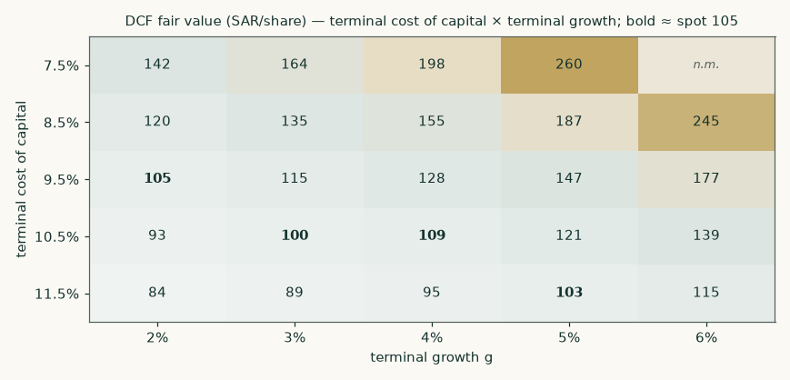
Figure 4. Cash-flow fair value (SAR/share) across the terminal cost of capital and terminal growth; the bold cells sit closest to the current price.
2 Technical and price structure
The shares last traded at SAR 104.80, near the low of their 52-week range (about SAR 100 to SAR 143) and below all four of their moving averages — roughly 1% under the 20-session average, 8% under the 50-session and 14% under the 200-session — after retracing much of the multi-year advance that followed the December 2022 listing. The moving-average stack below places the current price in that context. This section is descriptive; it carries no fundamental claim.
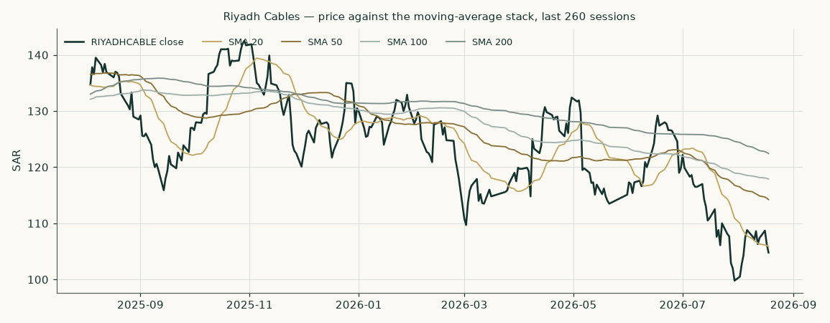
Figure 5. Price against its 20-, 50-, 100- and 200-session moving averages, last 260 sessions.
3 A probabilistic price map
Separately from the fundamental value, we map the range of prices the shares could plausibly reach over the next one and three months, from 50,000 simulated paths calibrated to the stock’s own volatility. This is a statement about price risk, not about fair value.
Percentile | One month | Three months
95th (upper) | 126.2 | 144.1
75th | 112.6 | 118.7
50th (median) | 104.8 | 105.1
25th | 97.6 | 92.9
5th (lower) | 87.2 | 76.5
Chance of finishing above today | 50% | 51%

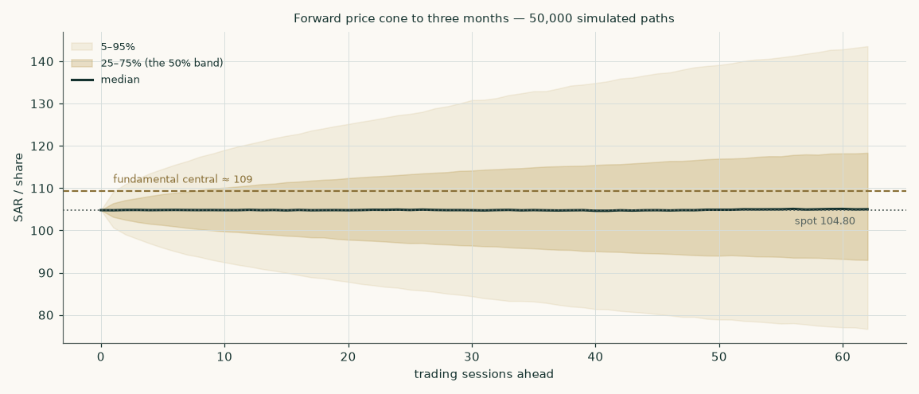
Figure 6. The forward price cone to three months — the shaded bands are the 25–75% and 5–95% ranges; the dashed brass line marks the fundamental central estimate.
The cone is well-calibrated in its outer bands and conservative in its inner one. Tested across the stock’s full trading history, its 80% and 90% bands contained 80% and 90% of actual outcomes — on target — while the 50% band contained 70%, wider than its label, so the inner band overstates the likely dispersion rather than understating it. The model’s implied ranks were close to uniform (a mean of 0.49 against an ideal of 0.50). On scored accuracy the cone was statistically indistinguishable from simply assuming the price follows a random walk over the roughly three and a half years the shares have been listed; it neither reliably beat that nor lagged it, which for a liquid large-cap is the honest result. Because the company only listed in December 2022, the calibration rests on that shorter own history together with the broader Saudi-market evidence behind the same simulation model; a five-year single-name record will exist in time. The level-touch chances above are read directly from the simulated paths.
4 Comparison of the lenses
The lenses disagree by design, and the disagreement is informative. The intrinsic discounted-cash-flow value (SAR 128) is the highest: it rewards a high return on capital, durable mid-single-digit growth and a low Saudi cost of capital, and it is terminal-heavy (81% of value beyond year five). The relative lens (SAR 86) is the most cautious: it holds the company to a mid-range exit multiple below where it trades today. Earnings power (SAR 102) and book value (SAR 95) sit between. Read together, the market price sits below the cash-flow lens and above the earnings-power, book and exit-multiple lenses; the reading depends entirely on how much weight one puts on the intrinsic economics versus the exit multiple. The weighted central of SAR 109 is 4% above the market price.
5 Catalysts to watch
- Margin prints — the quarterly gross margin. The single most important number. Each quarter’s reviewed margin tests the sustained-spread judgement directly.
- Metal prices — copper and aluminium. A sustained metal move changes revenue and the reported margin; watch that gross profit per tonne, not the headline margin, holds.
- Volume — Saudi grid and construction spend (Saudi Electricity Company, giga-projects, housing) drives domestic volume, about three-quarters of sales.
- Exports — the export share (about a quarter of sales, mostly the UAE) and any new-market wins, including the early-stage Syrian memorandum of understanding disclosed in 2026.
- Capital — semi-annual dividends (the FY2025 final was SAR 2.25/share), the small treasury holding of 282,500 bought-back shares, and any change in payout or the completion of the current capacity build.
6 Reading the probability zones
The fundamental range and the price cone answer different questions. The fundamental central (SAR 109) is where the business is worth on its cash flows; the price cone (a three-month 5–95% range of about SAR 77 to SAR 144) is where the price could travel on volatility alone. When the fundamental estimate sits above the price, as here, the gap is the potential the intrinsic lens sees; the cone is a reminder that the path is wide and the outcome uncertain over any short horizon.
7 Caveats and what would change our mind
- The margin — if the sustained gross margin settles below 14.5% — a competitive or metal-driven squeeze on the conversion spread — the cash-flow lens falls toward SAR 116.
- Terminal reliance — the value is terminal-heavy (81% of enterprise value). A higher terminal cost of capital or lower growth cuts it materially, as the sensitivity grid shows.
- Concentration — revenue is single-country-concentrated and customer-concentrated (one customer was about 19% of 2025 revenue); the beta is estimated on a short listed history with a wide confidence interval.
- Working capital — a working-capital-heavy model ties cash in copper inventory and receivables; a stretch in either absorbs the cash the cash-flow lens counts.
- Short record — the price cone rests on a three-and-a-half-year listed history, shorter than the five-year ideal.

Appendix A Financial statements
A.1 Income statement — three years actual, five years forecast
SAR mn | 2023 | 2024 | 2025 | FY26E | FY27E | FY28E | FY29E | FY30E
Revenue | 7,825 | 9,007 | 10,674 | 11,499 | 12,392 | 13,340 | 14,235 | 15,111
Gross profit | 973 | 1,287 | 1,733 | 1,750 | 1,898 | 2,043 | 2,187 | 2,321
Gross margin | 12.4% | 14.3% | 16.2% | 15.2% | 15.3% | 15.3% | 15.4% | 15.4%
EBITDA | 714 | 1,037 | 1,352 | 1,354 | 1,471 | 1,589 | 1,710 | 1,814
EBIT | 648 | 968 | 1,267 | 1,256 | 1,365 | 1,476 | 1,589 | 1,686
Net finance cost | -89 | -88 | -74 | -27 | -23 | -15 | -5 | 7
Profit before zakat | 559 | 881 | 1,192 | 1,229 | 1,342 | 1,461 | 1,583 | 1,693
Net profit | 518 | 817 | 1,085 | 1,112 | 1,215 | 1,322 | 1,433 | 1,532

A.2 Balance sheet — three years actual
SAR mn | 2023 | 2024 | 2025
Property, plant & equipment | 1,207 | 1,336 | 1,492
Inventory | 1,909 | 2,126 | 2,411
Trade & other receivables | 1,419 | 2,112 | 2,713
Cash & equivalents | 150 | 91 | 236
Total assets | 4,831 | 5,812 | 7,282
Gross borrowings incl. leases | 731 | 440 | 621
Net financial debt | 581 | 350 | 385
Equity attributable | 2,247 | 2,624 | 3,246

A.3 Forecast balance-sheet and cash-flow markers
SAR mn | FY26E | FY27E | FY28E | FY29E | FY30E
Net working capital | 3,220 | 3,470 | 3,735 | 3,986 | 4,231
Net financial debt (end) | 289 | 108 | -111 | -402 | -736
Capital expenditure | 218 | 223 | 227 | 228 | 242
Free cash flow to firm | 730 | 868 | 957 | 1,080 | 1,167
Dividend | 609 | 665 | 724 | 785 | 839
Attributable profit | 1,107 | 1,210 | 1,317 | 1,427 | 1,526

Appendix B Peer frame, risk register, and the research register
B.1 Peer frame
Peer | Market | Fwd EV/EBITDA | Note
Riyadh Cables (subject) | Tadawul | 11.9x (trailing) | high-return Gulf leader
Prysmian | Milan | ~8.5x | global cable major
Nexans | Paris | ~7.5x | global cable major
Polycab India | NSE | ~26x | high-growth EM premium
KEI Industries | NSE | ~24x | high-growth EM premium
Ducab | UAE (private) | — | regional peer, unlisted

B.2 Risk register
- Margin — concentrated in the conversion spread; a normalising or competed margin is the main downside.
- Metal — copper/aluminium price and availability; hedged, but a sustained move still moves reported results.
- Concentration — single-country and single-customer concentration (one customer ~19% of 2025 revenue).
- Cash — working-capital intensity and receivables quality (a SAR 151mn receivables impairment in 2025).
- Data — short listed history for the beta and the price-cone calibration.
B.3 Research register
Every figure in this study traces to a primary source. The full register — each input with its value, date, source and how it was constructed — is in the companion bibliography document. In summary: the historical income statement, balance sheet, cash flow, segment, cost and inventory figures come from Riyadh Cables’ own audited consolidated financial statements for 2022 through 2025 (KPMG, unmodified opinions); the 2026 near-term anchor is the company’s Tadawul-filed reviewed half-year results; the cost of capital uses the published Saudi sovereign and equity-risk-premium data and the Tadawul index for beta; and metal prices are the London Metal Exchange copper and aluminium references. No data aggregator, broker note or press report is a source for any company figure.

Appendix C Expert panel
Three independent valuation methods, each worked in full, each with a condition that would prove it wrong. They are labelled Expert 1, 2 and 3 and cast by method.
C.1 Expert 1 — earnings power
Worldview: value a stable manufacturer on mid-cycle earnings and a through-cycle multiple. Works when earnings are recurring; fails if the cycle breaks structurally. Mid-cycle EBITDA margin 11.9% on revenue of SAR 13,340mn gives EBIT of SAR 1,476mn; after net interest of SAR 15mn, tax and minorities, earnings are SAR 8.80 per share; at 13.0x that is SAR 120 (range SAR 91–148). Falsifier: a sustained margin below 14%.
C.2 Expert 2 — owner cash earnings
Worldview: an owner earns the free cash flow after real reinvestment; capitalise mid-cycle owner cash at the cost of equity. Works for a cash-generative business; fails if reinvestment is understated. Mid-cycle free cash flow to the firm of SAR 1,068mn, less after-tax interest, is owner cash of about SAR 1,059mn; grown at 4% and capitalised at 9.7% gives SAR 135 (range SAR 92–165). Falsifier: free cash conversion staying below half of earnings.
C.3 Expert 3 — cash returns versus the cost of capital
Worldview: value is invested capital plus the present value of returns above the cost of capital. Works when returns are measurable and durable; fails if the return advantage erodes. Invested capital of SAR 4,425mn plus the present value of economic profit (SAR 13,988mn) gives SAR 126 per share (range SAR 92–145). Falsifier: return on capital falling toward the cost of capital.
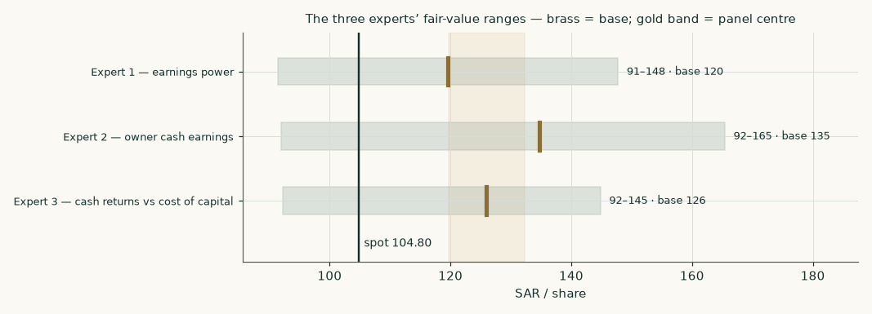
Figure 7. The three experts’ fair-value ranges; brass ticks are base cases, the gold band is the panel centre.
C.4 Cross-examination
- On the multiple: Expert 1’s multiple is challenged as too high for a single-country name — conceded in the bear case (10x), rejected as the base given the return profile.
- On reinvestment: Expert 2’s reinvestment is challenged as too light — rejected: capex has run at under 2% of revenue with the plant largely built, and the model still charges working-capital investment.
- On durability: Expert 3’s durability of returns is challenged — conceded that the low-30s% return on capital will fade, which is why the terminal return on capital is struck near 25% and terminal growth at 4%.
C.5 The three in one room
The three methods land at SAR 120, SAR 135 and SAR 126, a median of SAR 126 — close to the discounted-cash-flow lens and above the market. They agree the business is high-return and under-levered; they differ on how much of that return the future keeps.
C.6 Reading the divergence
The gap between the experts is almost entirely the terminal assumption: how durable the return advantage and the growth are. Expert 2, which capitalises owner cash into perpetuity, is the most sensitive to it and sits highest; Expert 1, on a fixed exit multiple, is the most anchored and sits lowest. The same single lever — the sustained margin and the terminal cost of capital — moves all three, which is why it is the study’s crux.

About this series
Testahil publishes independent, educational valuation studies. Each is built from a company’s own audited disclosures, values the business through several lenses, and states its assumptions and its uncertainty openly. A companion workbook carries the full model as live formulas; a companion bibliography lists every source. The studies are analysis, not advice.
Disclosure & disclaimer
This document is an independent educational analysis and is not investment advice, an offer, a solicitation, or a recommendation to buy or sell any security. It is not a price target. All values are model outputs shown as ranges and depend on assumptions that may prove wrong. The author holds no position in Riyadh Cables Group Company and received no compensation from it. Figures derive from the company’s own audited and reviewed financial statements and from published market and sovereign-risk data; while care has been taken, no warranty is given as to accuracy or completeness. Readers must reach their own conclusions and, where appropriate, take professional advice. Past performance and modelled scenarios are not guarantees of future results. Currency is Saudi riyals unless stated. Prices as at 2026-08-18.

