Testahil · Independent Valuation Study — Educational Analysis Not investment advice

Independent Valuation Study — Educational Analysis
Emirates Integrated Telecommunications Company PJSC (DFM: DU)
du · United Arab Emirates · Integrated telecom operator (mobile · fixed · wholesale · ICT and data centres) Edition of 8 September 2026 · anchored on the 7 September 2026 close · Spot AED 11.38 · Market capitalisation AED 51,584mn
READ FIRST. This study is an educational analysis, not investment advice, a recommendation or a solicitation. It never issues a rating or a price target: it publishes fair-value RANGES and probability DISTRIBUTIONS, and it separates what the business may be worth (sections 1, 4, 5) from where the price could plausibly trade (sections 2, 3, 6) — two different questions that are never blended. All figures are in United Arab Emirates dirhams (AED); the company reports, lists and pays dividends in AED, so no currency translation enters the model anywhere. Historical financials come exclusively from the company's own audited and reviewed consolidated financial statements, read from its investor-relations portal; every input is listed with source and date in the companion bibliography document.
Headline
The business. du is the second operator in the UAE's two-player telecom market: 9,280 thousand mobile customers, 744 thousand fixed subscriptions, four disclosed segments (Mobile, Fixed, Wholesale, ICT), FY2025 revenue AED 15,905mn and an EBITDA margin of 46.1% — with ZERO drawn debt in every year studied and a dividend paid out of essentially all of profit.
The valuation. Central AED 15.54 per share against a spot of AED 11.38 (+37%), inside a bear-to-bull range of AED 9.60 to 25.22. That central IS the cash-flow lens, not an average of several: the other lenses are published beside it as cross-checks at their own values, and the market-anchored relative lens reads AED 8.93. That gap is the study's honest tension, and section 4 explains rather than dissolves it.
The contested judgement. What required return does this business deserve? On du's own measured beta the cash-flow lens reads AED 15.54 — but the terminal that implies values du at 8.1x forward EBITDA in perpetuity, against the 7.0x the market pays for it today. Refuse that re-rating and hold today's multiple instead and the same cash flows are worth AED 13.78. Both are published side by side — the judgement is worth AED 1.77 per share and is never averaged into one number.
What is NOT contested. The fiscal regime. The 38% royalty plus 9% corporate tax was legislated only to 2026, but du disclosed the extension itself on 24 July 2026, covering 2027 to 2029 on the same structure with the AED 1.8bn combined floor expressly retained. A reversion after 2029 is priced as a named tail (AED 13.20), not as a live coin-flip.
The moment. This study is struck weeks after a regional war collapsed Gulf tourism and took 412 thousand mobile customers off du's base in a single quarter, and days after the company cut its own revenue guidance to 4-6% while raising the interim dividend. The company's operating licence was disclosed as running only to 8 August 2026, one day after this study's price anchor; it has since been renewed for twenty years, on terms the regulator has not published.

Valuation summary — every read at a glance
Lens | Bear | Base | Bull | Role | vs price
Discounted cash flow (the answer) | 9.60 | 15.54 | 25.22 | THE ANSWER | +37%
Relative multiples | 8.26 | 8.93 | 13.09 | cross-check | -22%
Normalised earnings power | 8.27 | 8.94 | 13.11 | not published for this class | -21%
Book value & sustainable return | 9.54 | 11.94 | 12.94 | a floor, never weighted | +5%
THE CENTRAL — the cash-flow lens, not an average | 9.60 | 15.54 | 25.22 | the class primary | +37%
NOT AVERAGED — the retired 45/25/20/10 blend, published unused |  | 12.21 |  | retired | +7%
Contested judgement, other way — no terminal re-rating |  | 13.78 |  | both ways, never averaged | +21%
Expert panel median (Appendix C) |  | 15.32 |  | cross-read | +35%
DCF terminal value share of enterprise value: 80%
Market price (2026-09-07) |  | 11.38

Table 1 — the valuation summary. The central is the cash-flow lens itself, AED 15.54, and its bear and bull columns are that same lens under its own two paths on one clock — NOT an envelope of four methods and NOT a weighted average of them. The other lenses are cross-checks, published at their own values so a reader sees the disagreement rather than a number in which it has been dissolved; the DISCLOSED FLOOR is book value per share, AED 2.24, and the book-and-sustainable-return lens above it is a cross-check that is never weighted, and normalised earnings power is not among this class's permitted cross-checks and is shown only so its removal is visible. The retired blend of AED 12.21 is printed for the same reason and feeds nothing. Every lens value is dated at the 2026-09-07 anchor, net of the AED 0.66 of dividends whose ex-dates fall between the 31-Dec-2025 valuation date and that anchor (the 0.40 final, paid 28-Apr-2026, and the 0.26 interim, ex 31-Jul-2026). The terminal value is 80% of the DCF enterprise value, and the terminal it implies is priced explicitly in section 1.7 rather than left as a caveat.
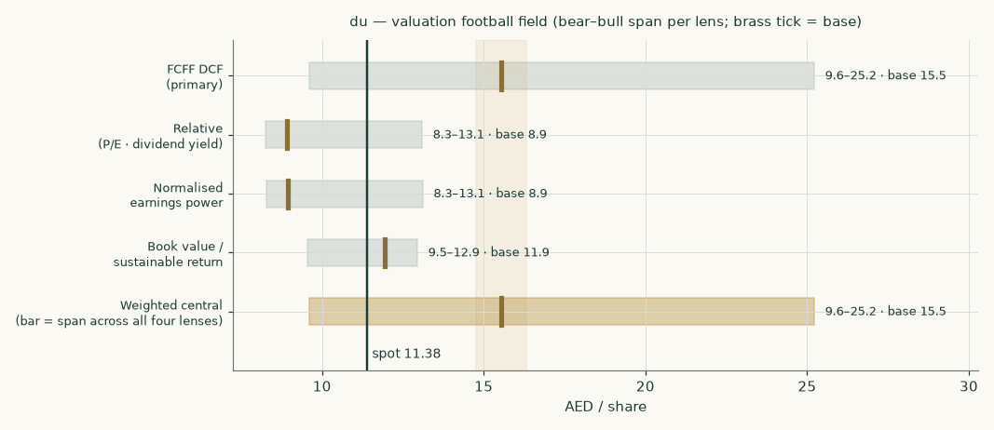
Figure 1 — the valuation football field: bear-to-bull span per lens, brass tick = base, dark line = spot.
Company overview — du at a glance
Emirates Integrated Telecommunications Company PJSC — branded du — launched service in 2007 as the UAE's second licensed operator and has settled into a stable duopoly with e& (formerly Etisalat). It is majority state-anchored: the Emirates Investment Authority is the controlling shareholder, and 2025's main capital-markets event was a secondary offering in which Mubadala's Mamoura vehicle sold three quarters of its stake (7.55% of the company), widening the free float without changing control.
The revenue mix that decides the company's class: FY2025 mobile services AED 7,075mn (44% of revenue), fixed services AED 4,380mn (28%), wholesale AED 2,568mn (16%) and ICT and associated telecom services AED 1,883mn (12%). The balance-sheet shape: network assets (property, plant and equipment AED 10,289mn plus right-of-use assets and intangibles) financed by equity of AED 10,148mn, structurally NEGATIVE working capital (-6.7% of revenue — customers and suppliers fund the operation), no borrowings, and cash plus term deposits of AED 2,250mn against lease liabilities of AED 1,939mn. That is an integrated telecom OPERATING COMPANY, with no captive lender, no development book and no holding-company discount to model: the lens set is the operating-company one — a full FCFF discounted cash flow as the primary lens, cross-read by relative multiples, normalised earnings power and a book/sustainable-return lens.
Two structural facts organise everything else. First, the state takes roughly 44% of pre-royalty profit (38% federal royalty plus 9% corporate tax since 2024; the pre-2024 construction took over half) — so every operating improvement reaches shareholders at barely more than half strength, and the fiscal regime is worth more than any operating driver. Second, the balance sheet is unleveraged with a near-total payout: du is run as a cash-distribution machine on a licence, which is why the licence renewal and the royalty renewal are the two catalysts that matter most (section 5).
The quarter this study is struck in: a regional war that began in February 2026 collapsed Gulf tourism and cut du's prepaid base by 412 thousand in Q2-2026, while postpaid kept growing and H1-2026 net profit still rose +12.6% on an EBITDA margin of 49.2% — the resilience and the vulnerability in one print. A ceasefire is in place; the recovery path is the forecast's biggest operating assumption and is sensitised explicitly.
1 Fundamental valuation
One lens carries the answer and the rest are cross-checks. For an integrated telecom operator the primary is the discounted cash flow: the company is a licence and a network generating a distributable cash stream, so the value is the present value of that stream and nothing else measures it directly. Relative multiples are published beside it as a cross-check; the DISCLOSED FLOOR is book value per share at AED 2.24, and the book-and-sustainable-return lens is a cross-check above it that is never weighted; normalised earnings power is shown but is NOT among this class's permitted cross-checks — it is computed here only so that its removal from the answer is visible rather than silent. The four are never averaged: an earlier edition of this study published a 45/25/20/10 weighted blend, and what those weights concealed was the SIZE of this study's disagreement with the market rather than its direction — the blend read +7% against the price where the cash-flow lens reads +37%, so a reader saw about a quarter of the disagreement actually held.
1.1 The cash-flow model — the primary lens, with the full waterfall
The model builds five explicit years from the four disclosed segments (section 1.6), charges the combined royalty-and-tax take on operating profit, funds the network and the lease book, releases (negative) working capital as revenue grows, and discounts each year's free cash flow at its own forward cost of capital. The full waterfall — every line of it a live formula in the companion workbook:
AED mn | FY26E | FY27E | FY28E | FY29E | FY30E
Revenue | 16,593 | 17,240 | 18,011 | 18,734 | 19,424
EBITDA | 7,937 | 8,239 | 8,624 | 8,977 | 9,309
depreciation & amortisation | -2,235 | -2,352 | -2,448 | -2,530 | -2,582
EBIT | 5,702 | 5,887 | 6,176 | 6,446 | 6,727
NOPAT — EBIT × (1 − 43.6%) | 3,218 | 3,322 | 3,485 | 3,638 | 3,796
depreciation & amortisation added back | 2,235 | 2,352 | 2,448 | 2,530 | 2,582
capital expenditure | -2,572 | -2,586 | -2,612 | -2,529 | -2,525
lease replacement | 0 | 0 | 0 | 0 | 0
change in working capital — a release adds, a build subtracts | 46 | 43 | 52 | 48 | 46
Free cash flow to the firm | 2,927 | 3,131 | 3,373 | 3,687 | 3,900
discount factor (glide) | 0.94 | 0.88 | 0.82 | 0.77 | 0.73
PV of FCFF | 2,743 | 2,752 | 2,782 | 2,855 | 2,836

Table 2 — the FCFF waterfall. EBITDA margin holds near 47.8% (an OUTPUT of the segment build, not an input); capital intensity glides from 15.5% of revenue at the data-centre peak to 13.0%; no lease replacement is charged inside the window because the lease liability is deducted in FULL as debt in the bridge and charging renewal here as well would bill the same obligation twice — the memo row prints zero and the terminal is where the renewal is paid for, which is where a perpetual obligation belongs; working-capital change is a cash RELEASE in every year because the working capital is negative and revenue grows.
Terminal growth is stated as a REAL rate and the headline rate is derived from it: real growth of 0.0% on the 2.0% long-run inflation this economy is expected to run gives a nominal 2.0%. The previous edition typed the nominal figure and argued it as population growth plus inflation minus price erosion — which names two real forces pointing opposite ways and puts a number on neither, so the real growth it implied was the residue of typing the nominal rather than anybody's estimate. Zero is what this study now assumes, and the sensitivity below prices the alternative rather than burying it.
What the terminal charges for is capital MAINTENANCE, at what replacement costs. Terminal operating profit after tax is AED 3,796mn; AED 2,582mn of depreciation and amortisation is added back — THE FULL charge, property, intangibles and right-of-use alike — because that profit is already struck after it, and AED 3,047mn charged against it — the same charge escalated over half the 16.70-year life of the depreciable owned base. That life is not picked: the depreciation notes give RANGES per class and no weighting, so it is derived from those notes' own two columns, the gross cost of the base over the year's own charge, and cross-checks at 15.96 years on the prior year. The working-capital line is a CREDIT of AED 26mn rather than a charge, because this company collects from its subscribers before it pays its suppliers and inflation makes that float worth more each year. That leaves AED 3,358mn, 88.5% of terminal profit.
One line in that block is easy to miss and matters: the LEASE renewal. The five forecast years add back the right-of-use depreciation and charge no lease replacement, because the lease liability is deducted in full as debt in the bridge and charging renewal there too would bill the same obligation twice. That argument does not survive into perpetuity — a one-off deduction of today's liability cannot cover renewals for ever — and the retired construction supplied the renewal only as a side effect of charging growth against the whole capital base — on a 1/g cycle of fifty years, against a lease term the company discloses at 10.1 years. So the terminal puts the renewal back EXPLICITLY: it adds back the FULL depreciation charge, right-of-use included, and escalates all of it into the replacement charge, and the right-of-use book enters the blended asset life at its own derived 10.24 years rather than at the network's. A lease is an asset with a life like any other here, and it re-prices when it renews. AN EARLIER EDITION OF THIS STUDY SAID THE REVERSE IN THIS PARAGRAPH AND IN THE CAPTION ABOVE — that the terminal 'neither adds back nor charges' the right-of-use depreciation, and that lease replacement was charged inside the window. Both were the wrong way round, both were caught by an outside audit, and the arithmetic never changed: what was wrong was the account of it.
That yields a terminal value of AED 76,879mn, whose present value is AED 55,920mn — 80% of enterprise value, against AED 80,545mn on the retired construction. A reader should sit with that share: at a 6.45% discount rate almost all of the value of a stable, licence-protected annuity IS the far future, and that is exactly why the two renewal catalysts in section 5 dominate everything else in this report. A marker beside it: a business holding its profit flat for ever, charging only the depreciation its books already record, would be worth AED 58,809mn.
The bridge from enterprise value to the equity — and to the anchor date
Step | AED mn | AED / share
Present value of the five forecast years | 13,969 | 3.08
Present value of the terminal value | 55,920 | 12.34
Enterprise value | 69,889 | 15.42
Terminal value share of enterprise value: 80%
less lease liabilities (the only debt-like item) | -1,939 | -0.43
plus cash and term deposits | 2,250 | 0.50
plus equity-accounted investees | 0.51 | 0.00
Equity value at 31-Dec-2025 | 70,201 | 15.49
× anchor accretion (1+Ke)^(250/365) = 1.0463, less the AED 0.66 of dividends gone ex in between
Fair value per share at the 2026-09-07 anchor |  | 15.54

Table 3 — enterprise value to equity. There are no minority interests (every subsidiary is wholly owned) and no borrowings to net: the bridge is leases out, cash in. The AED 0.66 deducted is TWO dividends, not one: the AED 0.40 final FY2025 (ex 12-Mar-2026, paid 28-Apr-2026) and the AED 0.26 H1-2026 interim (ex 31-Jul-2026, paid 21-Aug-2026). The test is the EX-date, not the payment date, because the anchor price is already ex both.
Scenario span on this lens: bear AED 9.60 (ARPU −5%, a quarter-million fewer subscribers, direct cost per unit +3%, the opex stack +50bp of revenue, capex +8%, +100bp on the discount rate, and terminal REAL growth of -0.5% — a perpetual real decline, written down as one, which on the 2.0% inflation path is a nominal 1.5%), bull AED 25.22 (the war recovery runs hot, the data-centre leg compounds, and terminal real growth of 1.0%, a nominal 3.0%). AN EARLIER EDITION'S BEAR CARRIED NO GROWTH LEG AT ALL: it was described as taking terminal growth of 2.0%, which is the BASE rate, so the single largest lever in the study moved for the bull and not for the bear and the bear was less bearish than its own description. Both scenario rates are now stated as REAL and derived to nominal on the house inflation path, like the base. The base case is deliberately NOT the midpoint of those two: it is built driver by driver in section 1.6.
1.2 Book value and sustainable return — the asset lens
Book value per share is AED 2.24 (audited FY2025 equity of AED 10,148mn over 4,533mn shares). du earned a return on average equity of 29.0% in FY2025 — a licensed duopoly running negative working capital needs very little equity, so the return on it is high by construction. The lens asks what a sustainable 27% return is worth against a perpetual cost of equity of 6.65%: justified price-to-book = (27% − 2.0%) / (6.65% − 2.0%) = 5.38×, i.e. AED 11.94 per share at the anchor. The multiple looks extreme against industrial norms; it is what the arithmetic of a small equity base and a low required return produces, and the honest caveat is that it is the lens MOST exposed to the regression beta discussed in section 1.8 — which is one reason it carries no weight in the answer at all. AND IT IS NOT THE FLOOR, WHICH EARLIER EDITIONS OF THIS STUDY CALLED IT. A justified price-to-book of 5.38× on a sustainable-return construction is a VALUATION; the disclosed floor is book value itself, AED 2.24 per share. The difference is not pedantic: at AED 11.94 this lens sits ABOVE two of the other three and ABOVE the traded price, and a number above the market is not a floor under anything.
1.3 Relative multiples
du trades at 17.8× its FY2025 earnings and 7.0× FY2025 EBITDA — and on the more current basis, including the reviewed first half of 2026, at 16.7× and 6.6×. Both framings are given because the trailing-year basis is seven months stale at the anchor and makes the share look dearer than the newer figures do.
The peer frame is where the previous edition of this study was wrong, and the correction matters enough to state in full. That edition applied a "peer median" of 15.5×. It was not a median of its own stated peer set, and it was not a current figure: it was a January-2026 aggregator reading built on FY2024 earnings. Re-derived from the peers' own filings at this study's anchor, the multiple is 12.9×.
Peer | Price (6-Aug-2026) | Trailing EPS | P/E | Yield | Basis
Mobily | SAR 61.30 | 4.76 | 12.9× | 4.9% | its own exchange filings
e& | AED 20.98 | 1.33 | 15.7× | 4.5% | its own filings, reported
stc | SAR 43.38 | 2.94 | 14.8× | 5.1% | aggregator
Ooredoo | QAR 13.04 | 1.18 | 11.2× | 5.7% | aggregator, off-anchor
Omantel | not sourced | 0.123 | 12.0× | 6.7% | aggregator, self-contradictory
Zain | KWD 0.611 | not sourced | refused | 6.7% | provider returned 11,365×
du (this company) | AED 11.38 | 0.68 | 16.7× | 5.6% | its own audited figures

Table 4 — the peer frame, re-derived. Only two of the six peers survive as clean observations: Mobily, whose 12.9× reconciles two independent ways from its own filings, and e& at 15.7×. Of the rest, one provider returned a corrupt 11,365× for Zain (refused rather than passed through), Omantel's quoted multiple and yield are mutually inconsistent, and Omantel in any case holds about 22% of Zain, so the two are not independent observations. NO PEER MEDIAN IS THEREFORE CLAIMED. The justified multiple is Mobily's own, defended as the closest structural analogue — a number-two operator in a Gulf duopoly-like market that closed the gap on its incumbent. Note what the corrected table shows about du itself: at 16.7× it trades ABOVE every peer in the set.
Applied to FY2026E earnings per share of AED 0.71 and rolled to the anchor: AED 8.93 per share [bear 12× → AED 8.26; bull 18.5× → AED 13.09]. A second, independent market cross-check from the dividend: du's FY2026E dividend of AED 0.70 at Mobily's own trailing yield (4.9%) is worth AED 14.24 — well ABOVE the earnings-multiple read, because du pays out far more of its earnings than the peer does. Peer EV/EBITDA could not be built from filings within this study's scope (net-debt detail per peer was not retrieved), so the lens runs on earnings and yield only; that limitation is stated rather than papered over.
1.4 Normalised earnings power — mid-cycle margin at current scale
The lens strips the cycle: the mid-cycle EBITDA margin (the middle forecast year, FY2028E, 47.9%) applied to CURRENT-scale revenue (FY2026E, AED 16,593mn), less FY2026E depreciation, plus FY2026E net finance income, taxed at the combined 43.6%: normalised earnings of AED 3,225mn, or AED 0.71 per share. At the justified 12.9× and rolled to the anchor: AED 8.94 [12× → 8.27; 18.5× → 13.11]. It reads within a few fils of the relative lens, and that is worth being blunt about rather than presenting as corroboration: du's current year IS close to mid-cycle — the war knocked the top line, not the margin, and the half-year to 30 June 2026 printed an EBITDA margin of 49.2%, the highest of any period from FY2022 to the reviewed half-year ended 30 June 2026, with the four full years in that window rising in every one of them (40.3% then 42.5% then 44.2% then 46.1%) — so normalising changes the earnings base by less than a fil. The two market-anchored lenses are therefore ONE reading of one multiple against one earnings number, not two independent reads — which is one reason neither is the answer here, and why an earlier edition that gave the pair 45% of a weighted central between them was counting one reading twice. The synthesis in 1.5 and the comparison in section 4 should be read on that basis.
1.5 Synthesis — one lens is the answer, the rest are cross-checks
The central is AED 15.54 (+37% to spot) and it is the cash-flow lens itself. Its range, AED 9.60 to AED 25.22, is that same lens under its own bear and bull paths on one clock — the present-value reads of one method, not the spread between four different ones. The cross-checks are published at their own values and disagree: the two market-anchored lenses read roughly at the market, the book floor at AED 11.94. Section 4 takes that disagreement seriously — it is a statement about the discount rate, not about the forecast — and the disagreement is shown rather than averaged away, because a number produced by averaging several methods is not more robust than the best of them: it is a new method with weights nobody tested, and it imports every weakness of the weakest lens at whatever weight somebody typed. Here the arithmetic of that is exact and is why the blend was retired: the retired 45/25/20/10 central of AED 12.21 read +7% against the price where the answer reads +37%.
1.6 The drivers — each disclosed segment grown on its own driver
The four disclosed segments, historically
Segment | FY2023* | FY2024 | FY2025 | FY2025 contribution | margin
Mobile | 7,004 | 6,548 | 7,075 | 4,304 | 60.8%
Fixed | 3,780 | 4,003 | 4,380 | 3,758 | 85.8%
Wholesale | 1,768 | 2,373 | 2,568 | 2,219 | 86.4%
ICT & associated | 1,084 | 1,712 | 1,883 | 365 | 19.4%
Total | 13,636 | 14,636 | 15,905 | 10,646

Table 5 — segment revenue (AED mn) and FY2025 contribution (revenue less direct costs, the company's own Note 38 measure). *FY2023 is on the pre-2024 segment basis (the wholesale/other boundary moved in the re-segmentation) and is shown for continuity, not comparability; the forecast is built off the consistent FY2024-25 basis. Segment revenue ties exactly to consolidated revenue in every year.
How the forecast is driven
Mobile and Fixed are built as volume × price — the finest level the company disclosed. Mobile: the quarterly customer base (8,916k at 31-Dec-2024 → 9,704k at 31-Dec-2025 → 9,280k at 30-Jun-2026, after the war quarter) times blended ARPU (AED 63.3/month in FY2025, 63.4 in Q2-2026). The frame reproduces the audited FY2025 mobile segment to within 0.1%: average base 9,310k × AED 63.3 × 12 = AED 7,072mn against a disclosed AED 7,075mn. The forecast path: recovery to 9,450k by end-2026 (the company itself reports gross adds still below pre-war levels), then to 10,450k by end-2030 — growth of roughly a quarter-million customers a year, well below the boom year 2025 added, with ARPU held roughly flat (AED 63.4 → 64.2).
Why the flat ARPU path is this study's most fragile revenue judgement
The company prints one blended mobile ARPU, and it has barely moved: AED 63.3 in FY2025 and 63.4 in the second quarter of 2026. Read on its own, that looks like pricing stability. It is not. du also discloses the customer base split between prepaid and postpaid every quarter, and that mix moved sharply: the postpaid share went from 20.3% to 22.1% in two quarters — not because postpaid surged, but because prepaid COLLAPSED, losing 499 thousand customers against 74 thousand postpaid gained. Those were largely low-value visitor SIMs, the cheapest customers on the book.
A postpaid customer is worth a multiple of a prepaid one. So a mix shift of that size is a mechanical tailwind to the blended figure. At the ratio observed at the one Gulf operator that discloses both legs, the mix shift alone would have lifted blended ARPU about +2.6%. The company reported +0.2%. The arithmetic only closes if each leg's OWN price fell about -2.4% over the same span. In other words the flat headline is not stability — it is two forces of similar size pulling in opposite directions, and the disclosure is not granular enough to separate them.
This matters because of what the forecast assumes elsewhere. The subscriber path in this study has prepaid RECOVERING as tourism normalises. A recovering prepaid base pushes the postpaid share back down, which removes the tailwind — and if the underlying per-leg erosion continues, the blended figure falls rather than holding flat. Holding the path flat is therefore a joint assumption that BOTH forces persist and keep cancelling. Section 1.9 prices the alternative directly: if the blended path instead erodes at the rate the decomposition implies, the cash-flow lens reads AED 12.83 rather than AED 15.54, -17%. It is the largest single downside in the study that does not come from the discount rate.
THE DECOMPOSITION HAS TWO DEFENSIBLE PERIOD PAIRS AND THIS STUDY NOW PUBLISHES BOTH, because an earlier edition published only the gentler one and an outside audit was right that the priced downside was calibrated on it. The pair above spans a full year — FY2025 average to the second quarter of 2026 on BOTH legs — and implies per-leg erosion of -2.39% a year. The other pair is the most recent observation: from the quarterly PEAK of AED 65.3 in the fourth quarter of 2025 to AED 63.4 in the second quarter of 2026, blended ARPU fell -2.91% while the mix shift alone should have LIFTED it +2.46% — implying per-leg erosion of -5.24% across those two quarters, more than twice the annual pair's rate. Carried as an annual rate that reads AED 9.83; compounded for five years (-10.21% a year) it reads AED 2.01. THE STUDY CARRIES NEITHER OF THE HARSHER TWO AND SAYS WHY: two quarters of a mix disrupted by a war is not a five-year trend, and compounding it is an extrapolation rather than a measurement. It is priced here anyway, because a scenario refused without a number beside it is an assertion.
A reader will reasonably ask why the two legs are not simply modelled separately. Because they cannot be identified. du publishes no prepaid or postpaid ARPU anywhere — not in the earnings releases, not in the presentations, not in the audited segment note, which splits Mobile from Fixed and never splits mobile itself. That is the regional norm rather than a du quirk: e&, stc and Mobily all publish the subscriber split with a single blended price, and Ooredoo is the sole Gulf exception. The mix did move, which in principle pins down the ratio between the legs if both prices were stable — so this study solved for that ratio on all 21 available quarter pairs. The answers range from -45× to 17×. 9 of the 21 imply a NEGATIVE ratio and 2 imply a postpaid customer worth LESS than a prepaid one; both are impossible. An estimate that swings that far depending on which two quarters are chosen is not measuring anything. So the split is NOT built. Building it would replace one disclosed number with two undisclosed ones joined by an imported assumption, and — because the arithmetic is mix-preserving — would reproduce exactly the same revenue while looking more precise. The gap is flagged instead, and the risk it creates is priced.
Fixed: subscribers 682k at 31-Dec-2024 → 735k at 31-Dec-2025 → 744k at 30-Jun-2026, forecast to 858k on continued fibre and fixed-wireless share gain, times an implied revenue per subscription (a consumer-plus-enterprise blend, so a revenue-intensity metric rather than a tariff) rising gently with the enterprise mix. That intensity metric is itself an implied figure — segment revenue over the average base — so it is a weaker construction than the mobile one and is labelled as such rather than presented as a price. Wholesale and ICT disclose no unit measures anywhere in the filings — that gap is flagged, and both are grown at segment level: wholesale on a war-recovery path (roaming and transit were hit; -0.8% in 2026 then ~+2%), ICT on the data-centre ramp (+11.0% at peak), which is anchored on the company's own disclosed programme: five data centres, a hyperscale campus with Microsoft as anchor tenant, and capital commitments UP a quarter-billion dirhams in six months.
How the cost side is built — cost per unit, and why no margin is an input
The company discloses its direct costs twice over, and never joins them up. On the face of the income statement they are split by NATURE into three lines — interconnect, commission, and devices and other direct services. In the segment note they are split by SEGMENT, one "interconnect and other direct costs" line each for Mobile, Fixed, Wholesale and ICT. Both views are published every period; the cross-tabulation between them never is.
That cross-tabulation is recoverable, and recovering it is what lets the cost side be built per unit rather than as a margin. Two structural facts do the work: Fixed and Wholesale carry no consumer acquisition channel and no handset sales, so their direct cost is interconnect and capacity; and commission is dealer and retail commission on the consumer mobile base, so it is a mobile cost. Given those, mobile interconnect falls out of total interconnect as a residual, and the mobile device line falls out of mobile's own segment total. The test that this is not a convenient fiction is that the residual device cost must come out POSITIVE and small in every period, and ICT's own direct cost plus that residual must foot exactly to the disclosed devices line. Both hold in all four disclosed periods, and the model asserts them rather than trusting them.
What emerges is a genuine per-unit cost stack for the mobile business, with each line moving for its own reason:
AED per mobile subscriber per month | FY2024A | FY2025A | H1-2025A | H1-2026A
Interconnect | 18.24 | 17.40 | 17.54 | 16.81
Commission | 5.69 | 6.14 | 6.12 | 6.31
Devices and other direct services | 0.52 | 1.26 | 1.40 | 0.96
Total mobile direct cost per subscriber | 24.45 | 24.81 | 25.06 | 24.08
Fixed capacity cost per subscription | 79.71 | 73.14 | 75.29 | 68.35
Wholesale direct cost / own revenue | 12.0% | 13.6% | 13.9% | 15.6%
ICT direct cost / own revenue | 79.2% | 80.6% | 80.8% | 78.5%

Table 6 — the direct-cost stack per unit, recovered from the company's own two disclosures. The two half-year columns are the important ones: they are like-for-like, so they measure DIRECTION rather than mixing seasonality into a year-on-year change.
The like-for-like half-years give each line a measured direction, and only two of them get to move in the forecast. Interconnect per subscriber fell -4.1%, and there is a named mechanism for it: regulated mobile-termination rates ratchet down, and terminated voice and SMS keep migrating to messaging apps, so the off-net bill per customer falls even as the base grows. The forecast takes -1.5% a year — barely a third of the observed fall, on the view that it decays as the substitution matures. Commission per subscriber rose +3.0%, which is the cost of winning and keeping a customer in a two-player market rising; the observed rate of +3.0% is carried forward unchanged. Everything else is anchored on the H1-2026 reviewed actual and held FLAT — including the fixed capacity cost, which fell -9.2% like-for-like. Stopping that improvement dead rather than projecting it is deliberate: the mechanism is real but decays at a rate the disclosure cannot size.
Two of those choices deserve to be challenged, so here is the evidence for them. Holding the H1-2026 rate through the second half of 2026 could flatter the year if second halves are structurally cheaper. They are: measured on 2025, the second-half rates came in at AED 25.01 per mobile subscriber against 25.06 in the first half, AED 71.33 against 75.29 on fixed, and 13.2% against 13.9% on wholesale. Three of the four were CHEAPER in the second half, so carrying a first-half rate forward overstates cost rather than understating it. And the wholesale rate has worsened at every single observation — 12.0%, 13.6%, 13.9%, 15.6% — which the company attributes to the conflict-hit roaming and transit mix. The forecast takes no credit for the recovery that attribution implies, and equally does not project further decay.
Wholesale and ICT cannot be built per unit at all, because no volume measure for either is disclosed anywhere in the filings. Both therefore carry a cost RATE on their own revenue, anchored on the reviewed half-year. That is the weakest part of the cost build and is labelled as such: it is the finest level the disclosure supports, not the level the method would prefer. The ICT rate in particular is held flat rather than improving, which reverses a judgement in the previous edition of this study — that edition projected a 2.1 percentage point margin gain on a data-centre-scale argument, and the disclosed series does not support a trend in either direction (79.2% worsened to 80.6% before improving to 78.5%). A story that cannot be measured has been removed from the model.
The consequence is the point of the whole exercise: NO margin in this study is an input. Contribution margin by segment, group gross margin and group EBITDA margin are all computed from volumes times unit costs, and they can therefore disagree with each other in informative ways. They do. Group gross margin declines across the forecast, 67.9% to 67.2%, while NOT ONE segment margin declines. That is entirely mix: ICT is the fastest-growing segment and by a wide margin the thinnest, so it dilutes the group as it succeeds. A single blended margin assumption — which is what the previous edition of this study used — cannot produce that result, and a reader looking at it would have no way to tell dilution-by-growth apart from erosion. That distinction is the argument for building the cost side this way.
What the build produces — margins as outputs
 | FY2025A | FY26E | FY27E | FY28E | FY29E | FY30E
Revenue (AED mn) | 15,905 | 16,593 | 17,240 | 18,011 | 18,734 | 19,424
growth |  | +4.3% | +3.9% | +4.5% | +4.0% | +3.7%
EBITDA (AED mn) | 7,338 | 7,937 | 8,239 | 8,624 | 8,977 | 9,309
EBITDA margin — an OUTPUT | 46.1% | 47.8% | 47.8% | 47.9% | 47.9% | 47.9%

Table 7 — the build's output. FY2026E growth of +4.3% lands inside the company's own revised 4-6% guidance. EVERY MARGIN IN THIS TABLE IS AN OUTPUT. Nothing about profitability is assumed: each cost line is grown on its own physical driver and the margin is whatever is left. On the direct-cost side that means mobile carries three separate per-subscriber costs — interconnect, which falls as termination rates ratchet down and terminated traffic migrates to messaging apps; commission, which rises with the cost of winning and keeping a customer; and a small, lumpy device line held flat — while fixed carries a per-subscriber capacity cost and wholesale and ICT carry a cost rate on their own revenue, because the company discloses no volume unit for either. On the operating-cost side, wages escalate on UAE wage inflation, network on network scale, the licence fee and credit losses on revenue, administration on CPI — never one blended index across physically different costs. Two things a reader should be able to see. First, the group gross margin 67.9% -> 67.2% DECLINES even though not one segment margin declines: that is mix, not erosion — ICT is the fastest-growing segment and by far the thinnest, so it dilutes the group as it grows. A single blended margin assumption cannot show that, which is the argument for building this way. Second, total operating expenses before depreciation RISE 0.7% in FY2026E against the audited 2025 figure. In an earlier edition of this study they fell, because the staff line was built on a mis-stated seasonal ratio — which made margin expansion an artefact of one input rather than an output of the build.
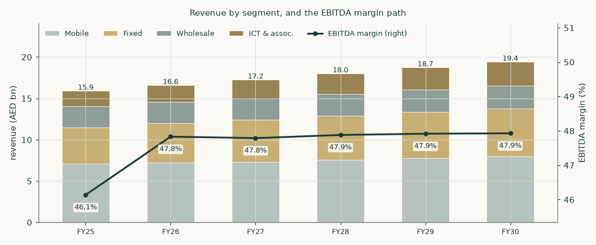
Figure 2 — revenue by segment and the EBITDA margin path. ICT is the growth leg; mobile the recovery story. The group EBITDA margin is flat-to-slightly-rising as an OUTPUT: segment margins widen modestly on the per-unit cost build while ICT — the fastest-growing and thinnest segment — dilutes the group as it grows. The two effects very nearly cancel, which is a result of the build rather than an assumption in it.
1.7 The crux — what required return does this business deserve?
Every valuation has one judgement that moves it more than all the others. Here it is not an operating driver and it is not the tax regime: it is the price of time. Both readings are computed and published; neither is averaged away.
 | Framing 1 — the measured return | Framing 2 — the market's return
How the terminal is set | capitalised at 6.45% with growth of 2.0% | du's own current trailing EV/EBITDA held into perpetuity
What that implies for the exit multiple | 8.10x forward EBITDA | 6.99x — no re-rating
Cash-flow fair value at the anchor | 15.54 | 13.78
THE CENTRAL — which IS the cash-flow lens, not a blend of it | 15.54 | 13.78
The judgement is worth | AED 1.77 per share on the cash-flow lens

Table 8 — the study's central judgement, both ways. The cash-flow lens rests on du's own measured beta of 0.557, which prices its equity at 6.83%. That is internally consistent — but the terminal it produces values du at 8.10 times forward EBITDA forever, against the 6.99 times the market pays today: a 16% re-rating embedded in a figure presented as intrinsic value. Framing 2 simply declines to assume it. This is the honest form of the observation that 80% of enterprise value sits beyond year five.
In real observable units, the two legs of the judgement price out like this. On the return leg the relation is CONVEX and a single slope misdescribes it, so the slope is quoted segment by segment rather than averaged: from beta 0.31 to 0.557 it runs AED 1.89 per 0.10; from 0.557 to 0.65, AED 1.35; and from 0.80 to 1.00, AED 0.85. An earlier edition quoted one number for all of it — the average over the FLATTEST segment — which understated what the first tenth of beta is worth by about a third. The regression's own 90% interval (0.31 to 0.65) spans AED 14.28 to 20.22, and a sector-average 0.80 gives AED 10.92. On the terminal leg: each turn of the exit multiple is worth about AED 1.59 per share. A reader who believes the market is simply wrong about du should take Framing 1; a reader who thinks a licensed single-market operator does not re-rate by a third should take Framing 2; the study refuses to choose for them.
What the price believes — the same model, read backwards
Every study states what IT believes and almost none states what the PRICE believes, and the two are the same model read backwards. Holding every other driver in this study at its published value and moving only the beta until the answer meets the market: at AED 11.38 the price is paying for an equity beta of 0.96 — a required return of 8.54% — against the 0.5569 this study measures and the 6.83% it produces. THAT IS NOT AN ABSURD NUMBER, and saying so is the point: a beta near one is an ordinary read for a single-market, single-licence operator whose licence economics were unpublished at the anchor. It sits just outside the regression's own 90% interval, whose top is 0.80, so the disagreement is real and it is narrow, and it is about the PRICE OF RISK rather than about the cash flows — every lens in this study consumes the same build. A reader who thinks a licensed duopoly should carry market risk has a coherent position, and this study does not hold it. This read is a diagnostic and it is kept OUT of the model: a rate solved from a price and then used in a valuation is a reverse-engineered discount rate arriving through a side door, which this house prohibits outright.
The same discipline applied to the study's own choices. 6 judgements in this study are worth more than 5% of the central; 4 of them are resolved toward a higher value and 2 toward a lower one, a two-sided sign test of p = 0.69. Any single contested choice is defensible; what would not be is a study resolving every one of them the same way and never noticing, which is how a lean survives an audit of its steps. The count is two-sided and the test is printed whether it flatters the study or not.
The two judgements that are NOT the crux, and why
The fiscal regime was the previous edition of this study's central judgement. It is not one any more, and the correction is worth stating plainly: du published its own disclosure of the royalty extension on 24 July 2026 — "Extension of Federal Royalty Scheme for the Period 2027-2029" — carrying the same 38% royalty and 9% corporate tax and expressly retaining the AED 1.8 billion combined annual floor. The prior edition recorded, wrongly, that only the other operator had disclosed it. A reversion to the pre-2024 construction after 2029 remains a real tail and is priced: AED 13.20 per share, against AED 15.54 on the current regime. It is a tail, not a coin-flip.
The licence is the second. The regulator extended du's operating licence only to 8 August 2026 — one day after this study's anchor — and has since renewed it for twenty years from 9 August 2026. The renewal announcement sets out obligations (resilience, route diversity, quality of service, national roaming) but publishes NO fee or revenue-share terms. This study therefore holds the licence fee at its historical 2.7% of revenue and flags that as an assumption, not a confirmed fact: each additional percentage point of revenue taken in licence fees costs about AED 0.52 per share.
1.8 Macro and country — rates, the peg, and the sourced cost of capital
The dirham is hard-pegged to the dollar, so the UAE imports US monetary policy: the central bank's base rate tracks the Fed, and at the sweep date the market was pricing possible HIKES rather than the cuts of six months earlier. The UAE sovereign is rated Aa2, and its dirham curve prices a few basis points ABOVE the US Treasury curve at matched tenors — the July-2026 auction release puts the January-2031 dirham bond at 4 basis points over comparable Treasuries. (The previous edition of this study said "through", which was backwards, and netted a ratings-table spread ten times the market's. Both are corrected below.) Growth is strong (around 5% real in 2025) even as the regional war cut the wider region's 2026 outlook; inflation is around 2%.
Component | Value | Source basis
Risk-free rate (Jan-2031 AED T-bond, the longest liquid AED tenor) | 4.48% | UAE MoF/WAM auction release, 30-Jul-2026
less UAE sovereign default spread — MARKET-observed on this very bond | 0.04% | UAE MoF/WAM auction release: +4bp over UST
Risk-free net of the sovereign spread | 4.44% | country risk enters ONCE, via the premium; and this clears the 4.32% matched-tenor Treasury floor
Beta — DU weekly vs the FTSE ADX General Index, 5 years | 0.557 | own regression; details below
Equity risk premium (UAE total, same market basis) | 4.29% | Damodaran mature 4.23% + a 6bp country premium scaled off the same 4bp
Cost of equity | 6.83% | build, not assumption
Marginal cost of debt (AED sovereign + GCC telecom spread) | 5.10% | stc sukuk curve evidence; du has no drawn debt
Cost of debt AFTER tax — interest shields both fiscal legs | 2.88% | 5.10% x (1 − 43.57%); the royalty base is profit AFTER interest, so the shield runs at the combined rate
Weights — market equity / lease debt | 96.4% / 3.6% | market capitalisation vs the audited lease book
Cost of capital — explicit window | 6.69% | 96.4% x 6.83% + 3.6% x 2.88%
Terminal risk-free rate, net of the same 4bp spread | 4.26% | terminal AED risk-free 4.30% less the same sovereign spread
Terminal cost of equity | 6.65% | same beta 0.5569 on the terminal premium 4.29%
Terminal cost of debt, after tax | 2.77% | 4.90% x (1 − 43.57%)
Cost of capital — terminal | 6.45% | 95% x 6.65% + 5% x 2.77%

Table 9 — the cost of capital, built from sourced parts. EVERY TOTAL HERE REPRODUCES FROM THE ROWS ABOVE IT, and an earlier edition's did not: it printed the cost of equity, a pre-tax cost of debt and the two weights and then a cost of capital those four do not produce, because the after-tax step was in the workbook and not on the page, and it gave the terminal rate with neither a terminal cost of equity nor a terminal cost of debt to build it from. Both steps are now printed. The sovereign spread is stripped from the risk-free rate because the equity premium already carries the country premium: counting it twice is the classic error this construction exists to avoid. The spread stripped and the premium added back are on the SAME basis — 4 basis points out, a 6 basis-point country premium in — which is the discipline that makes the netting safe. The alternative RATINGS basis (42bp out, a 64bp country premium in, giving a 6.77% cost of equity and 6.63% cost of capital) is published alongside and not averaged in. One test governs the choice: a default-free dirham rate cannot sit BELOW the default-free dollar rate at matched tenor under a hard peg. The market basis clears that floor at 4.44% against 4.32%; the ratings basis would breach it by about 26 basis points, which is why it is the alternative and not the primary.
The beta — measured, gated, and honestly low
du's beta is measured, not assumed, and this edition measures it differently from the last. Weekly log-returns on the exchange's own realised trading week against the FTSE ADX General Index, five years to 2026-07-17, Dimson lead-lag corrected because this share does not trade every session: beta 0.5569, R² 0.14, standard error 0.149, 249 observations, 90% confidence interval 0.31 to 0.80. The regression passes the usability gate (enough observations, explanatory power, an error smaller than the estimate). AN EARLIER EDITION PUBLISHED 0.488 FROM A DIFFERENT CONSTRUCTION — sampled on calendar week numbers rather than the exchange's own week, with no correction for thin trading — and the difference is worth about AED 1.05 a share. The regressor is not a free choice here and this study does not present it as one: du lists on the Dubai Financial Market, and the FTSE ADX General is a REGISTERED INTERIM substitute for a DFM index, adopted 10 August 2026 and held open 23 August 2026 on measured evidence that it explains the Dubai-listed names better than the Abu Dhabi names it actually covers. A BETA BUILT ON AN INTERIM REGRESSOR IS NOT A CONFORMING BETA and this one is published as such. The listing venue's own index is shown beside it rather than hidden: against the DFM General the same construction measures 0.461 (R² 0.20, a tighter fit), and an equal-weight composite of the market's own names — a coverage artefact rather than a market, and never a regressor — reads 0.431. All three land in the same place: a defensive, negative-net-debt telecom measuring well below 1 on either UAE index. That number is also the single assumption doing the most work in this study, because at these weights the cost of capital is essentially the cost of equity. Betas of 0.65 (the interval's top), 0.65 and 0.80 are priced in section 1.9: the last takes the DCF from AED 15.54 to AED 10.92 — close to the spot price. The market, at 17.8× trailing earnings, is implicitly charging a HIGHER required return than any of these regressions produce; section 1.7 prices that disagreement as the study's central judgement rather than dismissing it.
Where this construction is contested, and what the alternatives are worth
Contested construction | Base | Alternative | Worth (AED/share)
Risk-free tenor, LONGER AND HIGHER: Jan-2031 AED print vs a 10-year peg-extrapolated proxy | 4.48% | 4.69% | 14.87 vs 15.54 (-0.68)
Risk-free tenor, LONGER AND LOWER: the Feb-2033 AED sukuk, the only federal tranche beyond Jan-2031 | 4.48% | 4.13% | 16.82 vs 15.54 (1.27)
Sovereign basis: market-observed 4bp (primary) vs the ratings table 42bp | spread 0.04%, ERP 4.29% | spread 0.42%, ERP 4.87% | cost of capital 6.69% vs 6.63%; the ratings basis breaches the matched-tenor Treasury floor
Beta: regression vs the sector-implied prior | 0.557 | 0.80 | 15.54 vs 10.92
Terminal: capitalised at the cost of capital vs du's own current multiple | 8.10x implied | 6.99x held | 15.54 vs 13.78 — the study's central judgement
Post-2029 fiscal tail (no longer contested for 2027-29 — du disclosed the extension) | 43.6% | 51.1% | 15.54 vs 13.20

Table 10 — every contested construction priced, not just named. Two retired errors are preserved for the audit trail: an UN-netted risk-free rate would give a 6.87% cost of equity, the sovereign-risk double-count this method exists to prevent; and netting the ratings-table spread while adding back a ratings-based country premium — the previous edition's construction — put the "risk-free" dirham rate below the matched-tenor Treasury, which a hard peg cannot support.
The risk-free rate deserves its own paragraph, because it is the input an external review of this study contested hardest and because the resolution runs against that review. There is no liquid ten-year dirham government point at all: the UAE federal curve's longest conventional Treasury bond matures in January 2031, and the ONLY federal tranche beyond it is a February-2033 Islamic Treasury Sukuk — a different instrument type, which an earlier edition of this study mislabelled as a bond. That sukuk has been sold twice. Its debut, in February 2026, cleared 3.779%. A second tap of the SAME instrument two months later cleared 4.13% — 35 basis points higher. The review argued for the debut print, which would put the cash-flow lens at AED 18.32 rather than AED 15.54, +18%. That is far too large to wave away, so it was re-derived from the issuer's own auction releases rather than argued about.
The debut print does not survive that re-derivation. It is five and a half months older than this study's anchor, the issuer's own re-offer of the identical instrument contradicted it, and the Jan-2031 bond moved 3.90% → 3.85% → 4.30% → 4.48% across the same window. Using a stale debut as the current risk-free rate would import a rate environment that had ceased to exist. The rate used therefore stays at the most recent primary print on the longest liquid tenor, 4.48% — but the honest observation is that the tenor choice is a genuine RANGE, not a point: the two defensible longer alternatives sit on either side of it, worth 1.27 and -0.68 a share, so both are published in the table above rather than one being selected. One further correction belongs here: the spread on that auction is read FROM the ministry's release, not quoted from it. The original sentence is malformed, covering two tranches at once, and an earlier edition of this study presented it as a clean quotation. It was not.
1.9 Sensitivity — the discount rate, the growth, the regime and the war
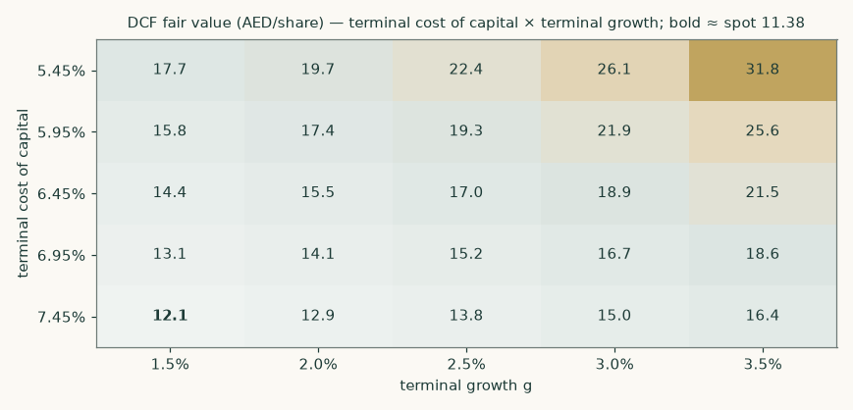
Figure 3 — DCF fair value against the terminal cost of capital and terminal growth. The centre cell reproduces the headline cash-flow lens exactly, which is the check a sensitivity grid has to pass before any other cell in it means anything. Note what the grid says as a whole: across the entire plausible range of terminal discount rate and terminal growth, every cell sits ABOVE the spot price of AED 11.38 — the lowest, at a 7.45% terminal cost of capital and 1.5% growth, still reads AED 12.1. For the market to be right on this lens, something outside this grid has to be wrong — the fiscal regime, the terminal multiple, or the cash flows themselves. Sections 1.7 and 4 take that seriously rather than treating the grid as vindication.
Driver (grid — * marks the base parameter) |  |  |  |  |  | swing
Beta (0.31 / 0.56* / 0.65 / 0.80 / 1.00) | 20.22 | 15.54 | 14.28 | 12.63 | 10.92 | 9.31
Combined fiscal take (40% / 44%* / 47% / 50% / 53%) | 16.68 | 15.54 | 14.45 | 13.50 | 12.52 | 4.16
Blended ARPU (×) (0.92 / 0.96 / 1.00* / 1.04 / 1.08) | 13.13 | 14.33 | 15.54 | 16.75 | 17.96 | 4.84
Subscribers ('000, shift) (-400 / -200 / +0* / +200 / +400) | 14.76 | 15.15 | 15.54 | 15.94 | 16.33 | 1.57
Direct cost per unit (×) (0.94 / 0.97 / 1.00* / 1.03 / 1.06) | 16.54 | 16.04 | 15.54 | 15.04 | 14.54 | 2.00
Blended ARPU drift (%/yr) (-2.5% / -1.5% / +0.0%* / +0.5% / +1.0%) | 12.70 | 13.81 | 15.54 | 16.14 | 16.74 | 4.04
Capex path (×) (0.85 / 0.93 / 1.00* / 1.10 / 1.20) | 16.45 | 16.00 | 15.54 | 14.94 | 14.33 | 2.12
Asset life, years (derived from the depreciation notes) (10.7 / 13.7 / 16.7* / 19.7 / 22.7) | 16.22 | 15.89 | 15.54 | 15.19 | 14.83 | 1.39

Table 11 — single-driver sensitivities on the DCF (AED/share). The asterisk in each row marks its own base parameter, which is NOT always the middle column: the beta and fiscal-take grids put theirs second. Each cell is a complete re-run of the model including the unit build, and every grid returns the headline exactly at its base parameter — a check this study has now failed twice and states both times. The first time the beta row sat on a retired construction and missed by AED 1.77; the second, caught by an outside audit, EVERY discount-rate grid in the study was still running the reinvestment-identity terminal this house retired on 3 September while the headline ran the sanctioned one, so each of them returned a number AED 0.66 above the headline it claimed to reproduce. The rank order is the honest hierarchy: the discount rate dwarfs every operating driver, and the fiscal take comes next; among operating drivers ARPU is king, which is why a duopoly that does not price-war deserves its premium.
Two rows deserve a note. The ARPU-drift row is not a generic price sensitivity: it is the mix-exhaustion case set out in 1.6, and it is the largest operating downside in the study — AED 12.70 at -2.5% a year against AED 15.54 in the base. The direct-cost row now scales COST PER UNIT rather than a margin, so it is a driver rather than an assumption being nudged.
One further test belongs here, because an external review asked for it: what is revenue at the company's guided midpoint worth? The build lands at +4.3% against a guided 4-6%, so the +5.0% midpoint is worth about AED 107mn of FY2026 revenue. The answer depends less on the revenue than on HOW it is won. Won on price, with no incremental unit cost or capex behind it, the cash-flow lens reads AED 16.09; won on volume, carrying both, it reads AED 16.20. On the same five-year revenue the price route is worth AED 0.17 more per share than the volume route. The build deliberately stays below the midpoint: it is driven by the disclosed subscriber and ARPU paths, and reverse-engineering a forecast to a guidance number is the opposite of building it from the ground up.
2 Technical and price structure
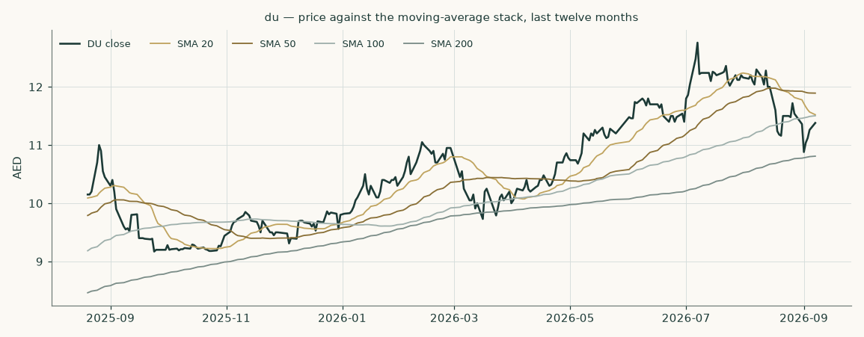
Figure 4 — price against the 20-, 50-, 100- and 200-session moving averages over the the last twelve months of trading.
Marker | Level (AED) | Reading
Last close | 11.38 | the anchor for everything in this study
20-session average | 11.52 | price is -1.2% against it
50-session average | 11.89 | price is -4.3% against it
100-session average | 11.50 | price is -1.1% against it
200-session average | 10.81 | price is +5.3% against it
52-week high (closing basis) | 12.76 | -10.8% from the high
52-week high (intraday) | 12.80 | -11.1% from the high — the conventional basis, and the wider of the two
52-week low (closing basis) | 9.17 | +24.1% from the low
52-week low (intraday) | 9.05 | +25.7% from the low — the same two bases as the high above
Annualised volatility | 29.9% | the fitted range-based volatility model's CURRENT state — elevated by the war-quarter swings — and the input to the price cone in section 3

The share sits +5.3% above its 200-session average but -10.8% below its 52-week closing high — an uptrend that has given back its top since the war quarter. Realised volatility over the last 50 sessions is 27.1%; the model's range-based estimate of 29.9% reflects the regime of the last months rather than a single session. None of this is a valuation argument; it is the price context the valuation has to be read against, and the gap between a recovering price and a fundamental central above it is what section 4 addresses.
3 A probabilistic price map
This section answers a different question from the valuation. It does not ask what the business is worth; it asks where the share price could plausibly be in one and three months, given how this share has actually moved. The engine simulates 50,000 price paths from a volatility model fitted to the daily high-low-open-close range, with a fat-tailed shock distribution and a drift anchored to the cost of carry — the dollar policy path under the dirham's peg, net of the dividend yield — carrying no directional view.
The widths below are tested rather than assumed, and the honest result is stated plainly: over the last five years of non-overlapping quarterly windows (18 of them, origins 2022-01-27 to 2026-04-29, each forecast using only data available before it), the model scored +4.36% against a random-walk benchmark anchored on the same cost of carry — statistically indistinguishable from the benchmark (the confidence interval spans zero), neither better nor worse. Outcomes were spread evenly across the distribution: a uniformity test returns p = 0.16, which at 18 windows means the test cannot reject uniformity — a statement about the test's power, not a certificate of calibration. THE COVERAGE SENTENCE IS WRITTEN FROM THE COVERAGE FIGURES rather than around them, because an earlier edition's was not and went on describing over-dispersion at every level after a re-run had moved one of the three onto its target: outcomes fell inside the 50% band 50% of the time, inside the 80% band 94%, and inside the 90% band 100% — on target where the middle band is concerned and OVER-covered in the tails. For this low-volatility share the bands run about 44% wider than the benchmark's, so the outer bands are generous and a reader should treat them as such. Over the full history the model UNDERPERFORMS the benchmark on windows that predate the 2022 change in the exchange's trading week. Those windows are excluded from the calibration for that reason, and the figures quoted above are the post-exclusion set — 18 windows with origins from 2022-01-27 to 2026-04-29, all after the change. The previous edition quoted a nineteen-window set beginning 27 October 2021 in the same breath as the exclusion, which was inconsistent.
This is a map of price dispersion, not a forecast, and it is never blended with the fair-value work above.
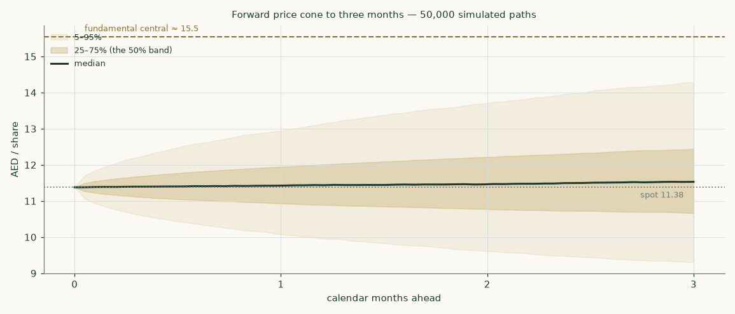
Figure 5 — the forward price cone to three months. The dashed brass line is the fundamental central estimate of 15.54; the dotted line is the spot of 11.38.
Percentile map (AED/share)
Horizon | 5th | 25th | Median | 75th | 95th | P(above spot)
One month — to 2026-10-07 | 10.03 | 10.91 | 11.43 | 11.98 | 13.06 | 53%
Three months — to 2026-12-07 | 9.28 | 10.66 | 11.54 | 12.46 | 14.32 | 55%

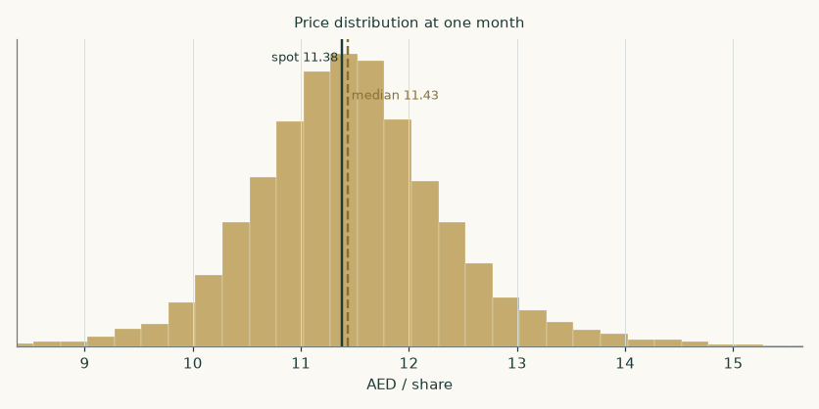
Figure 6 — price distribution at one month.
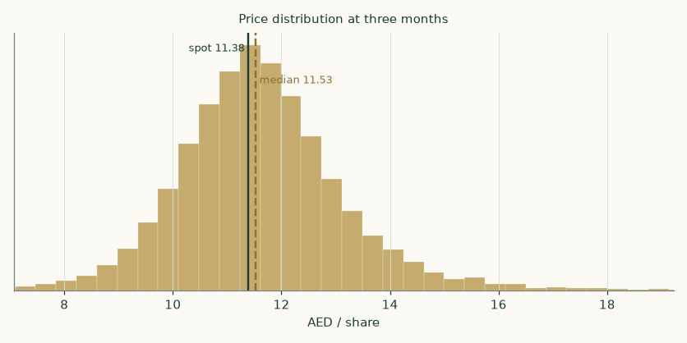
Figure 7 — price distribution at three months.
Level-touch ladder
Event | One month | Three months
Finishes 10% or more above spot | 11% | 24%
Finishes 10% or more below spot | 8% | 16%
Touches 10% above spot at any point | 18% | 41%
Touches 10% below spot at any point | 13% | 31%

4 Comparison of the lenses
The field disagrees, and the disagreement is informative. The cash-flow lens reads AED 15.54; the two market-anchored lenses read AED 8.93 and AED 8.94; the book lens AED 11.94. The spread is NOT about the forecast — all four lenses consume the same build, and the near-term numbers are anchored on a printed first half. It is about the price of time and certainty: the measured beta prices du's equity at a 6.8% required return, while the regional market, at the peer median multiple, implicitly charges something closer to the return implied by a 15-16× earnings multiple on a slow-growing annuity — two to three points more. Discount this study's own cash flows at that market-implied rate and you get, in effect, the relative lens.
What would close the gap from each side. The DCF is right and the market re-rates if: the fiscal regime is extended on current terms with the floor lapsing or lightening; the licence renews on comparable terms; the war recovery completes; and the data-centre leg starts printing revenue the market can see. The market is right and the DCF is generous if: the royalty regime reverts or worsens (Framing B alone closes most of the gap — AED 13.20); the measured beta understates the true risk of a single-market, single-licence operator (beta 0.80 alone takes the DCF to AED 10.92); or the capital base is older than the depreciation notes imply, which the second reading of those same notes puts at 22.97 years and is worth AED 14.79 a share. The central of AED 15.54 does NOT split the difference: it is the cash-flow lens, published with the cross-checks that disagree with it printed beside it at their own values, so a reader can judge the disagreement instead of receiving a number in which it has already been settled by a weight. An earlier edition of this study did settle it that way and reported AED 12.21, +7% against the price rather than the +37% this study actually holds — and the two market-anchored lenses that carried 45% of that blend are, as 1.4 shows, one reading of one multiple, not two.
An external review asked what those weights were worth, and it was right to. Priced against the blend this study published at the time, AED 12.21: moving the market-anchored family from 45% down to a quarter and giving the freed weight to the cash-flow lens read AED 13.53, and giving it to the book lens read AED 12.81 — up to 1.32 a share, and 0.72 between the two destinations. Not immaterial, and the answer was not to choose the weights better. The scheme is gone: the cash-flow lens IS the central at AED 15.54 and the other lenses are published beside it at their own values, so there is no weight left to set. The arithmetic above is kept as the record of what the retired construction did.
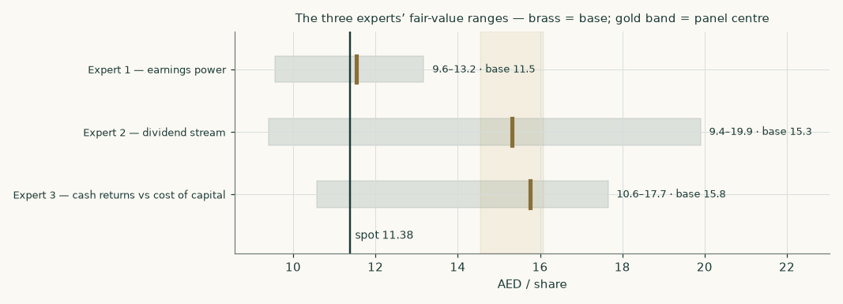
Figure 8 — the expert panel's three independent reads (Appendix C), against spot.
5 Catalysts to watch
- 1 · The POST-2029 fiscal regime (direction: either; size: the study's largest). The 2027-2029 extension is settled and is NOT a catalyst: du disclosed it itself on 24 July 2026, on the same 38% + 9% structure, with the AED 1.8bn combined annual floor expressly retained — which this study now models rather than merely quotes. What remains open is what follows it. The ministry has legislated the regime three years at a time twice; the next decision is due before the end of 2029 and the company has no visibility to offer before the ministry publishes. Reversion to the pre-2024 construction is worth the difference between the two framings: AED 15.54 against AED 13.20 per share. AN EARLIER EDITION OF THIS STUDY PRINTED THE OPPOSITE HERE — that only the other operator had disclosed the extension and du had not — which is precisely the error section 1.7 of the same document corrects. It was caught by an outside audit.
- 2 · The licence TERMS (direction: binary-adverse tail; timing: unknown). The renewal itself is DONE and is no longer a catalyst: the TDRA renewed both operators' licences for twenty years effective 9 August 2026, announced 12 August. What has not been published is the TERMS — the fee ratio in particular — and that is the open question a reader should watch: a renewal that raises the fee ratio costs roughly AED 0.52 per share per percentage point of revenue, and the regulator has not published them. AN EARLIER EDITION SAID THE OUTCOME WAS "DUE AT PRESS TIME" while section 1.7 of the same document already reported the renewal as granted.
- 3 · The war recovery (direction: up if the ceasefire holds). Prepaid subscribers, roaming and wholesale transit all recover with tourism; the company itself reports gross adds below pre-war levels with a ceasefire in place. The Q3-2026 print (late October) is the first clean read; a return to net adds above +150k/quarter would put the bull subscriber path in play.
- 4 · The data-centre leg (direction: up; horizon: 2027-2028). Five data centres plus the Microsoft-anchored hyperscale campus; commitments rose to AED 2,412mn at mid-2026. First disclosed hyperscale revenue — or a named second anchor tenant — would convert the ICT growth path from house assumption to disclosed run-rate.
- 5 · The dividend (direction: up, mechanically). The board raised the interim 8.3% in the same release that cut revenue guidance — a statement of intent. At the forecast payout the FY2026E dividend is AED 0.70; at the regional benchmark yield that alone is worth AED 14.24 per share (section 1.3).

6 Reading the probability zones
How to read sections 2-3 against section 1. The three-month cone spans AED 9.28 to 14.32 — the price can visit a lot of places in ninety days without any of them being a statement about value. The fundamental central of AED 15.54 sits OUTSIDE the cone's upper half: reaching it within a quarter would be a strong but not extraordinary move. Three zones, then:
- Below AED 10.66 (the cone's lower quarter): price weakness this deep with no fiscal or licence news would widen the value gap mechanically; with adverse regime news it would simply be the market pricing Framing B — check which before reading it as opportunity.
- AED 10.66 to 12.46 (the middle half): noise. Nothing in this band changes any conclusion in this study.
- Above AED 12.46: the market starting to pay for the recovery and the regime extension before they are printed. Even at the cone's top, AED 14.32, the share would still sit -8% against this study's central and only just above the book floor of AED 11.94 — three months of price movement does not settle a disagreement of this size either way.
The cone is honest about its own limits: for this share its bands have historically run wider than needed (section 3), so the outer zones are conservative.
7 Caveats and what would change our mind
- The discount rate is the study. A 0.557 measured beta against an Aa2 curve prices du's equity at 6.8%. Every conclusion that differs from the market traces to that number; section 1.8 prices the alternatives and section 4 takes the other side seriously. If du's risk is the sector's rather than its regression's, the central is several dirhams lower.
- The terminal value is most of the value. 80% of the DCF's enterprise value is beyond year five. That is the honest shape of a low-discount-rate annuity, and it is why the licence and the royalty — the two things that could touch the annuity itself — outrank every operating driver.
- The fiscal regime is not ours to forecast. Both framings are priced throughout; the study REFUSES a single number where the state has not yet published one. If a harsher-than-either construction emerged, both framings would need re-striking.
- The war path. The base case assumes the ceasefire holds and tourism normalises into 2027. A re-opened conflict invalidates the subscriber path, the wholesale recovery and possibly the multiple — the bear scenario, not the base.
- Wholesale and ICT are built top-down. No unit disclosures exist for either; both are flagged. The ICT ramp in particular leans on a disclosed programme whose revenue model (colocation vs services) the company has not yet broken out.
- The flat ARPU path, and the risk hidden inside it. The single most fragile revenue judgement in this study is that blended mobile ARPU holds roughly flat. Section 1.6 decomposes why: the flat reported figure is a postpaid mix tailwind worth about +2.6% set against per-leg price erosion of about -2.4%. Both must persist, and keep cancelling, for the path to hold. The mix shift came from a collapse in low-value visitor prepaid SIMs, and this study's own subscriber path assumes prepaid RECOVERS — which removes the tailwind and leaves the erosion exposed. Priced: the cash-flow lens falls to AED 12.83 (-17%). We cannot separate the two legs because du publishes no prepaid or postpaid ARPU, and solving for the ratio across all 21 available quarter pairs gives answers from -45× to 17× — so the gap is flagged, not filled.
- What we cannot build from the disclosure. Wholesale and ICT direct costs carry a rate on their own revenue rather than a cost per unit, because no volume measure for either segment is disclosed anywhere in the filings. That is the weakest part of an otherwise per-unit cost build. The ICT rate is held flat rather than improving, which withdraws a data-centre-scale margin story the previous edition of this study carried: the disclosed series does not support a trend in either direction, and an unmeasurable story has no place in the model.
- The second half of 2026 is a forecast, not a print. The FY2026E EBITDA margin of 47.8% sits above the company's own guided 46-47%, so the claim that has to stand up is the implied SECOND-HALF margin of 46.5%. The first half improved +2.1 points year on year; the implied second half improves only +1.3 points, so the forecast already assumes the year-on-year gain roughly halves. Reaching the guided midpoint would instead require a second-half margin of 43.9%, a year-on-year DETERIORATION against a first half that improved. Possible, and priced in 1.9 — but not what the filings point to.
- What would change our mind, concretely. A royalty construction harsher than Framing B; licence renewal terms materially above the current fee ratio; two consecutive quarters of negative postpaid net adds; a quarter in which the postpaid share of the mobile base FALLS back toward 20% while blended ARPU follows it down — the mix-exhaustion case above; mobile interconnect cost per subscriber turning UP in a like-for-like half-year pair, which would remove the only cost tailwind in the build; or the payout being cut other than for a named investment programme. Any one of these re-opens the build; the register in Appendix B tells a reader exactly which inputs to re-examine first.

Appendix A Financial statements
A.1 Income statement — three years historical and five years forecast (consolidated, AED mn)
AED mn | FY2023 | FY2024 | FY2025 | FY26E | FY27E | FY28E | FY29E | FY30E
Revenue | 13,636 | 14,636 | 15,905 | 16,593 | 17,240 | 18,011 | 18,734 | 19,424
EBITDA | 5,800 | 6,470 | 7,338 | 7,937 | 8,239 | 8,624 | 8,977 | 9,309
EBITDA margin | 42.5% | 44.2% | 46.1% | 47.8% | 47.8% | 47.9% | 47.9% | 47.9%
Depreciation & amortisation | -2,198 | -2,154 | -2,168 | -2,235 | -2,352 | -2,448 | -2,530 | -2,582
Operating profit (EBIT) | 3,601 | 4,316 | 5,170 | 5,702 | 5,887 | 6,176 | 6,446 | 6,727
Net finance income / (cost) | -40 | -8 | -20 | 4 | -3 | -7 | -9 | -5
Share of equity-accounted investments and net impairment | -2.7 | -2.5 | -1.0 | 0.0 | 0.0 | 0.0 | 0.0 | 0.0
Profit before royalty and tax | 3,559 | 4,306 | 5,149 | 5,706 | 5,884 | 6,168 | 6,438 | 6,723
Federal royalty and income tax | -1,891 | -1,819 | -2,244 | -2,486 | -2,564 | -2,688 | -2,805 | -2,929
Net profit | 1,668 | 2,488 | 2,905 | 3,220 | 3,320 | 3,481 | 3,633 | 3,794
Earnings per share (AED) | 0.37 | 0.55 | 0.64 | 0.71 | 0.73 | 0.77 | 0.80 | 0.84
Dividend per share (AED) | 0.34 | 0.54 | 0.64 | 0.70 | 0.72 | 0.75 | 0.79 | 0.82

Table A1 — every column now foots: the associates-and-impairment line, previously omitted, is what reconciled operating profit to profit before royalty in the audited statements. FY2023-25 are the audited figures (FY2024 on the re-presented basis of the FY2025 statements, so the two recent years sit on one presentation; FY2023 EBITDA is derived from audited components because the older format prints no such line, and is flagged as such). The FY2023 royalty is the old-regime charge; no corporate income tax existed before 2024.
A.2 Balance sheet — condensed house layout (consolidated, AED mn)
AED mn | FY2023 | FY2024 | FY2025 | FY26E | FY27E | FY28E | FY29E | FY30E
Property, plant and equipment | 9,723 | 9,838 | 10,289 | 10,887 | 11,403 | 11,860 | 12,173 | 12,432
Right-of-use assets | 1,597 | 1,657 | 1,515 | 1,515 | 1,515 | 1,515 | 1,515 | 1,515
Intangibles (excl. goodwill) | 1,111 | 847 | 870 | 963 | 1,031 | 1,083 | 1,109 | 1,127
Goodwill | — | 413 | 413 | 413 | 413 | 413 | 413 | 413
Net working capital | -965 | -1,220 | -1,062 | -1,108 | -1,152 | -1,203 | -1,251 | -1,297
Cash and term deposits | 1,937 | 2,283 | 2,250 | 2,023 | 1,899 | 1,856 | 1,979 | 2,158
Lease liabilities | 2,105 | 1,999 | 1,939 | 1,939 | 1,939 | 1,939 | 1,939 | 1,939
Total equity | 9,243 | 9,878 | 10,148 | 10,213 | 10,279 | 10,349 | 10,421 | 10,497
Net cash after leases | -168 | 285 | 311 | 84 | -40 | -83 | 40 | 219

Table A2 — a condensed layout: receivables, payables, contract balances and the royalty accrual are netted inside working capital (the FY2023 payables line still contained the royalty accrual, separately disclosed from FY2024; it is excluded in every year so the series is like-for-like). Zero drawn borrowings in every year shown. Goodwill was not a separate line in the FY2023 layout.
A.3 Forecast balance sheet and cash-flow markers
The equity walk: profit less the 98% payout compounds equity from AED 10,148mn to AED 10,497mn by FY2030E. The cash walk is the stress line: at a near-total payout plus the data-centre capex peak, cash and term deposits fall from AED 2,250mn to AED 2,158mn by the last forecast year — falling for three years, troughing in FY2028E and rebuilding in the last two as the capex peak passes, which is what the row above prints and what an earlier edition of this study wrongly described as a decline in every year. The reviewed mid-2026 position (term deposits nil after the royalty settlement and the final dividend) already shows the mechanic, and the undrawn AED 2.0bn facility is the disclosed backstop. Working capital RELEASES cash every year; the lease book is held flat, matched by non-cash lease additions, and no replacement is charged here because the liability is deducted in full as debt in the bridge — the renewal is paid for in the terminal instead.
Appendix B Peer frame, risk register — and the research register
B.1 Peers and the sector frame
Company | Market | Trailing P/E | Yield | Basis | Read-across
e& | UAE (ADX) | 15.7× | 4.50% | ISSUER FILINGS | the duopoly partner: scale + international assets. RE-DERIVED end-to-end from its own filings (TTM EPS AED 1.33 reported-attributable, close AED 20.98); an earlier edition of this table printed an aggregator ~20.7× and ~4.8%
stc | Saudi Arabia | ~18.9× | 5.07% | aggregator / issuer yield | the regional benchmark payer. The yield is the issuer figure; an earlier edition printed an aggregator ~5.2% the register had already superseded
Mobily | Saudi Arabia | 12.9× | 4.89% | ISSUER FILINGS | closest structural analogue — the #2 that closed the gap; SETS THE JUSTIFIED P/E. TTM EPS SAR 4.76 from Mobily's own issuer announcements on a 06-Aug-2026 close of SAR 61.30 = 12.88×, and the market-cap route ties independently at 12.89×. AN EARLIER EDITION OF THIS TABLE PRINTED ~15.5× AND ~2.9% — a January-2026 aggregator read on FY2024 earnings, and a yield that matched neither the issuer data nor this study's own sweep — while section 1.3 of the same document had already corrected both. Corrected and uncorrected figures in one delivery is what an outside audit caught here
Ooredoo | Qatar | ~12.5× | ~5.70% | aggregator | multi-market, softer growth
Zain | Kuwait | REFUSED | ~6-7% | aggregator (refused) | the provider returned 11,365× and was refused rather than passed through
Omantel | Oman | ~11.4× | ~6.7% | aggregator (inconsistent) | small-market incumbent; its quoted multiple and yield are mutually inconsistent, and it holds ~22% of Zain, so the two are not independent observations
DT / Vodafone | Developed | n/m | ~3.4% | aggregator | the developed bracket: more leverage, lower returns, lower multiples

Table B1 — the peer frame, with the BASIS of every line stated. Only two rows derive end-to-end from issuer filings (Mobily and e&) and only those two are used for anything; the rest are aggregator reads at the sweep date, labelled as such, and NO PEER MEDIAN IS CLAIMED anywhere in this study. du computes at 17.8× trailing earnings and 7.0× trailing EV/EBITDA from its own audited figures.
B.2 Risk register
Risk | Mechanism | Where it is priced
Fiscal regime reversion or worsening | combined take above the current 44% | Framing B throughout: AED 13.20
Licence renewal on worse terms | fee ratio above 2.7% of revenue | ~AED 0.52/share per +1pp (section 1.9)
War re-escalation | prepaid, roaming, wholesale transit reverse | subscriber sensitivity and the DCF bear
Required-return mismeasurement | the 0.557 regression beta understates true risk | beta grid to 0.80: AED 10.92
Data-centre execution | ICT ramp slips; capex stays high without the revenue | ICT growth and capex grids
Payout sustainability | near-total payout + capex peak drains liquidity | the cash walk in A.3; the undrawn facility is the backstop
Concentration | one market, one regulator, one licence | the cross-checks published beside the central in the summary table

B.3 The research register — layers, dated, negative results included
The full input register — every input with value, source and date, grouped by research layer, with the judgement table (each judgement paired with what would overturn it), the negative-results table and the source-discrepancy notes — ships as the companion bibliography document. Highlights a reader should know: all statement figures were read from the company's own audited/reviewed filings on its investor-relations portal (four complete fiscal years, plus both 2026 interims, swept in before the build); the UAE sovereign credit-default-swap quote was UNREACHABLE at the sweep date and the market spread was proxied by the traded Abu Dhabi dollar curve, disclosed rather than silently substituted; no public peer EV/EBITDA was clean enough to use; and no announcement of concluded licence-renewal terms existed at the sweep date — a dated negative search, not an oversight.
Appendix C The expert valuation panel
Three experts, three methods, each with worked arithmetic, a named sensitivity and a falsifier stated in advance. One caveat a reader is owed up front, because it limits what the panel proves: Expert 3's economic-profit method is ALGEBRAICALLY equivalent to the cash-flow model given the same profit, capital and cost of capital, and Expert 2's dividend model is a perpetuity on the same terminal cost of equity and growth at a payout near 100%. So of the three, only Expert 1 is genuinely independent of the primary lens; the other two are better read as consistency checks on it than as external corroboration. The panel median is reported on that understanding. They are labelled Expert 1/2/3; their methods, not their names, are the point. Cast by method: an earnings-power investor, a dividend-stream investor, and an economic-profit analyst.
C.1 Expert 1 — earnings power: through-cycle earnings at a conservative multiple
Worldview: buy durable earnings power at a multiple that does not need the story to work. Works best on stable franchises near mid-cycle; fails when the cycle is mistaken for the trend or when a regime change (here: fiscal) resets the earnings base itself.
Step | Value
Mid-cycle earnings per share (FY2028E) | 0.77
Through-cycle multiple applied | 15.0×
Value at FY2028, i.e. at 31-Dec-2028 (EPS × multiple) | 11.52
discounted 2.32 years — 31-Dec-2028 back to the anchor — at the 6.83% cost of equity | 9.88
plus the present value of dividends receivable between the anchor and FY2028 | 1.64
Expert 1 fair value (anchor date) | 11.53
Range: 12× to 17.5× the same earnings | 9.55 – 13.18

This construction was CORRECTED after external review, and the reviewer was right. The previous edition discounted two years from a 31-Dec-2025 base and then applied the same anchor-accretion factor the other lenses use, which nets to 1.32 years of discounting — a full year short of the 2.32 years that actually separate the anchor from the date these earnings arrive. Correcting the horizon on its own, though, changes almost nothing (AED 9.88) and would introduce a second, larger error: discounting a 2028 equity value straight to today silently discards the dividends paid in between, which for a company distributing essentially all of its earnings is worth AED 1.64 per share. Both defects sat in the same three lines. Fixed together, this lens moves from AED 9.90 to AED 11.53. The reviewer's premise was correct and their conclusion — that the lens was overstated — was wrong in sign.
Named sensitivity: the multiple. Each turn of the multiple is worth AED 0.66 per share at mid-cycle earnings. Falsifier, stated in advance: if FY2027 earnings per share prints below the FY2026 estimate — i.e. the war recovery stalls into earnings — the mid-cycle base is wrong and this read is withdrawn.
C.2 Expert 2 — the dividend stream: the natural lens for a full-payout duopoly
Worldview: for a company that pays out essentially everything, the dividend IS the cash flow; value it directly as a growing perpetuity. Works best when payout is policy, not accident, and the balance sheet cannot be raided; fails when the payout is about to be cut — the model capitalises a promise.
Step | Value
FY2026E dividend per share | 0.70
grown at 2.0% into a perpetuity at the terminal cost of equity 6.65% | 15.27
× the anchor accretion factor of 1.0463, as every other lens is rolled | 15.98
less the dividends gone ex before the anchor | 0.66
Expert 2 fair value (anchor date) | 15.32
Range: cut-and-higher-rate bear to 3%-growth bull | 9.41 – 19.90

Named sensitivity: the growth-rate spread (Ke − g). At these levels each 50 basis points of spread is worth roughly AED 1.65 per share. Falsifier: an interim or final dividend DECLARED lower than the prior year's equivalent — the first cut in the record — withdraws this read immediately.
C.3 Expert 3 — cash returns: economic profit on invested capital
Worldview: value = capital + the present value of returns ABOVE the cost of capital; a franchise is only worth a premium while its return spread lasts. Works best where invested capital is measurable and returns are stable; fails when intangible capital (spectrum rights, the licence itself) does the earning but sits off the balance sheet — which flatters the measured return.
Step | AED mn
Invested capital, FY2025 (PP&E + right-of-use + intangibles + goodwill + working capital) | 12,025
PV of five years of economic profit (NOPAT less capital charge at the forward rate) | 10,834
PV of the terminal economic-profit annuity | 47,966
Implied enterprise value | 70,825
bridge to equity (leases out, cash in), per share at the anchor | 15.76
Range: fading spreads on the low side; a judgemental +12% on the high side | 10.58 – 17.65

The return spread behind it: forecast returns on capital of 26% / 26% / 26% / 26% / 27% against forward costs of capital of 6.7% / 6.6% / 6.6% / 6.5% / 6.5% — a spread of roughly twenty points, which is what a licensed duopoly with negative working capital looks like in this framework. Named sensitivity: terminal capital intensity — if the data-centre era permanently raises invested capital per dirham of profit, the terminal annuity shrinks. Falsifier: return on invested capital printing below 20% for two consecutive years.
C.4 Cross-examination
- Expert 2 to Expert 1: your multiple is a market mood; my denominator is a policy rate. CONCEDED in part by Expert 1: the multiple carries sentiment — which is exactly why it is set against the closest structural analogue, Mobily, rather than against du's own historical average — and NOT at a peer median, which section 1.3 of this study expressly declines to claim because only two of six peers survive as clean observations. An earlier edition defended it as a median in this very answer.
- Expert 1 to Expert 2: you capitalise a promise at a 3.7-point spread; one cut and your number is fiction. REJECTED by Expert 2: the payout has risen through a war quarter and a guidance cut — the board has told you what the dividend is for.
- Expert 3 to both: neither of you charges for capital. The spread is the asset. CONCEDED by both — with the counter, ACCEPTED by Expert 3, that his invested-capital base omits the licence value itself, so his measured spread flatters the franchise precisely when the licence is up for renewal.
- All three to the primary model: the DCF's terminal value is 80% of enterprise value at a discount rate its own section calls the study's biggest assumption. The model's answer: the beta is measured, gated, cross-checked, and priced against its alternatives in two separate tables — the disagreement is put in front of the reader rather than resolved by fiat.
C.5 The three in one room
Where they land: Expert 1 at AED 11.53, Expert 2 at AED 15.32, Expert 3 at AED 15.76 — a panel median of AED 15.32. The shape of the disagreement is the study in miniature: the earnings-power read hugs the market because it borrows the market's multiple; the two cash-based reads sit together well above it because they price du's cash at du's measured risk — and, as section 1.7 sets out, that gap is itself the study's central unresolved judgement rather than a conclusion about it.
C.6 Reading the divergence
Gap | Driver of the gap | Worth (AED/share)
Expert 1 (11.53) vs Expert 2 (15.32) | market multiple vs measured cost of equity as the price of the same cash | 3.79
Expert 2 (15.32) vs Expert 3 (15.76) | payout-as-perpetuity vs capital-charged spread — small, because at ~100% payout the dividend nearly IS the economic profit | 0.44
Panel median vs the study's central (15.54) | both are cash-flow reads. Only ONE of the three panel members sets a terminal on a market multiple (Expert 1); Expert 2 capitalises at the terminal cost of equity and Expert 3 at the cost of capital, and the median is Expert 2. An earlier edition said two of three, which the three worked constructions printed above it contradict | 0.22

Table C1 — the divergence table: which assumption drives which gap.
About this series
Testahil publishes independent, educational valuation studies of listed companies and metals. Each study separates fundamental value (built from audited filings, bottom-up) from price probability (a calibrated simulation of where the price could trade), and publishes ranges and distributions rather than targets. Delivered studies are never retro-edited; corrections are made forward, in the open. The companion Excel model is formula-driven so every figure can be traced to its driver, and the companion bibliography lists every input with source and date.
Disclosure & Disclaimer
This document is educational analysis, not investment advice, an offer, a solicitation, or a recommendation to buy or sell any security. It expresses no rating and no price target. The authors hold no position in the securities discussed and receive no compensation from any issuer. All historical figures derive from the company's own published audited or reviewed consolidated financial statements; forecasts are the authors' own and are inherently uncertain. Probabilities describe model output, not promises. Markets can and do behave outside any model's bands. Readers should conduct their own research and consult their own advisers. © Testahil, 2026.

