Testahil · Independent Valuation Study — Educational Analysis Not investment advice

Air Arabia PJSC
Dubai Financial Market · AIRARABIA · Aviation — low-cost airline · Report date 9 August 2026 · prices as of 2026-08-07
READ FIRST — what this document is. An independent, educational valuation study of Air Arabia PJSC. It is not investment advice, not a solicitation, and it contains no rating and no price target. It presents fair-value RANGES from four valuation lenses, a probability map for the share price, and every assumption used to build them.
Sources. Built exclusively on the company's own audited consolidated financial statements FY2022–FY2025 (KPMG Lower Gulf, unqualified opinion on FY2025 dated 13-Feb-2026), the reviewed Q1-2026 interim (Grant Thornton UAE), and the company's own results presentations — all read from airarabia.com investor relations. Peer figures are cross-checks only and are labelled as such. A companion bibliography document lists every input with source and date.
Two judgements are shown both ways, never averaged. The 2026-27 fuel path (the official US energy-agency curve versus the airline association's high-fuel assumption) and the value of the joint-venture airline network (audited carrying value versus capitalised profit share). Each framing is priced in full and both appear side by side.
The companion workbook calculates. Every figure derivable from a driver is a live Excel formula; only audited history, the unit build's disclosed bases, and whole-model re-runs (the Monte Carlo map, sensitivity grids and scenario bounds) are pasted, and the workbook's READ FIRST sheet names those three classes.

Headline
Fair value clusters at AED 4.17 per share on the base framing and AED 4.42 with the joint-venture network capitalised — against a market price of AED 5.24. The market is paying about +26% above the base fundamental central (equivalently, the central sits -20% below the market — the same figure the summary table carries); the gap is, in large part, a price on two things this study deliberately prices both ways: cheaper fuel from 2027 and the five equity-accounted airlines the balance sheet carries at less than two times their annual profit contribution.
Air Arabia closed FY2025 with record results: revenue AED 7,788mn (+15%), profit before tax AED 1,831mn (+14%), 13.06mn passengers (+16%) at a record 85.3% seat load factor, a fleet of 90 A320-family aircraft, net CASH of AED 2,417mn including fixed deposits, and a dividend raised for the fourth straight year to 30 fils. The Q1-2026 quarter then absorbed the February–March regional airspace closures: revenue held (+1%) on 11% fewer consolidated passengers, while net profit fell 22% — a dip this study treats as exactly that, not a trend break.
Over the next three months the price map assigns a 50% band of AED 4.71–5.79 and a 90% band of AED 3.96–6.89 around the AED 5.24 spot — the fundamental ranges below are slower-moving claims about value, the map is a calibrated claim about price.
Valuation summary — every read at a glance
Lens | Bear | Base | Bull | Weight | vs spot
Discounted cash flow (primary) · terminal value 95% of EV | 0.62 | 4.35 | 9.68 | 45% | -17%
Relative multiples | 3.19 | 3.79 | 4.39 | 20% | -28%
Normalised earnings power | 2.59 | 3.43 | 4.27 | 20% | -35%
Book value and sustainable return | 3.84 | 5.17 | 5.88 | 15% | -1%
Weighted central (range weighted like the base) | 2.01 | 4.17 | 6.97 | 100% | -20%
Widest single-lens span (DCF scenarios; labelled, not a weighted range) | 0.62 | — | 9.68 | — | —

Alternative framings (never averaged into the central) | AED/share | vs spot
DCF with the JV network capitalised at 15x its profit share | 4.89 | -7%
Weighted central on that framing | 4.42 | -16%
DCF on the high-fuel alternative (association path held) | 2.30 | -56%
Expert panel median | 4.10 | -22%
Market price (2026-08-07) | 5.24 | —

The DCF row shows the terminal-value share of enterprise value beside the lens, as it should: 95% of the operating value sits beyond the five forecast years, because the fleet build-out's spending lands inside the window while much of its revenue lands after it.
Company overview
Air Arabia PJSC, incorporated 19 June 2007 and listed on the Dubai Financial Market, is the Middle East and North Africa's first and largest listed low-cost carrier. The GROUP operates a 90-aircraft Airbus A320-family fleet (plus five short-term leases) to 219 destinations across six hubs; the CONSOLIDATED company itself flies from Sharjah (54 aircraft) and Ras Al Khaimah (2) — the other 34 aircraft sit at the equity-accounted venture hubs and are valued separately in the bridge — with the first of 120 ordered A320neo-family aircraft (73 A320neo, 27 A321neo, 20 A321XLR — the 2019 order) delivered on 29 September 2025. Around the listed company sits a network of equity-accounted airline ventures: Air Arabia Abu Dhabi (49%, with Etihad), Air Arabia Egypt (raised to 49% in 2025), Fly Jinnah in Pakistan (45%), Air Arabia Maroc (44.13%), and — signed in 2025 — Air Arabia DMM (49%), a new Dammam-based Saudi carrier. The group also owns hotels (Centro Sharjah, Radisson Blu Dubai Marina), the COZMO travel network, aviation-services subsidiaries, and leases 17 of its aircraft to the venture airlines.
Class and lens. Air Arabia is an OPERATING COMPANY — a low-cost airline: 80% of FY2025 revenue is passenger fares plus baggage, 11% is ancillary services sold around the seat, 5% cargo and services, 3% aircraft leases to its own ventures and 1% hotels (the six disclosed lines sum exactly to audited revenue). The balance sheet is a fleet (AED 5,790mn owned equipment, AED 853mn right-of-use aircraft, AED 2,028mn pre-delivery payments) funded by secured aircraft debt and leases of AED 2,781mn against AED 2,417mn of NET CASH. The study therefore values the airline on discounted free cash flow with a passenger-level unit build, and handles the equity-accounted venture network explicitly in the enterprise-to-equity bridge — the one genuinely contested structural judgement.
1 Fundamental valuation
1.1 The cash-flow model — FCFF waterfall and the bridge to equity
Revenue is built from passengers times per-passenger rates; the cost stack is per-passenger lines with one escalator each (section 1.6). The waterfall below runs from EBITDA to enterprise value; every line of it is a live formula in the companion workbook.
AED mn | FY26E | FY27E | FY28E | FY29E | FY30E
Revenue | 7,869 | 8,451 | 9,257 | 10,095 | 10,952
EBITDA (incl. fees and other income) | 1,876 | 2,286 | 2,419 | 2,557 | 2,680
less depreciation & amortisation | 720 | 810 | 900 | 980 | 1,060
EBIT | 1,156 | 1,476 | 1,519 | 1,577 | 1,620
NOPAT (EBIT × (1 − 15%)) | 982 | 1,255 | 1,291 | 1,341 | 1,377
add back depreciation & amortisation | 720 | 810 | 900 | 980 | 1,060
less owned capex + pre-delivery payments | 2,000 | 1,900 | 1,900 | 1,950 | 2,000
less leased-fleet additions (gross right-of-use value) | 175 | 350 | 350 | 350 | 350
less change in working capital | 151 | -373 | -516 | -536 | -549
Free cash flow to the firm | -624 | 187 | 457 | 557 | 635
Discount factor (glide-compounded) | 0.9258 | 0.8592 | 0.7983 | 0.7426 | 0.6908
PV of FCFF | -577 | 161 | 365 | 413 | 439

The FY2026 free cash flow is negative (AED -624mn) and the window is lean throughout: after external critique, the ~9 leased aircraft the plan adds are charged at their gross right-of-use value inside FCFF (the 'all capacity is bought with capital' convention; financing mix is the discount rate's business). The alternative — treat new leases as value-neutral financing and charge nothing — is worth about +0.09/share and is noted, not adopted.
Enterprise value → equity | AED mn
PV of explicit years FY2026–30 | 801
PV of terminal value (growth 2.5%, terminal cost of capital 7.50%, reinvestment = g / return on capital = 17.5%) | 16,097
Enterprise value of the airline | 16,898
Terminal value as a share of enterprise value | 95%
plus net cash (cash + fixed deposits − borrowings − leases) | 2,417
plus non-operating assets (investments, investment property, net investment in lease) | 1,069
plus JV network at audited carrying value — BASE framing | 363
less minorities at audited carrying value | 1.29
Equity attributable, 31-Dec-2025 | 20,747
Per share at 2026-08-07: operating equity rolled at the cost of equity, cash and near-cash legs at the deposit yield, less the 30-fils dividend | AED 4.35
Same bridge with the JV network at 15× profit share — ALTERNATIVE framing | AED 4.89

1.2 Book value and sustainable return
Audited FY2025 book value is AED 1.80 per share. The trailing return on average attributable equity is 19.9%; the study strikes the SUSTAINABLE return at 18% — below the record year, because FY2025 carried a yield tailwind from constrained regional capacity. A justified price-to-book of (18% − 2.5%) / (7.86% − 2.5%) = 2.89× values the share at AED 5.17 at the anchor (bear 3.84 / bull 5.88 — all three legs on the same Gordon identity, (ROE − g) / (k − g), after critique caught the bear leg abandoning it).
1.3 Relative multiples
At 6.5× FY2027E EBITDA of AED 2,056mn EXCLUDING the fee/other-income stream — the basis peer multiples are computed on; the peer median rebuilt from primary filings is 6.5× — plus that fee stream valued separately as an after-tax annuity (AED 3,912mn), discounted and passed through the same bridge, the share is worth AED 3.79 (bear 3.19 at 5.0×, bull 4.39 at 8.0×). For context, the market currently pays 11.7× trailing EV/EBITDA ex-fees (10.6× including them — both bases published) and 15.0× trailing earnings — a premium to Ryanair (6.5×, 12.6× from its own filings), Wizz (4.7×), easyJet (3.5×, 12.4×) and the US profitable-carriers aggregate (7.6×, 12.9× — a survivorship-screened US dataset, labelled as such), nearer Kuwait's Jazeera Airways (~17.7× on FY2025). The relative lens's message is that the premium is already in the price; whether the JV network and the order book justify it is the study's central question, not the lens's input.
1.4 Normalised earnings power
Applying the mid-cycle EBITDA margin (23.4%, the FY2028E middle year) to FY2026E revenue at CURRENT scale, with FY2026E net finance income but EXCLUDING the JV share — after external critique correctly showed that multiplying JV earnings at 13× silently averaged the two JV framings inside the base central — gives normalised earnings of AED 0.267 per share; at 13× plus the JV network at BOOK that is AED 3.43 (bear 2.59 at 10×, bull 4.27 at 16×). The base-framing central now carries the JV at carrying value in every lens.
1.5 Synthesis — four lenses, one field
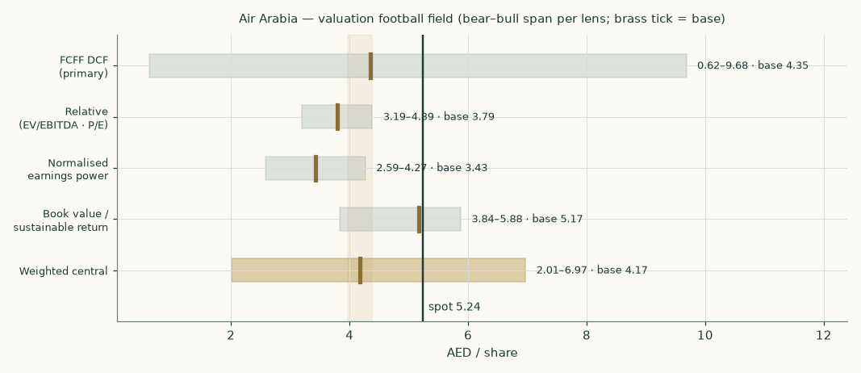
Figure 1 — the four lenses and the weighted central. Every lens base sits below the market price on the base framing; the capitalised-JV framing closes part of the gap.
1.6 Drivers — the unit build, each line on its own driver
The company discloses passengers, load factor and a full revenue and cost disaggregation, but not seats or available seat-kilometres; passengers × per-passenger rates is therefore the finest disclosed level, and that is where the model is built. Margins are OUTPUTS.
Unit economics (AED per passenger) | FY2024 | FY2025 | FY26E | FY27E | FY28E | FY29E | FY30E
Passengers (millions) | 11.22 | 13.06 | 12.85 | 13.95 | 15.15 | 16.35 | 17.55
Fare + baggage | 495 | 479 | 488 | 480 | 484 | 489 | 494
Ancillary | 60 | 65 | 67 | 70 | 73 | 76 | 79
Fuel = intensity x effective jet price (base) | 172 | 172 | 195 | 165 | 168 | 172 | 175
Fuel (high-fuel alternative) | — | — | 210 | 205 | 206 | 208 | 210
Staff | 79 | 82 | 84 | 87 | 90 | 92 | 95
Maintenance | 61 | 61 | 64 | 66 | 69 | 72 | 75
Landing & overflying | 36 | 36 | 37 | 37 | 38 | 39 | 40
Handling | 31 | 29 | 30 | 31 | 31 | 32 | 32
Other direct | 31 | 41 | 42 | 42 | 42 | 42 | 42

THE ANCHORS, stated. Fare + baggage: the FY2025 realised AED 478.7 per passenger, lifted +1.9% in FY2026 (the Q1-2026 print held revenue on 11% fewer passengers — scarcity pricing), given back -1.6% in FY2027 as regional capacity returns, then held at roughly zero real growth — and the FY2026 build sits within 0.1% of the Q1-2026 seasonal gross-up. Ancillary: FY2025's AED 64.8 per passenger at +4%/yr, the disclosed 2023-25 trend tapered. Fuel is now built BOTTOM-UP: cost per passenger = intensity 1.937 (FY2025 audited fuel over the ~USD 89/bbl 2025 market average) x an effective hedge-blended jet price path — its own commodity escalator. Every other cost class keeps its own escalator (wages, MRO, ~2% UAE tariff inflation; the other-direct line held flat as the 2025 wet-lease spike unwinds). Volume is fleet-led on the CONSOLIDATED fleet: 56 aircraft (Sharjah 54 + Ras Al Khaimah 2) to roughly 72 by FY2030 — about 7 owned and 9 leased additions from the 120-aircraft order — at a held ~85-86% load factor.
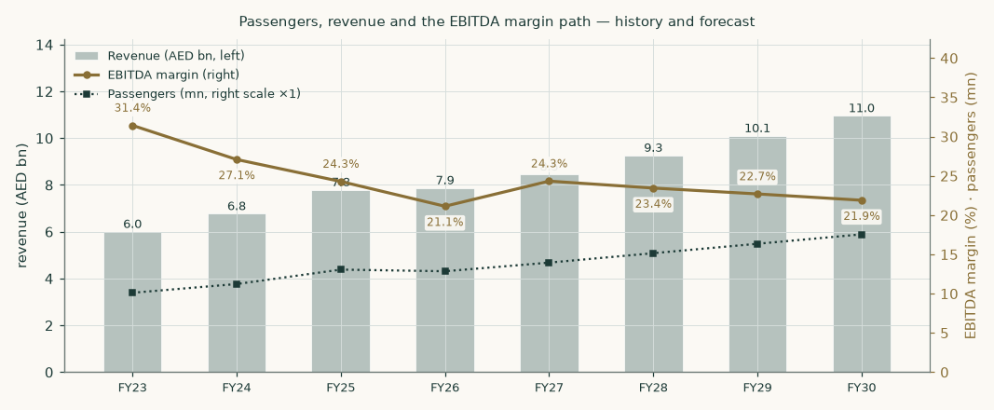
Figure 2 — passengers, revenue and the EBITDA margin path. The 2026 dip is the fuel spike plus flat traffic; 2027 recovers on the official-curve fuel path.
1.7 The crux — fuel, and what the joint ventures are worth
Two judgements dominate this valuation, and both are sensitised in their own physical units. FUEL: straight from the model's own grid, at 92.5% of the base fuel path the DCF is AED 5.12 and at 107.5% it is AED 3.57 — about AED 0.78 per share for each 7.5% move in the fuel line (roughly AED 13 per passenger). Priced BOTH ways as full paths: base (official-curve relief) AED 4.35; association-assumption held high, AED 2.30. THE JV NETWORK: at the audited carrying value it contributes AED 0.08 per share; capitalised at 15× its AED 190mn profit share it contributes AED 0.61 — the 0.55 per-share gap between the two framings is the single largest contested item in the study; the three ventures disclosed in both years grew their combined 100%-basis profits ~70% in FY2025 (the group's share grew 52% — a mix effect: the highest-stake venture, Morocco, declined while Pakistan tripled), and a new Saudi carrier was signed. One housekeeping note a reader of the auditor's report will want: the 'shares purchased during the year' it references is the venture transaction disclosed in note 1 — Air Arabia Egypt raised from 40% to 49% — not a buyback; share capital is unchanged and no treasury shares exist.
1.8 Macro & country — the cost of capital, built and evidenced
Component | Value | Evidence
AED government bond yield | 4.48% | UAE Ministry of Finance dirham T-Bond auction, July-2026, January-2031 tranche (4bp over comparable US Treasuries); May-2026 auction 4.30%
less the observed auction spread | 0.04% | the July-2026 auction itself priced 4bp over comparable US Treasuries — netting the spread the yield actually embeds keeps the rate currency-consistent under the peg (UST 5-yr 4.35% on 07-Aug-2026); the rating-table netting (0.42%, rf* 4.06%) is the disclosed alternative
Net risk-free rate | 4.44% | derived
Beta — adopted | 0.812 | own-stock five-year weekly regression against the published index of the exchange this share is listed on: R² 0.13, 260 weeks, standard error 0.128, 90% interval 0.60–1.02. The listing is a primary-source fact rather than an inference from the head office (the company is Sharjah-domiciled and its own investment portfolio holds securities listed on both UAE exchanges): the 2025 statements note 1, the 2025 annual report and the Q1-2026 interim note 1 all state the ordinary shares are listed on the Dubai Financial Market. No Dubai general-index series is registered for this purpose, so the regression stands on the FTSE Abu Dhabi general index as a registered interim substitute — stated in full below, as an interim regressor requires
Beta — cross-check (published, not used) | 1.086 | the identical regression against a Dubai general-index series that is held but is not the registered regressor: R² 0.40, 258 weeks, standard error 0.083, 90% interval 0.95–1.22. It is the HIGHER beta and explains three times as much of this share's weekly movement, so on the evidence it is the better measurement — and it would LOWER the valuation. It is published rather than used because which index a beta is measured against is a matter of method, settled once for every company, not something one study decides for itself. Priced in full: cost of equity 9.73%, cost of capital 9.21%, cash-flow value AED 3.51 per share (-0.83, -19%)
Equity risk premium | 4.87% | Damodaran UAE row, January-2026 (mature 4.23% + country 0.64%). The same file publishes no usable UAE sovereign-swap-based alternative — stated rather than substituted
Cost of equity | 8.39% | derived
Marginal cost of debt | 5.50% | see the evidence table below
Weights (gross debt / equity, market value) | 10.2% / 89.8% | market capitalisation at spot; gross debt as audited
Cost of capital — explicit window | 8.01% | derived
Cost of capital — terminal | 7.50% | risk-free normalised to 4.0%, premium 4.75%, debt weight 10% — norm-built, never backed out of a price

Cost-of-debt evidence | Rate | Nature
Lease book average finance charge (FY2025 note) | 4.0% | secured on the aircraft — a floor, not a marginal rate
FY2025 aircraft loan (AED 849.6mn for 5 aircraft) | n/d | mortgage-secured
Effective finance cost / average gross debt | 2.73% | blended, secured book
Fixed deposits earn (FY2025 note) | 4.41% | the asset-side opportunity rate
AED sovereign, January-2031 | 4.48% | the unsecured floor for any AED corporate
ADOPTED marginal unsecured cost of debt | 5.50% | sovereign + ~100bp; above every secured print and the deposit rate, as it must be

On the index the beta is measured against — stated plainly, because it is the second most consequential number in this valuation after the fuel path. This share is listed in Dubai, and the natural regressor would be a Dubai general index. No Dubai general-index series is held for this purpose, so every company measured this way stands on the FTSE Abu Dhabi general index instead, one UAE market proxy standing in for the other. That substitution is better supported than it sounds: across five years of weekly returns the Abu Dhabi index explains the Dubai-listed shares BETTER than it explains the Abu Dhabi-listed ones it actually covers (median R² 0.240 against 0.127), and every one of those Dubai names clears the minimum usability threshold. It is nonetheless a substitute, and for THIS share it is the weaker of the two available measurements: 0.40 against 0.13 on explanatory power. Both are therefore published with their full statistics and both are priced — AED 4.35 on the measurement used, AED 3.51 on the cross-check, a 19% difference in the cash-flow value. A reader who prefers the Dubai measurement can read the second figure as this study's own, already-computed answer; it is not hidden in a sensitivity table.
Tax: the UAE Domestic Minimum Top-up Tax puts the group at a 15% statutory rate from 2025; the audited effective rates were 8.79% (FY2024, the 9% year) and 11.6% on the filing's own tax-for-the-year reconciliation (11.0% on the income-statement charge, which nets a prior-period credit — both bases stated). The forecast provides at the full 15%, and the JV share is carried below the tax line (equity-method income arrives net of the ventures' own tax). Country backdrop: UAE real GDP grew 6.2% in 2025 (statistics-centre outturn, 30-May-2026; non-oil +6.8%), and the central bank's June-2026 review cut its 2026 projection to 1.7% — regional developments weighing on trade and tourism — before a projected 9.8% rebound in 2027: a profile consistent with this study's dip-then-recover volume path. Inflation printed ~1.3% in 2025 with ~2.3% projected for 2026; the base rate held at 3.65% (29-Jul-2026) under the dollar peg; Sharjah airport handled a record 19.48mn passengers in 2025, up 13.9%. Per-share figures are BASIC throughout; the filing states basic and diluted are equal.
1.9 Sensitivity
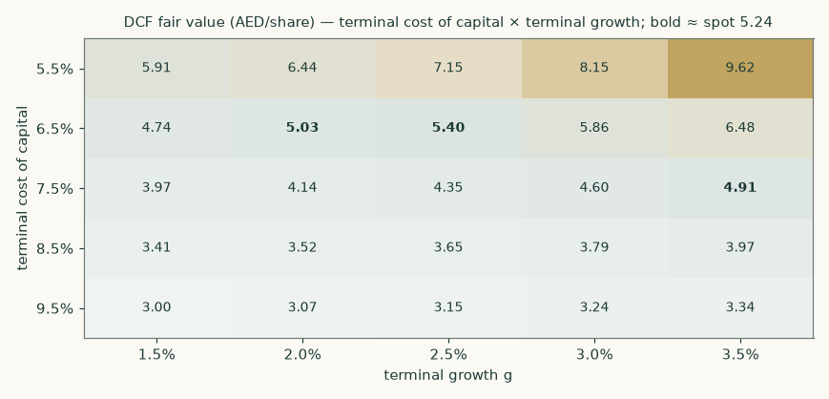
Figure 3 — DCF fair value across terminal cost of capital × terminal growth.
Driver (whole-model re-runs) | -2 steps | -1 | Base | +1 | +2
Beta (rightmost = the Dubai-index cross-check) [0.60 … 1.09] | 5.32 | 4.81 | 4.35 | 3.88 | 3.51
Fuel path multiplier [0.85× … 1.15×] | 5.90 | 5.12 | 4.35 | 3.57 | 2.79
Passenger volumes [0.90× … 1.10×] | 3.54 | 3.94 | 4.35 | 4.75 | 5.15
Fare per passenger [0.94× … 1.06×] | 2.53 | 3.44 | 4.35 | 5.25 | 6.16
Fleet capex [0.80× … 1.30×] | 4.93 | 4.64 | 4.35 | 3.91 | 3.47
JV value in the bridge (AED mn) [363 … 3,800] | 4.35 | 4.60 | 4.77 | 4.89 | 5.10
Working capital / revenue [-58% … -70%] | 4.16 | 4.25 | 4.35 | 4.44 | 4.53

Each cell is a complete revaluation at the perturbed driver, all else held. Where the perturbation moves the cost of capital, the accretion from the balance-sheet date to the pricing date moves with it — the accretion is a cost-of-equity effect, so holding it fixed while changing the rate would be inconsistent. (An earlier edition did hold it fixed, which left the base column of the rate rows reading AED 3.54 against a headline of 4.35; corrected, and the agreement is now checked automatically on every rebuild.) The middle column is the base value of AED 4.35 on every row EXCEPT the JV row, whose base (the audited carrying value) is its leftmost column — the remaining columns price successively richer JV framings — and the beta row, whose RIGHTMOST column is the Dubai-index cross-check described in 1.8.
2 Technical and price structure
The price closed 5.24 above a falling 20-day (5.09), a rising 50-day (5.20) and a rising 200-day (4.82). Momentum is neutral: RSI(14) is ~54 and the daily ATR near 0.15 (~2.9%) points to a normal tape. MACD (12·26·9) is below zero but turning up (−0.02 / −0.06 / +0.04). Over the last year it has ranged 3.63–6.03; the last close sits 13% below that high and 44% above that low.
Trading above the whole moving-average stack, on a rising 200-day
How the levels are computed (so they are checkable): support and resistance are recency-weighted clusters of fractal pivot highs/lows over the full cleaned trading history — not hand-drawn lines — with RSI(14) and ATR(14) on Wilder smoothing and the 52-week range from the same series; a cluster may sit slightly outside the 52-week range when older pivots carry the weight.
Level | AED | Reading
Resistance 3 | 6.03 | the 52-week high zone
Resistance 2 | 5.62 | minor supply shelf
Resistance 1 (nearest) | 5.40 | A daily close back above 5.40 would clear the nearest resistance and open the 6.03 zone.
Last close (2026-08-07) | 5.24 | above the whole moving-average stack
Support 1 (nearest) | 3.80 | A close below 3.80 would break the nearest support and open the 3.60 zone.
Support 2 | 3.68 | pivot cluster
Support 3 | 3.60 | the deeper shelf

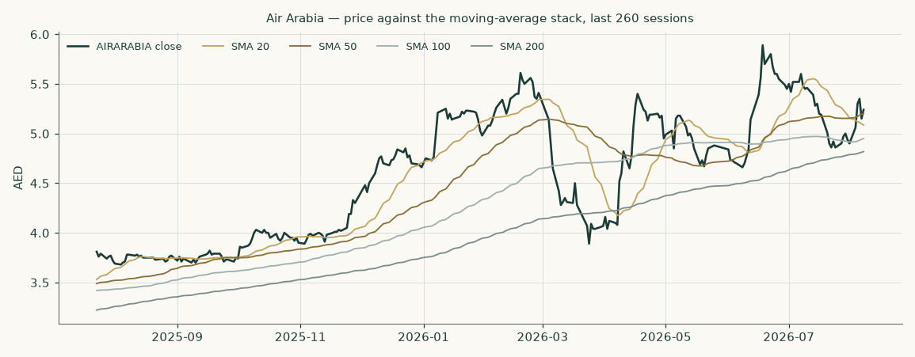
Figure 4 — price against the moving-average stack, last 260 sessions.
3 A probabilistic price map
From the 2026-08-07 close of AED 5.24, 50,000 simulated price paths — volatility fitted to this stock's own trading history, drift anchored to the risk-free rate net of the 5.7% trailing dividend yield — give the following bands:
 | One month | Three months
Check date | 2026-09-07 | 2026-11-09
5th percentile | 4.47 | 3.96
25th percentile | 4.93 | 4.71
Median | 5.23 | 5.22
75th percentile | 5.56 | 5.79
95th percentile | 6.14 | 6.89
Probability of finishing above spot | 49% | 49%
Probability of +10% or better at the check date | 14% | 26%
Probability of −10% or worse at the check date | 13% | 25%
Probability of touching +10% at any point | 24% | 49%
Probability of touching −10% at any point | 21% | 46%

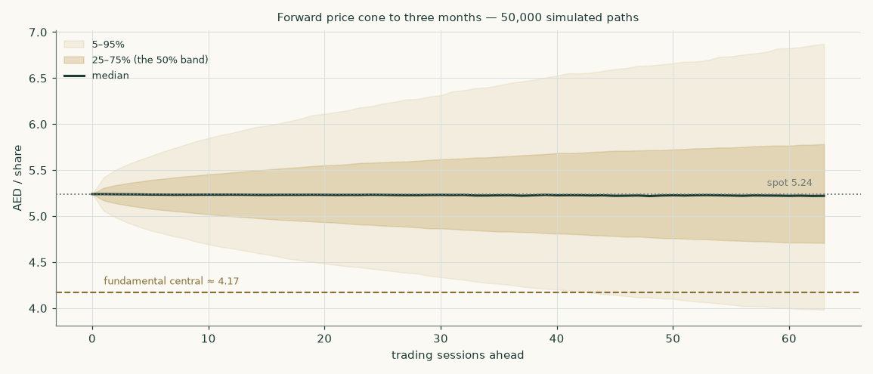
Figure 5 — the three-month price cone.
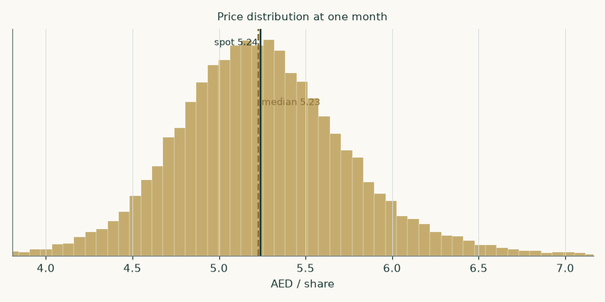
Figure 6 — the one-month terminal price distribution.
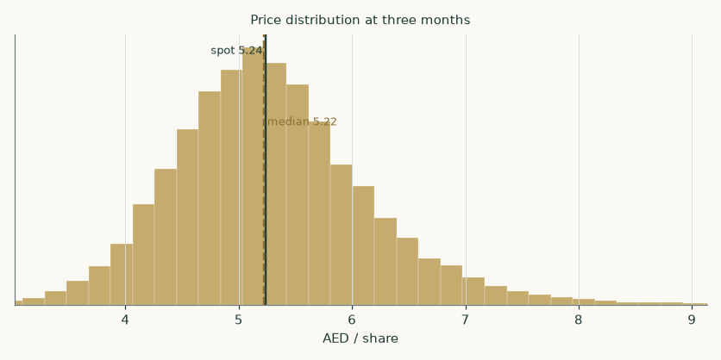
Figure 7 — the three-month terminal price distribution.
How much to trust these bands. Backtested on this stock's own history — every quarter-length window from 2012 to 2026, 58 of them — the simulation's probability bands beat a naive random-walk benchmark by a small margin on a standard probabilistic accuracy score (+0.7%), and over the most recent four-plus years the two are statistically indistinguishable: an honest, calibrated map rather than a crystal ball. Realised prices landed inside the 80% band 79% of the time and inside the 90% band 86% — about as close to nominal as 58 windows allow. The recent windows lean toward outcomes in the upper half of the bands (the share nearly tripled from its 2022 lows), which is visible in the distribution of where outcomes fell but does not reject uniformity on a standard test of the full history. These full-history figures are the ONE set of calibration statistics, quoted identically in the companion workbook (an earlier draft quoted a recent-window subset there — 83%/89% — without labelling the different window set; corrected).
4 Comparison of the lenses
Lens | What it sees | What it misses
DCF (base) | the fleet build-out's cash cost, the negative-working-capital engine, fuel relief from 2027 | the JV network's value beyond book; anything after FY2030 except through the terminal
DCF (JV capitalised) | the ventures as going concerns at a growth multiple | their startup risk — Saudi DMM is pre-operational, two ventures are being wound up
Relative | what the world pays for LCC earnings today | Air Arabia's net cash and JV optionality are only partly in sector multiples
Normalised | through-cycle earning power at current scale | growth beyond FY2026 scale
Book | audited equity and a sustainable return | slots, brand and the ventures — none on the balance sheet at economic value

All four lens bases sit between AED 3.43 and AED 5.17 — a tight cluster 20% below the market price. The market, in other words, is already paying for the JV-capitalised framing plus some of the order book's post-2030 tail. That is not irrational; it is simply not conservative, and this study's job is to show exactly which assumptions you must accept to get there.
5 Catalysts to watch
- Half-year 2026 results (mid-August 2026). The first full print after the airspace disruption: watch whether Q2 yields held the Q1 record load factor, and the first disclosure of summer bookings.
- The fuel path. The official curve has Brent averaging ~$82 in 2026 falling toward ~$65 in 2027; the airline association assumed ~$95 with jet fuel near $152. Defined precisely: each quarter the relief is deferred costs (fuel/pax FY26 − FY27) × FY27 passengers × (1−t) ÷ 4 ≈ AED 0.02 per share; the study prices both full paths side by side.
- Air Arabia DMM (Saudi Arabia). The 49% Dammam carrier signed in 2025: an operating-certificate date, fleet plan or launch schedule would move the JV framing from optionality toward earnings.
- Abu Dhabi expansion. The venture with Etihad plans ~40% capacity growth into the space Wizz Air abandoned in September 2025 — its profit share doubled in FY2025 and it pays no dividend yet.
- Airbus deliveries. Nine A320-family aircraft arrived in FY2025; the neo ramp (lower fuel burn, more seats) is the whole volume story, and Airbus's output remains constrained.
- The dividend ladder. Raised in each of the last four years — +6.5 fils then three 5-fil steps to 30 fils (a 5.7% trailing yield). The base case HOLDS 30 fils through the dip year (a ~109% payout funded by net cash) rather than assuming a fifth raise; a raise with FY2026 results would signal the board reads the dip as behind it.
6 Reading the probability zones
Zone (three months) | AED range | Chance ending there | What it would likely mean
Deep left tail | below 3.96 | 5% | renewed regional escalation or a demand shock; the fundamental floor arguments engage
Lower band | 3.96 – 4.71 | 20% | fuel stays high into 2027 or H1 results disappoint; price approaches the base fundamental central
Middle band | 4.71 – 5.79 | 50% | the ordinary drift of a well-owned share; no verdict on the framings
Upper band | 5.79 – 6.89 | 20% | fuel relief confirmed plus JV news; the market extends the capitalised framing
Right tail | above 6.89 | 5% | a step-change: Saudi launch detail, a special distribution, or an index event

7 Caveats — and what would change our mind
- The owned-versus-leased delivery split is not disclosed. Fleet financing is the model's weakest driver even after the rebuild: ~7 owned and ~9 leased consolidated additions are assumed, the leased units now charged at their gross right-of-use value inside the cash flows (with the value-neutral-financing alternative noted at ~+0.09/share). A disclosure of the financing plan for the neo ramp would replace an assumption with a fact.
- Fuel hedge ratios are not disclosed. The accounts show commodity swaps and collars out to 2028 but not the hedged share; the fuel sensitivity therefore overstates both directions somewhat.
- The JV network's disclosure is thin. One page of 100%-basis figures per venture, once a year. The contested judgement would collapse if the group consolidated a venture or published venture-level guidance.
- Geopolitics. H1-2026 showed the exposure: seven airspaces closed and the group still held revenue flat. A longer closure or a Gulf escalation is the bear case, and no probability map built on history prices an unprecedented event well.
- Older filings are scanned images. FY2022–FY2024 statements were machine-read and every figure used was cross-checked against the following year's typed comparative column; the FY2024 revenue-line table in the FY2025 filing itself contains a footing inconsistency, recorded in the bibliography rather than repaired.
- What would move the fair value UP. Confirmed 2027 fuel relief (adds ~AED 1.7 to the DCF versus the high-fuel path), a Saudi launch date, consolidated venture disclosure, or a faster neo ramp at held load factors.
- What would move it DOWN. Fuel high for longer, a yield war as regional capacity returns, a delivery slip pushing the capex-revenue mismatch deeper, or the dividend ladder breaking.
Appendix A — Financial statements
A.1 Income statement, three years audited + five years forecast (AED mn)
 | FY2023 | FY2024* | FY2025 | FY26E | FY27E | FY28E | FY29E | FY30E
Revenue | 6,000 | 6,766 | 7,788 | 7,869 | 8,451 | 9,257 | 10,095 | 10,952
Direct operating costs (CASH basis, all columns) | 3,726 | 4,588 | 5,506 | 5,801 | 5,967 | 6,632 | 7,320 | 8,041
memo: depreciation & amortisation within audited direct costs | 618 | 615 | 582 | — | — | — | — | —
EBITDA | 1,886 | 1,833 | 1,891 | 1,663 | 2,056 | 2,171 | 2,291 | 2,398
Depreciation & amortisation | 647 | 649 | 622 | 720 | 810 | 900 | 980 | 1,060
Operating profit | 1,239 | 1,184 | 1,270 | 943 | 1,246 | 1,271 | 1,311 | 1,338
Other income | 113 | 132 | 197 | 213 | 230 | 248 | 266 | 282
Finance income | 210 | 251 | 241 | 213 | 118 | 70 | 34 | 4
Finance costs | 102 | 82 | 67 | 84 | 86 | 90 | 93 | 99
Share of JV and associate profit | 88 | 125 | 190 | 194 | 229 | 270 | 310 | 348
Profit before tax | 1,548 | 1,609 | 1,831 | 1,513 | 1,778 | 1,817 | 1,882 | 1,933
Income tax | 0 | 142 | 202 | 227 | 267 | 273 | 282 | 290
Profit for the year | 1,548 | 1,468 | 1,629 | 1,286 | 1,511 | 1,545 | 1,600 | 1,643
Attributable to owners | 1,547 | 1,467 | 1,628 | 1,286 | 1,511 | 1,544 | 1,600 | 1,643
Earnings per share (AED) | 0.33 | 0.31 | 0.35 | 0.28 | 0.32 | 0.33 | 0.34 | 0.35

*FY2024 as restated in the FY2025 filing (lease-rental revenue reclassified into revenue, maintenance provisions re-measured). FY2023 as reported. RESTATED after critique: every column now shows direct costs on the CASH basis, with the depreciation embedded in the audited direct-cost line broken out as a memo row — the table foots top-to-bottom in every column. Forecast profit before tax excludes the JV share, which is carried below the tax line; history keeps the audited presentation.
A.2 Selected balance-sheet roll-forwards (AED mn)
 | FY2023* | FY2024 | FY2025 | FY2026E | FY2028E | FY2030E
Fleet assets (owned + right-of-use + advances) | 6,415 | 6,709 | 8,671 | 10,126 | 12,916 | 15,526
Inventories | 49 | 53 | 97 | — | — | —
Trade and other receivables (current) | 859 | 824 | 896 | — | — | —
Cash and fixed deposits | 5,246 | 5,320 | 5,199 | — | — | —
Borrowings and lease liabilities | 2,279 | 2,101 | 2,781 | — | — | —
Payables, deferred income and provisions | 4,826 | 5,085 | 6,180 | — | — | —
Working capital (net, operating) | -3,918 | -4,208 | -5,187 | -5,036 | -5,925 | -7,009
Net debt (negative = net cash) | -2,967 | -3,218 | -2,417 | -504 | 1,640 | 3,380
Equity attributable to owners | 7,534 | 7,950 | 8,409 | 8,295 | 8,550 | 8,993

*FY2023 column is the restated 1-January-2024 position from the FY2025 filing — the same basis as FY2024/25. The forecast columns are four linked roll-forwards (fleet assets, working capital, net debt via the financing walk, equity via profit less dividends), not a fully articulated balance sheet: the block of non-operating assets and the JV carrying value are deliberately NOT rolled, and the residual between the asset rolls and the equity roll is that unrolled block plus the financing timing — the workbook carries the same construction with a check row.
A.3 Cash-flow markers (AED mn)
 | FY2023 | FY2024 | FY2025 | FY2026E | FY2028E | FY2030E
Net cash from operating activities | 2,304 | 2,279 | 2,860 | — | — | —
Fleet capex incl. aircraft advances | 378 | 580 | 2,328 | 2,000 | 1,900 | 2,000
Free cash flow to the firm (model basis) | — | — | — | -624 | 457 | 635
Dividends paid to owners | 700 | 933 | 1,167 | 1,400 | 1,400 | 1,400

Appendix B — Peer frame, risk register, research register
B.1 Peer frame (cross-check only, never a build source)
Carrier | P/E | EV/EBITDA | Basis (close of Friday 7-Aug-2026; filings as dated)
Ryanair | 12.6× | 6.5× | PRIMARY: FY26 EBITDA €3,747.6mn (op profit + dep), 1,039.2mn shares and €2.7bn net cash per the Q1-FY27 report
easyJet | 12.4× | 3.5× | FY25 (Sep y/e) results; aggregator cross-check
Wizz Air | n/m (near-zero FY26 earnings) | 4.7× | PRIMARY: FY26 EBITDA €1,318.3mn, net debt €4.9bn — the cheapest member, stated rather than suppressed
IndiGo | n/m (FX loss year) | 11.1× | TTM INR; aggregator
Pegasus | 8.9× | 6.6× | EUR-functional IFRS (no inflation restatement — corrected label)
Jazeera Airways | 17.7× FY2025 (≈24× TTM after a Q1-2026 loss) | n/d | KWD; computed from market cap / reported profit
US air-transport aggregate | 12.9× | 7.6× | profitable firms only — a survivorship screen, US dataset, January-2026
Air Arabia at spot | 15.0× | 11.7× ex-fees / 10.6× incl-fees | FY2025 audited; both EBITDA bases published

B.2 Risk register
Risk | Mechanism | Where it is priced
Regional conflict / airspace closure | traffic and yields, as in Q1-2026 | bear scenario; zones section
Fuel above the official curve | largest single cost line (37% of direct costs) | the high-fuel framing, priced in full
Delivery slippage | volume growth is fleet-led | capex/pax sensitivities
Yield compression as capacity returns | FY2027 fare give-back already assumed | fare sensitivity ±6%
JV startup losses (Saudi DMM) | associate line dip | FY2026 JV growth held flat
Concentration: Sharjah hub slots | home-market advantage is also single-point exposure | caveats; not separately priced
Rate path under the dollar peg | deposit income falls if the Fed cuts | deposit-yield path 4.4% → 3.7%

B.3 Research register — where the study's facts come from
The build rests on 10 company-official documents (audited statements FY2022–FY2025, the reviewed Q1-2026 interim, the 2025 annual report and corporate press releases), 3 investor-presentation sources, and official-sector references (UAE central bank, the finance ministry's bond auctions, the January-2026 country-premium dataset, the airline association's monitors, the US energy agency's outlook). Three searches returned nothing and are recorded as such: seat/ASK disclosure, fuel-hedge ratios, and the owned-versus-leased forward delivery split. The full input-by-input listing, with dates and what each source contributed, is the companion bibliography document.

Appendix C — Expert panel
Three experts, labelled Expert 1/2/3, each committed to a genuinely different method, each showing complete workings and naming, in advance, the evidence that would prove them wrong.
C.1 Expert 1 — earnings power at a justified multiple
Worldview: an airline is worth what its mid-cycle earnings can be sold for. Cycles wash out; buy earnings power, not forecasts. Works best on established franchises with stable unit economics; fails at inflection points — a fleet doubling or a startup network breaks "mid-cycle".
Line | Value
Mid-cycle EBITDA margin (FY2028E) | 23.4%
Applied to FY2028E revenue (AED mn) | 9,257
plus fees/other income, less depreciation → EBIT (AED mn) | 1,519
plus net finance income (AED mn) | -19
plus JV profit share (AED mn) | 270
× (1 − 15% tax) × (1 − minorities) ÷ 4,667mn shares → EPS (AED) | 0.322
× justified multiple 13× | 4.19
× anchor accretion 1.0496, less the 30-fils dividend → value at the anchor | 4.10
Range at 10× / 16× | 3.08 – 5.11

Named sensitivity: each turn of the multiple is AED 0.34 per share. Falsifier, stated in advance: if H1-2026 EBITDA margin prints below 20%, the mid-cycle margin is wrong and this valuation falls with it.
C.2 Expert 2 — owner cash earnings capitalised
Worldview: profits are an opinion, cash is a fact. Value the average free cash the firm will actually throw off, capitalise it at the perpetual rate, and credit the cash pile separately. Works best on steady cash machines; fails when today's capex buys tomorrow's cash flows — it penalises investment years.
Line | Value
Average FCFF, FY2028–30 (the steadier years, AED mn) | 550
plus after-tax net finance income (AED mn) | -51
plus 40% of the JV profit share, after tax (the cash-remitted part, AED mn) | 105
Owner cash earnings (AED mn) | 604
Grown one year at 2.5% and capitalised at 7.86% − 2.5%, plus half the net cash (haircut for permanence) | 12,772
Per share, × anchor accretion 1.0496, less the 30-fils dividend | 2.57
Range (tighter rate + full cash / wider rate, no cash) | 1.78 – 3.47

Named sensitivity: every AED 100mn of sustained FCFF is about AED 0.31 per share at these rates. Falsifier: if FY2027 FCFF prints negative again, the "steadier years" average is fiction and the capitalisation collapses.
C.3 Expert 3 — cash returns against the cost of capital
Worldview: value is created only where the return on invested capital beats the cost of that capital; everything else is accounting. Start from invested capital, add the present value of the spread. Works best where capital and returns are measurable; fails when the capital base itself is mispriced — negative working capital makes the measured base small and the measured return huge.
Line | Value
Invested capital, FY2025 (fleet + intangibles + working capital, AED mn) | 4,847
PV of excess returns, explicit years (AED mn) | 2,779
PV of terminal excess returns (AED mn) | 9,017
Implied enterprise value (AED mn) | 16,642
Through the same bridge (net cash, non-operating, JV at book, minorities), per share | 4.29
Range (spread fades 40–45% / JV capitalised) | 3.13 – 4.83

The measured spread: forecast returns on invested capital of 15% / 17% / 15% / 15% / 14% against a ~8.7–8.9% cost of capital. Falsifier: if the FY2026 return on capital prints below the cost of capital (the fuel-spike year makes it close), the excess-return engine is idling and the base collapses toward invested capital plus cash.
C.4 Cross-examination
- Expert 2 to Expert 1: "Your multiple prices earnings the company must spend to keep. EPS is after depreciation but before the AED 1.9–2.0bn of yearly fleet spending — in an expansion, cash EPS is far lower." Expert 1 CONCEDES half: the multiple is struck at 13× rather than Jazeera's 17.7× precisely to haircut expansion-cycle earnings; the other half stands because leased deliveries never pass through capex.
- Expert 1 to Expert 2: "You average FY2028–30 cash flow and call it perpetual — but you exclude FY2026-27 precisely because they are investment years, then keep none of the growth that investment buys." Expert 2 REJECTS: the capitalisation already grows the base at 2.5% forever; counting the fleet's growth twice is how airlines get overvalued.
- Expert 3 to both: "Neither of you measures whether growth CREATES value. My spread says it does — barely: a ~14% terminal return against a ~8.7% bar. If the neo ramp lands at lease rates that push the true capital base up, the spread halves." Both CONCEDE the point defines the bear case; Expert 1 notes the measured spread has beaten the bar every audited year on record.
- All three on the JV network: Expert 1 would capitalise it (earnings are earnings), Expert 2 counts only remitted cash, Expert 3 carries it at book because its capital is unmeasurable from outside. The study keeps the disagreement: it IS the two published framings.
C.5 The three in one room
Ask the panel for one number and they refuse; ask for a region and they agree more than their methods suggest: Expert 1 at AED 4.10, Expert 2 at 2.57, Expert 3 at 4.29 — a median of 4.10, 22% below the market. Where they genuinely differ is not arithmetic but posture toward the ventures and the order book: the panel's whole spread is a debate about value that has not yet reached the consolidated accounts.
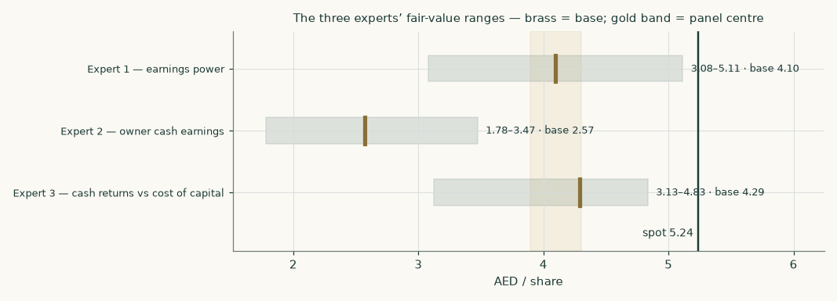
Figure 8 — the three experts' ranges against the market price.
C.6 Reading the divergence
Assumption | Expert 1 | Expert 2 | Expert 3 | Drives
Mid-cycle margin | 23.4% | n/a (cash basis) | inside the spread | E1 vs E2 gap
Investment years FY2026-27 | in the multiple | excluded from the base | in the spread years | E2's low base
JV network | would capitalise | cash remitted only (40%) | at book | the whole panel-vs-market gap
Net cash | implicitly in the multiple | half credited | fully in the bridge | E2 vs E3 gap
Terminal growth | in the multiple | 2.5% | 2.5% | small between panellists

About this series
Testahil publishes independent, educational valuation studies of listed companies across the Gulf, Egypt and beyond, each built the same way: primary sources only for the company's own numbers, a unit-level forecast wherever disclosure allows, four valuation lenses, a calibrated probability map for the share price, an adversarial expert panel — and a companion workbook that calculates rather than stores, so every assumption can be changed and every consequence seen. Forecast bands are tracked publicly and scored against their outcomes when they mature.
Disclosure & disclaimer
This document is educational analysis, not investment advice, not an offer, and not a solicitation. It contains no rating and no price target; all values are model outputs presented as ranges with their assumptions. The authors hold no position in Air Arabia PJSC and receive no compensation from any company mentioned. Figures are believed accurate as of 9 August 2026 but are not warranted; audited financial statements of Air Arabia PJSC remain the authoritative record. Investing involves risk, including loss of principal. Nothing here accounts for any reader's objectives or constraints. Seek licensed advice before acting.

