Testahil · Independent Valuation Study — Educational Analysis Not investment advice

Americana Restaurants International PLC
Abu Dhabi Securities Exchange: AMR · also listed on the Saudi Exchange as 6015 · restaurants and quick-service food · reports in US dollars
Valuation study, 9 August 2026 · market price AED 2.23 at the close of 7 August 2026 (USD 0.607 at the 3.6725 peg)
READ THIS FIRST. This is an educational valuation study, not investment advice, and it carries no recommendation and no price target. What it produces is a range of values from four independent methods, and a separate map of where the traded price could sit over the next one and three months. The two are different objects and are never blended: one is about what the business is worth, the other about how volatile its share price is.
WHAT THE NUMBERS REST ON. Every historical figure comes from the company's own audited consolidated financial statements and its own investor materials, read from its investor-relations library. No data vendor, broker note or news report is used as a source for anything the company itself reports. Outside figures appear only as cross-checks and are labelled as such wherever they occur.
THE ONE QUESTION THAT DECIDES IT. Americana's EBITDA margin went from 22.6% to 25.5% in a single year. If that gain is structural the shares are worth about AED 2.23; if it is cyclical, about AED 1.92. The market is at AED 2.23, between the two. Both readings are computed in full and published side by side in this report and in the companion workbook. Neither is averaged into the other.

Headline
Four methods, on their stated weights, put the equity between a weighted bear of AED 1.48 and a weighted bull of AED 3.33 a share (the widest single-lens extremes span 0.65 to 4.09), with a weighted central value of AED 2.15 — about 4% below the AED 2.23 the market is paying. That gap is not the interesting part of this study. The interesting part is that the whole of it, and rather more, turns on a single question the filings do not answer.
Americana operates 2,746 restaurants across twelve countries — KFC, Pizza Hut, Hardee's, Krispy Kreme and a widening tail of smaller brands — as a master franchisee. It does not own the brands; it pays for them, 5.6% of revenue in royalties last year, and in exchange it operates the restaurants, employs the people in them — 37,207 on the audited average full-time-equivalent measure, about 39,400 heads including part-time and contract staff — and carries the leases. That is the structural fact that governs everything else here, including why the company should not be valued on the multiples the brand owners command.
The last three audited years do not tell a simple story. Revenue was USD 2,413 million in 2023, FELL to USD 2,197 million in 2024, and recovered to USD 2,509 million in 2025 — so the company has only just regained the level it reached three years ago, while adding some 300 restaurants along the way. The recovery came with something more interesting than the revenue: in the first half of 2026 revenue rose 12.1%, the cost of food and packaging fell from 29.2% of sales to 27.4%, EBITDA margin expanded 290 basis points to 25.5%, and profit attributable to shareholders rose 59.2%.
Whether that margin gain holds is the study. Read as structural — procurement work, menu engineering, better economics in the delivery channel, all of which the company names — the shares are worth about AED 2.23. Read as cyclical — a friendly turn in traded food prices and a quiet period on promotion, both of which revert — they are worth about AED 1.92, which is BELOW the current price. The market price sits between the two readings, which is a reasonable place for it to sit.
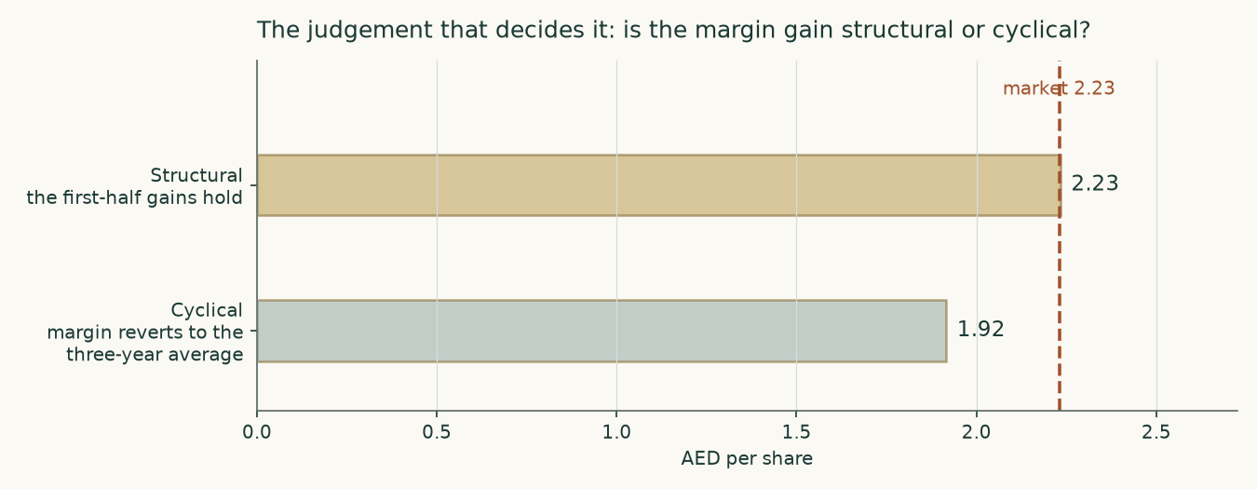
The question that decides it. Both readings are complete re-runs of the whole model, not a sensitivity applied to one number.
Valuation summary
Lens | Weight | Bear | Central | Bull | vs market | Terminal value share
Discounted cash flow | 50% | 1.37 | 2.23 | 4.09 | 0% | 74%
Relative multiples | 20% | 2.12 | 2.56 | 3.14 | 15% | —
Normalised earnings power | 20% | 1.56 | 2.07 | 2.57 | -7% | —
Book value and sustainable return | 10% | 0.65 | 1.04 | 1.39 | -53% | —
Weighted central (bear and bull weighted the same way) | 100% | 1.48 | 2.15 | 3.33 | -4% | —
Range across the lenses (unweighted extremes) | — | 0.65 | — | 4.09 | — | —
Expert panel median | — | — | 1.64 | — | -26% | —
Market price, 7 August 2026 | — | — | 2.23 | — | — | —

AED a share. The terminal value share is the portion of the cash-flow lens's enterprise value that sits beyond the fifth forecast year; it is shown again in the bridge from enterprise value to equity below.
The same table, the other way round — the open question priced twice
Reading of the margin | What it assumes | Value (AED) | vs market
Structural — the gains hold and improve slowly | The base case. Food and packaging stays near the 27.4% of revenue the company actually recorded in the first half of 2026, and the EBITDA margin runs from 25.4% to a peak of 25.4% before the growing delivery channel eases it to 24.9%. | 2.23 | 0%
Cyclical — the gains are competed away | The first half of 2026 is banked, and the EBITDA margin then reverts in a straight line to the three-year audited average of 22.8% by FY2030. | 1.92 | -14%

Neither is averaged into the other. The difference between them, 14%, is larger than the entire plausible range of the cost of capital.
The bridge from enterprise value to equity
Step | USD million | AED a share
Present value of the five forecast years | 1,348 | 0.59
Present value of the terminal value | 3,881 | 1.70
Enterprise value | 5,230 | 2.29
Less lease liabilities | (637) | (0.28)
Plus cash and bank deposits | 417 | 0.18
Less non-controlling interests | (1) | (0.00)
Equity attributable to shareholders | 5,008 | 2.19
Terminal value as a share of enterprise value | 74% | —

The company carries no bank debt. Its only borrowing is the capitalised lease estate, and it holds more cash and deposits than two-thirds of that liability.
Company overview
Americana Restaurants International PLC is registered in the Abu Dhabi Global Market and has been operating since 1969. It is the largest restaurant operator across the Middle East, North Africa and Kazakhstan. Its December 2022 initial public offering was the region's first concurrent dual listing: the same shares trade in Abu Dhabi and in Riyadh. Adeptio AD Investments holds 66.03%; its parent is owned equally by Mohamed Ali Rashed Alabbar and a subsidiary of the Public Investment Fund of Saudi Arabia.
The business is a master franchisee. It licenses KFC, Pizza Hut, Hardee's, Krispy Kreme, Costa Coffee, Peet's Coffee, Baskin-Robbins, TGI Fridays, Wimpy and Chicken Tikka, and has lately added two of its own: Malak Al Tawouk, acquired in the United Arab Emirates and Saudi Arabia, and carpo, launched in Qatar. Four power brands produce 94% of revenue. Home delivery is 52% of sales in the first half of 2026, against 42% in the same half two years earlier, largely through the company's own ordering application rather than third-party platforms.
Market | Restaurants at 31 Dec 2025 | FY2025 revenue (USD m) | Revenue per restaurant (USD 000) | Share of revenue | Restaurants at 30 Jun 2026
UAE | 652 | 845 | 1,295 | 33% | 664
Saudi Arabia | 766 | 630 | 822 | 25% | 761
Kuwait | 276 | 347 | 1,257 | 14% | 274
Egypt | 450 | 173 | 383 | 7% | 447
Morocco | 55 | 51 | 921 | 2% | 56
Lower Gulf | 287 | 258 | 899 | 10% | 279
Other markets | 263 | 238 | 905 | 9% | 265
Total | 2,749 | 2,541 | 924 | 100% | 2,746

Revenue is stated before intercompany eliminations, which is how the company discloses it. The Lower Gulf is Qatar, Oman and Bahrain; other markets are Kazakhstan, Iraq, Lebanon and Jordan. Revenue per restaurant is FY2025 revenue over the restaurant count at the SAME date, 31 December 2025; the June 2026 column is shown alongside so the direction of travel in each market is visible.
Two facts in that table matter more than the rest. The first is the spread in revenue per restaurant: a restaurant in the United Arab Emirates turns over USD 1,295 thousand a year, one in Egypt USD 383 thousand. Growth in Egypt therefore adds far less revenue per unit of capital than growth in the Gulf, which is why this study builds each market separately rather than applying one growth rate to the group. The second is concentration: the three Major Gulf markets produce 72% of revenue, and all three currencies are pegged to the US dollar. The company reports that 83% of revenue is earned in stable pegged currencies — which is why a dollar-reporting company with operations in Egypt and Kazakhstan is far less exposed to currency than its map suggests.
The three audited years, in one table
USD million | FY2023 | FY2024 | FY2025 | H1 2026
Revenue | 2,413 | 2,197 | 2,509 | 1,365
EBITDA | 546 | 484 | 596 | 348
EBITDA margin | 22.6% | 22.0% | 23.7% | 25.5%
Profit attributable to shareholders | 259 | 159 | 219 | 147
Restaurants at period end | 2,435 | 2,590 | 2,749 | 2,746
Cash and bank deposits | 384 | 295 | 417 | 383
Lease liabilities | 507 | 579 | 637 | 642
Bank debt | 4.4 | — | — | —

The 2023 restaurant count of 2,435 is the company's own disclosure in its FY2023 earnings release. EBITDA is reconstructed as operating profit plus depreciation, amortisation and impairments — it appears in no audited statement, and the releases publish a closely similar "Adjusted EBITDA". The 30 June 2026 cash figure includes the USD 22 million of treasury bills and deposit-linked notes reported that date as investments in financial assets; the earlier columns have no such line.
1 Fundamental valuation
Four lenses, applied independently and then weighted. The cash-flow model carries half the weight because the business is cash-generative and the estate is knowable restaurant by restaurant. The book lens carries the least, for reasons set out where it appears.
1.1 The cash-flow model
The model runs in US dollars, which is the company's reporting and functional currency, and converts to dirhams at the 3.6725 peg. Five explicit years, then a terminal value. The waterfall in full:
USD million | FY2026E | FY2027E | FY2028E | FY2029E | FY2030E
Revenue | 2,787 | 3,008 | 3,256 | 3,502 | 3,749
EBITDA | 708 | 760 | 819 | 876 | 934
EBITDA margin | 25.4% | 25.3% | 25.2% | 25.0% | 24.9%
Less depreciation and amortisation | (328) | (337) | (351) | (370) | (391)
EBIT | 371 | 414 | 458 | 495 | 531
NOPAT — EBIT after tax | 318 | 352 | 387 | 416 | 446
Add back depreciation and amortisation | 328 | 337 | 351 | 370 | 391
Less the recurring impairment charge | (9) | (9) | (10) | (11) | (12)
Less capital expenditure, including new leases | (356) | (381) | (408) | (432) | (455)
Less change in working capital | (-27) | (-22) | (-24) | (-24) | (-24)
Free cash flow to the firm | 317 | 329 | 355 | 379 | 406
Cost of capital | 9.7% | 9.7% | 9.7% | 9.7% | 9.7%
Discount factor | 0.912 | 0.831 | 0.757 | 0.690 | 0.629
Present value of free cash flow | 289 | 273 | 269 | 262 | 255

Taking a new restaurant lease is treated as an investment on this reading, so additions to right-of-use assets are charged in capital expenditure and the lease liability is deducted in the bridge. Change in working capital is a source of cash here, not a use, because the company collects at the till and pays suppliers on terms.
Terminal block | Value
Terminal-year NOPAT grown one year (USD m) | 460
Invested capital at the end of the forecast (USD m) | 905
Terminal return on incremental capital — faded to the payback-anchored target | 30%
Model-implied average return on closing capital (the bull reading) | 49%
Required reinvestment rate — growth over return on capital | 10.0%
Terminal growth | 3.0%
Terminal cost of capital | 9.71%
Terminal value (USD m) | 6,168
Present value of the terminal value (USD m) | 3,881
Terminal value as a share of enterprise value | 74%
Enterprise value (USD m) | 5,230
Equity value (USD m) | 5,008
Fair value per share at 31 December 2025 (USD) | 0.5963
Rolled to the 7 August 2026 anchor at the cost of equity, net of the USD 0.024 dividend paid in the window | x 1.0600 - 0.024
Fair value per share at the anchor (AED) | 2.23

74% of the enterprise value sits beyond the fifth year, which is why the terminal assumptions are sensitised on their own rather than buried in the total. The terminal return is NOT the model-implied average: the company's own store-economics table (USD 402 thousand a restaurant, three-year average payback, and the marginal brands beyond five years) says the incremental restaurant earns far less than the book average, so the return is faded to 30% and the reinvestment rate — growth over that return — is 10% of terminal profit. Every published value in this study is rolled from the 31 December 2025 valuation date to the 7 August 2026 price anchor at the cost of equity, net of the dividend paid between the two dates.
1.2 Book value and sustainable return
The company earned a 50% return on average equity in 2025. That number is spectacular and almost meaningless. An operator that leases every restaurant it runs and distributes about 92% of its earnings holds very little book equity — USD 435 million at the half year, against a market capitalisation of USD 5,100 million. A justified price-to-book multiple therefore divides a very large return by a very small base and is unstable in both directions. On a sustainable return of 42%, a terminal cost of equity of 10.22% and the same 3.0% terminal growth the cash-flow model uses, the justified multiple is 5.4 times book, which gives AED 1.04 a share. It is the lowest of the four lenses and carries the lowest weight. It is reported because leaving out the lens that disagrees would be dishonest, not because it is informative. One reconciliation note: the justified multiple implicitly retains growth over return — about a 93% payout — while the forecast distributes 85%; the difference is retained cash the firm-value lenses already count, so it is stated rather than adjusted.
1.3 Relative multiples
There is no clean comparable. The global names — Yum! Brands, Restaurant Brands, Domino's — are on the other side of Americana's contract: they collect royalties and carry EBITDA margins of 20% to 35% on a fraction of the revenue. The right comparators are the listed operator-franchisees — closest in structure, Devyani International and Sapphire Foods in India, which run the same two brands — though their published multiples may sit on a different lease-accounting basis and are read as indicative rather than precise.
Company | Market | EV / EBITDA | Price / earnings | EBITDA margin
Alamar Foods | Saudi Arabia | 115.5x | — | 2.6%
Herfy Food Services | Saudi Arabia | 17.6x | — | 7.6%
Halwani Bros | Saudi Arabia | 11.2x | 23.1x | 12.1%
Alsea | Mexico | 6.0x | 16.4x | 15.3%
Jubilant FoodWorks | India | 23.1x | 85.5x | 14.5%
Devyani International | India | 33.3x | — | 10.4%
Sapphire Foods | India | 27.6x | — | 9.5%
Yum! Brands | United States | 17.6x | 19.0x | 35.2%
Yum China | China | 9.5x | 17.5x | 15.1%
Restaurant Brands Intl. | Canada | 14.3x | 18.6x | 30.1%
Domino's Pizza | United States | 16.2x | 19.9x | 20.4%
Peer median (usable comparators) | — | 16.9x | 18.8x | —
Americana, FY2025 (the peers are as-published trailing figures) | United Arab Emirates | 8.9x | 23.3x | 23.7%

Outside market data as published by the aggregator, retrieved 9 August 2026. The medians take every row inside a stated band — 4 to 40 times for enterprise value to EBITDA, 5 to 45 times for price to earnings — which excludes one arithmetic artefact each (a peer on a depressed-earnings year whose multiple is noise, and one whose published figure appears to carry a basis error). The Indian franchisees' figures may sit on a pre-lease-capitalisation basis; the comparison is treated as indicative only. This table ANCHORS the two justified multiples — it is the reason 8.5 and 17 times sit below the medians — but no figure in it sources any number Americana itself reports.
The lens applies 8.5 times forward EBITDA — below the peer median — discounts the resulting enterprise value back one year, adds the intervening free cash flow and runs the same bridge. That gives AED 2.56 a share. The discount to the peer median is deliberate: Americana is the operator, it pays the royalty rather than receiving it, and it carries the whole lease estate on its balance sheet.
1.4 Normalised earnings power
This lens strips out growth and asks what the company earns at today's scale on a mid-cycle margin — and mid-cycle here means the MIDPOINT of the structural and cyclical FY2028 readings, 24.6%, not the structural path alone, which sits above every margin the company has ever recorded. Revenue at the FY2026 level of USD 2,787 million on that margin, depreciation, the recurring impairment charge and the full net finance result as they stand, taxed at 15.0% (the FY2027 rate on the rising path), gives normalised earnings of USD 273 million, or USD 0.0326 a share. At 17 times — just below the usable peer median — that is AED 2.07.
1.5 Synthesis — four lenses, one field
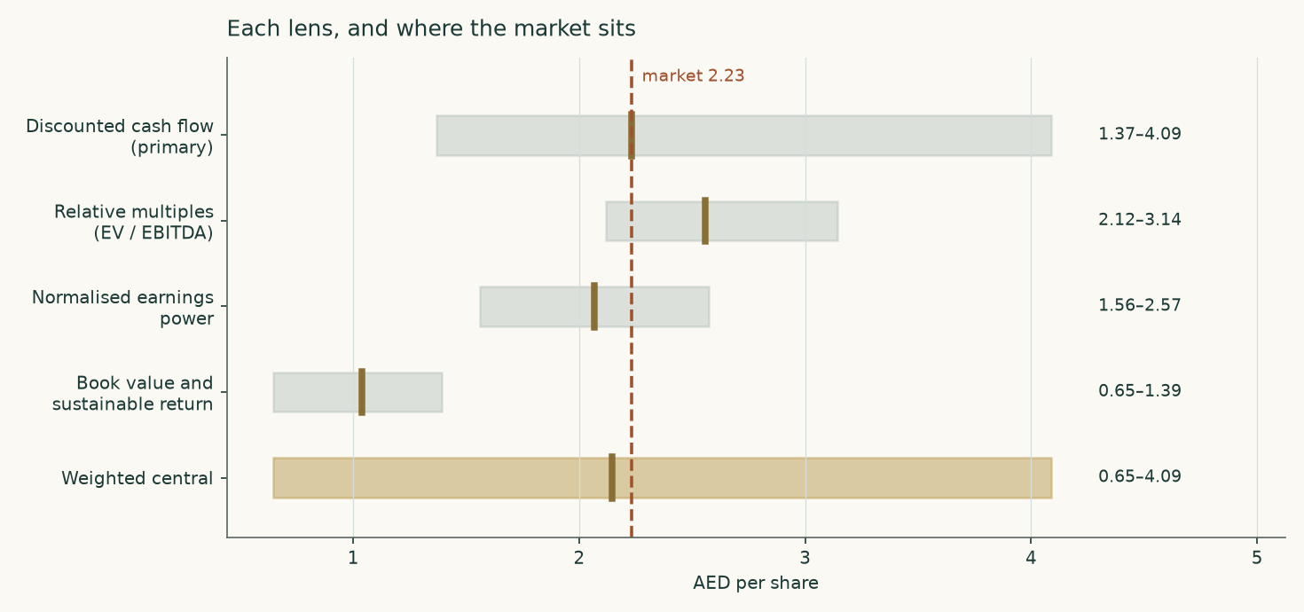
Each lens with its bear and bull bounds, and the market price. The bounds on the cash-flow lens are complete re-runs of the model, not one input flexed.
The three earnings-based lenses cluster between AED 2.07 and AED 2.56. The book lens sits far below them and is the outlier, for the reason given above. The weighted central value is AED 2.15.
1.6 The drivers — how revenue and cost are actually built
Revenue is not one growth rate. The company publishes its restaurant count country by country at each period end, and publishes segment revenue for the same units, so revenue is built as restaurants times revenue per restaurant across seven market units. The restaurant count grows on the company's own net-new-store programme; the revenue per restaurant grows on disclosed like-for-like sales growth, less a currency drag applied only in Egypt and the Kazakhstan-led group of markets, whose currencies are not pegged. The build reproduces reported revenue exactly in all three audited years, which is the test of whether it is a model or a decoration.
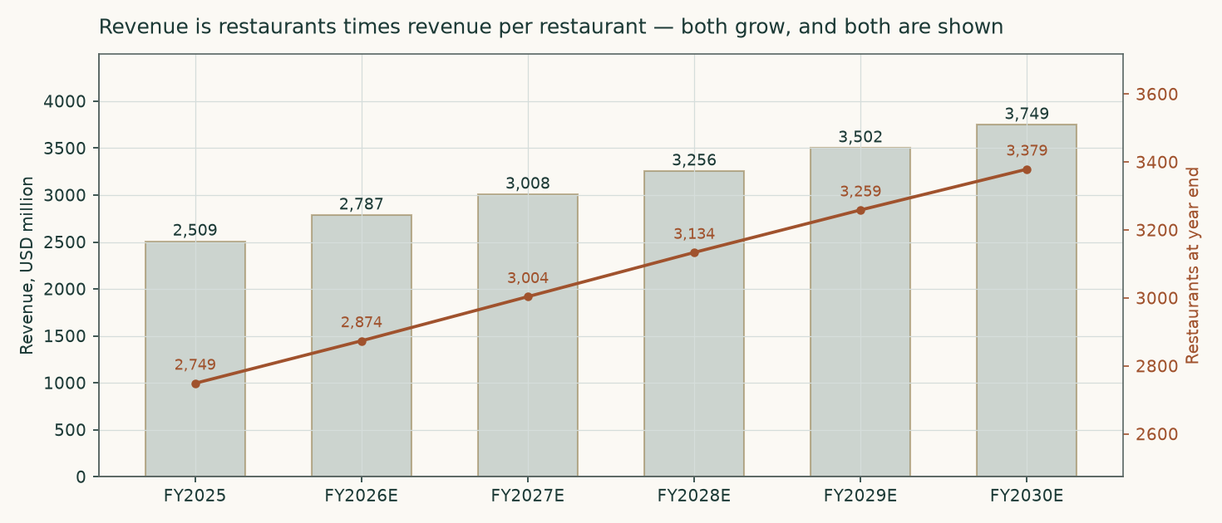
Revenue and the restaurant estate. Both sides of the volume-times-price build move, and both are shown.
Driver | How it is set | FY2026E | FY2030E
Net new restaurants | the 125 midpoint of the company's guidance for 2026, then 130, 130, 125, 120 — a two-year rise before the taper. The estate SHRANK by three in the first half of 2026, so the full-year guide needs about 128 net openings in the second half; the company reaffirmed it on 28 July | 125 | 120
Like-for-like sales growth | set just below the 6.3% delivered in the first half of 2026, converging on long-run inflation in the pegged markets | 5.5% | 3.5%
Restaurants at year end | an output of the two rows above | 2,874 | 3,379
Revenue (USD m) | an output | 2,787 | 3,749
Currency drag on dollar revenue per restaurant | Egypt 2.5% a year, the Kazakhstan-led markets 1.5%, Morocco 0.5%, every pegged market zero — set from the inflation differentials, though the two most recent disclosed readings ran the other way (Egypt dollar revenue +29% in FY2025, +23% in H1 2026) | — | —
EBITDA margin | an OUTPUT of the cost stack below, never an input — and the unit-built staff and delivery lines now cap it: the margin peaks near 25.4% and eases as the delivery channel grows | 25.4% | 24.9%

The cost side gets one escalator per driver class. A globally traded food basket does not move with local wages, and local wages do not move with fuel, so applying a single blended inflation rate across all of them would manufacture a margin path out of nothing:
Cost class | What drives it | FY2023 | FY2024 | FY2025 | FY2030E
Food, filling and packing materials | Traded food commodity basket | 31.1% | 29.2% | 28.5% | 27.1%
Brand royalties | Contractual percentage of branded food and beverage sales | 5.5% | 5.5% | 5.5% | 5.5%
Staff | Wages in the operating countries | 18.9% | 19.2% | 18.4% | 18.2%
Home delivery and transportation | Delivery-channel volume and fuel | 4.4% | 6.1% | 7.2% | 7.9%
Advertising and business development | Managed percentage of sales | 4.7% | 4.5% | 4.4% | 4.2%
Utilities and communication | Energy tariffs | 2.8% | 3.0% | 2.9% | 2.8%
Short-term and variable rent | Property rents | 2.1% | 2.0% | 1.7% | 1.7%
Maintenance and repairs | Domestic services | 2.9% | 3.0% | 2.9% | 2.8%
All other operating costs | the residual of the three expense notes | — | — | 5.3% | 5.3%
Other income | held at its FY2025 share — the half-point the margin needs beyond the cost lines | — | — | 0.5% | 0.5%

Each line as a share of revenue; the FY2030 staff and delivery shares are OUTPUTS of their unit builds — staff is headcount per restaurant times a wage growing at the audited 6% a year, and delivery is the channel share times a cost per delivered dollar — so the two biggest operating lines are built from volume and price, not escalated. Royalties are contractual and held flat. The food line is anchored on the 27.4% actually recorded in the first half of 2026.
1.7 The crux
The crux is the food and packaging line, and behind it the whole margin. Between the first half of 2025 and the first half of 2026 it fell from 29.2% of revenue to 27.4%. On 2026 revenue of about USD 2,787 million, that 180 basis points is worth roughly USD 50 million of EBITDA a year — more than a fifth of the group's entire operating profit. The company attributes it to procurement scale, menu optimisation and supplier negotiation. Those are real capabilities and they do not evaporate. But the same 180 points are equally consistent with a favourable turn in globally traded food prices and a period of restrained promotional intensity across the region, and those do revert.
Nothing in the filings settles it, and no amount of further analysis of the published numbers will. So the study does not pick. It computes both, publishes both, and lets the reader see that the market price sits between them:
 | Structural — the gains hold and improve slowly | Cyclical — the gains are competed away
EBITDA margin, FY2030E | 24.9% | 22.8%
Value per share (AED) | 2.23 | 1.92
Against the market price | 0% | -14%

The observable test is quarterly and public, and two of its readings are already in. The company disclosed the full quarterly series with its half-year results: 29.2% in the first and second quarters of 2025, 28.5% in the third, 27.1% in the fourth, then 27.3% in the first quarter of 2026 and 27.5% in the second. The trough was the fourth quarter of 2025, and the ratio has RISEN in the two quarters since — the two most recently disclosed readings lean toward the cyclical column, not the structural one. If the ratio holds near 27% through the second half of 2026 the structural reading is winning; a drift back toward 29% would confirm the cyclical one.
1.8 Macro, country risk and the cost of capital
The company reports in dollars and earns 83% of its revenue in currencies pegged to the dollar, so the cost of capital is built in dollars. The risk-free rate is the US ten-year Treasury yield less the US sovereign's own default spread, which prevents sovereign risk being counted twice — once in the base rate and again in the premium. Country risk then enters once, through an equity risk premium blended across all twelve operating countries on their share of revenue.
Country | Share of revenue | Equity risk premium (ratings) | Equity risk premium (credit-default-swap)
UAE | 33.2% | 4.81% | 4.81% *
Saudi Arabia | 24.8% | 4.94% | 5.51%
Kuwait | 13.7% | 5.07% | 5.40%
Egypt | 6.8% | 13.48% | 9.52%
Kazakhstan | 5.2% | 6.18% | 5.89%
Qatar | 3.9% | 4.81% | 4.90%
Oman | 3.6% | 6.92% | 5.89%
Bahrain | 2.7% | 11.01% | 8.65%
Jordan | 2.0% | 8.65% | 8.65% *
Morocco | 2.0% | 7.30% | 6.00%
Iraq | 1.5% | 13.48% | 10.00%
Lebanon | 0.6% | 31.40% | 31.40% *
Revenue-weighted blend | 100% | 6.20% | 5.93%

* No sovereign credit-default-swap is published for these countries, so the ratings-based premium is carried in that column and the substitution is flagged here rather than hidden. Country premiums as published by Aswath Damodaran of NYU Stern, January 2026 edition, read from the original data file. Revenue shares for the four separately disclosed countries are the company's own; within the two multi-country segments the split follows restaurant count, which is the only published physical measure at that level.
Component | Ratings basis | Credit-default-swap basis | Where it comes from
US ten-year Treasury yield | 4.65% | 4.65% | close of 7 August 2026
Less the US sovereign spread | 0.22% | 0.43% | the same source as the premium added back
Risk-free rate | 4.43% | 4.22% | the difference
Beta | 0.930 | 0.930 | the company's own weekly share returns
Blended equity risk premium | 6.20% | 5.93% | the table above
Cost of equity | 10.20% | 9.73% | built from the rows above
Cost of debt | 6.72% | 6.72% | the company's own borrowing rate — see below
Cost of debt after tax | 5.75% | 5.75%
Debt weight | 11.1% | 11.1% | lease liabilities over lease liabilities plus market capitalisation
Weighted cost of capital | 9.70% | 9.29%
Terminal cost of capital | 9.71% | — | on the terminal risk-free rate

Both premium bases are published. The valuation runs on the ratings basis; the credit-default-swap basis is 35 basis points cheaper and would raise the cash-flow value slightly.
The cost of debt deserves a note, because Americana has no bank debt at all — none at the end of 2024, none at the end of 2025, and USD 42 thousand of commitment charges in the whole of last year. Its only borrowing is the lease estate. The rate used here is therefore the company's own incremental borrowing rate, read straight out of its lease accounting: USD 40.9 million of lease finance cost over an average lease liability of USD 608 million, or 6.72%. The same construction on the 2024 accounts gives 5.95%. Determining that rate is one of the two matters the auditor singles out as most significant in the audit. It sits above the Abu Dhabi sovereign, which is what a corporate borrowing in the same currency must do.
Evidence on the cost of debt | Rate
Company incremental borrowing rate implied by FY2025 lease accounting | 6.72%
The same construction on the FY2024 accounts | 5.95%
Abu Dhabi ten-year sovereign, US dollars (Treasury plus the February 2026 new-issue spread of 55 basis points) | 4.90%
US ten-year Treasury | 4.65%
Bank debt outstanding at 31 December 2025 | none

Beta is measured on the company's own share price against the published index of the exchange those shares trade on, the FTSE ADX General Index, whose history runs to 2026-07-24. The regression uses 183 complete weekly observations over windows labelled 2022-12-30 to 2026-07-17 — 3.55 years, the whole life of the listing, which began in December 2022 — and both series are screened for data quality before either is used. The result carries the lead-lag correction that applies when a stock and its index need not react to the same news on the same day: beta 0.930, standard error 0.412, R-squared 8.4%.
The imprecision is the honest headline here rather than a footnote. A 90% confidence interval on this estimate runs from 0.25 to 1.61, which is wide enough to contain almost every figure a reasonable person might argue for, so no part of this valuation should be read as resting on beta being exactly right. What can be said is that the level is corroborated: adjusting the raw coefficient toward the market in the standard way gives 0.953, and the company sits, as one would expect of a consumer operator, below the property and banking names that dominate this index and above a defensive food producer.
Three earlier estimates are on the record and none is used. Before the Abu Dhabi index history was available this study regressed the company's Riyadh-listed line against the Saudi index and obtained 0.894 — the same shares, but priced against a different country's market cycle. An equally weighted basket of eighteen UAE-listed names gave 0.586, and a US-listed fund tracking a UAE index, which prices hours after the Abu Dhabi close, gave 0.469. The last two understated the figure by roughly half. A basket of the companies this series happens to cover is not a market: it changes whenever another company is added to the coverage, it mixes two exchanges together, and it contains the very company being valued, so the shares would be regressed partly against themselves.
1.9 Sensitivity
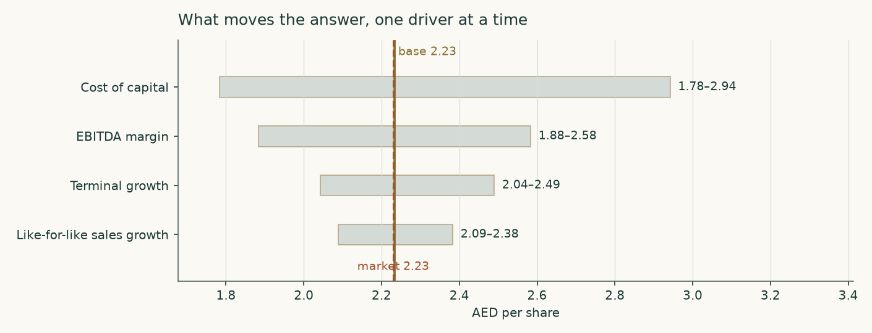
One driver at a time. The margin row is the widest, which is why the margin question is the study rather than a footnote.
Cost of capital \ terminal growth | 2.0% | 2.5% | 3.0% | 3.5% | 4.0%
8.20% | 2.60 | 2.76 | 2.94 | 3.17 | 3.45
8.95% | 2.29 | 2.41 | 2.54 | 2.70 | 2.90
9.70% | 2.04 | 2.13 | 2.23 | 2.35 | 2.49
10.45% | 1.84 | 1.91 | 1.99 | 2.08 | 2.18
11.20% | 1.67 | 1.72 | 1.78 | 1.85 | 1.93

AED a share. Each cell is a complete re-run of the model, including the unit build.
Cost of capital \ EBITDA margin | -2pp | -1pp | +0pp | +1pp | +2pp
8.20% | 2.49 | 2.72 | 2.94 | 3.17 | 3.39
8.95% | 2.15 | 2.35 | 2.54 | 2.74 | 2.94
9.70% | 1.88 | 2.06 | 2.23 | 2.41 | 2.58
10.45% | 1.67 | 1.83 | 1.99 | 2.14 | 2.30
11.20% | 1.50 | 1.64 | 1.78 | 1.93 | 2.07

The margin axis moves the answer further than the cost-of-capital axis across any range either could plausibly take.
2 Price structure
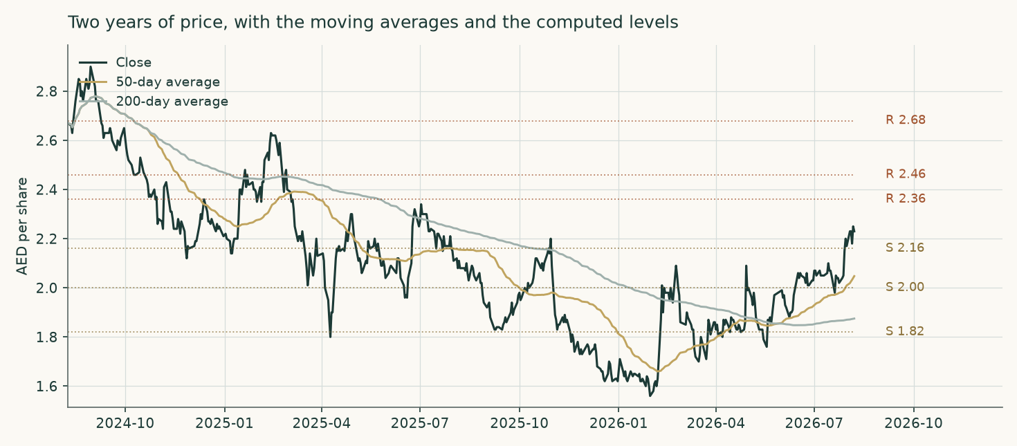
Two years of closing prices with the 50-day and 200-day averages, and the support and resistance levels computed from the same series.
The price closed 2.23 above a rising 20-day (2.11), a rising 50-day (2.05) and a rising 200-day (1.87). Momentum is firm: RSI(14) is ~64 and the daily ATR near 0.06 (~2.8%) points to a normal tape. MACD (12·26·9) is positive and rising (+0.05 / +0.04 / +0.01). Over the last year it has ranged 1.55–2.28; the last close sits 2% below that high and 44% above that low.
A daily close back above 2.36 would clear the nearest resistance and open the 2.68 zone. A close below 2.16 would break the nearest support and open the 1.82 zone.
Level | AED | Distance from the close
Resistance 1 | 2.36 | 5.8%
Resistance 2 | 2.46 | 10.3%
Resistance 3 | 2.68 | 20.2%
Support 1 | 2.16 | -3.1%
Support 2 | 2.00 | -10.3%
Support 3 | 1.82 | -18.4%

Computed from the daily price series used throughout this study (13 December 2022 to 7 August 2026, delivered in the study repository). Levels are clustered pivot highs and lows in the same cleaned price series the valuation and the probability map use; the first of each is the nearest to the last close. This is a description of the tape, and carries no view on value.
3 The probability price map
This section is about the share price, not the business. It answers a different question from everything above: given how this share has actually behaved, where could it be in one and three months? It is never blended with the valuation.
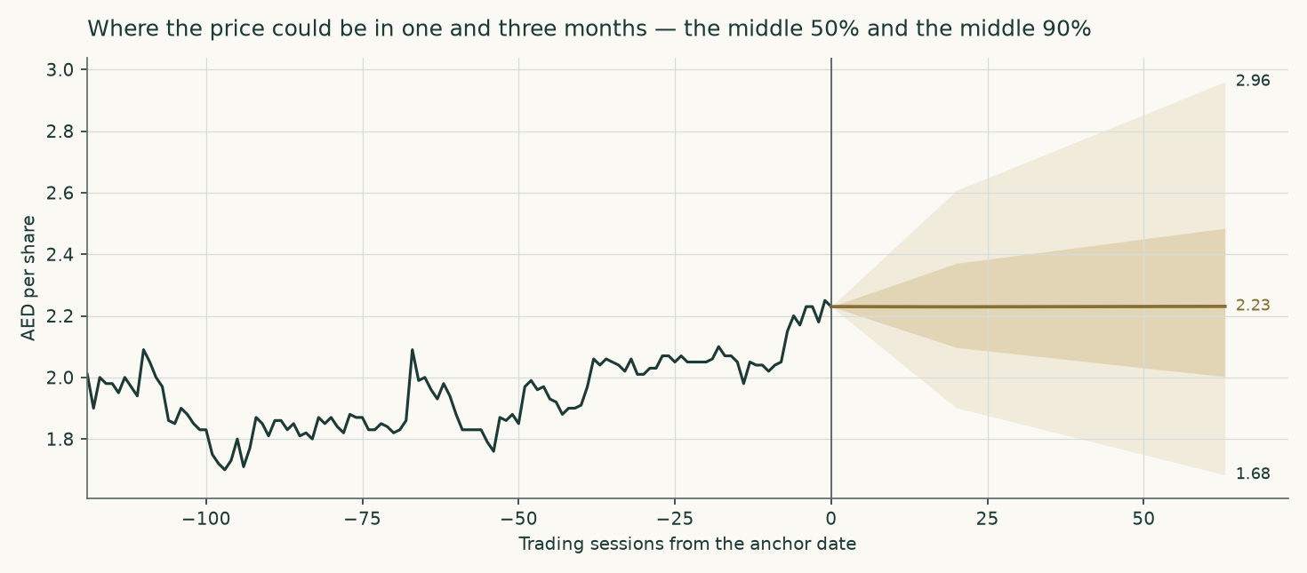
The middle 50% and the middle 90% of simulated outcomes, from the last close.
Horizon | 5th | 25th | Median | 75th | 95th | Chance above the market
One month, to 2026-09-07 | 1.90 | 2.10 | 2.23 | 2.37 | 2.61 | 50%
Three months, to 2026-11-09 | 1.68 | 2.00 | 2.23 | 2.48 | 2.96 | 50%

AED a share. Fifty thousand simulated paths from the close of 7 August 2026.
Level event | One month | Three months
Finishes 10% or more above the market price | 15% | 28%
Finishes 10% or more below | 13% | 25%
Touches 10% above at any point | 25% | 51%
Touches 10% below at any point | 21% | 47%

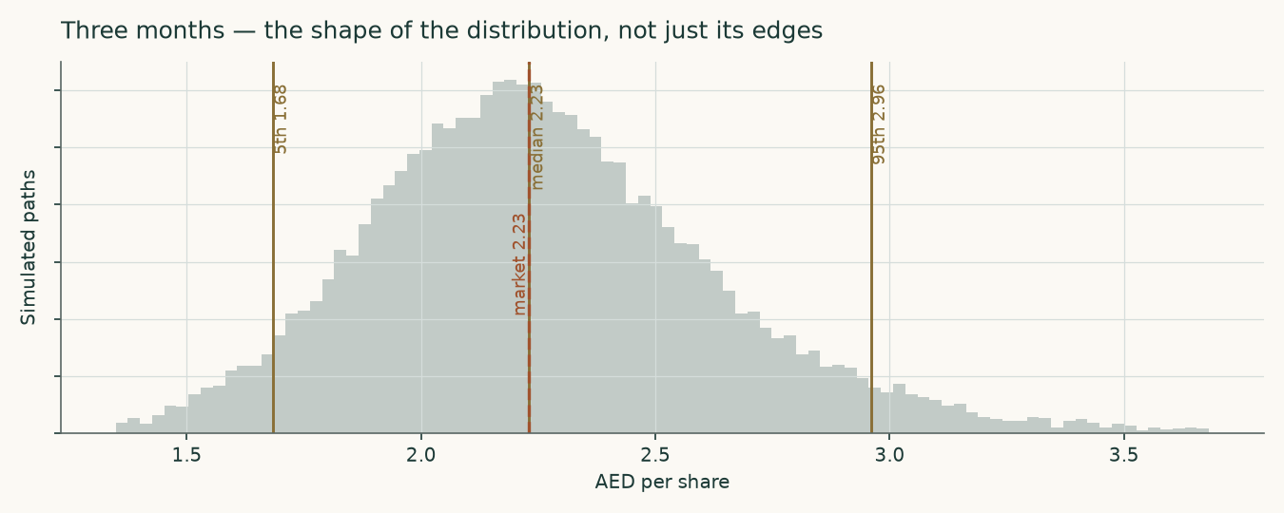
Three months — the whole distribution, not just its edges.
How much confidence this map deserves
The honest answer is: less than for most of the shares we cover, and here is exactly why. Americana listed on 12 December 2022. Its own price history supports only 10 non-overlapping three-month windows once a year of history is set aside to estimate volatility from — not the five years a proper single-name track record needs. Over those 10 windows the simulation scored -0.0054 against a random walk anchored on the same interest and dividend carry, which is marginally NEGATIVE: on this name's own short record the method has not beaten the simple benchmark. The spread of outcomes was well shaped — the realised price fell inside the 90% band in 100% of windows and inside the 80% band in 80% — and a formal test of whether outcomes land uniformly across the distribution is passed comfortably on the chi-square (p=0.35) and only marginally on the Kolmogorov-Smirnov (p=0.086). But ten windows cannot carry a strong claim either way.
The width and shape of the band are not fitted on Americana alone; they come from a pooled set of 19 UAE-listed shares. That set does carry the longer record: 271 windows over 4.25 years, on which the method scored +0.0065 against the same benchmark — positive, though the confidence interval still straddles zero. There the calibration is genuinely good: outcomes fell inside the 50%, 80% and 90% bands 53%, 80% and 89% of the time against targets of 50%, 80% and 90%, and the uniformity tests are comfortable (chi-square p=0.83, Kolmogorov-Smirnov p=0.808). The pooled window is 4.25 years rather than five because the United Arab Emirates changed its trading week in January 2022 and the earlier pattern of trading days is not comparable.
So: treat the shape of this distribution as reliable and the claim that it beats a coin toss as unproven for this particular share. Read the band, not the midpoint.
4 Comparison of the lenses
Lens | What it is really measuring | Central (AED) | What would move it most
Discounted cash flow | the cash the restaurants generate, discounted | 2.23 | the EBITDA margin, then terminal growth
Relative multiples | what the market pays other operators for EBITDA | 2.56 | the multiple chosen, which no peer settles
Normalised earnings power | mid-cycle earnings at today's scale | 2.07 | the mid-cycle margin, again
Book value and sustainable return | the return earned on a very small book | 1.04 | almost anything — the base is tiny

Three of the four converge, and they converge because they share an input: the margin. That is not four independent confirmations — it is one judgement seen from three angles. The reader should discount the apparent agreement accordingly. The fourth lens disagrees for a structural reason that has nothing to do with the margin, and is weighted down for it.
A second question, answered twice and worth less than expected
Americana leases essentially every restaurant it operates. At 31 December 2025 the capitalised lease liability was USD 637.5 million and the right-of-use asset USD 610.8 million — 35% of total assets, and larger than the entire owned property and equipment base. Determining the discount rate inside those leases is one of the two key audit matters in the filing. Whether that estate is treated as borrowed money or as next year's rent is a live question, so it is answered twice.
Reading | Value (AED) | Enterprise value (USD m) | Deducted in the bridge (USD m)
Leases capitalised, as the accounts present them | 2.23 | 5,230 | 220
Leases as an operating cost | 2.20 | 4,511 | -417

The two readings differ by under two percent once each is built consistently — charging the right-of-use additions as investment on the capitalised reading, and charging the whole rent bill as a cost on the other. That is a result worth stating: the accounting choice that dominates the balance sheet turns out not to be the thing that decides the value.
5 Catalysts
What to watch | When | Why it matters
Cost of food and packaging as a share of revenue | every quarter | the single observable test of the structural-versus-cyclical question; near 27% supports the higher value, drifting to 29% supports the lower
Like-for-like sales growth | every quarter | management guides to mid-single digits for 2026; the model assumes 5.5% in 2026 tapering to 3.5%
Net new restaurants against the 120–130 guidance | full year 2026 | the volume half of the build; the model takes the 125 midpoint
Malak Al Tawouk integration and the Kuwait launch | 2026–2027 | the first owned brand at scale, and the first test of whether the group can build rather than only license
The ADNOC Distribution partnership | over five years | preferential access to 200 high-traffic sites on a shared capital model — cheaper volume growth than the base case assumes
Domestic minimum top-up taxes in the remaining jurisdictions | 2026–2028 | the effective rate has gone from 4% to 14% in two years; the model carries it to 16%
The dividend | twice a year | USD 201.6 million was declared against 2025 and USD 100.8 million as an interim against 2026; a cut would end the distributable-cash reading of the shares

6 Reading the probability zones
The map in section 3 is not a forecast and the median is not a target. It says that if this share behaves over the next three months as it has behaved historically, and if nothing arrives that its past does not contain, then the middle half of the outcomes falls between AED 2.00 and AED 2.48, and nine times in ten it lands between AED 1.68 and AED 2.96.
The centre of that distribution is close to today's price by construction, not by judgement: the simulation is anchored on the interest rate less the dividend yield, which is what a share price is expected to do in the absence of news. It contains no view whatsoever on whether the shares are cheap. That view lives in sections 1 and 4, and it is a different kind of statement on a different time horizon — a valuation says where the price should settle over years, not where it will be in November.
The right way to use the two together: the valuation range and the three-month band overlap substantially. The valuation's central value of AED 2.15 sits at the 40% mark of the three-month distribution — inside it, not beyond it. Nothing in this study requires the market to be wrong within three months for the valuation to be right; it requires only that the business goes on earning what it earns.
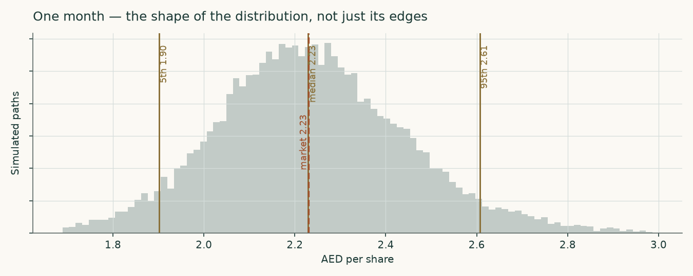
One month — a tighter distribution on the same construction.
7 Caveats, and what would change our mind
The margin. Stated once more because it is the whole study. If the food-cost gain of the last year reverses, the cyclical column is the right one and these shares are worth less than the market is paying, not more.
Three-quarters of the value is beyond year five. 74% of the enterprise value in the cash-flow lens sits in the terminal value. That is normal for a growing, cash-generative business at a 9.6% cost of capital, but it means the answer is sensitive to two numbers — terminal growth and the terminal cost of capital — that no filing can confirm.
The price record is short. The company listed in December 2022. Three and a half years of price history is enough to measure a beta and shape a distribution; it is not enough to prove the distribution beats a naive benchmark on this name, and section 3 says so plainly.
The allocation of new restaurants across markets is an estimate. The company guides the total but does not publish the split by country. The allocation here follows where the estate has actually grown. The group result is not very sensitive to it, because the growth rates differ between markets by more than the revenue per restaurant does — but it is an estimate, and it is the only one in the revenue build.
The margin is capped by the channel mix. The delivery channel is dearer to serve than the counter, and its share keeps rising; built as volume times price, the delivery line rises from 7.4% to 7.9% of revenue and holds the EBITDA margin near 25% rather than letting it expand indefinitely. The first edition of this study escalated delivery as a flat share and showed a higher terminal margin.
A controlled company. Adeptio holds 66.03%. The free float is a third of the shares, and the dividend policy, the acquisition programme and the capital structure are set by a holder whose interests need not coincide with a minority's.
Egypt and Kazakhstan. Together about 15% of revenue, in currencies that are not pegged and have not been stable. The model applies a currency drag to both; that drag is a judgement, not a disclosure.
What would change our mind. Food and packaging costs back above 29% of revenue for two consecutive quarters; like-for-like growth falling below 3%; average capital expenditure per restaurant rising above USD 500 thousand while the payback lengthens past four years; or a cut to the dividend. Any one of those would move this study materially, and the first is the one to watch.

Appendix A The statements
A.1 Income statement — three years audited, five years forecast
USD million | FY2023 | FY2024 | FY2025 | FY2026E | FY2027E | FY2028E | FY2029E | FY2030E
Revenue | 2,413 | 2,197 | 2,509 | 2,787 | 3,008 | 3,256 | 3,502 | 3,749
Cost of revenues | (1,152) | (1,029) | (1,144) | — | — | — | — | —
Gross profit | 1,262 | 1,167 | 1,365 | — | — | — | — | —
EBITDA | 546 | 484 | 596 | 708 | 760 | 819 | 876 | 934
EBITDA margin | 22.6% | 22.0% | 23.7% | 25.4% | 25.3% | 25.2% | 25.0% | 24.9%
Depreciation and amortisation | (252) | (278) | (307) | (328) | (337) | (351) | (370) | (391)
EBIT | 293 | 206 | 289 | 371 | 414 | 458 | 495 | 531
Impairments — audited, then the recurring charge | (2) | (14) | (6) | (9) | (9) | (10) | (11) | (12)
Finance income | 15 | 16 | 16 | 18 | 22 | 25 | 28 | 31
Finance costs | (31) | (36) | (44) | (46) | (49) | (51) | (54) | (57)
Profit before tax | 275 | 172 | 254 | 343 | 387 | 431 | 469 | 505
Income tax and zakat | (13) | (21) | (36) | (50) | (58) | (67) | (75) | (81)
Profit for the year | 262 | 151 | 218 | 293 | 329 | 365 | 394 | 424
Non-controlling interests | -2.9 | 7.4 | 0.7 | — | — | — | — | —
Profit attributable to shareholders | 259 | 159 | 219 | 293 | 329 | 365 | 394 | 424
Earnings per share (USD) | 0.0309 | 0.0189 | 0.0261 | 0.0349 | 0.0392 | 0.0434 | 0.0469 | 0.0505

EBIT is EBITDA less depreciation, above the impairment line; the audited operating profit is EBIT after it. The forecast charges a recurring impairment of 0.31% of revenue — the three-year audited average — rather than assuming a perfect estate. The non-controlling interest was 4.9% of FY2024 profit and has since collapsed to a rounding item; the forecast carries none.
A.2 Balance sheet
USD million | FY2023 | FY2024 | FY2025 | FY2026E | FY2027E | FY2028E | FY2029E | FY2030E
Property, equipment, intangibles and investment property | 399 | 391 | 408 | 422 | 438 | 455 | 471 | 486
Right-of-use assets | 499 | 566 | 611 | 626 | 654 | 693 | 739 | 789
Inventories | 156 | 134 | 155 | — | — | — | — | —
Trade and other receivables | 109 | 110 | 128 | — | — | — | — | —
Cash and bank deposits | 384 | 295 | 417 | 501 | 570 | 637 | 705 | 776
Total assets | 1,557 | 1,507 | 1,734 | — | — | — | — | —
Payables, tax and provisions | 487 | 440 | 531 | — | — | — | — | —
Lease liabilities | 507 | 579 | 637 | 669 | 702 | 736 | 772 | 809
Bank debt | 4 | — | — | — | — | — | — | —
Equity attributable to shareholders | 439 | 394 | 489 | 533 | 582 | 637 | 696 | 760
Net working capital | (222) | (195) | (248) | (275) | (297) | (322) | (346) | (371)
Net debt | 128 | 284 | 220 | 168 | 133 | 100 | 67 | 32

A condensed layout: it does not foot to zero, because provisions, the employee end-of-service liability, deferred tax and related-party balances are not shown separately. Every historical line is the audited closing figure.
A.3 Cash flow and the forecast markers
USD million | FY2023 | FY2024 | FY2025 | FY2026E | FY2027E | FY2028E | FY2029E | FY2030E
EBITDA | 546 | 484 | 596 | 708 | 760 | 819 | 876 | 934
Owned capital expenditure | (150) | (124) | (109) | (119) | (126) | (131) | (134) | (137)
Additions to right-of-use assets | — | 279 | 255 | 237 | 256 | 277 | 298 | 319
Lease payments — principal and interest | (200) | (212) | (233) | (248) | (268) | (290) | (312) | (334)
Income tax and zakat | (13) | (21) | (36) | (50) | (58) | (67) | (75) | (81)
Cash generated from operations, as reported | 540 | 433 | 589 | — | — | — | — | —
Free cash flow to the firm | — | — | — | 317 | 329 | 355 | 379 | 406
Dividends paid | (103) | (179) | (127) | (249) | (280) | (310) | (335) | (361)
Return on invested capital | — | — | — | 41.1% | 44.3% | 46.8% | 48.2% | 49.4%

Appendix B Peers, risks and sources
B.1 Peer frame
Reproduced from section 1.3 with the reason each name is present. A cross-check only.
Company | Market | Why it is here
Alamar Foods | Saudi Arabia | Regional franchisee operator (Domino’s, Wendy’s MENA)
Herfy Food Services | Saudi Arabia | Saudi QSR operator and food manufacturer
Halwani Bros | Saudi Arabia | Saudi packaged-food peer (consumer cross-check)
Alsea | Mexico | Largest Latin-American franchisee operator (Starbucks, Domino’s, BK)
Jubilant FoodWorks | India | Master franchisee, Domino’s India
Devyani International | India | Master franchisee, KFC/Pizza Hut India — closest structural analogue
Sapphire Foods | India | Master franchisee, KFC/Pizza Hut India
Yum! Brands | United States | Franchisor of KFC, Pizza Hut, Taco Bell
Yum China | China | Licensee-operator of KFC/Pizza Hut in China
Restaurant Brands Intl. | Canada | Franchisor of Burger King, Tim Hortons, Popeyes
Domino's Pizza | United States | Franchisor, delivery-led QSR

B.2 Risk register
Risk | How it would show up | Where it is priced
Margin reversion | food and packaging cost back toward 29% of revenue | the cyclical column, 1.92 a share
Concentration in three markets | a demand shock in the UAE, Saudi Arabia or Kuwait, which together are 72% of revenue | the like-for-like sensitivity
Franchisor relationships | loss or repricing of a master franchise agreement | not priced — it would invalidate the model rather than move it
Currency in Egypt and Kazakhstan | a further devaluation cutting dollar revenue | the currency drag in the unit build
Tax | further domestic minimum top-up taxes as more jurisdictions adopt them | the effective rate path to 16%
Lease renewal terms | landlords repricing on renewal in a strong retail market | the lease payment and right-of-use addition ratios
Controlling shareholder | a change in dividend or capital policy | the payout assumption; the enterprise value is unaffected
Acquisition integration | Malak Al Tawouk and Pizza Hut Oman failing to scale | not priced separately — organic guidance is used

B.3 Research register — what was consulted, and what was looked for and not found
# | Layer | Topic | Finding | Source | Date
F01 | Global | rate cycle & USD/FX regime | The US ten-year Treasury yields 4.66% and the Federal Reserve has eased to a 3.50–3.75% policy target; the dirham and riyal are pegged to the dollar, so this is the group's own rate cycle, not a foreign one | US Treasury constant-maturity yield, close of 7 August 2026; Federal Reserve policy target | 2026-08-07
F02 | Global | commodity complex (input/output) | Food and packaging input costs fell as a share of revenue through 2025 and into 2026 — 29.2% of sales in the first half of 2025 against 27.4% a year later — which the company attributes to procurement and menu | H1 2026 earnings presentation, cost of inventory evolution | 2026-07-28
F03 | Global | global sector demand | Listed quick-service comparators outside the region trade on a wide spread of enterprise value to EBITDA, with franchisors at the top of the range and operator-franchisees well below it — the structural split t | Peer market data, retrieved 9 August 2026, used as a cross-check only | 2026-08-09
F04 | Global | trade / sanctions / supply chains | Negative search — nothing found (searched the 2025 annual report, the FY2025 and H1 2026 filings and both earnings releases for supply-chain interruption, sanctions exposure and import restriction disclosures; | negative search | 2026-08-09
F05 | Country | regulatory environment (regulator, caps, tariffs, tax/subsidy) | The OECD Pillar Two global minimum tax now bites: the group booked USD 14.0 million of domestic minimum top-up tax in FY2025, and the legislation was effective at the reporting date in the United Arab Emirates, | Audited consolidated financial statements for the year ended 31 December 2025, note 28 | 2026-02-06
F06 | Country | sovereign macro (inflation, policy rate, FX/deval risk) | The IMF projects about 2% inflation from 2028 in the pegged Gulf markets that produce most of the revenue, against 5–6% in Egypt and 5–9% in Kazakhstan, the two large non-pegged exposures | IMF World Economic Outlook, retrieved through the IMF DataMapper API | 2026-08-09
F07 | Country | fiscal / political events with sector read-through | Sovereign risk across the twelve operating countries spans an equity risk premium of 4.87% in the United Arab Emirates and Qatar to 13.94% in Egypt and Iraq and 30.89% in Lebanon | Country default spreads and risk premiums, Aswath Damodaran, NYU Stern, read from the original data file | 2026-01-05
F08 | Industry | demand drivers & capacity/supply balance | The restaurant estate is disclosed country by country and brand by brand at each period end — 2,590 at the end of 2024, 2,749 at the end of 2025 and 2,746 at 30 June 2026 — which is what makes a volume-times-pr | FY 2024, FY 2025 and H1 2026 earnings presentations, portfolio evolution appendices | 2026-07-28
F09 | Industry | pricing | Like-for-like sales grew 9.7% in FY2025 and 6.3% in the first half of 2026, and management guides to mid-single-digit like-for-like growth for the full year | FY 2025 earnings presentation; H1 2026 earnings release | 2026-07-28
F10 | Industry | new entrants (named-competitor level) | The company entered the premium retail category with the launch of carpo in Qatar and acquired the Malak Al Tawouk business in the United Arab Emirates and Saudi Arabia, moving into the Arabic category where lo | H1 2026 earnings release and presentation | 2026-07-28
F11 | Industry | technology substitution | Home delivery is now 52% of revenue against 44% two years ago, and the company reports improving unit economics in the channel through its own ordering application rather than third-party platforms | FY 2025 and H1 2026 earnings presentations, channel mix | 2026-07-28
F12 | Industry | competitor capacity / price moves (named) | Negative search — nothing found (searched for disclosed capacity or price actions by named regional quick-service competitors — Alamar Foods, Herfy Food Services and the unlisted local operators — in company fi | negative search | 2026-08-09
F13 | Company | official financial statements | Audited consolidated financial statements for the year ended 31 December 2025: revenue USD 2,508.8 million, EBITDA USD 595.6 million, profit attributable to shareholders USD 219.1 million, total assets USD 1,73 | Audited consolidated financial statements for the year ended 31 December 2025, audited by Deloitte & Touche (M.E.) LLP, | 2026-02-06
F14 | Company | official financial statements | Audited consolidated financial statements for the year ended 31 December 2024: revenue USD 2,196.8 million, EBITDA USD 483.7 million, profit attributable to shareholders USD 158.8 million | Audited consolidated financial statements for the year ended 31 December 2024, audited by Deloitte & Touche (M.E.) LLP | 2025-02-11
F15 | Company | official financial statements | Audited consolidated financial statements for the year ended 31 December 2023: revenue USD 2,413.1 million, EBITDA USD 546.0 million, profit attributable to shareholders USD 259.5 million — the peak year the tw | Audited consolidated financial statements for the year ended 31 December 2023 | 2024-02-15
F16 | Company | official financial statements | Audited consolidated financial statements for the year ended 31 December 2022, carried as the comparative column of the FY2023 filing: revenue USD 2,378.5 million, operating profit USD 292.6 million, profit att | Audited consolidated financial statements for the year ended 31 December 2023, comparative column and note 34 — the comp | 2024-02-15
F17 | Company | split of planned restaurant openings by market | Negative search — nothing found (searched the H1 2026 and FY 2025 earnings presentations, both earnings releases and the 2025 annual report for a country-level breakdown of the 120-130 net new restaurants guide | negative search | 2026-08-09
F18 | Company | regular disclosures | Reviewed condensed consolidated interim financial statements for the three months ended 31 March 2026: revenue USD 649.7 million | Reviewed condensed consolidated interim financial statements, three months ended 31 March 2026 | 2026-04-28
F19 | Company | regular disclosures | Reviewed condensed consolidated interim financial statements for the six months ended 30 June 2026: revenue USD 1,364.5 million, up 12.1%; EBITDA USD 348.2 million at a 25.5% margin, up 290 basis points; profit | Reviewed condensed consolidated interim financial statements, six months ended 30 June 2026, review report by Deloitte & | 2026-07-28
F20 | Company | strategic plans & guidance | Management guides to 120–130 net new restaurants in 2026, mid-single-digit like-for-like growth, and net income margin expansion of 100 to 150 basis points against 2025 | H1 2026 earnings release and presentation | 2026-07-28
F21 | Company | IR communications (calls, presentations, releases) | The company publishes average capital expenditure per restaurant by brand (USD 402 thousand across 356 gross openings, three-year average payback), four-wall EBITDA, net working capital, channel mix and the fre | H1 2026 earnings presentation, key metrics by restaurant and the appendix | 2026-07-28
F22 | Company | one-off base-resetting transactions | Two named acquisitions: the Pizza Hut business in Oman, bought on 23 January 2025 for USD 10.6 million net of cash acquired and adding 40 net restaurants, and Malak Al Tawouk, whose United Arab Emirates franchi | Audited consolidated financial statements for the year ended 31 December 2025, note 36; H1 2026 earnings presentation | 2026-02-06
F23 | Company | ownership / stake changes (named-transaction rule) | Adeptio AD Investments holds 66.03% of the company. Adeptio AD Holdings, its parent, is owned equally by Mohamed Ali Rashed Alabbar and the Saudi Company for Gulf Food Investments, a subsidiary of the Public In | Audited consolidated financial statements for the year ended 31 December 2025, note 1; confirmed unchanged in the interi | 2026-07-28
F24 | Company | management & capital actions | The board declared USD 201.6 million against FY2025 — 91.99% of net profit — and has already declared a USD 100.8 million interim, USD 0.012 a share, against 2026. It holds 25 million treasury shares against a | FY 2025 earnings presentation; H1 2026 earnings release; signature pages of the FY2025 and H1 2026 statements | 2026-07-28

Entries marked as a negative search record a category that was searched with nothing found — recorded so a reader can see what was looked for, not only what was located. The full source list, with every input and where it came from, is in the companion bibliography document.

Appendix C The expert panel
Three valuation specialists, each working from a genuinely different method, each shown in full: the worldview, when the method works and when it fails, a worked valuation with every intermediate line, a named sensitivity with numbers, and a falsification condition stated in advance. They are then cross-examined against each other.
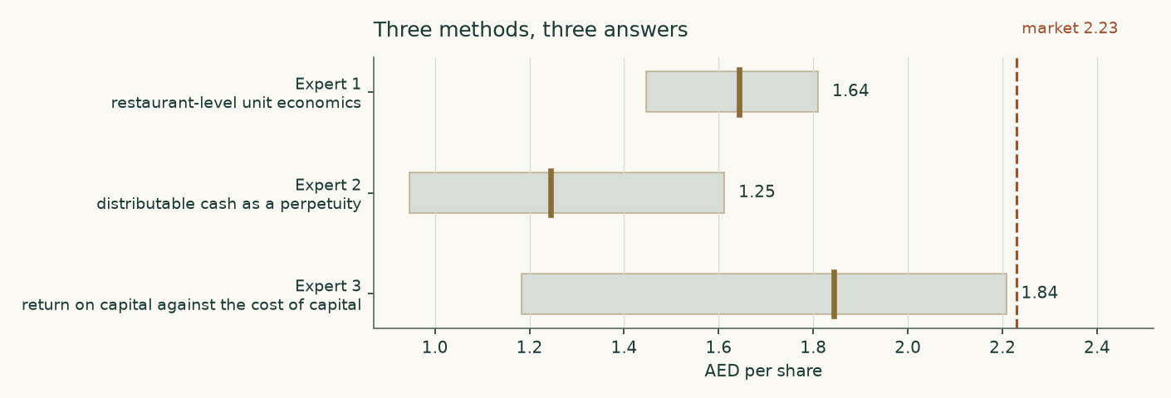
Three methods, three answers, and the market price.
C.1 Expert 1 — Restaurant-level unit economics
Worldview. A restaurant chain is a portfolio of individual cash machines. Value it by what one restaurant earns against what one restaurant costs to build, then count the restaurants and take off what head office and the landlords cost.
When it works. When the operator publishes store-level economics, as this one does, and when the estate is homogeneous enough for an average to mean something.
When it fails. When new restaurants are systematically worse than the ones already open, so the portfolio average flatters the marginal decision — and when a large part of the estate sits in markets where the currency, not the restaurant, drives the result.
Falsifier, stated in advance. Average capital expenditure per restaurant rising above roughly USD 500 thousand while payback lengthens beyond four years would break the arithmetic this lens rests on.
C.2 Expert 2 — Distributable cash as a perpetuity
Worldview. The only thing an outside shareholder in a controlled company receives is the dividend. Capitalise what is actually paid, at the return the risk demands, and grow it at what the business can sustain.
When it works. When the payout is high, established and covered by cash rather than by accounting profit — as here, at roughly 92% of FY2025 earnings and with an interim already declared against 2026.
When it fails. When the payout is discretionary and the controlling shareholder has a reason to change it, or when the dividend is funded from a balance sheet that is quietly running down.
Falsifier, stated in advance. A cut in the declared dividend, or free cash flow falling below the distribution for two consecutive years, would end this reading.
C.3 Expert 3 — Return on capital against the cost of capital
Worldview. Value is the capitalised current profit plus whatever the business earns above its cost of capital on the capital it goes on to invest. If the spread is positive, growth is worth paying for; if it is not, growth destroys value.
When it works. When invested capital is measurable and the spread is wide and stable, so the growth term is not doing all the work.
When it fails. When most of the invested capital is a right-of-use asset whose measurement depends on lease-term judgements — which is exactly the key audit matter in this filing.
Falsifier, stated in advance. The return on invested capital falling to the cost of capital would collapse the growth term to zero and take roughly a fifth off this value.
C.1 continued — Expert 1, the working
The estate is valued as a portfolio of restaurants: what one earns against what one costs to build, multiplied by the number of them, less what head office and the landlords take.
Line | Value | Where it comes from
Four-wall EBITDA, first half of 2026 (USD m) | 433 | disclosed — revenue less cost of revenues and selling costs, before depreciation
Annualised (USD m) | 866 | doubled
Restaurants at 31 December 2025 | 2,749 | disclosed
Four-wall EBITDA per restaurant (USD 000) | 315 | the two above
Average capital cost of one restaurant (USD 000) | 402 | disclosed, across 356 openings
Cash return on the cost of one restaurant | 78% | the two above
Less corporate overhead (USD m) | (174) | general and administrative expenses less their depreciation share
Less maintenance capital expenditure (USD m) | (45) | the derived maintenance rate on FY2026 revenue
Less lease payments (USD m) | (248) | the disclosed rent bill on FY2026 revenue
Owner cash earnings after tax (USD m) | 339 | the lines above, taxed
Capitalisation rate | 8.2% | the terminal cost of equity less two points for the growth in the estate
Business value (USD m) | 3,341 | owner cash earnings capitalised
Plus cash and deposits, less minorities (USD m) | 416 | disclosed
Value per share (AED) | 1.64
Named sensitivity | AED 1.45 – 1.81 | capitalisation rate 150 basis points higher to 100 lower

C.2 continued — Expert 2, the working
Line | Value | Where it comes from
Dividend declared against FY2025 (USD m) | 201.6 | disclosed — 91.99% of net profit
Shares outstanding (million) | 8,399 | disclosed, net of treasury
Dividend per share (USD) | 0.0240 | the two above
Growth assumed | 3.0% | the same long-run rate the cash-flow model uses
Cost of equity | 10.22% | the terminal cost of equity
Value per share (USD) | 0.3391 | the dividend grown one year, capitalised
Value per share (AED) | 1.25
Named sensitivity | AED 0.95 – 1.61 | growth 2% with the cost of equity a point higher, against growth 4% with it 50 basis points lower

C.3 continued — Expert 3, the working
Line | Value | Where it comes from
NOPAT, FY2026E (USD m) | 318 | the cash-flow model
Invested capital, FY2026E (USD m) | 772 | owned assets, right-of-use assets and working capital
Return on invested capital | 41.1% | the two above
Cost of capital | 9.70% | built in section 1.8
The spread | 31.4% | the return above the cost — the whole case in one number
Value of current profit (USD m) | 3,271 | NOPAT capitalised at the terminal cost of capital
Value of future growth (USD m) | 1,166 | the present value of the spread on capital not yet invested
Enterprise value (USD m) | 4,437 | the two above
Value per share (AED) | 1.84 | after the same bridge
Named sensitivity | AED 1.18 – 2.21 | no value from future growth at all, against the growth term 18% higher

C.4 Cross-examination
Expert 2 to Expert 1. "You capitalise four-wall EBITDA less an overhead allocation. But four-wall EBITDA is reported by the company on its own definition, and it excludes the corporate cost of running 2,700 restaurants across twelve tax jurisdictions. Your overhead deduction is a single line taken from the general and administrative note. Are you confident that is the whole of it?"
CONCEDED in part. The general and administrative note is the whole of the disclosed above-restaurant cost, but the selling and marketing line also contains shared costs the company says are allocated on floor space, and some of those are corporate. Expert 1's value is therefore an upper bound on this method. It is the highest of the three, which is consistent with that concession.
Expert 1 to Expert 2. "You value the company on the dividend it happens to pay. It paid 92% of earnings last year because it had nothing better to do with the cash. If it finds something better — and it has just bought two brands — your value falls even though the business has improved. That is backwards."
REJECTED, with a caveat. The dividend is capitalised with a growth rate attached; redirecting cash into restaurants that earn 56% on capital would raise the growth term and offset the lower payout. The caveat is that the method cannot see that trade happening until the dividend actually grows, so it lags. Expert 2's value is the lowest of the three, which is the price of that lag.
Expert 3 to both. "Both of you value the estate as it stands. Neither of you asks whether the return on capital survives the next 600 restaurants. Americana is opening into progressively less prime sites — that is what a maturing estate does — and the payback table the company publishes already shows Pizza Hut, Krispy Kreme and the growth brands at over five years against KFC at 2.4."
CONCEDED, and it is the sharpest point in the panel. The published payback data does show the marginal restaurant earning materially less than the average one. Expert 3's method is the only one of the three that prices this explicitly, through the spread on incremental capital. It is why his value sits between the other two rather than at an extreme.
Expert 2 to Expert 3. "Your invested capital is 70% right-of-use assets — an accounting construction whose size depends on lease-term judgements the auditor flags as a key matter. Your return on invested capital is therefore an artefact of a judgement, not a fact."
CONCEDED. It is why the study computes the lease treatment both ways in section 4. The reassuring finding is that the two readings differ by under two per cent once each is built consistently, so this particular objection turns out not to move the answer.
C.5 The three in one room
Put together, the three agree on more than their numbers suggest. All three think the restaurant estate earns a genuine, wide return on the capital it consumes — 56% on incremental capital, a three-year average payback, a cash return on the cost of a restaurant of about 78%. None of them disputes that. What they disagree about is what an outside minority shareholder gets from it.
Expert 1 says: everything, eventually, because the cash is real and the estate is growing. Expert 2 says: only what is handed over, and what is handed over is a 4% yield growing at three points a year, which is worth what a 4% yield growing at three points a year is worth. Expert 3 says: the estate's return is the right thing to look at, but you have to ask what it will be on the NEXT restaurant, not the average one — and the company's own payback disclosure says the answer is less.
The panel median is AED 1.64, BELOW both the weighted central value of AED 2.15 and the market price of AED 2.23. That is worth stating plainly rather than smoothing away: the three methods that pay closest attention to what a minority shareholder actually receives, and to what the marginal restaurant earns, come out lower than the four-lens weighting does. The four-lens result leans on the cash-flow model, which values the whole firm and assumes the margin gain holds. The panel leans on distributions and on incremental returns. Both are in the report.
C.6 Where they diverge, and which assumption drives it
Pair | Gap (AED) | The assumption that drives it
Expert 1 vs Expert 2 | 0.40 | whether value accrues to the firm or only to the dividend. Expert 1 capitalises all owner cash earnings; Expert 2 capitalises only the declared distribution, which is about 60% of it.
Expert 1 vs Expert 3 | -0.20 | the return on the NEXT restaurant. Expert 1 applies the portfolio average; Expert 3 prices a spread that narrows as the estate matures.
Expert 3 vs Expert 2 | 0.60 | reinvestment. Expert 3 gives credit for growth funded from retained cash; Expert 2 treats retained cash as value that has not yet reached the shareholder.

About this study
Testahil publishes independent valuation studies and calibrated probability ranges. Every study is built the same way: the company's own filings first, a model built from drivers rather than growth rates, several independent methods rather than one, and an explicit account of what would prove the study wrong.
The historical figures here come from Americana Restaurants' own audited consolidated financial statements for 2022 through 2025, its reviewed interim statements for the first quarter and first half of 2026, and its own earnings presentations and releases — all read from the company's investor-relations library. Outside data appears only as a cross-check and is labelled where it appears. Every input, with its value, its date and where it came from, is listed in the companion bibliography document. The companion workbook contains the model itself: 897 live formula cells, so a reader can change a driver and watch it reprice.
This study was checked before release. Every formula cell in the workbook was recalculated independently of the software that wrote it and reconciled against the model that produced it — 897 of 897 agree, with none unresolved and none unchecked. Each of 28 drivers was then changed in the delivered file and the whole workbook re-evaluated, to confirm the headline value moves in the direction it should; a further 71 inputs were swept to confirm none of them is inert.
Disclosure
This document is educational analysis. It is not investment advice, not a recommendation, and not an offer or solicitation to buy or sell any security. It contains no rating and no price target; what it contains is a range of values produced by explicit methods from stated assumptions, and a separate statistical description of price dispersion.
Valuation is not measurement. Every figure beyond the audited history is a model output that depends on assumptions a reasonable person could disagree with, and the study says where those disagreements would lead. Past performance is not a guide to future results. The value of shares can fall as well as rise. Readers should form their own view and, where appropriate, take professional advice.
Testahil holds no position in Americana Restaurants International PLC and has no business relationship with the company. No part of this study was reviewed by the company before publication.
Prices and market data are as at the close of 7 August 2026. Company financial data is as reported in the audited statements to 31 December 2025 and the reviewed interim statements to 30 June 2026. Country risk premiums are the January 2026 edition. Study date: 9 August 2026.

