Testahil · Independent Valuation Study — Educational Analysis Not investment advice

Independent Valuation Study — Educational Analysis
Emirates Integrated Telecommunications Company PJSC (DFM: DU)
du · United Arab Emirates · Integrated telecom operator (mobile · fixed · wholesale · ICT and data centres) Anchor 2026-08-07 · Spot AED 12.30 · Market capitalisation AED 55,755mn
READ FIRST. This study is an educational analysis, not investment advice, a recommendation or a solicitation. It never issues a rating or a price target: it publishes fair-value RANGES and probability DISTRIBUTIONS, and it separates what the business may be worth (sections 1, 4, 5) from where the price could plausibly trade (sections 2, 3, 6) — two different questions that are never blended. All figures are in United Arab Emirates dirhams (AED); the company reports, lists and pays dividends in AED, so no currency translation enters the model anywhere. Historical financials come exclusively from the company's own audited and reviewed consolidated financial statements, read from its investor-relations portal; every input is listed with source and date in the companion bibliography document.
Headline
The business. du is the second operator in the UAE's two-player telecom market: 9,280 thousand mobile customers, 744 thousand fixed subscriptions, four disclosed segments (Mobile, Fixed, Wholesale, ICT), FY2025 revenue AED 15,905mn and an EBITDA margin of 46.1% — with ZERO drawn debt in every year studied and a dividend paid out of essentially all of profit.
The valuation. Weighted central AED 13.90 per share against a spot of AED 12.30 (+13%), inside a weighted bear-to-bull range of AED 9.74 to 20.28 and a wider span across the four lenses of AED 8.19 to AED 28.65. The cash-flow lens alone reads AED 18.89; the market-anchored relative lens reads AED 8.86. That gap is the study's honest tension, and section 4 explains rather than hides it.
The contested judgement. What required return does this business deserve? On du's own measured beta the cash-flow lens reads AED 18.89 — but the terminal that implies values du at 10.1x forward EBITDA in perpetuity, against the 7.6x the market pays for it today. Refuse that re-rating and hold today's multiple instead and the same cash flows are worth AED 14.81. Both are published side by side — the judgement is worth AED 4.08 per share and is never averaged into one number.
What is NOT contested. The fiscal regime. The 38% royalty plus 9% corporate tax was legislated only to 2026, but du disclosed the extension itself on 24 July 2026, covering 2027 to 2029 on the same structure with the AED 1.8bn combined floor expressly retained. A reversion after 2029 is priced as a named tail (AED 16.11), not as a live coin-flip.
The moment. This study is struck weeks after a regional war collapsed Gulf tourism and took 412 thousand mobile customers off du's base in a single quarter, and days after the company cut its own revenue guidance to 4-6% while raising the interim dividend. The company's operating licence was disclosed as running only to 8 August 2026, one day after this study's price anchor; it has since been renewed for twenty years, on terms the regulator has not published.

Valuation summary — every read at a glance
Lens | Bear | Base | Bull | Weight | vs spot
Discounted cash flow (primary) | 11.03 | 18.89 | 28.65 | 45% | +54%
Relative multiples | 8.19 | 8.86 | 12.99 | 25% | -28%
Normalised earnings power | 8.21 | 8.87 | 13.01 | 20% | -28%
Book value & sustainable return | 10.86 | 14.12 | 15.33 | 10% | +15%
Weighted central | 9.74 | 13.90 | 20.28 | 100% | +13%
Span across lenses (min/max, not weighted) | 8.19 |  | 28.65 | —
Contested judgement, other way — no terminal re-rating |  | 14.81 |  | — | +20%
Expert panel median (Appendix C) |  | 18.46 |  | — | +50%
DCF terminal value share of enterprise value: 83%

Table 1 — the valuation summary. Weighted central AED 13.90, with its bear and bull columns weighted on the same 45/25/20/10 basis; the row beneath shows the wider min/max span across lenses, which is NOT a weighted figure. Every lens value is dated at the 2026-08-07 anchor, net of the AED 0.66 of dividends whose ex-dates fall between the 31-Dec-2025 valuation date and that anchor (the 0.40 final, paid 28-Apr-2026, and the 0.26 interim, ex 31-Jul-2026). The terminal value is 83% of the DCF enterprise value, and the terminal it implies is priced explicitly in section 1.7 rather than left as a caveat.
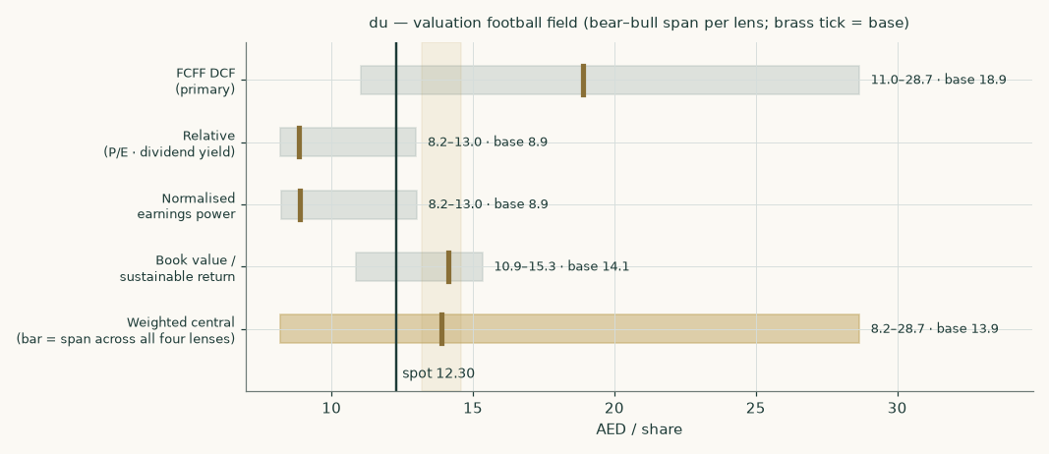
Figure 1 — the valuation football field: bear-to-bull span per lens, brass tick = base, dark line = spot.
Company overview — du at a glance
Emirates Integrated Telecommunications Company PJSC — branded du — launched service in 2007 as the UAE's second licensed operator and has settled into a stable duopoly with e& (formerly Etisalat). It is majority state-anchored: the Emirates Investment Authority is the controlling shareholder, and 2025's main capital-markets event was a secondary offering in which Mubadala's Mamoura vehicle sold three quarters of its stake (7.55% of the company), widening the free float without changing control.
The revenue mix that decides the company's class: FY2025 mobile services AED 7,075mn (44% of revenue), fixed services AED 4,380mn (28%), wholesale AED 2,568mn (16%) and ICT and associated telecom services AED 1,883mn (12%). The balance-sheet shape: network assets (property, plant and equipment AED 10,289mn plus right-of-use assets and intangibles) financed by equity of AED 10,148mn, structurally NEGATIVE working capital (-6.7% of revenue — customers and suppliers fund the operation), no borrowings, and cash plus term deposits of AED 2,250mn against lease liabilities of AED 1,939mn. That is an integrated telecom OPERATING COMPANY, with no captive lender, no development book and no holding-company discount to model: the lens set is the operating-company one — a full FCFF discounted cash flow as the primary lens, cross-read by relative multiples, normalised earnings power and a book/sustainable-return lens.
Two structural facts organise everything else. First, the state takes roughly 44% of pre-royalty profit (38% federal royalty plus 9% corporate tax since 2024; the pre-2024 construction took over half) — so every operating improvement reaches shareholders at barely more than half strength, and the fiscal regime is worth more than any operating driver. Second, the balance sheet is unleveraged with a near-total payout: du is run as a cash-distribution machine on a licence, which is why the licence renewal and the royalty renewal are the two catalysts that matter most (section 5).
The quarter this study is struck in: a regional war that began in February 2026 collapsed Gulf tourism and cut du's prepaid base by 412 thousand in Q2-2026, while postpaid kept growing and H1-2026 net profit still rose +12.6% on an EBITDA margin of 49.2% — the resilience and the vulnerability in one print. A ceasefire is in place; the recovery path is the forecast's biggest operating assumption and is sensitised explicitly.
1 Fundamental valuation
Four lenses, weighted into one field: the discounted cash flow carries 45%, relative multiples 25%, normalised earnings power 20% and the book lens 10%.
1.1 The cash-flow model — the primary lens, with the full waterfall
The model builds five explicit years from the four disclosed segments (section 1.6), charges the combined royalty-and-tax take on operating profit, funds the network and the lease book, releases (negative) working capital as revenue grows, and discounts each year's free cash flow at its own forward cost of capital. The full waterfall — every line of it a live formula in the companion workbook:
AED mn | FY26E | FY27E | FY28E | FY29E | FY30E
Revenue | 16,593 | 17,240 | 18,011 | 18,734 | 19,424
EBITDA | 7,937 | 8,239 | 8,624 | 8,977 | 9,309
less depreciation & amortisation | -2,235 | -2,352 | -2,448 | -2,530 | -2,582
EBIT | 5,702 | 5,887 | 6,176 | 6,446 | 6,727
NOPAT — EBIT × (1 − 43.6%) | 3,218 | 3,322 | 3,485 | 3,638 | 3,796
add back depreciation & amortisation | 2,235 | 2,352 | 2,448 | 2,530 | 2,582
less capital expenditure | -2,572 | -2,586 | -2,612 | -2,529 | -2,525
less lease replacement | -0 | -0 | -0 | -0 | -0
less change in working capital | 46 | 43 | 52 | 48 | 46
Free cash flow to the firm | 2,927 | 3,131 | 3,373 | 3,687 | 3,900
discount factor (glide) | 0.94 | 0.88 | 0.83 | 0.78 | 0.74
PV of FCFF | 2,750 | 2,766 | 2,804 | 2,885 | 2,874

Table 2 — the FCFF waterfall. EBITDA margin holds near 47.8% (an OUTPUT of the segment build, not an input); capital intensity glides from 15.5% of revenue at the data-centre peak to 13.0%; lease replacement is charged at right-of-use depreciation so the lease book neither inflates nor starves the cash flow; working-capital change is a cash RELEASE in every year because the working capital is negative and revenue grows.
Terminal value: terminal-year NOPAT grown at 2.5% with a reinvestment rate set by the growth itself — g / return on capital = 2.5% / 27.4% = 9.1% of NOPAT — capitalised at the terminal cost of capital of 6.17% less growth. That yields a terminal value of AED 96,248mn, whose present value is AED 70,929mn — 83% of enterprise value. A reader should sit with that number: at a 6.17% discount rate almost all of the value of a stable, licence-protected annuity IS the far future, and that is exactly why the two renewal catalysts in section 5 dominate everything else in this report.
The bridge from enterprise value to the equity — and to the anchor date
Step | AED mn | AED / share
Present value of the five forecast years | 14,079 | 3.11
Present value of the terminal value | 70,929 | 15.65
Enterprise value | 85,009 | 18.75
Terminal value share of enterprise value: 83%
less lease liabilities (the only debt-like item) | -1,939 | -0.43
plus cash and term deposits | 2,250 | 0.50
plus equity-accounted investees | 0.51 | 0.00
Equity value at 31-Dec-2025 | 85,320 | 18.82
× anchor accretion (1+Ke)^(219/365) = 1.0387, less the AED 0.66 final dividend paid 28-Apr-2026
Fair value per share at the 07-Aug-2026 anchor |  | 18.89

Table 3 — enterprise value to equity. There are no minority interests (every subsidiary is wholly owned) and no borrowings to net: the bridge is leases out, cash in. The H1-2026 interim dividend of AED 0.26, declared 23-Jul-2026 but unpaid at the anchor, stays in the share.
Scenario span on this lens: bear AED 11.03 (ARPU −5%, a quarter-million fewer subscribers, margins −3%, +100bp on the discount rate, terminal growth 2.0%), bull AED 28.65 (the war recovery runs hot and the data-centre leg compounds). The base case is deliberately NOT the midpoint of those two: it is built driver by driver in section 1.6.
1.2 Book value and sustainable return — the asset lens
Book value per share is AED 2.24 (audited FY2025 equity of AED 10,148mn over 4,533mn shares). du earned a return on average equity of 29.0% in FY2025 — a licensed duopoly running negative working capital needs very little equity, so the return on it is high by construction. The lens asks what a sustainable 27% return is worth against a perpetual cost of equity of 6.35%: justified price-to-book = (27% − 2.5%) / (6.35% − 2.5%) = 6.36×, i.e. AED 14.12 per share at the anchor. The multiple looks extreme against industrial norms; it is what the arithmetic of a small equity base and a low required return produces, and the honest caveat is that it is the lens MOST exposed to the low regression beta discussed in section 1.8 — which is why it carries only a 10% weight.
1.3 Relative multiples
du trades at 19.2× its FY2025 earnings and 7.6× FY2025 EBITDA — and on the more current basis, including the reviewed first half of 2026, at 18.1× and 7.2×. Both framings are given because the trailing-year basis is seven months stale at the anchor and makes the share look dearer than the newer figures do.
The peer frame is where the previous edition of this study was wrong, and the correction matters enough to state in full. That edition applied a "peer median" of 15.5×. It was not a median of its own stated peer set, and it was not a current figure: it was a January-2026 aggregator reading built on FY2024 earnings. Re-derived from the peers' own filings at this study's anchor, the multiple is 12.9×.
Peer | Price (6-Aug-2026) | Trailing EPS | P/E | Yield | Basis
Mobily | SAR 61.30 | 4.76 | 12.9× | 4.9% | its own exchange filings
e& | AED 20.98 | 1.33 | 15.7× | 4.5% | its own filings, reported
stc | SAR 43.38 | 2.94 | 14.8× | 5.1% | aggregator
Ooredoo | QAR 13.04 | 1.18 | 11.2× | 5.7% | aggregator, off-anchor
Omantel | not sourced | 0.123 | 12.0× | 6.7% | aggregator, self-contradictory
Zain | KWD 0.611 | not sourced | refused | 6.7% | provider returned 11,365×
du (this company) | AED 12.30 | 0.68 | 18.1× | 5.2% | its own audited figures

Table 4 — the peer frame, re-derived. Only two of the six peers survive as clean observations: Mobily, whose 12.9× reconciles two independent ways from its own filings, and e& at 15.7×. Of the rest, one provider returned a corrupt 11,365× for Zain (refused rather than passed through), Omantel's quoted multiple and yield are mutually inconsistent, and Omantel in any case holds about 22% of Zain, so the two are not independent observations. NO PEER MEDIAN IS THEREFORE CLAIMED. The justified multiple is Mobily's own, defended as the closest structural analogue — a number-two operator in a Gulf duopoly-like market that closed the gap on its incumbent. Note what the corrected table shows about du itself: at 18.1× it trades ABOVE every peer in the set.
Applied to FY2026E earnings per share of AED 0.71 and rolled to the anchor: AED 8.86 per share [bear 12× → AED 8.19; bull 18.5× → AED 12.99]. A second, independent market cross-check from the dividend: du's FY2026E dividend of AED 0.70 at Mobily's own trailing yield (4.9%) is worth AED 14.24 — well ABOVE the earnings-multiple read, because du pays out far more of its earnings than the peer does. Peer EV/EBITDA could not be built from filings within this study's scope (net-debt detail per peer was not retrieved), so the lens runs on earnings and yield only; that limitation is stated rather than papered over.
1.4 Normalised earnings power — mid-cycle margin at current scale
The lens strips the cycle: the mid-cycle EBITDA margin (the middle forecast year, FY2028E, 47.9%) applied to CURRENT-scale revenue (FY2026E, AED 16,593mn), less FY2026E depreciation, plus FY2026E net finance income, taxed at the combined 43.6%: normalised earnings of AED 3,225mn, or AED 0.71 per share. At the justified 12.9× and rolled to the anchor: AED 8.87 [12× → 8.21; 18.5× → 13.01]. It reads within a few fils of the relative lens, and that is worth being blunt about rather than presenting as corroboration: du's current year IS close to mid-cycle — the war knocked the top line, not the margin, and the first half of 2026 printed the best margin in the company's history — so normalising changes the earnings base by less than a fil. The two market-anchored lenses are therefore ONE reading of one multiple against one earnings number, carrying 45% of the weighted central between them, not two independent reads. The synthesis in 1.5 and the comparison in section 4 should be read on that basis.
1.5 Synthesis — four lenses, one field
Weighted central: AED 13.90 (+13% to spot), full span AED 8.19 to AED 28.65. The DCF (45% weight) reads +54% above the market; the two market-anchored lenses read roughly at the market. Section 4 takes that disagreement seriously — it is a statement about the discount rate, not about the forecast.
1.6 The drivers — each disclosed segment grown on its own driver
The four disclosed segments, historically
Segment | FY2023* | FY2024 | FY2025 | FY2025 contribution | margin
Mobile | 7,004 | 6,548 | 7,075 | 4,304 | 60.8%
Fixed | 3,780 | 4,003 | 4,380 | 3,758 | 85.8%
Wholesale | 1,768 | 2,373 | 2,568 | 2,219 | 86.4%
ICT & associated | 1,084 | 1,712 | 1,883 | 365 | 19.4%
Total | 13,636 | 14,636 | 15,905 | 10,646

Table 5 — segment revenue (AED mn) and FY2025 contribution (revenue less direct costs, the company's own Note 38 measure). *FY2023 is on the pre-2024 segment basis (the wholesale/other boundary moved in the re-segmentation) and is shown for continuity, not comparability; the forecast is built off the consistent FY2024-25 basis. Segment revenue ties exactly to consolidated revenue in every year.
How the forecast is driven
Mobile and Fixed are built as volume × price — the finest level the company disclosed. Mobile: the quarterly customer base (8,916k at 31-Dec-2024 → 9,704k at 31-Dec-2025 → 9,280k at 30-Jun-2026, after the war quarter) times blended ARPU (AED 63.3/month in FY2025, 63.4 in Q2-2026). The frame reproduces the audited FY2025 mobile segment to within 0.1%: average base 9,310k × AED 63.3 × 12 = AED 7,072mn against a disclosed AED 7,075mn. The forecast path: recovery to 9,450k by end-2026 (the company itself reports gross adds still below pre-war levels), then to 10,450k by end-2030 — growth of roughly a quarter-million customers a year, well below the boom year 2025 added, with ARPU held roughly flat (AED 63.4 → 64.2).
Why the flat ARPU path is this study's most fragile revenue judgement
The company prints one blended mobile ARPU, and it has barely moved: AED 63.3 in FY2025 and 63.4 in the second quarter of 2026. Read on its own, that looks like pricing stability. It is not. du also discloses the customer base split between prepaid and postpaid every quarter, and that mix moved sharply: the postpaid share went from 20.3% to 22.1% in two quarters — not because postpaid surged, but because prepaid COLLAPSED, losing 499 thousand customers against 74 thousand postpaid gained. Those were largely low-value visitor SIMs, the cheapest customers on the book.
A postpaid customer is worth a multiple of a prepaid one. So a mix shift of that size is a mechanical tailwind to the blended figure. At the ratio observed at the one Gulf operator that discloses both legs, the mix shift alone would have lifted blended ARPU about +2.6%. The company reported +0.2%. The arithmetic only closes if each leg's OWN price fell about -2.4% over the same span. In other words the flat headline is not stability — it is two forces of similar size pulling in opposite directions, and the disclosure is not granular enough to separate them.
This matters because of what the forecast assumes elsewhere. The subscriber path in this study has prepaid RECOVERING as tourism normalises. A recovering prepaid base pushes the postpaid share back down, which removes the tailwind — and if the underlying per-leg erosion continues, the blended figure falls rather than holding flat. Holding the path flat is therefore a joint assumption that BOTH forces persist and keep cancelling. Section 1.9 prices the alternative directly: if the blended path instead erodes at the rate the decomposition implies, the cash-flow lens reads AED 15.62 rather than AED 18.89, -17%. It is the largest single downside in the study that does not come from the discount rate.
A reader will reasonably ask why the two legs are not simply modelled separately. Because they cannot be identified. du publishes no prepaid or postpaid ARPU anywhere — not in the earnings releases, not in the presentations, not in the audited segment note, which splits Mobile from Fixed and never splits mobile itself. That is the regional norm rather than a du quirk: e&, stc and Mobily all publish the subscriber split with a single blended price, and Ooredoo is the sole Gulf exception. The mix did move, which in principle pins down the ratio between the legs if both prices were stable — so this study solved for that ratio on all 21 available quarter pairs. The answers range from -45× to 17×. 9 of the 21 imply a NEGATIVE ratio and 2 imply a postpaid customer worth LESS than a prepaid one; both are impossible. An estimate that swings that far depending on which two quarters are chosen is not measuring anything. So the split is NOT built. Building it would replace one disclosed number with two undisclosed ones joined by an imported assumption, and — because the arithmetic is mix-preserving — would reproduce exactly the same revenue while looking more precise. The gap is flagged instead, and the risk it creates is priced.
Fixed: subscribers 682k at 31-Dec-2024 → 735k at 31-Dec-2025 → 744k at 30-Jun-2026, forecast to 858k on continued fibre and fixed-wireless share gain, times an implied revenue per subscription (a consumer-plus-enterprise blend, so a revenue-intensity metric rather than a tariff) rising gently with the enterprise mix. That intensity metric is itself an implied figure — segment revenue over the average base — so it is a weaker construction than the mobile one and is labelled as such rather than presented as a price. Wholesale and ICT disclose no unit measures anywhere in the filings — that gap is flagged, and both are grown at segment level: wholesale on a war-recovery path (roaming and transit were hit; -0.8% in 2026 then ~+2%), ICT on the data-centre ramp (+11.0% at peak), which is anchored on the company's own disclosed programme: five data centres, a hyperscale campus with Microsoft as anchor tenant, and capital commitments UP a quarter-billion dirhams in six months.
How the cost side is built — cost per unit, and why no margin is an input
The company discloses its direct costs twice over, and never joins them up. On the face of the income statement they are split by NATURE into three lines — interconnect, commission, and devices and other direct services. In the segment note they are split by SEGMENT, one "interconnect and other direct costs" line each for Mobile, Fixed, Wholesale and ICT. Both views are published every period; the cross-tabulation between them never is.
That cross-tabulation is recoverable, and recovering it is what lets the cost side be built per unit rather than as a margin. Two structural facts do the work: Fixed and Wholesale carry no consumer acquisition channel and no handset sales, so their direct cost is interconnect and capacity; and commission is dealer and retail commission on the consumer mobile base, so it is a mobile cost. Given those, mobile interconnect falls out of total interconnect as a residual, and the mobile device line falls out of mobile's own segment total. The test that this is not a convenient fiction is that the residual device cost must come out POSITIVE and small in every period, and ICT's own direct cost plus that residual must foot exactly to the disclosed devices line. Both hold in all four disclosed periods, and the model asserts them rather than trusting them.
What emerges is a genuine per-unit cost stack for the mobile business, with each line moving for its own reason:
AED per mobile subscriber per month | FY2024A | FY2025A | H1-2025A | H1-2026A
Interconnect | 18.24 | 17.40 | 17.54 | 16.81
Commission | 5.69 | 6.14 | 6.12 | 6.31
Devices and other direct services | 0.52 | 1.26 | 1.40 | 0.96
Total mobile direct cost per subscriber | 24.45 | 24.81 | 25.06 | 24.08
Fixed capacity cost per subscription | 79.71 | 73.14 | 75.29 | 68.35
Wholesale direct cost / own revenue | 12.0% | 13.6% | 13.9% | 15.6%
ICT direct cost / own revenue | 79.2% | 80.6% | 80.8% | 78.5%

Table 6 — the direct-cost stack per unit, recovered from the company's own two disclosures. The two half-year columns are the important ones: they are like-for-like, so they measure DIRECTION rather than mixing seasonality into a year-on-year change.
The like-for-like half-years give each line a measured direction, and only two of them get to move in the forecast. Interconnect per subscriber fell -4.1%, and there is a named mechanism for it: regulated mobile-termination rates ratchet down, and terminated voice and SMS keep migrating to messaging apps, so the off-net bill per customer falls even as the base grows. The forecast takes -1.5% a year — barely a third of the observed fall, on the view that it decays as the substitution matures. Commission per subscriber rose +3.0%, which is the cost of winning and keeping a customer in a two-player market rising; the observed rate of +3.0% is carried forward unchanged. Everything else is anchored on the H1-2026 reviewed actual and held FLAT — including the fixed capacity cost, which fell -9.2% like-for-like. Stopping that improvement dead rather than projecting it is deliberate: the mechanism is real but decays at a rate the disclosure cannot size.
Two of those choices deserve to be challenged, so here is the evidence for them. Holding the H1-2026 rate through the second half of 2026 could flatter the year if second halves are structurally cheaper. They are: measured on 2025, the second-half rates came in at AED 25.01 per mobile subscriber against 25.06 in the first half, AED 71.33 against 75.29 on fixed, and 13.2% against 13.9% on wholesale. Three of the four were CHEAPER in the second half, so carrying a first-half rate forward overstates cost rather than understating it. And the wholesale rate has worsened at every single observation — 12.0%, 13.6%, 13.9%, 15.6% — which the company attributes to the conflict-hit roaming and transit mix. The forecast takes no credit for the recovery that attribution implies, and equally does not project further decay.
Wholesale and ICT cannot be built per unit at all, because no volume measure for either is disclosed anywhere in the filings. Both therefore carry a cost RATE on their own revenue, anchored on the reviewed half-year. That is the weakest part of the cost build and is labelled as such: it is the finest level the disclosure supports, not the level the method would prefer. The ICT rate in particular is held flat rather than improving, which reverses a judgement in the previous edition of this study — that edition projected a 2.1 percentage point margin gain on a data-centre-scale argument, and the disclosed series does not support a trend in either direction (79.2% worsened to 80.6% before improving to 78.5%). A story that cannot be measured has been removed from the model.
The consequence is the point of the whole exercise: NO margin in this study is an input. Contribution margin by segment, group gross margin and group EBITDA margin are all computed from volumes times unit costs, and they can therefore disagree with each other in informative ways. They do. Group gross margin declines across the forecast, 67.9% to 67.2%, while NOT ONE segment margin declines. That is entirely mix: ICT is the fastest-growing segment and by a wide margin the thinnest, so it dilutes the group as it succeeds. A single blended margin assumption — which is what the previous edition of this study used — cannot produce that result, and a reader looking at it would have no way to tell dilution-by-growth apart from erosion. That distinction is the argument for building the cost side this way.
What the build produces — margins as outputs
 | FY2025A | FY26E | FY27E | FY28E | FY29E | FY30E
Revenue (AED mn) | 15,905 | 16,593 | 17,240 | 18,011 | 18,734 | 19,424
growth |  | +4.3% | +3.9% | +4.5% | +4.0% | +3.7%
EBITDA (AED mn) | 7,338 | 7,937 | 8,239 | 8,624 | 8,977 | 9,309
EBITDA margin — an OUTPUT | 46.1% | 47.8% | 47.8% | 47.9% | 47.9% | 47.9%

Table 7 — the build's output. FY2026E growth of +4.3% lands inside the company's own revised 4-6% guidance. EVERY MARGIN IN THIS TABLE IS AN OUTPUT. Nothing about profitability is assumed: each cost line is grown on its own physical driver and the margin is whatever is left. On the direct-cost side that means mobile carries three separate per-subscriber costs — interconnect, which falls as termination rates ratchet down and terminated traffic migrates to messaging apps; commission, which rises with the cost of winning and keeping a customer; and a small, lumpy device line held flat — while fixed carries a per-subscriber capacity cost and wholesale and ICT carry a cost rate on their own revenue, because the company discloses no volume unit for either. On the operating-cost side, wages escalate on UAE wage inflation, network on network scale, the licence fee and credit losses on revenue, administration on CPI — never one blended index across physically different costs. Two things a reader should be able to see. First, the group gross margin 67.9% -> 67.2% DECLINES even though not one segment margin declines: that is mix, not erosion — ICT is the fastest-growing segment and by far the thinnest, so it dilutes the group as it grows. A single blended margin assumption cannot show that, which is the argument for building this way. Second, total operating expenses before depreciation RISE 0.7% in FY2026E against the audited 2025 figure. In an earlier edition of this study they fell, because the staff line was built on a mis-stated seasonal ratio — which made margin expansion an artefact of one input rather than an output of the build.
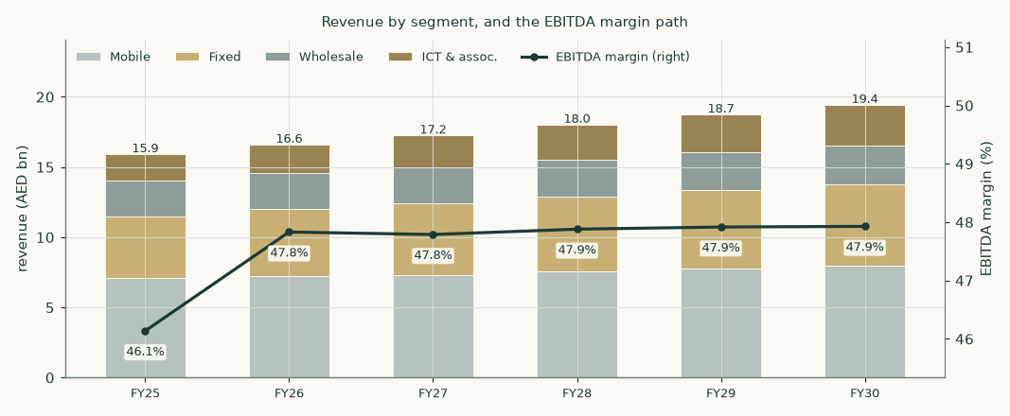
Figure 2 — revenue by segment and the EBITDA margin path. ICT is the growth leg; mobile the recovery story. The group EBITDA margin is flat-to-slightly-rising as an OUTPUT: segment margins widen modestly on the per-unit cost build while ICT — the fastest-growing and thinnest segment — dilutes the group as it grows. The two effects very nearly cancel, which is a result of the build rather than an assumption in it.
1.7 The crux — what required return does this business deserve?
Every valuation has one judgement that moves it more than all the others. Here it is not an operating driver and it is not the tax regime: it is the price of time. Both readings are computed and published; neither is averaged away.
 | Framing 1 — the measured return | Framing 2 — the market's return
How the terminal is set | capitalised at 6.17% with growth of 2.5% | du's own current trailing EV/EBITDA held into perpetuity
What that implies for the exit multiple | 10.09x forward EBITDA | 7.56x — no re-rating
Cash-flow fair value at the anchor | 18.89 | 14.81
Weighted central on the same lens set | 13.90 | 12.07
The judgement is worth | AED 4.08 per share on the cash-flow lens

Table 8 — the study's central judgement, both ways. The cash-flow lens rests on du's own measured beta of 0.488, which prices its equity at 6.53%. That is internally consistent — but the terminal it produces values du at 10.09 times forward EBITDA forever, against the 7.56 times the market pays today: a 34% re-rating embedded in a figure presented as intrinsic value. Framing 2 simply declines to assume it. This is the honest form of the observation that 83% of enterprise value sits beyond year five.
In real observable units, the two legs of the judgement price out like this. On the return leg: every 0.10 on beta is worth roughly AED 1.60 per share, so the regression's own 90% interval (0.35 to 0.62) spans AED 16.41 to 22.40, and a sector-average 0.80 gives AED 13.89. On the terminal leg: each turn of the exit multiple is worth about AED 1.61 per share. A reader who believes the market is simply wrong about du should take Framing 1; a reader who thinks a licensed single-market operator does not re-rate by a third should take Framing 2; the study refuses to choose for them.
The two judgements that are NOT the crux, and why
The fiscal regime was the previous edition of this study's central judgement. It is not one any more, and the correction is worth stating plainly: du published its own disclosure of the royalty extension on 24 July 2026 — "Extension of Federal Royalty Scheme for the Period 2027-2029" — carrying the same 38% royalty and 9% corporate tax and expressly retaining the AED 1.8 billion combined annual floor. The prior edition recorded, wrongly, that only the other operator had disclosed it. A reversion to the pre-2024 construction after 2029 remains a real tail and is priced: AED 16.11 per share, against AED 18.89 on the current regime. It is a tail, not a coin-flip.
The licence is the second. The regulator extended du's operating licence only to 8 August 2026 — one day after this study's anchor — and has since renewed it for twenty years from 9 August 2026. The renewal announcement sets out obligations (resilience, route diversity, quality of service, national roaming) but publishes NO fee or revenue-share terms. This study therefore holds the licence fee at its historical 2.7% of revenue and flags that as an assumption, not a confirmed fact: each additional percentage point of revenue taken in licence fees costs about AED 0.61 per share.
1.8 Macro and country — rates, the peg, and the sourced cost of capital
The dirham is hard-pegged to the dollar, so the UAE imports US monetary policy: the central bank's base rate tracks the Fed, and at the sweep date the market was pricing possible HIKES rather than the cuts of six months earlier. The UAE sovereign is rated Aa2, and its dirham curve prices a few basis points ABOVE the US Treasury curve at matched tenors — the July-2026 auction release puts the January-2031 dirham bond at 4 basis points over comparable Treasuries. (The previous edition of this study said "through", which was backwards, and netted a ratings-table spread ten times the market's. Both are corrected below.) Growth is strong (around 5% real in 2025) even as the regional war cut the wider region's 2026 outlook; inflation is around 2%.
Component | Value | Source basis
Risk-free rate (Jan-2031 AED T-bond, the longest liquid AED tenor) | 4.48% | UAE MoF/WAM auction release, 30-Jul-2026
less UAE sovereign default spread — MARKET-observed on this very bond | 0.04% | UAE MoF/WAM auction release: +4bp over UST
Risk-free net of the sovereign spread | 4.44% | country risk enters ONCE, via the premium; and this clears the 4.32% matched-tenor Treasury floor
Beta — DU weekly vs the FTSE ADX General Index, 5 years | 0.488 | own regression; details below
Equity risk premium (UAE total, same market basis) | 4.29% | Damodaran mature 4.23% + a 6bp country premium scaled off the same 4bp
Cost of equity | 6.53% | build, not assumption
Marginal cost of debt (AED sovereign + GCC telecom spread) | 5.10% | stc sukuk curve evidence; du has no debt
Weights — market equity / lease debt | 96.6% / 3.4% | market capitalisation vs the audited lease book
Cost of capital — explicit window | 6.41%
Cost of capital — terminal | 6.17% | terminal risk-free 4.30%, debt weight 5%

Table 9 — the cost of capital, built from sourced parts. The sovereign spread is stripped from the risk-free rate because the equity premium already carries the country premium: counting it twice is the classic error this construction exists to avoid. The spread stripped and the premium added back are on the SAME basis — 4 basis points out, a 6 basis-point country premium in — which is the discipline that makes the netting safe. The alternative RATINGS basis (42bp out, a 64bp country premium in, giving a 6.44% cost of equity and 6.32% cost of capital) is published alongside and not averaged in. One test governs the choice: a default-free dirham rate cannot sit BELOW the default-free dollar rate at matched tenor under a hard peg. The market basis clears that floor at 4.44% against 4.32%; the ratings basis would breach it by about 26 basis points, which is why it is the alternative and not the primary.
The beta — measured, gated, and honestly low
du's beta is measured, not assumed: weekly log-returns against the FTSE ADX General Index — adopted as the base market index for the UAE in this edition — five years, 256 observations: beta 0.488, R² 0.12, standard error 0.083, 90% confidence interval 0.35 to 0.62. The regression passes the usability gate (enough observations, explanatory power, an error smaller than the estimate). du itself lists on the Dubai Financial Market, so the choice of UAE index is itself shown both ways rather than hidden: against the DFM General — the listing venue's own index — the same construction measures 0.472 (R² 0.20, a tighter fit), and an equal-weight composite of the market's own large names cross-checks both at 0.400. All three land in the same place: a defensive, negative-net-debt telecom measuring below 0.5 on either UAE index. That number is also the single assumption doing the most work in this study, because at these weights the cost of capital is essentially the cost of equity. Betas of 0.62 (the interval's top), 0.65 and 0.80 are priced in section 1.9: the last takes the DCF from AED 18.89 to AED 13.89 — close to the spot price. The market, at 19.2× trailing earnings, is implicitly charging a HIGHER required return than any of these regressions produce; section 1.7 prices that disagreement as the study's central judgement rather than dismissing it.
Where this construction is contested, and what the alternatives are worth
Contested construction | Base | Alternative | Worth (AED/share)
Risk-free tenor, LONGER AND HIGHER: Jan-2031 AED print vs a 10-year peg-extrapolated proxy | 4.48% | 4.69% | 17.90 vs 18.89 (-0.99)
Risk-free tenor, LONGER AND LOWER: the Feb-2033 AED sukuk, the only federal tranche beyond Jan-2031 | 4.48% | 4.13% | 20.82 vs 18.89 (1.92)
Sovereign basis: market-observed 4bp (primary) vs the ratings table 42bp | spread 0.04%, ERP 4.29% | spread 0.42%, ERP 4.87% | cost of capital 6.41% vs 6.32%; the ratings basis breaches the matched-tenor Treasury floor
Beta: regression vs the sector-implied prior | 0.488 | 0.80 | 18.89 vs 13.89
Terminal: capitalised at the cost of capital vs du's own current multiple | 10.09x implied | 7.56x held | 18.89 vs 14.81 — the study's central judgement
Post-2029 fiscal tail (no longer contested for 2027-29 — du disclosed the extension) | 43.6% | 51.1% | 18.89 vs 16.11

Table 10 — every contested construction priced, not just named. Two retired errors are preserved for the audit trail: an UN-netted risk-free rate would give a 6.57% cost of equity, the sovereign-risk double-count this method exists to prevent; and netting the ratings-table spread while adding back a ratings-based country premium — the previous edition's construction — put the "risk-free" dirham rate below the matched-tenor Treasury, which a hard peg cannot support.
The risk-free rate deserves its own paragraph, because it is the input an external review of this study contested hardest and because the resolution runs against that review. There is no liquid ten-year dirham government point at all: the UAE federal curve's longest conventional Treasury bond matures in January 2031, and the ONLY federal tranche beyond it is a February-2033 Islamic Treasury Sukuk — a different instrument type, which an earlier edition of this study mislabelled as a bond. That sukuk has been sold twice. Its debut, in February 2026, cleared 3.779%. A second tap of the SAME instrument two months later cleared 4.13% — 35 basis points higher. The review argued for the debut print, which would put the cash-flow lens at AED 23.18 rather than AED 18.89, +23%. That is far too large to wave away, so it was re-derived from the issuer's own auction releases rather than argued about.
The debut print does not survive that re-derivation. It is five and a half months older than this study's anchor, the issuer's own re-offer of the identical instrument contradicted it, and the Jan-2031 bond moved 3.90% → 3.85% → 4.30% → 4.48% across the same window. Using a stale debut as the current risk-free rate would import a rate environment that had ceased to exist. The rate used therefore stays at the most recent primary print on the longest liquid tenor, 4.48% — but the honest observation is that the tenor choice is a genuine RANGE, not a point: the two defensible longer alternatives sit on either side of it, worth 1.92 and -0.99 a share, so both are published in the table above rather than one being selected. One further correction belongs here: the spread on that auction is read FROM the ministry's release, not quoted from it. The original sentence is malformed, covering two tranches at once, and an earlier edition of this study presented it as a clean quotation. It was not.
1.9 Sensitivity — the discount rate, the growth, the regime and the war
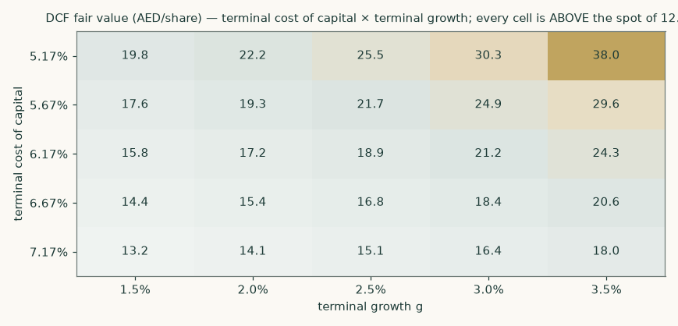
Figure 3 — DCF fair value against the terminal cost of capital and terminal growth. The centre cell reproduces the headline cash-flow lens exactly, which is the check a sensitivity grid has to pass before any other cell in it means anything. Note what the grid says as a whole: across the entire plausible range of terminal discount rate and terminal growth, every cell sits ABOVE the spot price of AED 12.30 — the lowest, at a 7.17% terminal cost of capital and 1.5% growth, still reads AED 13.2. For the market to be right on this lens, something outside this grid has to be wrong — the fiscal regime, the terminal multiple, or the cash flows themselves. Sections 1.7 and 4 take that seriously rather than treating the grid as vindication.
Driver (grid) |  |  | base |  |  | swing
Beta (0.35 / 0.49 / 0.62 / 0.65 / 0.80) | 22.40 | 18.89 | 16.41 | 15.93 | 13.89 | 8.51
Combined fiscal take (40% / 44% / 47% / 50% / 53%) | 20.23 | 18.89 | 17.60 | 16.47 | 15.31 | 4.92
Blended ARPU (×) (0.92 / 0.96 / 1.00 / 1.04 / 1.08) | 16.00 | 17.45 | 18.89 | 20.33 | 21.78 | 5.77
Subscribers ('000, shift) (-400 / -200 / +0 / +200 / +400) | 17.95 | 18.42 | 18.89 | 19.36 | 19.83 | 1.88
Direct cost per unit (×) (0.94 / 0.97 / 1.00 / 1.03 / 1.06) | 20.08 | 19.48 | 18.89 | 18.30 | 17.70 | 2.37
Blended ARPU drift (%/yr) (-2.5% / -1.5% / +0.0% / +0.5% / +1.0%) | 15.47 | 16.81 | 18.89 | 19.61 | 20.33 | 4.86
Capex path (×) (0.85 / 0.93 / 1.00 / 1.10 / 1.20) | 19.92 | 19.40 | 18.89 | 18.21 | 17.53 | 2.39
Terminal ROIC (18% / 22% / 27% / 30% / 34%) | 18.04 | 18.49 | 18.89 | 19.03 | 19.21 | 1.17

Table 11 — single-driver sensitivities on the DCF (AED/share); the middle column is the base. Each cell is a complete re-run of the model including the unit build, and each grid returns the base case at its base parameter — a check this study failed in its previous edition, where the beta row was computed on a retired construction and its base cell missed the headline by AED 1.77. The rank order is the honest hierarchy: the discount rate dwarfs every operating driver, and the fiscal take comes next; among operating drivers ARPU is king, which is why a duopoly that does not price-war deserves its premium.
Two rows deserve a note. The ARPU-drift row is not a generic price sensitivity: it is the mix-exhaustion case set out in 1.6, and it is the largest operating downside in the study — AED 15.47 at -2.5% a year against AED 18.89 in the base. The direct-cost row now scales COST PER UNIT rather than a margin, so it is a driver rather than an assumption being nudged.
One further test belongs here, because an external review asked for it: what is revenue at the company's guided midpoint worth? The build lands at +4.3% against a guided 4-6%, so the +5.0% midpoint is worth about AED 107mn of FY2026 revenue. The answer depends less on the revenue than on HOW it is won. Won on price, with no incremental unit cost or capex behind it, the cash-flow lens reads AED 19.54; won on volume, carrying both, it reads AED 19.68. On the same five-year revenue the price route is worth AED 0.20 more per share than the volume route. The build deliberately stays below the midpoint: it is driven by the disclosed subscriber and ARPU paths, and reverse-engineering a forecast to a guidance number is the opposite of building it from the ground up.
2 Technical and price structure
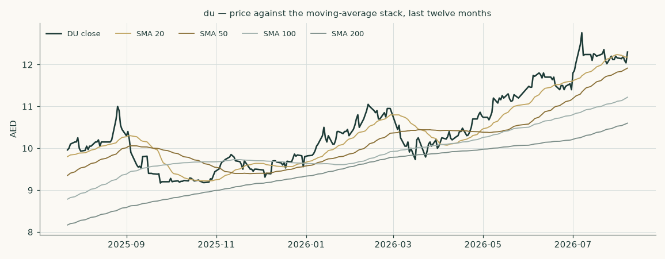
Figure 4 — price against the 20-, 50-, 100- and 200-session moving averages over the the last twelve months of trading.
Marker | Level (AED) | Reading
Last close | 12.30 | the anchor for everything in this study
20-session average | 12.18 | price is +1.0% against it
50-session average | 11.92 | price is +3.2% against it
100-session average | 11.22 | price is +9.6% against it
200-session average | 10.60 | price is +16.0% against it
52-week high (closing basis) | 12.76 | -3.6% from the high
52-week high (intraday) | 12.80 | -3.9% from the high — the conventional basis, and the wider of the two
52-week low (closing basis) | 9.17 | +34.1% from the low
52-week low (intraday) | 9.05 | +35.9% from the low — the same two bases as the high above
Annualised volatility | 28.1% | the fitted range-based volatility model's CURRENT state — elevated by the war-quarter swings — and the input to the price cone in section 3

The share sits +16.0% above its 200-session average but -3.6% below its 52-week closing high — an uptrend that has given back its top since the war quarter. Realised volatility over the last 50 sessions is 21.4%; the model's range-based estimate of 28.1% reflects the regime of the last months rather than a single session. None of this is a valuation argument; it is the price context the valuation has to be read against, and the gap between a recovering price and a fundamental central above it is what section 4 addresses.
3 A probabilistic price map
This section answers a different question from the valuation. It does not ask what the business is worth; it asks where the share price could plausibly be in one and three months, given how this share has actually moved. The engine simulates 50,000 price paths from a volatility model fitted to the daily high-low-open-close range, with a fat-tailed shock distribution and a drift anchored to the cost of carry — the dollar policy path under the dirham's peg, net of the dividend yield — carrying no directional view.
The widths below are tested rather than assumed, and the honest result is stated plainly: over the last five years of non-overlapping quarterly windows (18 of them, origins 2022-01-27 to 2026-04-29, each forecast using only data available before it), the model scored -0.74% against a random-walk benchmark anchored on the same cost of carry — statistically indistinguishable from the benchmark (the confidence interval spans zero), neither better nor worse. Outcomes were spread evenly across the distribution: a uniformity test returns p = 0.69, which at 18 windows means the test cannot reject uniformity — a statement about the test's power, not a certificate of calibration. On coverage the honest finding is OVER-dispersion, not calibration: outcomes fell inside the stated bands MORE often than advertised at every level (61% inside the 50% band, 94% inside the 80%, 100% inside the 90%), and for this low-volatility share the bands run about 53% wider than the benchmark's. The cone is too wide rather than too confident, and a reader should treat the outer bands as generous. Over the full history the model UNDERPERFORMS the benchmark on windows that predate the 2022 change in the exchange's trading week. Those windows are excluded from the calibration for that reason, and the figures quoted above are the post-exclusion set — 18 windows with origins from 2022-01-27 to 2026-04-29, all after the change. The previous edition quoted a nineteen-window set beginning 27 October 2021 in the same breath as the exclusion, which was inconsistent.
This is a map of price dispersion, not a forecast, and it is never blended with the fair-value work above.
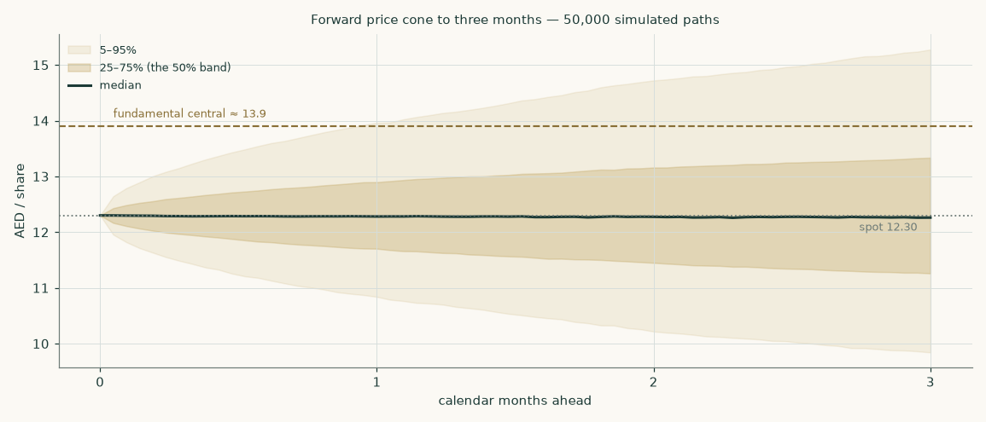
Figure 5 — the forward price cone to three months. The dashed brass line is the fundamental central estimate of 13.90; the dotted line is the spot of 12.30.
Percentile map (AED/share)
Horizon | 5th | 25th | Median | 75th | 95th | P(above spot)
One month — to 2026-09-07 | 10.85 | 11.71 | 12.28 | 12.89 | 13.88 | 49%
Three months — to 2026-11-09 | 9.82 | 11.26 | 12.26 | 13.35 | 15.32 | 49%

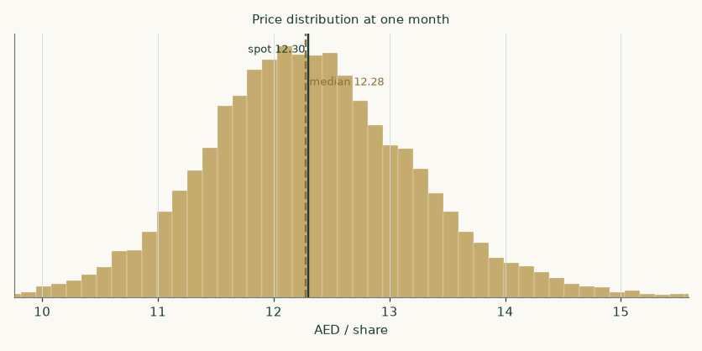
Figure 6 — price distribution at one month.
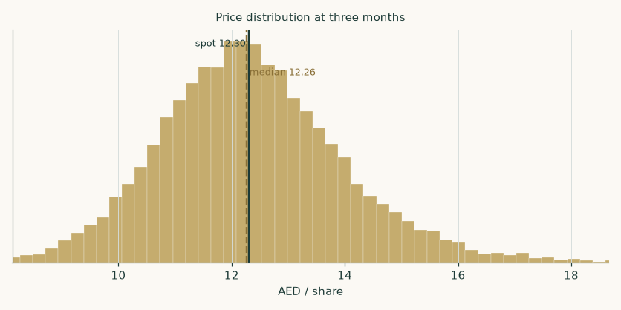
Figure 7 — price distribution at three months.
Level-touch ladder
Event | One month | Three months
Finishes 10% or more above spot | 9% | 22%
Finishes 10% or more below spot | 8% | 21%
Touches 10% above spot at any point | 15% | 41%
Touches 10% below spot at any point | 13% | 38%

4 Comparison of the lenses
The field disagrees, and the disagreement is informative. The cash-flow lens reads AED 18.89; the two market-anchored lenses read AED 8.86 and AED 8.87; the book lens AED 14.12. The spread is NOT about the forecast — all four lenses consume the same build, and the near-term numbers are anchored on a printed first half. It is about the price of time and certainty: the measured beta prices du's equity at a 6.5% required return, while the regional market, at the peer median multiple, implicitly charges something closer to the return implied by a 15-16× earnings multiple on a slow-growing annuity — two to three points more. Discount this study's own cash flows at that market-implied rate and you get, in effect, the relative lens.
What would close the gap from each side. The DCF is right and the market re-rates if: the fiscal regime is extended on current terms with the floor lapsing or lightening; the licence renews on comparable terms; the war recovery completes; and the data-centre leg starts printing revenue the market can see. The market is right and the DCF is generous if: the royalty regime reverts or worsens (Framing B alone closes most of the gap — AED 16.11); the measured beta understates the true risk of a single-market, single-licence operator (beta 0.80 alone takes the DCF to AED 13.89); or terminal reinvestment needs are heavier than 9.1% of profit. The weighted central of AED 13.90 embodies exactly this balance: it leans toward the cash flows but pays the market-anchored lenses the 45% respect their discipline has earned — while noting, as 1.4 does, that those two lenses are one reading of one multiple, not two.
Those weights are a house judgement, and an external review was right to ask what they are worth. If the market-anchored family carried 25% of the weight instead of 45%, the central would read AED 15.91 were the freed weight given to the cash-flow lens and AED 14.95 were it given to the book lens — up to 2.01 a share, and 0.95 between the two destinations. The weights are NOT changed — the same scheme is applied to every operating company this house covers, and re-tuning it for one name is how a standard stops being one — but the alternatives are published here rather than described as immaterial, because they plainly are not.
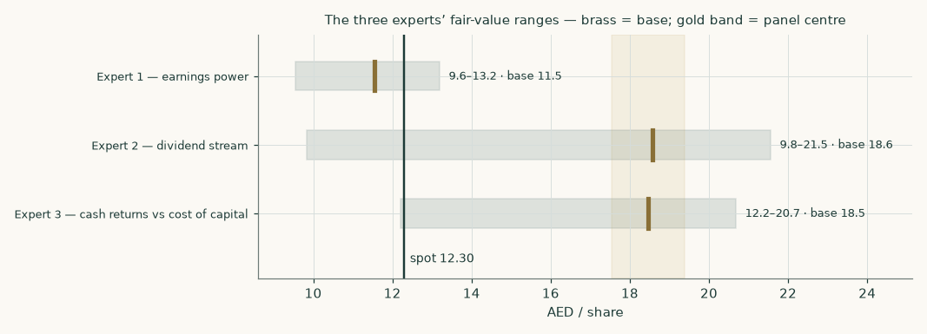
Figure 8 — the expert panel's three independent reads (Appendix C), against spot.
5 Catalysts to watch
- 1 · The post-2026 fiscal regime (direction: either; size: the study's largest). du's own filings describe the 38% + 9% regime as effective 2024-2026. The other operator has disclosed a ministry notification extending the structure through 2029; du's mirroring disclosure — and whether the AED 1.8bn combined floor carries over — is the single most valuable sentence the company can publish: AED 18.89 versus AED 16.11 per share between the framings.
- 2 · The licence renewal (direction: binary-adverse tail; timing: now). The TDRA extension ran to 8 August 2026 with conclusion expected "on or before" that date — i.e. the outcome is due at press time. Renewal on comparable terms is the base case and would be a non-event; a renewal that raises the fee ratio costs roughly AED 0.61 per share per percentage point of revenue.
- 3 · The war recovery (direction: up if the ceasefire holds). Prepaid subscribers, roaming and wholesale transit all recover with tourism; the company itself reports gross adds below pre-war levels with a ceasefire in place. The Q3-2026 print (late October) is the first clean read; a return to net adds above +150k/quarter would put the bull subscriber path in play.
- 4 · The data-centre leg (direction: up; horizon: 2027-2028). Five data centres plus the Microsoft-anchored hyperscale campus; commitments rose to AED 2,412mn at mid-2026. First disclosed hyperscale revenue — or a named second anchor tenant — would convert the ICT growth path from house assumption to disclosed run-rate.
- 5 · The dividend (direction: up, mechanically). The board raised the interim 8.3% in the same release that cut revenue guidance — a statement of intent. At the forecast payout the FY2026E dividend is AED 0.70; at the regional benchmark yield that alone is worth AED 14.24 per share (section 1.3).

6 Reading the probability zones
How to read sections 2-3 against section 1. The three-month cone spans AED 9.82 to 15.32 — the price can visit a lot of places in ninety days without any of them being a statement about value. The fundamental central of AED 13.90 sits inside the cone's upper half: reaching it within a quarter would be a strong but not extraordinary move. Three zones, then:
- Below AED 11.26 (the cone's lower quarter): price weakness this deep with no fiscal or licence news would widen the value gap mechanically; with adverse regime news it would simply be the market pricing Framing B — check which before reading it as opportunity.
- AED 11.26 to 13.35 (the middle half): noise. Nothing in this band changes any conclusion in this study.
- Above AED 13.35: the market starting to pay for the recovery and the regime extension before they are printed; at the cone's top the share would still sit below the cash-flow lens but at the weighted central.
The cone is honest about its own limits: for this share its bands have historically run wider than needed (section 3), so the outer zones are conservative.
7 Caveats and what would change our mind
- The discount rate is the study. A 0.488 measured beta against an Aa2 curve prices du's equity at 6.5%. Every conclusion that differs from the market traces to that number; section 1.8 prices the alternatives and section 4 takes the other side seriously. If du's risk is the sector's rather than its regression's, the central is several dirhams lower.
- The terminal value is most of the value. 83% of the DCF's enterprise value is beyond year five. That is the honest shape of a low-discount-rate annuity, and it is why the licence and the royalty — the two things that could touch the annuity itself — outrank every operating driver.
- The fiscal regime is not ours to forecast. Both framings are priced throughout; the study REFUSES a single number where the state has not yet published one. If a harsher-than-either construction emerged, both framings would need re-striking.
- The war path. The base case assumes the ceasefire holds and tourism normalises into 2027. A re-opened conflict invalidates the subscriber path, the wholesale recovery and possibly the multiple — the bear scenario, not the base.
- Wholesale and ICT are built top-down. No unit disclosures exist for either; both are flagged. The ICT ramp in particular leans on a disclosed programme whose revenue model (colocation vs services) the company has not yet broken out.
- The flat ARPU path, and the risk hidden inside it. The single most fragile revenue judgement in this study is that blended mobile ARPU holds roughly flat. Section 1.6 decomposes why: the flat reported figure is a postpaid mix tailwind worth about +2.6% set against per-leg price erosion of about -2.4%. Both must persist, and keep cancelling, for the path to hold. The mix shift came from a collapse in low-value visitor prepaid SIMs, and this study's own subscriber path assumes prepaid RECOVERS — which removes the tailwind and leaves the erosion exposed. Priced: the cash-flow lens falls to AED 15.62 (-17%). We cannot separate the two legs because du publishes no prepaid or postpaid ARPU, and solving for the ratio across all 21 available quarter pairs gives answers from -45× to 17× — so the gap is flagged, not filled.
- What we cannot build from the disclosure. Wholesale and ICT direct costs carry a rate on their own revenue rather than a cost per unit, because no volume measure for either segment is disclosed anywhere in the filings. That is the weakest part of an otherwise per-unit cost build. The ICT rate is held flat rather than improving, which withdraws a data-centre-scale margin story the previous edition of this study carried: the disclosed series does not support a trend in either direction, and an unmeasurable story has no place in the model.
- The second half of 2026 is a forecast, not a print. The FY2026E EBITDA margin of 47.8% sits above the company's own guided 46-47%, so the claim that has to stand up is the implied SECOND-HALF margin of 46.5%. The first half improved +2.1 points year on year; the implied second half improves only +1.3 points, so the forecast already assumes the year-on-year gain roughly halves. Reaching the guided midpoint would instead require a second-half margin of 43.9%, a year-on-year DETERIORATION against a first half that improved. Possible, and priced in 1.9 — but not what the filings point to.
- What would change our mind, concretely. A royalty construction harsher than Framing B; licence renewal terms materially above the current fee ratio; two consecutive quarters of negative postpaid net adds; a quarter in which the postpaid share of the mobile base FALLS back toward 20% while blended ARPU follows it down — the mix-exhaustion case above; mobile interconnect cost per subscriber turning UP in a like-for-like half-year pair, which would remove the only cost tailwind in the build; or the payout being cut other than for a named investment programme. Any one of these re-opens the build; the register in Appendix B tells a reader exactly which inputs to re-examine first.

Appendix A Financial statements
A.1 Income statement — three years historical and five years forecast (consolidated, AED mn)
AED mn | FY2023 | FY2024 | FY2025 | FY26E | FY27E | FY28E | FY29E | FY30E
Revenue | 13,636 | 14,636 | 15,905 | 16,593 | 17,240 | 18,011 | 18,734 | 19,424
EBITDA | 5,800 | 6,470 | 7,338 | 7,937 | 8,239 | 8,624 | 8,977 | 9,309
EBITDA margin | 42.5% | 44.2% | 46.1% | 47.8% | 47.8% | 47.9% | 47.9% | 47.9%
Depreciation & amortisation | -2,198 | -2,154 | -2,168 | -2,235 | -2,352 | -2,448 | -2,530 | -2,582
Operating profit (EBIT) | 3,601 | 4,316 | 5,170 | 5,702 | 5,887 | 6,176 | 6,446 | 6,727
Net finance income / (cost) | -40 | -8 | -20 | 4 | -3 | -7 | -9 | -5
Share of equity-accounted investments and net impairment | -2.7 | -2.5 | -1.0 | 0.0 | 0.0 | 0.0 | 0.0 | 0.0
Profit before royalty and tax | 3,559 | 4,306 | 5,149 | 5,706 | 5,884 | 6,168 | 6,438 | 6,723
Federal royalty and income tax | -1,891 | -1,819 | -2,244 | -2,486 | -2,564 | -2,688 | -2,805 | -2,929
Net profit | 1,668 | 2,488 | 2,905 | 3,220 | 3,320 | 3,481 | 3,633 | 3,794
Earnings per share (AED) | 0.37 | 0.55 | 0.64 | 0.71 | 0.73 | 0.77 | 0.80 | 0.84
Dividend per share (AED) | 0.34 | 0.54 | 0.64 | 0.70 | 0.72 | 0.75 | 0.79 | 0.82

Table A1 — every column now foots: the associates-and-impairment line, previously omitted, is what reconciled operating profit to profit before royalty in the audited statements. FY2023-25 are the audited figures (FY2024 on the re-presented basis of the FY2025 statements, so the two recent years sit on one presentation; FY2023 EBITDA is derived from audited components because the older format prints no such line, and is flagged as such). The FY2023 royalty is the old-regime charge; no corporate income tax existed before 2024.
A.2 Balance sheet — condensed house layout (consolidated, AED mn)
AED mn | FY2023 | FY2024 | FY2025 | FY26E | FY27E | FY28E | FY29E | FY30E
Property, plant and equipment | 9,723 | 9,838 | 10,289 | 10,887 | 11,403 | 11,860 | 12,173 | 12,432
Right-of-use assets | 1,597 | 1,657 | 1,515 | 1,515 | 1,515 | 1,515 | 1,515 | 1,515
Intangibles (excl. goodwill) | 1,111 | 847 | 870 | 963 | 1,031 | 1,083 | 1,109 | 1,127
Goodwill | — | 413 | 413 | 413 | 413 | 413 | 413 | 413
Net working capital | -965 | -1,220 | -1,062 | -1,108 | -1,152 | -1,203 | -1,251 | -1,297
Cash and term deposits | 1,937 | 2,283 | 2,250 | 2,023 | 1,899 | 1,856 | 1,979 | 2,158
Lease liabilities | 2,105 | 1,999 | 1,939 | 1,939 | 1,939 | 1,939 | 1,939 | 1,939
Total equity | 9,243 | 9,878 | 10,148 | 10,213 | 10,279 | 10,349 | 10,421 | 10,497
Net cash after leases | -168 | 285 | 311 | 84 | -40 | -83 | 40 | 219

Table A2 — a condensed layout: receivables, payables, contract balances and the royalty accrual are netted inside working capital (the FY2023 payables line still contained the royalty accrual, separately disclosed from FY2024; it is excluded in every year so the series is like-for-like). Zero drawn borrowings in every year shown. Goodwill was not a separate line in the FY2023 layout.
A.3 Forecast balance sheet and cash-flow markers
The equity walk: profit less the 98% payout compounds equity from AED 10,148mn to AED 10,497mn by FY2030E. The cash walk is the stress line: at a near-total payout plus the data-centre capex peak, cash and term deposits fall from AED 2,250mn to AED 2,158mn by the last forecast year, declining in every year of the forecast with no rebuild inside the window — the audited mid-2026 position (term deposits nil after the royalty settlement and final dividend) already shows exactly this mechanic, and the undrawn AED 2.0bn facility is the disclosed backstop. Working capital RELEASES cash every year; the lease book is held flat with replacement charged at depreciation.
Appendix B Peer frame, risk register — and the research register
B.1 Peers and the sector frame
Company | Market | Trailing P/E | Yield | Read-across
e& | UAE (ADX) | ~20.7× | ~4.8% | the duopoly partner: scale + international assets earn the premium multiple
stc | Saudi Arabia | ~18.9× | ~5.2% | the regional benchmark payer
Mobily | Saudi Arabia | ~15.5× | ~2.9% | closest structural analogue — the #2 that closed the gap; sets the justified P/E
Ooredoo | Qatar | ~12.5× | ~4.6% | multi-market, softer growth
Zain | Kuwait | ~9× | ~6-7% | levered multi-market; the bracket floor
Omantel | Oman | ~11.4× | ~6.7% | small-market incumbent, yield-heavy
DT / Vodafone | Developed | n/m | ~3.4% | the developed bracket: more leverage, lower returns, lower multiples

Table B1 — aggregator reads at the sweep date, labelled cross-check; never a build source. du computes at 19.2× trailing earnings and 7.6× trailing EV/EBITDA from its own audited figures.
B.2 Risk register
Risk | Mechanism | Where it is priced
Fiscal regime reversion or worsening | combined take above the current 44% | Framing B throughout: AED 16.11
Licence renewal on worse terms | fee ratio above 2.7% of revenue | ~AED 0.61/share per +1pp (section 1.9)
War re-escalation | prepaid, roaming, wholesale transit reverse | subscriber sensitivity and the DCF bear
Required-return mismeasurement | the 0.488 regression beta understates true risk | beta grid to 0.80: AED 13.89
Data-centre execution | ICT ramp slips; capex stays high without the revenue | ICT growth and capex grids
Payout sustainability | near-total payout + capex peak drains liquidity | the cash walk in A.3; the undrawn facility is the backstop
Concentration | one market, one regulator, one licence | the weight given to market-anchored lenses in the synthesis

B.3 The research register — layers, dated, negative results included
The full input register — every input with value, source and date, grouped by research layer, with the judgement table (each judgement paired with what would overturn it), the negative-results table and the source-discrepancy notes — ships as the companion bibliography document. Highlights a reader should know: all statement figures were read from the company's own audited/reviewed filings on its investor-relations portal (four complete fiscal years, plus both 2026 interims, swept in before the build); the UAE sovereign credit-default-swap quote was UNREACHABLE at the sweep date and the market spread was proxied by the traded Abu Dhabi dollar curve, disclosed rather than silently substituted; no public peer EV/EBITDA was clean enough to use; and no announcement of concluded licence-renewal terms existed at the sweep date — a dated negative search, not an oversight.
Appendix C The expert valuation panel
Three experts, three methods, each with worked arithmetic, a named sensitivity and a falsifier stated in advance. One caveat a reader is owed up front, because it limits what the panel proves: Expert 3's economic-profit method is ALGEBRAICALLY equivalent to the cash-flow model given the same profit, capital and cost of capital, and Expert 2's dividend model is a perpetuity on the same terminal cost of equity and growth at a payout near 100%. So of the three, only Expert 1 is genuinely independent of the primary lens; the other two are better read as consistency checks on it than as external corroboration. The panel median is reported on that understanding. They are labelled Expert 1/2/3; their methods, not their names, are the point. Cast by method: an earnings-power investor, a dividend-stream investor, and an economic-profit analyst.
C.1 Expert 1 — earnings power: through-cycle earnings at a conservative multiple
Worldview: buy durable earnings power at a multiple that does not need the story to work. Works best on stable franchises near mid-cycle; fails when the cycle is mistaken for the trend or when a regime change (here: fiscal) resets the earnings base itself.
Step | Value
Mid-cycle earnings per share (FY2028E) | 0.77
Through-cycle multiple applied | 15.0×
Value at FY2028, i.e. at 31-Dec-2028 (EPS × multiple) | 11.52
discounted 2.40 years — 31-Dec-2028 back to the anchor — at the 6.53% cost of equity | 9.89
plus the present value of dividends receivable between the anchor and FY2028 | 1.64
Expert 1 fair value (anchor date) | 11.54
Range: 12× to 17.5× the same earnings | 9.56 – 13.19

This construction was CORRECTED after external review, and the reviewer was right. The previous edition discounted two years from a 31-Dec-2025 base and then applied the same anchor-accretion factor the other lenses use, which nets to 1.40 years of discounting — a full year short of the 2.40 years that actually separate the anchor from the date these earnings arrive. Correcting the horizon on its own, though, changes almost nothing (AED 9.89) and would introduce a second, larger error: discounting a 2028 equity value straight to today silently discards the dividends paid in between, which for a company distributing essentially all of its earnings is worth AED 1.64 per share. Both defects sat in the same three lines. Fixed together, this lens moves from AED 9.88 to AED 11.54. The reviewer's premise was correct and their conclusion — that the lens was overstated — was wrong in sign.
Named sensitivity: the multiple. Each turn of the multiple is worth AED 0.66 per share at mid-cycle earnings. Falsifier, stated in advance: if FY2027 earnings per share prints below the FY2026 estimate — i.e. the war recovery stalls into earnings — the mid-cycle base is wrong and this read is withdrawn.
C.2 Expert 2 — the dividend stream: the natural lens for a full-payout duopoly
Worldview: for a company that pays out essentially everything, the dividend IS the cash flow; value it directly as a growing perpetuity. Works best when payout is policy, not accident, and the balance sheet cannot be raided; fails when the payout is about to be cut — the model capitalises a promise.
Step | Value
FY2026E dividend per share | 0.70
grown at 2.5% into a perpetuity at the terminal cost of equity 6.35% | 18.52
× the anchor accretion factor of 1.0387, as every other lens is rolled | 19.23
less the dividends gone ex before the anchor | 0.66
Expert 2 fair value (anchor date) | 18.57
Range: cut-and-higher-rate bear to 3%-growth bull | 9.84 – 21.55

Named sensitivity: the growth-rate spread (Ke − g). At these levels each 50 basis points of spread is worth roughly AED 2.41 per share. Falsifier: an interim or final dividend DECLARED lower than the prior year's equivalent — the first cut in the record — withdraws this read immediately.
C.3 Expert 3 — cash returns: economic profit on invested capital
Worldview: value = capital + the present value of returns ABOVE the cost of capital; a franchise is only worth a premium while its return spread lasts. Works best where invested capital is measurable and returns are stable; fails when intangible capital (spectrum rights, the licence itself) does the earning but sits off the balance sheet — which flatters the measured return.
Step | AED mn
Invested capital, FY2025 (PP&E + right-of-use + intangibles + goodwill + working capital) | 12,025
PV of five years of economic profit (NOPAT less capital charge at the forward rate) | 11,070
PV of the terminal economic-profit annuity | 60,033
Implied enterprise value | 83,127
bridge to equity (leases out, cash in), per share at the anchor | 18.46
Range: fading spreads on the low side; a judgemental +12% on the high side | 12.20 – 20.67

The return spread behind it: forecast returns on capital of 26% / 26% / 26% / 26% / 27% against forward costs of capital of 6.4% / 6.4% / 6.3% / 6.2% / 6.2% — a spread of roughly twenty points, which is what a licensed duopoly with negative working capital looks like in this framework. Named sensitivity: terminal capital intensity — if the data-centre era permanently raises invested capital per dirham of profit, the terminal annuity shrinks. Falsifier: return on invested capital printing below 20% for two consecutive years.
C.4 Cross-examination
- Expert 2 to Expert 1: your multiple is a market mood; my denominator is a policy rate. CONCEDED in part by Expert 1: the multiple carries sentiment — which is exactly why it is set at the peer median rather than du's own historical average.
- Expert 1 to Expert 2: you capitalise a promise at a 3.7-point spread; one cut and your number is fiction. REJECTED by Expert 2: the payout has risen through a war quarter and a guidance cut — the board has told you what the dividend is for.
- Expert 3 to both: neither of you charges for capital. The spread is the asset. CONCEDED by both — with the counter, ACCEPTED by Expert 3, that his invested-capital base omits the licence value itself, so his measured spread flatters the franchise precisely when the licence is up for renewal.
- All three to the primary model: the DCF's terminal value is 83% of enterprise value at a discount rate its own section calls the study's biggest assumption. The model's answer: the beta is measured, gated, cross-checked, and priced against its alternatives in two separate tables — the disagreement is put in front of the reader rather than resolved by fiat.
C.5 The three in one room
Where they land: Expert 1 at AED 11.54, Expert 2 at AED 18.57, Expert 3 at AED 18.46 — a panel median of AED 18.46. The shape of the disagreement is the study in miniature: the earnings-power read hugs the market because it borrows the market's multiple; the two cash-based reads sit together well above it because they price du's cash at du's measured risk — and, as section 1.7 sets out, that gap is itself the study's central unresolved judgement rather than a conclusion about it.
C.6 Reading the divergence
Gap | Driver of the gap | Worth (AED/share)
Expert 1 (11.54) vs Expert 2 (18.57) | market multiple vs measured cost of equity as the price of the same cash | 7.04
Expert 2 (18.57) vs Expert 3 (18.46) | payout-as-perpetuity vs capital-charged spread — small, because at ~100% payout the dividend nearly IS the economic profit | 0.11
Panel median vs the study's weighted central (13.90) | the synthesis deliberately weights the market-anchored lenses the panel's cash-flow majority does not | 4.56

Table C1 — the divergence table: which assumption drives which gap.
About this series
Testahil publishes independent, educational valuation studies of listed companies and metals. Each study separates fundamental value (built from audited filings, bottom-up) from price probability (a calibrated simulation of where the price could trade), and publishes ranges and distributions rather than targets. Delivered studies are never retro-edited; corrections are made forward, in the open. The companion Excel model is formula-driven so every figure can be traced to its driver, and the companion bibliography lists every input with source and date.
Disclosure & Disclaimer
This document is educational analysis, not investment advice, an offer, a solicitation, or a recommendation to buy or sell any security. It expresses no rating and no price target. The authors hold no position in the securities discussed and receive no compensation from any issuer. All historical figures derive from the company's own published audited or reviewed consolidated financial statements; forecasts are the authors' own and are inherently uncertain. Probabilities describe model output, not promises. Markets can and do behave outside any model's bands. Readers should conduct their own research and consult their own advisers. © Testahil, 2026.

