Testahil · Independent Valuation Study — Educational Analysis Not investment advice

Fertiglobe plc
Abu Dhabi Securities Exchange · FERTIGLB | Nitrogen fertilisers
Valuation study, 9 August 2026 · price basis 2026-08-07 · reported in US dollars, priced in dirhams
READ FIRST
This is an educational valuation study. It is not investment advice, it is not a recommendation, and it contains no rating and no price target. What it contains is a range of fair value produced by four independent methods, and a probability distribution for the share price over the next one and three months. Both are estimates and both can be wrong.
What this study is built from. Every historical figure comes from Fertiglobe plc's own issued financial statements, downloaded from the company's investor-relations archive. Four complete audited financial years were obtained — 2022, 2023, 2024 and 2025 — together with the interim statements for the first quarter and first half of 2026. No data vendor, broker note or press report was used as the source of any figure the company itself reports. Market multiples for comparable companies are the one exception, and they are used only as a cross-check and labelled as such.
The currency. Fertiglobe reports and functions in US dollars. Its shares trade in dirhams on the Abu Dhabi Securities Exchange. The valuation is therefore built in dollars, which is the currency of the company's revenue, its gas contracts and almost all of its debt, and translated to dirhams per share at the central bank peg of 3.6725 only at the final step.
The single most important judgement. The company's gas cost in Egypt and Algeria moves with the price of the product it makes. That one fact governs how much of a fertiliser price rise the company actually keeps. It is measured here from disclosed data rather than assumed, and the question it raises — whether today's elevated prices persist — is answered twice, not once. Both answers are carried through to a value and published side by side.

Headline
Four valuation methods place Fertiglobe between AED 1.27 and AED 2.79 per share. The weighted centre of that range is AED 2.15, against a market price of AED 2.54 on 2026-08-07 — a premium of -15.5%. The range is wide because this is a commodity producer at an unusual moment in its price cycle, and honest ranges for such businesses are wide.
The company earned 1,025 million of EBITDA in 2025 on 2,827 million of revenue. In the first half of 2026 alone it earned 713 million of adjusted EBITDA on 2,001 million of revenue, as conflict in the Middle East closed the Strait of Hormuz and drove urea from $440 to $637 per tonne. The central question for a buyer today is how much of that is durable.
The finding that matters. A naive reading of the first half of 2026 doubles the company's earnings power. That reading is wrong, and the company said so itself. Gas pricing in Egypt and Algeria is linked to the product price, so the cost side rises with the revenue side. Measured across the three periods the company has disclosed, roughly 48% of every incremental dollar of realised price is absorbed by cost before it reaches profit. A model that escalated costs on general inflation instead would have overstated the value of this company by a wide margin.

Valuation summary
Method | What it measures | Value (AED/share) | Weight | Note
Cash flow | Five years of free cash flow to the firm, then a terminal block | 2.19 | 45% | Terminal value is 55.2% of enterprise value
Relative multiples | Mid-cycle EBITDA on a peer-anchored enterprise multiple | 2.06 | 20% | 5.8 times enterprise value to EBITDA
Normalised earnings power | Mid-cycle profit on a justified earnings multiple | 2.79 | 20% | 11 times earnings
Book value and sustainable return | Book equity marked to the return it earns | 1.27 | 15% | Weakest lens here — see section 1.2
Weighted centre |  | 2.15 | 100% | Market price AED 2.54

Summary valuation table. Terminal value as a share of enterprise value is shown against the cash-flow method because that method is the one it applies to.
The same company, valued twice
The price of nitrogen fertiliser over the next five years is the study's central contested judgement, and there is no honest way to settle it from the evidence available today. Rather than average two views into one number that nobody holds, both are computed in full and published side by side.
 | Framing A — normalisation | Framing B — structurally tight
The argument | The 2026 spike is a war premium. As the Strait reopens and Chinese exports resume, prices fall back toward the marginal cost of European production. | Demand growth outside China of about 11.4 million tonnes to 2030 outpaces roughly 9.1 million tonnes of additions, and European tariffs on Russian product keep rising. Prices hold near recent levels.
Urea by 2028 ($/t) | 440 | 550
Ammonia by 2028 ($/t) | 420 | 530
EBITDA by 2030 ($m) | 1,024 | 1,385
Enterprise value ($m) | 5,980 | 8,610
Terminal value share of enterprise value | 55.2% | 61.2%
Value (AED/share) | 1.76 | 2.62

The two framings are not a bull case and a bear case. They are two defensible readings of the same evidence, and the difference between them is the honest measure of what is not known.
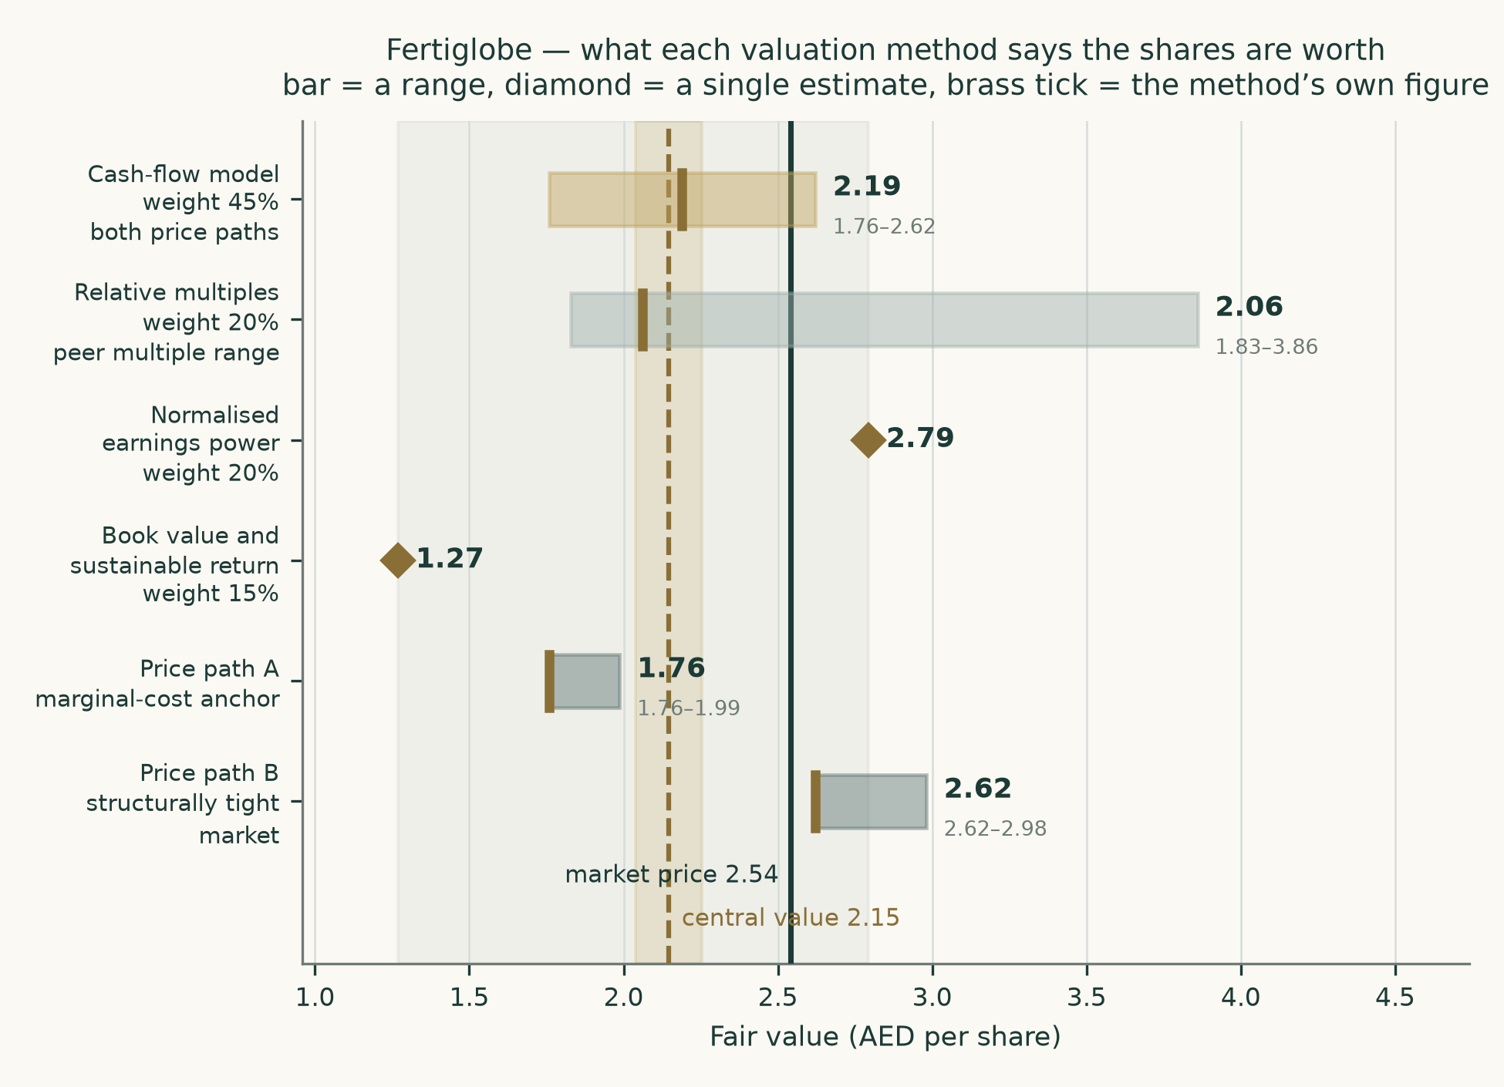
Figure 1. The four valuation methods and the two price framings, against the market price.
Company overview
Fertiglobe plc produces and sells nitrogen-based fertilisers — ammonia and urea — from four plants across three countries, and markets both its own output and product bought from third parties. It is the largest nitrogen fertiliser producer in the Middle East and North Africa and describes itself as the world's largest seaborne exporter of urea and net ammonia combined. It listed on the Abu Dhabi Securities Exchange on 27 October 2021. Abu Dhabi National Oil Company completed its purchase of OCI N.V.'s entire holding in October 2024 and now owns 87.4%, leaving a free float of 12.6%.
Plant | Country | Ownership | Urea capacity (Mt) | Ammonia capacity (Mt)
Egyptian Fertilizers Company | Egypt | 100% | 1.4 | 0.4
Egypt Basic Industries Corporation | Egypt | 75% | — | 0.7
Sorfert Algérie | Algeria | 51% | 1.3 | 0.8
Ruwais Fertilizer Industries | United Arab Emirates | 100% | 2.1 | 0.1

Plant footprint. Group merchant capacity is 5.1 million tonnes of urea and 1.5 million tonnes of merchant ammonia, the ammonia figure being net of what is consumed internally to make urea.
Why this is valued as an operating company
The classification matters more than any other single decision in a study, because it determines which method is used, and a wrong classification invalidates everything downstream. Three facts from the filings settle it here.
- All revenue comes from the sale of nitrogen products. The FY2025 segment note states the group has "one revenue stream from contracts with customers which is the sales of Fertilizers products (Ammonia and Urea)". There is no lending book, no rental stream and no development pipeline.
- The two reportable segments are production and marketing of own-produced volumes, which earned 2,332 million of revenue in 2025 at a 45.4% EBITDA margin, and third-party trading, which earned 495 million at 3.8%. The second is a working-capital business attached to the first, not a separate enterprise needing its own method.
- The balance sheet is plant. Property, plant and equipment of 2,499 million out of 4,950 million of total assets, with no investment property and no portfolio of equity stakes. The subsidiaries are consolidated operating plants, not holdings — which is what distinguishes this from a holding company.
The company is therefore valued on free cash flow to the firm, cross-checked by multiples, by normalised earnings power and by book value. It does not straddle two classes, so the legs are not split.
1. Fundamental valuation
1.1 Cash-flow model
The model runs five forecast years against three years of history. Volumes come from installed capacity times utilisation; prices from published benchmarks times a measured realisation ratio; costs from a pass-through relationship calibrated against the company's own disclosed segment economics. The 2026 forecast year is not modelled in full — the first half is already reported, and is carried as reported, with only the second half forecast.
US$ million | 2026 | 2027 | 2028 | 2029 | 2030
Revenue | 3,770 | 3,267 | 3,095 | 3,121 | 3,164
EBITDA | 1,334 | 1,105 | 1,017 | 1,016 | 1,024
Depreciation and amortisation | 305 | 315 | 325 | 333 | 340
EBIT | 1,029 | 790 | 692 | 683 | 684
EBITDA margin | 35.4% | 33.8% | 32.8% | 32.6% | 32.4%
Tax at 13.1% | 135 | 104 | 91 | 90 | 90
NOPAT (EBIT after tax) | 894 | 686 | 601 | 594 | 594
add back depreciation and amortisation | 305 | 315 | 325 | 333 | 340
less capital expenditure | -175 | -240 | -285 | -315 | -335
less increase in working capital | -139 | 74 | 26 | -3 | -6
Free cash flow to the firm | 885 | 835 | 666 | 608 | 593
Discount factor | 0.8949 | 0.8020 | 0.7198 | 0.6469 | 0.5822
Present value of free cash flow | 792 | 670 | 480 | 394 | 345

Figure in full: the free cash flow waterfall under framing A, from EBITDA to the present value of each year's cash flow. Framing B follows the identical structure on the higher price path.
Enterprise value to equity | US$ million | Note
Present value of forecast free cash flow | 2,680 | Five years, discounted at 11.9% declining to 11.1%
Present value of terminal value | 3,300 | 55.2% of enterprise value
Enterprise value | 5,980
less net debt | -621 | At 30 June 2026
less non-controlling interests | -1,409 | Proportionate share of equity value — see below
Equity attributable to owners | 3,949
Value per share (US$) | 0.4787
Value per share (AED) | 1.76 | At the peg of 3.6725

The enterprise value to equity bridge, framing A. Terminal value as a share of enterprise value is 55.2%.
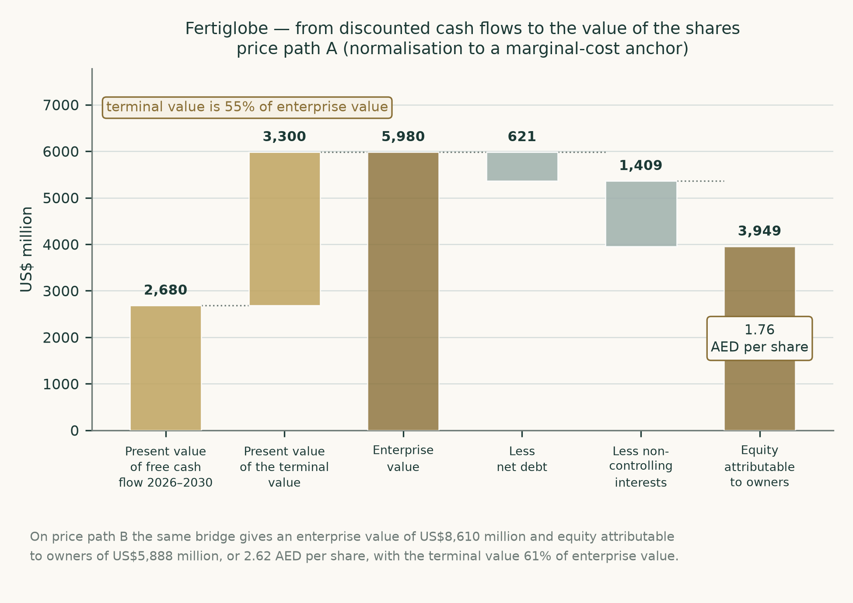
Figure 2. From cash flow to equity value: the bridge in picture form.
Non-controlling interests are unusually large here and deserve their own sentence. Outside shareholders own 49.01% of Sorfert in Algeria and 25% of Egypt Basic Industries, and together took 26.3% of group profit in 2025. Because the cash flows discounted above are the consolidated ones, that share must come out. Deducting it on a proportionate-earnings basis gives AED 1.76 per share; deducting the book value of those interests instead gives AED 2.19. The earnings basis is used because it reflects what those shareholders actually own — a share of the cash flows, not a share of a historical cost figure — and it is the more conservative of the two. Both are shown so the reader can see the size of the choice.
1.2 Book value and sustainable return
Book equity attributable to owners was 1,356 million at the end of 2025, or AED 0.60 per share. The return on that equity averaged 23.0% over the last three years, against a cost of equity of 12.0%. Capitalising the excess gives a justified price-to-book of 2.10 times and a value of AED 1.27.
This is the weakest of the four lenses for this particular company, and it is given the smallest weight for a specific reason rather than a general one. The reserves line carries a negative balance of 1,118 million, described in the accounts as net repayments of equity to previous shareholders out of contributions made in earlier years. Book equity is therefore a legacy of the pre-listing capital structure rather than a measure of capital employed today, which simultaneously deflates book value per share and inflates the apparent return on it. The two distortions partly offset in the formula above, but not reliably, and a reader should treat this lens as a sanity check rather than as evidence.
1.3 Relative multiples
Company | Market | Enterprise value to EBITDA | Character
Nutrien | US | 7.4x | diversified nutrient, retail attached
CF Industries | US | 6.1x | pure nitrogen, Henry Hub advantaged
Yara International | NO | 5.2x | nitrogen, European gas cost
OCI Global | NL | 5.6x | nitrogen and methanol
Industries Qatar | QA | 9.1x | Gulf petrochemical and fertiliser
SABIC Agri-Nutrients | SA | 10.4x | Gulf nitrogen, Tadawul rating
Fertiglobe — applied | AE | 5.8x | Below the Gulf peers, above the European ones

Comparable companies. Peer multiples are market data used as a cross-check; they are not a source for any Fertiglobe figure.
The applied multiple of 5.8 times sits deliberately between the two clusters. Fertiglobe earns Gulf gas economics on part of its base, which argues for the higher end, but a third of its assets sit in Egypt and a sixth in Algeria, which argues for the lower. Applied to mid-cycle EBITDA of 1,191 million — the average of the last three forecast years across both price framings — it gives AED 2.06 per share. On trailing figures the shares change hands at 4.4 times enterprise value to EBITDA, annualising the first half of 2026, which flatters the multiple because that half was exceptional.
1.4 Normalised earnings power
Stripping out the cycle, mid-cycle revenue of 3,458 million at the three-year average EBITDA margin of 36.2% gives 1,250 million of EBITDA, 925 million of EBIT after depreciation, and 571 million of profit attributable to owners after interest, tax and minorities. That is US$ 0.0692 per share. At 11 times — a modest multiple for a capital-intensive commodity producer with a controlling shareholder and a thin float — the shares are worth AED 2.79.
1.5 Synthesis — four lenses, one field
The four methods do not agree, and the spread between them is itself information. The cash-flow method is the highest at AED 2.19 because it capitalises a long stream at a cost of capital held down by a low measured beta. The relative and book methods are the lowest, at AED 2.06 and AED 1.27, because they anchor on what the market pays for comparable assets and on a distorted book figure respectively. Normalised earnings power sits between them at AED 2.79.
Weighting them gives a centre of AED 2.15. The cash-flow method carries the largest weight because it is the only one that prices the specific mechanism this company runs on — the link between its selling price and its gas cost. The book method carries the smallest for the reason given in section 1.2.
1.6 Drivers
Each disclosed segment is grown on its own driver. Margins are outputs of the build, never inputs to it.
Driver | How it is built | Source
Own-produced sales volume (kt, by product) | Installed capacity by plant and product is disclosed, and quarterly sales volumes are disclosed by product. Volume is capacity times utilisation, both sourced. | Bottom-up
Realised price per tonne ($/t, by product) | Published benchmark prices by product and region, multiplied by a realisation ratio measured against disclosed segment revenue over three independent periods. | Bottom-up
Cash cost per tonne ($/t) | Calibrated against realised price from disclosed segment revenue and EBITDA over three periods, and cross-checked physically against gas consumption intensity and the disclosed delivered gas price. | Bottom-up
Third-party trading revenue and margin | Volumes are disclosed but purchase prices are not, so the leg is carried at a segment margin measured from disclosed segment EBITDA. The gap is flagged: this is the one leg not built from unit economics. | Segment level — gap flagged
Forecast tax rate | Average of three sourced estimates computed on the workbook sheet — four-year aggregate effective, four-year aggregate cash, and a jurisdiction-weighted statutory build on disclosed asset weights. | Bottom-up
Working capital | Projected from the receivable, inventory and payable days measured off the filed statements, with the gas accrual removed from payables because it is not a trade payable in the ordinary course. | Bottom-up
Equity risk premium | Each operating country priced off its own published sovereign row and weighted by disclosed non-current assets by country. | Bottom-up
Cost of debt | The company's own most recent borrowings, tranche by tranche, at their disclosed margins over the reference rate. | Bottom-up
Beta | Regression of the share's own weekly returns against an equal-weight composite of the local market over the full listed history. | Bottom-up

The driver table. Eight of the nine drivers are built from unit economics. The ninth — third-party trading — is carried at a segment margin because the company discloses traded volumes but never a purchase price, and that gap is stated rather than papered over.
The two unit relationships that matter are worth showing directly, because both were measured rather than assumed.
 | FY2024 | FY2025 | H1 2026
Own-produced volume (kt) | 5,345 | 5,498 | 2,571
— of which urea | 4,225 | 4,228 | 2,045
— of which ammonia | 1,119 | 1,267 | 523
Volume-weighted benchmark ($/t) | 355 | 418 | 628
Realised price ($/t) | 355 | 424 | 621
Realisation ratio | 0.998 | 1.016 | 0.989
Cash cost ($/t) | 224 | 231 | 345
EBITDA margin, own product | 36.8% | 45.4% | 44.4%

The unit build, measured across three independently disclosed periods. The realisation ratio — what the company actually gets against the published benchmark — sat within two percent of one in all three, which is what makes it usable as a forward driver.
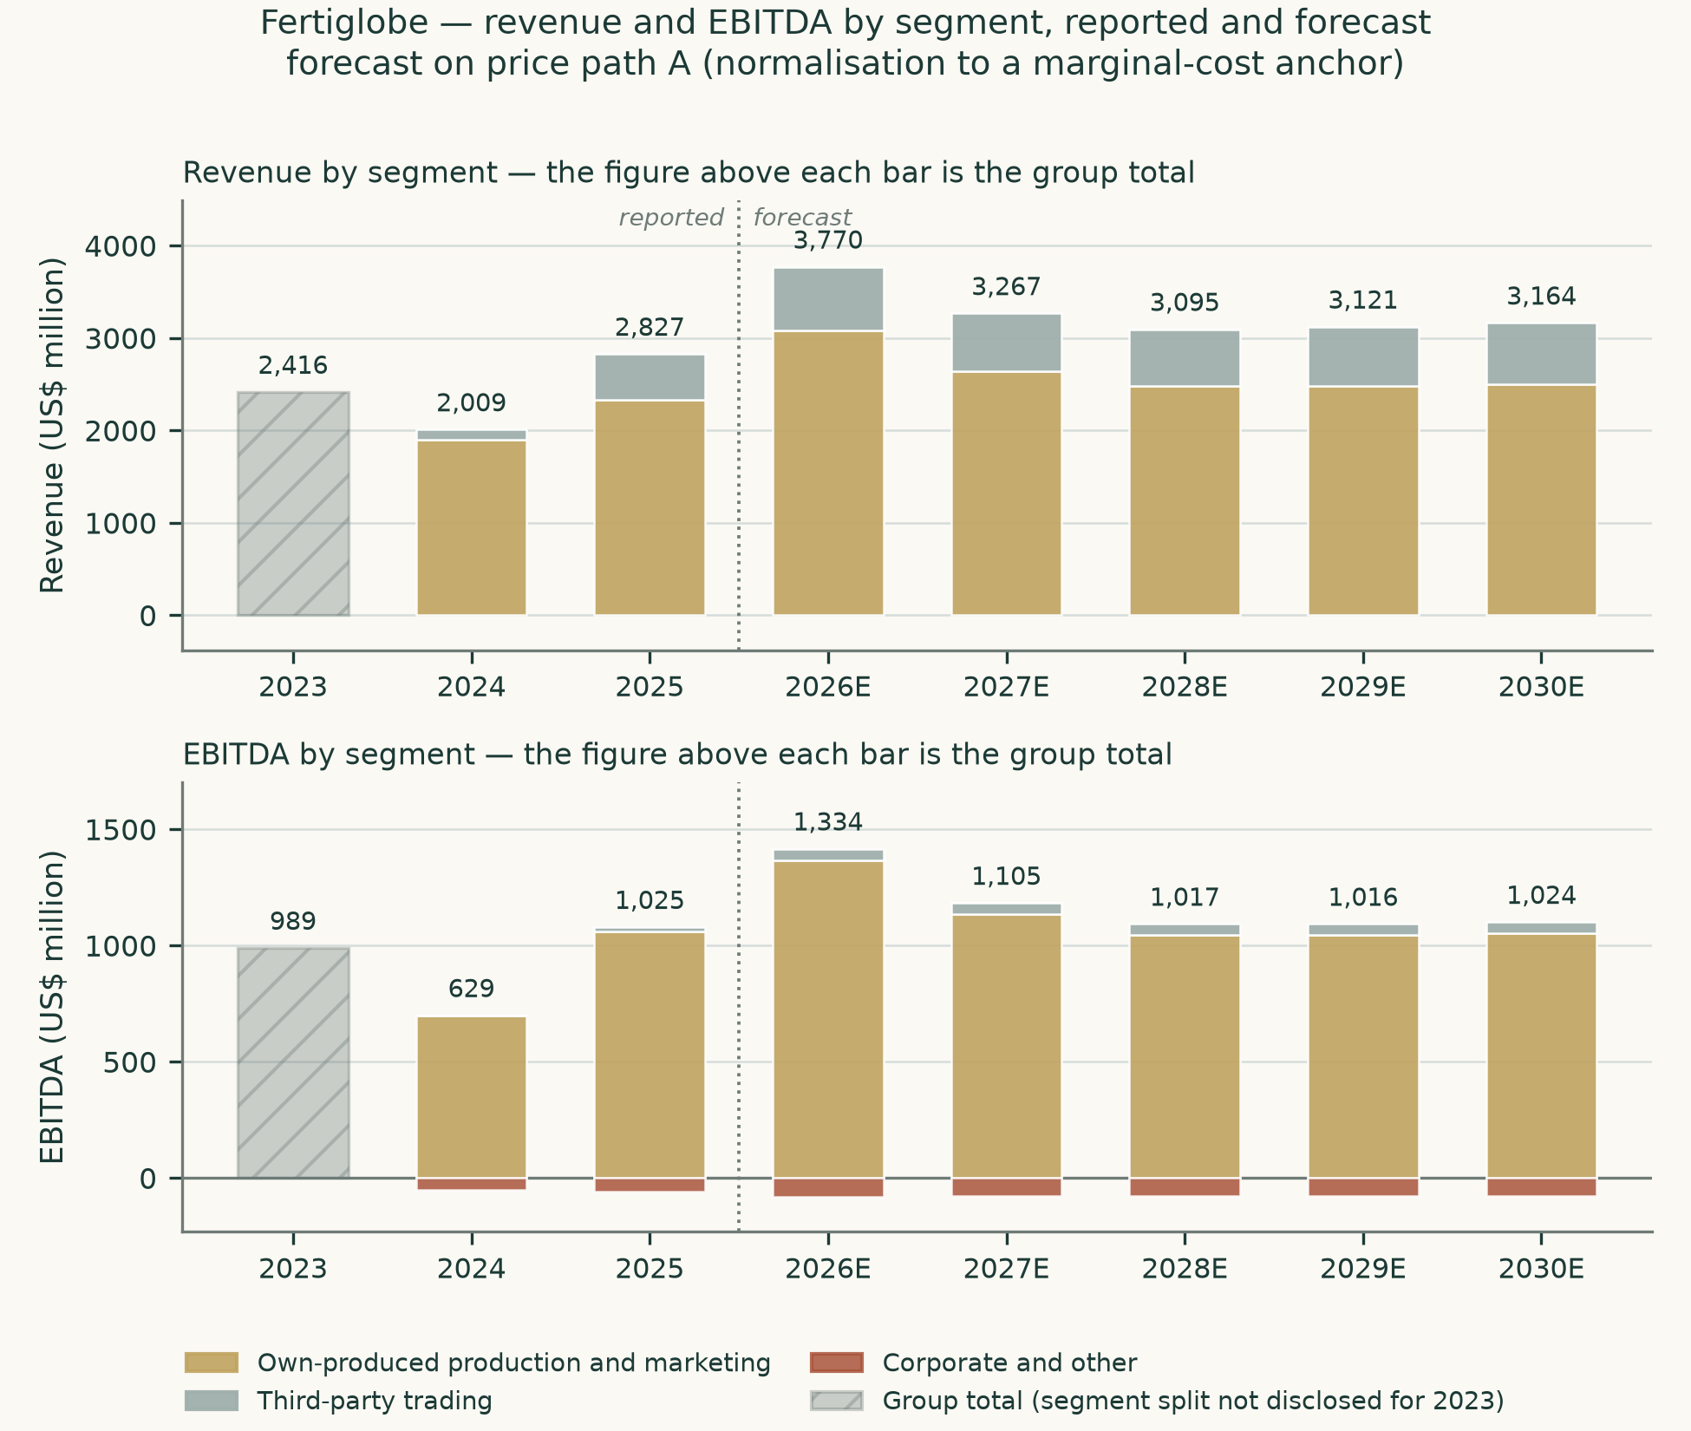
Figure 3. Revenue and profit by segment, reported and forecast.
1.7 The crux
Everything above turns on one question: when the price of urea rises by a dollar, how much of that dollar does Fertiglobe keep?
The FY2025 audited segment note says the production entities "all benefit from long term gas offtake agreements with no/limited price exposure on the supply of natural gas". Read alone, that says the company keeps almost all of it, and a model built on that reading would value Fertiglobe very highly indeed on 2026 prices.
The chief executive said something different on the second-quarter results call on 6 August 2026: "we have gas-linked — sorry, product-linked gas pricing effectively in both Egypt as well as Algeria. So, product prices are very strong. We'll see a higher gas cost." He put the delivered gas price for the second quarter at $6 per million British thermal units, or $8 including the Algerian profit-share arrangement.
These two statements cannot both be complete. The study resolves the conflict in favour of the more recent and more specific one, and then does the thing that settles it properly — measures the relationship from the company's own numbers.
Period | Realised price ($/t) | Cash cost ($/t) | Change in price | Change in cost
FY2024 | 355 | 224
FY2025 | 424 | 231 | 69 | 7
H1 2026 | 621 | 345 | 197 | 114

Cost against price, from disclosed segment revenue and segment EBITDA divided by disclosed own-produced volume. Three periods, three independent filings.
Regressing cash cost per tonne on realised price per tonne across those three periods gives a slope of 0.481 with an R-squared of 0.960. In plain terms: about 48% of every additional dollar of price is consumed by cost before it reaches profit. Three observations is a small sample and the study says so plainly — but two independent checks support it.
- The relationship survives removing the Algerian gas accrual. That accrual is a retrospective catch-up rather than a run rate, and stripping it out changes the slope only from 0.481 to 0.489. The link is therefore not an artefact of that one item.
- The physics agrees. At roughly 24 million British thermal units of gas per tonne of product sold, the observed cost increase between 2025 and the first half of 2026 implies the delivered gas price rose by about $4.74 per unit. Working back from the $6 the chief executive disclosed for the second quarter puts the earlier price near $1.26 — which is exactly where legacy Algerian and Egyptian contract gas would be expected to sit. The accounting and the engineering arrive at the same place by different routes.
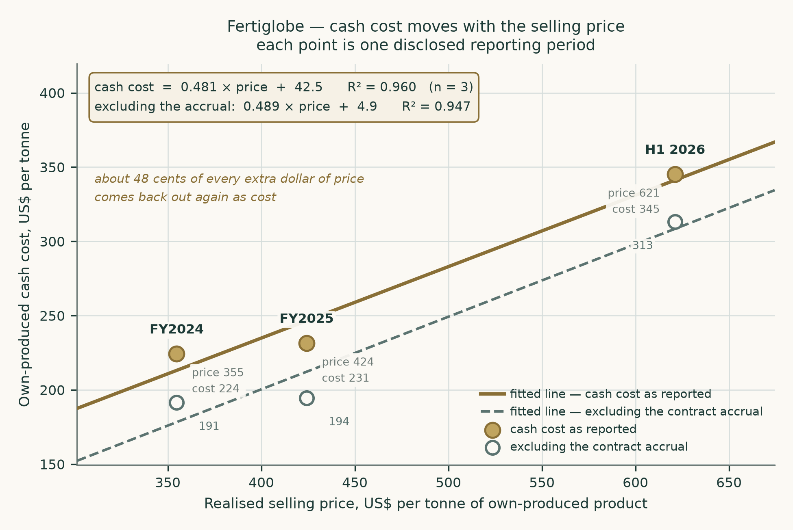
Figure 4. Cash cost per tonne against realised price per tonne, with the fitted relationship. This is the study's central piece of evidence.
Why this cuts both ways. The link is not simply bad news. It is what the chief executive called right-way risk: when prices fall, the gas cost falls with them, and the margin is defended from below as well as capped from above. It makes Fertiglobe a less volatile business than its revenue line suggests — and a less explosive one than the first half of 2026 suggests.

1.8 Macro and country
Fertiglobe operates across three sovereigns with very different risk, and the cost of capital is built from the ground up to reflect that rather than treating the company as purely Emirati.
Country | Rating | Default spread | Equity risk premium | Non-current assets
Abu Dhabi | Aa2 | 0.42% | 4.9% | 50.9%
Egypt | Caa1 | 6.37% | 13.9% | 31.1%
Algeria | Not rated | 3.83% | 10.1% | 16.1%
Other | — | — | 4.2% | 1.9%
Weighted |  |  | 8.5% | 100%

Each country is priced off its own published sovereign row and weighted by where the plants actually are. Treating the company as purely Emirati would have used 4.9% instead of 8.5% — a difference that would have flowed straight into the valuation.
The risk-free rate is normalised so sovereign risk is counted once and not twice. The Abu Dhabi dollar sovereign yields about 5.1%, being the US 10-year Treasury at 4.7% plus the emirate's own credit spread. Removing that same spread again leaves a normalised risk-free rate of 4.7%. Country risk then enters once, inside the equity risk premium above. Using the raw local yield together with a country-loaded premium would have double-counted it.
Component | Rating basis | Credit-default-swap basis | Source
Normalised risk-free rate | 4.7% | 4.7% | Abu Dhabi dollar sovereign, net of its own default spread
Beta | 0.931 | 0.931 | Own-share weekly regression, 4.68 years, n=242
Equity risk premium | 8.5% | 7.1% | Asset-weighted across the three operating countries
Cost of equity | 12.7% | 11.3%
Cost of debt before tax | 5.7% | 5.7% | Marginal — see the evidence table below
Cost of debt after tax | 4.9% | 4.9% | At the forecast tax rate of 13.1%
Weight of equity | 90.2% | 90.2% | Market capitalisation
Weighted average cost of capital | 11.9% | 10.7%
Terminal cost of capital | 11.1% | 10.1% | At a normalised 20.0% debt weight

The cost of capital, published on both premium bases as the house method requires. The rating basis is used for the headline; the credit-default-swap basis is shown because Algeria has no traded swap, so that column is not fully comparable.
The cost of debt is marginal and forward-looking, taken from the company's own most recent borrowings rather than from anything historical.
Facility | Amount | Margin | Used?
Term facilities B and C | $1,100m | SOFR + 0.90% | Yes — spread renegotiated down from 150 and 140 basis points during 2025
ADNOC term loan | $300m | SOFR + 1.05% | Yes — drawn 27 March 2025
Revolving credit facility | $600m | SOFR + 1.15% | Undrawn at year end
Sorfert term loan | $35m | Algerian bank rate + 1.95% | Foreign-currency tranche, carried at local-equivalent cost
Weighted average capitalisation rate | — | 6.6% | NOT used — this is a historical accounting rate, not a marginal cost
Marginal cost of debt applied | — | 5.7% | US 10-year plus the average margin on the two most recent facilities

Cost-of-debt evidence. The rate applied sits above the Abu Dhabi sovereign at 5.1%, as a same-currency corporate must, and below the accounting capitalisation rate the company discloses for a different purpose.
Debt is 94.9% US dollar denominated, matching the currency of the cash flows. The remaining 5.1% is the Algerian dinar tranche and two Australian dollar trade facilities, both carried at local-equivalent cost rather than at their headline foreign coupon.
The forecast tax rate is not lifted from any single reported year, because no single reported year is representative — the company reported effective rates of 14.0%, 7.0% and 4.0% across the last three, each flattered by items that do not recur. Three independent estimates are computed and averaged:
Method | Rate | Basis
Four-year aggregate effective rate | 10.4% | Total tax charge over total pre-tax profit, 2022 to 2025
Four-year aggregate cash rate | 15.7% | Total tax actually paid over total pre-tax profit, 2022 to 2025
Jurisdiction-weighted statutory rate | 13.4% | Published corporate rates weighted by assets in each country
Applied | 13.1% | The average of the three

1.9 Sensitivity
The value is most sensitive to the gas pass-through rate and to the price path — which is to say, to the crux. It is next most sensitive to beta, which is the study's most fragile input for reasons set out in the caveats.
Gas pass-through rate | 0.30 | 0.40 | 0.48 | 0.55 | 0.65
Value (AED/share) | 2.99 | 2.31 | 1.76 | 1.29 | 0.64

Price path shift | -20% | -10% | +0% | +10% | +20%
Value (AED/share) | 1.04 | 1.40 | 1.76 | 2.12 | 2.49

Beta | 0.47 | 0.40 | 0.93 | 0.60 | 1.40
Value (AED/share) | 2.68 | 2.90 | 1.76 | 2.33 | 1.30

Tax rate | 8% | 11% | 13% | 16% | 20%
Value (AED/share) | 1.88 | 1.81 | 1.76 | 1.69 | 1.60

One-way sensitivities, framing A. The first two lines are the crux; the third is the fragile input.
Terminal cost of capital \ growth | 1.0% | 1.5% | 2.0% | 2.5% | 3.0%
10.1% | 1.88 | 1.91 | 1.93 | 1.96 | 2.00
10.6% | 1.80 | 1.82 | 1.84 | 1.86 | 1.89
11.1% | 1.73 | 1.74 | 1.76 | 1.78 | 1.80
11.6% | 1.66 | 1.67 | 1.68 | 1.70 | 1.71
12.1% | 1.60 | 1.61 | 1.62 | 1.63 | 1.64

Two-way sensitivity of value to the terminal cost of capital and terminal growth, in AED per share.
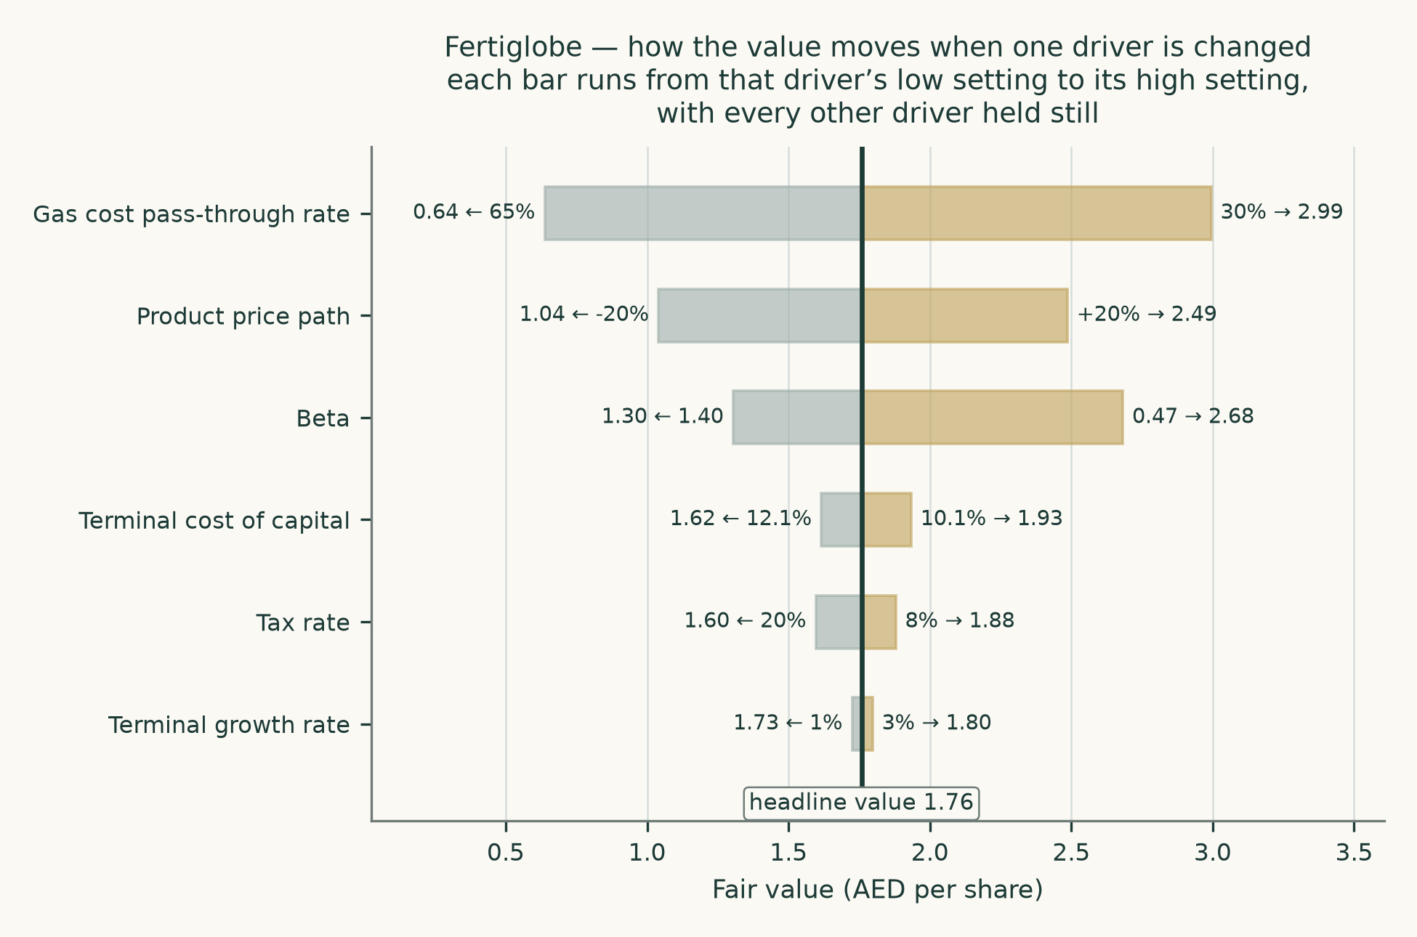
Figure 5. What moves the value, ranked.
2. Technical and price structure
The price closed 2.54 below a falling 20-day (2.63), a falling 50-day (2.77) and a flat 200-day (2.78). Momentum is soft: RSI(14) is ~34 and the daily ATR near 0.06 (~2.4%) points to a normal tape. MACD (12·26·9) is below zero but turning up (−0.06 / −0.06 / +0.00). The 50-day crossed beneath the 200-day 1 session ago — a fresh death-cross, a momentum-regime change rather than noise inside an intact trend. Over the last year it has ranged 2.35–3.85; the last close sits 34% below that high and 8% above that low.
Resistance | AED | Support | AED
R1 | 2.59 | S1 | 2.45
R2 | 2.69 | S2 | 2.34
R3 | 2.74 | S3 | 2.25

Resistance and support, nearest first, from clustered price pivots weighted by recency and blended with the moving-average stack.
Indicator | Reading
Last close | AED 2.54 on 2026-08-07
20-day moving average | AED 2.63 (falling)
50-day moving average | AED 2.77 (falling)
200-day moving average | AED 2.78 (flat)
Relative strength index (14) | 34
Average true range (14) | AED 0.062 (2.4% of price)
52-week range | AED 2.35 to AED 3.85
Position in range | 34.0% below the high, 8.1% above the low

Bull case: A daily close back above 2.59 would clear the nearest resistance and open the 2.74 zone. Bear case: A close below 2.45 would break the nearest support and open the 2.25 zone.
This section describes the tape and nothing more. It carries no view on the business, because a chart cannot see one.
3. Probability map for the share price
Separately from the valuation above, the study estimates a probability distribution for the share price at one and three months, built from the share's own price history. This is a statement about the range of outcomes, not a forecast of one.
One month — to 2026-09-07
Percentile | 5th | 25th | 50th | 75th | 95th
Price (AED) | 2.24 | 2.42 | 2.54 | 2.66 | 2.87
Change from AED 2.54 | -11.9% | -4.8% | -0.1% | +4.8% | +13.0%

Move | ±5% | ±10% | ±15% | ±20%
Chance of touching, up | 41.6% | 15.7% | 5.3% | 1.8%
Chance of touching, down | 41.1% | 13.2% | 3.2% | 0.7%
Chance of ending above | 24.3% | 9.4%
Chance of ending below | 24.3% | 8.1%

Three months — to 2026-11-09
Percentile | 5th | 25th | 50th | 75th | 95th
Price (AED) | 2.01 | 2.32 | 2.53 | 2.76 | 3.19
Change from AED 2.54 | -20.7% | -8.7% | -0.3% | +8.8% | +25.5%

Move | ±5% | ±10% | ±15% | ±20%
Chance of touching, up | 64.8% | 41.9% | 25.7% | 15.6%
Chance of touching, down | 64.8% | 39.1% | 20.7% | 9.6%
Chance of ending above | 34.4% | 22.5%
Chance of ending below | 35.3% | 21.6%

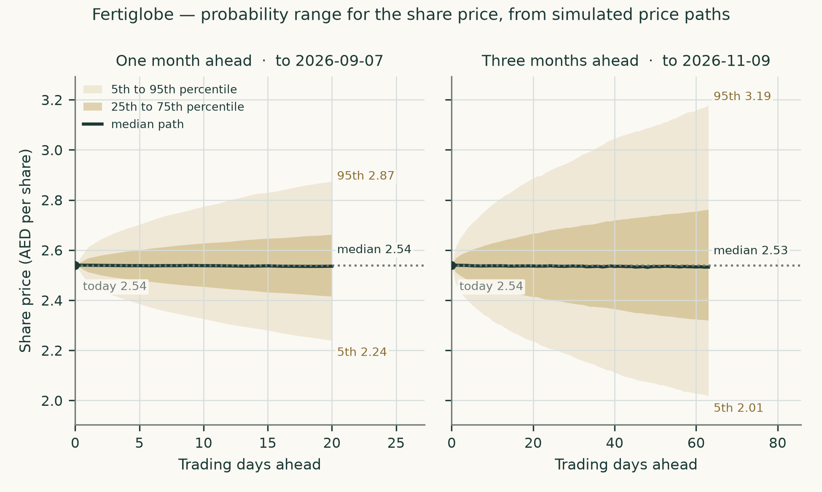
Figure 6. The one and three month probability ranges.
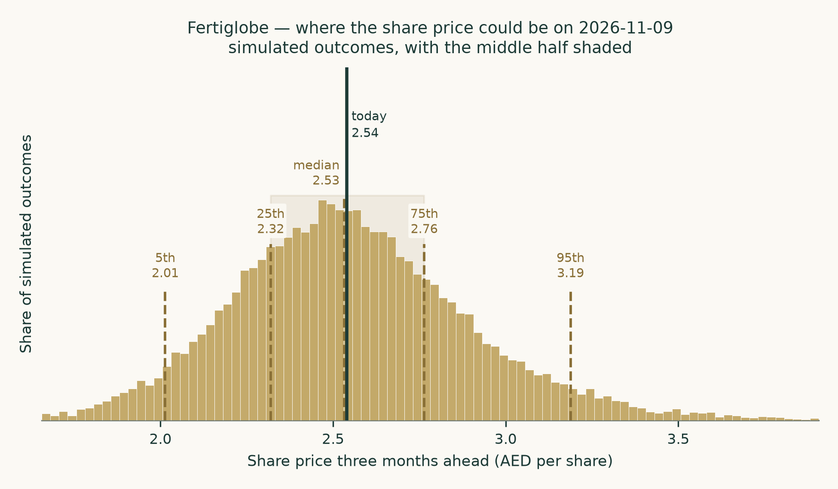
Figure 7. The distribution of possible prices at three months.
How much to trust this
The method was tested against the share's own history before being used. Fertiglobe listed on 27 October 2021, so the price record runs 4.77 years — a literal five-year test is not available for this company, and the test therefore covers the whole of its listed life, which is the maximum evidence that exists. Over 14 independent three-month windows from 2022-11-11 to 2026-02-19, the method scored -0.0015 against a random-walk benchmark that already includes the time value of money. That is statistically indistinguishable from the benchmark: the method neither beat it nor lost to it, and the study says so rather than claiming an edge it did not demonstrate.
Where the method did do well is in the shape of the distribution, which is what a probability range is actually for. Realised outcomes fell across the predicted percentiles roughly evenly — a chi-square test on that spread returns p=0.74 and a Kolmogorov-Smirnov test p=0.44, both comfortably consistent with the bands being honest. Actual outcomes landed inside the 50% band 43% of the time and inside the 90% band 100% of the time.
One caveat is recorded rather than buried. Re-running the same test from five different starting points to get more observations produces a distribution that is no longer evenly spread (p=0.022), with outcomes tilted slightly below the centre of the range. Those runs overlap each other, which makes the statistical test read as more significant than it is, so it is not treated as a verdict — but it is a hint that the centre of the range may sit a little high, and a reader should lean on the width of the bands rather than their midpoint.
4. Comparison of the lenses
Method | Value (AED) | Against the market price | What it assumes that the others do not
Cash flow | 2.19 | -14% | That the gas link, the price path and the cost of capital are all right for five years and beyond
Relative multiples | 2.06 | -19% | That the market is pricing comparable assets sensibly today
Normalised earnings power | 2.79 | +10% | That there is such a thing as a mid-cycle margin for this business, and that the last three years contain it
Book value | 1.27 | -50% | That book equity means something — which here it largely does not

The methods disagree by a factor of two from bottom to top. That is not a failure of the analysis; it is the correct output for a commodity producer whose selling price doubled in six months and whose cost base follows it. Any single number presented without that spread would be more precise than the evidence permits.
5. Catalysts
Catalyst | Direction | What to watch
Chinese urea export policy | Down | Exports were absent until quota guidance in May 2026 and remain minimal. A full reopening is the largest single downside to the price path.
The Strait of Hormuz | Both | Reopening relieves the logistics cost that hit the first half of 2026 but removes the supply squeeze holding prices up. The two partly cancel.
Settlement of the Algerian gas contract | Down / clarifying | The accrued liability reached $469 million by 30 June 2026 with no agreed payment schedule. Settlement converts an estimate into a cash obligation and reveals the true formula.
European tariffs on Russian product | Up | Already EUR 60 per tonne and scheduled to reach EUR 315 by 2028. Egyptian and Algerian product enters duty free.
The lower-carbon ammonia plant | Up | One million tonnes, operations expected 2027, total project cost under $500 million. Excluded from this valuation entirely — see below.
European gas prices | Up | Gas above $20 per unit puts European producers under water and sets a floor under ammonia. It is the mechanism behind the marginal-cost anchor.

The lower-carbon ammonia project deserves a note because its exclusion is deliberate. The parent is warehousing the project, and Fertiglobe holds only an option to move to 54% ownership after completion. It is therefore not a consolidated cash flow today and is carried at nothing. If exercised on the terms described, it would add capacity worth roughly a sixth of the current merchant base for a capital cost the parent has already largely borne. That is real value sitting outside the numbers in this study.
6. Reading the probability zones
The percentile table in section 3 is easy to misread, so here is what it does and does not say.
- The 50th percentile is not a forecast. It is the middle of a distribution, and the distribution is wide. Half of all outcomes fall on each side of it.
- The touch probabilities are higher than the ending probabilities, and that is not an error. A price can trade through a level during the period and come back; touching is easier than finishing.
- The bands come from the share's own volatility, not from the valuation. A share can be cheap on the analysis in section 1 and still spend three months falling. The two halves of this study answer different questions and are deliberately not reconciled.
- The bands widen with the square root of time, roughly. The three-month range is wider than the one-month range because more can happen, not because the outlook is worse.
7. Caveats and what would change our mind
Concern | Why it matters | What would change the answer
The pass-through rate rests on three observations | It is the single most consequential number in the study and the sample is tiny. The physical cross-check and the accrual-stripped rerun both support it, but neither is a substitute for more data. | Two more reported half-years at different price levels. If the slope moves to 0.65 the value falls to AED 0.64; at 0.30 it rises to AED 2.99.
The beta is weak | The regression against the local market gives 0.931 but explains only 10.0% of the share's movement, with a 90% confidence interval from 0.47 to 1.40. The reason is economic, not statistical: this share is driven by global nitrogen prices, and the local index is mostly banks and property. | A beta of 1.0 rather than 0.93 would cut the cash-flow value materially. The sensitivity table in section 1.9 shows the range; a reader who believes the local index is the wrong yardstick should read the low end of the cash-flow lens and lean on the other three.
The Algerian gas liability is unsettled | $469 million accrued at 30 June 2026, retrospective to November 2023, with negotiations unconcluded and no payment schedule. The auditors treated it as a key audit matter. | The settled formula. If the final price is materially above what has been accrued, both the liability and the forward cost rate rise together.
Two primary sources disagree | The audited segment note describes limited gas price exposure; the chief executive describes product-linked pricing. The study follows the latter. | A clear statement in the next annual report. If the segment note wording proves the accurate one, the value is materially higher than shown here.
The float is thin | A 12.6% free float against an 87.4% state-owned parent. Price discovery is limited and the share can move on flow rather than fundamentals. | Nothing in the near term. It is a permanent feature to price, not an event to wait for.
Terminal value dominates | 55.2% of enterprise value sits beyond year five under framing A and 61.2% under framing B. That is normal for a long-lived asset base and still means most of the answer is an assumption. | The two-way sensitivity in section 1.9 is the honest map of that exposure.
Third-party trading is not built bottom-up | The company discloses traded volumes but never a purchase price, so this leg is carried at a segment margin rather than unit economics. | Disclosure of trading cost of goods sold. The leg is small — under a fifth of revenue and under a fiftieth of profit — so the gap is flagged rather than fatal.

Appendix A — Financial statements
A.1 Income statement — three years reported, five years forecast
US$ million | FY2023 | FY2024 | FY2025 | 2026E | 2027E | 2028E | 2029E | 2030E
Revenue | 2,416 | 2,009 | 2,827 | 3,770 | 3,267 | 3,095 | 3,121 | 3,164
EBITDA | 989 | 629 | 1,025 | 1,334 | 1,105 | 1,017 | 1,016 | 1,024
Depreciation and amortisation | 279 | 280 | 298 | 305 | 315 | 325 | 333 | 340
EBIT | 710 | 349 | 727 | 1,029 | 790 | 692 | 683 | 684
EBITDA margin | 40.9% | 31.3% | 36.2% | 35.4% | 33.8% | 32.8% | 32.6% | 32.4%
Net finance cost | -123 | -120 | -114
Profit before tax | 587 | 229 | 614
Profit for the year | 505 | 214 | 589
Attributable to owners | 349 | 160 | 434 | 637 | 488 | 434 | 434 | 438

Reported years are taken line by line from the audited consolidated statements. Forecast years are framing A.
A.2 Balance sheet
US$ million | FY2023 | FY2024 | FY2025 | H1 2026
Property, plant and equipment | 2,700 | 2,597 | 2,499 | —
Inventories | 134 | 164 | 336 | 441
Trade and other receivables | 314 | 291 | 493 | 543
Cash and cash equivalents | 760 | 634 | 735 | 1,373
Total assets | 4,626 | 4,411 | 4,950 | 5,642
Trade and other payables | 327 | 481 | 820 | 958
Gross interest-bearing debt | 1,665 | 1,682 | 1,741 | 1,994
Net debt | 996 | 1,135 | 1,164 | 621
Equity attributable to owners | 1,445 | 1,242 | 1,356 | —
Non-controlling interests | 425 | 296 | 443 | —
Total equity | 1,870 | 1,538 | 1,800 | 2,163

A.3 Forecast balance sheet and cash flow markers
US$ million | 2026E | 2027E | 2028E | 2029E | 2030E
Property, plant and equipment | 2,369 | 2,294 | 2,254 | 2,236 | 2,231
Net working capital | 534 | 460 | 434 | 438 | 443
Invested capital | 2,903 | 2,754 | 2,688 | 2,674 | 2,674
Return on invested capital | 30.8% | 24.9% | 22.3% | 22.2% | 22.2%
Net debt | 503 | 257 | 104 | 3 | -84
Capital expenditure | 175 | 240 | 285 | 315 | 335
Free cash flow to the firm | 885 | 835 | 666 | 608 | 593

The working-capital cycle is projected from the cycle the company actually runs, not plugged. Receivable days, inventory days and payable days measured off the filed statements were 64, 63 and 82 respectively for 2025, the payable figure excluding the Algerian gas accrual because that is not a trade payable in the ordinary course. Including it would have shown a negative cash conversion cycle of 27 days and made the business look as though suppliers funded it; excluding it gives 45 days, which is the honest figure and the one used.

Appendix B — Peers, risks and sources
B.1 Comparable companies
Company | Market | Enterprise value to EBITDA | Character
Nutrien | US | 7.4x | diversified nutrient, retail attached
CF Industries | US | 6.1x | pure nitrogen, Henry Hub advantaged
Yara International | NO | 5.2x | nitrogen, European gas cost
OCI Global | NL | 5.6x | nitrogen and methanol
Industries Qatar | QA | 9.1x | Gulf petrochemical and fertiliser
SABIC Agri-Nutrients | SA | 10.4x | Gulf nitrogen, Tadawul rating

B.2 Risk register
Risk | Type | Assessment
Nitrogen price cycle | Market | The dominant exposure, partly self-hedged by the gas link
Algerian gas contract settlement | Contractual | Unquantified until agreed; accrued but not settled
Egyptian gas supply | Operational | Curtailments hit the second quarter of 2025; management reported no interruptions through the first half of 2026
Regional conflict and shipping routes | Geopolitical | Directly affected export volumes and logistics cost in 2026
Country risk in Egypt and Algeria | Sovereign | Priced explicitly through the asset-weighted equity risk premium
Concentrated ownership and thin float | Governance / liquidity | 87.4% held by one shareholder
Currency | Financial | Low — reporting, revenue and most debt are all in US dollars, and the dirham is pegged

B.3 Sources
The complete source record — every input with its value, date and derivation, grouped by research layer, together with the primary documents, the judgements and what would overturn each of them, and the searches that returned nothing — is published as a separate document accompanying this study. In summary:
Category | Count | Detail
Complete audited financial years obtained | 4 | FY2022, FY2023, FY2024 and FY2025, each from the signed consolidated statements
Interim periods of the current year | 2 | First quarter and first half of 2026, both already on the public record and both incorporated before the forecast was built
Company documents read | 6+ | Audited statements, interim statements, management discussion and analysis reports, investor presentations and the results-call transcript
Distinct inputs recorded | 204 | Each with a value, a source, a date and a research layer
Aggregator-sourced figures in the build | 0 | Peer market multiples are used as a cross-check only and are labelled as such

Appendix C — Expert panel
Three analysts were asked to value the company by genuinely different methods. Each shows their workings, names the assumption their answer rests on, and states in advance what would prove them wrong.
C.1 Expert 1 — the multiple
Worldview: a commodity producer is worth what the market pays for comparable cash flows. Discounted cash flow models of cyclical businesses are precision theatre; the multiple embeds what buyers actually believe.
When it works: at cycle midpoints, and where the peer set is genuinely comparable. When it fails: at cycle extremes, when every peer is mispriced together, and when the peer set differs in gas cost, country risk or capital structure — all three of which apply here to some degree.
Line | Value
Mid-cycle EBITDA (US$m) | 1,191
Multiple applied | 6.4x
Enterprise value (US$m) | 7,621
less net debt (US$m) | -621
less non-controlling interests | 26.3% of equity value
Value per share (AED) | 2.30

Named sensitivity: each half-turn on the multiple moves the value by roughly AED 0.20 per share. Falsifier stated in advance: if Gulf nitrogen peers de-rate below 7 times while Fertiglobe's own earnings hold, this method is reading a sector sentiment rather than a company value, and should be discounted.
C.2 Expert 2 — the cash flow
Worldview: only the cash a business produces matters, and the job is to model the mechanism that produces it. For this company that mechanism is the link between selling price and gas cost, and any model that ignores it is valuing a different company.
When it works: where the operating mechanics are understood and documented. When it fails: when the discount rate is uncertain, which it badly is here — the beta explains only 10.0% of the share's movement.
Line | Framing A | Framing B
Present value of five years of cash flow (US$m) | 2,680 | 3,341
Present value of terminal value (US$m) | 3,300 | 5,269
Enterprise value (US$m) | 5,980 | 8,610
Terminal share of enterprise value | 55.2% | 61.2%
Terminal return on capital applied | 13.5% | 18.2%
Reinvestment rate | 14.8% | 11.0%
Value per share (AED) | 1.76 | 2.62

Named sensitivity: moving the gas pass-through from 0.48 to 0.65 takes the value from AED 1.76 to AED 0.64. Falsifier stated in advance: if the company reports a half-year in which realised price falls sharply and cash cost per tonne does not follow it down, the pass-through relationship is not real and this valuation is wrong in both directions at once.
C.3 Expert 3 — the assets
Worldview: in a commodity industry, price eventually returns to the cost of building new supply. What the existing plants would cost to replace is therefore the anchor, and earnings are the noise around it.
When it works: over long horizons, and where capacity is fungible and tradeable. When it fails: when existing assets carry something a new entrant cannot buy — which is exactly the case here, because the legacy Algerian and Egyptian gas contracts are not available to anyone building today. This method therefore understates.
Line | Value
Installed capacity (kt) | 6,600
Replacement cost per tonne of capacity (US$) | 1,250
Replacement enterprise value (US$m) | 8,250
less net debt (US$m) | -621
Value per share (AED) | 2.50

Named sensitivity: a $250 change in replacement cost per tonne moves the value by about AED 0.54 per share. Falsifier stated in advance: a greenfield ammonia-urea complex announced anywhere in the Gulf at a materially different capital cost per tonne would reset this anchor immediately.
C.4 Cross-examination
Challenge | From | Response
"Your multiple is borrowed from companies with different gas contracts and different country risk. It cannot be the anchor." | Expert 2 to Expert 1 | Conceded in part. The multiple applied sits below the Gulf peers precisely for that reason, but the objection is right that the peer set is imperfect.
"Two thirds of your value is a terminal number resting on a beta that explains six percent of anything." | Expert 1 to Expert 2 | Conceded. This is the method's real weakness and the reason the study weights it at less than half rather than relying on it alone.
"Replacement cost ignores that the whole business is a legacy gas contract ""wrapped in steel." | Expert 2 to Expert 3 | Conceded, and stated by Expert 3 in advance. The method is a floor, not a valuation.
"Your cash flow model assumes the pass-through holds when prices fall. It has only ever been observed while they rose." | Expert 3 to Expert 2 | Rejected, with a caveat. The chief executive described the arrangement as symmetric, and a contract formula does not know which way the price is moving. But the observation is fair that it has not yet been tested downward, and it is recorded as the stated falsifier.
"If the audited note is right and gas exposure really is limited, all three of you are too low." | Expert 1 to all | Accepted as a live possibility and carried in the caveats. It is the single reading of the evidence under which this study is materially too conservative.

C.5 The three in one room
Put together, the three converge more than their methods suggest they should. Expert 1 lands at AED 2.30, Expert 2 at AED 1.76 on framing A, and Expert 3 at AED 2.50. The spread is about AED 0.74 per share, or roughly a eighth of the middle value — narrow, given that one counted cash flows, one counted comparable multiples and one counted steel.
They agree on the mechanism and disagree about its durability. All three accept that the gas link is real and that it caps the upside from a price spike. Expert 2 is willing to model five years of it; Expert 1 doubts anyone can; Expert 3 thinks it does not matter over a long enough horizon. Where they genuinely part company is the terminal value, and that is also where the study is least certain.
C.6 Divergence table
Assumption | Expert 1 | Expert 2 | Expert 3 | Drives how much of the gap?
Mid-cycle EBITDA | 1,191m | Modelled per year | Not used | Small — the levels are close
Terminal treatment | Multiple embeds it | 55.2% of value | Replacement cost is the terminal | Large — this is the main divergence
Cost of capital | Implicit in the multiple | 11.9% | Not used | Large — Expert 2 alone is exposed to the weak beta
Gas pass-through | Implicit | 0.48 explicit | Irrelevant | Moderate — all three are exposed, only one prices it
Value of the legacy gas contracts | Partly in the multiple | In the cash flows | Excluded by construction | Explains why Expert 3 is a floor

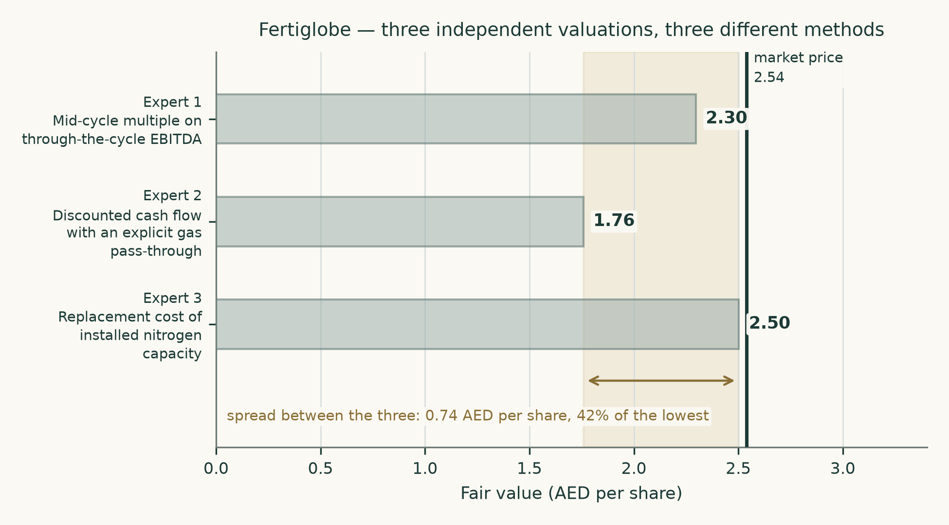
Figure 8. The three expert valuations and their spread.

About
Testahil publishes independent valuation studies and calibrated probability ranges for listed securities, together with a public record of every forecast made and how it turned out. Studies are built from primary sources — the company's own issued financial statements and disclosures — and every figure in a study traces to a dated source in the accompanying source document.
Two things are published for every company: a fair-value range produced by four independent methods, and a probability distribution for the share price over defined horizons. They answer different questions and are not reconciled with one another. Neither is a rating and neither is a price target, because a single number implies a confidence that the evidence does not support.
Every probability range is tested against the security's own price history before it is published, scored against a benchmark that already includes the time value of money, and reported honestly whether it beat that benchmark or not. In this study it did not beat it, and section 3 says so.
Disclosure
This document is educational analysis. It is not investment advice, an offer, a solicitation, or a recommendation to buy or sell any security. It contains no rating and no price target.
The analysis rests on public information believed to be reliable, principally the company's own audited and interim financial statements, management commentary, investor presentations and results-call transcript, together with published sovereign risk data and market prices. No representation is made that it is complete or free of error. Forward-looking figures are estimates and will differ, possibly materially, from what actually happens.
Valuation involves judgement. Reasonable analysts using the same public information will reach different conclusions, and this study makes the largest of its own judgements visible and computes the most consequential one two ways rather than one. Readers should form their own view and, where appropriate, take professional advice.
Price basis 2026-08-07. Study date 2026-08-10. Currency: figures in US dollars unless marked AED; per-share values converted at 3.6725 dirhams to the dollar.

