Testahil · Independent Valuation Study — Educational Analysis Not investment advice

Independent Valuation Study — Educational Analysis
Elsewedy Electric Company S.A.E. (EGX: SWDY)
Diversified industrial group — wires and cables, engineering and construction, electrical products, digital solutions and infrastructure investment · Egyptian Exchange · reporting currency EGP · analysis anchored on the closing price of 105.20 on 2026-08-05.
READ FIRST — what this document is. This is an educational valuation study. It contains no recommendation, no rating and no price target. What it contains is a fair-value range built from disclosed financial statements, a stated cost of capital, and explicitly listed assumptions — together with a separate, probabilistic map of where the share price could trade over the next one and three months. The two are different objects and are never blended.
What a fair value is not. A fair-value estimate is a statement about what the business appears to be worth on the assumptions set out here. It is not a forecast of the share price, and it carries no implied timeframe. A share can trade above or below an intrinsic estimate for years.
Where the numbers come from. Every figure traces to a source recorded in the accompanying source register: the company's own audited and interim financial statements and earnings releases, exchange filings, and named market data. Where a figure is derived rather than disclosed, it is labelled as derived and the derivation is shown.
The single largest uncertainty. This company earns more than 70% of its revenue outside Egypt, but it reports, is listed and is financed in Egyptian pounds. The answer therefore depends heavily on which currency's cost of capital you believe applies. Both readings are computed and both are shown.

Headline
Elsewedy Electric is the largest listed industrial group on the Egyptian Exchange by revenue: EGP 281,049mn in FY2025, up +21% on FY2024 and +36% a year compounded over the last two years. It converts copper into cable, builds substations and power plants under turnkey contract, and sells meters, transformers and digital grid products across 15 countries. Just over 70% of the revenue is earned abroad, and the order book stands at roughly USD 6.5bn.
The operating story of the last two years is a margin normalisation, not a deterioration. The gross margin ran at 18.9% in FY2024 when a collapsing pound turned cheaply bought copper inventory into windfall profit; it settled to roughly 14.5% in FY2025 as that effect washed out. Revenue kept compounding through it. Net profit after minority interests was essentially flat at EGP 17,330mn against EGP 17,461mn — a flat result on a +21% revenue increase is the whole of the margin story in one line. The first quarter of 2026 reaccelerated: revenue EGP 75,298mn (+27%) and attributable profit EGP 4,845mn (+17%).
The balance sheet is not the constraint people assume. Gross borrowings are large because the working-capital cycle is large, but the group holds very substantial offsetting cash: net bank debt was EGP 19,789mn at the end of FY2025, only 0.6× EBITDA. And the debt is cheap in a way that is easy to miss: the audited notes disclose average rates of 28.7% on Egyptian-pound liabilities but 6.5% on dollars and 3.9% on euros. The blended rate actually paid works out near 12.3%, roughly half what a purely domestic Egyptian borrower pays.
On our primary construction the four lenses centre at EGP 74.52 per share against a market price of 105.20 — the price sits about +41% above the central estimate. That gap is not mainly an argument about the business; it is an argument about the discount rate. Discounted at an Egyptian cost of equity of 28.4%, the cash flows support roughly EGP 63.10. Discount the hard-currency share of those same cash flows at a hard-currency cost of capital of about 10.1% and the same model produces EGP 91.15, which is above today's price. The market appears to be applying something close to the second view. Both are shown, and neither is hidden inside an average.
Valuation summary — every read at a glance
Read | Basis | Range (EGP/share) | Central | vs spot
Discounted cash flow | 5-year FCFF, cost of capital gliding 26.9% → 15.1%, terminal growth 5%; 77% of enterprise value comes from the terminal value | 35.37 – 110.39 | 63.10 | -40%
Relative multiples | 6.5× mid-cycle EV/EBITDA (trailing 8.0×; trailing P/E 13.0×) | 61.23 – 91.62 | 73.38 | -30%
Normalised earnings power | mid-cycle EBITDA margin 11.1% at a justified 9.0× P/E | 94.04 – 154.50 | 120.91 | +15%
Book value and sustainable return | justified price-to-book 1.5× on book value of 32.92/share at a sustainable return on equity of 23.5% | 33.77 – 53.71 | 48.47 | -54%
Weighted central | DCF 45% · relative 20% · normalised 20% · book 15% | 33.77 – 154.50 | 74.52 | -29%
Market price | closing price on the anchor date | — | 105.20 | —
ALTERNATIVE READINGS — not included in the weighted central above
Currency of discounting | the same cash flows with the hard-currency leg discounted at 10.1% instead of the Egyptian rate — a different view of country risk, not a fifth lens | — | 91.15 | -13%
Rating-basis cost of capital | the same model on the rating column of the published country-risk table rather than the market-spread column (see section 1.8) | — | 44.88 | -57%
Minority interests charged before net debt | an alternative sequencing of one line of the bridge (see section 1.8) | — | 62.20 | -41%

The alternative readings are shown so that each genuinely contested choice carries a number the reader can see, rather than being averaged silently into the headline. They are deliberately excluded from the weighted central because each answers a different question — which currency's cost of capital applies, which column of a risk table to use, how to sequence one line of the bridge — and blending them would hide the disagreement instead of showing it. Ranges are bear-to-bull within each lens; the central is the weighted base. Terminal value is 77% of the discounted-cash-flow enterprise value — a high share, disclosed here and again in the bridge, and the reason the terminal assumptions are stress-tested in section 1.9.
Company overview — Elsewedy Electric at a glance
Item | Detail
Founded / listed | Established 1938 by the Elsewedy family; listed on the Egyptian Exchange as SWDY
What it does | Manufactures wires, cables and accessories; executes turnkey engineering and construction projects (substations, transmission and distribution, power generation, civil works); makes transformers, busway and electrical products; supplies meters and digital grid solutions; and holds infrastructure assets including industrial development, logistics, utilities and independent power projects
Scale | More than 20,000 employees across 31 production facilities in 15 countries; FY2025 revenue EGP 281,049mn
Geographic mix | Over 70% of revenue earned outside Egypt (the company's disclosure — a statement about where the customer is). Separately, this study derives the share that is hard-currency LINKED, i.e. dollar-priced, at about 63%; the lower figure is the one used wherever the currency question is valued
Order book | Approximately USD 6.5bn, above the group's typical historical range
Shares outstanding | 2,141mn
Market capitalisation | EGP 225,210mn at the anchor price
Ownership | El Sewedy family ~68.0% · Electra Investment Holding 20.4% · free float ~11.6%. Electra, an Abu Dhabi holding vehicle, acquired about 20% in a July-2024 tender offer at USD 1.05 per share (~USD 449mn). Note the company's own shareholder chart is easy to misread: taken in legend order it implies a 20.37% free float, but that slice is Electra's. The genuine float is roughly half that
Net bank debt | EGP 19,789mn at 31 December 2025 (0.6× EBITDA)
Last strategic transaction | Electra Investment Holding's tender offer concluded July 2024: 428mn shares (20.0%) at USD 1.05, about USD 449mn — roughly EGP 50 per share at the rate then prevailing. Recorded because it is the last price at which a strategic buyer cleared a fifth of the company, but NOT used as a valuation anchor: it is two years stale, struck before the earnings base grew by about half, and sits at under half today's price
Dividend record | EGP 1.00 per share on the FY2024 result; EGP 1.85 on FY2025 (+85%), approved 6 May 2026 and paid from 4 June 2026 — about EGP 3,960mn, or 22.9% of attributable profit, which is close to the 25% payout the forecast assumes

Two structural facts govern everything that follows. First, the revenue base is majority hard currency while the share, the accounts and the borrowing are Egyptian — so the company is a natural hedge against the currency its shareholders are exposed to. Second, the business consumes working capital in direct proportion to its growth: inventories, contract assets and receivables less payables and contract liabilities ran at 24.1% of revenue in FY2023 and 23.1% in FY2024. In FY2024 the group earned EBITDA of EGP 31,602mn and converted only EGP 3,979mn of it into operating cash after interest and tax. Growth here is expensive, and that is the crux of the valuation.
1 Fundamental valuation
1.1 The cash-flow model — the primary lens, with the full waterfall
The primary lens is a five-year free-cash-flow-to-the-firm model. Revenue is not forecast as a growth rate applied to a revenue line: it is built from volumes and prices, unit by unit — tonnes of cable at a copper-linked price per tonne, MVA of transformer, meters, and the engineering order book converted at a disclosed rate. Gross profit is built the same way, from profit per tonne, per MVA and per meter. Margins are therefore OUTPUTS of the build rather than assumptions fed into it, and the historical version of that build reconciles to the audited income statement to within EGP 1mn on both revenue and gross profit in FY2023 and FY2024. Section 1.6 sets out the units. Cash flow is then taken all the way to present value, line by line, below.
EGP mn | FY26E | FY27E | FY28E | FY29E | FY30E
Revenue | 365,556 | 408,521 | 442,252 | 477,217 | 514,192
of which domestic | 139,722 | 158,474 | 173,355 | 188,850 | 205,234
of which foreign | 225,834 | 250,048 | 268,897 | 288,367 | 308,958
EBITDA | 41,094 | 44,941 | 48,914 | 53,240 | 57,882
EBITDA margin | 11.2% | 11.0% | 11.1% | 11.2% | 11.3%
Less depreciation and amortisation | (3,838) | (4,289) | (4,644) | (5,011) | (5,399)
EBIT | 37,256 | 40,651 | 44,271 | 48,229 | 52,483
NOPAT — EBIT × (1 − 25%) | 27,942 | 30,488 | 33,203 | 36,172 | 39,363
Add back depreciation and amortisation | 3,838 | 4,289 | 4,644 | 5,011 | 5,399
Less capital expenditure | (10,967) | (11,847) | (12,383) | (12,408) | (12,341)
Less change in working capital | (19,437) | (9,882) | (7,758) | (8,042) | (8,504)
Free cash flow to the firm | 1,377 | 13,049 | 17,706 | 20,733 | 23,917
Forward cost of capital | 26.9% | 23.0% | 19.5% | 17.1% | 15.1%
Discount factor | 0.7880 | 0.6408 | 0.5360 | 0.4577 | 0.3975
Present value of FCFF | 1,085 | 8,362 | 9,490 | 9,490 | 9,508

Every line is computed, not typed: the waterfall runs EBITDA → depreciation and amortisation → EBIT → NOPAT → add back depreciation → less capital expenditure → less the change in working capital → free cash flow to the firm → discount factor → present value. Working-capital change is the difference in net working capital held at a constant 23.0% of revenue, the level the audited balance sheets actually show.
The bridge from enterprise value to the equity
Step | EGP mn | Note
Present value of the five forecast years | 37,935 | sum of the present-value row above
Present value of the terminal value | 124,875 | terminal value 314,122 capitalised at 15.1% and discounted at the year-5 factor 0.3975
Enterprise value | 162,810 | the two lines above
Terminal value as a share of enterprise value | 77% | disclosed here and in the summary table; stress-tested in section 1.9
Less net bank debt | (19,789) | disclosed at 31 December 2025
Plus equity-accounted investees | 6,474 | carrying value, uplifted modestly; these earn outside the consolidated cash flow
Less minority interests | (14,419) | minorities take 9.6% of group profit, so they are charged the same share of the value
Equity attributable to shareholders | 135,075
Fair value per share (EGP) | 63.10 | against a spot of 105.20 (-40%)

1.2 Book value and sustainable return — the asset lens
Book value attributable to shareholders is estimated at EGP 70,464mn, or 32.92 per share, rolling the audited FY2024 figure forward for FY2025 profit less the dividend paid. The trailing return on average equity is 27.6%. That number is flattered: FY2023 and FY2024 both carried devaluation gains on copper inventory bought before the pound moved, so the sustainable rate is struck lower, at 23.5%.
A justified price-to-book multiple is (return on equity − growth) ÷ (cost of equity − growth). At a blended cost of equity of 17.6% — the average of the explicit-window 28.4% and the terminal 17.6% — that gives 1.5× book, or EGP 48.47 per share. This is the weakest of the four lenses for this company and carries the lowest weight, for a specific reason: three years of currency translation have moved reported book value in ways that have little to do with the earning power of the assets, and a group whose value sits in an order book and a brand is poorly described by its balance sheet. It is retained because it is the lens that disagrees most, and a lens that only ever agrees is not doing any work.
1.3 Relative multiples
Measure | Value | Comment
Enterprise value / EBITDA (trailing) | 8.0× | enterprise value 244,999 over FY2025 EBITDA 30,622
Price / earnings (trailing, attributable basis) | 13.0× | price 105.20 over attributable earnings per share of 8.10
Price / earnings (trailing, as-reported basis) | 14.8× | the company's own reported earnings per share is struck after the Egyptian employee and board profit-share appropriation, so screens and data vendors show this higher multiple. Both are given because a reader comparing against a screen will see the second
Price / book | 3.2× | book value 32.92 per share
Net bank debt / EBITDA | 0.6× | light net leverage against a large gross book
Justified enterprise value / EBITDA | 6.5× | applied to FY2027E EBITDA and then DISCOUNTED BACK two years, because a forward multiple produces a forward enterprise value. The multiple is set below the company's own trailing multiple as an Egyptian-market discount. NOTE: no peer multiple is computed anywhere in this study, so this is a judgement anchored on SWDY's own trading history, not a peer-derived figure — an earlier draft asserted a "peers trade at 8–11×" range that was not supported by any calculation, and it has been withdrawn
Implied value per share | 73.38 | bear 61.23 at 5.5× / bull 91.62 at 8.0×

Two things about this lens should be read before its number is. First, applying a multiple to a forecast year gives an enterprise value AS AT that year; it has to be discounted back before it can be compared with today's price. Not doing so would have produced EGP 117.67 per share instead of 73.38 — a EGP 44.29 overstatement, which an earlier draft of this study contained. Second, the justified multiple is a judgement, not a peer-derived figure.
The honest difficulty with this lens is that there is no clean comparable. The nearest listed regional peer in cables is a Saudi manufacturer with a fraction of the revenue, no turnkey contracting arm and a very different balance sheet; the global cable majors are European and carry neither Egyptian sovereign risk nor Egyptian growth. Applying a discounted multiple to mid-cycle EBITDA is therefore a sanity check on the cash-flow model rather than an independent valuation, and it is weighted accordingly.
1.4 Normalised earnings power — where this sits in the cycle
The question this lens asks is what the group earns in a year that is neither a currency windfall nor a margin trough. Mid-cycle revenue is taken as the FY2027 forecast of EGP 442,252mn and the mid-cycle EBITDA margin as 11.1% — the average of the later forecast years, comfortably below the FY2024 outturn of 13.6% and above the FY2025 trough of 10.9%.
Step | EGP mn
Mid-cycle revenue | 442,252
Mid-cycle EBITDA at 11.1% | 48,914
Less depreciation and amortisation | (4,644)
Mid-cycle EBIT | 44,271
Less net interest | (3,470)
Plus share of equity-accounted investees | 1,302
Less tax at 25% and minority interests at 9.6% | (13,342)
Normalised attributable earnings | 28,761
Normalised earnings per share (EGP) | 13.43
At a justified 9.0× price/earnings (EGP per share) | 120.91

Bear 94.04 at 7.0× and bull 154.50 at 11.5×. The justified multiple is held well below what a comparable industrial franchise would attract in a developed market, because an Egyptian cost of equity near 28% mathematically compresses what any stream of earnings is worth.
1.5 Synthesis — four lenses, one field
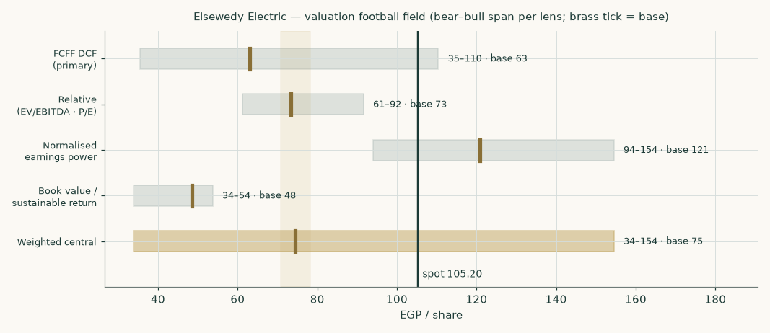
Figure 1 — the four lenses and the weighted central against the market price of 105.20. Each bar is that lens's bear-to-bull span; the brass tick is its base case.
Lens | Bear | Base | Bull | Weight | Contribution
Discounted cash flow (primary) | 35.37 | 63.10 | 110.39 | 45% | 28.39
Relative multiples | 61.23 | 73.38 | 91.62 | 20% | 14.68
Normalised earnings power | 94.04 | 120.91 | 154.50 | 20% | 24.18
Book value and sustainable return | 33.77 | 48.47 | 53.71 | 15% | 7.27
Weighted central | 33.77 | 74.52 | 154.50 | 100% | 74.52

The four lenses do not agree, and the disagreement is informative rather than embarrassing. The two lenses that look at earnings — relative multiples and normalised earnings power — land near or slightly above the market price. The two that discount cash or capital at an Egyptian cost of capital land well below it. This is the same disagreement in two forms: a multiple imported from a market with a low cost of capital implicitly assumes a low cost of capital, and a discounted model applied with an Egyptian one does not. The weighted central of EGP 74.52 sits between them.
1.6 The drivers — a two-currency revenue build and a segment margin build
Revenue is not forecast as a growth rate applied to a revenue line. It is built from volumes and prices, unit by unit, on the company's own disclosed segment data — and the historical build reconciles to the audited income statement to within EGP 1mn on both revenue and gross profit in each of FY2023 and FY2024. Margins are therefore outputs of the build, not inputs to it.
The unit economics, as disclosed
Unit measure | FY2023 | FY2024 | FY2025
Cable volume (tonnes) | 156,748 | 167,665 | 154,621 (implied)
Cable price per tonne (EGP) | 360,780 | 522,361 | 595,898
Cable gross profit per tonne (EGP) | 90,020 | 119,043 | 88,173
Copper cost per tonne (EGP) | 260,275 | 414,359 | 495,000
Fabrication uplift over copper | 1.386× | 1.261× | 1.204×
Cable conversion margin | 25.0% | 22.8% | 14.8%
Transformer volume (MVA) | 14,521 | 17,619 | 17,516 (implied)
Transformer gross profit per MVA (EGP) | 136,347 | 221,068 | —
Meter volume (units) | 4,057,065 | 3,850,726 | 5,550,494 (implied)
Meter gross profit per unit (EGP) | 418 | 707 | —
Operating load between gross profit and EBITDA | 5.9% | 5.3% | 3.6%

Volumes, prices per tonne and gross profit per tonne for FY2023 and FY2024 are the company's own disclosures — the per-unit gross profit figures reproduce the published 90,020 and 119,043 per tonne, 418 and 707 per meter, and 136,345 and 221,065 per MVA exactly. FY2025 volumes are implied from the disclosed first-quarter prints and the prior-year seasonal share, and the FY2025 cable price per tonne is the residual against disclosed group revenue — which back-solves a fabrication uplift of 1.204, sitting between the two audited years. That the residual lands inside the historical range is the check that it is economics rather than a plug absorbing an error.
The single most important line in that table is the cable conversion margin. It ran at 25.0% in FY2023 and 22.8% in FY2024 — years when a collapsing pound turned cheaply bought copper inventory into windfall profit — and roughly halved to 14.8% in FY2025. That one number is most of the group's gross-margin decline, and it is disclosed rather than inferred: it comes from the published gross profit per tonne.
How the forecast is driven
Driver | FY2025 base | FY26E | FY27E | FY28E | FY29E | FY30E
Copper (USD/tonne) | 10,000 | 13,400 | 14,000 | 14,000 | 14,000 | 14,000
USD/EGP average rate | 49.5 | 51.0 | 54.0 | 57.5 | 61.0 | 64.5
Cable volume (tonnes) | 154,621 | 163,898 | 172,093 | 178,977 | 186,136 | 193,581
Cable volume growth | — | 6.0% | 5.0% | 4.0% | 4.0% | 4.0%
Fabrication uplift | 1.204× | 1.300× | 1.300× | 1.300× | 1.300× | 1.300×
Transformer volume (MVA) | 17,516 | 18,918 | 20,242 | 21,456 | 22,529 | 23,655
Meter volume (units, mn) | 5.6 | 5.9 | 6.2 | 6.5 | 6.7 | 7.0
Order book, year-end (EGP mn) | 323,700 | 328,070 | 332,417 | 335,010 | 336,718 | 336,718
Order-book conversion rate | — | 27.0% | 26.5% | 26.0% | 25.5% | 25.0%
Operating load (% of revenue) | 3.6% | 4.0% | 4.3% | 4.6% | 4.8% | 5.0%

Copper is held near the current market level rather than forecast — a directional view on the metal would dominate the valuation, and it is carried in the sensitivity instead. Because copper is passed through, a higher copper price raises revenue without raising profit per tonne, which is why the gross margin percentage falls as revenue rises. The operating load glides back toward the historical norm rather than assuming the unusually low FY2025 level persists — the single most conservative choice in the build.
What the build produces — margins as outputs
EGP mn | FY26E | FY27E | FY28E | FY29E | FY30E
Revenue | 365,556 | 408,521 | 442,252 | 477,217 | 514,192
Gross profit | 55,716 | 62,507 | 69,258 | 76,147 | 83,592
Gross margin | 15.2% | 15.3% | 15.7% | 16.0% | 16.3%
Less operating costs, net | (14,622) | (17,566) | (20,344) | (22,906) | (25,710)
EBITDA | 41,094 | 44,941 | 48,914 | 53,240 | 57,882
EBITDA margin | 11.2% | 11.0% | 11.1% | 11.2% | 11.3%

The FY2026 conversion margin is not assumed — it is solved so that the build reproduces the EBITDA margin implied by the disclosed first-quarter 2026 result (11.2%). That quarter reported revenue +27% and attributable profit +17% year on year, so any build showing margins collapsing in FY2026 would be contradicted by the company's own print. The solved cable gross profit per tonne sits inside the historical range and, as a share of the realised price, between the FY2025 trough and the FY2024 peak.
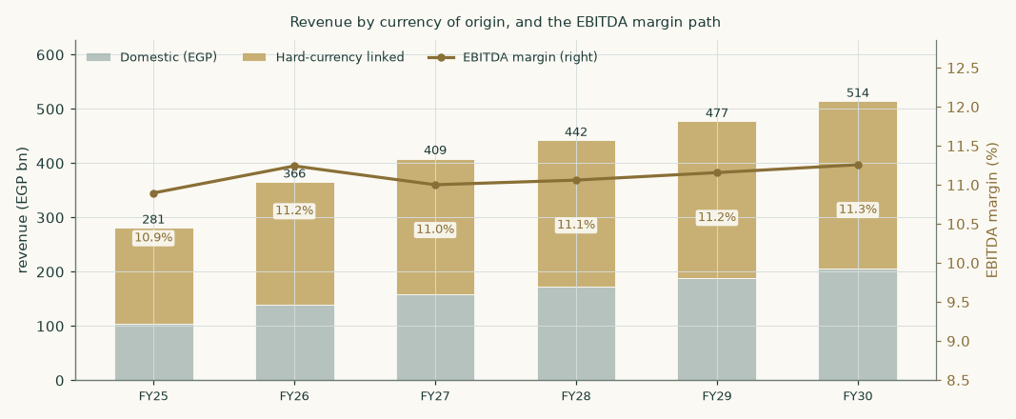
Figure 2 — revenue by currency of origin with the EBITDA margin path. The hard-currency leg does the growing; the margin recovers gently as the copper-price inflation of 2024–25 washes out of the revenue denominator.
The segment build behind the margin
Segment | FY2025 revenue (EGP mn) | Share | FY2025 gross margin | FY2030E revenue (EGP mn) | FY2030E share
Cables | 92,138 | 32.8% | 14.8% | 227,245 | 44.2%
Raw material (copper rod) | 60,448 | 21.5% | 12.4% | 130,330 | 25.3%
Engineering & construction | 87,101 | 31.0% | 9.0% | 84,180 | 16.4%
Transformers | 17,704 | 6.3% | 27.7% | 33,088 | 6.4%
Meters & digital | 16,594 | 5.9% | 21.9% | 27,977 | 5.4%
Other electrical products | 3,206 | 1.1% | 40.8% | 5,162 | 1.0%
Infrastructure investment | 3,858 | 1.4% | 49.7% | 6,211 | 1.2%
Group | 281,049 | 100.0% | 14.5% | 514,192 | 100.0%

FY2025 sub-segment revenue is built from the unit economics above, with cables as the residual against disclosed group revenue. FY2025 gross margins are calibrated so the total reproduces the gross profit assembled from the disclosed nine-month and fourth-quarter prints: cable gross profit is pinned to the published figure per tonne, and the remaining lines carry FY2024's margins scaled by a single solved factor of 0.804 — a roughly 20% compression across the board, which is what the disclosed prints require.
1.7 The crux — working capital first, the currency second, margins third
The FY2024 accounts contain the single most important number in this study. The group earned EBITDA of EGP 31,602mn and generated operating cash flow, after interest and tax, of EGP 3,979mn — about 13% of it. The difference went into working capital: inventories rose EGP 25,914mn and receivables EGP 40,144mn in a single year. Some of that was funded by customers — contract liabilities rose EGP 28,221mn — but the net absorption was still severe.
Working capital | FY2023 | FY2024 | FY2025 (estimated)
Inventories | 30,882 | 56,796 | —
Contract assets | 16,180 | 18,052 | —
Trade and other receivables | 46,592 | 86,736 | —
Less trade and other payables | (31,938) | (54,808) | —
Less contract liabilities | (25,060) | (53,281) | —
Net working capital | 36,655 | 53,495 | 64,641
As a share of revenue | 24.1% | 23.1% | 23.0%

The unit build makes a second point that a percentage-of-revenue model hides. Copper is passed through: a higher copper price raises revenue without raising the profit earned on each tonne. But working capital scales with revenue, so a copper spike CONSUMES cash while adding almost no profit. That is visible in FY2026E, where revenue rises +30% — most of it copper — and the resulting EGP 19,437mn working-capital build cuts free cash flow to the firm to just EGP 1,377mn, against EGP 13,049mn the following year once the step-up is absorbed. A rising copper price is not good news for this business in the year it happens.
The model holds this ratio flat at 23.0% of revenue, which is what the two audited years show. That single assumption is worth a great deal: every percentage point of revenue added to or removed from working-capital intensity is worth roughly EGP 1.03 per share. If the group ever converts its order book without funding it — collecting faster, or pushing more of the funding onto suppliers and customers — the cash-flow model reprices sharply upward. If discipline slips as the backlog is executed, it reprices down just as fast.
1.8 Macro and country — rates, the pound, and the sourced cost of capital
The discount rate is a schedule, not a number. Each forecast year is discounted at that year's own forward rate, moving from the explicit-window rate to the terminal rate; the terminal value is capitalised at the terminal rate and brought back using the same cumulative factor as the year-5 cash flow. One date, one price of time — the terminal value never gets a cheaper discount than a cash flow arriving on the same day.
Component | Explicit window | Terminal | Source and construction
Risk-free rate | 22.3% | 10.5% | observed 10-year local-currency government yield; terminal built from the central bank's own stated medium-term inflation target plus a standard real-rate convention
Less sovereign default spread | (3.4%) | — | netted out so sovereign default risk is not charged twice — once in the local yield and again in the country premium
Adjusted risk-free rate | 18.9% | 10.5%
Beta | 1.009 | 1.009 | own-stock weekly regression against a 31-name equal-weight local composite over five years: R-squared 0.291, n = 258, standard error 0.098, 90% interval [0.85, 1.17]
Equity risk premium | 9.4% | 7.0% | published country-premium file, credit-default-swap basis; normalised downward for the terminal rather than held at a crisis-era level
Cost of equity | 28.4% | 17.6%
Cost of debt (blended, pre-tax) | 13.0% | 10.5% | currency-blended — see the evidence immediately below
Debt weight | 8.1% | 25.0% | net debt against market capitalisation for the explicit window; a normalised structure for the terminal, because the steady state cannot be described by today's weights
Cost of capital | 26.9% | 15.1%

The cost of debt — three pieces of evidence, not an assumption
A disclosed contractual range is not evidence of what a company pays. Three things are shown instead.
Test | Evidence
Currency composition of the debt book | The audited interest-rate note discloses average rates on financial liabilities of 28.7% in Egyptian pounds, 6.5% in US dollars and 3.9% in euros. Reconciling those against the rate actually paid implies roughly 44% of the book is in Egyptian pounds and 56% in hard currency. Treating this company as a domestic borrower would overstate its cost of debt by about 1,326 basis points.
Independently computed effective rate, two periods | FY2024: interest expense of 7,707 against average loans and credit facilities of 49,982 = 15.4%. First quarter 2025, annualised on the same basis = 12.3%, the fall reflecting the central bank's easing.
Bounds | The adopted 13.0% sits 74 basis points from the most recent effective rate and below the peak-period rate of 15.4%. Both bounds hold.

This is not a technicality. A cheap, majority-hard-currency debt book is one of the two genuine competitive advantages this company has over a domestic-only competitor — the other being that its revenue is hard-currency too. It is also why the balance sheet looks more leveraged than it is: the gross book is large because working capital is large, but it costs roughly 12.3% and is more than two-thirds offset by cash.
Where this construction is contested, and what the alternatives are worth
Four choices in the cost of capital above are legitimately arguable, and external reviewers have argued them. Rather than defend each in prose, each alternative is computed and its value published here, so a reader who prefers a different convention can take the number directly.
Choice made | The alternative | Fair value on the alternative | Why we keep ours
Equity risk premium on the credit-default-swap basis (9.4%), with the sovereign spread netted at 3.4% | The rating basis from the same published table: spread 6.4%, premium 13.9%, cost of equity 30.0% | EGP 44.88 (against 63.10) | Both are columns of the same published source. The market-observed basis is preferred to the agency-rating basis, which lags. This is the single largest open question in the cost of capital and the alternative is worth roughly 18.22 per share
Minority interests charged against consolidated equity, after net debt | Charged against unlevered enterprise value, before net debt | EGP 62.20 (-0.89) | The audited borrowings note records facilities granted to the company AND its subsidiaries, guaranteed by promissory notes from subsidiaries — so minorities do bear a share of the debt. The alternative assumes all borrowing sits at the parent, which the note contradicts
Capital weights on net debt | On gross debt (24.1% weight, cost of capital 23.9%) | raises the value | Net debt is the quantity the bridge subtracts; using it in both places keeps the two consistent, and it is the more conservative of the two
Risk-free rate 22.3% | External readings of the same instrument on the same date range from about 21.3% to 23.0%, and disagree with each other | roughly ±1% of value per 100bp | The adopted figure sits inside the range of external readings rather than at either end. Because the readings conflict, the rate is carried in the sensitivity grid rather than presented as precise

The rating-basis column is the one most often raised against this study. It is not a correction to an error — both bases are published by the same source and both appear in this study's input register — but it is a material choice, and at EGP 44.88 the alternative sits well below the primary. A reader who prefers agency ratings to market spreads should use that number.
1.9 Sensitivity — the discount rate, the growth, the currency, the margin and the collection
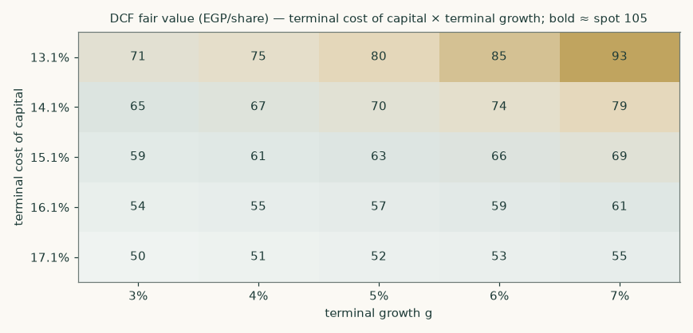
Figure 3 — discounted-cash-flow fair value per share across the terminal cost of capital and terminal growth. Bold cells sit within EGP 6 of the market price of 105.20.
Each anchor is varied independently around its own base, so the tables show what the valuation needs the world to do rather than what growth rate the model needs.
Explicit-window cost of capital → | 23.9% | 25.4% | 26.9% | 28.4% | 29.9%
terminal 13.1% | 84.34 | 81.96 | 79.66 | 77.45 | 75.31
terminal 14.1% | 74.62 | 72.51 | 70.47 | 68.50 | 66.60
terminal 15.1% | 66.83 | 64.93 | 63.10 | 61.33 | 59.62
terminal 16.1% | 60.44 | 58.71 | 57.05 | 55.44 | 53.89
terminal 17.1% | 55.11 | 53.53 | 52.00 | 50.53 | 49.11

Explicit-window against terminal cost of capital, each moved independently — the grid that shows what the valuation needs the economy to do.
Sensitivity | Range tested | Fair value span (EGP/share) | Swing
Beta | 0.6 – 1.3 | 51.73 – 86.86 | 35.13
Exchange-rate path | base −10% to +20% | 1.20 – 71.94 | 70.74
Gross profit per unit | −15% to +15% | 42.22 – 83.98 | 41.76
Copper price | −15% to +15% | 49.83 – 76.36 | 26.53
Working capital / revenue | 20.0% – 26.0% | 60.01 – 66.18 | 6.17
Terminal return on invested capital | 15% – 30% | 55.98 – 67.38 | 11.40
Terminal growth | 3% – 7% | 58.71 – 69.33 | 10.62

Every row is a full re-run of the unit build, not a multiplier applied to a finished revenue line: a currency or copper move flows through the price per tonne, the working capital and the gross profit exactly as it does in the base case. Note the copper row — the swing is small and can even run the 'wrong' way, because a higher metal price raises revenue and working capital without raising the profit earned per tonne. Ranked by swing, the terminal assumptions and the cost of capital dominate every operating driver.
The beta deserves a note. At 1.009 with an R-squared of 0.291 over 258 weekly observations and a standard error of 0.098, this is a well-identified estimate by the standards of this market — the 90% interval spans [0.85, 1.17], comfortably narrower than twice the point estimate, so it is not flagged as a weak instrument. It is also economically sensible: the largest industrial constituent of an index should have a beta near one. A defensive-staple prior of 0.6–0.9 and a cyclical prior of 1.0–1.5 bracket it, and a diversified industrial with a contracting arm belongs in the second.
2 Technical and price structure
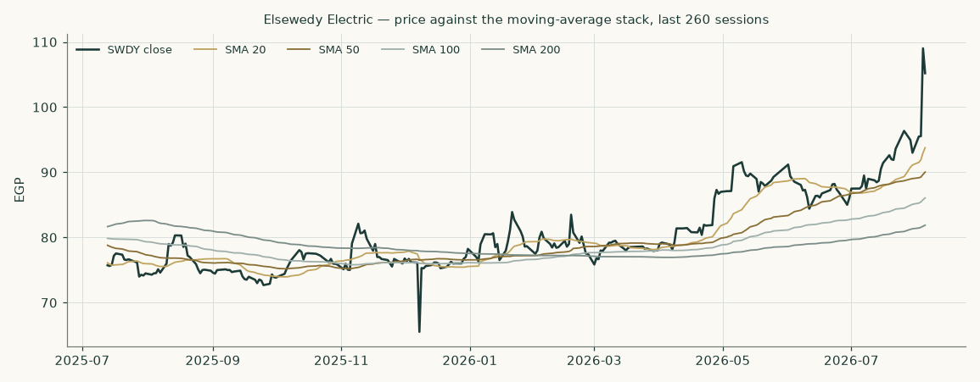
Figure 4 — price against the 20-, 50-, 100- and 200-session moving averages over the last 260 sessions.
Marker | Level (EGP) | Reading
Last close | 105.20 | the anchor for everything in this study
20-session average | 93.77 | price is +12% against it
50-session average | 90.04 | price is +17% against it
100-session average | 86.07 | price is +22% against it
200-session average | 81.88 | price is +28% against it
52-week high (closing basis) | 109.02 | -4% from the high
52-week high (intraday) | 114.50 | -8% from the high — the conventional basis, and the wider of the two
52-week low | 65.52 | +61% from the low
Annualised volatility | 48.4% | estimated from the daily range, the input to the price cone in section 3

The share is above every moving average in the stack, and the stack itself is in ascending order — the configuration that describes an established uptrend. The price has compounded +37% over the last twelve months and sits -4% from its 52-week high. Realised volatility of about 48% a year is high in absolute terms and unremarkable for this market. None of this is a valuation argument; it is the price context the valuation has to be read against, and the gap between a strongly trending price and a fundamental central below it is precisely what section 4 addresses.
One caveat on the volatility that sets the width of the price cone in section 3. The 48.4% annualised figure is dominated by a single session: the shares rose 14.1% on 4 August 2026 on roughly eleven times normal volume. Realised volatility over the last 50 sessions is 36.1%; strip out that one session and it falls to 22.0%. The cone in section 3 is therefore wide because of one day's move, and a reader who regards that session as a one-off should treat the bands as correspondingly generous.
3 A probabilistic price map
This section answers a different question from the valuation. It does not ask what the business is worth; it asks where the share price could plausibly be in one and three months, given how this share has actually moved. The engine simulates 50,000 price paths from a volatility model fitted to the daily high-low-open-close range, with a fat-tailed shock distribution and a drift anchored to the cost of carry rather than to any view.
The widths below are calibrated rather than assumed. Tested by walk-forward simulation over a full five years — 19 independent non-overlapping quarterly windows from 2021-10-05 to 2026-04-12, each one forecast using only data available before it — the model scored +1.50% better than a random-walk benchmark anchored on the same cost of carry. Outcomes fell inside the stated bands at close to the advertised rate (47% inside the 50% band, 68% inside the 80%, 84% inside the 90%), and the outcomes were spread evenly across the distribution rather than bunching at one end — a uniformity test returns p = 0.28, comfortably consistent with a well-calibrated forecast. Over the very long run the picture is more mixed: across the full 14-year history the model still beats the benchmark (+1.07%) but its bands are about 22% wider than they need to be, which is a real limitation and is stated here rather than left out.
This is a map of price dispersion, not a forecast, and it is never blended with the fair-value work above.
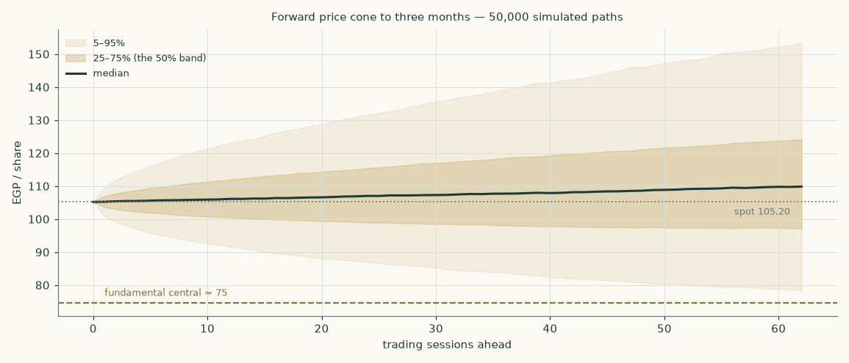
Figure 5 — the forward price cone to three months. The dashed brass line is the fundamental central estimate of 74.52; the dotted line is the spot of 105.20.
Percentile map (EGP/share)
Horizon | 5th | 25th | Median | 75th | 95th | Probability above spot
1 month (to 2026-09-06) | 87.47 | 99.11 | 106.68 | 114.90 | 130.17 | 55%
3 months (to 2026-11-05) | 78.30 | 96.94 | 109.91 | 124.46 | 154.19 | 59%

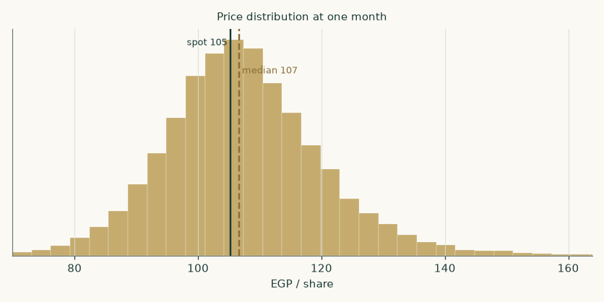
Figure 6 — the one-month price distribution.
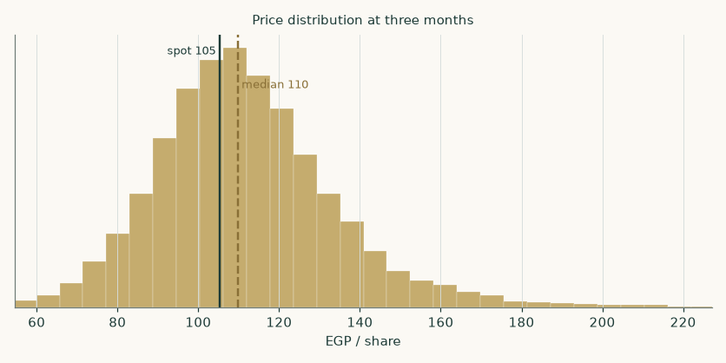
Figure 7 — the three-month price distribution.
Level-touch ladder
Event | 1 month | 3 months
Finishes 10% or more above spot | 23% | 39%
Finishes 10% or more below spot | 14% | 21%
Touches 10% above spot at any point | 37% | 63%
Touches 10% below spot at any point | 25% | 45%

Touch probabilities exceed finish probabilities because a path can visit a level and come back. This distinction matters for anyone thinking about a level rather than a date.
4 Comparison of the lenses
Read | What it says | What it assumes
Fundamental (weighted) | EGP 74.52 central, -29% against the market | an Egyptian cost of capital applied to the whole company, and no real terminal growth
Cash flow alone | EGP 63.10, -40% | a cost of capital gliding 26.9% to 15.1%
Currency-of-discounting alternative | EGP 91.15, -13% | the hard-currency cash-flow leg discounted at about 10.1%
Multiples | EGP 73.38, -30% | a discounted peer multiple is the right way to price this
The market | 105.20 | revealed preference of the marginal buyer
Three-month price map | median 109.91, 59% chance of finishing above spot | volatility persists as it has; no view on value

The reading we take from this is that the disagreement between the market and the cash-flow model is almost entirely a disagreement about the discount rate, and that this is a genuinely open question rather than a mistake by one side. A company that earns more than 70% of its money in hard currency, borrows more than half its book in hard currency at 6.5%, and holds assets in fifteen countries is only partly an Egyptian risk. Charging it the full Egyptian equity risk premium — which is what our primary construction does — is the conservative choice, not the obviously correct one. Charging it none of that premium, which is roughly what the market price implies, is the aggressive one.
Our own weighting sits closer to the conservative end because the shares are bought and sold in Egyptian pounds on an Egyptian exchange, the dividends are paid in Egyptian pounds, and the ability of a foreign shareholder to realise value depends on Egyptian capital-account conditions. That is a real risk and it belongs in the discount rate. But a reader who believes that convertibility is not the binding constraint, and that the hard-currency earnings should be valued as hard-currency earnings, will reach a materially higher number using the same cash-flow forecasts — EGP 91.15 on the alternative shown. Neither reader is being unreasonable, and this study declines to hide that behind a single figure.
No rating and no price target is expressed here or anywhere else in this document. The output is a range and a distribution.
5 Catalysts to watch
Catalyst | Why it matters | What to watch
Half-year 2026 results | the first read on whether the first quarter's reacceleration is a trend or a comparison effect, and on whether margins have stopped falling | gross margin against the 2025 exit rate; whether revenue growth holds above 20%
Working-capital conversion | the model's largest single assumption is that working capital stays near 23.0% of revenue | operating cash flow against EBITDA in the interim statements; inventory and receivable days
The exchange rate | about 63% of revenue is hard-currency linked, so both the translated result and the working capital move with the pound | the pace of depreciation against the roughly 6% a year assumed here, and whether the gap to interest-rate parity closes through rates or through the currency
Central bank policy | the discount rate glide assumes continued disinflation; a stall raises the cost of capital across the whole model | policy meetings and the inflation path against the stated targets
Copper | copper is the dominant input in the largest segment and is passed through with a lag | whether contracts continue to reprice fast enough to protect the cable gross margin during price spikes
Order intake | the roughly USD 6.5bn backlog underwrites the engineering and construction forecast | new awards against burn; the geographic mix of new work
Dividend policy | the payout has been modest against earnings; a step up would change the book and earnings lenses materially | the distribution proposed on the FY2026 result

6 Reading the probability zones
The three-month distribution in section 3 has a median of 109.91 and a 5th-to-95th percentile span of 78.30 to 154.19. Read that span honestly: it means the model considers a -26% move and a +47% move to be equally unremarkable tail outcomes over a single quarter. Anyone who finds that range uncomfortably wide is reacting to the volatility of the share rather than to the model.
Zone | Three-month range (EGP) | How to read it
Lower tail | below 78.30 | a 1-in-20 outcome; would require a genuine shock — a currency event, a policy reversal, or a material contract failure
Lower half of the central band | 96.94 – 109.91 | ordinary drift lower; this zone overlaps the upper end of the fundamental range
Upper half of the central band | 109.91 – 124.46 | ordinary drift higher; the market continuing to price the hard-currency reading
Upper tail | above 154.19 | a 1-in-20 outcome; would need a step change in the order book, the margin, or the perceived country risk
Where the fundamental central sits | 74.52 | below the 25th percentile of the three-month distribution — the price map and the valuation genuinely disagree, and that disagreement is the point

7 Caveats and what would change our mind
- The FY2025 income statement is partly derived. Revenue, profit after tax, profit after minority interests, total assets and net bank debt for FY2025 are disclosed. Gross profit is assembled from the nine-month and fourth-quarter prints. The split of the remainder between operating costs, net finance and tax is closed arithmetically to the reported profit, which implies an effective tax rate of 25.0% against 30.1% in FY2024. The audited FY2025 statements are the falsifier. FY2023 and FY2024 are taken directly from audited statements and earnings releases and are not estimated.
- The FY2025 balance sheet beyond total assets and net debt is triangulated. Three independent methods put gross debt between 67,105 and 76,166; the midpoint is carried. This matters far less than it sounds, because the valuation bridge subtracts only the disclosed net bank debt of 19,789, not the triangulated gross figure.
- The terminal value is a large share of the answer. 77% of the enterprise value comes from the terminal value. This is disclosed in the summary table, in the bridge and here. It is a consequence of a high discount rate applied to a business still growing fast — the explicit years are heavily discounted, so the perpetuity carries the weight. The terminal assumptions are stressed across cost of capital, growth and return on invested capital in section 1.9.
- The FY2026 margin rests on one inferred quarter. The cable conversion margin for FY2026 is solved so the build reproduces the EBITDA margin implied by the disclosed first-quarter 2026 result. That implied margin is not itself disclosed — it is backed out of reported revenue and attributable profit using assumed tax, minority, finance and depreciation rates. The solved gross profit per tonne is a large step up on the FY2025 trough, and although it sits inside the historical range and below pure copper-cost scaling, the whole forecast margin path inherits that one calibration — and through it, THREE of the four lenses: the cash-flow model, the relative lens (which applies a multiple to FY2027 EBITDA) and the normalised-earnings lens all sit on the same foundation. Only the book lens is independent of it, and that is the lens that disagrees most. The half-year 2026 result is the near-term test.
- The currency of discounting is unresolved, and it is the biggest single question. Our primary construction charges the full Egyptian equity risk premium to a company earning most of its money elsewhere. The alternative construction gives EGP 91.15. We have chosen the conservative reading and shown the other in full rather than splitting the difference silently.
- Terminal growth of 5% is roughly zero in real terms. The terminal risk-free rate embeds 5% inflation, so a 5% nominal terminal growth rate assumes the company stops growing in real terms forever. For a business with a growing hard-currency export franchise that is a conservative assumption, and the 6% and 7% columns of the growth grid are not aggressive.
- Minority interests are charged at their profit share, not at book. Minorities take 9.6% of group profit but only 7.7% of book equity. Charging them the profit share removes EGP 14,419mn from the equity value — roughly 6.74 per share more than a book-value treatment would. This is the conservative choice and is stated so a reader who prefers the other convention can add it back.
- Segment revenue for FY2025 is apportioned, not disclosed line by line. The company disclosed that wires and cables contributed about 59% of revenue and engineering and construction about 27%; the remainder is split using the last fully disclosed quarterly segment table. Segment shares affect the blended margin, not the revenue total.
- Concentration of control. The founding family holds 68.0% and the free float is 11.6%. Minority shareholders have limited influence over capital allocation, related-party dealings and distribution policy. This is a governance fact, not an allegation, and it is one reason the justified multiples used here carry a discount.
- What would change our mind, specifically. Upward: sustained operating cash conversion above 60% of EBITDA for two consecutive halves; a credible reduction in the perceived country risk premium; order intake materially above burn. Downward: working capital rising through 26.0% of revenue; the cable gross margin failing to stabilise; a stall in disinflation that freezes the discount rate glide.

Appendix A Financial statements
A.1 Income statement — three years historical and five years forecast (consolidated, EGP mn)
EGP mn | FY2023 | FY2024 | FY2025 | FY26E | FY27E | FY28E | FY29E | FY30E
Revenue | 152,186 | 231,982 | 281,049 | 365,556 | 408,521 | 442,252 | 477,217 | 514,192
Gross profit | 29,077 | 43,898 | 40,720 | — | — | — | — | —
EBITDA | 20,035 | 31,602 | 30,622 | 41,094 | 44,941 | 48,914 | 53,240 | 57,882
EBITDA margin | 13.2% | 13.6% | 10.9% | 11.2% | 11.0% | 11.1% | 11.2% | 11.3%
Depreciation and amortisation | (2,296) | (2,260) | (2,951) | (3,838) | (4,289) | (4,644) | (5,011) | (5,399)
EBIT | 17,739 | 29,342 | 27,671 | 37,256 | 40,651 | 44,271 | 48,229 | 52,483
Net finance costs | (2,124) | (3,515) | (3,400) | (4,127) | (3,554) | (3,053) | (2,695) | (2,409)
Share of equity-accounted investees | 604 | 1,132 | 1,302 | 1,406 | 1,519 | 1,640 | 1,772 | 1,913
Profit before tax | 16,218 | 26,959 | 25,573 | — | — | — | — | —
Income tax | (5,080) | (8,122) | (6,393) | — | — | — | — | —
Profit for the year | 11,138 | 18,837 | 19,180 | — | — | — | — | —
Non-controlling interests | (1,022) | (1,376) | (1,850) | — | — | — | — | —
Profit attributable to shareholders | 10,116 | 17,461 | 17,330 | 23,403 | 25,655 | 28,761 | 32,311 | 36,224
Earnings per share (EGP) | 4.73 | 8.16 | 8.10 | 10.93 | 11.98 | 13.43 | 15.09 | 16.92

FY2023 and FY2024 are taken from the company's audited consolidated statements and earnings releases. FY2025 is disclosed at the revenue, profit-after-tax and profit-after-minority lines; the intermediate lines are derived as described in section 7. Forecast profit is struck after net interest on the estimated debt and cash balances and after tax and minority interests, and therefore differs slightly from the free-cash-flow waterfall in section 1.1, which is a pre-financing measure by construction. Statutory earnings per share as reported by the company is struck after the Egyptian employee and board profit-share appropriation and is accordingly lower than the figures shown here.
A.2 Balance sheet — condensed house layout (consolidated, EGP mn)
EGP mn | FY2023 | FY2024 | FY2025 (estimated)
Property, plant and equipment | 18,009 | 27,544 | 33,024
Equity-accounted investees | 3,802.8 | 6,474 | —
Inventories | 30,882 | 56,796 | —
Contract assets | 16,180 | 18,052 | —
Trade and other receivables | 46,592 | 86,736 | —
Cash and cash equivalents | 25,552 | 38,180 | 51,828
Total assets | 151,449 | 249,527 | 311,090
Loans and borrowings | 41,766 | 59,083 | 71,617
Trade and other payables | 31,938 | 54,808 | —
Contract liabilities | 25,060 | 53,281 | —
Equity attributable to shareholders | 35,724 | 55,275 | 70,464
Non-controlling interests | 2,384 | 4,252 | 5,852
Net bank debt | 14,768 | 20,028 | 19,789
Net working capital | 36,655 | 53,495 | 64,641
Net debt / EBITDA | 0.74× | 0.63× | 0.65×

FY2023 and FY2024 are audited. For FY2025 only total assets and net bank debt are disclosed; equity is rolled forward from the audited FY2024 figure for FY2025 profit less the dividend paid, and gross debt and cash are triangulated (three methods spanning 67,105 to 76,166). Only the disclosed net figure enters the valuation.
A.3 Forecast balance sheet and cash-flow markers
EGP mn | FY26E | FY27E | FY28E | FY29E | FY30E
Net working capital | 84,078 | 93,960 | 101,718 | 109,760 | 118,264
Property, plant and equipment | 40,153 | 47,710 | 55,450 | 62,847 | 69,788
Intangible assets and goodwill | 1,459 | 1,459 | 1,459 | 1,459 | 1,459
Invested capital | 125,690 | 143,129 | 158,627 | 174,066 | 189,512
Return on invested capital | 22.2% | 21.3% | 20.9% | 20.8% | 20.8%
Capital expenditure | (10,967) | (11,847) | (12,383) | (12,408) | (12,341)
Change in working capital | (19,437) | (9,882) | (7,758) | (8,042) | (8,504)
Free cash flow to the firm | 1,377 | 13,049 | 17,706 | 20,733 | 23,917
Shareholders' equity | 88,016 | 107,258 | 128,828 | 153,062 | 180,230
Net debt | 27,358 | 23,957 | 16,044 | 5,129 | -9,025

The FY2024 accounts are the reason the free-cash-flow line above should be read carefully. That year the group turned EGP 31,602mn of EBITDA into EGP 3,979mn of operating cash after interest of EGP 7,707mn and tax of EGP 4,891mn, then spent EGP 8,766mn on capital expenditure. The forecast assumes working-capital intensity stops rising, which is what allows free cash flow to turn positive and build. If it does not, the model is wrong in the direction that matters most.
Appendix B Peer frame, risk register — and the research register
B.1 Peers and the sector frame
Company | Market | Relevance | Caution
Riyadh Cables | Saudi Arabia | the nearest listed regional cable manufacturer | a fraction of the revenue, no contracting arm, a much lighter balance sheet and a pegged currency — the multiple is not transferable
Electro Cable Egypt | Egypt | the only other listed Egyptian cable manufacturer, and the closest match on country risk and input costs | far smaller, domestically concentrated, heavily levered and currently loss-making — it sets a floor for country risk, not a benchmark for quality
European cable majors | Europe | the closest match on business model — cables plus projects, with a large order book | developed-market cost of capital and no emerging-market convertibility risk; their multiples import an assumption rather than test one
Regional engineering and construction contractors | Gulf and North Africa | the right frame for the roughly 27% of revenue that is turnkey project work | project accounting differs, and backlog quality is not comparable across disclosure regimes

The absence of a clean comparable is itself a finding. This is a diversified industrial group with a manufacturing business, a contracting business and an infrastructure portfolio, listed in a frontier market, earning most of its revenue elsewhere. Any single peer multiple applied to it imports assumptions about country risk that the cash-flow model tests explicitly. That is why the relative lens carries a fifth of the weight and not more.
B.2 Risk register
Risk | Mechanism | Rough valuation impact
Currency and convertibility | the ability to realise hard-currency earnings in Egyptian pounds, and the pace of depreciation | the exchange-rate sensitivity spans 70.74 per share
Cost of capital / disinflation stall | the discount-rate glide assumes continued easing | the explicit-against-terminal grid spans 35.23 per share
Working-capital discipline | growth is funded by inventory and receivables | 6.17 per share across the tested range
Margin normalisation overshooting | cable margins fail to stabilise after the currency windfall unwinds | 41.76 per share across ±2 percentage points
Terminal return on capital | the perpetuity assumes returns stay near the historical level | 11.40 per share across the tested range
Governance and control | free float of 11.6%; minority influence over capital allocation is limited | expressed through the discount applied to the justified multiples, not as a separate line
Execution and country concentration in the order book | projects across Africa and the Gulf carry counterparty, payment and political risk | sits inside the engineering and construction margin assumption
Disclosure lag | the FY2025 audited statements were not reachable at the time of writing; several FY2025 lines are derived | stated in full in section 7; falsified or confirmed by the audited FY2025 accounts

B.3 The research register — layers, dated, negative results included
Research for this study proceeded in four layers: the global and macroeconomic backdrop; the country; the industry; and the company itself. The full source-by-source register, with dates, layers and the four-field provenance of every input, is published as a separate bibliography document accompanying this study. Two negative results are recorded here because they shaped what could and could not be asserted.
- The audited FY2025 consolidated statements could not be retrieved. The company's investor-relations site and the exchange's filing archive were unreachable from the research environment. FY2025 is therefore built from disclosed headline figures reported by financial press covering the exchange filing, cross-checked against each other and against the quarterly path. Every derived line is labelled.
- No FY2025 or Q1-2026 segment table was obtainable. The last fully disclosed segment table is the first quarter of 2025. Segment shares for FY2025 are apportioned from company commentary and that table.

Appendix C The expert valuation panel
Three independent valuation approaches are run against the same disclosed facts by three notional experts, each committed to a different method and each required to state what would prove them wrong. They are not asked to agree, and they do not.
C.1 Expert 1 — earnings power: mid-cycle earnings at a justified multiple
Worldview: a business is worth a multiple of what it earns in a normal year. Cycles average out; discount-rate models multiply small errors in the rate by large terminal values and produce false precision. Find the mid-cycle earnings, apply a defensible multiple, stop.
When it works: for established franchises with a long operating record and a stable competitive position — which describes this company well. When it fails: when the multiple is imported from a market with a different cost of capital, which is precisely the trap here.
Step | Value
Mid-cycle revenue (FY2028 forecast, EGP mn) | 442,252
Mid-cycle EBITDA margin | 11.8%
Mid-cycle EBIT (EGP mn) | 47,542
Less net interest (EGP mn) | (3,053)
After tax and minority interests — earnings per share (EGP) | 14.50
Justified price/earnings multiple | 9.5×
Fair value (EGP per share) | 137.70
Range (7.0× to 12.0×) | 101.47 – 173.94

Named sensitivity: each one-turn change in the multiple is worth EGP 14.50 per share, and each percentage point of mid-cycle EBITDA margin is worth roughly EGP 1.05 per share.
Falsifier, stated in advance: if the group's EBITDA margin fails to hold above 11% for two consecutive full years, the mid-cycle margin assumed here is wrong and this valuation should be discarded, not adjusted.
C.2 Expert 2 — the accountant: owner cash earnings from the statements
Worldview: earnings are an opinion, cash is a fact. The only number that matters is what an owner could take out of the business each year after everything the business needs to keep running at its current scale — including the working capital that growth consumes. Capitalise that, and nothing else.
When it works: it is the correct discipline for exactly this kind of company, where reported profit and cash generation have diverged sharply. When it fails: it undervalues a business genuinely investing ahead of demand, because it charges growth capital against the owner without crediting the growth it buys.
Step | Value
Average free cash flow to the firm, FY2028–FY2030 (EGP mn) | 20,785
Less after-tax interest (EGP mn) | (2,021)
Less minority share (9.6%) | (1,810)
Owner cash earnings (EGP mn) | 16,954
Capitalised at cost of equity less growth | 17.6% − 5%
Fair value (EGP per share) | 66.19
Range | 40.82 – 72.60

This is the harshest of the three readings, at EGP 66.19, and the reason is specific and defensible: it takes the FY2024 evidence — EGP 31,602mn of EBITDA converting to EGP 3,979mn of operating cash — as a statement about the business model rather than about one unusual year.
Named sensitivity: if working capital intensity fell by two percentage points of revenue, this valuation would rise by roughly a third, because the entire gap between this expert and the other two is the cash the order book absorbs.
Falsifier, stated in advance: two consecutive halves in which operating cash flow exceeds 60% of EBITDA would refute the premise that this business structurally cannot convert its earnings, and this number should then be abandoned.
C.3 Expert 3 — cash returns: return on capital against the cost of capital
Worldview: value is created only when the return on invested capital exceeds the cost of that capital, and the amount created is the spread multiplied by the capital employed. Growth without a positive spread destroys value; growth with one compounds it. Start from the capital already invested and add the present value of the economic profit earned on it.
When it works: it is the sharpest available test of whether growth is worth funding, and it makes the discount-rate question unavoidable rather than buried. When it fails: it is acutely sensitive to how invested capital is measured, and to the currency in which the cost of capital is struck.
Step | Value
Invested capital at the FY2025 base (EGP mn) | 99,125
Present value of economic profit, five explicit years (EGP mn) | 14,148
Present value of terminal economic profit (EGP mn) | 43,913
Enterprise value (EGP mn) | 157,186
Fair value (EGP per share) | 60.72
Range — the upper bound is the hard-currency discounting case | 49.99 – 91.15

Year | FY26E | FY27E | FY28E | FY29E | FY30E
Return on invested capital | 22.2% | 21.3% | 20.9% | 20.8% | 20.8%
Cost of capital that year | 26.9% | 23.0% | 19.5% | 17.1% | 15.1%
Spread | -4.7pp | -1.7pp | +1.4pp | +3.7pp | +5.6pp
Economic profit (EGP mn) | 1,279 | 1,606 | 5,222 | 9,046 | 13,007

This table is the single most revealing exhibit in the study. The spread is negative in the early years — the group earns roughly 22% on capital while its cost of capital is 27% — and turns positive only as the discount rate glides down. On this reading the company is not currently creating value at an Egyptian cost of capital; it creates value only if that cost of capital normalises, or if the correct cost of capital is the hard-currency one.
Named sensitivity: a two-percentage-point parallel reduction in the cost-of-capital schedule flips the spread positive from the first forecast year and adds materially more than any operating assumption tested elsewhere in this study.
Falsifier, stated in advance: if return on invested capital falls below 15% for two consecutive years while the cost of capital stays above 20%, this approach concludes the business is consuming value at scale and the estimate should collapse toward invested capital.
C.4 Cross-examination
Challenge | From | Response
"A multiple is just a discount rate you have not written down. Yours implies a cost of equity nowhere near the one this market charges." | Expert 3 to Expert 1 | Conceded in part. The multiple is deliberately discounted below developed-market levels for exactly this reason, but the discount is a judgement rather than a derivation, and it is the weakest joint in this method.
"You are charging the owner for working capital that funds an order book which will convert to cash. That is a timing charge treated as a permanent one." | Expert 1 to Expert 2 | Rejected. Two audited years show working capital rising with revenue, not converting. Until a year shows conversion, treating it as permanent is the evidence-led position.
"Your invested-capital base is understated because it excludes goodwill written off and assets held at historical cost through three devaluations." | Expert 2 to Expert 3 | Conceded. A higher capital base would lower the measured return on capital and shrink the spread, making this reading more pessimistic, not less. The direction of the error is unfavourable to the conclusion already reached.
"All three of you are answering an Egyptian question about a company that earns 70% of its money elsewhere." | The panel to itself | Accepted as the central unresolved issue. It is why Expert 3's range extends up to the hard-currency case, and why the main study presents both readings rather than an average.

C.5 The three in one room
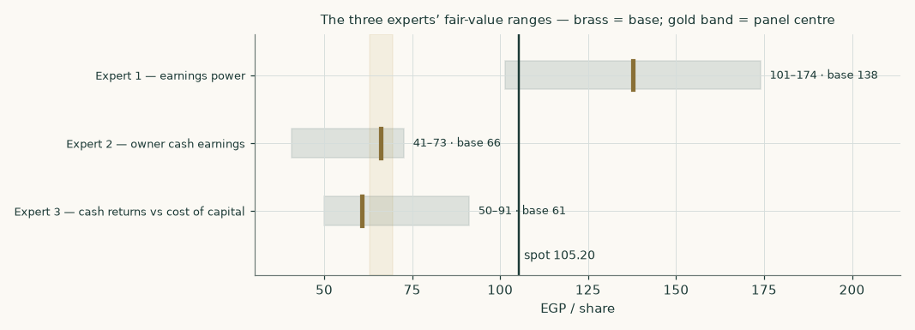
Figure 8 — the three experts' ranges. The gold band is the panel centre of 66.19; the vertical line is the market price of 105.20.
The panel spans EGP 60.72 to 137.70 — a factor of 2.3 between the most and least generous reading. That is a wide disagreement and it is not noise. Expert 1 values earnings and lands near the market price. Expert 2 values cash and lands well below it. Expert 3 values the spread between returns and the cost of capital and finds that the answer depends entirely on which cost of capital applies. The panel median of 66.19 sits -37% against the market price and close to the study's own weighted central of 74.52.
C.6 Reading the divergence
Assumption | Expert 1 | Expert 2 | Expert 3 | Why it swings the answer
Working capital | ignored — earnings basis | charged in full, permanently | charged through invested capital | the largest single source of the gap between Experts 1 and 2
Discount rate | implicit in the multiple | 17.6% explicit | the full glide, year by year | Expert 3 is the only one who lets it change over time, which is why his spread turns
Currency of discounting | not addressed | Egyptian throughout | both readings shown in the range | worth more than every operating assumption combined
Growth | embedded in the multiple | 5% perpetual | funded explicitly through reinvestment | only Expert 3 makes growth pay for the capital it needs
Terminal value | none — no perpetuity | a perpetuity of owner cash | 77% of the value in the study's main model | the reason Expert 1 is insensitive to the terminal debate and the others are not

The instruction to the reader is not to average these three. It is to decide which of the three premises is true — whether working capital converts, and which currency's cost of capital applies — and then to use the corresponding number. The disagreement is a map of what you need to have a view on.
About this series
This series publishes independent, educational valuation studies of listed companies. Each study is built from disclosed financial statements and named market data, states its assumptions explicitly, computes every figure in an auditable model rather than in prose, and publishes the ranges its assumptions produce. Studies never carry a rating or a price target. Where a figure is estimated rather than disclosed, it is labelled. Where a source could not be reached, the gap is recorded rather than filled.
The probabilistic price map in section 3 is produced by a volatility model that is tested by walk-forward simulation against a random-walk benchmark before it is allowed to publish a range. It describes price dispersion and carries no view on value. It is never combined with the fair-value work.
Disclosure & Disclaimer
This document is educational analysis and is not investment advice, an offer, or a solicitation to buy or sell any security. It contains no recommendation, no rating and no price target. The author holds no position in the security discussed and has no business relationship with the company. Figures are drawn from public sources believed reliable but not independently verified; where figures are derived or estimated this is stated in the text. Valuation is inherently uncertain and depends on assumptions that reasonable analysts will dispute — several such disputes are set out explicitly in this document rather than resolved silently. Past performance and simulated distributions are not guides to future returns. Readers must reach their own conclusions and should consider taking independent advice. No liability is accepted for any loss arising from use of this material.

