TESTAHIL Research — Valuation Study For information only — not investment advice

Emirates Central Cooling Systems Corporation PJSC (DFM: EMPOWER)
The world's largest listed district-cooling utility — contracted chilled-water capacity serving Dubai under a regulated-tariff regime · Dubai Financial Market · reporting currency AED · analysis anchored on the closing price of 1.50 on 7 August 2026 · study dated 9 August 2026.
READ FIRST — what this document is. An educational valuation study. It contains no recommendation, no rating and no price target. It contains a fair-value range built from the company's own audited financial statements, a sourced cost of capital and explicitly listed assumptions — and, separately, a probabilistic map of where the share price could trade over the next one and three months. The two are different objects and are never blended.
The first structural judgement — the consumption question. Chilled-water consumption per connected refrigeration ton fell sharply in the first half of 2026, in a conflict year, and the shares fell with it. Whether that usage recovers is the single question this study turns on, and it is computed BOTH ways as full models: a recovery case and a case in which usage never recovers. The finding the reader should take away is quantitative: because roughly 76% of consumption revenue is electricity and water purchased from DEWA and passed through, permanent loss of the usage shock moves the discounted-cash-flow value by only 2.7% — far less than the share-price reaction implies. The capacity charge, not the meter, carries the value.
The second structural judgement — the tax rate, framed twice. The audited 2025 effective tax rate is exactly 9.0% under UAE corporate tax. Whether the 15% domestic minimum top-up tax reaches Empower through consolidation into the DEWA group (whose revenue far exceeds the EUR 750m threshold) is contested and unresolved. The entire valuation is therefore published both ways — 2.664 against 2.483 on the primary lens, 2.250 against 2.139 on the weighted central — side by side, never averaged.
What to check first. Section 1.7 (the consumption grid), the two tax columns of the valuation summary below, and section 1.8's cost-of-debt evidence — the three places where a reader who disagrees with this study will find the disagreement priced.
The companion workbook. The Excel model calculates live — changing a driver reprices the statements, the discounted cash flow and the fair value. Only three classes of cell are pasted values, named on its own READ FIRST sheet: the audited and disclosed history; the historical calibration of the unit build (the implied capacity rate per refrigeration ton, a research judgement rather than an arithmetic step); and whole-model re-runs — the probabilistic price map and the sensitivity grids, where each cell is a complete revaluation.

Headline
Empower is the world's largest district-cooling utility by connected capacity: 1,707k refrigeration tons (RT) connected and 2,018k RT contracted at 30 June 2026, serving about 1,796 buildings — roughly 80% of Dubai's district-cooling market. It sells cooling on two legs priced under a regulated tariff: a contracted CAPACITY (demand) charge, paid on connected tons regardless of usage, and a metered CONSUMPTION charge for chilled water actually drawn. The distinction is the whole study: the capacity leg is the fixed-cost recovery and, effectively, the profit pool, while the consumption leg's dominant cost — electricity and water purchased from DEWA, AED 1,468mn in 2025, about 76% of consumption revenue — is largely a pass-through.
The financial character is a regulated utility's: the EBITDA margin has held between 47.6% and 50.5% in every audited year since 2021, revenue compounded from AED 2,464mn (2021) to 3,419mn (2025), and net profit reached AED 1,004mn in 2025. Net debt was AED 2,991mn at 30 June 2026 (1.8× 2025 EBITDA) after the 2025 refinancing of both AED 2.75bn revolving facilities at a reduced margin. The dividend is committed at AED 875mn a year for 2025 and 2026 — 0.087 per share, a 5.8% yield at the anchor price — and free cash flow to equity runs almost exactly at the payout: covered, but not slack.
2026 is the conflict year. Iranian strikes hit UAE infrastructure between February and April; a ceasefire has held — fraying — since 8 April. The Dubai market index fell 21.9% peak to trough and the central bank cut its 2026 GDP growth guidance from 5.6% to 1.7%. Empower's first half showed the transmission mechanism: revenue grew +4.5%, but the second quarter standalone FELL 2.7% year on year as consumption dropped 42m ton-hours (equivalent full-load hours -9% to 698 hours), tied by the interim notes partly to conflict-hit hospitality occupancy. The shares closed the anchor session at 1.50, 23% below their 52-week high of 1.96, the last leg of the fall coming after the 5 August half-year release.
On the four lenses used here the fair-value field centres at AED 2.250 per share under the 9% tax framing and 2.139 under the 15% framing, inside a bear-to-bull field of 1.737 to 2.714, against a market price of 1.50. One disclosed transaction brackets the question from above: DEWA took its stake from 56% to 80% in February 2026 by buying Dubai Holding's 24% at AED 2.16 per share — a related-party CONTROL price, +44% above the anchor close, recorded here as a reference point and never as fair value.
Valuation summary — every read at a glance, both tax framings side by side
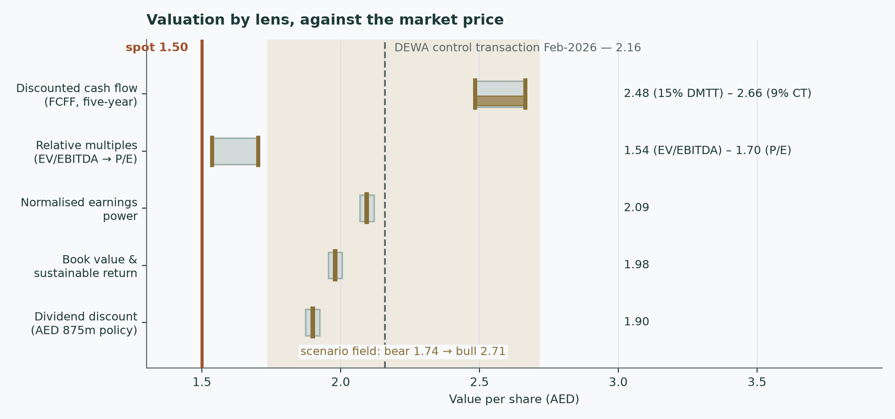
Figure 1 — the valuation field: each lens's range, both tax framings of the central estimate, the market price of 1.50 and the DEWA control print of 2.16.
Read | Basis | At 9% tax | At 15% tax | vs spot
Discounted cash flow (primary) | 5-year free cash flow to the firm on the two-leg unit build, cost of capital 6.77%, terminal growth 2.5%. Terminal value = 80.8% of enterprise value (80.9% under the 15% framing) — disclosed here, in the bridge and in section 1.9 | 2.664 | 2.483 | +78%
Relative multiples | Tabreed 10.7× EV/EBITDA on 2026E EBITDA (gives 1.536); Tabreed 16.6× P/E on 2026E attributable profit (gives 1.701). Peers are themselves war-depressed — a market-regime reading, not an independent fundamental | 1.536 | 1.536 | +2%
Normalised earnings power | 2026E with consumption at the UNSHOCKED per-ton level; justified multiple 19.9× from the sustainable return and the cost of equity | 2.094 | 1.956 | +40%
Book value and sustainable return | justified price-to-book 5.9× on book value of 0.334/share at a sustainable return on equity of 30.5% | 1.980 | 1.980 | +32%
Weighted central | cash flow 50% · relative 20% · normalised 15% · book 15%; the two tax columns are alternatives, never averaged | 2.250 | 2.139 | +50%
Scenario field | bear 1.737 (war re-escalation, usage never recovers, 15% tax, +100bp on the cost of equity) to bull 2.714 (full recovery, 110k RT/yr) | 1.737 – 2.714 | (bear is struck at this tax rate) | —
Dividend cross-check (unweighted) | the committed AED 875mn growing at 2.5%, capitalised at the cost of equity | 1.899 | 1.899 | +27%
Market price | closing price, 7 August 2026 | 1.50 | 1.50 | —
DEWA control purchase — reference only | February 2026, related-party purchase of a 24% block at a control price; a disclosed reference point, not fair value | 2.16 | 2.16 | +44%

Fair values are ranges and distributions, never a target. The two tax columns are the study's central contested judgement published in full: 9% is the audited 2025 effective rate, 15% is the domestic minimum top-up rate that would apply if consolidation into the DEWA group sweeps Empower into the OECD minimum-tax regime. Neither is averaged into the other anywhere in this document. The terminal-value share of enterprise value (80.8%) is stated beside the lens it belongs to because it is the number a sceptical reader should weigh first.
Company overview — Empower at a glance
Item | Detail
Listed | Dubai Financial Market, 16 November 2022, at the tail of the Dubai privatisation programme; par value AED 0.10
What it does | Builds and operates district-cooling plants and distribution networks in Dubai, selling chilled water to towers, malls, hotels and districts under long-term connection agreements; also manufactures pre-insulated pipes (Logstor) and operates the Dubai airport cooling concession through a 70%-owned subsidiary (DXB CoolCo, a 35-year concession acquired in 2023, inside the connected base)
Scale | 1,707k RT connected / 2,018k RT contracted at 30 June 2026 (+3.1% connected in the half); about 1,796 buildings; roughly 80% of the Dubai district-cooling market
Revenue model | Two legs on one asset base: capacity (demand) charges, contracted and paid on connected tons regardless of usage — about 40% of first-half 2026 revenue per the earnings deck — and metered consumption charges, about 49%, with connection and other fees the remaining 11%. The split of the two legs in AED is not separately disclosed in the statements; consumption revenue is disclosed in the auditor's key-audit-matter section each year and the split is reconstructed from it (section 1.6)
Regulation | Dubai Executive Council Resolution 6/2021 governs district cooling; tariffs require approval by the Regulatory and Supervisory Bureau. This study holds the tariff FLAT in nominal AED throughout — no real escalation is assumed anywhere
Ownership | DEWA 80% since February 2026 (it bought Dubai Holding's 24% at AED 2.16 per share); free float about 20%. DEWA is simultaneously the controlling shareholder and the sole supplier of the largest cost line — a governance concentration discussed in section 7
Shares / market value | 10,000mn shares; AED 15,000mn at the anchor price of 1.50
Net debt | AED 2,991mn at 30 June 2026 (1.8× 2025 EBITDA): two AED 2.75bn revolving credit facilities, fully refinanced in 2025 at a reduced margin over EIBOR, less cash and term deposits
Dividend | AED 875mn a year committed for 2025 AND 2026, paid in two instalments (October and April) — 0.087 per share, 5.8% at the anchor price
Tax status | UAE corporate tax at 9%; the 2025 audited effective rate is exactly 9.0%. Whether the 15% domestic minimum top-up tax reaches Empower through DEWA-group consolidation is contested — the study's dual-framed judgement

Two structural facts govern everything that follows. First, the two-leg tariff means the profit pool sits in the contracted capacity charge: consumption revenue carries a 76% pass-through cost, so a swing in usage moves revenue far more than it moves cash flow. Second, the balance sheet runs on other people's working capital: customer deposits and long payment terms to a related-party supplier hold net working capital NEGATIVE at about 51% of revenue — growth here releases cash rather than consuming it, the mirror image of most utilities' build-out phase.
1 Fundamental valuation
1.1 The cash-flow model — the primary lens, with the full waterfall
The primary lens is a five-year free-cash-flow-to-the-firm model built from physical units, not from a revenue growth rate: connected refrigeration tons × the capacity rate, plus consumption per connected ton × the connected base, plus the small pipes line — each leg on its own driver, with margins falling out as OUTPUTS (section 1.6 shows the build and its exact reconciliation to the audited 2025 statements). The waterfall below runs the base case at the 9% audited tax rate; the 15% minimum-tax framing follows it, in full, immediately after.
AED mn | FY26 | FY27 | FY28 | FY29 | FY30
Revenue | 3,503 | 3,842 | 4,042 | 4,222 | 4,380
of which consumption | 1,918 | 2,163 | 2,276 | 2,378 | 2,467
of which capacity and other | 1,568 | 1,662 | 1,749 | 1,827 | 1,896
EBITDA | 1,702 | 1,843 | 1,945 | 2,034 | 2,112
EBITDA margin | 48.6% | 48.0% | 48.1% | 48.2% | 48.2%
Less depreciation and amortisation | (380) | (390) | (399) | (405) | (408)
EBIT | 1,323 | 1,452 | 1,545 | 1,629 | 1,703
NOPAT — EBIT × (1 − 9%) | 1,204 | 1,322 | 1,406 | 1,483 | 1,550
Add back depreciation and amortisation | 380 | 390 | 399 | 405 | 408
Less capital expenditure | (571) | (548) | (501) | (453) | (404)
Add working-capital release | 43 | 174 | 103 | 92 | 81
Free cash flow to the firm | 1,055 | 1,338 | 1,408 | 1,527 | 1,636
Discount factor | 0.9366 | 0.8773 | 0.8217 | 0.7696 | 0.7208
Present value of FCFF | 988 | 1,174 | 1,157 | 1,175 | 1,179

Every line is computed, not typed. Working capital is NEGATIVE for this company — customer deposits and payables fund the cycle — so growth RELEASES cash: the working-capital line adds to free cash flow every year, at the audited 2025 ratio of -51.4% of revenue. Capital expenditure is priced per new refrigeration ton (AED 4,889 per RT added, derived from the 2025 cash figures) plus a maintenance allowance on the installed base.
AED mn — the same model at the 15% minimum tax | FY26 | FY27 | FY28 | FY29 | FY30
NOPAT — EBIT × (1 − 15%) | 1,124 | 1,234 | 1,314 | 1,385 | 1,448
Free cash flow to the firm | 976 | 1,251 | 1,315 | 1,429 | 1,533
Present value of FCFF | 915 | 1,098 | 1,082 | 1,102 | 1,108

The bridge from enterprise value to the equity — both framings
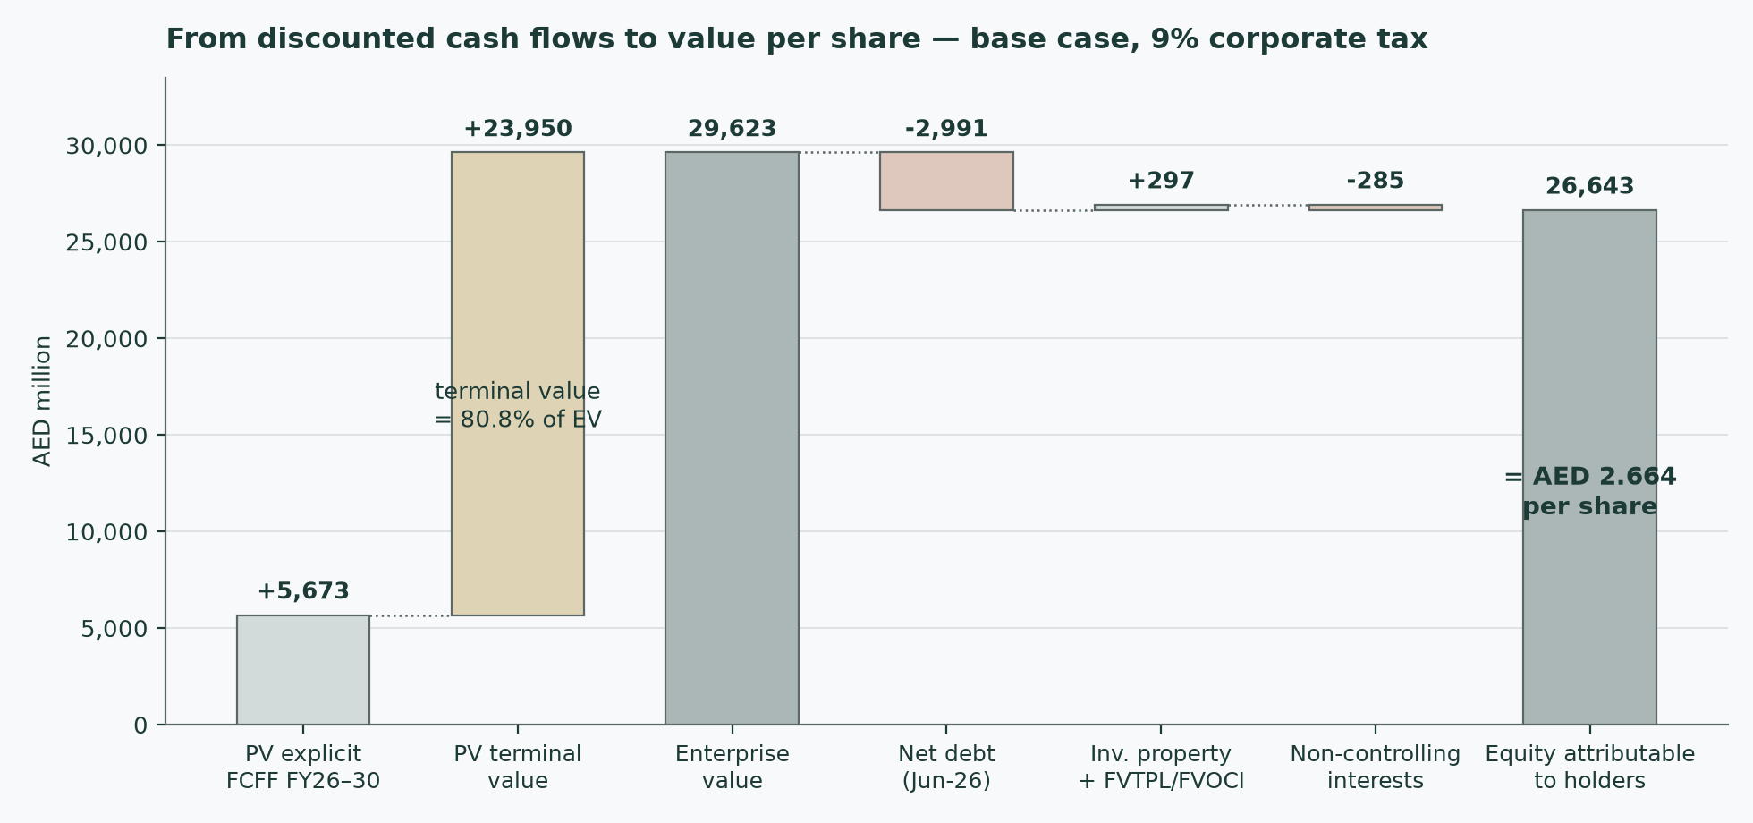
Figure 2 — from the discounted cash flows to the per-share value, both tax framings side by side.
Step | At 9% | At 15% | Note
Present value of the five forecast years | 5,673 | 5,305 | sum of the present-value rows above
Terminal value | 33,227 | 31,130 | final-year NOPAT grown 2.5% × (1 − reinvestment rate 10.8%), capitalised at 6.77% − 2.5%. The reinvestment rate is forced to growth ÷ terminal return on capital (23.2%) so growth is paid for
Present value of the terminal value | 23,950 | 22,490 | discounted at the year-5 factor
Enterprise value | 29,623 | 27,794 | the two lines above
Terminal value as a share of enterprise value | 80.8% | 80.9% | high, as it must be for a regulated utility whose explicit window is only five years; disclosed here, in the summary table, and stress-tested in section 1.9. Expert 3 challenges it directly in Appendix C
Less net debt | (2,991) | (2,991) | 30 June 2026 reviewed balance sheet: borrowings and leases less cash and term deposits — reproduces the company's own presented figure exactly
Plus investment properties | 169 | 169 | non-operating side pocket, at book; its depreciation is excluded from the operating model for the same reason
Plus financial assets held at fair value | 128 | 128 | cash-like holdings outside the operating model, at book
Less minority interests (1.1% of profits) | (285) | (266) | minorities (the 30% of DXB CoolCo and others) take 1.1% of group profit and are charged the same share of the value — the internally consistent convention when the group is valued above book
Equity attributable | 26,643 | 24,834
Fair value per share (AED) | 2.664 | 2.483 | against a spot of 1.50: +78% and +66% respectively

The valuation is struck on the 30 June 2026 reviewed balance sheet against an anchor price five weeks later; no accretion roll is applied across that short window. The difference between the two columns — AED 0.181 per share, 6.8% of the 9% value — is the entire price of the tax question, and it is left visible rather than averaged away.
1.2 Book value and sustainable return — the asset lens
Book value attributable to shareholders is AED 3,338mn at 30 June 2026, or 0.334 per share — the share trades at 4.5× book. That multiple is not the anomaly it appears: the equity base is small because the assets are largely debt- and customer-deposit-funded and the company has distributed heavily since listing, so the sustainable return on equity is high — 30.5% on the average of the last two year-end equity bases. A justified price-to-book multiple, (return on equity − growth) ÷ (cost of equity − growth), gives 5.9× book at the 7.22% cost of equity and 2.5% growth — AED 1.980 per share.
This is the lens most exposed to its own construction: a high-ROE, low-book business makes the justified multiple acutely sensitive to the return assumption (each percentage point of sustainable ROE is worth roughly AED 0.071 per share). It is retained at a 15% weight because it prices the question the other lenses skip — what the installed asset base earns — but it is read as corroboration, not as a primary estimate.
1.3 Relative multiples — what the market pays for GCC cooling today
Step | Value | Comment
Tabreed enterprise value / EBITDA (trailing) | 10.7× | the only listed pure district-cooling peer (Dubai Financial Market); derived from its market value plus net debt over 2025 EBITDA, and flagged as derived. Tabreed runs much higher leverage, which is why the comparison is made at the enterprise line rather than on price/earnings alone
Applied to Empower 2026E EBITDA | 1,702 | the base-case build, shock year included
Implied enterprise value | 18,216
Less net debt, plus the side pockets, less minorities | — | the same bridge as section 1.1
Implied value per share — EV/EBITDA basis | 1.536 | +2% against spot
Tabreed price/earnings 16.6× on 2026E attributable profit of 1,025 | 1.701 | the earnings-basis read; DEWA itself trades near 16.8× as a secondary marker

Read this lens for what it is: a market-regime reading, not an independent fundamental. The peer multiples are themselves struck in a war-discounted market — Tabreed and DEWA fell with the index — so applying them imports the conflict discount rather than testing it. That is exactly why the lens carries 20% weight and why its gap to the cash-flow lens (1.536 against 2.664) is treated in section 4 as information about the market's risk pricing, not as an error in either number.
1.4 Normalised earnings power — the unshocked year
The question this lens asks: what does 2026 earn if the consumption shock had not happened — usage per connected ton at the 2025 level, everything else unchanged? Revenue would be AED 3,625mn (against 3,503mn shocked), EBITDA 1,731mn, and attributable profit 1,051mn — earnings per share of 0.105. Capitalised at a justified multiple of 19.9× — built from the sustainable return on equity (30.5%), the retention that 2.5% growth requires, and the 7.22% cost of equity — that is AED 2.094 per share (1.956 if the 15% minimum tax applies).
The lens deliberately measures the gap between the market's reaction and the earnings arithmetic: the whole shock is worth about AED 122mn of revenue in the year, most of which is passed-through electricity and water cost that disappears with it.
1.5 Synthesis — four lenses, one field
Lens | At 9% | At 15% | Weight
Discounted cash flow | 2.664 | 2.483 | 50%
Relative multiples | 1.536 | 1.536 | 20%
Normalised earnings power | 2.094 | 1.956 | 15%
Book value and sustainable return | 1.980 | 1.980 | 15%
Weighted central | 2.250 | 2.139 | —
Dividend cross-check (unweighted) | 1.899 | 1.899 | —

The lenses disagree in an orderly way. The cash-flow model sits highest because it credits the contracted growth backlog and the negative-working-capital funding model in full; the relative lens sits lowest because it imports today's war-discounted market regime; the normalised and book lenses sit between. The weighting leans on the cash-flow model because this is a regulated utility with contracted revenue — the class of business a discounted-cash-flow model prices best — and the field runs 1.737 to 2.714 bear to bull. Both tax columns are carried through every row; nothing is averaged across them.
1.6 The drivers — a two-leg unit build, margins as outputs
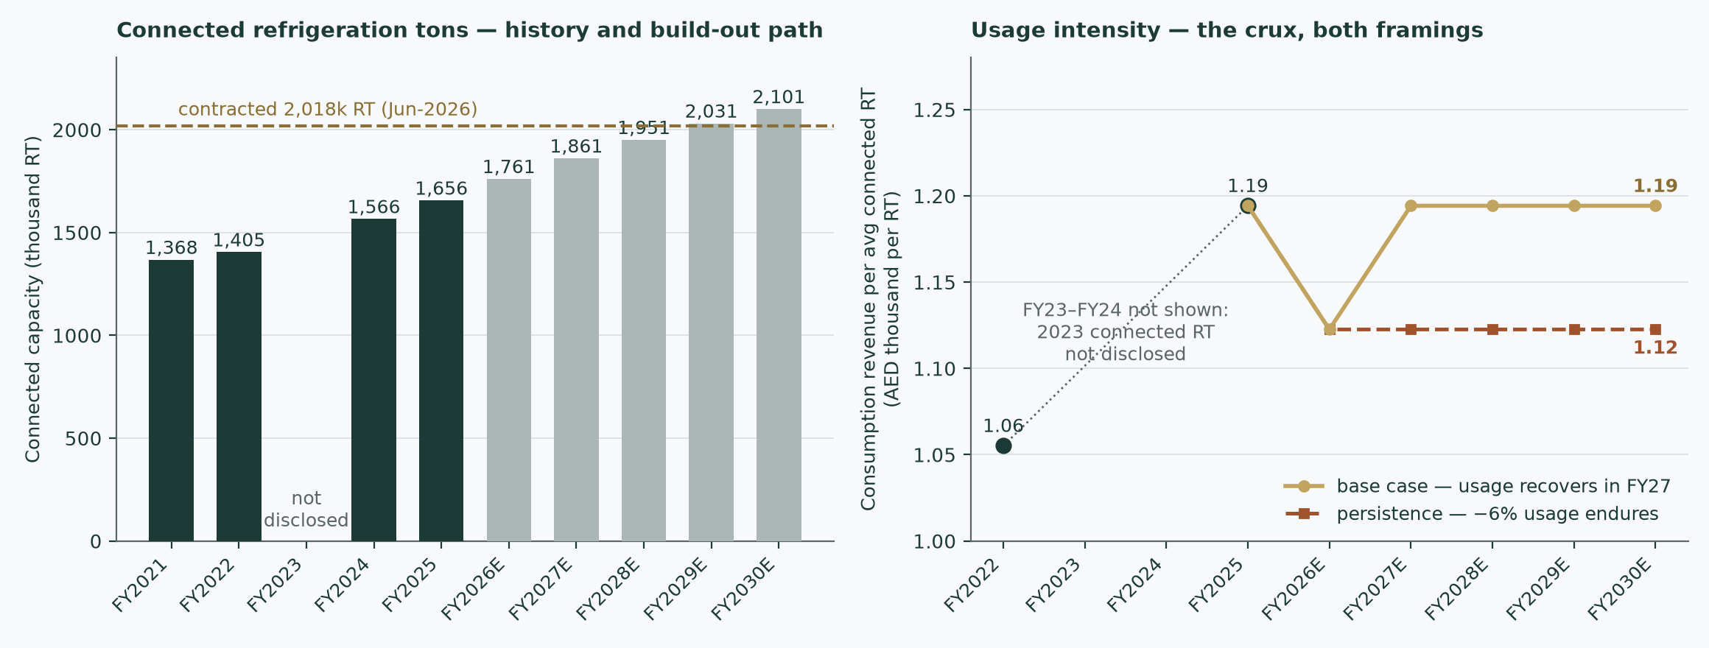
Figure 3 — the unit engine: connected capacity, consumption per connected ton and the revenue that falls out of them.
Revenue is built from physical units at the finest level the company disclosures allow. The volume driver is CONNECTED CAPACITY, taken from the company's own history and guidance: 1,656k RT at end-2025, 1,707k at 30 June 2026, company guidance of 100–110k of new connections for 2026 (the model uses the midpoint), and a contracted backlog of 311k RT already signed but not yet connected — a pre-sold pipeline that funds the additions assumed for 2027 onward, tapering as the Dubai build-out matures.
Driver (per year) | FY25 | FY26 | FY27 | FY28 | FY29 | FY30
Connected capacity, year-end (k RT) | 1,656 | 1,761 | 1,861 | 1,951 | 2,031 | 2,101
New connections in the year (k RT) | — | 105 | 100 | 90 | 80 | 70
Average connected base (k RT) | — | 1,708 | 1,811 | 1,906 | 1,991 | 2,066
Consumption revenue per average RT (AED/yr) | 1,194 | 1,123 | 1,194 | 1,194 | 1,194 | 1,194
Capacity and other revenue per average RT (AED/yr) | 918 | 918 | 918 | 918 | 918 | 918

The capacity rate per ton is IMPLIED, not published — no per-ton tariff schedule is disclosed anywhere in the filings — so it is solved from disclosed total revenue, the disclosed consumption figure in the auditor's key-audit-matter section, and the pipes line, then held flat at the regulated tariff. The consumption rate carries the 6% 2026 shock and recovers to the 2025 level through 2027 in the base case — the crux, section 1.7.
The cost stack is escalated one class at a time, never on a single blended index. Electricity and water purchased from DEWA — AED 1,468mn in 2025, 76.3% of consumption revenue and 43% of total revenue — moves with its own physical driver, the consumption leg itself (DEWA's slab tariff is flat; its fuel surcharge floats monthly). Staff and other cash operating costs (AED 398mn in 2025 across cost of sales and administration) escalate on a UAE wage path of 2.5% a year. Interest income on the airport concession receivable amortises slowly down. The build reproduces audited 2025 EBITDA of AED 1,642mn exactly before any forecast year is struck.
What the build produces | FY26 | FY27 | FY28 | FY29 | FY30
Revenue (AED mn) | 3,503 | 3,842 | 4,042 | 4,222 | 4,380
EBITDA (AED mn) | 1,702 | 1,843 | 1,945 | 2,034 | 2,112
EBITDA margin — an OUTPUT | 48.6% | 48.0% | 48.1% | 48.2% | 48.2%
Capital expenditure (AED mn) | 571 | 548 | 501 | 453 | 404
Working capital released (AED mn) | 43 | 174 | 103 | 92 | 81

The margin path is not assumed: it emerges from the two-leg mix. It dips in the shock year, then recovers toward the audited range (47.6–50.5%) as consumption normalises and the connected base grows into the cost stack.
1.7 The crux — does consumption per connected ton recover?
Usage per connected ton fell 6% in 2026 on the model's full-year reading of the disclosed half-year figures (equivalent full-load hours were -9% in the half itself). The base case lets it recover to the 2025 level through 2027, on the view that the loss is hospitality-linked and the truce holds. The alternative is computed as a FULL model, not a sensitivity: usage never recovers. The grid below prices every stop between.
Consumption per connected ton, from 2027 | Implied AED per RT | Fair value at 9% | vs base
90% of the 2025 level | 1,075 | 2.546 | -4.4%
94% of the 2025 level — the never-recovers case | 1,123 | 2.594 | -2.7%
97% of the 2025 level | 1,158 | 2.629 | -1.3%
100% of the 2025 level — the base case | 1,194 | 2.664 | +0.0%
103% of the 2025 level | 1,230 | 2.700 | +1.3%

The finding is the study's headline: permanent loss of the entire shock — the never-recovers case — moves the discounted-cash-flow value from 2.664 to 2.594, just 2.7% (2.416 under the 15% tax framing). The arithmetic reason is the pass-through: about 76% of every dirham of consumption revenue leaves again as electricity and water purchased from DEWA, so the meter's contribution to cash flow is thin. The market's read-through from the consumption miss to the equity — a share price 23% off its high — is larger than the cash-flow arithmetic supports. The capacity charge, not the meter, carries the value; what WOULD move the value is a tariff cut or a stall in connections, which is why sections 5 and 7 watch those, not the weather.
1.8 Macro and country — rates, the peg, and the sourced cost of capital
The macro frame is unusually clean for an emerging-market study: the dirham is hard-pegged, so the UAE imports the Federal Reserve's path and the currency leg drops out of the valuation entirely. The central bank's base rate stood at 3.65% at the end of July 2026; the federal government's dirham bond programme gives a sovereign curve, and its longest print — the January-2031 tranche auctioned on 30 July 2026 — yields 4.48%. The conflict is the macro event: the market index fell 21.9% peak to trough, GDP guidance was cut from 5.6% to 1.7%, and the equity risk pricing that survives into August is part of what section 1.3 measures.
Component | Credit-rating basis | Market-spread basis | Construction
Risk-free rate before adjustment | 4.48% | 4.48% | the longest AED sovereign print (4.4-year tenor; the gap to the five-year-plus cash-flow horizon is flagged as a limitation)
Less the sovereign default spread | 0.39% | 0.52% | the UAE's own default spread on each basis, from the July-2026 edition of the published country-risk dataset; the market-spread column uses the Abu Dhabi sovereign credit-default swap as the quoted UAE proxy — flagged
Adjusted risk-free rate | 4.09% | 3.96% | country risk must enter once, through the equity premium — not twice
Beta | 0.652 | 0.652 | own-stock weekly regression against the DFM General Index over the full listing window (3.6 years, n=190): R² 0.157, standard error 0.110, 90% interval 0.47–0.83
Equity risk premium | 4.81% | 5.01% | the UAE total premium on each basis, same dataset — the same basis of spread that was stripped from the risk-free rate is the one added back here
Cost of equity | 7.22% | 7.23% | the two constructions CONVERGE to within a basis point — the contested choice of basis is priced and turns out to cost nothing
Cost of debt (marginal) | 4.92% | 4.92% | the company's OWN 2025 borrowing-cost capitalisation rate, struck on the full refinance of both AED 2.75bn facilities at a reduced margin over EIBOR — see the evidence table below
Weights (equity / debt) | 83.4% / 16.6% | 83.4% / 16.6% | market value of equity at the anchor price; net debt at the reviewed June-2026 balance sheet
Cost of capital at 9% tax | 6.77% | 6.77% | the rate the base case discounts at
Cost of capital at 15% tax | 6.72% | 6.72% | marginally lower — the tax shield on debt is worth more

No glide path is applied to the cost of debt or the cost of capital: both revolving facilities float over EIBOR, the 2025 refinance already reset the margin, and the forward curve is flat to mildly higher — a glide would be invented, not sourced. The explicit-window rate equals the terminal rate, stated openly.
The cost of debt — three pieces of evidence, not an assumption
Evidence | Rate | What it establishes
AED sovereign yield (January-2031 tranche, auctioned 30 July 2026) | 4.48% | the floor: a same-currency corporate cannot sustainably borrow below its sovereign
Empower's own 2025 borrowing-cost capitalisation rate | 4.92% | the company's audited all-in cost on its freshly refinanced book — sits 44bp above the sovereign, as it must; adopted as the marginal cost of debt
The same disclosure a year earlier (2024) | 5.99% | the down-trajectory: the 2025 refinance cut the all-in cost by about 107bp as EIBOR fell and the margin was renegotiated. Three-month EIBOR stood near 3.66% at the study date; the exact contractual margin is not disclosed in any filing (recorded as a documented absence in the bibliography), so the capitalisation rate is the closest disclosed all-in figure

Every contested construction in this section is PRICED rather than asserted: the two premium bases are both computed (they converge); the tax question is carried as two full columns everywhere; the short sovereign tenor and the Abu Dhabi credit-default-swap proxy are flagged in place; and the beta's sampling error is shown so a reader can re-run the cost of equity at either end of the interval (0.47 lifts the fair value, 0.83 lowers it — the direction is worth roughly AED 0.346 per share per half-point of discount rate, per the grid in section 1.9).
1.9 Sensitivity — the discount rate, the growth, and the scenarios
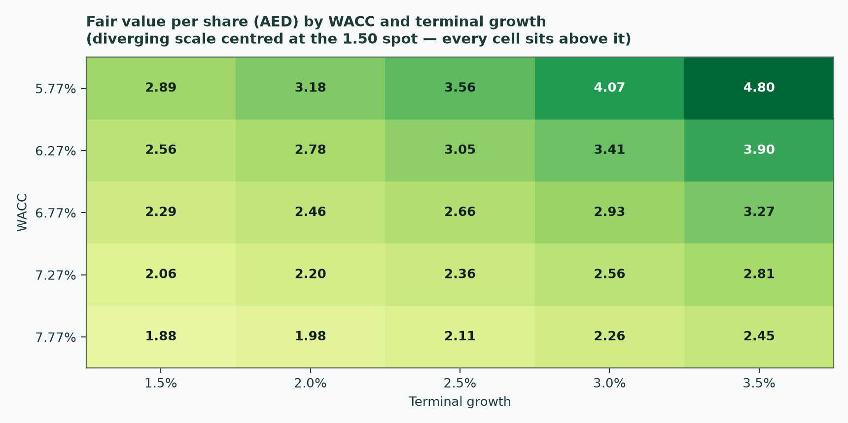
Figure 4 — fair value per share against cost of capital and terminal growth; the crux grid alongside.
Fair value at 9% (AED/share) | g = 1.5% | g = 2.0% | g = 2.5% | g = 3.0% | g = 3.5%
Cost of capital 5.77% | 2.889 | 3.178 | 3.555 | 4.067 | 4.804
Cost of capital 6.27% | 2.557 | 2.775 | 3.051 | 3.410 | 3.898
Cost of capital 6.77% (base) | 2.287 | 2.456 | 2.664 | 2.927 | 3.269
Cost of capital 7.27% | 2.065 | 2.198 | 2.359 | 2.557 | 2.807
Cost of capital 7.77% | 1.877 | 1.984 | 2.111 | 2.264 | 2.452

The base cell (2.664) sits at 6.77% and 2.5%. A half-point of discount rate is worth roughly AED 0.346 per share — more than the entire consumption crux — which is the honest hierarchy of what matters in this valuation: rate, tax, tariff, then usage.
Scenario | What is assumed | Fair value (AED/share)
Bear — war re-escalation | usage falls a further 6% in 2027 and never recovers; new connections halve (the pipeline freezes); the 15% minimum tax lands; the cost of equity rises 100bp as the market re-prices UAE risk | 1.737
Base | recovery through 2027, guidance-midpoint connections, both tax framings published | 2.250 / 2.139
Bull — full recovery | usage recovers fully; connections run at the top of guidance (110k RT a year); 9% tax | 2.714

The bear and bull are full model re-runs — unit paths, cost stack, discount rate and tax all moved together — not lens blends or grid look-ups.
2 Technical and price structure
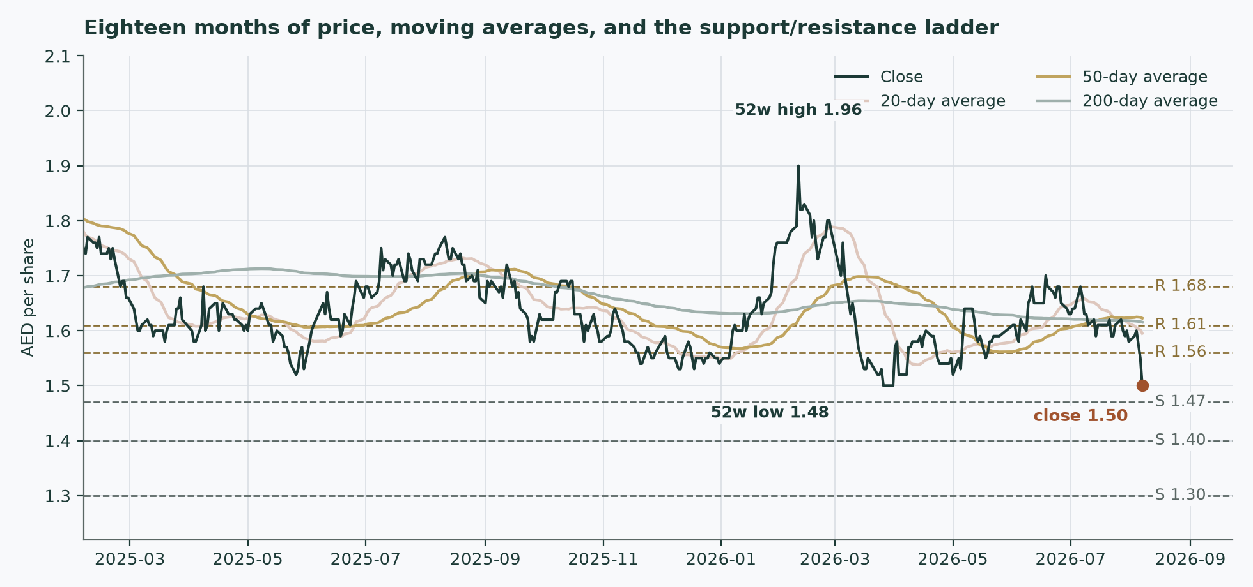
Figure 5 — price against the 20-, 50- and 200-session moving averages, with the support and resistance ladder.
Marker | Level (AED) | Reading
Last close (7 August 2026) | 1.50 | the anchor for everything in this study
20-session average | 1.60 | price is -6.0% against it; the average is falling
50-session average | 1.62 | price is -7.6% against it; flat
200-session average | 1.62 | price is -7.1% against it; flat
Momentum (14-session RSI) | 29 | washed out — a reading under 30 marks the sell-off as stretched by its own recent standards
MACD (12·26·9) | -0.020 | negative and still falling — the down-move has not yet lost momentum
Average true range (14-session) | 2.3% | of price per session — a normal tape, not a dislocated one
52-week range | 1.48 – 1.96 | the close sits 23% below the high and 1% above the low
Resistance | 1.56 / 1.61 / 1.68 | nearest first, from recency-weighted swing clusters
Support | 1.47 / 1.40 / 1.30 | nearest first; the second and third are round-number shelves

The price closed 1.50 below a falling 20-day (1.60), a flat 50-day (1.62) and a flat 200-day (1.62). Momentum is washed out: RSI(14) is ~29 and the daily ATR near 0.03 (~2.3%) points to a normal tape. MACD (12·26·9) is negative and still falling (−0.02 / −0.01 / −0.01). The 50-day crossed above the 200-day 16 sessions ago — a fresh golden-cross, a momentum-regime change rather than noise inside an intact trend. Over the last year it has ranged 1.48–1.96; the last close sits 23% below that high and 1% above that low.
One configuration deserves its own sentence: the 50-session average crossed ABOVE the 200-session 16 sessions ago — a golden cross, conventionally a regime-change signal — and it sits oddly against a price that has since sold off below the whole stack. The cross reflects the spring recovery from the war trough; the sell-off is the August earnings reaction. When a trend signal and the tape disagree this directly, the tape is the fresher fact. A daily close back above 1.56 would clear the nearest resistance and open the 1.68 zone. A close below 1.47 would break the nearest support and open the 1.30 zone.
3 A probabilistic price map
This section answers a different question from the valuation: not what the business is worth, but where the share price could plausibly trade in one and three months given how this share actually moves. Fifty thousand price paths are simulated from a volatility model fitted to the daily trading range, with a fat-tailed shock distribution and a drift anchored to the cost of carry — the local deposit rate less the 5.8% dividend yield, which is why the median path sits a shade below spot. It carries no directional view, and it is never blended with the fair-value work above.
The widths are calibrated rather than assumed, and the evidence is stated plainly. The probability bands are calibrated on the UAE market panel (18 names, walk-forward tested with each forecast made using only data available before it); the panel's forecast accuracy is statistically indistinguishable from — marginally ahead of — a benchmark random walk anchored on the same cost of carry. For Empower itself only 10 non-overlapping three-month windows exist since the late-2022 listing. On those windows every realised outcome fell INSIDE the 80% band, and the centring is clean (the average percentile of the realised outcomes was 0.46, statistically uniform on the standard tests). The bands as published are, if anywhere, conservative — about 28% wider than this stock's own short history would warrant, and that width has a cost: on those same windows the bands scored a few percent behind the benchmark on average sharpness, the price of never missing. A reader should treat the intervals as honest but wide.
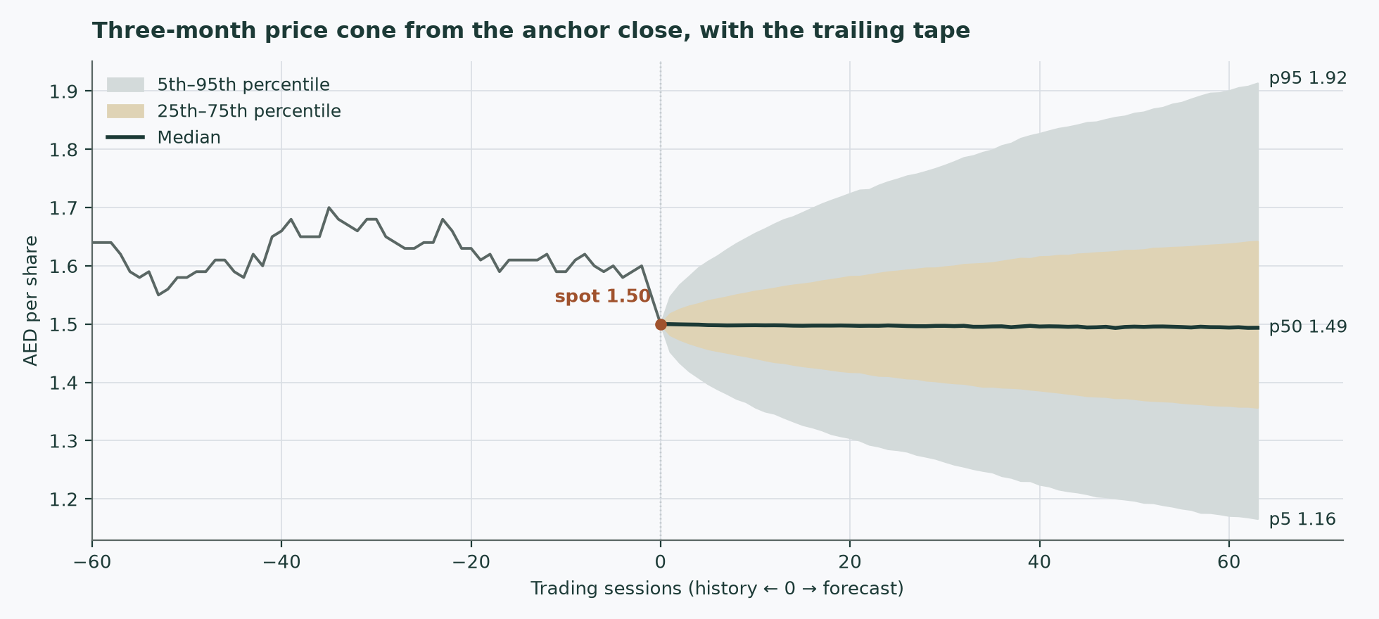
Figure 6 — the forward price cone to three months. The dashed lines mark the fundamental central estimates (2.250 and 2.139); the dotted line is the spot of 1.50.
Percentile map (AED/share)
Horizon | 5th | 25th | Median | 75th | 95th | Probability above spot
1 month (to 2026-09-07) | 1.31 | 1.42 | 1.50 | 1.58 | 1.71 | 49%
3 months (to 2026-11-09) | 1.16 | 1.36 | 1.49 | 1.64 | 1.92 | 49%

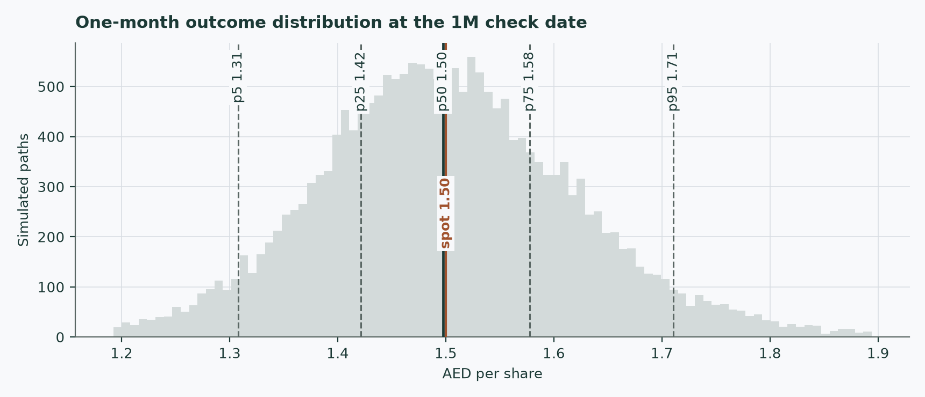
Figure 7 — the one-month price distribution.
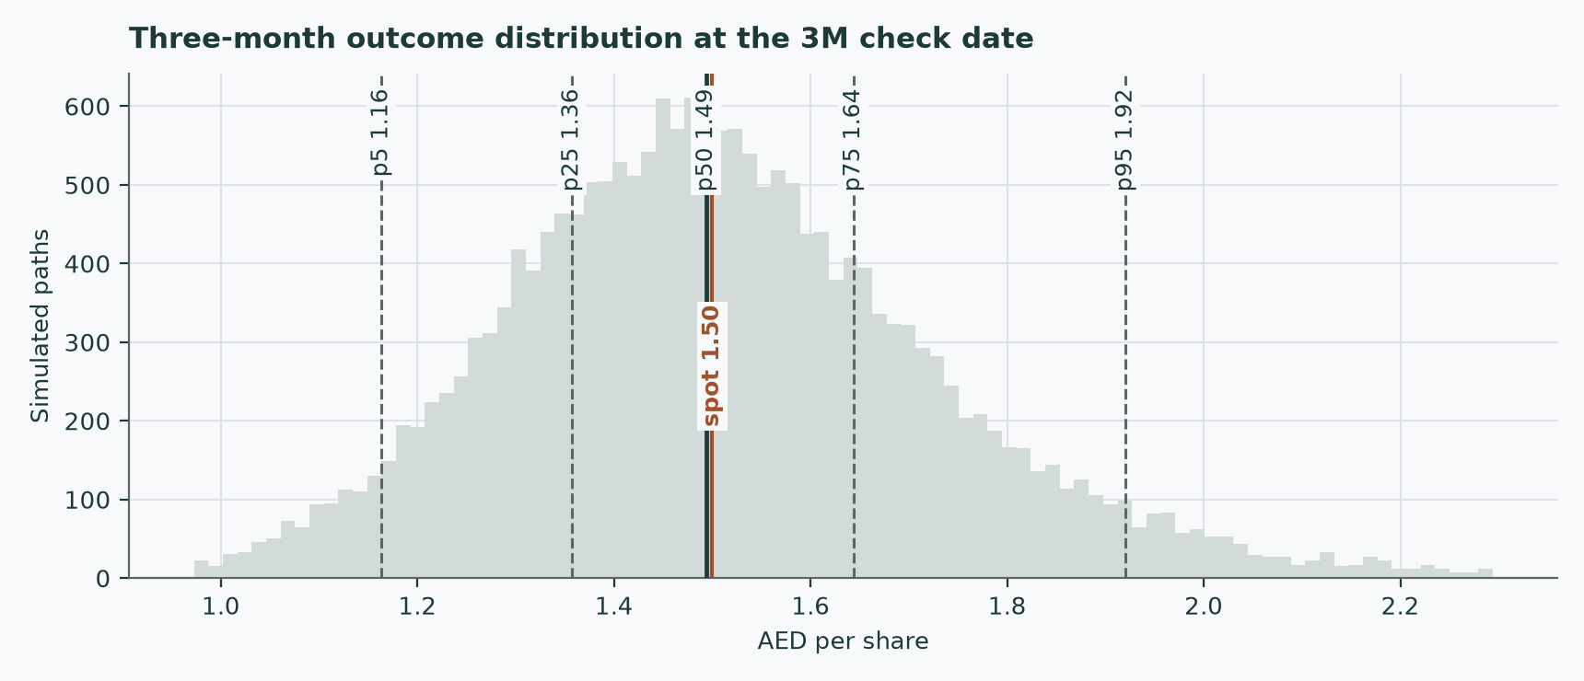
Figure 8 — the three-month price distribution.
Level-touch ladder
Event | 1 month | 3 months
Finishes 10% or more above spot | 11% | 24%
Finishes 10% or more below spot | 10% | 24%
Touches 10% above spot at any point | 18% | 45%
Touches 10% below spot at any point | 16% | 43%

Touch probabilities exceed finish probabilities because a path can visit a level and come back. The anchor volatility is about 32% annualised — elevated for a regulated utility, which is itself a statement about the conflict regime the share is trading in.
4 Comparison of the lenses
Read | What it says | What it assumes
Cash flow (primary) | AED 2.664 / 2.483 by tax framing, +78% / +66% against the market | the tariff stays flat but is not cut; the contracted backlog connects; the crux recovers (and barely matters if it does not)
Weighted central | AED 2.250 / 2.139, +50% / +43% | a fifth of the weight deliberately given to today's war-discounted market regime through the relative lens
Relative multiples | AED 1.536, +2% | the current GCC utility pricing regime is the right regime to capitalise
The market | 1.50 | revealed preference of the marginal seller in a conflict summer, after a weak volume quarter
DEWA control purchase (reference) | AED 2.16, +44% above spot | what the controlling shareholder paid a related party for control economics in February — bounds the question from above, proves nothing about minority value
Three-month price map | median 1.49, 49% chance of finishing above spot | volatility persists as it has; no view on value

The reading we take from this: the market is pricing the consumption shock as if it were a structural impairment of the profit pool, and the cash-flow arithmetic says it is not — the pool sits in the contracted capacity charge, which grew through the war half. The genuine open questions are the ones the market prices less visibly: whether the 15% minimum tax reaches the company (0.181 per share, published as its own column), and whether the regulator's next tariff review stays flat (not priced — flagged as the model's single most valuable assumption). Between the 2.139 central under the harsher tax framing and the 1.50 market price lies the war discount itself; a reader who expects the conflict regime to persist should weight the relative lens harder, and the field published here lets them.
No rating and no price target is expressed here or anywhere else in this document. The output is a range and a distribution.
5 Catalysts to watch
Catalyst | Why it matters | What to watch
Truce durability | the whole 2026 demand shock transmits through hospitality occupancy; re-escalation onto UAE soil is the bear case, de-escalation unwinds the market's regime discount | incident tempo against the April ceasefire framework; any strike on Dubai infrastructure
Third-quarter 2026 results (November) | the first FULL summer quarter carrying the consumption shock — the highest-usage months of the year | equivalent full-load hours against the 698-hour first-half print; whether capacity revenue keeps growing through it
October dividend instalment | half the committed AED 875mn; the payout is covered almost exactly, so any hesitation is information | confirmation of the instalment and any wording change on the 2027 policy
Minimum-tax clarification | whether DEWA-group consolidation sweeps Empower into the 15% regime — worth AED 0.181 per share on the primary lens, published here as its own column | Ministry of Finance guidance on domestic minimum top-up tax scope for government-group entities; the tax note of the 2026 annual filing
Connection pace | the volume driver: guidance is 100–110k RT of 2026 connections against a 311k RT contracted backlog | connected and contracted capacity in each results deck; the fifth Business Bay plant award moving to construction
The 2027 tariff round | the flat regulated tariff is the single most valuable assumption in the model; a cut at review would do what no consumption shock can | any Regulatory and Supervisory Bureau consultation or Executive Council resolution touching district-cooling tariffs
DEWA's intentions at 80% | further buy-in or squeeze-out speculation is NOT modelled; what is real today is a thinner float, index-weight mechanics and reduced liquidity | any disclosure of stake changes; index-provider treatment of the reduced float

6 Reading the probability zones
The three-month distribution has a median of 1.49 and a 5th-to-95th span of 1.16 to 1.92. Read the span honestly: the model considers a -22% move and a +28% move equally unremarkable tail outcomes over a single quarter of a conflict-regime tape.
Zone | Three-month range (AED) | How to read it
Lower tail | below 1.16 | a 1-in-20 outcome; would need a genuine shock — re-escalation onto UAE soil, a tariff-review surprise, or a dividend wobble
Lower half of the central band | 1.36 – 1.49 | ordinary drift lower; the market continuing to price the war regime
Upper half of the central band | 1.49 – 1.64 | ordinary drift higher; a quiet summer and the October instalment arriving on schedule
Upper tail | above 1.92 | a 1-in-20 outcome; would need visible de-escalation or a re-rating of the sector
Where the fundamental centrals sit | 2.139 / 2.250 | BOTH tax framings sit above even the 95th percentile (1.92) of the three-month distribution — the price map and the valuation genuinely disagree, and stating that gap at its full size is the point: nothing in the volatility structure suggests the gap closes within a quarter

7 Caveats and what would change our mind
- Consumption failing to recover in the 2027 prints. The base case restores usage per connected ton to the 2025 level through 2027. The full never-recovers model costs only 2.7% on the primary lens, so this is a watch-item rather than a value risk — but two consecutive halves with equivalent full-load hours below the 2026 trough would put the shock outside anything hospitality-linked, and the recovery assumption should then be abandoned, not stretched.
- The minimum tax being confirmed. If the 15% domestic minimum top-up tax is confirmed to reach Empower through DEWA-group consolidation, shift weight to the 15% column published throughout — the work is already done; nothing needs re-estimating.
- War re-escalation onto UAE soil. The bear machinery is explicit: usage down a further 6% and never recovering, connections halved, the harsher tax, and 100bp on the cost of equity — AED 1.737 per share. A reader can adopt it wholesale rather than improvising a discount.
- A tariff cut at a regulatory review. The flat regulated tariff is the single most valuable assumption in the model — it underwrites the capacity charge that carries 80.8% of the enterprise value into the terminal. No cut occurred in the 2024–26 record swept here, but the model contains no machinery for one, deliberately: it would be a regime change, to be re-modelled, not sensitised.
- Construction limitations, stated. The sovereign anchor is a 4.4-year bond against five-plus years of cash flows (the longest AED print available); the index series behind the beta regression is an aggregator pull with roughly a fifth of sessions missing, absorbed by weekly sampling and flagged in the bibliography; and the first-half revenue-mix percentages (40/49/11) come from the investor deck, not the audited notes — the audited statements disclose only the consumption figure, in the auditor's key-audit-matter section.
- Related-party concentration. The 80% owner is also the sole supplier of the largest cost line and the counterparty of the 2026 control transaction. Tariff bargaining, input pricing and any future buy-in all run through one related party. This is a governance fact, not an allegation, and it is one reason the relative lens and the scenario field are published alongside the model rather than folded into it.
- What would change our mind, specifically. Upward: visible de-escalation; the minimum-tax question resolving at 9%; connections printing at or above the top of guidance. Downward: a tariff-review consultation proposing cuts; equivalent full-load hours below the 2026 trough for two consecutive halves; the dividend reset below the committed AED 875mn.

Appendix A Financial statements
A.1 Income statement — three years audited and five years forecast (consolidated, AED mn)
AED mn | FY2023 | FY2024 | FY2025 | FY26 | FY27 | FY28 | FY29 | FY30
Revenue | 3,035 | 3,260 | 3,419 | 3,503 | 3,842 | 4,042 | 4,222 | 4,380
Interest income on the concession receivable | 39 | 59 | 58 | 57 | 55 | 53 | 52 | 50
Cost of sales | (1,741) | (1,917) | (1,989) | — | — | — | — | —
Gross profit | 1,333 | 1,402 | 1,488 | — | — | — | — | —
General and administrative expenses | (220) | (235) | (247) | — | — | — | — | —
Operating profit | 1,120 | 1,192 | 1,273 | — | — | — | — | —
EBITDA (derived: operating profit + D&A) | 1,468 | 1,552 | 1,642 | 1,702 | 1,843 | 1,945 | 2,034 | 2,112
EBITDA margin | 48.4% | 47.6% | 48.0% | 48.6% | 48.0% | 48.1% | 48.2% | 48.2%
Depreciation and amortisation | (348) | (359) | (370) | (380) | (390) | (399) | (405) | (408)
EBIT (forecast basis) | — | — | — | 1,323 | 1,452 | 1,545 | 1,629 | 1,703
NOPAT at 9% / at 15% | — | — | — | 1,204 / 1,124 | 1,322 / 1,234 | 1,406 / 1,314 | 1,483 / 1,385 | 1,550 / 1,448
Profit before tax | 943 | 998 | 1,103 | — | — | — | — | —
Income tax (credit) / expense | 17 | (90) | (99) | — | — | — | — | —
Profit for the year | 960 | 908 | 1,004 | — | — | — | — | —
Attributable to shareholders | 953 | 897 | 993 | — | — | — | — | —
Earnings per share (AED, derived) | 0.095 | 0.090 | 0.099 | — | — | — | — | —

Every FY2023-25 line is taken directly from the company's audited consolidated statements (the 2023 income-statement figure of interest income on the airport concession receivable is presented INSIDE gross profit by the company, and the same presentation is kept here). EBITDA is a house derivation — operating profit plus depreciation and amortisation — labelled as such; the audited statements contain no EBITDA line. The 2023 tax line is a CREDIT (first recognition of deferred tax assets ahead of UAE corporate tax). Forecast financing, tax and attributable lines are shown only where the model constructs them; the free-cash-flow waterfall in section 1.1 is a pre-financing measure by construction.
A.2 Balance sheet — condensed house layout (consolidated, AED mn)
AED mn | FY2023 | FY2024 | FY2025 | 30-Jun-2026
Property, plant and equipment | 6,935 | 6,995 | 7,195 | 7,275
Intangible assets | 340 | 328 | 316 | 310
Airport-concession receivable (amortised cost, non-current) | 19 | 1,305 | 21 | 21
Investment properties | 86 | 118 | 171 | 169
Inventories | 44 | 54 | 56 | 57
Trade and other receivables | 319 | 275 | 304 | 434
Term deposits | 28 | 30 | 58 | 40
Cash and cash equivalents | 539 | 1,937 | 2,256 | 2,472
Total assets | 9,728 | 11,183 | 11,817 | 12,267
Bank borrowings (current + non-current) | 4,492 | 5,498 | 5,503 | 5,503
Lease liabilities | 4 | 6 | 2 | 1
Trade and other payables | 1,403 | 1,678 | 2,165 | 2,459
Total liabilities | 6,417 | 7,810 | 8,320 | 8,739
Equity attributable to shareholders | 3,144 | 3,198 | 3,311 | 3,338
Non-controlling interests | 167 | 176 | 186 | 191
Total equity | 3,311 | 3,373 | 3,497 | 3,528
Net debt (borrowings + leases − cash − deposits) | 3,930 | 3,537 | 3,192 | 2,991

FY2023, FY2024 and FY2025 are audited; the June-2026 column is the reviewed interim. The net-debt row reproduces the company's own presented figure at 30 June 2026 (2,991mn) exactly. The 2023 step-up in borrowings funded the airport-concession acquisition; the 2024-25 rise in cash is retained operating cash ahead of the October dividend instalments.
A.3 Forecast balance-sheet and cash-flow markers
AED mn | FY26 | FY27 | FY28 | FY29 | FY30
Property, plant and equipment | 7,404 | 7,579 | 7,698 | 7,763 | 7,777
Net working capital (negative = funded by customers/payables) | (1,800) | (1,974) | (2,077) | (2,169) | (2,250)
Working capital released in the year | 43 | 174 | 103 | 92 | 81
Capital expenditure | (571) | (548) | (501) | (453) | (404)
Depreciation and amortisation | 380 | 390 | 399 | 405 | 408
Free cash flow to the firm at 9% | 1,055 | 1,338 | 1,408 | 1,527 | 1,636
Free cash flow to the firm at 15% | 976 | 1,251 | 1,315 | 1,429 | 1,533
Dividends (committed policy held flat) | 875 | 875 | 875 | 875 | 875

Two features to read carefully. Net working capital is negative and grows more negative with revenue — customer deposits and payables to the related-party supplier fund the cycle, so each year RELEASES cash into the free-cash-flow line. And free cash flow to equity — the firm figure less roughly AED 154mn of after-tax net finance cost — runs almost exactly at the AED 875mn payout in the shock year: the dividend is covered, with the growth funded by the working-capital release and the revolving facilities' headroom. Net borrowings are held flat by construction; the model neither assumes deleveraging credit nor new debt-funded expansion.
Appendix B Peer frame, risk register — and the research register
B.1 Peers and the sector frame
Measure | Empower | Tabreed | DEWA (parent)
What it is | Dubai district cooling, about 80% of the emirate | UAE-wide and regional district cooling; the only listed pure peer | the Dubai power and water monopoly; consolidates Empower
2025 revenue (AED mn) | 3,419 | 2,460 | —
2025 EBITDA margin | 48.0% | 51.6% | —
Net debt / EBITDA | 1.8× | 4.6× | —
Trailing price / earnings | 15.1× | 16.6× | 16.8×
Dividend yield | 5.8% | 4.8% | 4.4-5.0%
Source and date | this study, audited statements and the 7-Aug-2026 close | FY2025 results via exchange disclosures; market value from a data provider dated 22-Jun-2026; multiples derived and flagged as derived | market data as of early Aug-2026; secondary marker only — the parent consolidates the subject

Emicool, the third Dubai operator, is private (a Dubai Investments / Actis joint venture) and provides no usable multiple; no listed peer exists for the airport-concession leg. The leverage gap is the reason the peer comparison is made at the enterprise line: Tabreed carries several turns more net debt, so raw price/earnings comparisons flatter the wrong name.
B.2 Risk register
Risk | Mechanism | Where it is priced
Tariff review | the regulator approves tariffs; a cut would reprice the capacity charge — the profit pool itself | NOT priced — flagged as the model's single most valuable assumption (sections 1.7 and 7); a cut is a regime change requiring a re-model
War re-escalation | hospitality occupancy → consumption; risk premium → discount rate; connection pipeline → volumes | the bear scenario, AED 1.737 per share, is a full re-run with all four channels moved together
Minimum top-up tax | consolidation into the DEWA group could lift the rate from 9% to 15% | published as a full second column everywhere: 0.181 per share on the primary lens
Consumption persistence | usage per connected ton stays at the shocked level | a full alternative model: 2.7% on the primary lens — small, because of the pass-through (section 1.7)
Related-party concentration | the controlling shareholder is also the sole input supplier and the tariff counterweight | a governance fact discussed in section 7; one reason the relative lens keeps weight
Float and liquidity | free float near a fifth after the February control purchase; index treatment and exit liquidity are thinner | not separately priced; noted as a reason market-price signals are noisier than usual
Data limitations | a 4.4-year sovereign anchor against longer cash flows; an index series with missing sessions behind the beta; deck-sourced revenue-mix percentages | each flagged in place (section 1.8, section 7) and recorded in the bibliography

B.3 The research register — the sources this study stands on
Research proceeded from the company's own filings outward: audited statements first, then the interim record, the investor-relations material, the regulator, the sovereign data and the market. The main sources, dated, are tabulated below; the companion bibliography document records every input's value, source and date individually, together with the searches that returned nothing.
Source | Type | Date | What was taken
Audited consolidated financial statements, FY2022–FY2025 (PwC, unqualified) | Company filing | 2023–Feb-2026 | the full income statement, balance sheet and cash-flow record; revenue and cost notes; borrowings and refinancing notes; related-party purchases; the capitalisation rate; consumption revenue via the auditor's key-audit-matter sections
Condensed interim financial statements, Q1-2026 and H1-2026 (limited review) | Company filing | May / Aug 2026 | the study-year actuals: quarterly revenue, profit, the June-2026 balance sheet, and the note tying the consumption fall partly to conflict-hit hospitality occupancy
H1-2026 earnings presentation | Company investor relations | 5-Aug-2026 | connected and contracted capacity, connection guidance, equivalent full-load hours, the revenue mix, net debt as presented, and the dividend commitment
Dubai Executive Council Resolution 6/2021; Regulatory and Supervisory Bureau instruments | Regulator | 2021–2025 | the tariff-regulation frame behind the flat-tariff assumption
UAE Ministry of Finance dirham T-Bond auction result | Sovereign data | 30-Jul-2026 | the risk-free anchor
Published country-risk dataset (July-2026 edition) | Reference dataset | 1-Jul-2026 | the UAE default spreads and equity risk premia on both bases
DFM daily price history for EMPOWER (supplied) and a DFM General Index series | Market data | to 7-Aug-2026 | the anchor price, volatility, the moving-average structure, the beta regression and the price distributions
Tabreed and DEWA results and market data | Peer disclosures / market data | Jun–Aug 2026 | the relative-multiples lens — cross-check only, never a source for Empower's own numbers
Wire and reference coverage of the 2026 conflict and ceasefire | Press | to 9-Aug-2026 | the macro timeline; where sources disagreed on the truce status, both readings were recorded rather than resolved

Appendix C The expert valuation panel
Three valuation approaches are run against the same disclosed facts by three notional experts, each committed to a different method, each showing every intermediate line, and each required to state in advance what would prove them wrong. They are not asked to agree, and they do not.
C.1 Expert 1 (infrastructure cash flow) — the contracted asset base, discounted
Worldview: a regulated utility with contracted revenue is the one class of business a discounted-cash-flow model prices well — the cash flows are visible, the regulator caps the upside, and the right answer is the present value of the contract stack. When it works: precisely here. When it fails: when the terminal assumptions smuggle in more value than the explicit years justify — which is why every terminal choice below is shown and challenged in C.4.
Step (base case, 9% tax, AED mn) | FY26 | FY27 | FY28 | FY29 | FY30
Revenue | 3,503 | 3,842 | 4,042 | 4,222 | 4,380
EBITDA | 1,702 | 1,843 | 1,945 | 2,034 | 2,112
EBIT | 1,323 | 1,452 | 1,545 | 1,629 | 1,703
NOPAT | 1,204 | 1,322 | 1,406 | 1,483 | 1,550
Free cash flow to the firm | 1,055 | 1,338 | 1,408 | 1,527 | 1,636
Present value | 988 | 1,174 | 1,157 | 1,175 | 1,179

Terminal block and bridge | Value
Sum of the five present values (AED mn) | 5,673
Terminal value — final NOPAT × (1 + 2.5%) × (1 − 10.8%) ÷ (6.77% − 2.5%) | 33,227
Present value of the terminal value (AED mn) | 23,950
Enterprise value (AED mn) | 29,623
Less net debt; plus investment properties and fair-value assets; less minorities (1.1% of profits) | (2,991) / 297 / (285)
Equity attributable (AED mn) | 26,643
Fair value per share (AED) | 2.664
Range — the consumption-grid endpoints, each carrying half the effect of a ±50bp move in the cost of capital | 2.40 – 2.90

Named sensitivity: the consumption-recovery grid of section 1.7 — the full span from never-recovers to overshoot is worth AED 0.153 per share, while a half-point of discount rate is worth about AED 0.346. My valuation is a discount-rate argument first and a volume argument barely at all.
Falsifier, stated in advance: two consecutive half-years with equivalent full-load hours below the 2026 trough. That would mean the demand loss is structural, not hospitality-linked, and the recovery leg of my base case should be discarded rather than delayed.
C.2 Expert 2 (income) — the committed dividend, capitalised
Worldview: for a minority shareholder in a company controlled at 80% by its own supplier, the only cash flow that is real is the one that arrives — the dividend. Value the commitment, check its coverage, and treat everything else as the controller's business. When it works: income-controlled utilities exactly like this. When it fails: when the payout is about to change in either direction — a committed dividend is a floor and a ceiling only until it is not.
Step | Value
Committed distribution (AED mn a year, 2025 and 2026) | 875
Per share (AED) | 0.087
Grown at 2.5% and capitalised at the 7.22% cost of equity | × 1.025 ÷ (7.22% − 2.5%)
Fair value per share (AED) | 1.899
Range — growth 2.0% to 3.0% | 1.71 – 2.13

Coverage is the whole argument, so here it is, line by line:
AED mn | FY26 | FY27 | FY28 | FY29 | FY30
Free cash flow to the firm (9%) | 1,055 | 1,338 | 1,408 | 1,527 | 1,636
Less after-tax net finance cost (held at the 2025 level — the book is floating and was just refinanced) | (154) | (154) | (154) | (154) | (154)
Free cash flow to equity | 901 | 1,184 | 1,254 | 1,373 | 1,481
Dividend | 875 | 875 | 875 | 875 | 875
Coverage | 1.03× | 1.35× | 1.43× | 1.57× | 1.69×

In the shock year coverage is almost exactly one — the payout absorbs essentially all the equity cash flow, and the growth is funded by the working-capital release and the revolving facilities' headroom. That is covered, not slack, and it is why my number sits below the cash-flow expert's: I pay for the distribution I can see, not the terminal value I cannot.
Named sensitivity: each half-point of assumed growth is worth roughly AED 0.213 per share across my range — the entire argument is the capitalisation rate against the growth of a committed number.
Falsifier, stated in advance: a dividend reset below the committed level, or a payout financed by facility drawdown for two consecutive periods. Either breaks the premise that the distribution is an economic signal rather than a promise.
C.3 Expert 3 (relative value, the sceptic) — anchor on what is actually paid
Worldview: models are opinions; transactions are facts. Anchor on what the market pays for the same economics today, use the harsher of any contested framing, and treat every model premium over the market as a claim requiring extraordinary evidence. When it works: regimes, like this one, where the marginal price-setter is distressed or absent and model values float free of clearing prices. When it fails: when the anchor set is itself mispriced — a war-discounted peer group imports the war.
Step | Value
Tabreed enterprise value / EBITDA (derived, flagged) | 10.7×
× Empower 2026E EBITDA (AED mn) | 1,702
Implied enterprise value (AED mn) | 18,216
Less net debt; plus side pockets; less minorities — per share (AED) | 1.536
Tabreed price/earnings 16.6× on 2026E attributable profit (1,025 AED mn) — per share (AED) | 1.701
The February control print — what the controller itself paid a related party | 2.16
My tax base: the 15% minimum-tax column, on prudence | 2.483 on the cash-flow model — noted, not adopted
Range — from the market price to the control print | 1.50 – 2.16
Central — the earnings-basis read | 1.70

Named sensitivity: each turn of the peer earnings multiple is worth AED 0.102 per share. My range's top is not a multiple at all — it is the one disclosed transaction (2.16), and I note that a control price paid between related parties bounds the question from above without proving anything about what a minority share is worth.
Falsifier, stated in advance: a GCC utility re-rating — Tabreed sustained above thirteen times enterprise value to EBITDA — without Empower following. That would show the discount is company-specific rather than regime-wide, and my regime-anchored central should be abandoned.
C.4 Cross-examination
Challenge | From | Response
"81% of your enterprise value is terminal, earning a 23% return on capital forever — at a REGULATED utility. The regulator exists to take that return away." | Expert 3 to Expert 1 | Rejected in part, conceded in part. The measured return is inflated by the funding model, not by tariff generosity: customers' deposits and payables hold working capital negative, so the capital base the return is struck on is artificially small — the same tariff on a conventionally funded balance sheet would show an ordinary return, and the regulator prices the tariff, not the ratio. CONCEDED: the tariff-review risk is real, it is the one lever that reaches the capacity charge, and it deserves exactly the bear-case weight it gets.
"You are capitalising a promise. The committed dividend runs to 2026 only, and your coverage table shows it absorbing all the equity cash flow in the shock year." | Expert 1 to Expert 2 | Partly conceded. The commitment is two years old and covered at one times, not slack. But the counterparty is the 80% owner, which collects four-fifths of every instalment itself and set the policy — the incentive alignment is unusually direct, and the distribution record since listing has only stepped up.
"Your anchors are war prices. You are not measuring Empower; you are measuring March." | Expert 2 to Expert 3 | Conceded, and embraced. That is what a relative lens is FOR — it prices the regime the shares must actually be sold into. The mistake would be presenting it as intrinsic; nobody here does. My range top is a real transaction, not a war print.
"All three of you assume the tariff stays flat." | The panel to itself | Accepted as the shared, unpriced assumption — stated in sections 1.7, 5 and 7. A tariff cut would move every method in the same direction at once, which is exactly why it is flagged rather than diversified away.

C.5 The three in one room
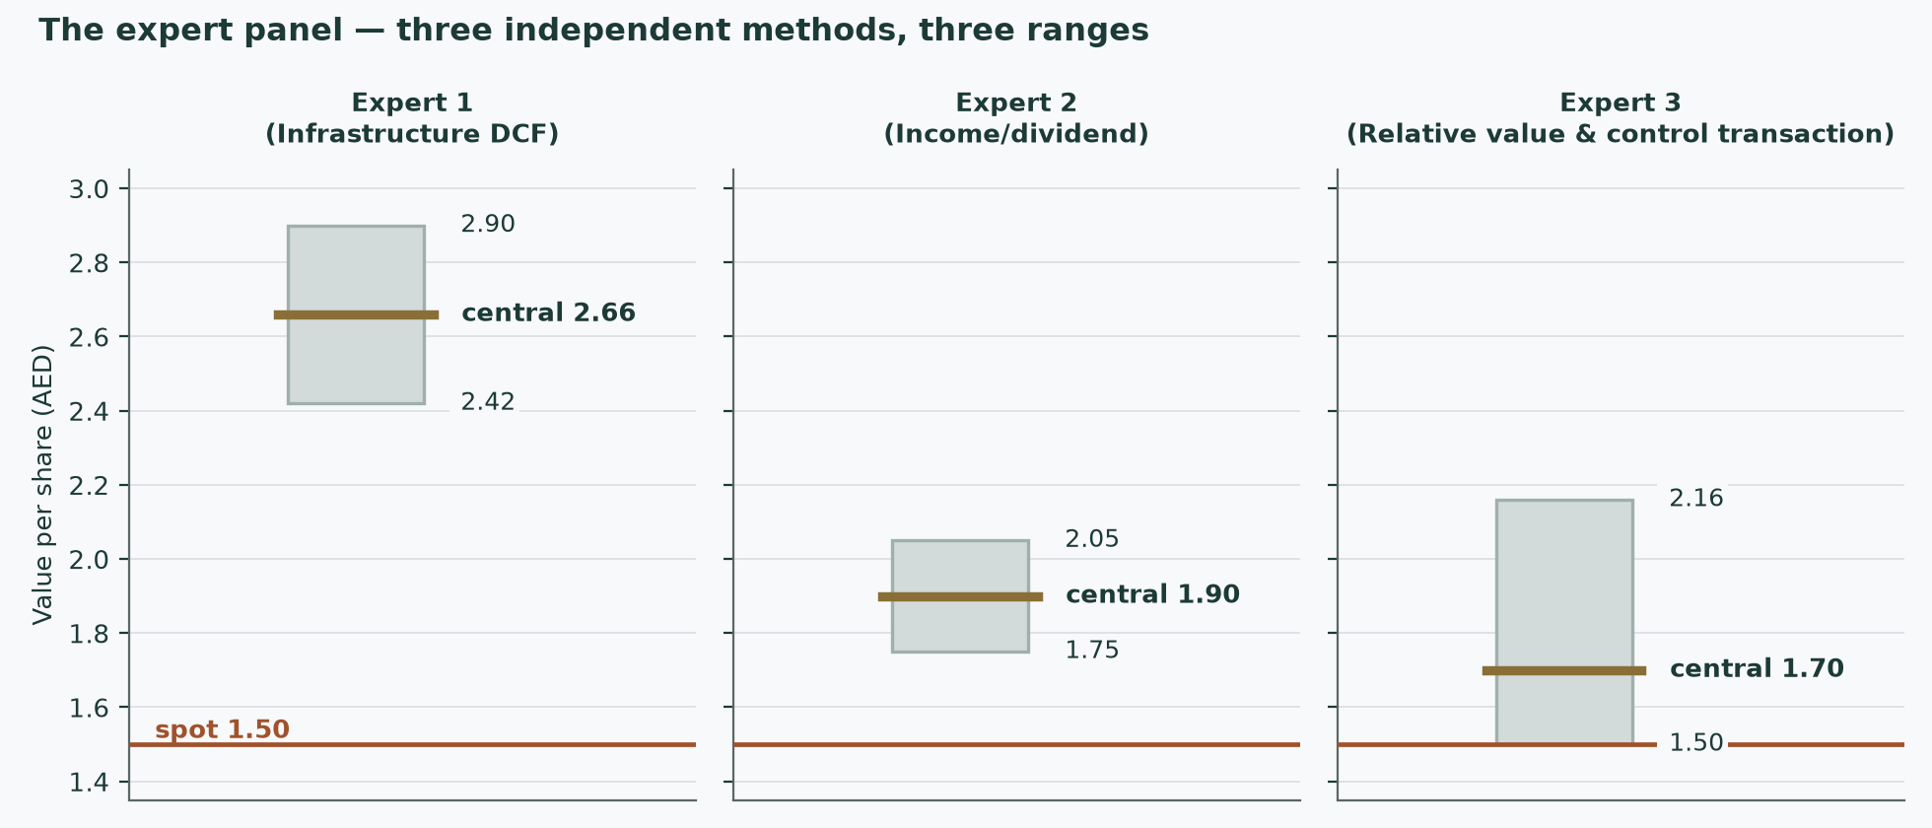
Figure 9 — the three experts' ranges against the market price of 1.50 and the control print of 2.16.
The panel spans AED 1.50 to 2.90 — and the disagreement is orderly, not noisy. Expert 1 discounts the contract stack and lands highest (2.40–2.90); Expert 2 capitalises the committed dividend and lands in the middle (1.71–2.13); Expert 3 anchors on what the war-discounted market actually pays and lands lowest (1.50–2.16, central 1.70). Notice what the room agrees on: every range sits at or above the market price, every method finds the capacity charge rather than the meter carrying the value, and every falsifier is observable within two reporting periods. The study's own weighted central (2.250 / 2.139 by tax framing) sits between Expert 1 and Expert 2 — which is what a weighting that gives the market regime a real vote should produce.
C.6 Reading the divergence
Assumption | Expert 1 | Expert 2 | Expert 3 | What it is worth
Tax basis | 9% (audited rate) | embedded in the payout | 15% on prudence | AED 0.181 per share on the cash-flow model — the gap between the two published columns
Terminal claim | full terminal value (81% of enterprise value) | a perpetuity of the committed dividend only | none — the current multiple regime is assumed permanent | AED 0.963 per share between Expert 1's central and Expert 3's — the largest single gap in the room
Consumption recovery | recovers through 2027; grid shown | not sensitive — the dividend is fixed either way | embedded in the peer prices | AED 0.071 per share even in the never-recovers case — small by construction (the pass-through)
Risk premium | model-built cost of equity from the sovereign and the published premium | the same 7.22% rate, applied to a committed flow | whatever the market embeds — the war discount is kept, not modelled out | the half-point grid: AED 0.346 per share per 50bp

The instruction to the reader is not to average the three. It is to decide which premise you hold — whether the terminal claim of a regulated monopoly is bankable, whether a committed dividend is a floor, whether today's regime prices are the right anchor — and use the corresponding number. The disagreement is a map of what you need a view on.
About this series
This series publishes independent, educational valuation studies of listed companies. Each study is built from disclosed financial statements and named market data, states its assumptions explicitly, computes every figure in an auditable model rather than in prose, and publishes the ranges its assumptions produce. Studies never carry a rating or a price target. Where a figure is estimated rather than disclosed, it is labelled. Where a source could not be reached or a disclosure does not exist, the gap is recorded in the accompanying bibliography rather than quietly filled in.
The probabilistic price map in section 3 is produced by a volatility model that is tested by walk-forward simulation against a carry-anchored random-walk benchmark before it is allowed to publish a range. It describes price dispersion and carries no view on value. It is never combined with the fair-value work.
Disclosure & Disclaimer
For information only — not investment advice. This document is educational analysis and is not an offer or a solicitation to buy or sell any security. It contains no recommendation, no rating and no price target. The author holds no position in the security discussed and has no business relationship with the company. Figures are drawn from public sources believed reliable but not independently verified; where figures are derived or estimated this is stated in the text. Valuation is inherently uncertain and depends on assumptions that reasonable analysts will dispute — several such disputes are set out explicitly in this document, and two (the tax framing and the consumption recovery) are published as full alternative computations rather than resolved silently. Past performance and simulated distributions are not guides to future returns. Readers must reach their own conclusions and should consider taking independent advice. No liability is accepted for any loss arising from use of this material.

