Operating card · nine subagents  TESTAHIL Agent Card  Say the task in plain words; the main session routes it to the agent whose description matches, the agent works alone in a fresh context, and its report comes back to you. Name the agent only where a request reads two ways. | stored in .claude/agents/  loaded from main at session start  inspect or edit with /agents

What to say the words in the middle column are what the router matches on
Task | Say this | Agent | What comes back · where it stops
Is the repo clean? | › Run the gates before I commit  › Is the repo clean? | testahil-gate-runner  R-ENF-04 · mirrors CI | One table: gate · population examined · PASS / FAIL / UNRUNNABLE · the command’s own output.  read-only, never fixes
Is a study deliverable? | › Audit the PHDC study  › Is the AMOC study deliverable? | testahil-qc-auditor  R-ENF-02 · R-GAP-01 · depth bar | The filled QC table as QC_GATE_{date}.md, every row naming its artefact, plus one row about the answer against the price.  writes nothing else
The answer looks wrong | › How come ARCC’s fair value is half what it trades at?  › Challenge the ARCC answer | testahil-answer-challenger  R-GAP-01 · R-GAP-02 | Every candidate defect priced as a number, ours hunted before the market’s — the terminal reinvestment identity, capex against the volume it buys.  never edits the study
Sources before drivers | › Run the sweep for ELEC  › Start the information sweep on ELEC | testahil-sweep-researcher  Step 2A · four rings | The study’s sweep.py and sweep_register.json, the company IR attempt logged either way.  stops and asks if official statements cannot be obtained
Fresh prices, covered name | › Roll forward COMI (attach the export)  › Recalibrate and forecast COMI | testahil-rollforward-operator  trigger (b) · R-GRADE-01 | Updated page, ledger, technical read, chart and per-name record; the lifecycle invariant asserted.  never publishes · fair{} untouched
Campaign name | › Run the fundamental walk-forward on AMOC  › Next name in the campaign | testahil-walkforward-runner  R-FCAL-01 · R-GAP-01 · R-MERGE-01 | Training record, rebuilt study, lesson drafts — then the close: PR, merge on green, the gap reported only past 10%.  stops before lessons_add.py for your scope ruling
A rule changes | › Add this rule to the project instructions: …  › Amend [R-CAL-02]: … | testahil-protocol-scribe  R-DOC-01 · R-DOC-02 | Both governing documents amended in one commit, the identifier assigned, both stamps bumped, the gates green.  hands you the full digest text to paste
A critique arrives | › Here is a critique of the ADNOCLS study — respond  › Approved: implement rows CC-5, CW-20 | testahil-critique-responder  Critique_Response v2 · R-GAP-01 | Every finding on its own row, priced before it is judged, receipts on every rejection.  stops at the report; implements only on your approval
Composite-beta backlog | › Re-issue the beta on SCEM  › Clear the next name in the beta backlog | testahil-beta-reissuer  R-BETA-04 · R-IDX-01 · R-GAP-01 | Before and after: regressor, beta, R², tier, Ke, WACC, each lens, the weighted centre.  stops if v2 sovereign inputs can’t be sourced live
How a prompt travels, and where each agent sits
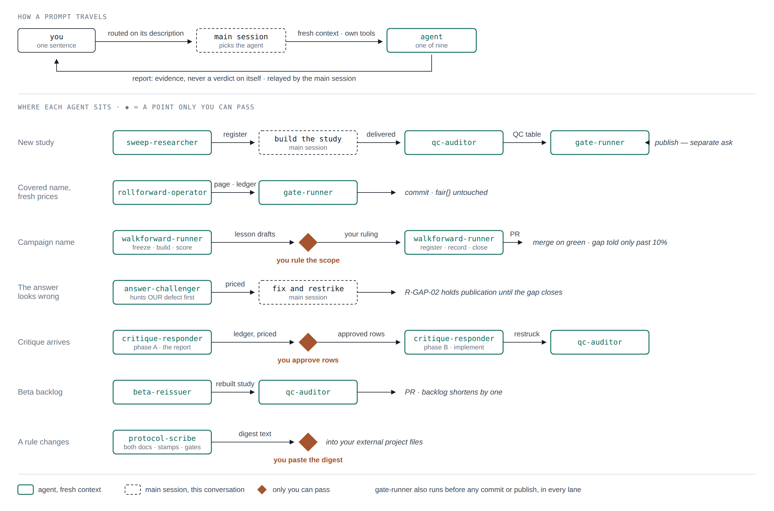
Every prompt goes through the main session to one agent, which works alone and hands back evidence. The seven lanes show what each agent passes to the next step, and the three diamonds mark the points only you can pass: ruling on a lesson’s scope, approving a critique response, and pasting the digest into your own project files.
Name the agent when a request could read two ways. Fresh OHLC for a ticker has the same input shape as a new study — say “roll forward”. “Check the study” splits two ways: repo gates is gate-runner, a delivered study is qc-auditor.
Three routes. Plain ask is the default and the description does the routing; name the agent when it could go two ways; /agents lists, inspects or edits a definition, and never runs one.
What all nine share. They read the live state rather than a remembered number, declare what they examined, report evidence rather than verdicts, and never publish on their own.

