Testahil · Independent Valuation Study Educational analysis · not investment advice

Egyptian International Pharmaceutical Industries Company (EIPICO)
Independent valuation study · The Egyptian Exchange · ticker PHAR · Egyptian pounds
Prepared 10 September 2026 · share price EGP 127.30 at the close of 3 September 2026 · 168.756 million shares in issue
Read first
PRICE DATE 3 September 2026 — the latest known close, the price this valuation is measured against. ISSUE DATE 10 September 2026 — the day this edition was issued. A recalibration issues a new document carrying its own issue date; the two dates are stated separately because they are not the same fact.
What this is. An independent, educational valuation of a listed Egyptian pharmaceutical manufacturer, built from the company's own audited financial statements. It contains no rating, no recommendation and no price target. It expresses value as a RANGE and, separately, as a probability distribution.
What it is built on. Four consecutive years of audited consolidated financial statements — FY2022 through FY2025 — with the auditor's report and full notes, together with the board of directors' own operating statistics and the company's investor presentation. Every historical figure in this study traces to one of those documents. No data vendor, broker note or press report is used to build any number about the company itself.
The one number to hold on to. There is no single number, and that is deliberate. Five readings put fair value between EGP 62 and EGP 122 a share. Because the contested judgement below is carried BOTH ways and the two are never averaged, the study publishes TWO weighted centres: EGP 101.42 a share on the permanent-provision reading and EGP 121.61 on the normalising one. The market price is EGP 127.30. That gap is the study, and section 1.7 states exactly what would have to be true for the market to be right.
What this study deliberately does NOT do. It does not put a revenue line on the company's new biologicals plant, because the company has published no volume, price or utilisation guidance for it. It charges the plant's depreciation and its interest, because both follow mechanically from the licence the company obtained in December 2025. Section 1.7 then solves for how much the plant must sell to justify the market price and states that in observable units.
This is the second edition. It folds in the reviewed first quarter of 2026 and the separately issued audited FY2023 and FY2024 statements, obtained after the first issue. The first quarter CONFIRMED the study's central mechanism — the construction balance is transferring and the depreciation charge has more than doubled — but it also came in softer than the first edition assumed on revenue, associates and capital spending. The weighted centre moves from a single EGP 79.64 to a PAIR — EGP 101.42 and EGP 121.61 a share. Section 7 lists what changed and by how much.
The first-quarter review is QUALIFIED. The auditor qualified the conclusion on three matters: the associates' own periodic statements were not received; the active-ingredient company was recognised at cost after loss of control rather than remeasured and equity-accounted; and NO expected-credit-loss charge was recognised in the quarter. The third goes straight to this study's contested judgement and is the reason it is still carried both ways.
The contested judgement is carried both ways. The credit-loss and provision charge is the study's single most consequential contested judgement. It is computed on two frames and both are published side by side, in the summary table, in the body, in the workbook and in an expert's range. They are never averaged into one number — which is why this edition publishes two weighted centres rather than one. The first edition weighted both frames at a quarter each inside a single centre, and weighting both frames inside one number IS averaging them; that centre has been withdrawn.

Headline
EIPICO is Egypt's largest pharmaceutical manufacturer by units and its largest pharmaceutical exporter, and it has just finished building something big. Revenue grew 24.4% in FY2025 to EGP 9,441 million, attributable profit rose 31.6% to EGP 1,442 million, and the shares have roughly doubled this year. The question this study asks is not whether the business is good. It is whether EGP 127.30 a share already pays for a plant that has not yet sold anything.
The company spent the last three years building EIPICO 3, a biologicals and biosimilars facility it describes as the first in Egypt to manufacture from cell culture through to finished product, at a stated cost of USD 100 million. At 31 December 2025 the construction balance stood at EGP 4,901 million — larger than the entire depreciated property base of EGP 3,070 million. The Egyptian Drug Authority licensed it in December 2025. From FY2026 that balance starts depreciating: the charge goes from an audited EGP 117.7 million to EGP 304 million in FY2026E and EGP 446 million at its peak. The finance cost, meanwhile, does NOT rise: the first quarter of 2026 ran at EGP 312.9 million, an annual rate of about EGP 1,251 million against EGP 1,333 million actually borne in FY2025, so the forecast charges LESS interest, not more. The net mechanical change this study carries is therefore EGP 103 million a year of additional pre-tax charge, not the EGP 700 million a first reading of the licensing event suggests. The larger figure would require adding back the EGP 551 million of interest that was being capitalised, and the company's own first quarter says that is not what is happening. Either way the plant contributes no revenue yet.
Against that, four methods that do not depend on the new plant at all — discounted cash flow, run on two framings of the provision charge and so giving five readings in total; book value against sustainable return; triangulated multiples; and normalised earnings power — cluster between EGP 62 and EGP 122. The market is above all of them.
The first quarter of 2026, reviewed and published in May, settles part of that question and sharpens the rest. Fixed assets rose EGP 1,140 million and the construction balance fell EGP 918 million in three months; depreciation and amortisation went to EGP 56.2 million from EGP 26.6 million a year earlier, more than double. The plant is in service and the charge has arrived, exactly as this study said it would. What has not arrived is the revenue: net sales grew 10.1% and attributable profit FELL 10.9% to EGP 284 million.
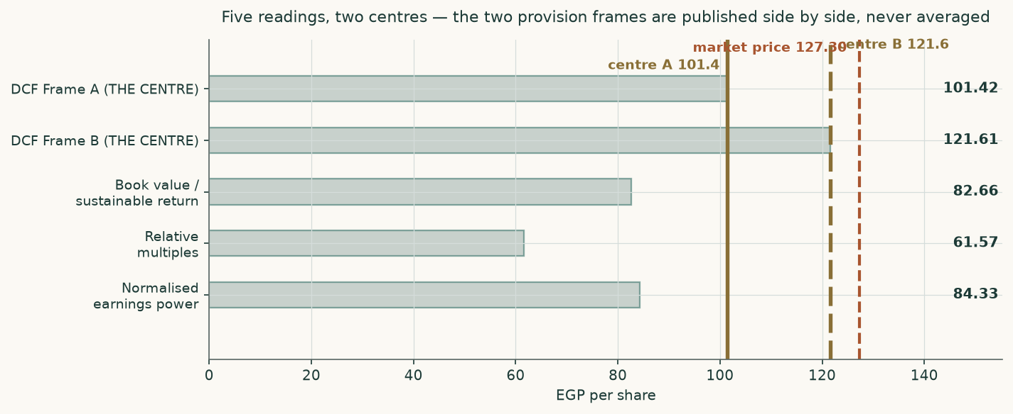
Figure 1 — five readings and TWO centres. The two provision frames are published side by side and are never averaged into one number.
Valuation summary
Reading | EGP / share | vs market | Note
Discounted cash flow — Frame A (THE CENTRE) | 101.42 | -20% | three-year average margin 22.9%
Discounted cash flow — Frame B (THE CENTRE) | 121.61 | -4% | three-year average margin 22.9%
Book value and sustainable return | 82.66 | -35% | justified 2.23x book of EGP 37.00
Relative multiples | 61.57 | -52% | three multiples, each on the earnings of its own period
Normalised earnings power | 84.33 | -34% | three-year average margin 22.9%
CENTRE — Frame A | 101.42 | -20% | The cash-flow read on Frame A, unweighted. The other lenses are published beside it and averaged into none of it
CENTRE — Frame B | 121.61 | -4% | The cash-flow read on Frame B. The two centres are NEVER averaged
Memo — the weighted blend this edition replaced (Frame A / Frame B) | 89.13 / 99.22 |  | Printed so the change is visible. Its weights were never tested out of sample, and on a two-sided answer a blend pulls both frames toward the same three shared readings — damping exactly the disagreement two frames exist to show
Field low to field high | 61.57 – 121.61 |  | The spread between the readings IS the uncertainty
Market price | 127.30 |  | Close of 3 September 2026

Table 1 — the summary valuation table. TWO centres, never one: the contested judgement is carried both ways and weighting both frames inside a single number would average them. Terminal value is stated beside each cash-flow reading on BOTH bases — as a share of the core operating value and of the total, which also carries the associates and the assets held for sale.
Key figures | Value | Key figures | Value
Market capitalisation | EGP 21,483m | Net debt | EGP 7,364m
Enterprise value | EGP 28,851m | FY2025 revenue | EGP 9,441m
FY2025 EBITDA | EGP 2,484m | FY2025 attributable profit | EGP 1,442m
Trailing price / earnings | 14.90x on shares in issue, 14.31x on the FY2025 weighted average | Trailing enterprise value / EBITDA | 11.6x
Cost of equity | 25.92% | Discount rate, first year | 23.04%
Discount rate, terminal | 14.36% | Proposed dividend, FY2025 | EGP 3.50 (2.7% yield)

Table 2 — the figures a reader needs before anything else. Enterprise value uses the post-deconsolidation non-controlling interest of EGP 4.0 million that the valuation bridge uses, so the enterprise value and the multiple beside it are struck on one basis. The audited 31 December 2025 minority of EGP 288.7 million would give EGP 29,136 million instead; the two are not mixed. Two trailing multiples are shown because the share count rose during FY2025 and both readings are legitimate.
Company overview
EIPICO was founded in 1980 in Tenth of Ramadan City with capital of EGP 7 million and began producing in 1985. It is today the largest operating subsidiary of the Arab Company for Drug Industries and Medical Appliances, which holds 51.34% of its shares. The rest of the share list is dominated by medical-profession institutions — an investment company, the professions federation and its pension fund together hold a further 12.02% — with 36.64% in other hands.
The business is a vertically integrated generic and branded pharmaceutical manufacturer. It runs 54 production lines across three plants, produced 2,208 million units in FY2025 against 3,383 million of its own disclosed capacity, and sold 357.3 million packs of 414 registered preparations across 27 therapeutic groups. It employs about 4,981 people. It makes its own primary packaging through a wholly-owned ampoule and vial subsidiary and a plastics factory, which is why the packaging cost line is only partly exposed to imports.
Revenue channel | FY2024 (EGP m) | FY2025 (EGP m) | Growth | Share of FY2025
Direct domestic sales | 1,530 | 1,943 | 27% | 21%
Domestic distributors | 2,664 | 3,591 | 35% | 39%
Government tenders and supply | 634 | 751 | 18% | 8%
Export | 2,500 | 2,967 | 19% | 32%
Contract manufacturing | 36 | 49 | 38% | 1%
Total (company only) | 7,364 | 9,302 | 26% | 100%

Table 3 — the disclosed revenue split, each total SUMMED from its own column. Exports are 32% of the book and are earned in hard currency; the domestic price is set administratively by the Egyptian Drug Authority. The step from this separate-company total to the audited consolidated revenue is the subsidiary's external sales: 1.01 times in FY2025 and 1.03 times in FY2024. The forecast carries the FY2025 reading. Two observations are not a trend, and the FY2024 reading would add about 1.6% to forecast revenue; the range is disclosed rather than the single figure being presented as measured fact.
Two things about this company are unusual enough to change how it must be valued. First, it is nearly currency-neutral on its balance sheet: the audited note shows a net monetary position of minus USD 0.5 million at the year end, against a company that earns USD 60 million of export revenue. It hedges by matching, not by contract. Second, its two equity-accounted associates contributed EGP 512 million in FY2025 — 36% of attributable profit — against a carrying value of only EGP 676 million. Carrying value is not a usable proxy for what that stake is worth, so this study values it on its earnings instead.
1. Fundamental valuation
1.1 The cash-flow model
The company is valued as an operating business: free cash flow to the firm over five explicit years, discounted on a rate that glides from today's cost of capital to a normalised one, plus a terminal value. Frame A of the contested provision judgement is shown here in full; Frame B differs only in that one line and is carried through to its own value per share.
EGP million | FY2026E | FY2027E | FY2028E | FY2029E | FY2030E
Revenue | 11,442 | 13,825 | 16,179 | 18,523 | 20,911
EBITDA | 3,022 | 3,666 | 4,307 | 4,933 | 5,595
EBITDA margin | 26.4% | 26.5% | 26.6% | 26.6% | 26.8%
Less depreciation and amortisation | (304) | (425) | (446) | (437) | (423)
EBIT | 2,718 | 3,241 | 3,861 | 4,496 | 5,172
Tax rate (the EFFECTIVE rate the business bears) | 23.5% | 23.5% | 23.5% | 23.5% | 23.5%
NOPAT = EBIT x (1 − tax rate) | 2,079 | 2,479 | 2,953 | 3,439 | 3,957
Add back depreciation and amortisation | 304 | 425 | 446 | 437 | 423
Less capital expenditure | (1,430) | (622) | (566) | (593) | (627)
Less increase in working capital | (1,114) | (1,133) | (942) | (944) | (911)
Free cash flow to the firm | -161 | 1,149 | 1,891 | 2,340 | 2,841
Discount rate | 23.04% | 20.71% | 18.17% | 16.05% | 14.36%
Discount factor | 0.8128 | 0.6733 | 0.5698 | 0.4910 | 0.4294
Present value of free cash flow | -131 | 773 | 1,078 | 1,149 | 1,220

Table 4 — the full free-cash-flow waterfall through to present value, Frame A.
Enterprise value to equity value | EGP million | EGP / share
Present value of five years of free cash flow | 4,089 | 24.23
Present value of the terminal value | 17,403 | 103.13
Core enterprise value | 21,492 | 127.36
Terminal value as a percentage of CORE enterprise value | 81%
Add: earning associates at normalised earnings times the multiple | 2,750 | 16.30
Add: the pre-revenue active-ingredient company at CARRYING COST | 228 | 1.35
Add: assets held for sale | 12 | 0.07
Total enterprise value | 24,483 | 145.08
Terminal value as a percentage of TOTAL enterprise value | 71%
Less: net debt | (7,364) | (43.64)
Less: non-controlling interests | (4) | (0.02)
Equity value — Frame A | 17,115 | 101.42
Equity value — Frame B | 20,523 | 121.61

Table 5 — the enterprise-to-equity bridge. The terminal share is shown on BOTH bases, as a line of the bridge rather than a footnote: it is 81% of the CORE operating value and 71% of the total, which also carries the associates and the assets held for sale. The pre-revenue active-ingredient company sits on its OWN line at carrying cost — it is not earnings, and it is not folded into a line that says it is. The non-controlling interest deducted is the post-deconsolidation figure; the audited 31 December 2025 minority of EGP 288.7 million belonged to the subsidiary that was deconsolidated in the first quarter, and section 7 records that the net debt above is the December balance while this deduction is the March one.
1.2 Book value and sustainable return
Book value attributable to shareholders was EGP 6,243 million at the year end, EGP 37.00 a share. Return on average equity was 24.6% in FY2024 and 26.5% in FY2025. The forecast path is 20.4% / 23.5% / 26.1% / 27.4% / 27.8% — it RISES through the window rather than settling, so the sustainable return used here is the mean of its last three years, 27.11%, read off that path rather than chosen. A business earning 27.1% on equity while its perpetual cost of equity is 16.00% is worth more than its book: the multiple that relationship justifies is (return less growth) over (cost of equity less growth), or 2.23 times book — EGP 82.66 a share.
1.3 Relative multiples
The company's own traded history is the primary anchor here, because it is computable entirely from primary material: audited attributable profit against the year-end close. It traded on 4.7 times in 2022, 6.6 times in 2023, 6.2 times in 2024, 8.7 times in 2025 — a four-year mean of 6.57. Each year divides that year's audited attributable profit by that year's own weighted-average share count, so FY2025 uses 162.02 million shares rather than the 168.76 million now in issue: the capital increase completed during that year. At EGP 127.30 the shares trade on 14.90 times trailing attributable earnings on the count in issue today, or 14.31 times on the audited weighted average — both readings are legitimate and both are given — and 11.6 times trailing EBITDA. The earnings multiple has more than doubled against its own four-year history. That is the single most important fact about this share price.
Multiple | Times | EGP / share | Where it comes from
Justified forward multiple from this model, on FY2026E earnings | 8.24x | 67.77 | a FORWARD multiple on FORWARD earnings of EGP 8.22. Retention must equal growth 7% over sustainable return 27.1%, so payout is 74%
The company's own four-year mean multiple, on trailing earnings | 6.57x | 56.15 | a TRAILING multiple on TRAILING earnings of EGP 8.54 — year-end closes against audited attributable profit
Struck peer reference, cost-of-equity adjusted, on trailing earnings | 7.12x | 60.80 | a TRAILING multiple on TRAILING earnings. The midpoint of the only two disclosed observations, 26.7x and 16.0x — not a median of a peer set. Those companies face a cost of equity near 10%, not 16.0%
Average of the three — the relative lens | 7.31x | 61.57 | Averaged on the sheet, not asserted

Table 6 — three multiples triangulated, EACH APPLIED TO THE EARNINGS OF ITS OWN PERIOD. Left unadjusted for the cost-of-equity gap, the struck peer reference alone would give EGP 182.39 a share; the size of that gap IS the country-risk discount, shown rather than hidden. The peers behind the third leg are not named and their financial statements are not published, so that leg cannot be rebuilt from their filings — a stated limitation of the leg, and the reason the lens carries two other legs.
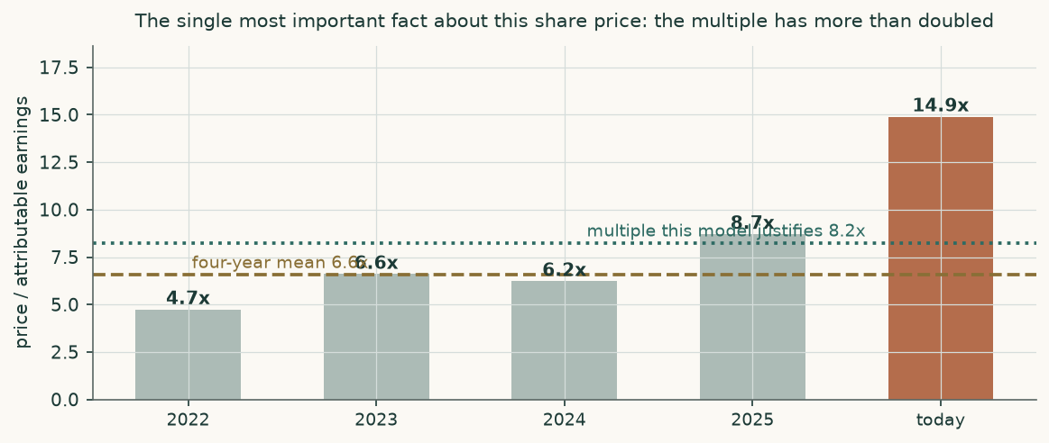
Figure 2 — the traded multiple against its own history and against what the model justifies.
1.4 Normalised earnings power
FY2025 was the best operating year in the company's history: a 25.1% operating margin against 23.5% in FY2023 and 20.1% in FY2024. This lens deliberately gives part of that back. Applying the three-year average margin of 22.9% to FY2027 revenue, financing it at that year's cost of debt, taxing it at 23.5% and adding the normalised associate contribution gives EGP 10.23 a share of sustainable earnings. Capitalised at the PERPETUAL cost of equity of 16.00% less 7% growth, on the 74% payout that growth rate permits, that is EGP 84.33 a share. Using today's crisis-level cost of equity of 25.92% in a perpetuity would be a category error: a steady-state multiple takes a steady-state rate.
1.5 Synthesis — four methods, five readings, two centres
Four methods produce five readings, because the cash-flow method is run on both framings of the contested provision judgement. They run from EGP 62 to EGP 122. That spread is not a failure of the methods; it is the honest measure of how much the answer depends on which question you ask.
There is no single weighted centre, and the absence is deliberate. The two provision frames are never averaged, and weighting both of them inside one number averages them. So the cash-flow weight of 50% is carried in full on ONE frame at a time, beside the three lenses that do not turn on the judgement at all — book value against sustainable return at 20%, relative multiples at 15%, and normalised earnings power at 15%. That gives EGP 101.42 a share on Frame A and EGP 121.61 on Frame B, against a market price of EGP 127.30. Which of the two a reader uses is a judgement about the debtor book, and it belongs to the reader.
1.6 Drivers — every segment grown on its own driver
Revenue is not grown as a percentage. It is built from THREE product lines, each with its own volume and its own price, all taken from disclosure. The company's board report splits the same total two different ways — by sales channel and by product line — and the two only reconcile once contract manufacturing is separated out.
LINE 1 AND LINE 2, the company's OWN preparations. It sold 351.8 million packs of them in FY2025 for EGP 9,160 million. The investor presentation puts export volume at 60 million packs earning EGP 2,967 million, which is USD 1.00 a pack at the disclosed average rate. The remainder — 291.8 million packs carrying EGP 6,193 million — is the domestic book at EGP 21.22 a pack, against EGP 18.85 in FY2024: a realised price up 12.6% on volume up 19.5%.
LINE 3, preparations made under contract for third parties. This is a different business and it is now modelled as one: 5.49 million packs in FY2025 against 8.87 million in FY2024, carrying EGP 142.3 million of product value. The company books EGP 49.4 million of that as a manufacturing fee — EGP 9.00 a pack against EGP 4.04 the year before — and the remaining EGP 93.0 million reaches the market through its own domestic channels.
That separation matters more than its size. The channel disclosure puts domestic revenue at EGP 6,286 million, but that figure CARRIES the contract-made product while the pack count against it does NOT carry the contract packs. Dividing one by the other reads EGP 21.54 a pack rather than the EGP 21.22 the company actually realised on its own preparations — 1.50% too high, in every forecast year. The two disclosures now close on each other to the thousand pound in both years, and the model asserts it. Margins are an OUTPUT of this build, never an input.
Driver | FY2026E | FY2027E | FY2028E | FY2029E | FY2030E
Domestic packs, own preparations (million) | 307.9 | 332.5 | 357.4 | 380.7 | 401.6
Domestic price per pack (EGP) | 24.62 | 27.57 | 30.05 | 32.31 | 34.57
Export packs (million) | 63.0 | 68.7 | 74.5 | 80.5 | 86.1
Export price per pack (USD) | 1.01 | 1.02 | 1.03 | 1.04 | 1.05
Exchange rate (EGP per USD) | 55.1 | 60.2 | 64.0 | 67.2 | 70.1
Contract-manufactured packs (million) | 6.31 | 7.06 | 7.77 | 8.39 | 8.98
Contract manufacturing fee per pack (EGP) | 10.44 | 11.69 | 12.75 | 13.70 | 14.66
Contract product resold, price per pack (EGP) | 19.66 | 22.02 | 24.00 | 25.80 | 27.61
Revenue (EGP million) | 11,442 | 13,825 | 16,179 | 18,523 | 20,911
Gross margin (an output) | 43.2% | 42.8% | 42.9% | 43.2% | 43.5%

Table 7 — the forecast driver table. THREE product lines, each with its own volume and its own price, moving separately and in the currency each is actually earned in. Nothing on this table is a revenue growth rate.
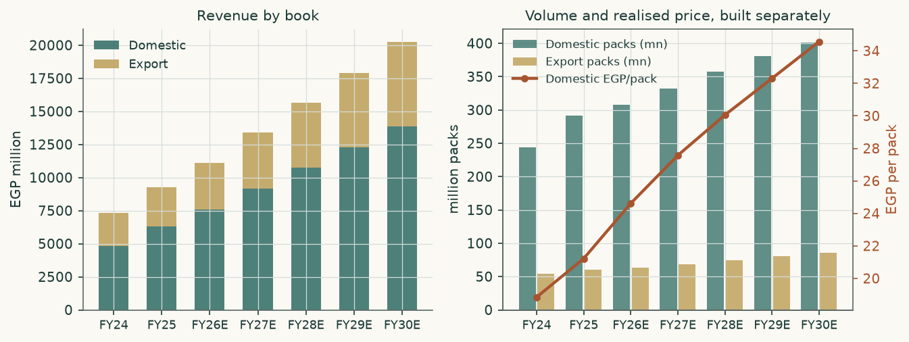
Figure 3 — revenue by book, and the volumes and prices underneath it.
The cost side gets the same discipline, and this matters more than it sounds. The audited cost-of-sales note splits production cost into physically distinct lines, and each one is escalated on its OWN driver rather than on a single blended inflation index:
Cost line | Share of production cost | Escalated on
Imported active ingredients | 54.9% | a hard-currency price path passed through the exchange-rate path
Packaging materials | 24.6% | 55% on the hard-currency path, the balance domestic — the group makes its own primary packaging
Labour | 9.8% | Egyptian wage growth, which is running above consumer prices
Energy and utilities | 3.4% | the regulated tariff schedule, ABOVE consumer prices while subsidy reform runs
Other consumables and services | 5.7% | domestic consumer prices
Depreciation | 1.7% | nothing — it is excluded here and comes from the property roll-forward instead

Table 8 — one escalator per driver class. A single blended index across these lines would make the forecast margin an artefact of the index rather than of the business.
1.7 The crux
The crux is the new plant, and it is worth being precise about what this study does and does not assume. It CHARGES the plant: EGP 4,901 million of construction balance transfers into depreciable assets on the company's own disclosed licensing timetable, taking the depreciation charge from EGP 118 million in FY2025 to EGP 304 million in FY2026 and EGP 446 million by FY2028. What it does NOT do is add the EGP 551 million of interest capitalised into the construction balance in FY2025 back onto the income statement. That would be the textbook consequence of the asset entering service, and the first cut of this model assumed it — but the company's own first quarter of 2026 says otherwise: financing expense of EGP 312.9 million ran DOWN 6.1% year on year, an annual rate near EGP 1,251 million against EGP 1,333 million actually borne in FY2025. The forecast is calibrated to that observed quarter rather than to the textbook, and the difference is disclosed here rather than left as an unexplained gap. It does NOT credit the plant with any revenue, because the company has published none.
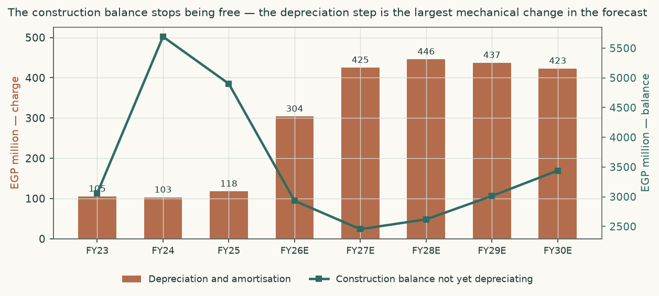
Figure 4 — the depreciation step, and the construction balance that causes it.
So the honest question is not what the plant is worth. It is how much it must sell. Solving the same model for the market price: an additional EGP 2,216 million of revenue by FY2030 at a 45% contribution margin closes the gap from EGP 101.42 to EGP 127.30. That is 10% of FY2030 revenue, or about USD 32 million a year — 0.32 times the USD 100 million the company says it invested in the plant.
Two things have to be published for that hurdle to be checkable, and they are. THE RAMP: the incremental revenue is not dropped into the final year. It is phased 0% / 10% / 30% / 60% / 100% of the FY2030 level across FY2026E to FY2030E. The same total placed entirely in the final year would be a materially LOWER and easier hurdle, so a reverse valuation that does not state its ramp cannot be audited. THE REINVESTMENT: the incremental revenue is charged capital expenditure at the same share of revenue as the existing business, and working capital on the same day ratios, so it meets the identical reinvestment discipline. Left uncharged — which is how the first cut of this model ran it — the hurdle prices out about USD 115 million a year instead of USD 32 million, which understates what the market is actually asking of the plant.
The same arithmetic read the other way is worth stating, because it is the plainest summary of what is at issue. At EGP 127.30 the market is paying EGP 25.88 a share — EGP 4,368 million, 20% of the entire share price — for a plant this study values at nothing, against a stated build cost of USD 100 million, about EGP 7,011 million. The market is not merely paying for the plant to work; it is paying roughly 0.6 times what the plant cost to build. That is the proposition, stated as a multiple of an observable outlay rather than as a valuation.
And the lead molecule is not first into its own market, which makes the hurdle harder than the contribution margin above makes it look. The Egyptian Drug Authority approved a competing adalimumab biosimilar — Alvotech's AVT02, marketed in Egypt as Adalimumab-EVA and commercialised by Bioventure — on 29 August 2023. That is twenty-seven months before this company launched its own adalimumab in December 2025, and adalimumab is the one molecule of the fourteen in the published pipeline that has actually reached the market. So the revenue above has to be won against an approved rival rather than into an empty field, and the 45% contribution margin the solve assumes should be read as a ceiling. This changes nothing in the answer, because the crux is stated rather than forecast. It raises the bar a reader has to clear before agreeing with the market.
Why this number is useful. It is observable. Roughly USD 32 million a year of biosimilar revenue by 2030 is a figure the company will eventually disclose, and a reader can check this study against it. An asset turn of 0.32 times on a specialist biologics facility is demanding but not absurd; whether it is achievable in Egypt, at Egyptian reimbursement prices, on a product set still moving through registration, is the question the market is answering yes to and this study is declining to answer either way.

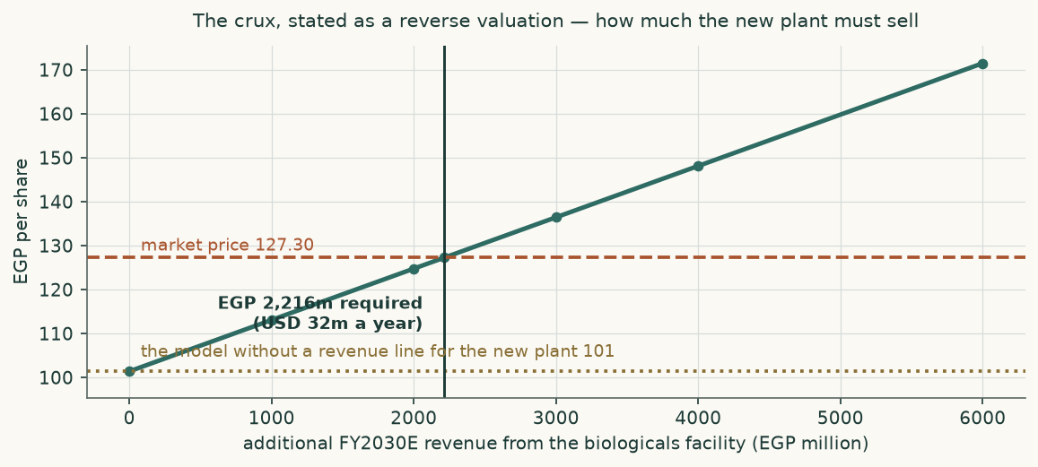
Figure 5 — the crux stated as a reverse valuation.
The first quarter of 2026 is the first real test of all this, and it is worth setting the forecast against it line by line rather than claiming a hit.
Line | Q1-2026 actual | Read into a full year | This study's FY2026 | How the forecast stands against it
Net sales (EGP m) | 2,533 | 10,398 | 11,442 | 10.0% against the quarter's run-rate
Gross margin | 42.4% | — | 43.2% | within 77 basis points
Depreciation and amortisation (EGP m) | 56.2 | 225 | 304 | the step is real; the study is ahead on timing only
Transfers out of construction (EGP m) | 918 | 3,670 | 3,400 | confirmed, and the study is if anything conservative
Finance cost (EGP m) | 313 | 1,251 | 1,250 | reset to the quarter
Provision charge as a share of sales | 2.57% | — | 5.25% / 4.50% | no credit-loss charge was taken at all — see below
Associates (EGP m) | 13.1 | 52 | 250 | the quarter is incomplete by the auditor's own statement
Capital expenditure (EGP m) | 325 | 1,299 | 1,430 | reset upward to the quarter
Attributable profit (EGP m) | 284 | 1,285 | 1,355 | the study is 5% above the quarter's seasonal read
Attributable earnings per share (EGP) | 1.68 | 7.61 | 8.03 | the two lines the appendix must reproduce, checked here

Table 9 — the forecast against the first quarter it can be checked on, INCLUDING the bottom line. The middle column reads the quarter into a year on the FY2025 seasonal shape ONLY for net sales (24.4% of sales) and for attributable profit and earnings per share (22.1% of profit). Every other line in that column is a plain four-times annualisation, because no seasonal shape is disclosed for it — stated rather than implied.
Two of those rows carry more weight than the rest. The depreciation line is the study's central claim and it is confirmed: the charge is running at roughly double last year on a plant that has only just entered service, and the model's own depreciation rate reproduces the quarter to within 3%. The provision line is the study's contested judgement, and here the quarter does NOT settle it: the company took EGP 65 million of provisions and inventory write-downs but no credit-loss charge whatsoever, against receivables that grew EGP 798 million in the same three months. The auditor qualified the review on precisely that point. Put a number on it: Frame A's 5.25% of revenue applied to the quarter's own sales would have charged EGP 133.0 million — 47% of the attributable profit the quarter actually reported — and even the three-year expected-credit-loss mean of 3.03% would have charged EGP 76.6 million, or 27% of it. A charge that is omitted in the first quarter is deferred, not avoided, which is why both frames still run.
1.8 Macro and country — the cost of capital
The quoted ten-year Egyptian local-currency government yield is 23.00%. That yield is not riskless: it contains the sovereign's own default risk. Subtracting Egypt's sovereign credit-default-swap spread of 3.42% leaves a normalised risk-free rate of 19.58%. Adding beta times the TOTAL equity risk premium gives the cost of equity. Charging the raw 23.00% yield AND a country-loaded premium would give 29.34% and would count sovereign risk twice; that construction is not used here.
Cost of capital | Swap basis | Rating basis | Source and construction
Ten-year local-currency yield | 23.00% | 23.00% | Observable print of 6 August 2026 — the SAME date as the share price used throughout. A market-data series, not an auction print: the central bank auction page could not be read, so the level is indicated rather than proven, and it is sensitised
Less sovereign default spread | 3.42% | 5.97% | Country risk-premium dataset, Egypt row, MID-YEAR (July 2026) vintage, spreads measured 30 June 2026
Normalised risk-free rate | 19.58% | 17.03% | The subtraction above
TOTAL equity risk premium | 9.52% | 13.48% | Same dataset, same row, its two TOTAL equity risk premium columns. This is the figure that multiplies beta
memorandum: country risk premium | 5.32% | 9.28% | The dataset's separate COUNTRY risk premium column, shown so a reader checking that column finds the same numbers this study calls by that name. It is NOT added to the cost of equity — the total premium above already contains it
Beta | 0.666 | 0.666 | Own-stock weekly regression against the published EGX30 index of the exchange this share is listed on, 4.94 years; R-squared 0.143, n = 256, standard error 0.135
COST OF EQUITY | 25.92% | 26.01% | The two bases agree to 9 basis points
Cost of debt, local currency | 25.50% | 25.50% | Sovereign yield plus 250 basis points — above the sovereign by construction
Cost of debt, hard currency | 7.50% | 7.50% | Dollar and euro term loans from two Gulf banks
carried at local-equivalent cost | 12.34% | 12.34% | coupon compounded with 4.5% expected currency depreciation
Blended cost of debt, after tax | 14.64% | 14.64% | book split 50% local / 50% hard currency, borrowings note (17)
Weights (net debt basis) | 74% / 26% | 74% / 26% | Market-value equity, never book equity
DISCOUNT RATE, FIRST YEAR | 23.04% |  | On gross debt: 22.64% — both published
DISCOUNT RATE, TERMINAL | 14.36% |  | cost of equity 16.00%, cost of debt after tax 9.56%, DERIVED debt weight 25.5% on today's market values. The forecast balance sheet, once funded, carries 36.2% on book at FY2030E, which would give 13.67% — both are published and neither is 20%

Table 10 — the cost of capital, built rather than asserted, and published on both bases the source provides.
A cost-of-debt cross-check that a reader can run. Two FY2025 figures are in play and they are not the same line: INTEREST ON CREDIT FACILITIES of EGP 1,275.31 million, which is what an interest RATE has to be computed on, and the income statement's FINANCE COSTS of EGP 1,332.95 million, which is that interest plus EGP 57.63 million of bank commissions and charges. Both are in the same note. The company expensed EGP 1,275 million of interest in FY2025 and capitalised a further EGP 551 million into the construction balance. On average gross debt of EGP 8,999 million that is 14.2% expensed and 20.3% all-in. The 18.9% marginal rate used here sits inside that pair, which is the test that matters: a marginal rate below what the company actually pays, or above what it actually incurs, would not be credible.
One arithmetic point that looks wrong and is not. The first-year discount rate of 23.04% sits close to the 23.00% quoted government yield. That is a consequence of the normalisation, not an error: the quoted yield contains default risk that this build strips out and re-charges inside the equity premium, where it belongs. Comparing a cost of capital built on a normalised risk-free rate to a raw quoted yield is comparing two different things.
1.9 Sensitivity
Before the grids, the one input that carries the study's contested judgement, read every way the disclosed statements allow. Frame A carries 5.25% of revenue. That is NOT the three-year average, and this edition no longer calls it one: it is struck marginally above the mean of the two years either side of the FY2024 spike. Every reading, and what each is worth:
Reading of the provision charge | Share of revenue | Frame A value (EGP/share)
Carried — struck above the two non-outlier years | 5.25% | 101.42
Mean of the three disclosed years, including the FY2024 spike | 6.52% | 91.29
Expected-credit-loss component alone, three-year mean | 3.03% | 119.21
The two non-outlier years, FY2023 and FY2025 | 5.15% | 102.22

Table 11 — the contested judgement, priced on every reading of it the audited statements support. The three-year mean of 6.52% includes the FY2024 spike of 9.25%; the expected-credit-loss component alone averages 3.03% across the same three years. For context that none of these readings carries: the first quarter of 2026 booked NO expected credit loss at all.
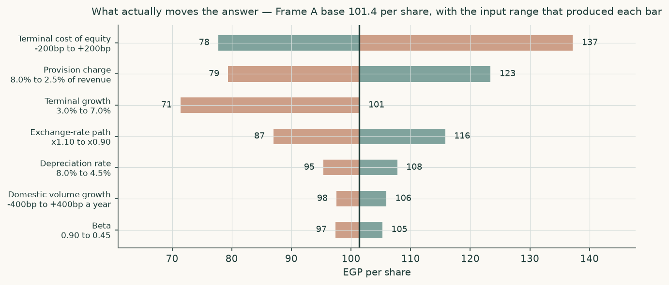
Figure 6 — what actually moves the answer. Each bar is the full range of the value per share across a plausible range of that one input.
Terminal growth → | 3% | 4% | 5% | 6% | 7%
Cost of equity -200 basis points | 89 | 97 | 107 | 120 | 137
Cost of equity -100 basis points | 80 | 86 | 94 | 104 | 117
Cost of equity +0 basis points | 71 | 77 | 83 | 91 | 101
Cost of equity +100 basis points | 64 | 69 | 74 | 81 | 88
Cost of equity +200 basis points | 58 | 62 | 66 | 71 | 78

Table 12 — the value per share across the cost of equity and terminal growth together. Every cell is a complete revaluation. The grid runs from EGP 58 to EGP 137 a share, and that FULL range is what is published — quoting only its upper part would delete the half of the study's own risk display that matters most.
The crux is sensitised in real observable units rather than in percentage points. On the published ramp and with the incremental revenue charged the same reinvestment identity as the existing business, a quarter of the required revenue — EGP 554 million of FY2030 sales, or USD 8 million a year — is worth about EGP 6.47 a share.
2. Technical and price structure
The price closed 130.05 above a rising 20-day (101.58), a rising 50-day (92.49) and a rising 200-day (82.58). Momentum is stretched: RSI(14) is ~71 and the daily ATR near 7.84 (~6.0%) points to a volatile tape. MACD (12·26·9) is positive and rising (+11.68 / +7.24 / +4.44). Over the last year it has ranged 43.60–156.00; the last close sits 17% below that high and 198% above that low.
Level | EGP | Distance from the close
Third resistance | 156.00 | 22.5%
Second resistance | 150.00 | 17.8%
Nearest resistance | 140.00 | 10.0%
Last close | 127.30 | —
Nearest support | 92.40 | -27.4%
Second support | 88.49 | -30.5%
Third support | 85.40 | -32.9%

Table 13 — support and resistance, computed from recency-weighted pivot clusters on the same cleaned price history the probability map uses.
The structural point matters more than the levels. The nearest support sits -27% below the last close. The move that took this share from about EGP 90 in late July to EGP 150 on 3 August happened in four sessions, two of them at the exchange's daily limit, and it left no traded structure behind it. A price that gaps up through empty space has nothing under it if sentiment turns — which is why the three-month probability band below is as wide as it is.
A daily close back above 140.00 would clear the nearest resistance and open the 156.00 zone. A close below 92.40 would break the nearest support and open the 85.40 zone.
3. Probabilistic price map
The valuation above says where the shares should be. This section says something different and narrower: given how this share has actually behaved, where might the price be in one and three months? It is a statement about the distribution of outcomes, not a forecast of one.
Percentile of the simulated distribution | One month | Three months
5th percentile | 104.91 | 96.09
25th percentile | 121.95 | 120.51
50th percentile | 132.72 | 136.87
75th percentile | 144.45 | 155.44
95th percentile | 167.85 | 194.60
Check date | 2026-09-06 | 2026-11-08

Table 14 — the percentile map. The anchor is the EGP 130.05 close of 2026-08-06.
Probability | One month | Three months
Finishes above the anchor | 57% | 61%
Finishes 10% or more above | 27% | 41%
Finishes 10% or more below | 16% | 21%
TOUCHES 10% above at any point | 44% | 65%
TOUCHES 10% below at any point | 30% | 44%

Table 15 — the level-touch ladder. Touching a level at any point during the window is far more likely than finishing beyond it.
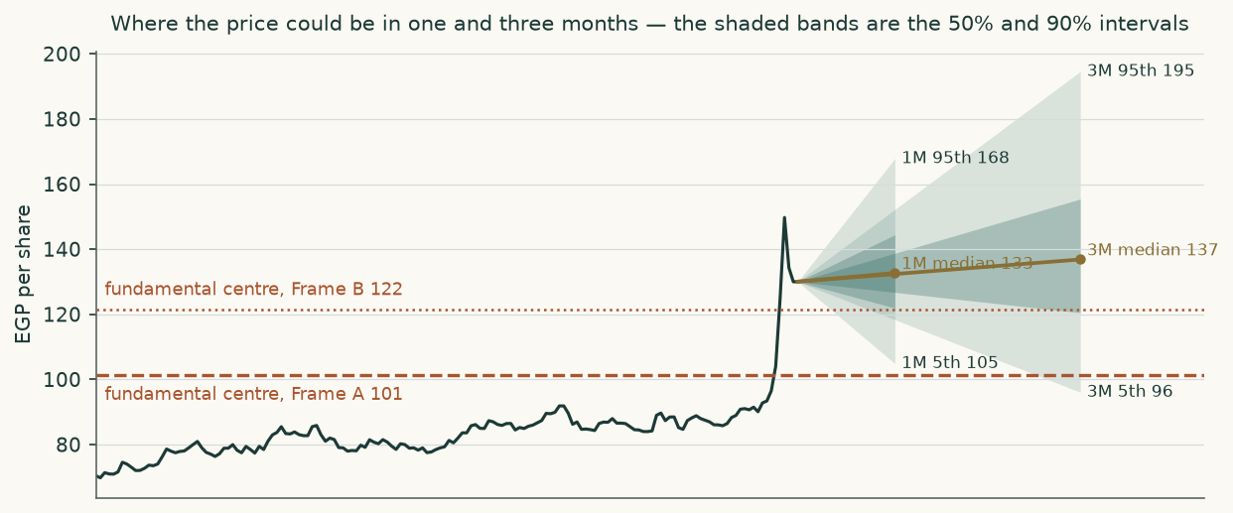
Figure 7 — the price history and the one- and three-month bands.
How much should a reader trust this? The method was tested by re-running it every quarter across the whole cleaned price history, without ever letting it see the future, and checking each forecast against what actually happened. Three window sets are reported: the last five years, 19 non-overlapping three-month windows; the full 13.8-year history, 56 windows; and the period AFTER the currency break that dominates the older history — 16 windows from 2022-06-20 to 2026-03-24. The third is published because it is the set that matches the period the bands shown above are built on. All three are reported together; reporting only two of three would be a choice about which evidence a reader sees.
What the tests DO show is that the bands are honestly sized, which is the property that matters for reading them. Across the five-year window set the outcome fell inside the 90% band 100% of the time and inside the 50% band 47% of the time, and the distribution of where outcomes landed within the bands was statistically indistinguishable from uniform (chi-square p = 0.447, Kolmogorov-Smirnov p = 0.676). The bands are also about 1.47 times as wide as the benchmark's, which means they are conservative rather than flattering. Read them as an honest width, not as a claim to foresight.
Two volatilities, both published. The simulation is fed 62.90% annualised at the one-month horizon and 53.55% at three months — the two windows genuinely differ, and stating only the lower of them would understate the near-term width the map itself shows. A reader who back-solves an annualised volatility from the published fifth and ninety-fifth percentiles under a plain lognormal will get a NARROWER number than either, because the simulated process is not a plain lognormal: it carries a fat-tailed innovation and mean reversion in variance, both of which pull the central quantiles in relative to the volatility that feeds them. The generator, its parameters and the window outcomes behind the coverage statistics are listed in the accompanying bibliography so the check can be run properly rather than approximated.
4. Comparison of the lenses
Lens | EGP / share | What it is most sensitive to | When it misleads
Discounted cash flow, Frame A | 101.42 | the terminal discount rate and the terminal growth rate — 81% of the value is in the terminal block | when five explicit years are not long enough to reach a steady state, which for a plant entering service is exactly the risk
Discounted cash flow, Frame B | 121.61 | the same, plus the speed at which the provision charge normalises | if the credit losses are structural rather than cyclical
Book value and sustainable return | 82.66 | the sustainable return on equity and the perpetual cost of equity | when a large part of the asset base is not yet earning — which is true here, with EGP 4,901 million still in construction at the year end
Relative multiples | 61.57 | the cost of equity, through all three of its inputs | when the comparable companies face a different country risk, which is why the struck reference is adjusted rather than applied raw
Normalised earnings power | 84.33 | the choice of normal margin | when the business has genuinely re-based upward, in which case a three-year average understates it

Table 16 — the four methods against each other — five readings, because the cash-flow method is run on both framings of the contested judgement — including where each one fails.
The readings disagree in an informative direction. The lowest is the relative lens at EGP 61.57; the highest is the cash-flow reading on the normalising frame at EGP 121.61. The cash-flow readings charge the new plant's full cost and credit it with nothing, so they sit low despite capturing five years of the volume and price growth the existing business is already delivering. The relative lens prices the company on what a 27.1% return and a 16.0% perpetual cost of equity can justify, which supports about 8.24 times forward earnings against the 14.90 times trailing the market pays. None of them is wrong. The gap between them is the value of growth, and the market is paying for more of it than any of them contains.
5. Catalysts
What to watch | Why it matters | When
First disclosed revenue from the biologicals plant | the whole crux. Section 1.7 says roughly USD 32 million a year by 2030 is required to justify the market price; the first disclosure calibrates how plausible that is | FY2026 results, and every quarter after
The FY2026 depreciation charge | this study assumes it steps from EGP 118 million to about EGP 304 million as the construction balance transfers. A materially smaller step means the plant is being commissioned more slowly than assumed | FY2026 results
Whether capitalised interest stops | EGP 551 million of interest was capitalised in FY2025. The textbook consequence of the plant entering service is that this becomes an expense. It has NOT happened yet — the first quarter of 2026 ran financing expense DOWN 6.1% year on year — and this study charges the observed quarter, not the textbook. If the step does arrive it is worth about EGP 551 million a year of pre-tax profit | FY2026 interim and full year
The credit-loss and provision charge | the study's contested judgement. The disclosed charge runs 5.07%, 9.25% and 5.23% of revenue across the three audited years — a three-year mean of 6.52% — and the first quarter of 2026 took none at all. Which frame the next two years resemble is worth more than a point of margin | each set of results
The Saudi associate | note (33) attributes EGP 428 million of associate income to this one holding in FY2025 and EGP 190 million in FY2024. The FY2024 figure EXCEEDS the group associate line of EGP 151.6 million for that year, so the other holdings were a net drag of EGP 38.4 million — the individual disclosure and the group line are both reported here rather than one being quoted without the other. This study normalises the WHOLE associate stream to EGP 250 million against a three-year mean of EGP 246.1 million | each set of results
The active-ingredient project | a separate USD 165 million company that this study does NOT consolidate and does NOT value. It reaches the accounts only through the associate line | trial batches indicated for 2027
The exchange rate | exports are 32% of revenue but hard-currency inputs are 68.4% of the disclosed cost stack — the imported active ingredient plus the imported SHARE of packaging, not the whole packaging line, because the group makes its own primary packaging. So a weaker pound is a NET NEGATIVE for this company, the opposite of the usual exporter reflex | continuous

Table 17 — the events that would move this valuation, and the direction each cuts.
6. Reading the probability zones
The bands in section 3 are frequently misread, so here is how to use them.
- The percentile map is the probability that the price ENDS the window beyond a level. It is what a position held to the check date experiences.
- The touch ladder is the probability that the price TOUCHES a level at any point inside the window, even if it comes back. It is always the larger of the two, and it is what a stop-loss experiences. On the three-month window the difference is substantial: 21% of paths finish 10% or more below the anchor, but 44% touch that level at some point.
- A band is not a limit: the 90% band is not a maximum. One outcome in ten is designed to fall outside it, and over a long enough run one will.
- Width is information: the bands here are wide — the three-month 90% band runs from EGP 96.09 to EGP 194.60 — because this share has been genuinely volatile: the annualised volatility implied by its recent trading is about 54%. A narrow band on a share that moved 44% in two sessions would be a lie.
- These are not a valuation: the bands describe where the PRICE may go. The valuation describes what the BUSINESS appears to be worth. They are different questions and this study keeps them apart on purpose. The lower fundamental centre, EGP 101.42, sits below the entire three-month band, whose floor is EGP 96.09; the higher, EGP 121.61, sits inside it. That is worth noticing rather than reconciling away.
7. Caveats, and what would change our mind
Caveat | What it costs the study | What would settle it
The first-quarter review conclusion is QUALIFIED on three matters | no expected-credit-loss charge was recognised in the quarter; the associates' own statements were not received; and the active-ingredient company was recognised at cost after loss of control rather than remeasured and equity-accounted. The first flatters the quarter's profit, the second makes the associate line incomplete, the third is a measurement question this study side-steps by carrying that company at cost | an unqualified half-year review
No revenue is modelled for the biologicals plant | the cash-flow lenses are understated by whatever the plant earns. This is the largest single limitation and it is deliberate | the company disclosing biosimilar revenue, volumes or utilisation
The valuation bridge is anchored on the audited 31 December 2025 balance sheet, not on the March one | net debt was EGP 9,065m at 31 March against EGP 7,364m at 31 December, but the quarter also paid the FY2025 dividend and built working capital, and the forecast still carries a full FY2026 of cash flow. Using the March balance sheet AND a full forecast year would charge the same quarter twice. On the March net debt alone the value would be about EGP 10 a share lower | a half-year balance sheet, at which point the anchor can move forward cleanly
The ten-year government yield is a market-data series, not an auction print | the discount rate now carries the 23.00% level observable on the same date as the share price, but the central bank's own auction page refused the request, so the level is indicated rather than proven. The rate is sensitised over a wide range in section 1.9 | a live read of the auction curve; a 200 basis-point error is worth about EGP 7 a share
The enterprise-to-equity bridge mixes two consolidation perimeters | net debt is the audited 31 December 2025 figure, when the active-ingredient company was still consolidated; the non-controlling interest deducted, EGP 4.0 million, is the post-deconsolidation figure, and the retained stake is added separately at cost. A single perimeter would either deduct the December minority of EGP 288.7 million without the separate addition, or move the whole bridge to the March balance sheet. The difference is about EGP 3.04 a share on the cash-flow readings | a half-year balance sheet on one perimeter
The forward interest path falls while the debt does not | the charge is calibrated to the first quarter of 2026 and is right for FY2026E, but it declines to EGP 1,030 million by FY2030E on a funded borrowing book that ends the window near where it started. The implied average rate falls to 10.93% against a blended MARGINAL cost of debt of 18.89% used in the discount rate. This affects the earnings-based lenses, not the cash-flow ones, which are computed before interest | a disclosed debt-amortisation schedule
The associate contribution is normalised, not built up | the associates published no accounts through this company's filings, so a EGP 250 million normalisation stands in for a real forecast. It is worth EGP 16.30 a share | the Saudi associate publishing separate accounts
Peer multiples are market data, not primary company data | the relative lens's third leg rests on observed peer trading rather than on peer filings. It is one of three legs and is labelled as a cross-check throughout | building each peer from its own audited statements
One disclosed operating figure was restated between annual reports | the FY2024 tablet production line reads 1,513 million units in the FY2024 report and 1,352 million in the FY2025 report. The later filing is used. It affects a utilisation statistic, not a valuation input | a company explanation of the restatement
The market index explains little of this share’s week-to-week movement | the beta is regressed against the published index of the exchange the shares are listed on, and that index explains 14.3% of the weekly variation over 256 observations. The coefficient is 0.666 with a 90% range of 0.443 to 0.889, and that range is wide enough to matter to the valuation. A previous edition regressed against an equal-weighted basket of 36 local names, which fit better — 23.5% — and gave 0.629. That basket is not a market: it changes whenever a share is added to it and it shares members with the very set it is used to price, so it tracks any one of them more closely than a real index does. A better fit against the wrong yardstick is not a reason to use the wrong yardstick. Both figures and their statistics are published in the bibliography | a longer price history, or a defensible set of listed peers whose own betas clear the same usability test
The pre-2020 portion of the price history is thin | the price export carries 162–195 sessions a year before 2020 against roughly 245 real exchange sessions. It affects only the longest calibration window, not the live bands, which are built on the post-2022 period | a complete exchange-sourced price history

Table 18 — every limitation this study knows about, and what would resolve it.
One caveat from the first edition is now closed: the FY2026 first-quarter interim, which could not be reached at any official source online, was supplied directly and is in this edition. The secondary reporting recorded then as an unverified cross-check turned out to be accurate to the pound on both sales and attributable profit.
What would change the conclusion, stated in advance so it can be checked: if the company disclosed biosimilar revenue on a path toward USD 32 million a year, the cash-flow lenses would move to the market price and this study would be wrong to have flagged the gap. If the FY2026 depreciation charge came in near EGP 118 million rather than EGP 304 million, the plant is not in service and the whole timetable in this study shifts out a year.
Appendix A — the financial statements
A.1 Income statement: three audited years and five forecast years
EGP million | FY2023 | FY2024 | FY2025 | 2026E | 2027E | 2028E | 2029E | 2030E
Revenue | 5,232 | 7,591 | 9,441 | 11,442 | 13,825 | 16,179 | 18,523 | 20,911
Cost of sales | 2,896 | 4,184 | 5,287 | 6,503 | 7,910 | 9,231 | 10,522 | 11,823
Gross profit | 2,335 | 3,406 | 4,154 | 4,939 | 5,916 | 6,948 | 8,002 | 9,088
Gross margin | 44.6% | 44.9% | 44.0% | 43.2% | 42.8% | 42.9% | 43.2% | 43.5%
Selling and marketing | 648 | 915 | 1,000 | 1,190 | 1,410 | 1,618 | 1,834 | 2,049
Research and development | 43.2 | 70.5 | 70.9 | 97.3 | 124.4 | 153.7 | 185.2 | 209.1
General and administrative | 147.5 | 188.5 | 221.1 | 268.9 | 324.9 | 372.1 | 422.3 | 470.5
Credit losses and provisions | 265 | 702 | 494 | 601 | 726 | 849 | 972 | 1,098
Operating profit | 1,229 | 1,529 | 2,366 | 2,718 | 3,241 | 3,861 | 4,496 | 5,172
EBITDA | 1,335 | 1,631 | 2,484 | 3,022 | 3,666 | 4,307 | 4,933 | 5,595
Depreciation and amortisation | 105.2 | 102.8 | 117.7 | 304.0 | 425.2 | 445.8 | 437.3 | 423.1
Finance costs | 408 | 960 | 1,333 | 1,250 | 1,210 | 1,150 | 1,090 | 1,030
Share of associates | 75 | 152 | 512 | 250 | 250 | 250 | 250 | 250
Profit attributable to shareholders | 822 | 1,096 | 1,442 | 1,355 | 1,785 | 2,306 | 2,837 | 3,401
Attributable earnings per share (EGP) | 5.53 | 7.37 | 8.90 | 8.03 | 10.58 | 13.66 | 16.81 | 20.15
memorandum: retained after a 40% payout | 493 | 657 | 865 | 813 | 1,071 | 1,383 | 1,702 | 2,040

Table 19 — three audited years and five forecast years. Every forecast line is the model row the valuation itself uses. The attributable-profit line is attributable profit; the retained portion is a separate memorandum line beneath it, because the equity roll-forward in Appendix A.2 needs it. The finance-cost line is the charge the model carries, calibrated to the first quarter of 2026 — it is not the marginal cost of debt used in the discount rate, which is a different and higher forward rate. Earnings per share for FY2023 and FY2024 use the 148.76 million shares then in issue and FY2025 uses the audited weighted average of 162.02 million; the forecast columns use the 168.76 million now in issue.
A.2 Balance sheet
EGP million | FY2023 | FY2024 | FY2025 | FY2026E | FY2027E | FY2028E | FY2029E | FY2030E
Property, plant and equipment | 964 | 1,045 | 3,070 | 6,174 | 6,857 | 6,820 | 6,591 | 6,376
Projects under construction | 3,058 | 5,694 | 4,901 | 2,931 | 2,454 | 2,620 | 3,013 | 3,440
Inventories | 2,242 | 3,585 | 3,887 | 4,721 | 5,591 | 6,323 | 7,063 | 7,774
Trade receivables | 2,358 | 3,049 | 3,325 | 3,950 | 4,621 | 5,230 | 5,836 | 6,417
Cash and bank balances | 676 | 1,295 | 1,433 | 1,433 | 1,433 | 1,433 | 1,433 | 1,433
Trade payables | 176 | 410 | 780 | 980 | 1,214 | 1,442 | 1,672 | 1,879
Gross borrowings (the funding plug) | 4,880 | 9,200 | 8,798 | 10,518 | 10,786 | 10,473 | 9,878 | 8,962
Net debt | 4,204 | 7,905 | 7,364 | 9,085 | 9,352 | 9,039 | 8,445 | 7,528
Equity attributable to shareholders | 4,257 | 4,654 | 6,243 | 7,056 | 8,127 | 9,511 | 11,213 | 13,254
Book value per share (EGP) | 28.62 | 31.28 | 37.00 | 41.81 | 48.16 | 56.36 | 66.45 | 78.54

Table 20 — the balance sheet, WHICH BALANCES. The property and construction lines roll forward on the transfer schedule and working capital is projected from the disclosed day ratios; cash is held at the audited operating minimum and gross borrowings carry whatever the asset side needs that trade credit, provisions and equity do not supply. The first edition froze cash AND borrowings for five years while equity compounded, which left the forecast columns out by up to 6.6% of total assets with no check row to show it. Borrowings therefore RISE before they fall: the working-capital build and the first year's capital spending are debt-funded while a 40% payout continues. The lines above are a summary; the full statement, a total liabilities-and-equity row and an explicit balance-check row are in the accompanying model, where the check reads zero in every forecast column and carries residuals of −4.1, +0.2 and +0.4 million in the three audited columns — under 0.05% of total assets, from grouping the filed statement into these captions.
A.3 Cash flow and the working-capital markers
Marker | FY2025 audited | FY2026E | FY2027E | FY2028E | FY2029E | FY2030E
Inventory days | 268 | 265 | 258 | 250 | 245 | 240
Receivable days | 129 | 126 | 122 | 118 | 115 | 112
Payable days | 54 | 55 | 56 | 57 | 58 | 58
Cash conversion cycle | 343 | 336 | 324 | 311 | 302 | 294
Capital expenditure (EGP m) | 1,355 | 1,430 | 622 | 566 | 593 | 627
Free cash flow to the firm (EGP m) | — | -161 | 1,149 | 1,891 | 2,340 | 2,841

Table 21 — the asset-conversion cycle, projected rather than plugged. The 268-day inventory position is a stated policy: the company holds a strategic raw-material stockpile it says covers at least eight months.
A.4 The far forecast years as ranges, and the years that carry none
The method behind this forecast has been replayed on the company's own past — rebuilt year-end by year-end under the same mechanical rules, projected forward and scored against what the company later reported. That exercise measures how far out this method has been, and the far forecast years are published here as the RANGE that measurement supports rather than as points. It covers one, two and three years ahead, so the third forecast year carries a measured range and the fourth and fifth carry NONE. No range is invented for them: an invented one would corrupt the very error it is scored against.
EGP million | 2028E | 2029E | 2030E | Basis of the range | Readings behind it
Revenue — as published | 16,179 | 18,523 | 20,911 | — | —
Revenue — low of the range | 28,014 | no measured range | no measured range | span | 3
Revenue — high of the range | 32,737 | no measured range | no measured range | span | 3
Cost of sales — as published | 9,231 | 10,522 | 11,823 | — | —
Cost of sales — low of the range | 15,199 | no measured range | no measured range | span | 3
Cost of sales — high of the range | 17,973 | no measured range | no measured range | span | 3
Gross profit — as published | 6,948 | 8,002 | 9,088 | — | —
Gross profit — low of the range | 12,717 | no measured range | no measured range | span | 3
Gross profit — high of the range | 14,799 | no measured range | no measured range | span | 3
Profit for the year — as published | 2,324 | 2,855 | 3,419 | — | —
Profit for the year — low of the range | 3,995 | no measured range | no measured range | span | 3
Profit for the year — high of the range | 7,912 | no measured range | no measured range | span | 3
Depreciation and amortisation — as published | 446 | 437 | 423 | — | —
Depreciation and amortisation — low of the range | 250 | no measured range | no measured range | span | 2
Depreciation and amortisation — high of the range | 269 | no measured range | no measured range | span | 2
Capital expenditure — as published | 566 | 593 | 627 | — | —
Capital expenditure — low of the range | 1,220 | no measured range | no measured range | span | 2
Capital expenditure — high of the range | 3,012 | no measured range | no measured range | span | 2

Table 22 — the third forecast year as a range, and the fourth and fifth stated as carrying none. The range is the point projection MULTIPLIED by how far the outturn came in from the projection at each replayed year-end, so a factor above one means the outturn came in ABOVE the projection — which is the direction almost every reading runs, because the method under-stated the scale of this company in a decade of currency moves rather than mis-stating its shape. Reading the multiplier the other way up would move a forecast the wrong way, and both values look equally ordinary on a page, which is why the direction is stated here rather than left to be inferred. The basis is a SPAN and is not called anything else: it is the widest and the narrowest of the readings behind it, not a percentile, because a percentile needs more readings than this record holds. The range at the third forecast year on revenue, cost of sales, gross profit and profit for the year is the full span of 3 past observations of this method's own error. That is too few to carry a probability, and none is claimed: it is the widest and narrowest this method has been on this company, not a confidence interval. The range at the third forecast year on depreciation and amortisation and capital expenditure is the full span of 2 past observations of this method's own error. That is too few to carry a probability, and none is claimed: it is the widest and narrowest this method has been on this company, not a confidence interval. The fourth and fifth forecast years are shown as published in Appendix A.1 and are marked here as carrying no measured range, because the replay covers three years ahead and no further. Nothing in this table changes the valuation: the fair-value range in the summary is struck on the point path above it, and this is the disclosure of how wide the method's own error has been around that path.
Appendix B — peers, risks and the research record
B.1 Peers
Company or reference | Multiple | Basis | Status in this study
Listed Saudi Arabian generics manufacturer | 26.7x | trailing price / earnings | market data, cross-check only
Regional and international mid-cap generic manufacturers | ~16x | trailing price / earnings | market data, cross-check only
STRUCK REFERENCE USED — the midpoint of the two observations above | 21.35x | trailing price / earnings | the third leg of the relative lens, adjusted for the cost-of-equity gap. NOT a median of a disclosed peer set: only the two observations above are disclosed, the companies are not named, and this multiple therefore cannot be rebuilt from their filings
EIPICO today, on shares in issue | 14.90x | trailing price / earnings | computed from audited attributable profit and the market price
EIPICO today, on the FY2025 weighted-average count | 14.31x | trailing price / earnings | the same profit over the audited weighted average of 162.02 million shares. Both readings are published
EIPICO, own four-year mean | 6.57x | trailing price / earnings | computed entirely from primary material — the second leg of the relative lens

Table 23 — the peer set. No peer figure is used to build any historical number for EIPICO; peers appear only as a cross-check.
B.2 Risks
Risk | How it would show up | Severity
The new plant under-delivers | depreciation and interest charged with no revenue against them; reported profit falls for two to three years | High
Administered price freeze | the domestic price-per-pack driver stops tracking inflation while imported input costs keep rising | High
Currency depreciation | the imported active ingredient plus the imported SHARE of packaging are 68.4% of the disclosed cost stack against a 32% export share — a weaker pound is net negative here. Counting the WHOLE packaging line as imported would give 79.4%, which the group's own primary-packaging manufacture rules out | High
Credit losses prove structural | the provision charge stays near 5.25% of revenue permanently; this is Frame A, and it is already the more conservative of the two published cases. A charge at the three-year mean of 6.52% instead would put Frame A at EGP 91.29 a share | Medium
Concentration in the domestic distributor channel | 39% of revenue passes through distributors, and the company itself says it deals with a small number of them | Medium
Refinancing | EGP 8,798 million of gross borrowings against EGP 1,433 million of cash, half of it hard-currency | Medium
Controlling shareholder | a 51.34% holder whose interests may not align with the minority on capital allocation | Low to medium

B.3 The research record
Every figure in this study traces to a numbered source in the accompanying bibliography, which lists the primary documents actually read, every input with its value, date and construction, the judgements made with what would overturn each one, the searches that found nothing, and the places where a secondary source disagrees with the audited filing. Four consecutive audited financial years were obtained from the company's own investor-relations page: FY2022, FY2023, FY2024 and FY2025, each with the auditor's report and full notes, and each carrying both separate and consolidated statements.
Appendix C — three experts, three methods
Three analysts with genuinely different methods were asked the same question. They are labelled Expert 1, 2 and 3. Each shows their working, names the one sensitivity that matters most to their answer, and states in advance what would prove them wrong.
C.1 Expert 1 — the cash-flow analyst
Worldview: a company is worth the cash it will generate for whoever owns the capital, discounted at what that capital costs. Everything else is a shortcut to that number.
When it works: for a business with a stable, forecastable operating model and a capital structure that is not about to change. When it fails: when most of the value sits beyond the explicit forecast — which is the case here, at 81% of enterprise value in the terminal block.
Working | EGP million
Present value of five years of free cash flow | 4,089
Terminal free cash flow | 2,787
Terminal discount rate less growth | 14.36% − 7% = 7.36%
Terminal value | 40,533
Present value of the terminal value | 17,403
Core enterprise value | 21,492
Associates and assets held for sale | 2,991
Less net debt and minorities | (7,368)
Equity value | 17,115
Value per share (EGP) | 101.42

Named sensitivity: the terminal discount rate. Every 100 basis points on it is worth roughly EGP 13 a share. At 81% terminal weight, this expert is mostly forecasting one number.
Falsifier, stated in advance: "If free cash flow to the firm in FY2027 comes in below EGP 804 million — 30% below my forecast — my five-year build is wrong and so is the terminal that grows out of it."
C.2 Expert 2 — the asset-and-return analyst
Worldview: forecasts are opinions; the balance sheet is a fact. Start from what the company owns, ask what return it earns on it, and pay a multiple of book that the return justifies. Never pay for growth you have not seen.
When it works: for asset-heavy businesses and in markets where forecasting is genuinely hard. When it fails: when a large part of the asset base is not yet earning, which understates the return and therefore the multiple.
Working | Value
Equity attributable to shareholders | EGP 6,243m
Shares in issue | 168.756m
Book value per share | EGP 37.00
Return on average equity, FY2025 | 26.5%
Sustainable return on equity | 27.1%
Perpetual cost of equity | 16.00%
Growth | 7%
Justified multiple of book = (return − growth) / (cost of equity − growth) | 2.23x
Value per share (EGP) | 82.66

Named sensitivity: the sustainable return. If it settles at 20% rather than 27.1%, the justified multiple falls to 1.44 times and the value to EGP 53.44 a share.
Falsifier: "If return on average equity falls below 18% in either FY2026 or FY2027, the 27.1% I am capitalising is a peak, not a level, and my multiple is too high."
This expert adds one point the others miss: EGP 4,901 million of the asset base earned nothing in FY2025. Measured against capital that is actually working, the return is far higher than 27.1% — which is an argument for paying up, and this expert declines to make it, because the plant has not yet demonstrated a return.
C.3 Expert 3 — the market-implied analyst
Worldview: do not ask what a company is worth. Ask what the market price already assumes, and judge whether those assumptions are reasonable. It is a discipline against arguing with a price.
When it works: when a price has moved a long way and the question is what it now embeds. When it fails: it never produces an independent value — it can only tell you what you are being asked to believe.
What the market price requires | Value
Market price | EGP 127.30
Value from the cash-flow model without the new plant | EGP 101.42
Gap to be explained | EGP 25.88 a share
Equity value of that gap | EGP 4,368m
Additional FY2030 revenue required at a 45% contribution margin | EGP 2,216m
as a share of FY2030 revenue | 10%
in US dollars a year | USD 32m
against the plant's stated cost of USD 100 million | 0.32x asset turn
Implied value per share if that is delivered | EGP 127.30

Named sensitivity: the contribution margin assumed on the new revenue. At 35% rather than 45%, the required revenue rises to about EGP 2,849 million, or USD 41 million a year.
Falsifier: "If the company discloses biosimilar revenue below USD 20 million a year in its third full year of operation, the price is not discounting a plausible ramp — it is discounting a hope."
C.4 Cross-examination
Challenge | Conceded or rejected
Expert 2 to Expert 1: "Three-quarters of your value is a terminal number. You are not forecasting cash flow, you are forecasting a perpetuity." | CONCEDED. Expert 1 accepts the terminal weight is high and points to the sensitivity table as the honest response: the published grid across a plausible terminal cost of equity and growth combination runs EGP 58 to EGP 137 a share, and the WHOLE of that range is published rather than its comfortable half.
Expert 1 to Expert 2: "You are capitalising a return earned on a capital base that excludes a third of the assets. Your multiple is measured against the wrong denominator." | REJECTED, with a qualification. Expert 2 answers that book equity is book equity, and that a plant which has not yet earned anything belongs in the denominator until it does — but concedes the lens will understate the company for as long as that remains true, and says so in the study.
Expert 3 to both: "You are both producing numbers below the market price and neither of you can say why the market is wrong." | CONCEDED, and it is the point. Neither cash-flow nor book-based lens contains the new plant's revenue. Expert 3's contribution is to convert that omission into a testable number rather than an argument.
Expert 2 to Expert 3: "Your method assumes the gap is entirely the new plant. It could be the associates, or a re-rating of Egyptian equities generally." | CONCEDED in part. Expert 3 agrees the attribution is a choice, and notes the associate stake would have to be worth roughly three times the value assumed here to close the gap on its own — which is possible, and is a second testable proposition rather than a refutation.
Expert 1 to Expert 3: "A 45% contribution margin on biosimilars is your assumption, not a disclosure." | CONCEDED. Expert 3 sensitises it explicitly rather than defending it, and the study publishes both.

C.5 The three in one room
Put together, the disagreement narrows to a single question, which is a good sign. All three agree on the audited history, on the cost of capital construction, and on the fact that the depreciation step is real and has already arrived. On the existing business — 65% capacity utilisation, a growing export book earned in hard currency, an administered domestic price that at least tracks inflation — their own worked values run from EGP 82.66 to EGP 101.42 a share. The study's own lower centre, EGP 101.42, sits inside that; the higher, EGP 121.61, sits above it. Those are the numbers; no wider claim is made for the business than its own lenses support.
Where they part is what the new plant is worth today. Expert 1 says: nothing until it produces cash, so EGP 101.42. Expert 2 says: nothing until it produces a return, so EGP 82.66. Expert 3 says: the market says EGP 25.88 a share, which requires USD 32 million a year of biosimilar sales, and that is a proposition rather than a valuation. The room does not resolve it. It converts it into something a reader can check in twelve months.
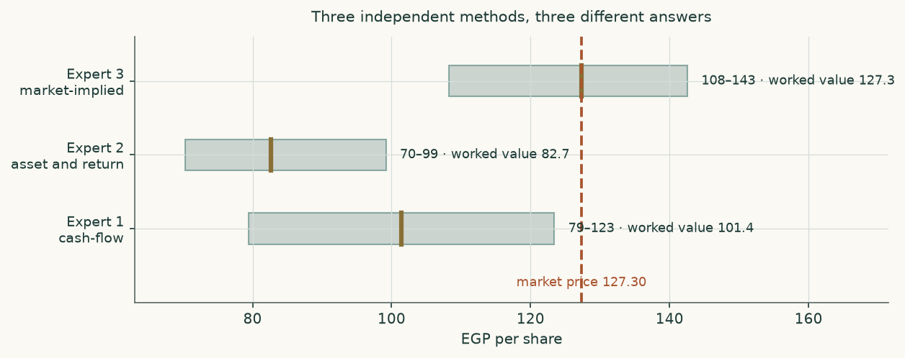
Figure 8 — three methods, three ranges, one market price.
C.6 Divergence table — which assumption drives which gap
Pair | Gap (EGP/share) | The single assumption that drives it
Expert 1 less Expert 2 | 18.76 | whether five years of forecast growth is credited at all. Expert 1 discounts it; Expert 2 refuses to pay for growth not yet earned
Expert 3 less Expert 1 | 25.88 | entirely the biologicals plant's revenue, which Expert 1 sets to zero and Expert 3 infers from the price
Frame A less Frame B | -20.19 | the credit-loss and provision charge alone — 5.25% of revenue permanently against a decay to 2.5%. Nothing else differs between the two
Frame A centre less market price | -25.88 | the sum of the above: no plant revenue, a relative lens anchored on what the company's own return justifies, and a normalised rather than peak margin
Frame B centre less market price | -5.69 | the same, with the provision charge normalising instead of permanent
Frame A centre less Frame B centre | -20.19 | the contested judgement alone, carried through the whole model. This is the number an average would have hidden

Table 24 — every gap in this study isolated to the assumption that causes it.
About this study
This is an independent, educational valuation study. It was prepared from the company's own audited financial statements and its own published operating disclosures, obtained directly from its investor-relations page. The valuation model behind it is a live spreadsheet: every figure that can be derived from a driver is a formula, and changing a driver reprices the model. That claim was tested on the delivered file rather than asserted — every formula cell was independently recalculated and reconciled to the model, and each input was perturbed in place to confirm the answer moves in the right direction.
The probability map in section 3 comes from a simulation engine calibrated on the Egyptian market as a whole and tested by re-running it across the full price history without letting it see the future. What that testing establishes about this individual share — how often the outcome fell inside the band, whether it fell uniformly within it, and how wide the band is — is reported in section 3, with the window counts behind each figure.
Disclosure
This document is educational analysis, not investment advice, and not a recommendation to buy, sell or hold any security. It contains no rating and no price target. Fair value is expressed as a range and as a distribution because that is what the evidence supports.
The author holds no position in the securities discussed and receives no compensation from the company, its shareholders or any party with an interest in its share price. The study was not commissioned by, shown to, or reviewed by the company before publication.
All historical financial figures are the company's own audited consolidated figures as published in its annual reports. Forward-looking figures are the author's estimates and will be wrong in detail; the sensitivity analysis in section 1.9 and the caveats in section 7 state by how much and in which direction. Market data used for peer comparison is labelled as such and is not used to construct any figure about the subject company.
Past performance and back-tested performance are not guides to future results. A probability band is not a guarantee: one outcome in ten is designed to fall outside a 90% band.

