**Section A**

**Answer ALL questions (30 X 1 = 30)**

1. **--------------is used to identify a computer on a local network.**
2. IP address
3. Computer User name
4. MAC address
5. Serial number
6. **The following are output devices except-----------**
7. Printer
8. Monitor
9. webcam
10. speaker
11. **----------- was used in creating third-gen computers.**
12. Transistors
13. Vacuum tubes
14. Logic gates
15. Silicon processors
16. **A CPU consists of----------.**
17. CUDA cores
18. Microcontrollers
19. Microprocessors
20. cores
21. **Computers have ---------main components.**
22. 4
23. 3
24. 18
25. 1
26. **--------------- is the brain of the computer.**
27. CPU
28. GPU
29. RAM
30. Motherboard

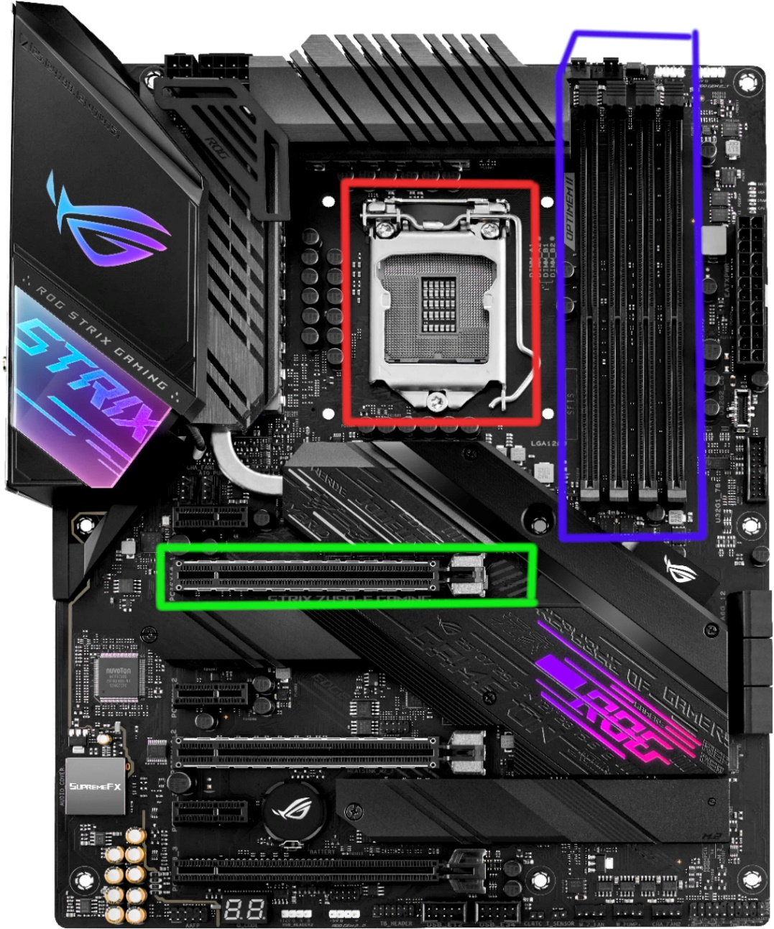

1. **The green box holds the --------------**
2. CPU
3. GPU
4. RAM
5. Hard disk
6. **The Red box is for -----------.**
7. CPU
8. RAM
9. GPU
10. Hard Disk
11. **The Blue box is for --------**
12. RAM
13. Hard Disk
14. GPU
15. CPU
16. **The following image is a screenshot of (a)----------**

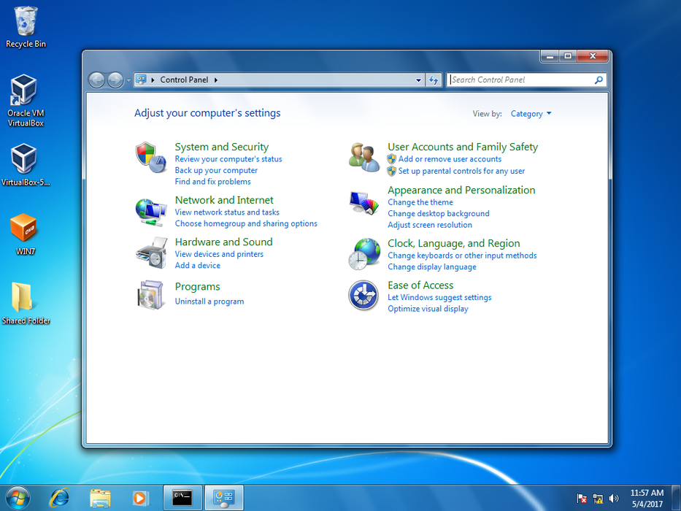

1. Control Panel
2. Windows Explorer
3. Chrome
4. Internet explorer
5. **Hardware and Sounds can be accessed through---------**
6. windows
7. Mozilla Firefox
8. Google Chrome
9. Control Panel
10. **--------- is used to make adjustments to your computer**
11. Disk manager
12. Google Chrome
13. CorelDraw
14. Control Panel
15. **GPU stands for --------**
16. Graphic Processing Unit
17. Global Prevention Unit
18. General Purpose Unit
19. General Protocol Unit
20. **Splitting of disks into a different volume of sizes is done through---------and it is referred to as**

**--------.**

1. Disk management, Disk Partition
2. Device management, Disk splitting
3. Diagnosis, Troubleshoot
4. Eject, Disk format
5. **---------is used to update hardware drivers.**
6. Driver’s Update
7. Control Panel
8. General Properties
9. Device manager
10. **--------is the process of reducing an icon size on your desktop.**
11. Right-click => Sort by => Size
12. Right-click => view => small
13. Right-click => New => Folder
14. Right-click => Refresh
15. **“mkdir” stands for--------**
16. make directory
17. mike dirham
18. make direction
19. I don’t know
20. **CMD is a____.**
21. Command prompt interface
22. A black box
23. A program
24. An IDLE
25. **Patrick decided to delete the boot file inside his windows folder, He might not be able to**

**---------**

1. On his computer after shutdown
2. Open an app on his computer
3. Recover his boot file
4. I don’t know
5. **The following image is a screenshot of----------**

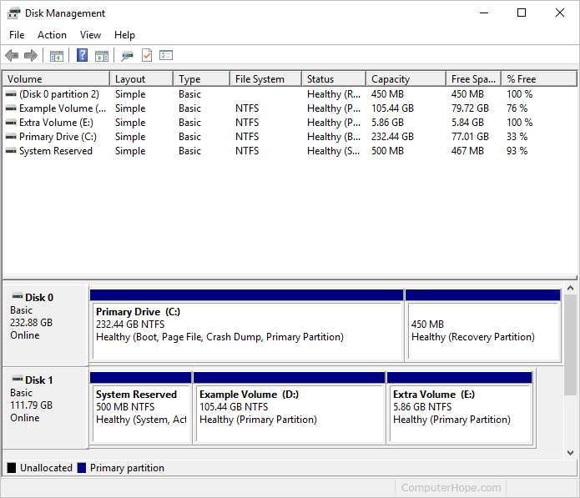

1. Device manager
2. Disk management
3. Disk Partition
4. EaseUs Partition Manager
5. **LAN stands for --------------**
6. Local Area Network
7. Long Antenna Network
8. Logistics and Area Networking
9. None of the above
10. **Identify the following numbers accordingly.**

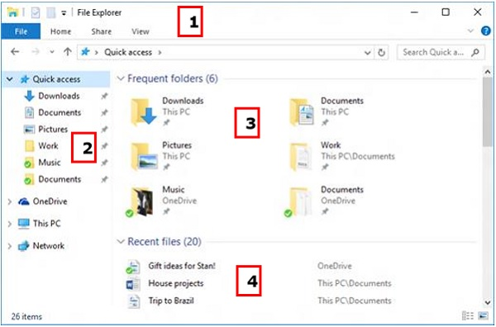

1. File Explorer ribbon, Navigation Pane, Frequent folders, Recent files section
2. Navigation Pane, Frequent folders, File Explorer ribbon, Recent files section
3. Recent files section, Frequent folders, File Explorer ribbon, Navigation Pane
4. Navigation Pane, Recent files section, File Explorer ribbon, Frequent folders
5. **Example of an IP address**
6. 44050594893882
7. 123.456.1.1
8. 12.3
9. 1234.566.77777
10. **The following image is an image of.**

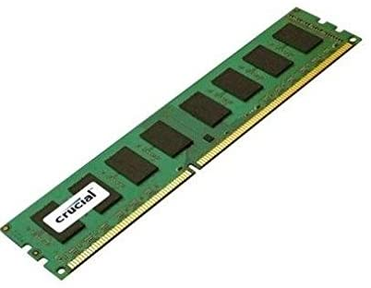

1. RAM
2. CPU
3. GPU
4. Hard Disk
5. **-------------- is volatile.**
6. RAM
7. Hard disk memory
8. Sd card
9. Flash drive
10. **Windows 10 is an----.**
11. Application
12. Server OS
13. Network
14. None of the above
15. **------------- is used to access the user directory.**
16. Cd user
17. Ping user
18. Config user
19. mkdir user
20. **Drivers can be installed both online and locally.**
21. yes
22. no
23. **----------- can be used to change the time and date of a computer.**
24. settings
25. control panel
26. file explorer
27. desktop
28. **The image below is an image of___**

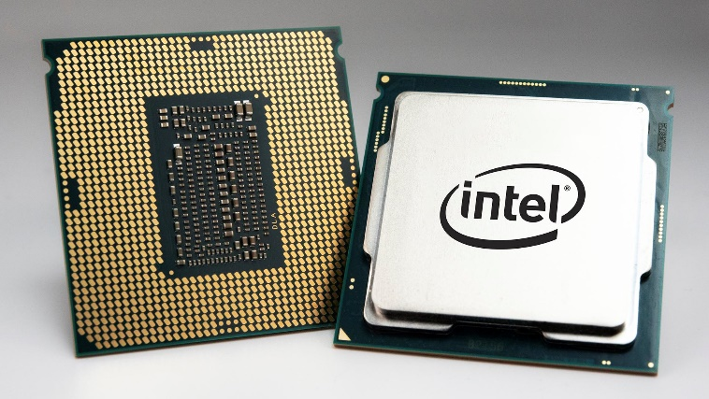

1. CPU
2. Hard disk
3. GPU
4. Arduino

**Section B**

**Write down the answers for the following questions 3 X 10 = 30**

1. **Write down the given command to open a folder on vscode through cmd.**

Answer:

>>Mkdir (File name/project name)

>>Cd (File name/project name)

>>code

1. **Write down the steps to create a LAN.**

Answer:

Items needed

Computer with a network adapter, router, or access point.

Disable all firewall software.

Make sure the computer is off

Set up the router by connecting it to power and connect a network cable to your computer network port from the router network port

On your computer and let your computer recognize your router

Open up your browser and enter your router IP address (it’s mostly located at the back of your modem)

If prompted enter your username and password

Run your router setup wizard

Open your network sharing center

Setup a new connection

Click **Next**, and then follow the on-screen instructions to set up a wireless network. When the network setup is complete, continue to the next step to connect to the network.

1. **State five merits and demerits of LAN and WAN**

**Merits of LAN:**

* Low cost
* Easy configuration
* Easy to manage:
* Speed​​:

**Demerits of LAN**

* Data sharing is limited to system availability
* Insecure due to high exposure
* Network range is very limited

**Merits of WAN:**

* Wide range coverage
* Accessible to more users
* Secure due to better technology used such as ipv6 and HTTP

**Demerits of WAN**

* Speed might reduce based on network coverage range
* Low bandwidth
* Cost is expensive

1. **Explain the steps to format a computer.**

Get your OS boot media into a flash drive from the OS website e.g. windows 10 from Microsoft.com

Connect your flash drive to your system

Reboot your system and enter the BIOS setting by clicking F12

Select your USB

Boot from your USB

Wait till an interface comes up

Follow the instructions carefully

Note: when getting to the disk selection, make sure you chose the appropriate drive to install your window(for clean window install) or, choose to keep all documents and wipe all programs and reset windows to default settings.

1. **Should someone ask you to get a CPU that has a great clock speed, how would you go about it?**

Answer:

CPU time = I x CPI/R

I = instructions

CPI = Cycles per instruction

R= clock rate = 1/T

**Section C**

**Write down the answers for the following questions 2 X 20 = 40**

* 1. **What is an operating system?**

Answer:

An operating system is a system software that manages computer hardware, software resources, and provides common services for computer programs, such as managing files, tweaking computer settings like time, internet usage limit, changing image background etc. It can also be referred as the middle man in a computer.

* 1. **Point out the error in this command, type in the correct command**

**cd://documents/test**

**Answer:**  1) cd://documents/test

2) cd documents\test

* 1. **What is a log file and why is it useful?**

**Answer:**

A log file is a file that records either events that occur in an operating system or other software runs, or messages between different users of a communication software. Logging is the act of keeping a log. In the simplest terms, messages are written to a single log file. They are very useful because you can always go back to your logfile of your program or system to identify an error if one occurs at a given task at a given time

* 1. **Supposed I created a home network and I can’t add a specific computer, how can I resolve this issue?**

Answer: check if the user is connected to the home network by checking your list of computers available under your network or, you can ping the computer to identify it on your network