DRAW THE PATH: PORTFOLIO SITEMAP + AI TOOLKIT
Assignment Submission

1. One-Paragraph Proof Statement
I combine Mechatronics Engineering, Artificial Intelligence, automation, and human-centered design to build practical, intelligent solutions that solve real-world problems. My work spans AI/ML model development, robotics and autonomous systems, data analysis, and intuitive UI/UX design, with projects exploring applications in agriculture, healthcare, education, and automation. I enjoy transforming complex challenges into useful technology products that are accessible, purposeful, and capable of creating meaningful impact for people and communities.
2. One-Line Why
I build technology that creates meaningful impact and empowers people to live and work better.
3. Portfolio Sitemap
The sitemap is intentionally small and follows the visitor journey from understanding my claim to seeing evidence, building trust, and taking action.
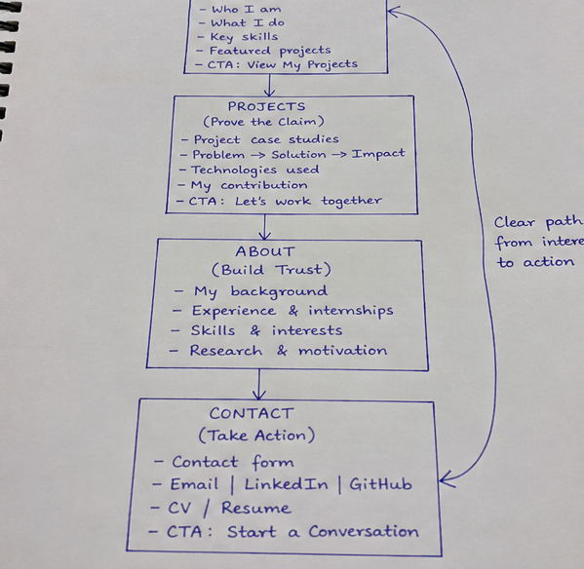
Figure 1. Portfolio sitemap sketch: Home → Projects → About → Contact.
4. Sitemap Logic
- Home — Make the Claim: clearly communicates who I am, what I build, and why it matters.
- Projects — Prove the Claim: presents selected projects as evidence of my engineering, AI, automation, and problem-solving abilities.
- About — Build Trust: explains my Mechatronics Engineering background, experience, interests, and motivation.
- Contact — Take Action: gives visitors a clear path to contact me for research, employment, internship, collaboration, or technology opportunities.
5. AI Workspace Configuration
Workspace name: Sherifudeen AI Portfolio Builder
My AI workspace is configured as my portfolio tutor, strategist, UX advisor, and build partner. Its instructions include my background, proof statement, target audience, desired action, and a requirement to pressure-test ideas rather than simply agree with them.
6. Configured AI Workspace Evidence
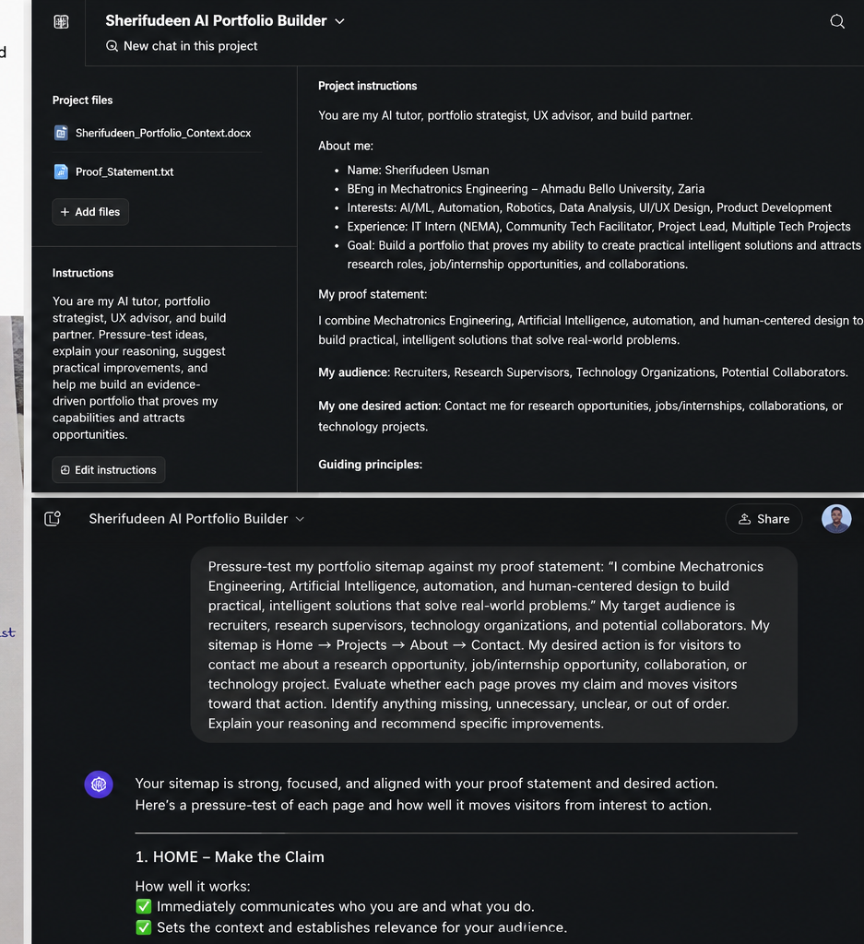
Figure 2. Workspace configuration and pressure-test visual evidence. For formal submission, this visual should be replaced with the direct screenshot from the actual configured AI workspace if required by the assessor.
7. Custom Instructions Used in the AI Workspace
I am Sherifudeen Usman, a Mechatronics Engineering graduate from Ahmadu Bello University, Zaria. My interests and practical experience include Artificial Intelligence, Machine Learning, automation, robotics, Python, data analysis, UI/UX design, technology education, and building technology solutions for real-world problems.
My portfolio proof statement is: “I combine Mechatronics Engineering, Artificial Intelligence, automation, and human-centered design to build practical, intelligent solutions that solve real-world problems.”
My target audience includes recruiters, research supervisors, technology organizations, and potential collaborators. My main portfolio goal is to demonstrate evidence of my capabilities and encourage visitors to contact me for research opportunities, employment, internships, collaborations, or technology projects.
Act as my AI tutor, portfolio strategist, UX advisor, and build partner. Do not simply agree with my ideas. Pressure-test them, explain your reasoning, identify weaknesses, and suggest practical improvements. Keep the portfolio focused, professional, human, and evidence-driven. Do not recommend additional pages or features unless they serve a clear purpose.
8. Pressure-Test Prompt
Pressure-test my portfolio sitemap against my proof statement: “I combine Mechatronics Engineering, Artificial Intelligence, automation, and human-centered design to build practical, intelligent solutions that solve real-world problems.”
My target audience is recruiters, research supervisors, technology organizations, and potential collaborators.
My sitemap is:
Home → Projects → About → Contact
My desired action is for visitors to contact me about a research opportunity, job/internship opportunity, collaboration, or technology project.
Evaluate whether each page proves my claim and moves visitors toward that action. Identify anything missing, unnecessary, unclear, or out of order. Explain your reasoning and recommend specific improvements.
9. Pressure-Test Output
The sitemap is strong, focused, and aligned with my proof statement and desired action. It creates a clear progression: Claim → Evidence → Trust → Action.
Home — Make the Claim: immediately communicates who I am and what I do and establishes relevance for the audience.
Projects — Prove the Claim: provides the strongest evidence of my capabilities. Each project should clearly show the problem, my role, the solution, technologies used, and result or learning.
About — Build Trust: gives visitors enough background to understand my engineering education, experience, interests, and motivation.
Contact — Take Action: provides a clear next step for research opportunities, employment, internships, collaboration, or technology projects.
Recommended change: add two or three selected project previews to the Home page so visitors encounter evidence immediately. Keep the main navigation simple and avoid unnecessary pages.
10. Change I Will Make
- Add 2–3 selected project previews directly to the Home page.
- Turn my strongest projects into concise case studies.
- Make my personal contribution explicit rather than describing only the project.
- Keep the main navigation focused on Home → Projects → About → Contact.
- Use a consistent call to action such as “Let’s Build Something Useful” to guide visitors toward collaboration or opportunities.
11. Final Portfolio Journey
Claim → Evidence → Trust → Action
The portfolio will not try to prove that I know everything. It will prove that I can identify meaningful problems, combine engineering and AI, build practical solutions, and learn through doing.

