EBS Volumes

In AWS (Amazon Web Services), EBS (Elastic Block Store) volumes are block-level storage devices that you can attach to EC2 (Elastic Compute Cloud) instances.
An EBS volume is like a virtual hard drive in the cloud. It provides durable, high-performance block storage that persists independently of the life of an EC2 instance.
EBS Volumes are used just like a Volumes concept in Docker, in Docker these volumes are used to store the data persistently with independent of Docker containers.

Key Features of EBS:
- Persistent Storage: Data on EBS volumes persists (Long-term storage/Durability) even after the associated EC2 instance is stopped or terminated (unless explicitly deleted).
- Attach to EC2 Instances: You can attach an EBS volume to one EC2 instance at a time (except for Multi-Attach with some volume types).
- Snapshots: You can create point-in-time backups (called snapshots) which are stored in Amazon S3.
- Scalable: You can resize or change the performance characteristics of your EBS volumes.
- Encrypted: Volumes can be encrypted for data at rest and in transit.

Note: EBS volumes should create in the same available zone, where the EC2 instance/machine is available/created.

Types of EBS Volumes:
- General Purpose SSD (gp3 / gp2) – Balanced price/performance.
- Provisioned IOPS SSD (io2 / io1) – High performance, designed for critical workloads.
- Throughput Optimized HDD (st1) – Low-cost, high-throughput for big data.
- Cold HDD (sc1) – Lowest cost, infrequent access workloads.
- Magnetic (standard) – Legacy, not commonly used anymore.

Use Cases:
- Hosting a database like MySQL or PostgreSQL.
- Running applications that require fast, persistent storage.
- Storing application logs, data files, or container storage.
- Boot volumes for EC2 instances (the operating system disk).

Instance Store Volumes:
In AWS, an Instance Store Volume is temporary (ephemeral) block-level storage that is physically attached to the host server on which your EC2 instance runs.
Features:
- Temporary storage that only lasts for the lifetime of the EC2 instance.
- Also called ephemeral storage.
- It is physically attached to the host machine, offering very fast I/O performance.
- Data is lost if the instance is stopped, terminated, or fails.

EC2 Instance Types That Support Instance Store:
Not all EC2 instances offer instance store volumes. It’s available mostly on older generation and storage-optimized or compute-optimized instances:
Instance Family | Instance Types with Instance Store
C (Compute) | c3, c5d, c6gd, etc.
D (Dense storage) | d2, d3, d3en, h1
I (I/O optimized) | i2, i3, i3en, i4i
M (General) | m3, m5d, m6gd, etc.
R (Memory) | r3, r5d, r6gd, etc.
Z (High compute/memory) | z1d
X, F | Some instances in these families

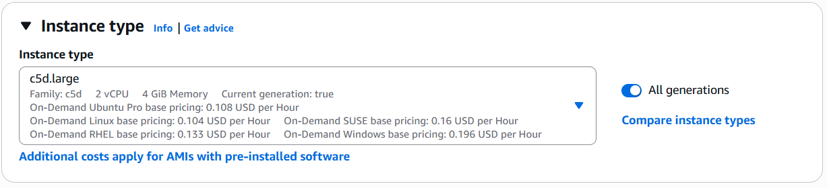
Fig: Instance type is c5d.large.
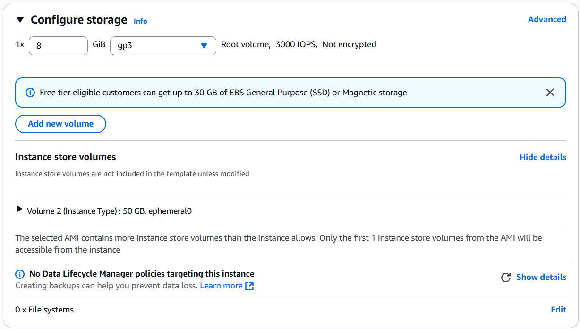
Fig: A default instance volume (volume 2, 50GB) is added to the instance type c5d.large.

Note: These instance store volumes are fixed in size we cannot edit or modify them.

Now let’s work with the EBS volumes practically.

Procedure: Create an EC2 instance add/attach the EBS volume to it.

Step1: Create an EC2 instance (Windows) by creating VPC, RT, IGW, subnet and SG.

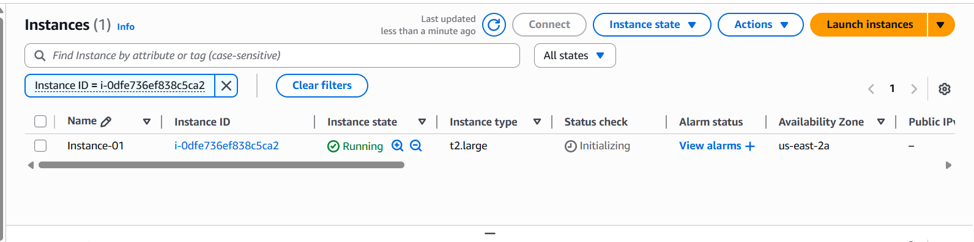
Fig: EC2 instance is created in the AZ of us-east-2a.

Note: Choose the instance type t2.large (2CPU, 8GB) to support the windows OS Instances.

To connect to the windows EC2 instance, we have to choose RDP client, and upload private key file, then the file get Decrypted to generate the password for the instance, by using this password we can login/connect to the EC2 instance.

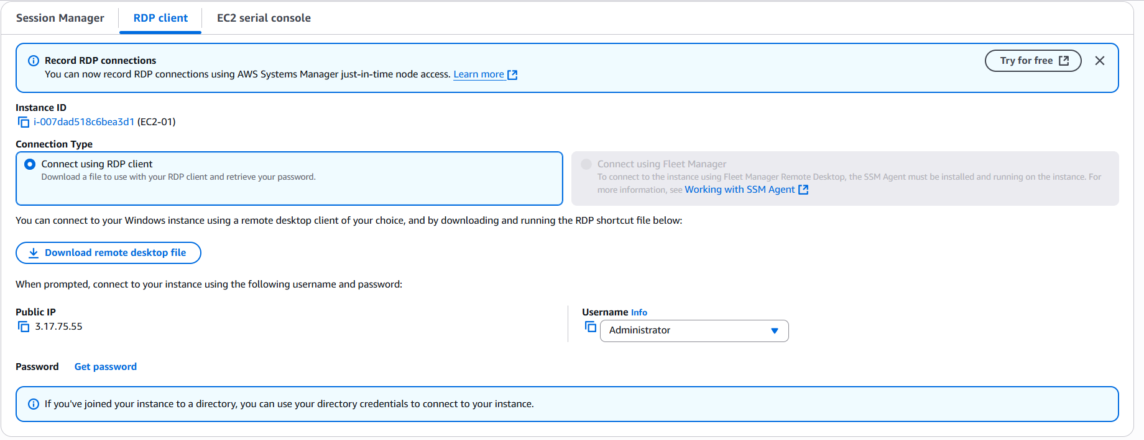

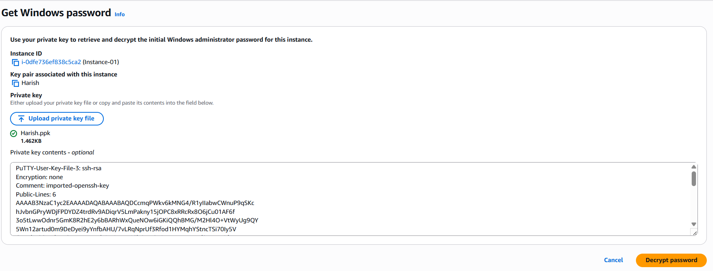
Fig: Decrypt password.

Note: The private key should be .pem file (not the ppk file) is used to generate the password.
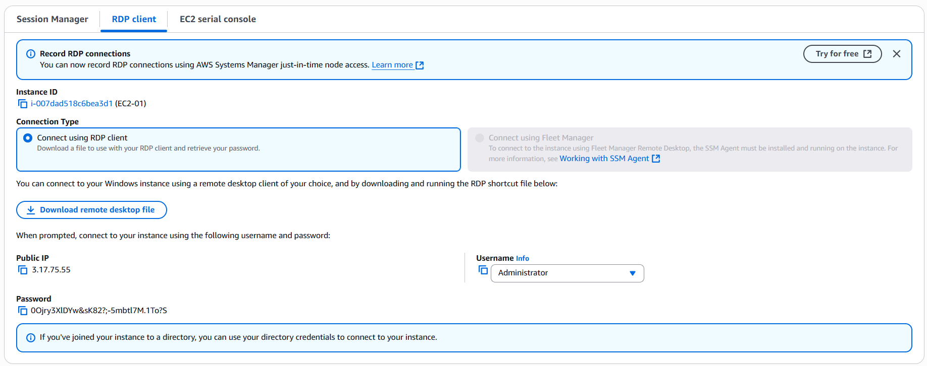
Fig: Password is created.

Username: Administrator
Password: 0Ojry3XlDYw&sK82?;-5mbtl7M.1To?S
Public IP: 3.17.75.55
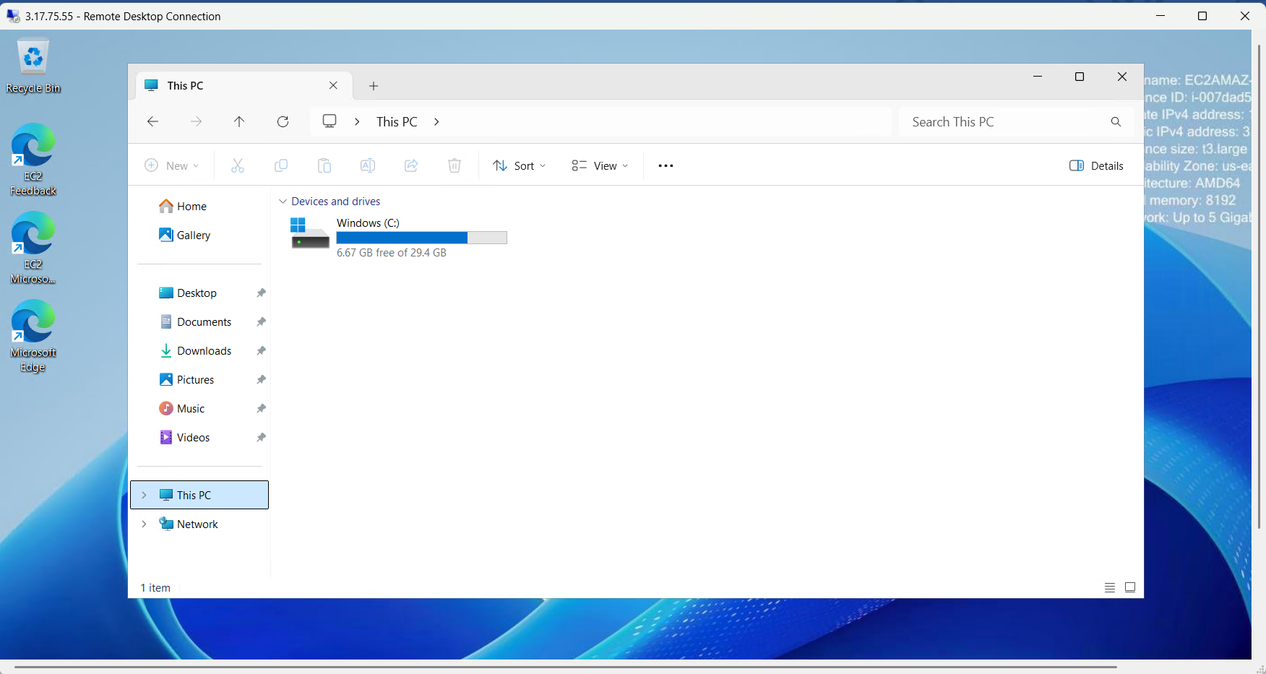
Fig: Only C-Drive [Windows (c)] is present with the Windows instance.

Now the requirement is we have to add the extra storage Volume/Drive (EBS volume) to the above EC2 instance.

Step2: Now create the EBS volume in the same Available zone (us-east-2a) in which EC2 instance is created.
Go ToEC2EBS volumeCreate volume.
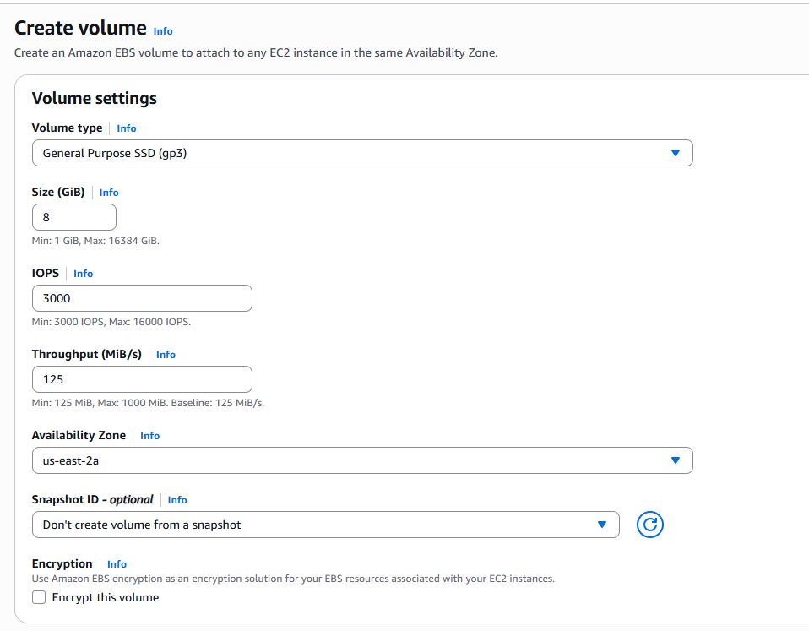
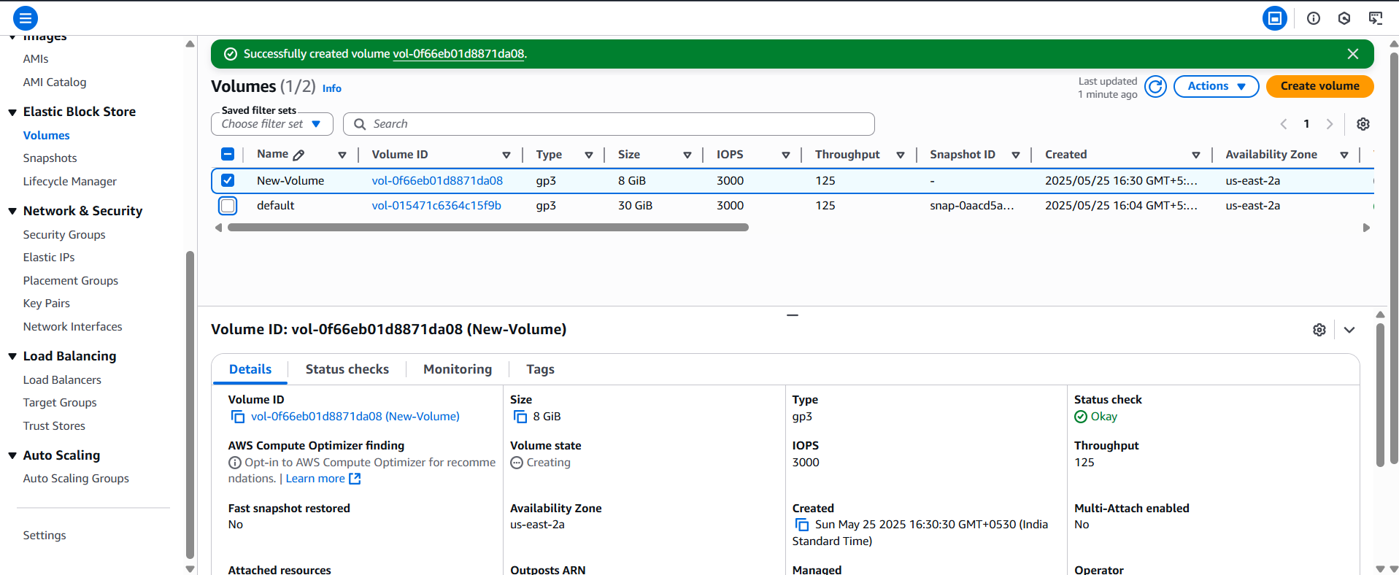
Fig: EBS Volume (New-Volume) is created successfully in AZ of us-east-2a.

Step3: Attach the EBS Volume (New-Volume) to the instance (Instance-01).

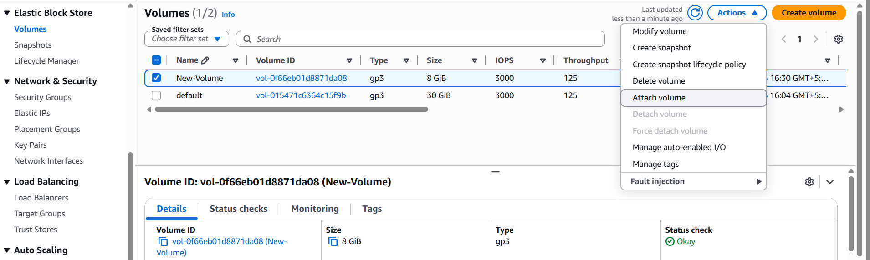
Fig: Attaching the EBS volume (New-Volume) to the instance.
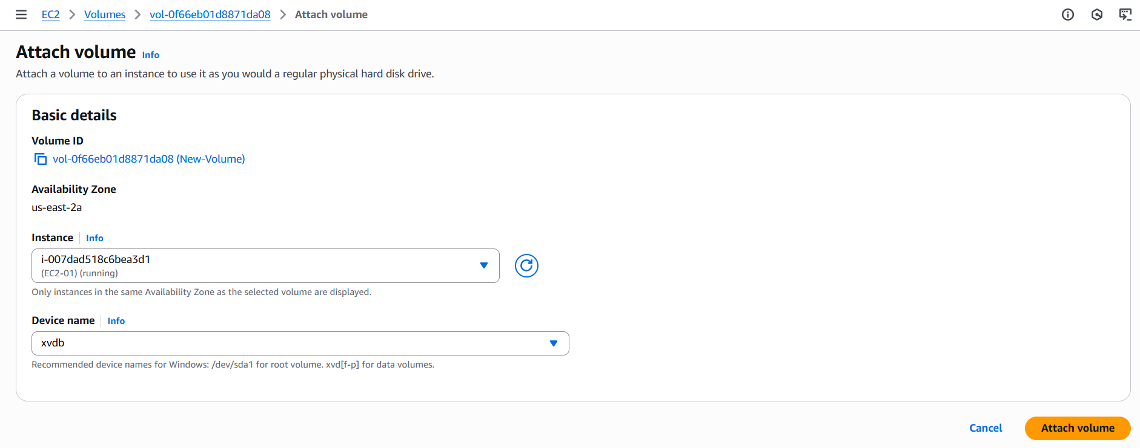
Fig: Configuring the Attachment.
Instance-01 ID

After attaching the EBS volume to the instance we unable see this volume in the EC2 instance (Windows/Linux), for this we have to some settings or configuration in the EC2 instance (Windows).
As shown in below figures.
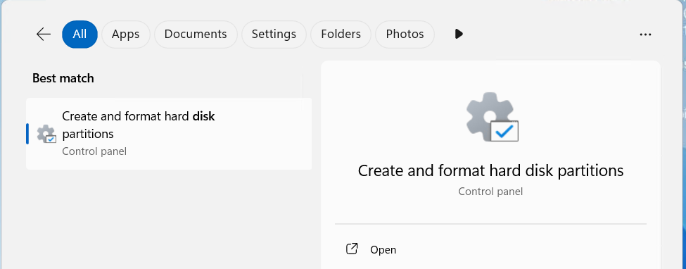
Fig: Disk management (In windows instance).
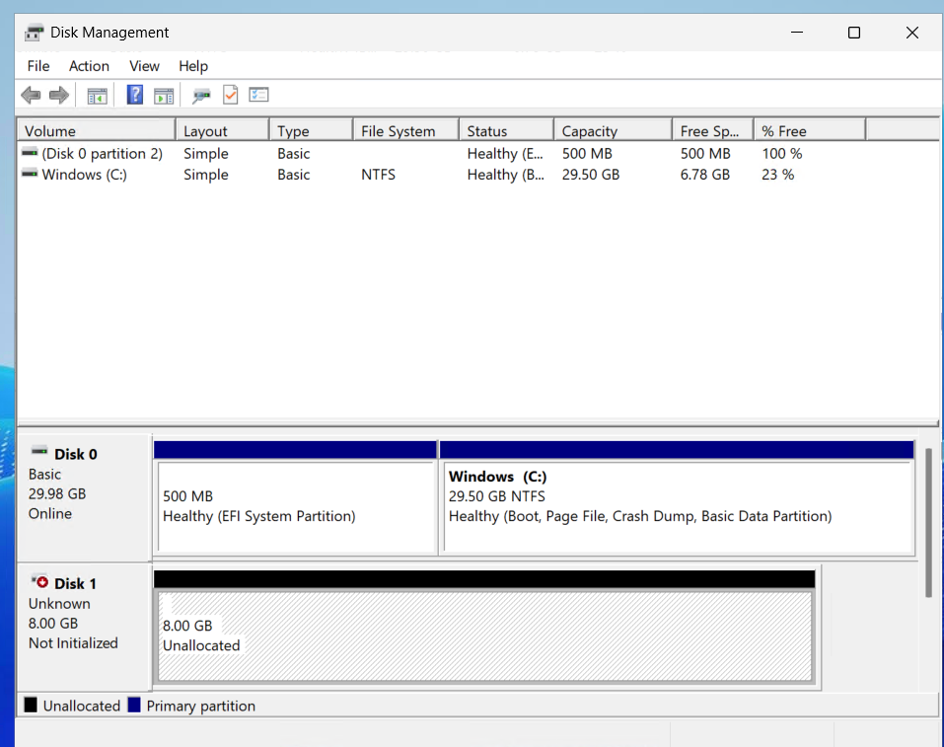
Fig: Dick (New-Volume) is attached successfully.

But the new Disk (New-Volume) is not initialized (offline) it, so we have to initialize by right clicking on it.
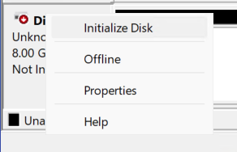
Fig: Initializing Disk

After right clicking and initializing the disk, the disk will come online, now right click on the volume and click “New simple volume”.
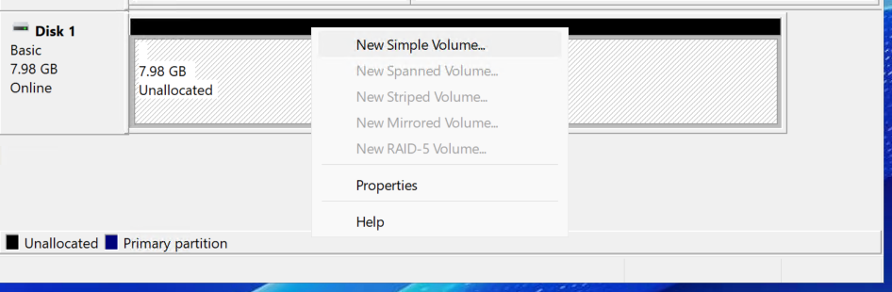
Fig: New simple volume.
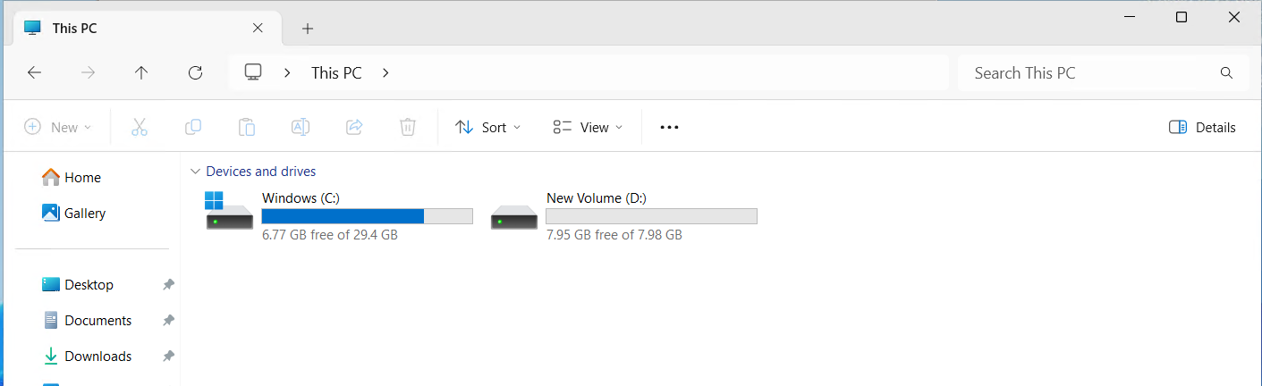
Fig: New-Volume is attached to the instance-01 successfully.

Note: A single EBS volume cannot be attached to the multiple EC2 instance at a time. But we can use EFS volume (shared volume).

Attaching of EBS Volumes with Linux machines (EC2).

Now attach the EBS Volume to the Linux EC2 instance.

Step1: Create the EC2 instance (Linux), by creating VPC, subnet, IGW, RT and SG.

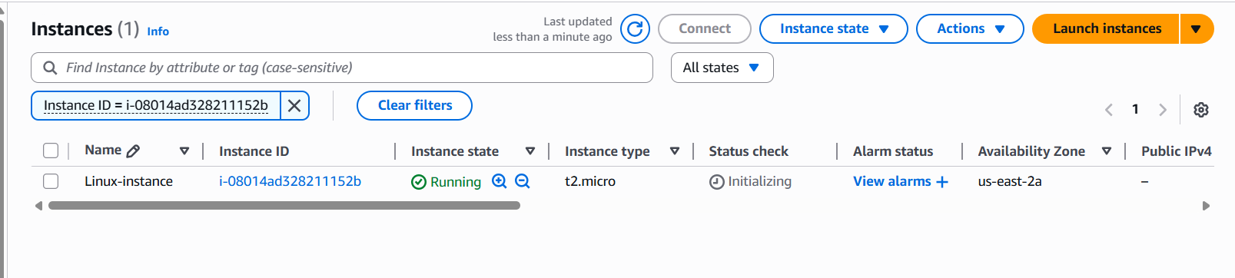
Fig: Linux instance created.

Step2: Now login to the Linux instance check how many Volumes (Disk) present.
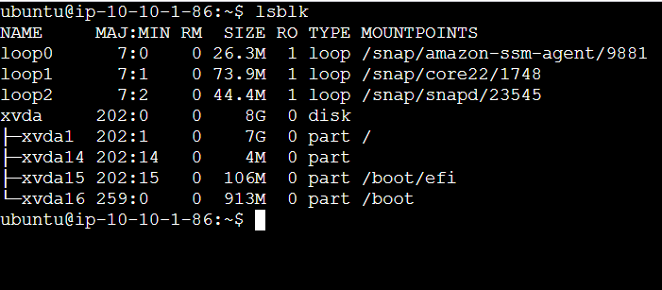
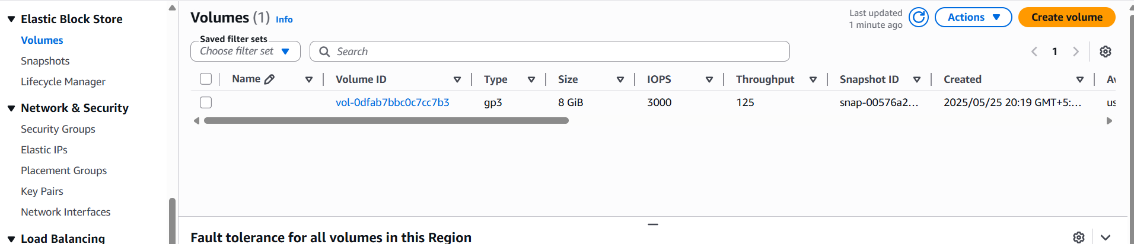
Fig: Default volume (Disk) present with Linux instance is 8GB size.

Step3: Create New EBS volume (New-Disk) in a same AZ (us-east-2a) and attach it to the Linux instance.

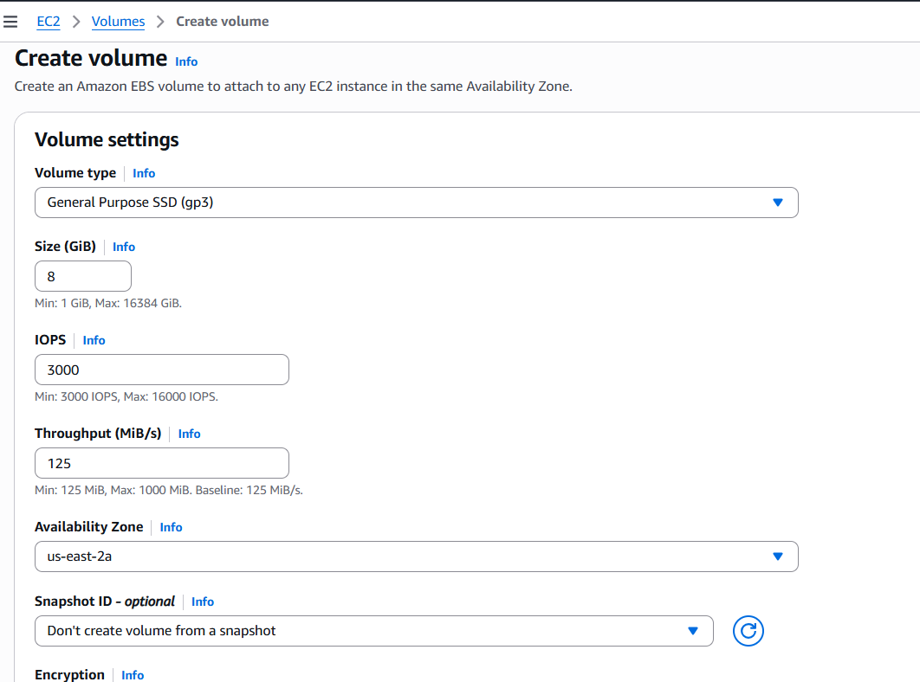
Fig: EBS volume (size 8GB) configuring in the same AZ us-east-2a.

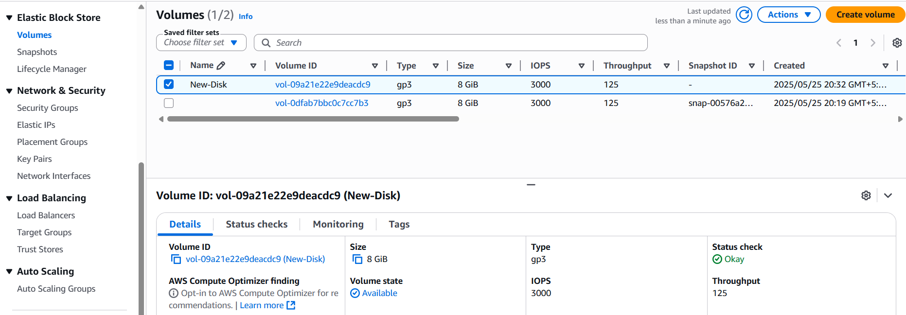
Fig: New EBS volume (New-Disk) is created.

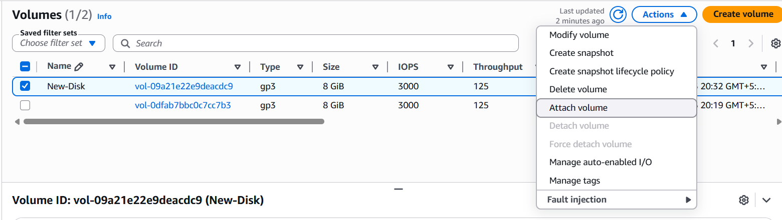
Fig: Attaching the New-Disk with the Linux instance.
Linux-instance ID

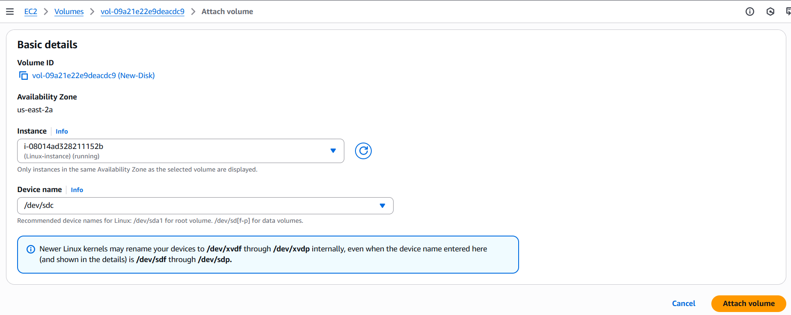
Fig: Configuring attachment with Linux Instance.
Internal Disk name (/dev/sdd).

Now once check in the Linux EC2 instance whether it is attached or not.
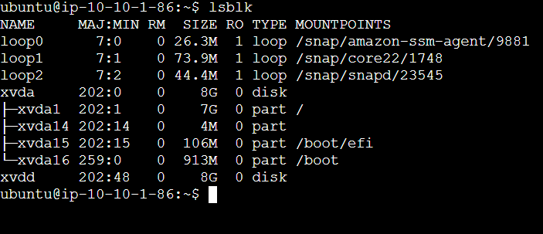
In above figure we can see the extra new disk (xvdd 8GB) attached successfully.
But we can use this disk until unless we mount this volume to any folder.

Step4: Mount the volume (xvdd 8GB) to a specific folder by creating a folder.

To add a new disk to a Linux instance and make it usable (i.e., mount it to a folder), you must perform a few steps before mounting. Here's a clean step-by-step guide:

Steps to Add and Mount a New Disk in Linux
Assuming the new disk appears as /dev/xvdd, here’s what you do:

1. Confirm the New Disk is attached
Command: lsblk
Look for a device like /dev/xvdd with no partitions under it.

2. Partition the Disk
Use fdisk to create a partition on the new disk:
Command: sudo fdisk /dev/xvdd
Inside the “fdisk” prompt:
- Press n to create a new partition
- Press p to make it primary
- Press 1 for the partition number (default)
- Accept default start and end sectors (just press Enter)
- Press w to write and exit
You should now have /dev/xvdd1 (partition 1 on the disk)

3. Format the New Partition
Format it with a filesystem (e.g., ext4):
Command: sudo mkfs.ext4 /dev/xvdd1
You can also use xfs, btrfs, etc., depending on your needs.
To store files on Disk, you need to put a filesystem on it — like creating a filing system in a cabinet.

4. Create a Mount Point (Folder)

Command: sudo mkdir /mnt/data
You can name the folder anything, like /mnt/backup, /data, etc.

5. Mount the Partition

Command: sudo mount /dev/xvdd1 /mnt/data
Now the disk is usable at /mnt/data.

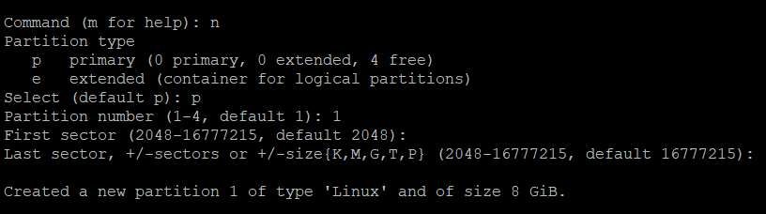
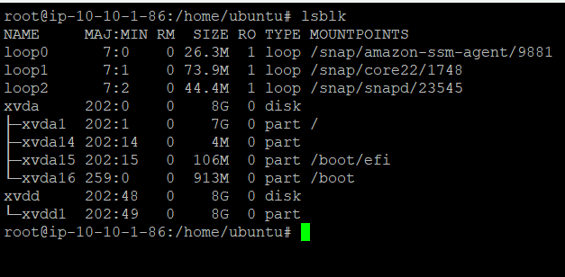
Fig: New partition is created (xvdd1).

Now format the new partition.
Command: mkfs.ext4 /dev/xvdd1

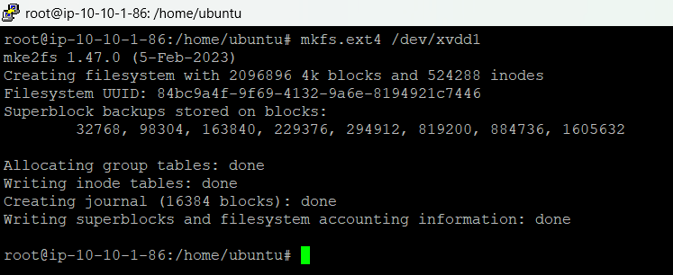
Fig: File system is put on this Disk.

Now create a mount point by creating a new folder.
Command: mkdir /mnt/data
Then mount the disk to the mount point (folder: /mnt/data).
Command: mount /dev/xvdd1 /mnt/data
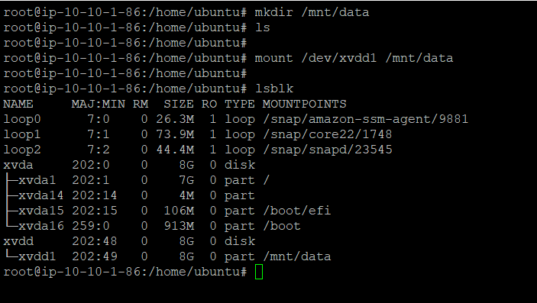

Now if we upload whatever the data in the folder (/mnt/data) it is stored in the New-Disk (xvdd1). Now we can use this Newly added Disk efficiantly.

