RDS (Relational Data Base Service )

Amazon RDS (Relational Database Service) is a managed database service provided by AWS that makes it easy to set up, operate, and scale a relational database in the cloud.
Amazon RDS is a Platform-as-a-Service (PaaS) offering that handles much of the administrative overhead involved with running a database, such as: (What does RDS handles for you?).
- Creates the database for you (no manual setup needed).
- Takes backups automatically so your data is safe.
- Keeps the software updated with the latest patches.
- Watches your database and alerts you if something goes wrong.
- Let’s you increase the database size or power easily when your app grows.
AWS RDS supports multiple popular relational database engines:
- Amazon Aurora (AWS’s high-performance, MySQL and PostgreSQL-compatible engine)
- MySQL
- PostgreSQL
- MariaDB
- Oracle
- Microsoft SQL Server

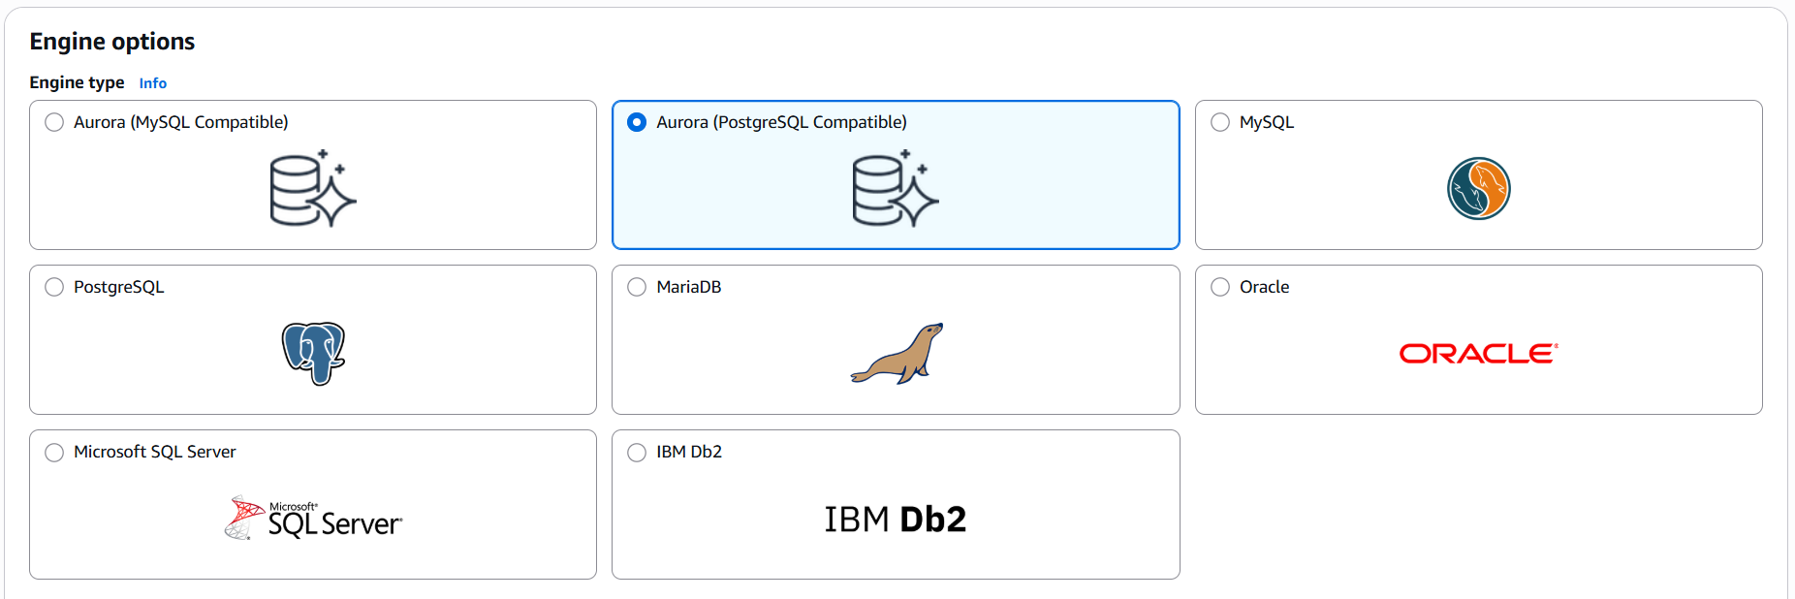

Benefits of Using RDS
- Fully managed: You focus on your app, AWS handles the DB infrastructure.
- Highly available: Built-in features for disaster recovery and HA.
- Scalable: Easily scale up/down based on your needs.
- Secure: Built-in network isolation and encryption options.
- Cost-effective: Pay-as-you-go pricing with reserved instance options.

Common Use Cases
- Web and mobile applications
- E-commerce platforms
- Business applications (e.g., ERP, CRM)
- Data analytics platforms
- SaaS applications

The Data Base services provided by the AWS is are given below:
Category | Services
Relational DB | RDS, Aurora
NoSQL DB | DynamoDB, DocumentDB
In-Memory DB | ElastiCache, MemoryDB
Time Series DB | Timestream
Graph DB | Neptune
Ledger DB | QLDB
Data Warehouse | Redshift

Now let’s work with the AWS RDS (MySQL) practically.
Procedure: Create a MySQL DB in two different AZ, next create a Windows instance, then install the MySQL workbench in the Windows instance and connect to the MySQL DB (AWS RDS) using this MySQL workbench. And try to make the Failover to the primary DB and check what happends.

Step1: Create a VPC with two subnets in two different AZ.
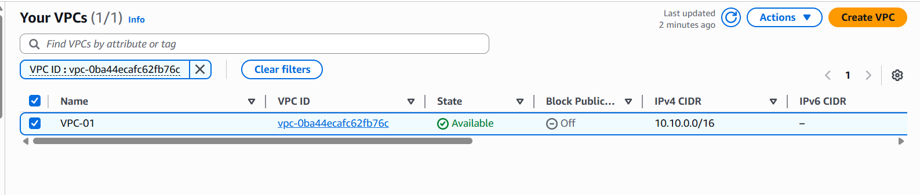
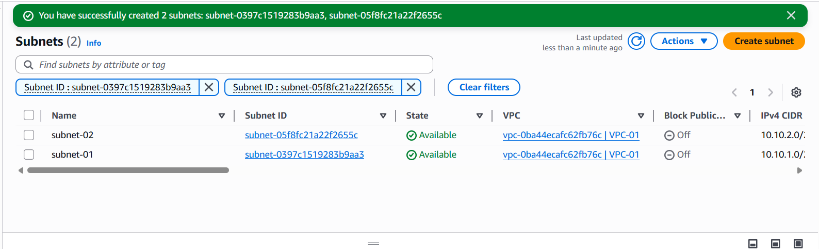
Fig: VPC (VPC-01)
Note: Enable DNS while creating VPC.
Fig: Subnet-01 (us-east-1a) & subnet-02 (us-east-1b)

Step2: Create a Subnet Group with (subnet-01 & subnet-02).
Go ToAurora and RDS (global search)Subnet groupCreate DB subnet group
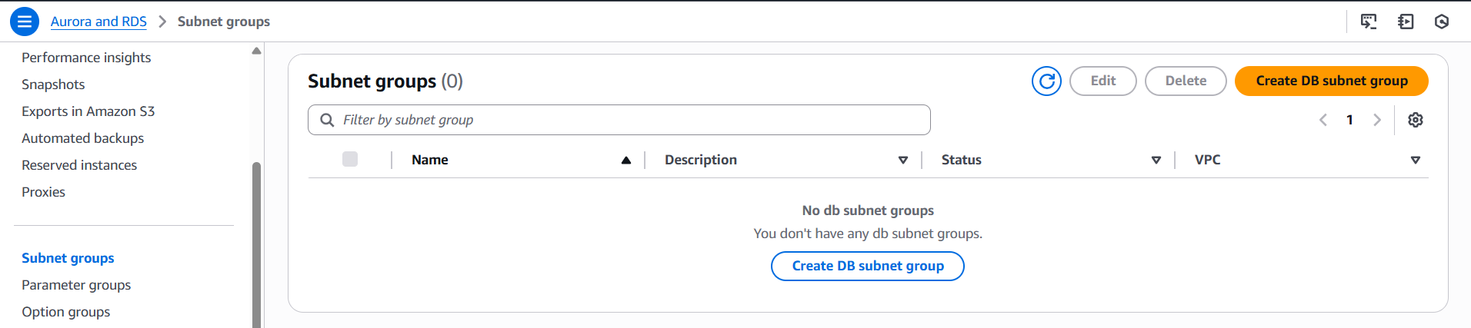
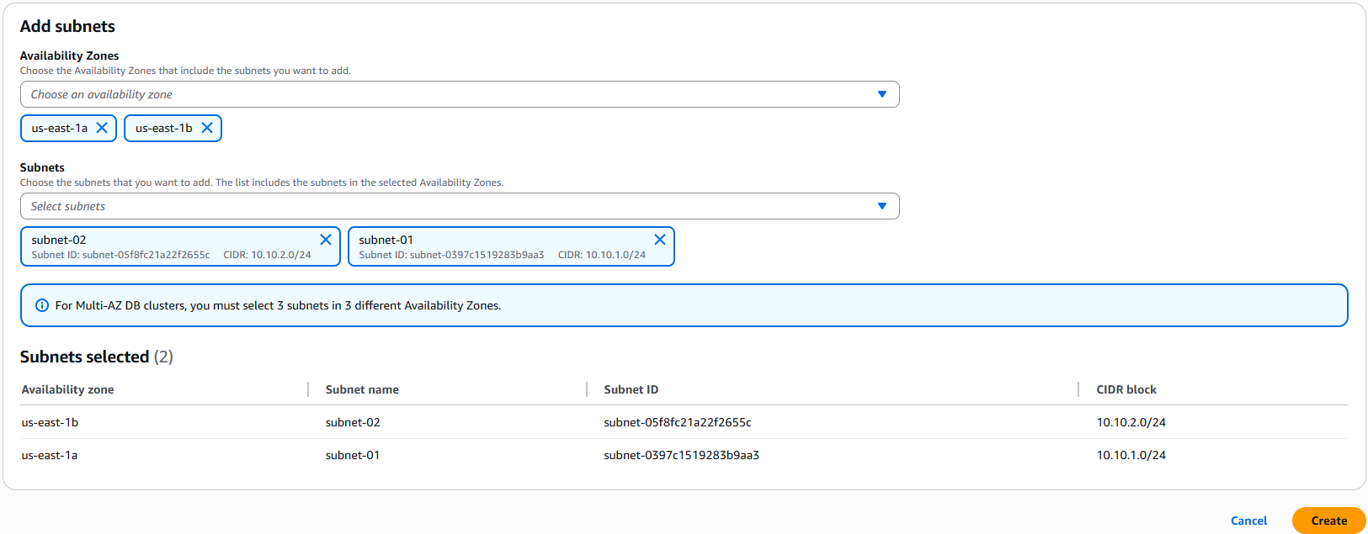
Fig: Subnets (subnet-01 & subnet-02) added to subnet group (MySQL-subnet-group).
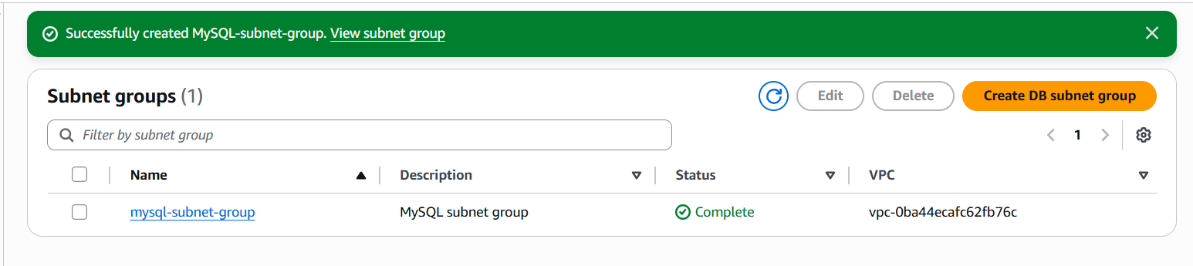
Fig: Subnet group (MySQL-subnet-group) is created successfully.

Step3: Create MySQL (RDS) by replicating it in two AZ (us-east-1a & ua-east-1b).
Go ToAurora and RDS (global search)DatabaseCreate databaseSelect MySQL Basic configurations
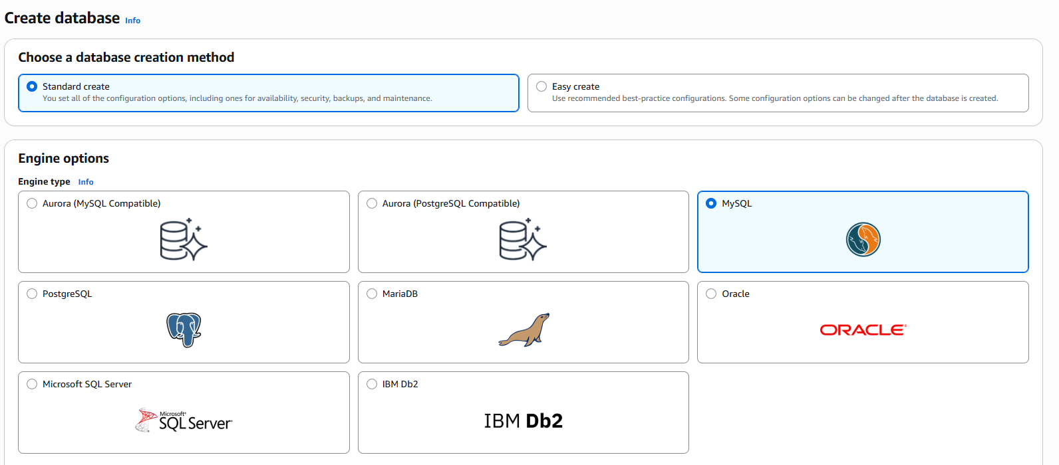
Fig: Choose MySQL DB.
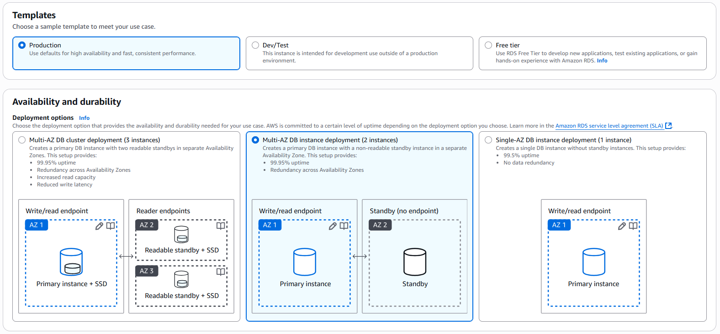

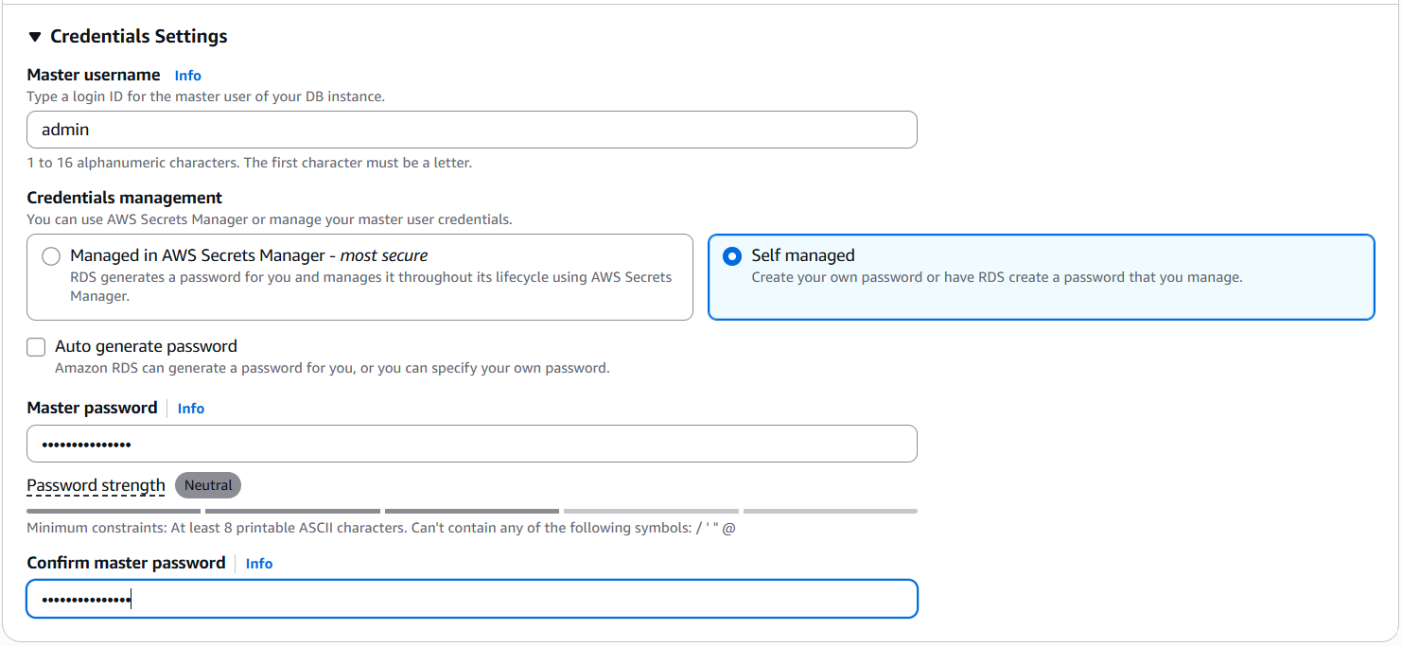
Fig: Configuring the credentials of MySQL.

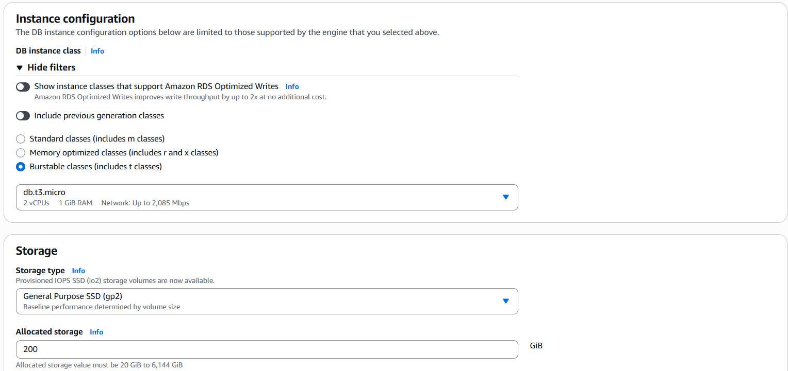

Fig: Configuring of instance & storage.

Note: gp2 storage type get low cost.

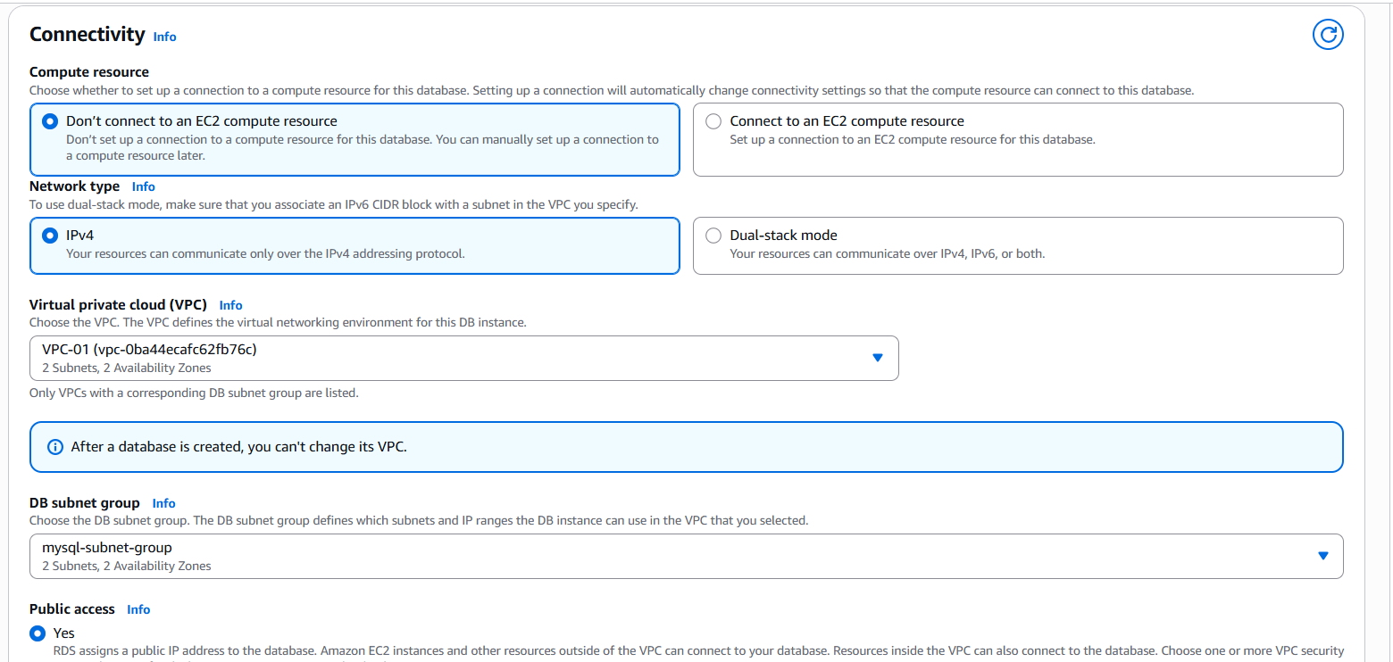
Fig: Connectivity configuration.

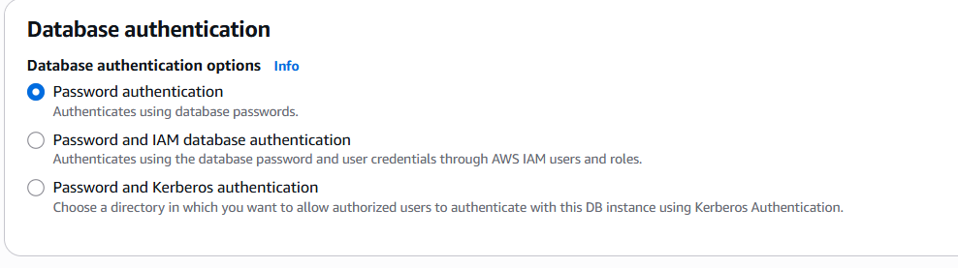
Fig: Choosing password authentication.

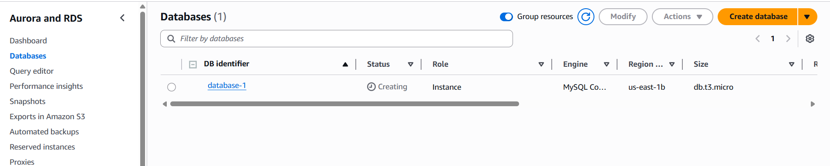
Fig: MySQL (database-1) is created successfully.
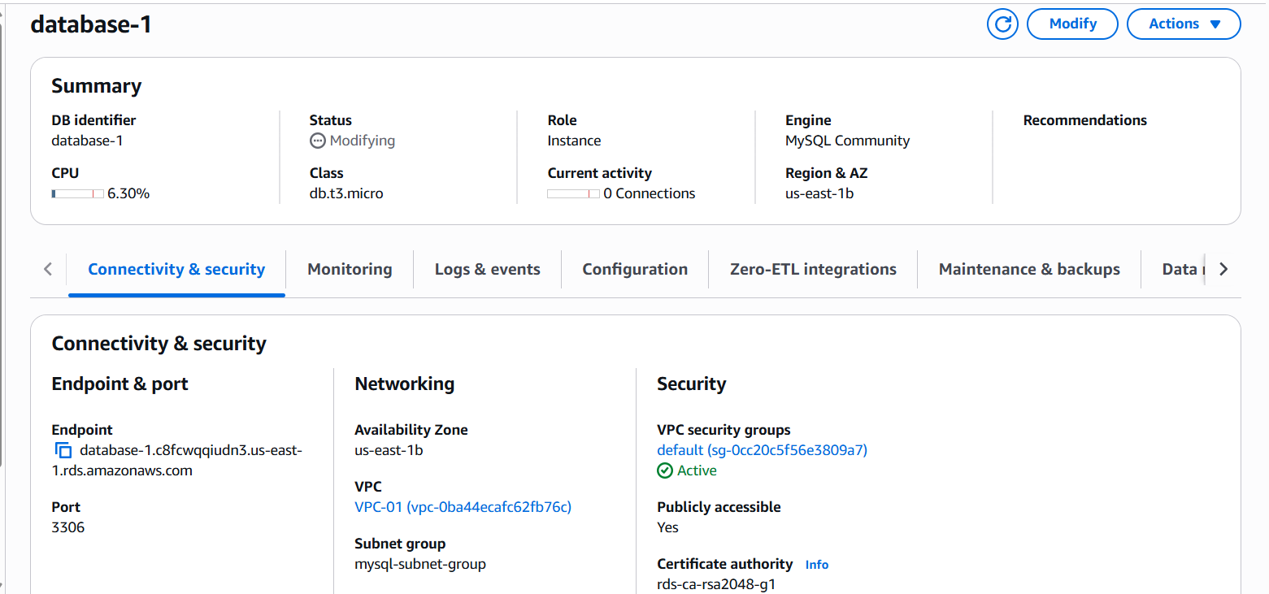
Fig: Data base Endpoint.

Note: By using this endpoint we are going to connect the MySQL work bench.

Step4: Create a windows instance and download the MySQL workbench in it.

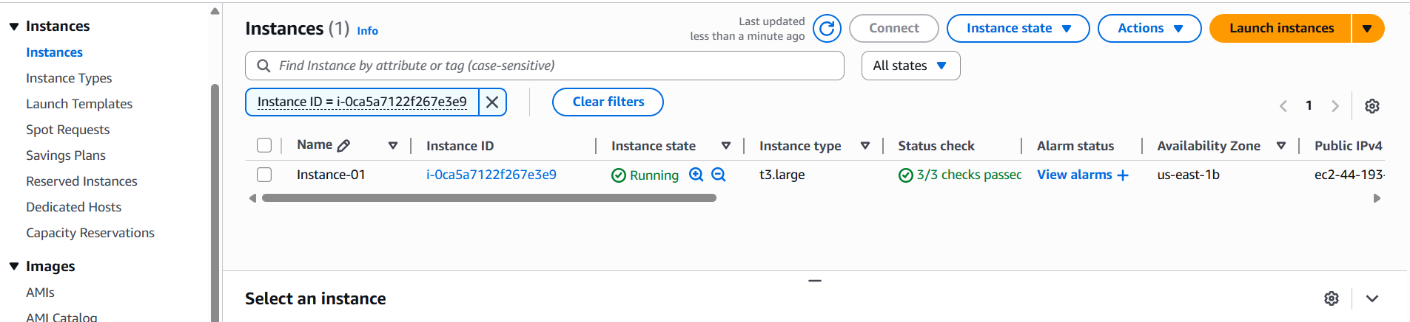
Fig: Windows instance is created.

Now install MySQL work bench in it.

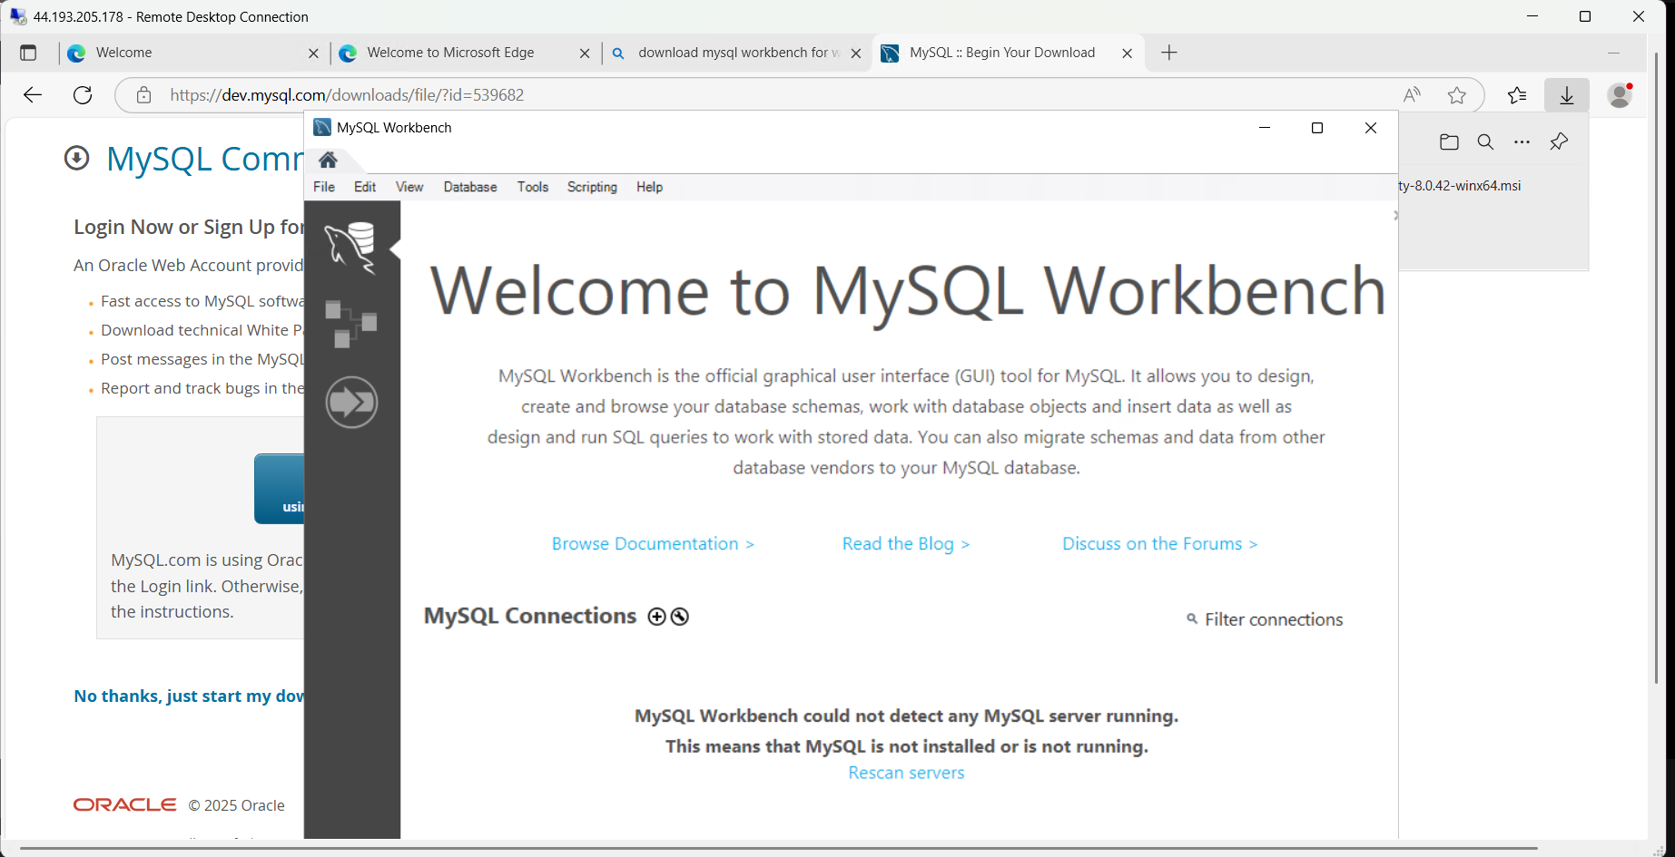
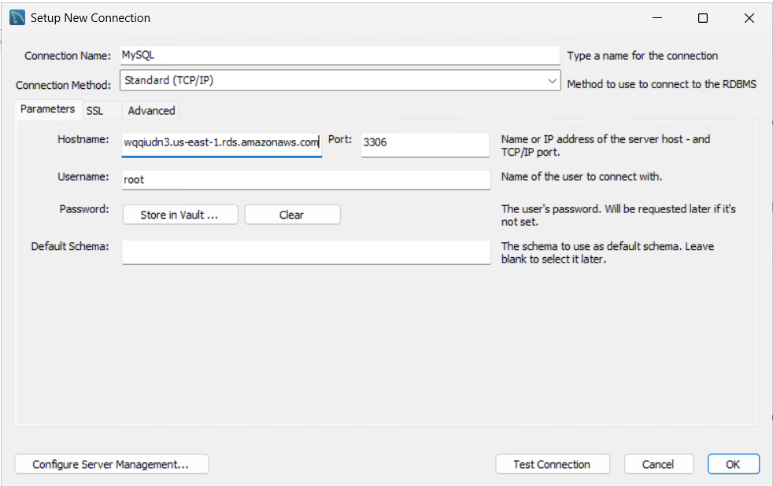

Hostname: MySQL endpoint (database-1.c8fcwqqiudn3.us-east-1.rds.amazonaws.com)
Connection name: MySQL (give any name).

This DB (MySQL) is deployed in two available zones of instances (us-east-1a & us-east-1b).
Us-east-1a: primary.
Us-east-1b: Secondary.
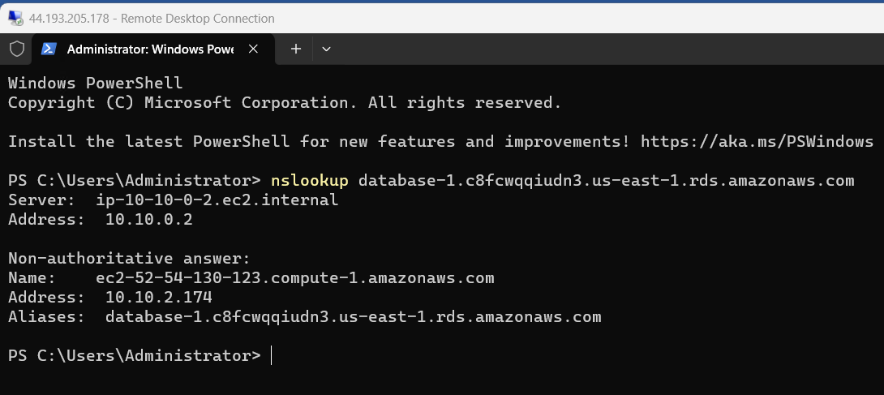
Fig: Before failover the MySQL is runs on 10.10.2.174 instance.

Now failover the primary DB in us-east-1a AZ. And check the IP.
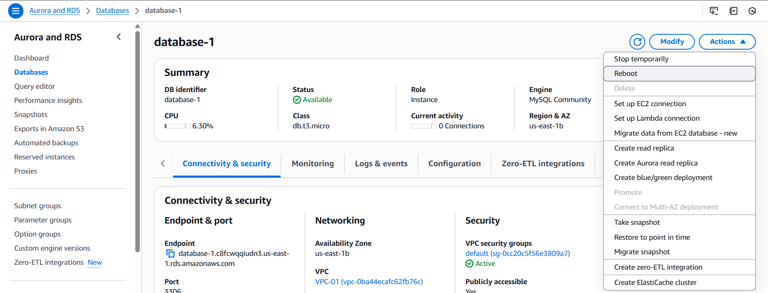
Fig: Reboot the MySQL DB.

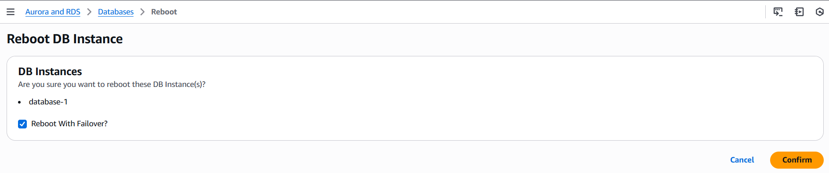
Fig: Reboot with failover.
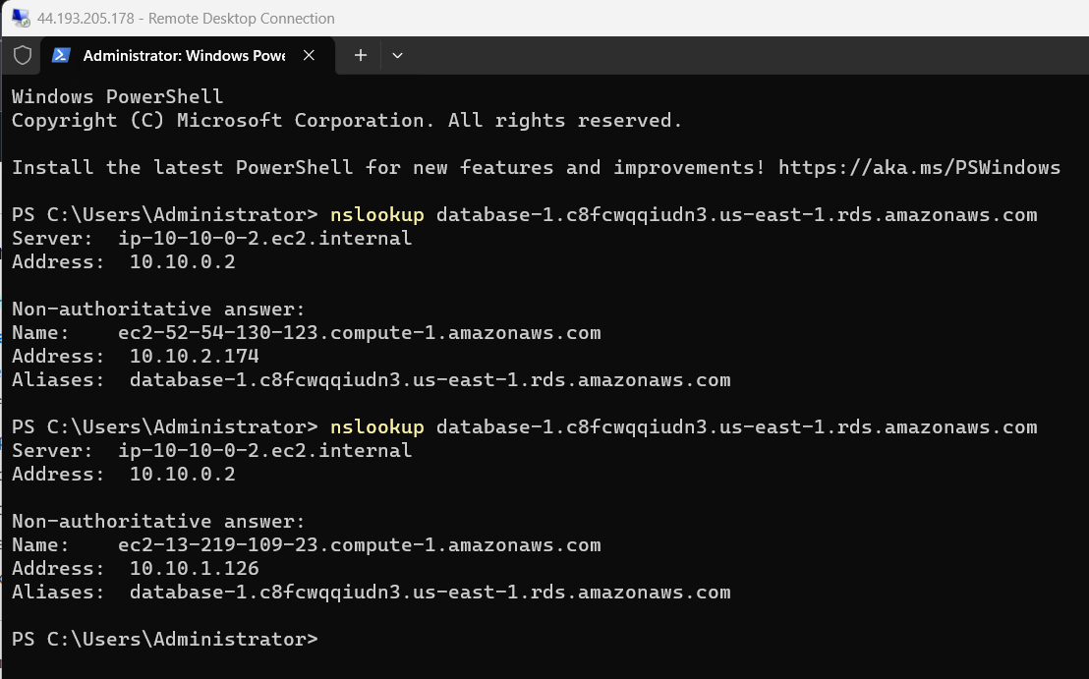
Fig: Changed to the IP of 10.10.1.126.

Block Diagram:
Maintain sync
MySQL DB Endpoint
Web/App
Web/App
Read/write
Read only
Primary DB
Secondary DB
Us-east-1b
Us-east-1a

