**Pushing of Local files and folder to the remote repository**

Step1: Create a folder and within it create the file using git bash.

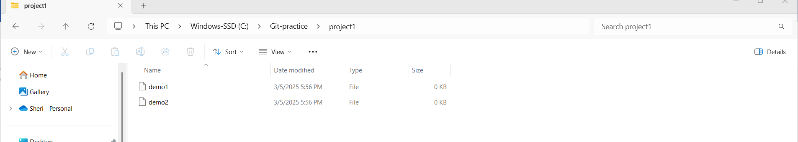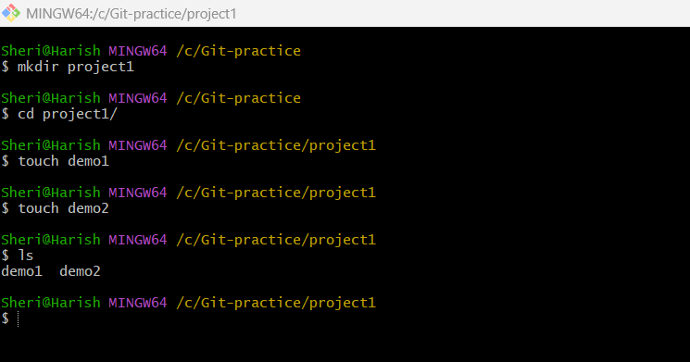

Fig: Files (demo1 & demo2) in local machine.

**Note:** These folder and files are created in our local machine only.

Step2: Do the git init command.

The **git init** command initializes a **new Git repository** in a directory. It sets up all the necessary files and configurations for Git to start tracking changes in the project.

It creates a hidden **.git** directory inside the project folder.

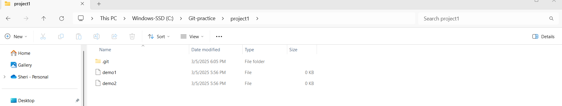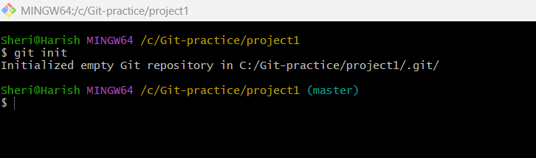

**Note:** After doing git init command the git server is installed or downloaded in our local machine.

Step2: Check the status of the git repository.

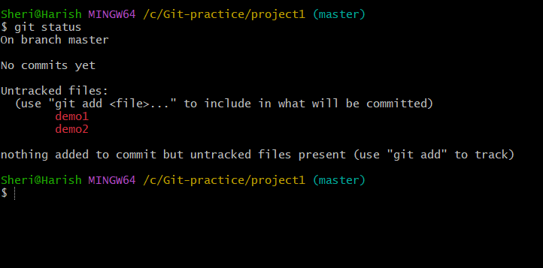

Fig: Working area of git stages.

Both the files (demo1 & demo2) are in working area.

Step3: Now perform **git add .** Command in order to add those files to the git repository.

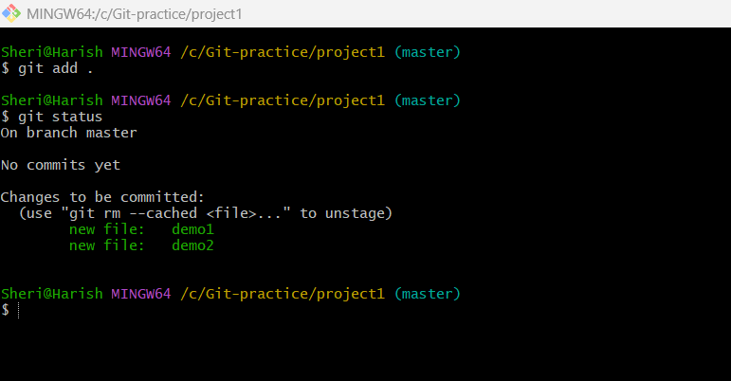

Step4: perform the git commit command to save the files into the repository.

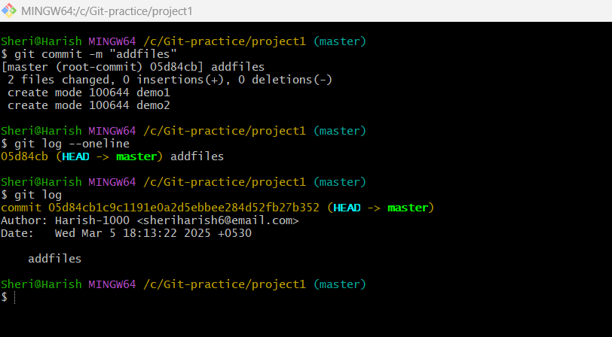

**git log:** The git log command is used to view the commit history of a Git repository.

**git log - -oneline:** The git log command is used to view the commit history of a Git repository in one line.

In order to push the local files to the git hub repository we have to create the destination repository in GitHub.

**git remote –v:** command is used to list all remote repositories linked to your local Git repository. It displays the remote repository URLs associated with your project.

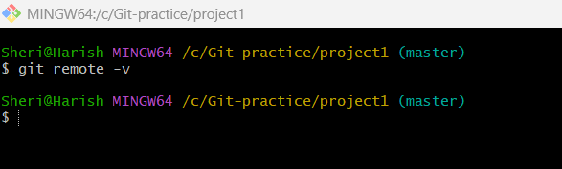

From above figure no destination repository is created in GitHub. So create the repository in GitHub

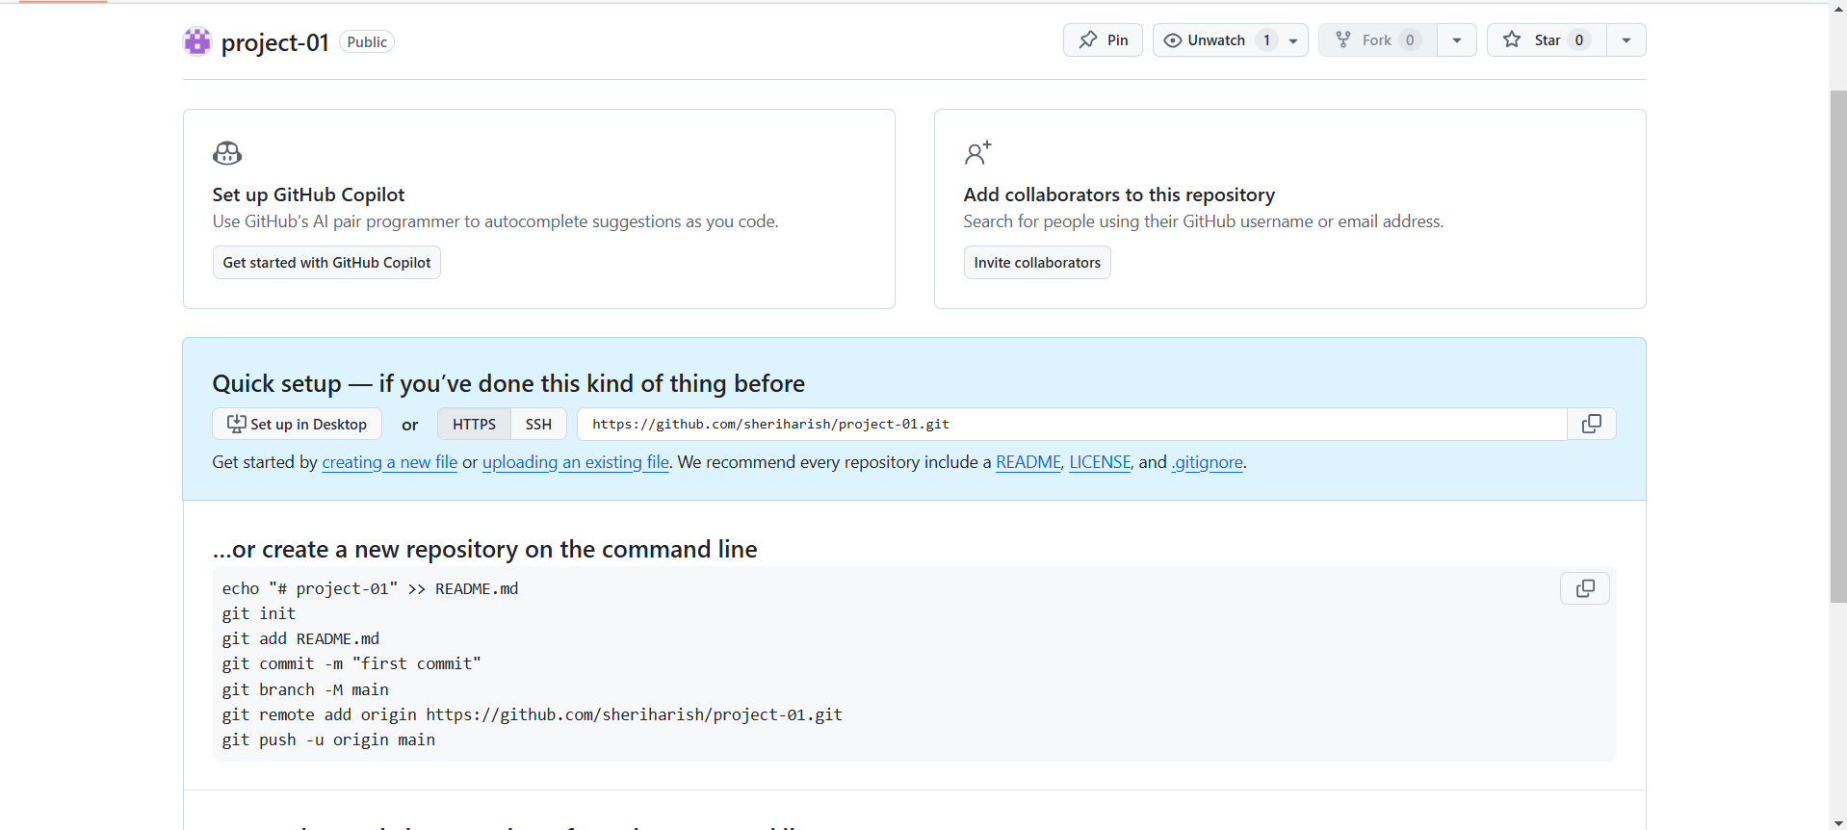

We can add the destination repository by using blow command.

“git remote add origin <http/github.com/>”

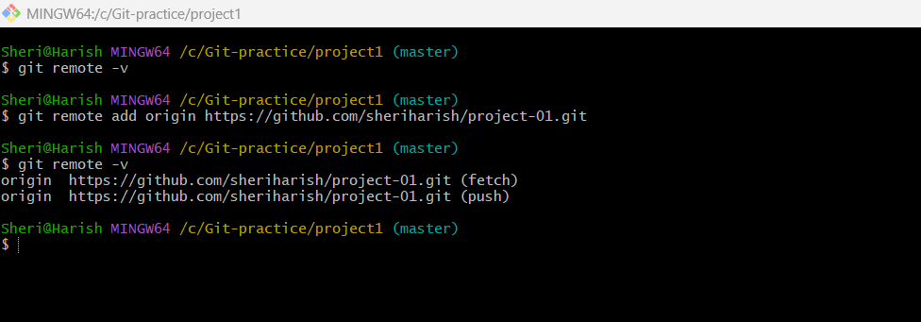

Fig: Destination repository is created.

Step5: Now push the files into the destination repository (project-01) using command

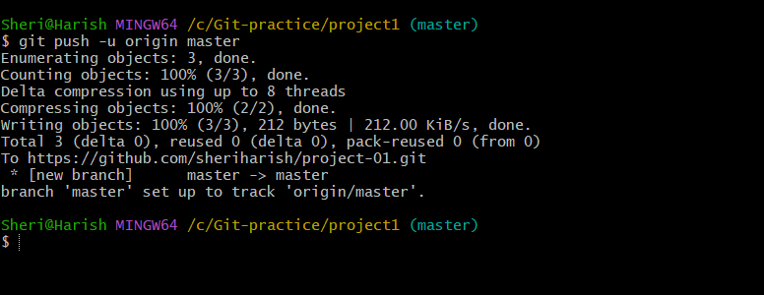“git push –u origin master/main” .

Fig: Successfully pushed files into destination repository (project-01).

