**Project-5**

**Title:** Creating of Windows VM and adding additional Disk to it.

Step1: Create a resource group (RG).

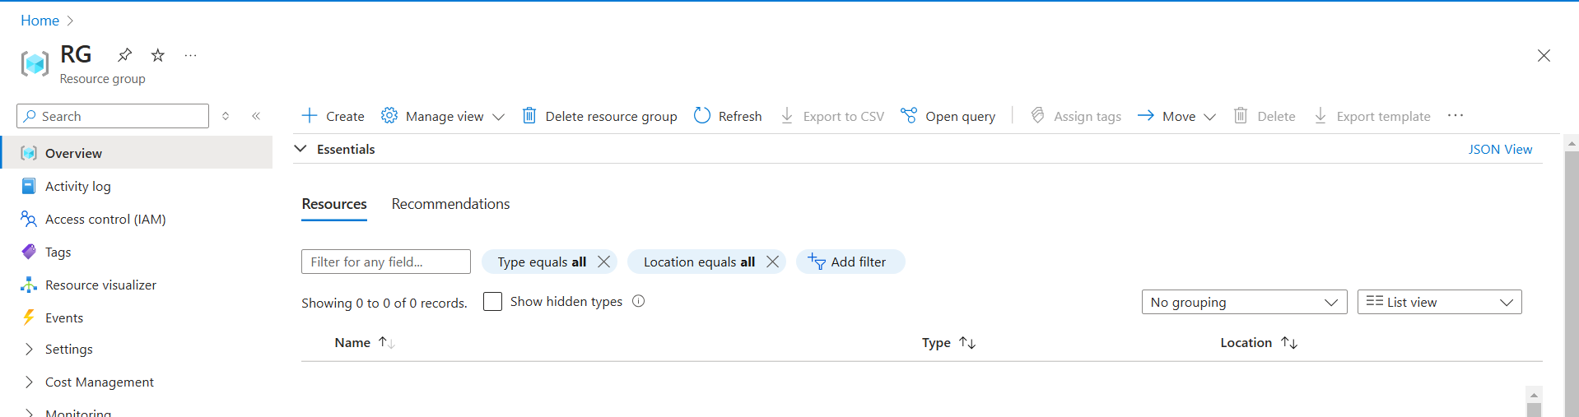

**Fig:** Resource group (RG).

Step2: Create a Windows VM (Win-VM) in that resource group (RG).

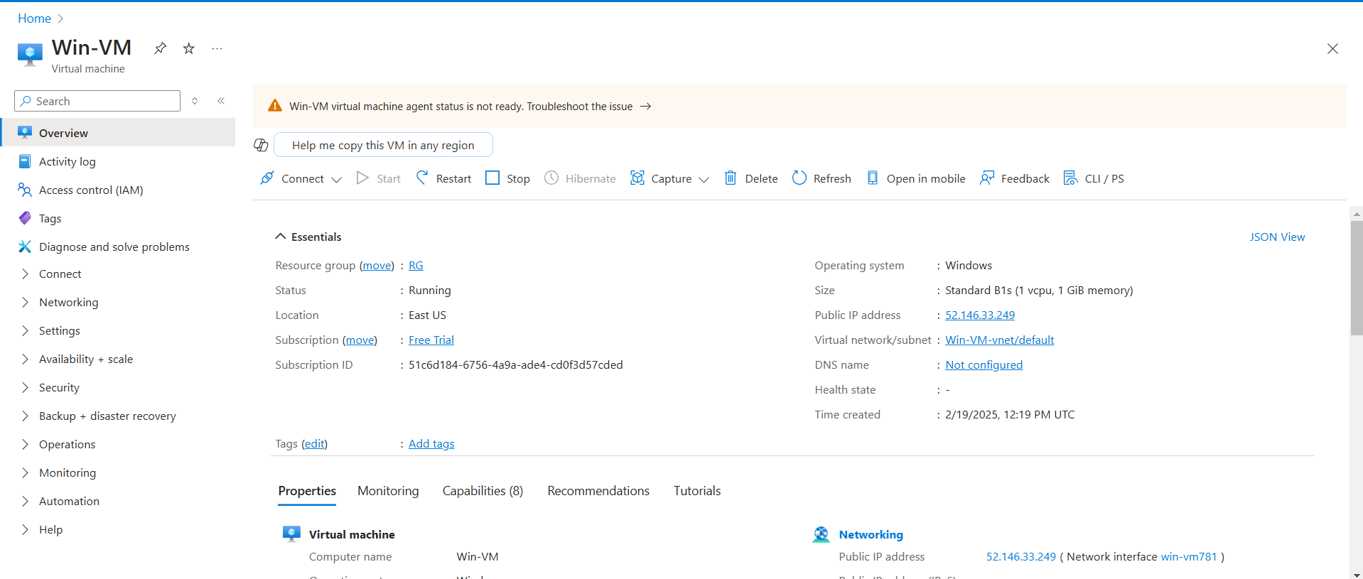

**Fig:** Windows Virtual machine (Win-VM).

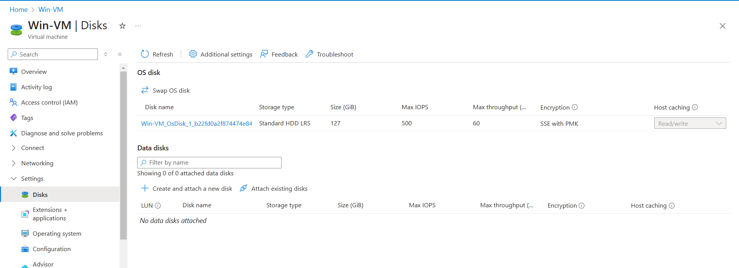

**Fig:** Default Disk provided by Microsoft (size: 127GB).

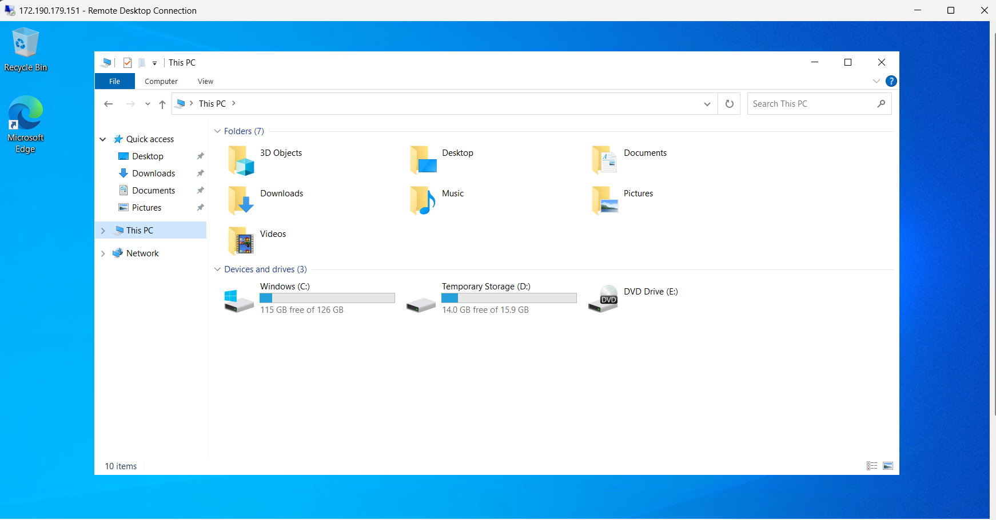

Fig: GUI view of Disk.

Step3: Add additional Disk to the windows VM (Win-VM).

**Go to🡪settings🡪Disks🡪Create and attach a new disk, shown in below figure.**



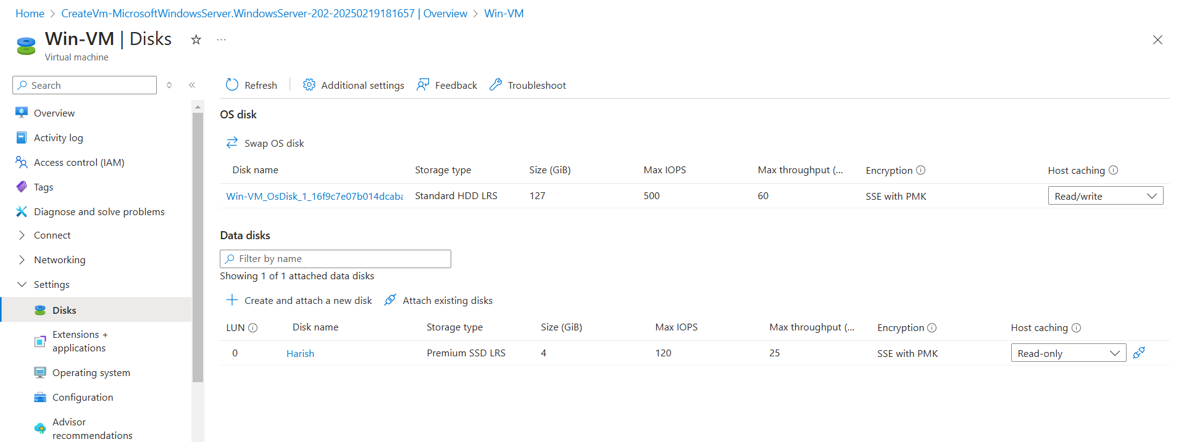

**Fig:** New additional Disk with name Harish is added to the Windows VM.

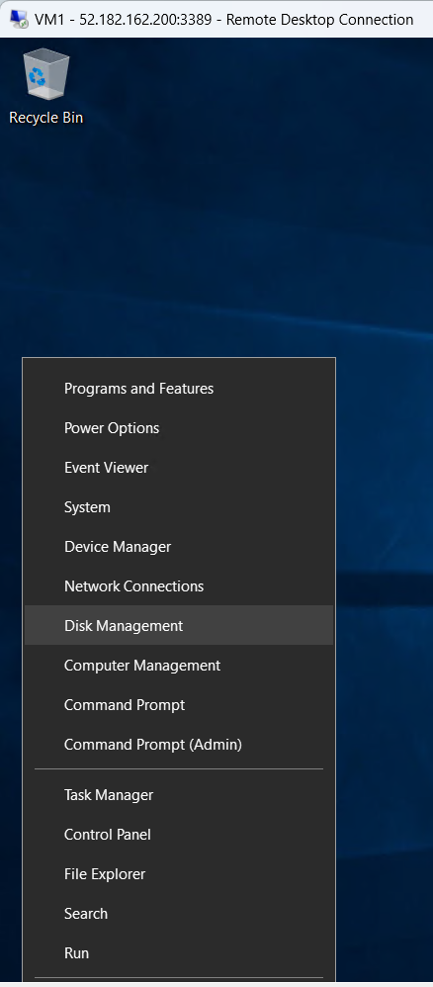

Now open the windows VM using RDP, then right click on the windows button, open the

“**Disk management**”.

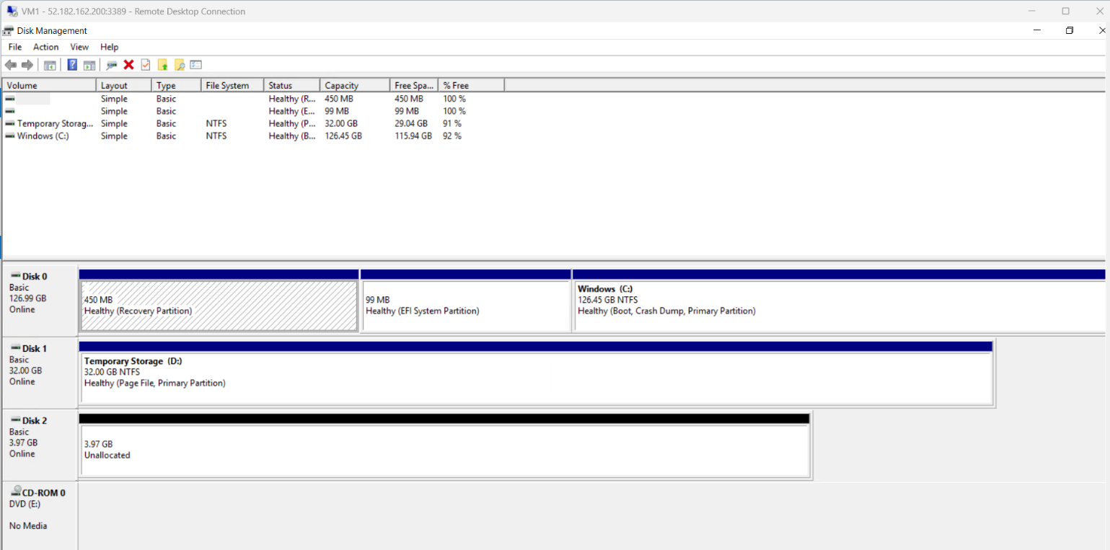**Fig:** New Disk 2 is unallocated to the windows VM.

The black color “Disk 2” is the new disk which is **unallocated**. To allocate it right click on the empty space on the Disk 2 and click on the “**new simple volume**”. Now it will connects to our windows VM. (Allocated to the windows VM) by changing its color to blue as show in the below figure.

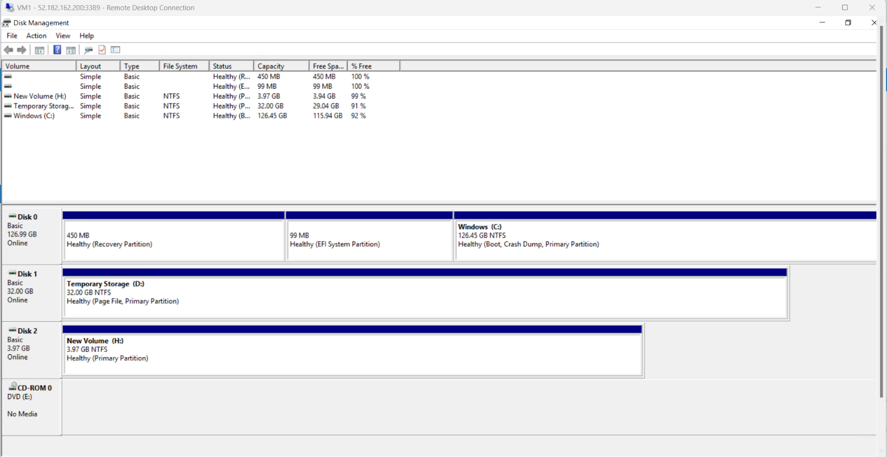

**Fig:** Disk 2 is allocated to the windows VM.

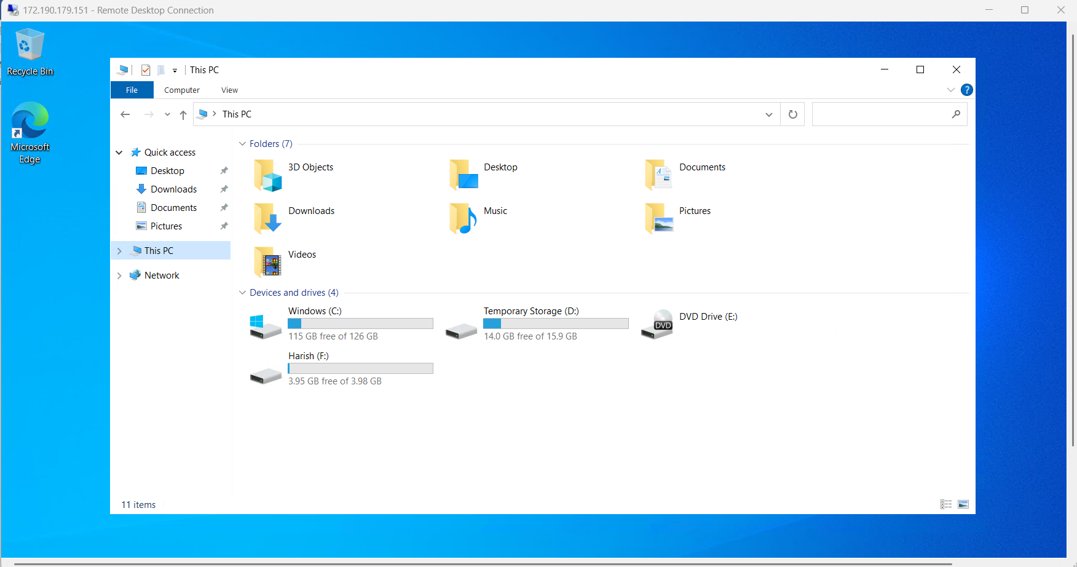

**Fig:** New extra Disk [Harish (F)] successfully added to the Windows VM.

**Note:** whatever we stored in the temporary storage is get erased when our VM is stopped and started it. But not in windows (c), and New Volume (H) disk.