**Project-3**

**Title:** Creating of azure load balancer in Global tier.

Azure load balancer support both regional and Global.

That mean Azure Load Balancer primarily operates within a single Azure region. It distributes traffic among virtual machines or other resources within that region. How ever

Azure has expanded the capabilities of Azure Load Balancer to include a global tier. This allows you to distribute traffic across multiple Azure regions.

**Features:**

* It is also known as Network Load Balancer.
* It can supports both Regional and Globally. That mean if over VM’s present within region or outside the region it can be distributes Network traffic easily.
* It works as proxy based routing.

**Proxy-based Routing** is a network architecture where a **proxy server** acts as an intermediary between clients and the actual servers they want to access. Instead of clients directly connecting to the target servers, they send their requests to the proxy server.

* It operates at the Transport Layer (Layer 4) of the OSI model.
* It supports TCP & UDP protocol.
* It sends the request to the Backend pool (where servers are present) using Round Robin method.

**Let’s create the Azure load balancer in global tier.**

**step1:** Create two resource groups in different regions (like east-RG & west-RG).

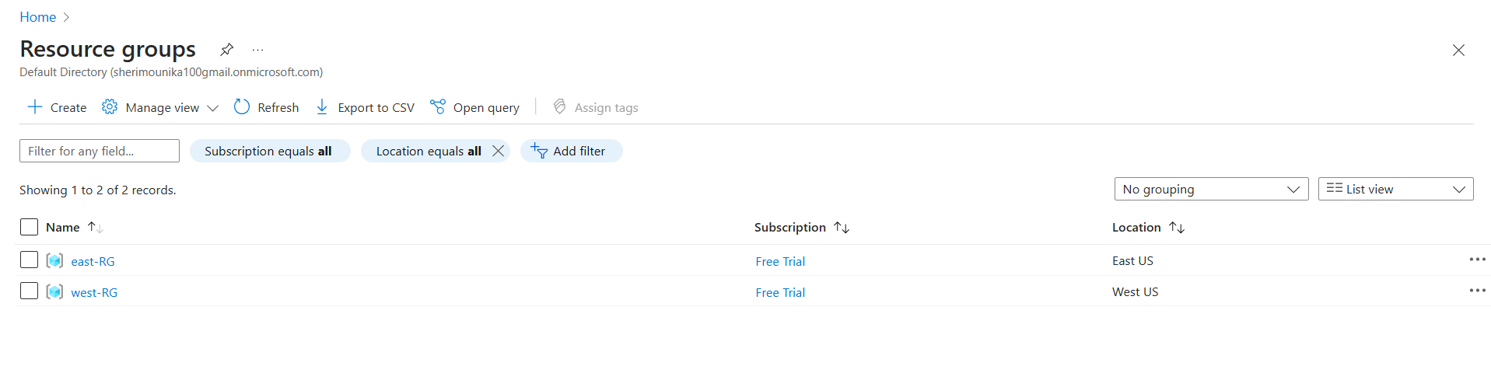

**Step3:** Create two Linux VM’s in corresponding resource group (east-RG & west-RG) and installing Nginx on them.

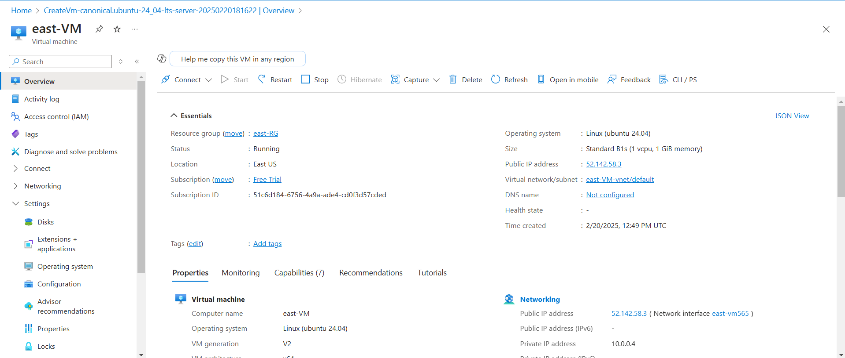

**Fig:** east-VM in East US region (east-RG).

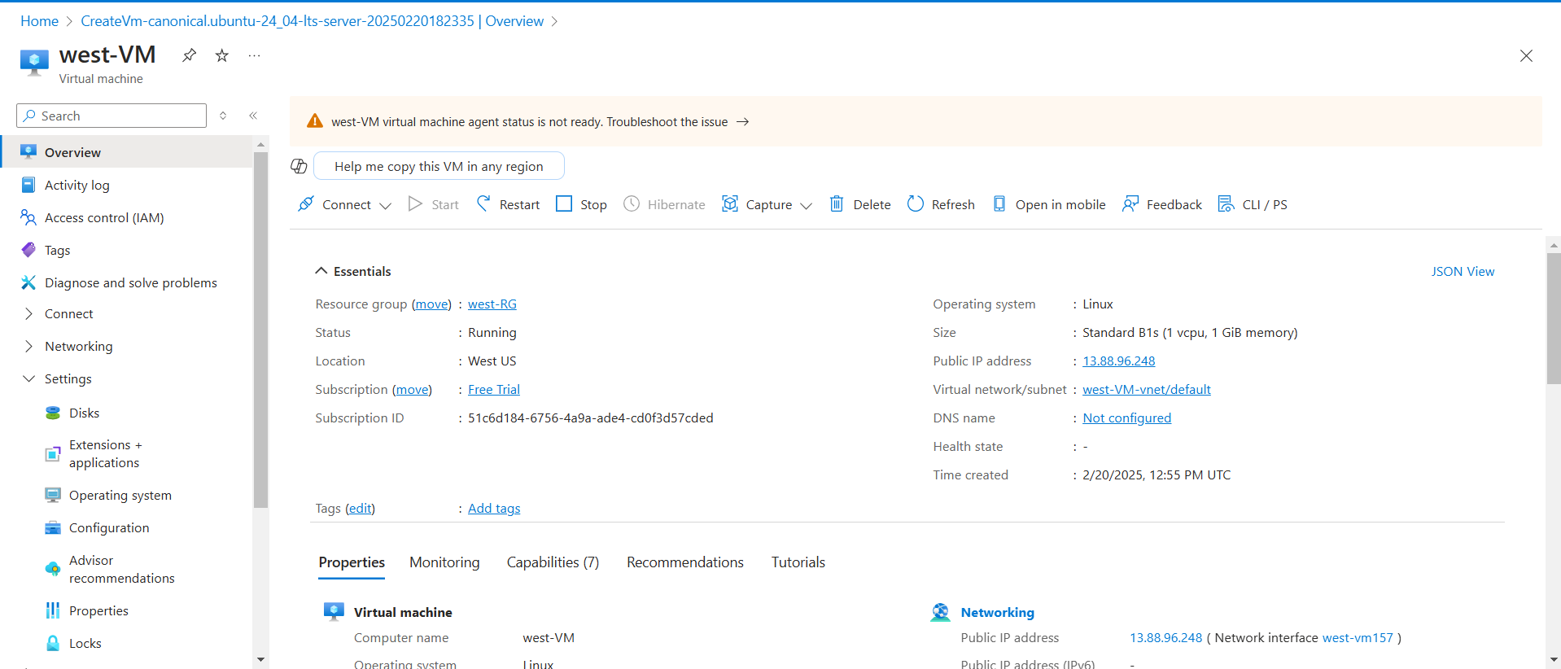

**Fig:** west-VM in west US region (west-RG).

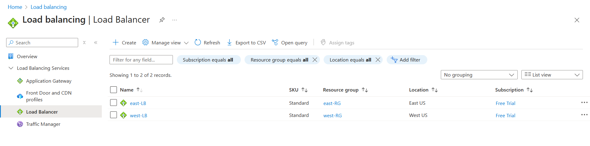**Step4:** Create two regional load balancers (east-LB & west-LB).

**Fig:** Regional load balancers in east and west US.

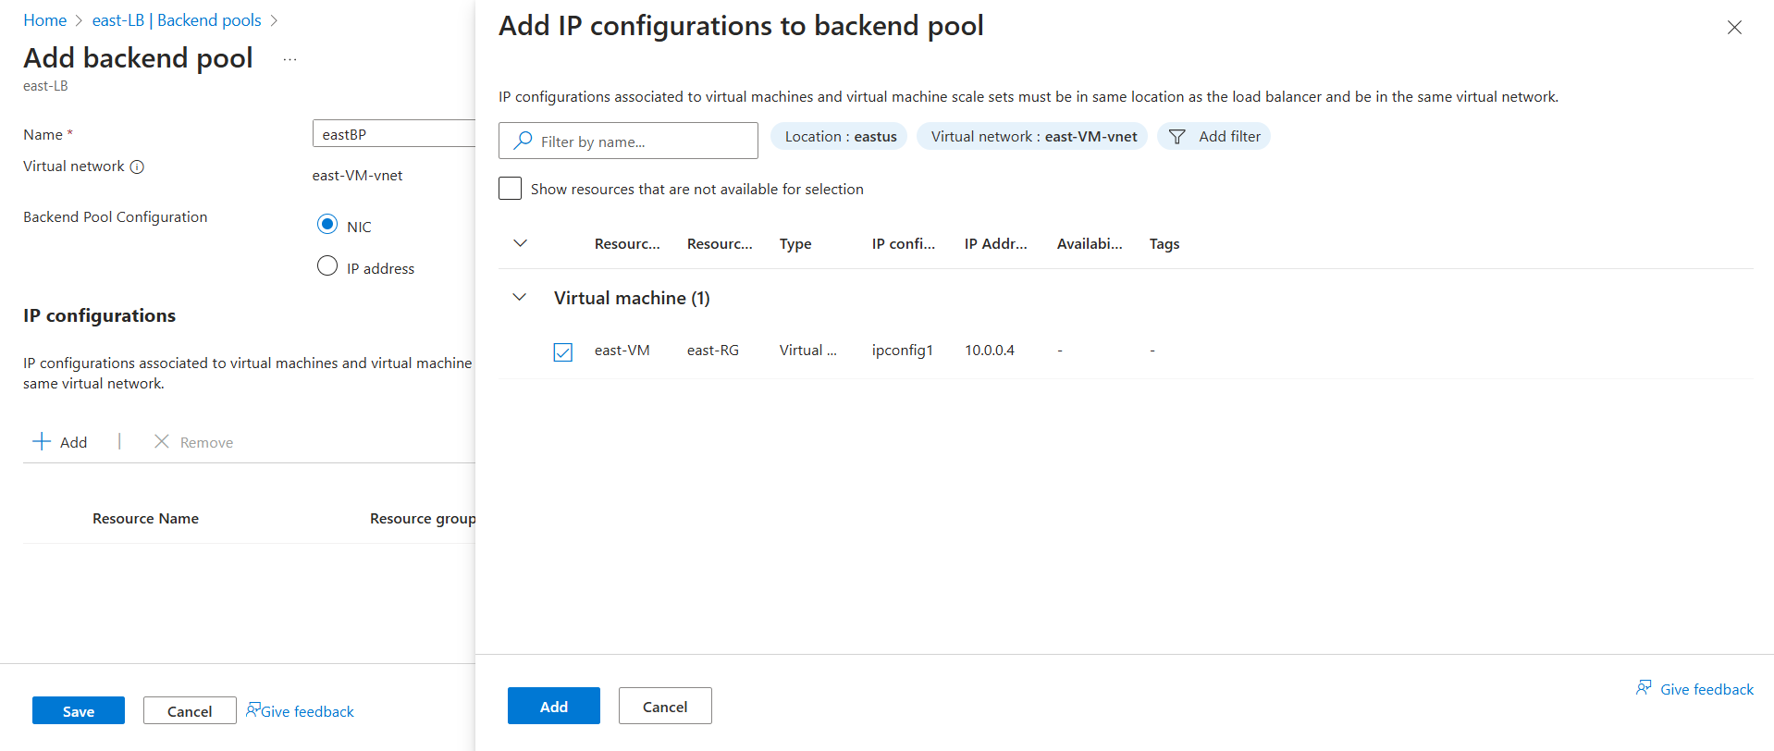**Step5:** Add east-VM to the backend pool of east-LB. And write load balancer rules.

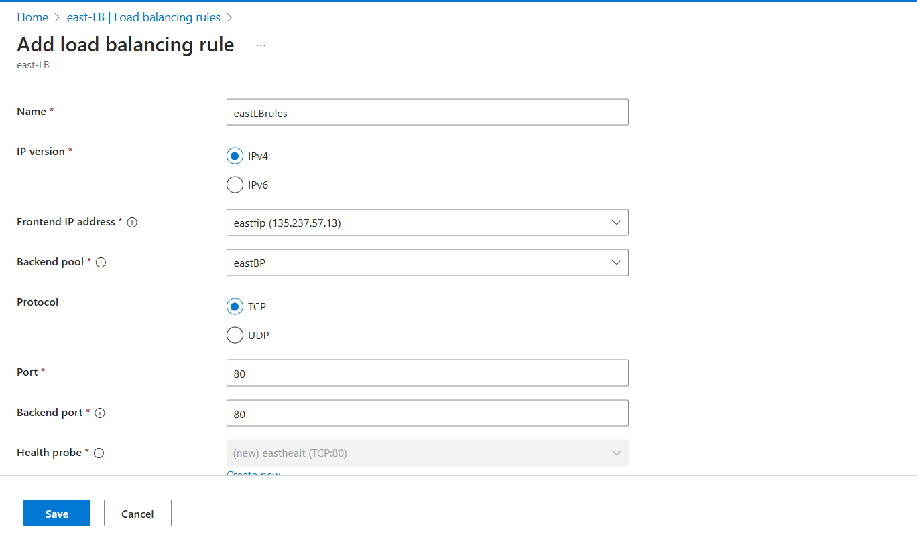

**Step6:** Add west-VM to the backend pool of west-LB and write load balancer rule to it.

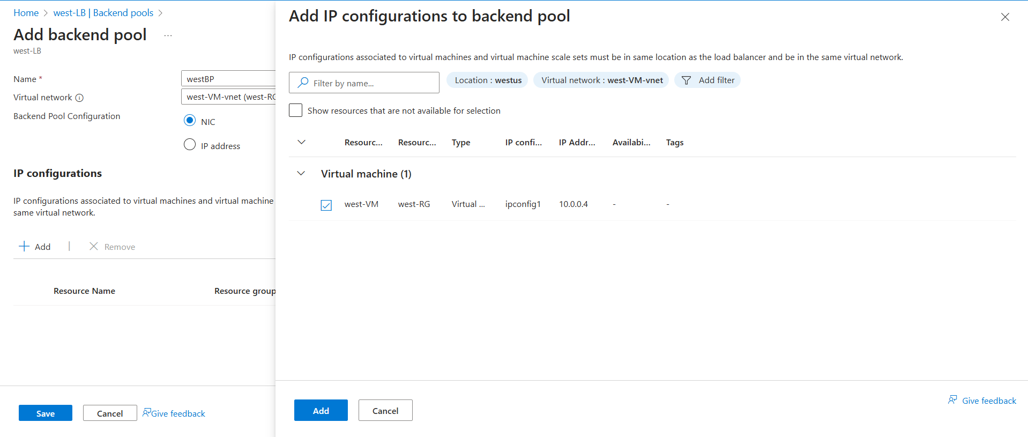

**Fig:** Adding west-VM to Backend pool of west-LB.

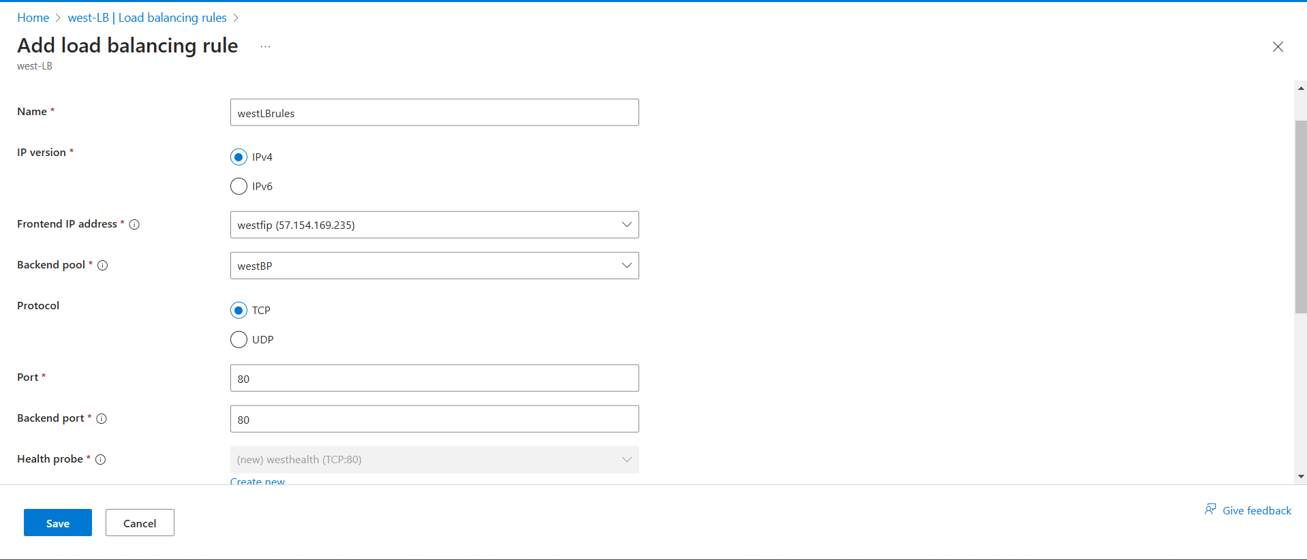

**Fig:** west-LB rules.

**Step7:** Now create the Global Load balancer (global-LB) by separately creating a resource group (global-RG) in home region (ex: central US).

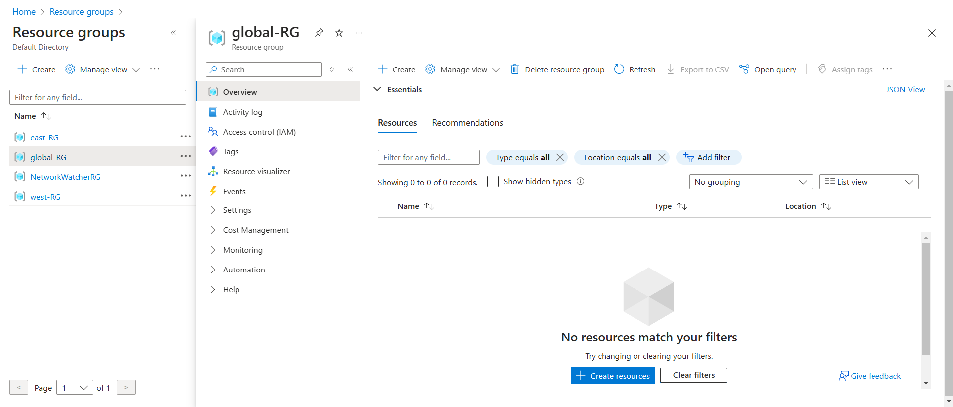

**Fig:** Resource group (global-RG) for Global load balancer in central US.

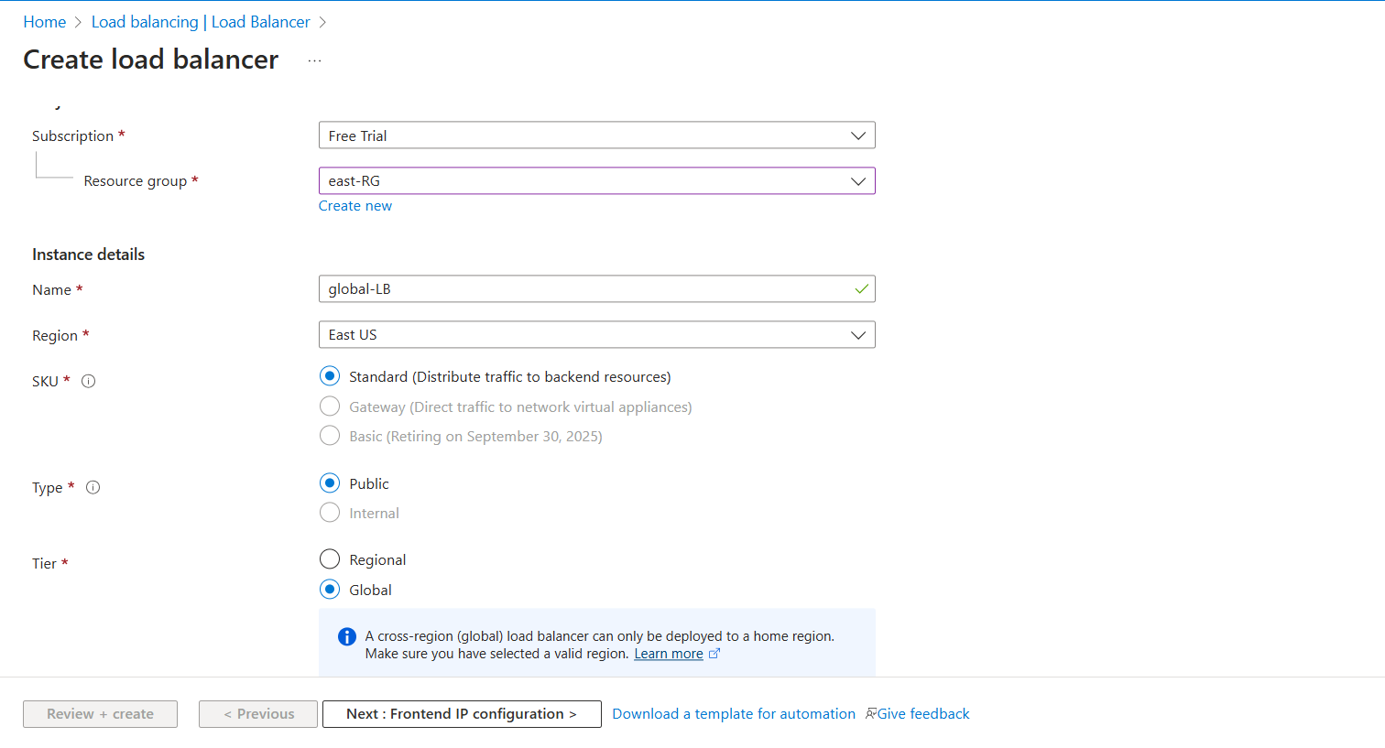

**Fig:** global tier Load balancer (global LB).

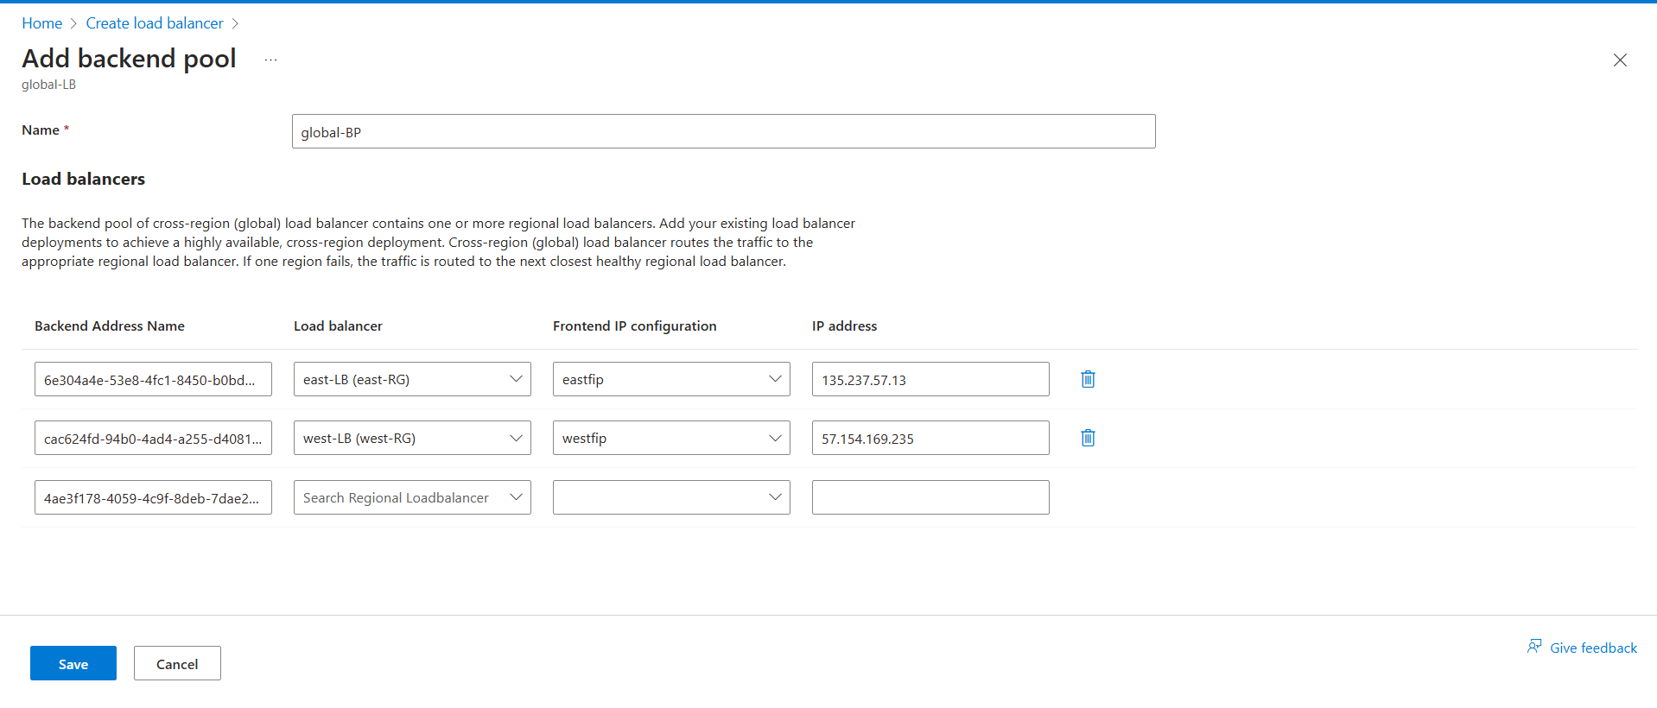

**Fig:** Backend pool of global load balancer.

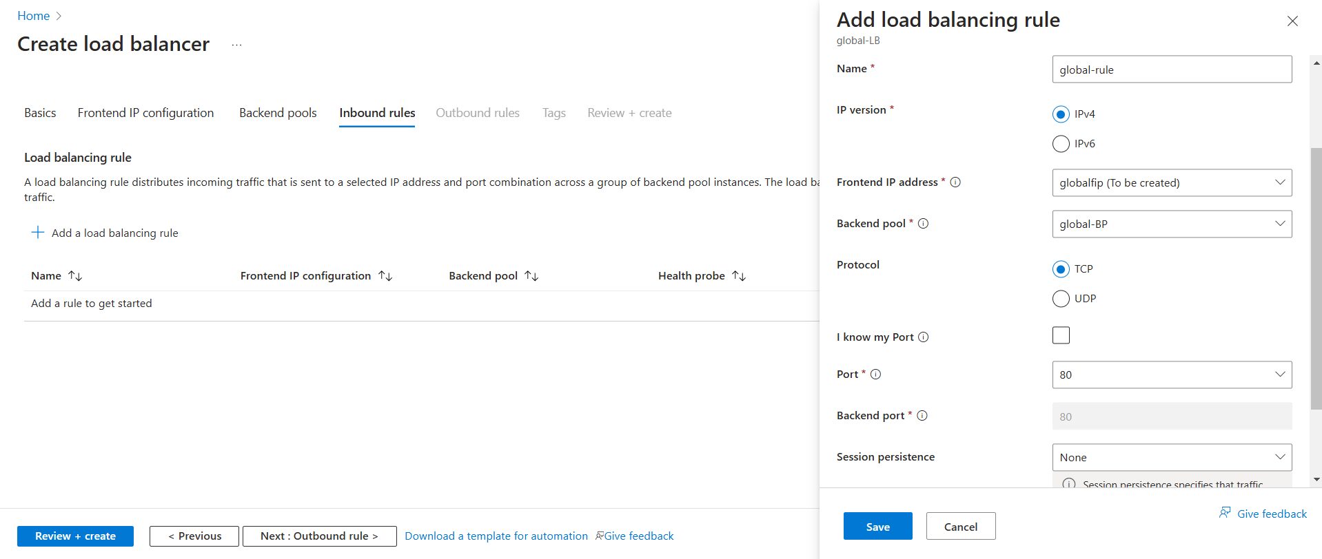

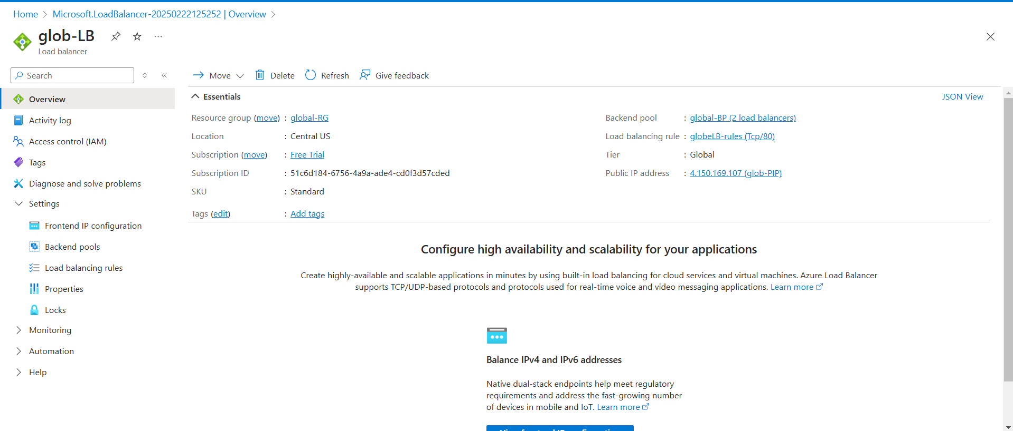**Fig:** Adding of load balancer rules.

**Fig:** Global Load Balancer (glob-LB).

**Note:** Global load balancer can only be created in some specific regions such as Central US, East Asia, East US 2, North Europe, Southeast Asia, UK South, US Gov Virginia, West Europe, West US and China North 2.

**Step8:** Now by using the front IP of global load balancer, brows in and browser to check whether our webservers (Nginx) are attached to it or not properly.

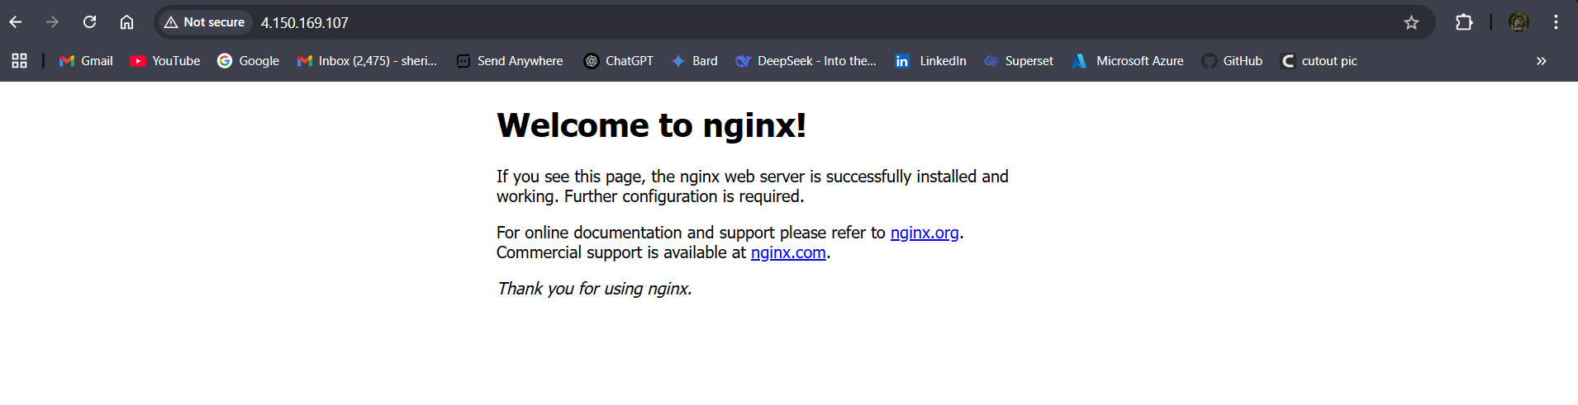

**Fig:** Nginx Web server.