**Project-4**

**Title:** Create a Windows VM in one region and move that VM to another Region.

In order move a windows VM from one region to other, first we have to create two resource group in different location and create one Windows VM in any one resource group and move it to other resource group.

Block Diagram:

West US-RG

East US-RG

Win-VM

**Procedure:**

**Step1:** Create the resource group (eastus-RG) in East US region.

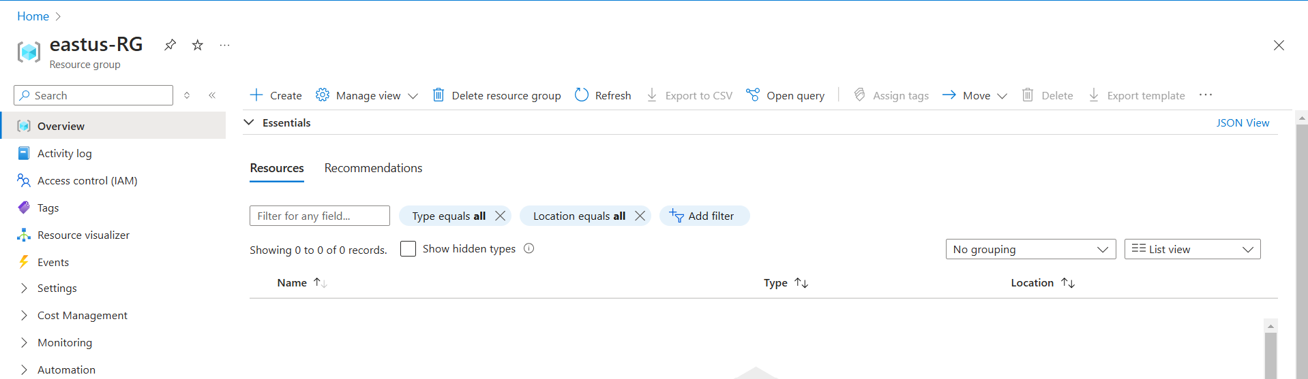

**Fig:** Resource group (eastus-RG) in east us.

**Step2:** Create a Windows VM (Win-VM) in the resource group of eastus-RG.

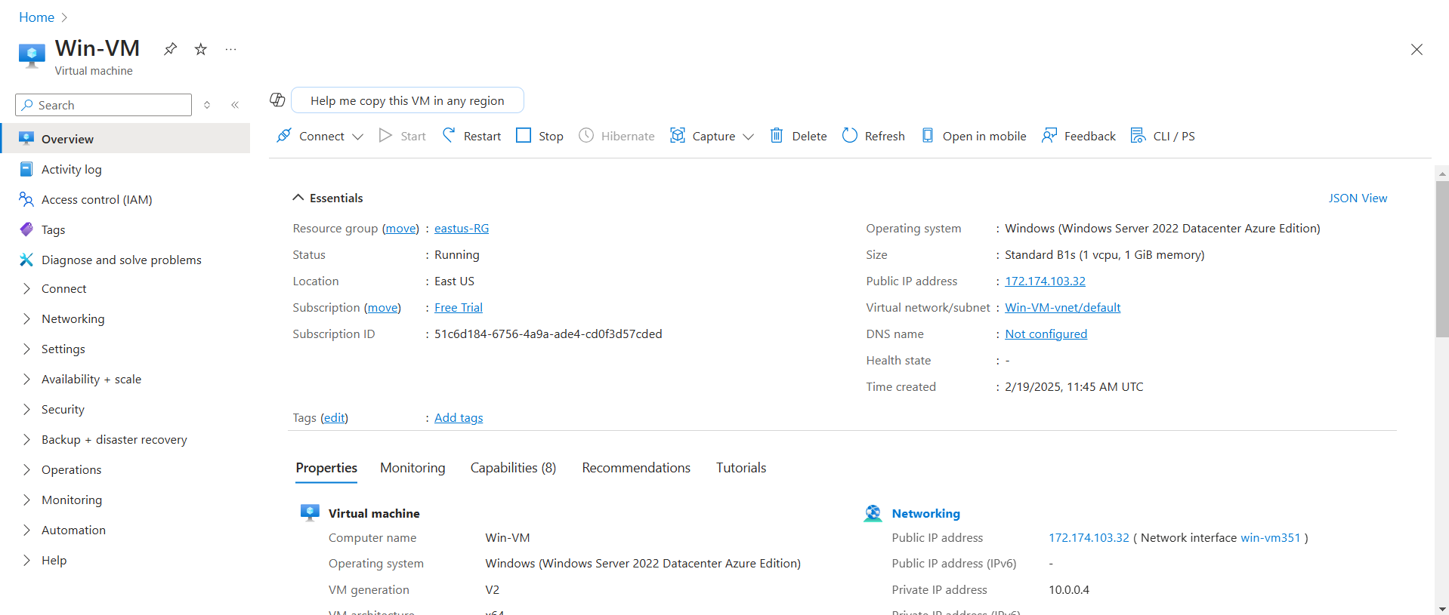

**Fig:** Windows VM in east us region of resource group.

Step3: Now create another resource group (westus-RG) in west US region.

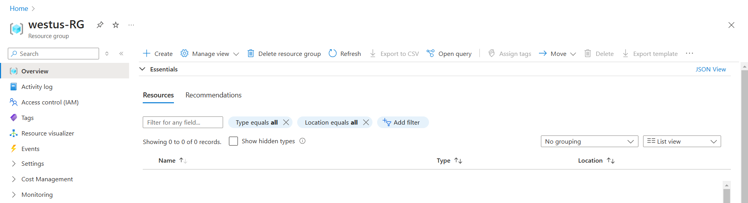

**Fig:** Resource group (westus-RG) in West US region.

**Step4:** Move this Windows VM to the other region resource group (westus-RG).

🡺Click on the **move** option

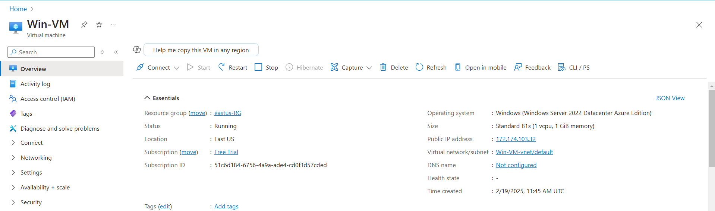

🡺Select the target resource group.

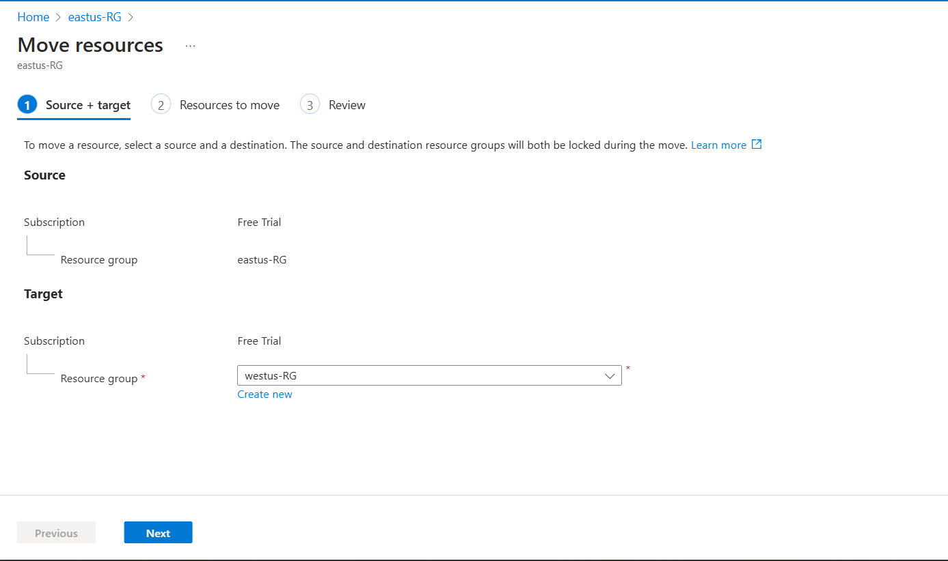

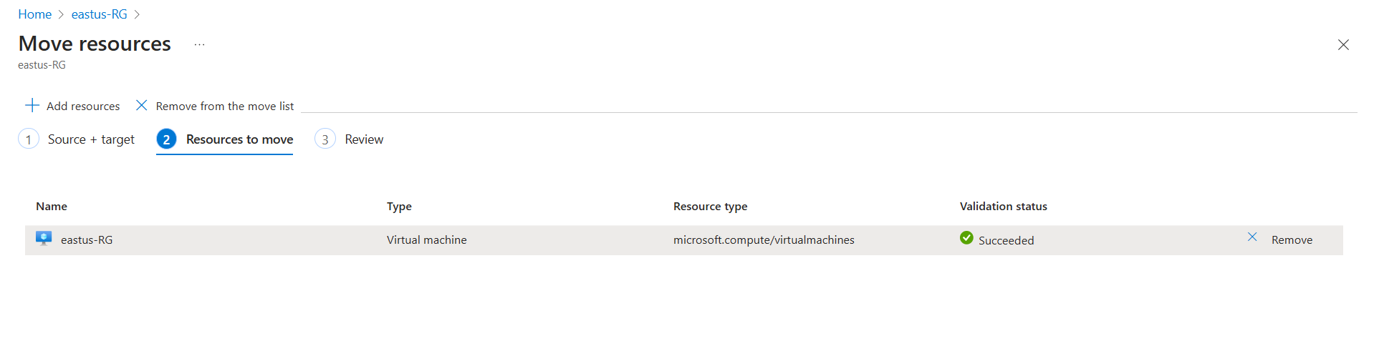🡺Select the resource which is to be moved.

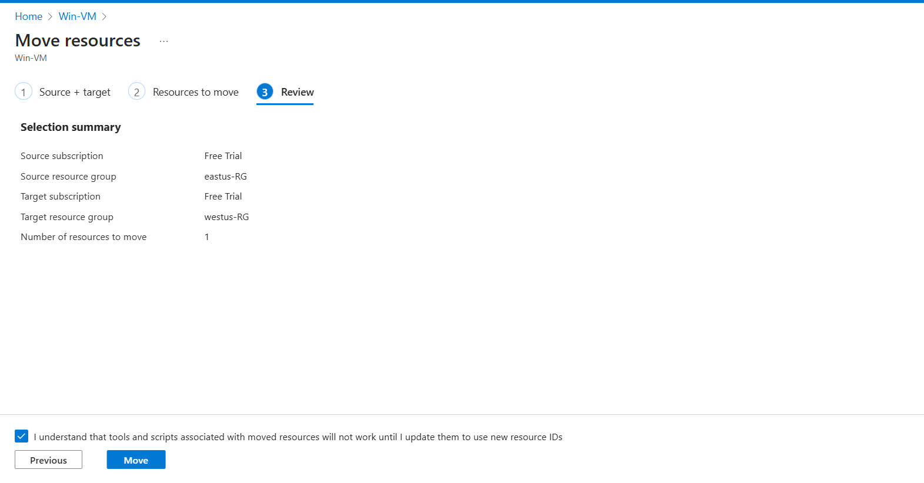

Step5: Check whether Win-VM is moved from east us region to west us region.

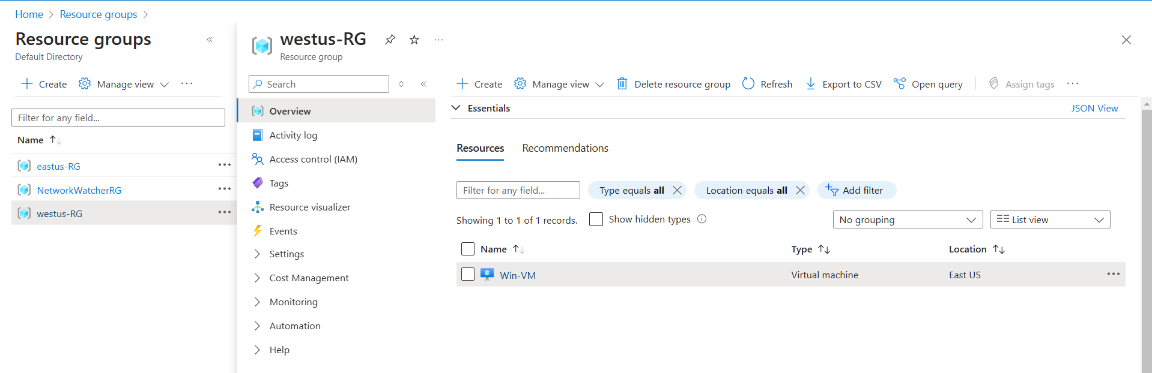

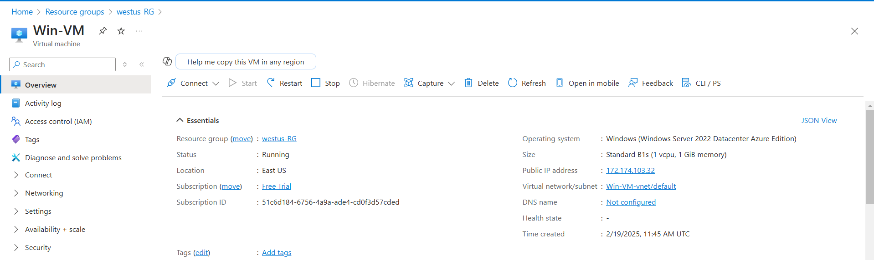

**Fig:** Win-VM is successfully moved from east to west region.