1.
#!/bin/sh

NUMS="1 2 3 4 5 6 7"

for NUM in $NUMS
do
Q=`expr $NUM % 2`
if [ $Q -eq 0 ]
then
echo "Number is an even number!!"

fi
echo "Found odd number"
done
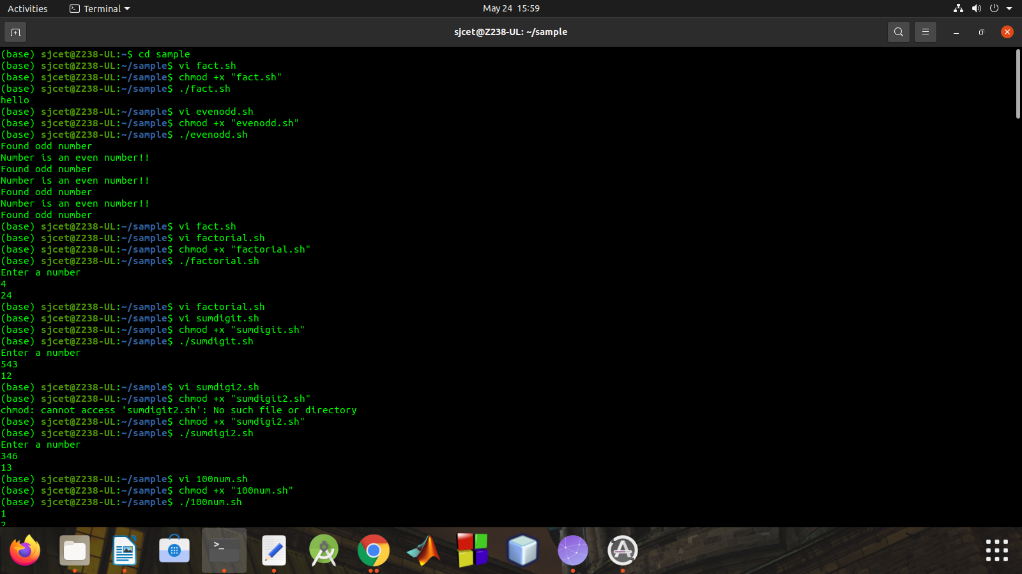

2.
echo "Enter a number"
read num

fact=1

while [ $num -gt 1 ]
do
fact=$((fact * num)) #fact = fact * num
num=$((num - 1)) #num = num - 1
done

echo $fact

3.
echo "Enter a number"
read num

sum=0
while [ $num -gt 0 ]
do
mod=$((num % 10)) #It will split each digits
sum=$((sum + mod)) #Add each digit to sum
num=$((num / 10)) #divide num by 10.
done

echo $sum

4.

echo "Enter a number"
read num

sum=0

while [ $num -gt 0 ]
do
mod=`expr $num % 10` #It will split each digits
sum=`expr $sum + $mod` #Add each digit to sum
num=`expr $num / 10` #divide num by 10.
done

echo $sum

5.

i=1
while [ $i -le 100 ]
do
echo $i
i=$(($i+1))
done
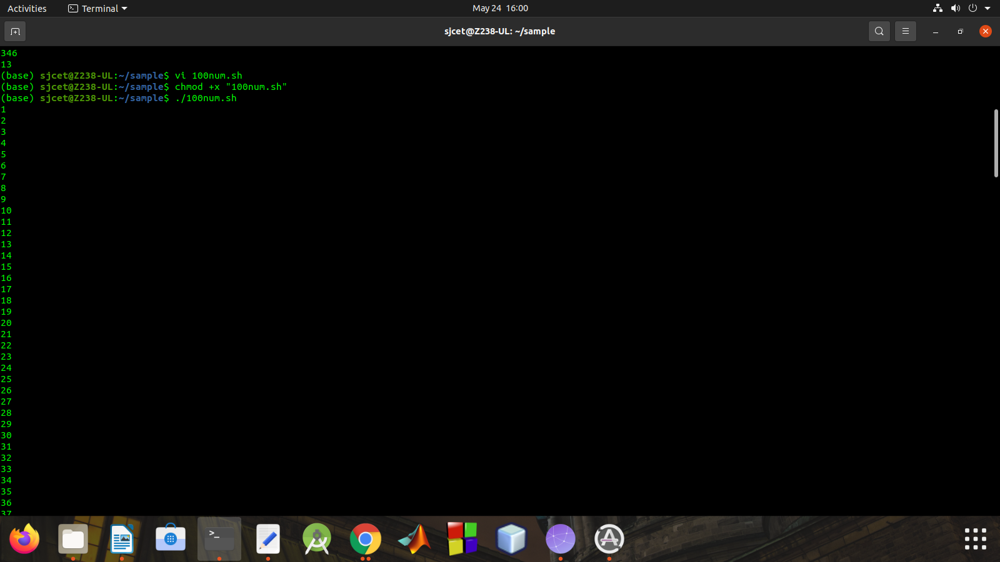
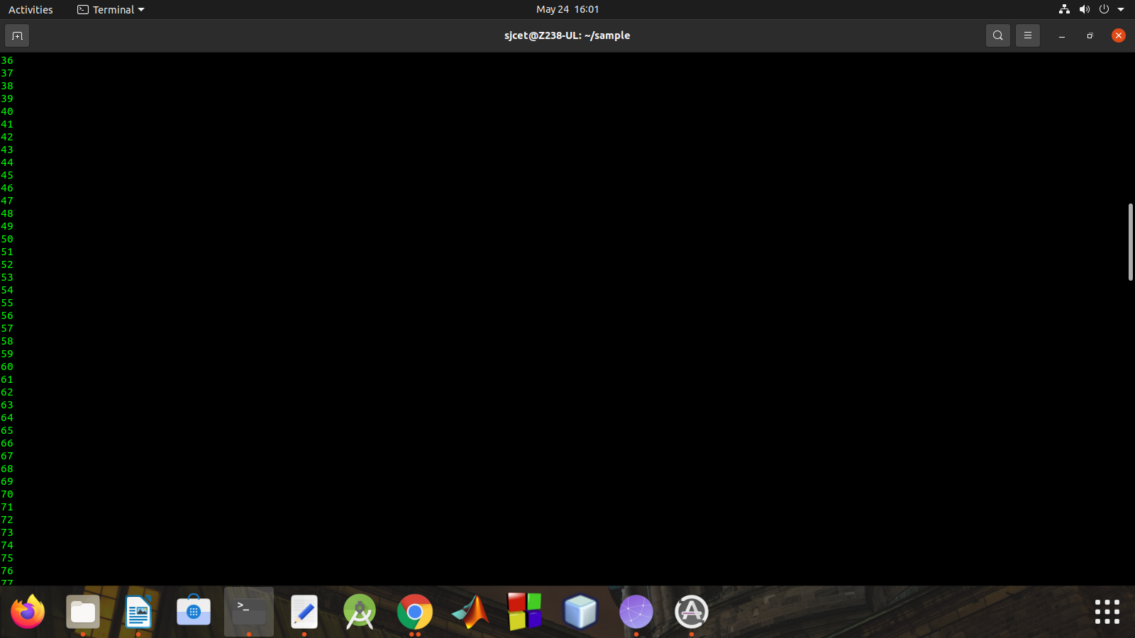

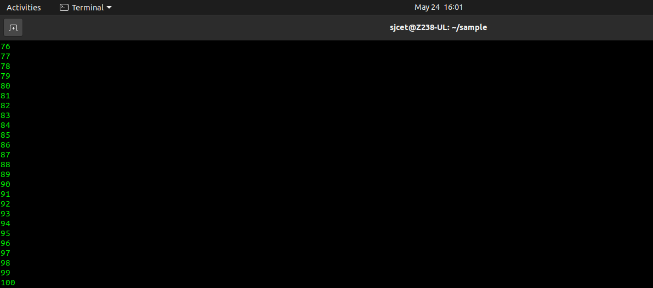

6.

echo "Enter Size(N)"
read N

i=1
max=0

echo "Enter Numbers"
while [ $i -le $N ]
do
read num
if [ $i -eq 1 ] #set first number as max
then
max=$num
else #from number 2 update max if the num > max.
if [ $num -gt $max ]
then
max=$num
fi
fi
i=$((i + 1)) #increment i by 1
done

echo $max
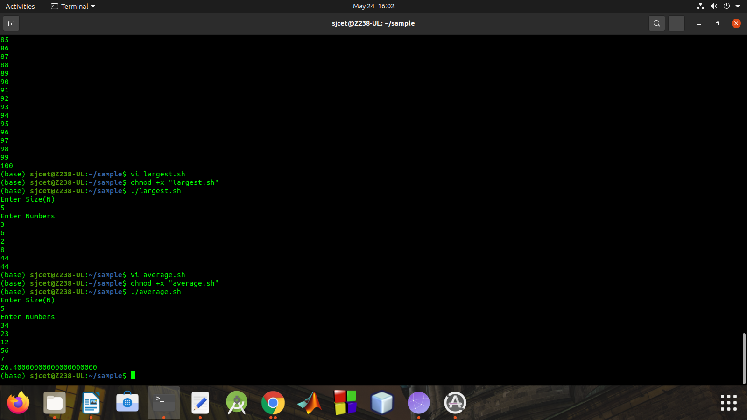

7.

echo "Enter Size(N)"
read N

i=1
sum=0

echo "Enter Numbers"
while [ $i -le $N ]
do
read num #get number
sum=$((sum + num)) #sum+=num
i=$((i + 1))
done

avg=$(echo $sum / $N | bc -l)

echo $avg

8.

echo "Enter Size(N)"
read N

i=1
sum=0

echo "Enter Numbers"
while [ $i -le $N ]
do
read num #get number
sum=$((sum + num)) #sum+=num
i=$((i + 1))
done

echo $sum
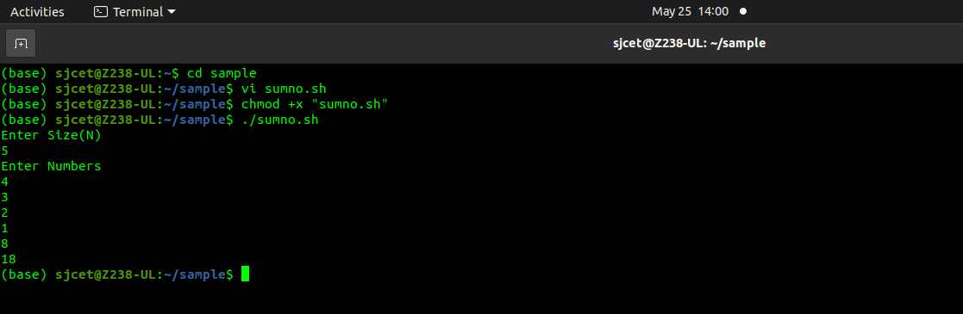

9.

echo "Enter Num1"
read num1
echo "Enter Num2"
read num2
echo "Enter Num3"
read num3

if [ $num1 -gt $num2 ] && [ $num1 -gt $num3 ]
then
echo $num1
elif [ $num2 -gt $num1 ] && [ $num2 -gt $num3 ]
then
echo $num2
else
echo $num3
fi

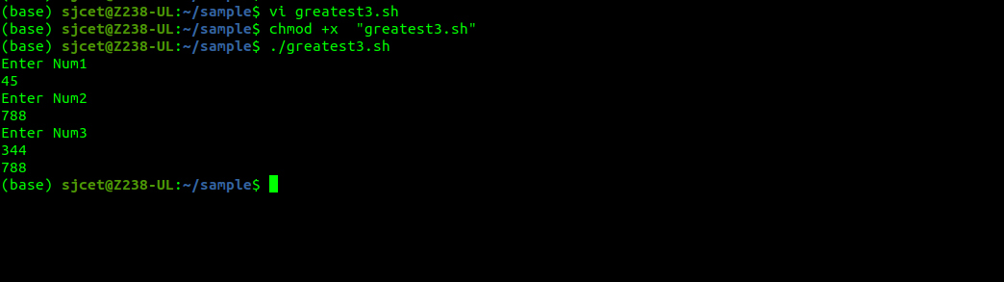

10.

num1=45
num2=20
ans=`expr $num1 \* $num2`
echo $ans
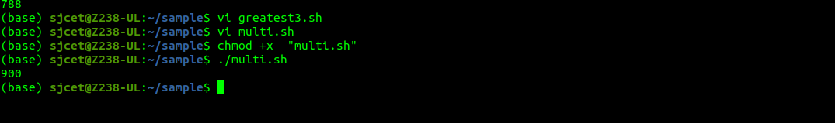

11.

arr=(10 20 30 40 50)

sum=0

for i in ${arr[@]}
do
sum=`expr $sum + $i`
done

echo $sum

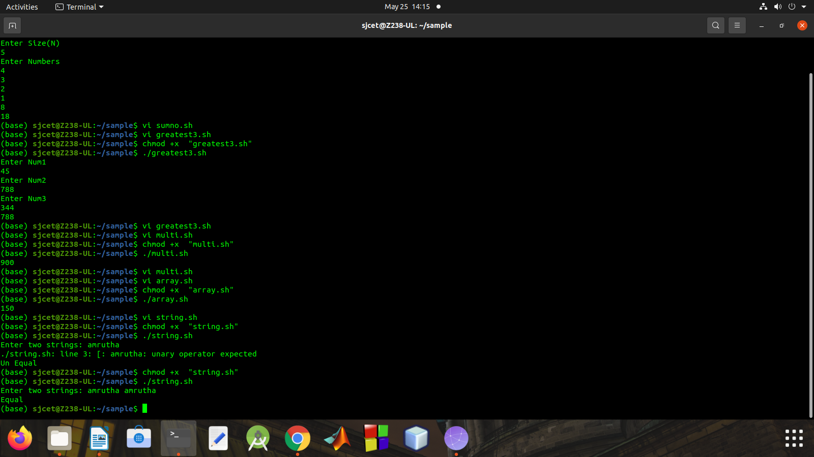

12.

read -p "Enter two strings: " str1 str2

if [ $str1 == $str2 ]
then
echo "Equal"
else
echo "Un Equal"
fi

