Creating Repository in GitHub

Step 1 Click new nearby repository

Step 2 Give the repository name

Step 3 select the "Add README"

Step 4 Click Create Repository

Adding Content to README file

Step 1 Open the repository create

Step 2 Open README.md in edit mode and add the content

Step 3 Click commit changes

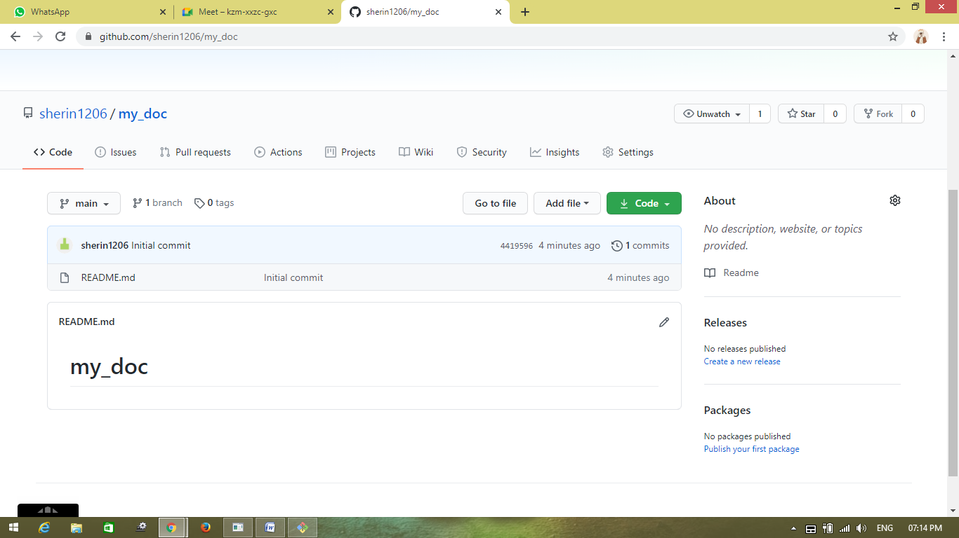

Cloning Repository:

$ ls

AppData/

'Application Data'@

Contacts/

Cookies@

Desktop/

eclipse/

eclipse-workspace/

Favorites/

Links/

'Local Settings'@

Music/

'My Documents'@

NetHood@

NTUSER.DAT

ntuser.dat.LOG1

ntuser.dat.LOG2

NTUSER.DAT{fd2528e9-7130-11e4-80c1-a4badb27af85}.TM.blf

NTUSER.DAT{fd2528e9-7130-11e4-80c1-a4badb27af85}.TMContainer00000000000000000001.regtrans-ms

NTUSER.DAT{fd2528e9-7130-11e4-80c1-a4badb27af85}.TMContainer00000000000000000002.regtrans-ms

ntuser.ini

Pictures/

PrintHood@

Recent@

'Saved Games'/

Searches/

SendTo@

'Start Menu'@

Templates@

Videos/

God@Sony MINGW64 ~

$ git clone https://github.com/sherin1206/my_doc.git

Cloning into 'my_doc'...

remote: Enumerating objects: 3, done.

remote: Counting objects: 100% (3/3), done.

remote: Total 3 (delta 0), reused 0 (delta 0), pack-reused 0

Unpacking objects: 100% (3/3), 588 bytes | 1024 bytes/s, done.

God@Sony MINGW64 ~

$ ls

AppData/ eclipse/ Music/ ntuser.dat.LOG1 ntuser.ini Searches/

'Application Data'@ eclipse-workspace/ 'My Documents'@ ntuser.dat.LOG2 Pictures/ SendTo@

Contacts/ Favorites/ my_doc/ NTUSER.DAT{fd2528e9-7130-11e4-80c1-a4badb27af85}.TM.blf PrintHood@ 'Start Menu'@

Cookies@ Links/ NetHood@ NTUSER.DAT{fd2528e9-7130-11e4-80c1-a4badb27af85}.TMContainer00000000000000000001.regtrans-ms Recent@ Templates@

Desktop/ 'Local Settings'@ NTUSER.DAT NTUSER.DAT{fd2528e9-7130-11e4-80c1-a4badb27af85}.TMContainer00000000000000000002.regtrans-ms 'Saved Games'/

Videos/

Moving to the repository:

God@Sony MINGW64 ~

$ pwd

/c/Users/God

God@Sony MINGW64 ~

$ cd my_doc

God@Sony MINGW64 ~/my_doc (main)

$

Adding files to repository-Add command: