Attention-Augmented ResNet50 Transfer Learning for Pancreatic Tumor Classification with Grad-CAM Explanations and a Web-Based Inference Service
Sahana Sruthi R. S  B.Tech Computer Science and Engineering  With Artificial Intelligence and Data Analytics  Sri Ramachandra Institute of Higher Education and Research  Chennai, India  e0324026@sriher.edu.in | Sherin .A  B.Tech Computer Science and Engineering  With Artificial Intelligence and Data Analytics  Sri Ramachandra Institute of Higher Education and Research  Chennai, India  e0324027@sriher.edu.in

Abstract—Finding tumors early is hard and any computer help must be accurate yet easy for a doctor to check. This paper shows a transfer-learning classifier that tells normal pancreatic images apart from pancreatic tumor images. An ImageNet-pretrained ResNet50 is used as a fixed feature extractor. On top of it a Convolutional Block Attention Module, called CBAM and a two‑way linear layer are trained. The training uses class‑weighted cross‑entropy, mild data augmentation and stops early when validation loss stops improving. Gradient‑weighted class activation mapping, called Grad‑CAM is linked to the residual stage so that a heat map appears for every decision. The trained model is served by a FastAPI backend and a React interface. It gives class probabilities a confidence number and an attention overlay for any JPG or PNG image that is uploaded. On a test set of 412 images—225 normal and 187 pancreatic tumor—none of which were used during training the model classified every image correctly. This gave an area under the ROC curve of 1.000 and the 95 % lower confidence bound on accuracy's 0.991. Because a perfect score should raise questions the paper also looks at reasons, for optimism. These include not using identifiers and not having an external test set. It lists the checks needed before any clinical claim is made.
Index Terms— tumor classification, medical image analysis, transfer learning, ResNet50 CBAM attention, Grad‑CAM, computer‑aided diagnosis, deep learning.

I. INTRODUCTION

Pancreatic cancer has one of the chances of survival among common types of cancer. In the United States about 13% of people live five years after diagnosis [1]. Many patients find out they have the disease late because early stages rarely cause any clear signs [2]. Imaging is the way to find the cancer before it is too late but reading scans of the pancreas is hard. The organ is small deep in the body and surrounded by structures that look similar. This makes it easy to miss tumors especially when doctors are very busy.

Deep learning has become a way to help with this problem. Systems made for checking CT scans have reached an accuracy that is important for patients [3]. Convolutional networks have been shown to tell the difference between non-cancerous tissue in the pancreas. These networks also work when tested on patients from places [4]. Surveys of the field also show that most models are trained in a few places and rarely explain why an image was labeled the way it was [5]. These two problems, not being clear and the difficulty of using a trained network are the reason for this work.

We create a small and easy to repeat process around a model that is well understood. Residual networks [6] that have been trained on ImageNet [7] give visual features. A CBAM block [8] changes the weight of those features before the classification. Grad-CAM [9] turns the convolutional activations into a heat map that can be shown with the prediction. Keeping the model the same means we only fit about half a million parameters, which is good for small data and short training times. The contributions are as follows.

(1) A two-class classifier for images that uses a ResNet50 that is not changed a CBAM block that can be trained and a simple head for classification. (2) A way to train the model that uses a split that keeps the groups balanced loss that pays attention to certain classes some small changes to the images and checking the loss to choose the best model. The test folder is not touched until the end. (3) A service that can be used where a FastAPI backend sends predictions, results and heat maps to a React website. (4) A clear look at the results: the accuracy on the test set is perfect so the paper spends much time explaining why that number should be taken with care as it does showing it.

The rest of the paper is organized like this. Section II looks at work done in the area. Section III explains the method. Section IV talks about how it was made. Section V gives details about the experiments. Section VI. Talks, about the results. Section VII lists the problems. What can be done next. Section VIII ends with a conclusion.

II. RELATED WORK

A. Learning-based analysis

I see that work on imaging usually falls into two main areas: finding or classifying lesions and segmenting lesions at the voxel level. I see that Big screening studies show that deep learning models can spot problems on scans with strong accuracy [3]. Other studies using case-control designs and data from hospitals check whether a model still works when applied to groups of patients [4]. Public datasets have grown a lot making training easier. The Medical Segmentation Decathlon includes a I see that the pancreas and tumor task includes volumes labelled by experts [10]. Recently the PanTS collection brings together 36,390 CT scans from 145 centres all with detailed tumor labels at the voxel level [11]. For segmentation networks U-family networks [12] are the common and perform best on these benchmarks. The problem we are looking at here is slice-level classification. A simpler setup that is useful for triage and, for teaching tools.

B. Evaluation pitfalls in imaging

The accuracy of models in imaging can sometimes be misleading depending on how the data are divided. If slices from the patient appear in both the training and test sets—like neighboring slices—the model may learn patterns specific to that patient instead of real disease features. This means the models performance scores might look good. They don’t show how well the model will work on new unseen patients [13]. A known study on chest X-ray models showed that accuracy dropped significantly when the models were used at a different hospital. This happened because the models had learned hospital- features, such as equipment settings rather than actual signs of disease [14]. These results help us understand our findings, in Section VI.

C. Attention and explainability

Attention modules do not add extra computation yet they help the network focus on the most important parts of the image both in terms of channels and spatial locations. CBAM first uses a channel gate. Then a spatial gate [8]. After the network makes a prediction methods such as Grad‑CAM highlight regions by weighting activation maps with gradients derived from the class score. This shows where the network is looking [9]. We must be careful. These maps do not prove that the network is reasoning correctly. Studies have found that explanation maps change little when the network’s weights are randomized [15]. Therefore we use these overlays as a guide, for reviewers not as evidence that the network’s decisionsre clinically valid.

III. PROPOSED METHODOLOGY

A. Pipeline overview
The classifier takes a RGB image and outputs a probability for each of two classes Normal (label 0) and Pancreatic Tumor (label 1). Figure 1 shows the flow. An input image is. Cropped, normalised with ImageNet statistics passed through the frozen ResNet50 trunk recalibrated by CBAM and mapped to two logits by a linear layer. A softmax converts the logits to probabilities and a Grad-CAM branch runs on the residual block when an explanation is requested.
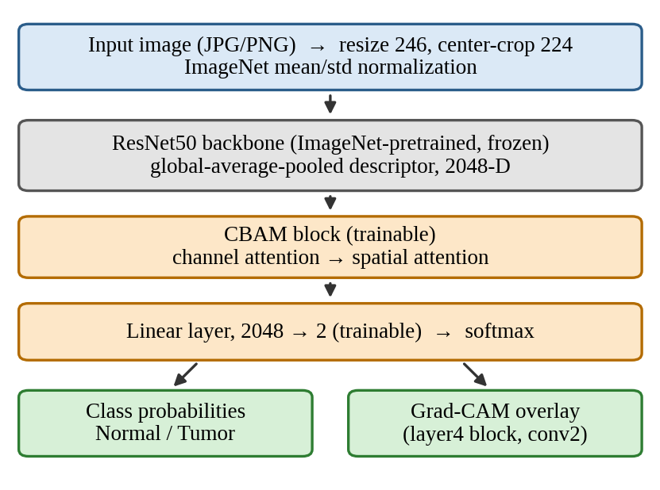
Fig. 1. Architecture of the proposed classifier. Gray: frozen; orange: trained; green: outputs.

B. Preprocessing and augmentation

Every image is converted to RGB. For training a random resized crop to 224×224 pixels (scale 0.85–1.0 aspect ratio 0.95–1.05) is followed by a flip with probability 0.5 a rotation of up to ±10° and light colour jitter (brightness and contrast 0.10, saturation 0.05 hue 0.02). The transformations are intentionally gentle because strong geometric or intensity changes can distort the appearance on which the decision depends. Validation, test and service‑time images skip augmentation: they are resized so the short side is 246 pixels, centre‑cropped to 224×224 and normalised with the ImageNet mean and standard deviation.

C. Backbone

The backbone is ResNet50 initialized from ImageNet weights. Its final classification layer is removed, leaving a descriptor produced by global average pooling. All backbone parameters (about 23.5 million) stay fixed during training so the network acts as a feature extractor and the risk of overfitting a dataset is reduced.

D. CBAM recalibration

I see that CBAM applies channel attention and spatial attention. For a feature map F the channel gate is

Mc(F) = σ( MLP(AvgPool(F)) + MLP(MaxPool(F)) ) (1)

where MLP is a shared two‑layer perceptron with reduction ratio 16 and σ is the sigmoid. The spatial gate then applies a 7×7 convolution to the channel‑wise mean and maximum maps:

Ms(F) = σ( conv7×7([meanc(F); maxc(F)]) ). (2)

In the implementation the block is placed after pooling so the 2048‑dimensional descriptor is reshaped to a 2048×1×1 map. At that size the spatial gate sees a location and reduces to a learned scalar rescaling, which means the recalibration is carried mainly by the channel gate. This is a simplification that keeps the trainable part small (about 0.53 million parameters, including the 4,098 of the linear classifier) but it differs from the usual practice of inserting CBAM inside the convolutional stages.

E. Grad‑CAM explanations

To explain a prediction the classifier uses Grad‑CAM through the pytorch‑grad‑cam package targeting the second convolution of the last bottleneck in layer4. The channel weights are the averaged gradients of the predicted class score the weighted activation maps are summed and passed through a ReLU and the result is normalised to [0 1] colourised with a jet map and blended with the input at a ratio of 0.55 to 0.45. If the package cannot be imported the service falls back to an intensity‑based heat map; that fallback is purely cosmetic. Carries no information about the classifier so it should be disabled in any setting where overlays are interpreted.

F. Loss function

Class imbalance in the training partition is handled with weighted cross‑entropy. With N training images and nc images in class c the weight of class c is

wc = N / (2 nc) (3)

so that the minority class contributes more, to the gradient.

IV. SYSTEM IMPLEMENTATION
A. Training configuration
Training is carried out in PyTorch [18]. Follows the settings shown in Table I. Weights are optimized using AdamW [17]; when a CUDA device is available mixed‑precision arithmetic activates automatically otherwise the code runs on the CPU. A fixed random seed of 42 governs the data split and initialization. Each epoch compares the validation loss with the loss seen so far and the weights, from the epoch that gives the lowest loss are restored at the end. This ensures that the saved checkpoint is chosen without referencing the test folder. Early‑stopping patience was set to five epochs. The loss kept improving so all 20 epochs were executed and Training finished after 20 epochs.
TABLE I
TRAINING CONFIGURATION
Setting | Value
Optimizer | AdamW
Learning rate / weight decay | 1×10⁻⁴ / 1×10⁻⁴
Batch size | 16
Maximum epochs | 20
Early-stopping patience | 5 epochs (min. Δ = 10⁻⁴)
Loss | Class-weighted cross-entropy
Backbone | ResNet50, frozen
Input size | 224×224
Validation share | 20% of training, stratified
Random seed | 42

B. Backend service
The trained checkpoint is loaded once when the system starts and kept in memory. A FastAPI application shows the endpoints that are listed in Table II. Only JPG and PNG files can be. If no checkpoint is ready the request is rejected with a clear message instead of giving made‑up results.The service runs on port 8003. Sends back JSON that contains the predicted label, its confidence, the probabilities for each class and, for the Grad‑CAM route base64‑encoded original, heat‑map and overlay images.
TABLE II
REST ENDPOINTS OF THE INFERENCE SERVICE
Endpoint | Method | Purpose
/predict | POST | Label, confidence, class probabilities
/gradcam | POST | Prediction plus heat map and overlay
/metrics | GET | Stored test-set metrics
/model-info | GET | Checkpoint path, device, classes
/health | GET | Service and model status

C. Front end

The user interface is a single-page React application created using Vite. It includes an image uploader, a section that displays the predicted class along, with the confidence level a bar chart showing the two class probabilities made with Recharts, a viewer that displays the image the heat map and the overlay all together a section that explains the loaded model and a visible disclaimer that says the output is a research aid and not a diagnosis.

V. EXPERIMENTAL SETUP

A. Dataset

Experiments use the Pancreatic Tumor image dataset [19], a two-class collection of Pancreatic Tumor images stored as JPG files in separate training and testing folders. The imaging modality of the collection is CT. The training folder contains 1,600 images (900 700 tumor). The testing folder, which forms the basis of every result in Section VI contains 412 images: 225 187 tumor, a ratio of 54.6%, to 45.4%. Folder names are a bit different, in each release. One might be called "Pancreatic Tumor". Another might be called "Pancreatic Cancer." The loader takes all these names and connects them to the same tumor label.

The testing folder was not read during training. From the training folder 20% of the images were set aside by random sampling to form a validation set used for checkpoint selection and the remaining 80% were used to fit the model. No patient identifiers accompany the images so the split could be performed at image level.

B. Evaluation metrics

I looked at test performance. Found that it can be described with accuracy, precision, recall (sensitivity) specificity, F1‑score and the area under the ROC curve (AUC). All of these values were calculated with scikit‑learn [20]. The AUC is understood as the likelihood that a selected tumor image gets a higher tumor score than a randomly selected normal image [21]. Using TP, TN, FP and FN to represent the confusion matrix counts,

Sensitivity = TP / (TP + FN) Specificity = TN / (TN + FP). (4)

Since a score has no sampling variability in the point estimate I also include Clopper–Pearson 95% confidence intervals. Additionally I provide two probability-quality measures: log-loss and the Brier score both calculated from the saved, per-image probabilities.

C. Hardware and software

The code base was built on a Windows 11 computer using Python and PyTorch [18]. It used a GPU that supports CUDA when one was available and switched to the CPU automatically if not. The numbers shown below came from running the evaluation script, on the saved checkpoint. The results were saved into the metrics folder. No graph or chart was drawn by hand.

VI. RESULTS AND DISCUSSION

A. Training behavior
Fig. 2 Shows loss and accuracy for each epoch. Training loss and validation loss both fall from 0.65 to about 0.08 and 0.09 and they stay together so there is no sign of overfitting. Validation accuracy goes above 0.97 after the two epochs and then stays near 0.98 for the rest of the run while training accuracy stays at about the same level even though augmentation is used. The early plateau is expected because the backbone is frozen and only the attention block and the linear head are being updated. Pretrained features already separate the two classes well. The extra improvement after the epoch mainly comes from confident predictions, shown by loss reduction rather, than more correct classifications.
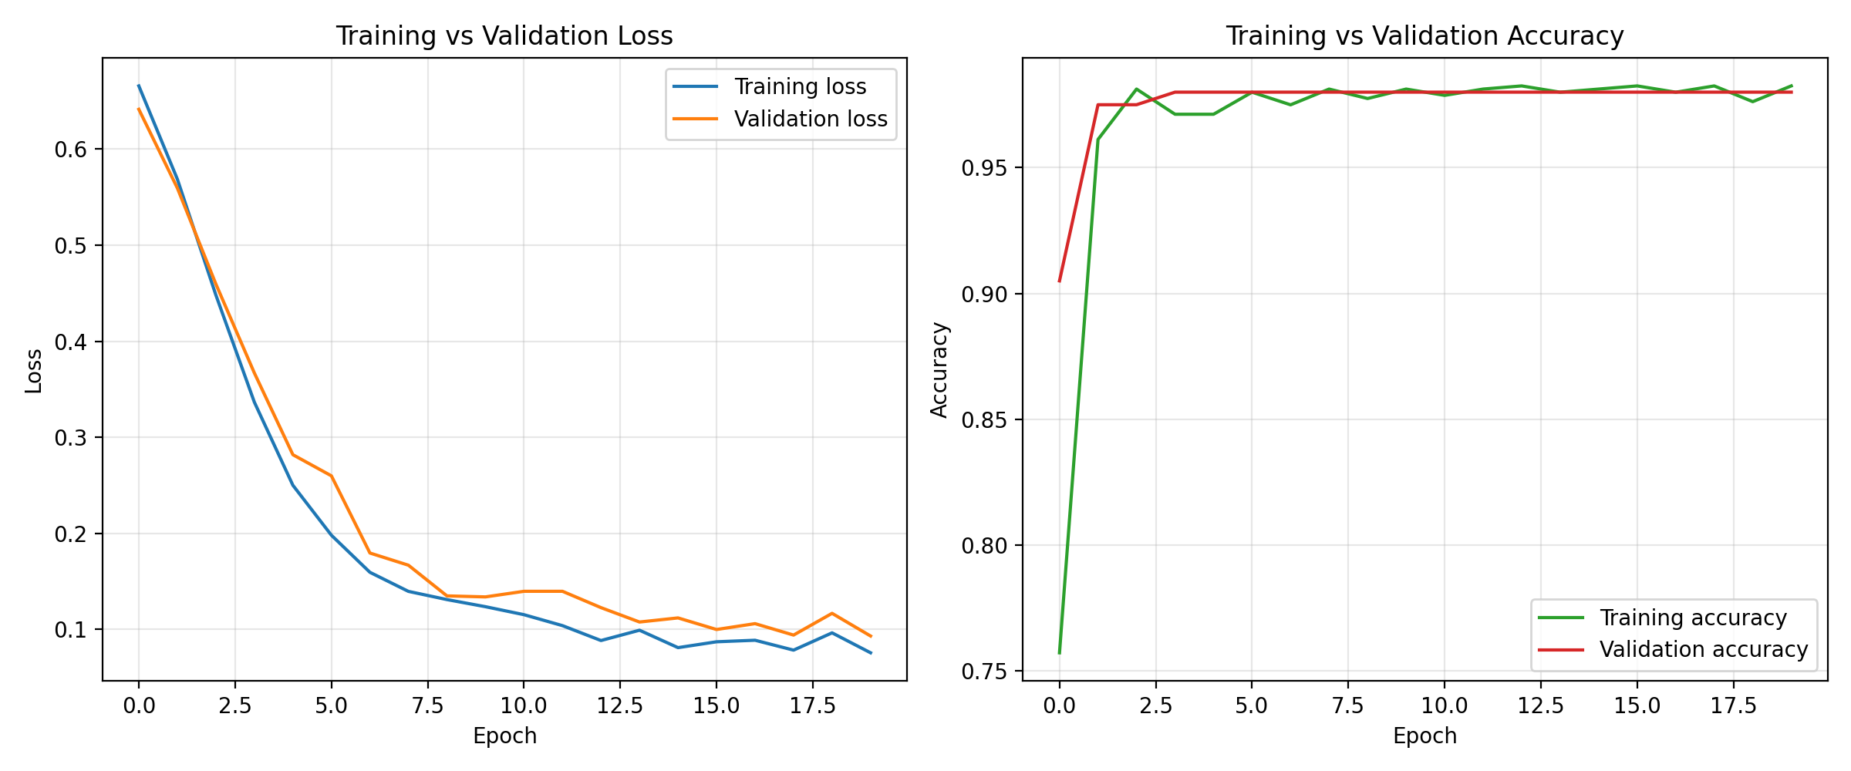
Fig. 2. Displays the training loss and validation loss on the left and the accuracy on the right across 20 epochs. The curves in Fig. 2 Are produced by the training script and the epoch counter in Fig. 2 Starts, at zero.

B. Test-set performance
Table III presents the test results. The network correctly classified all 412 images that were held out. The confusion matrix in Figure 3(a) has no values outside the diagonal meaning there were no misclassifications. The ROC curve in Figure 3(b) reaches the left corner and the AUC is 1.000 which indicates perfect discrimination.
Because the test set is small compared to the range of clinical imaging variability it is important to look at the point estimates along with their confidence intervals. Since there were zero errors in 412 images the lower 95% confidence bound for accuracy is 0.991. For sensitivity based on 187 tumor images the lower bound is 0.980. For specificity based on 225 images the lower bound is 0.984.
This means the data are consistent with an error rate of up, to about one percent.. If the test images do not represent future patients well the actual error rate could be much higher.
TABLE III
TEST-SET RESULTS (N = 412)
Metric | Value | 95% CI (exact)
Accuracy | 1.000 | [0.991, 1.000]
Sensitivity (recall) | 1.000 | [0.980, 1.000]
Specificity | 1.000 | [0.984, 1.000]
Precision | 1.000 | —
F1-score | 1.000 | —
AUC-ROC | 1.000 | —
Log-loss | 0.105 | —
Brier score | 0.014 | —

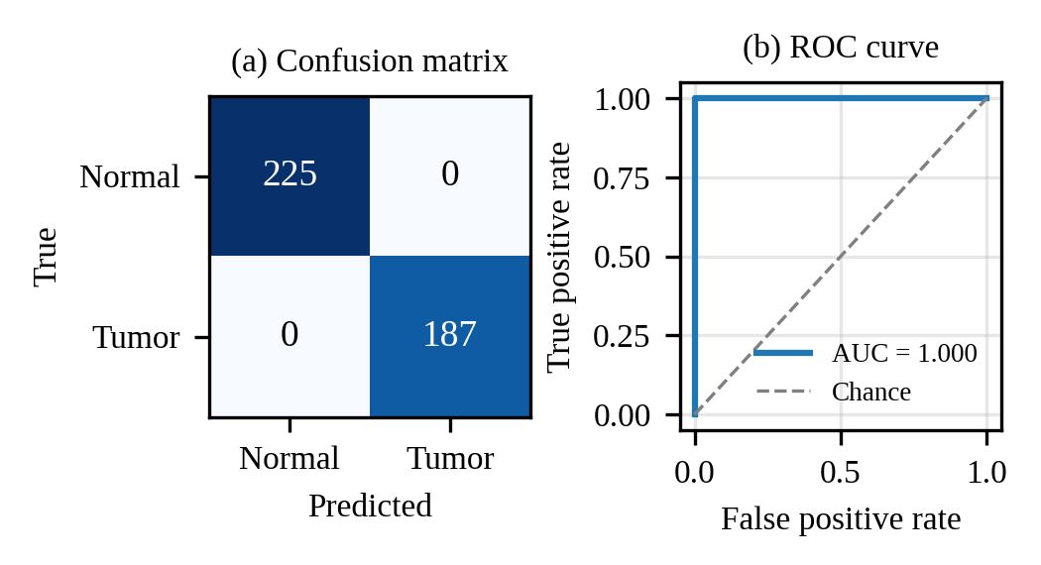
Fig. 3. Test-set confusion matrix (a) and ROC curve (b).

C. Probability behavior
Perfect classification does not mean the model is sure. Figure 4 shows the predicted tumor probability for each test image. Every normal image got a tumor probability of most 0.336 (average 0.148) and every tumor image got at least 0.890 (average 0.963) so any decision threshold between these two numbers would also have led to zero mistakes. The log-loss of 0.105 and Brier score of 0.014 show that the probabilities are clearly separated but not very high, which matches a backbone and a short low-learning-rate run. Confidence is much lower, for images (average top-class probability 0.852) compared to tumor images (0.963) a trend that could be because normal pancreatic tissue has more different looks and because of class weighting.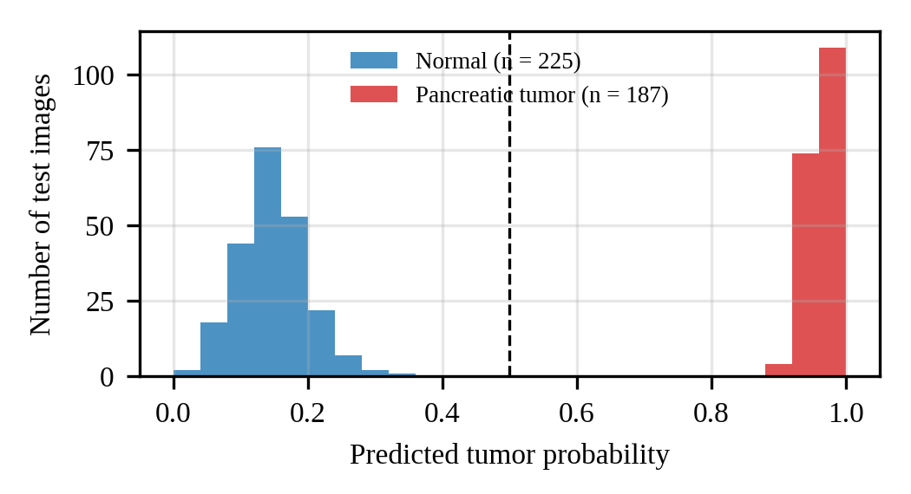
Fig. 4. Distribution of predicted tumor probability on the test set. The dashed line marks the 0.5 decision threshold.

D. Interpreting a perfect score

If you get a result of 100 percent on a medical test set you should. Please think carefully before you celebrate. I notice that validation accuracy during training was 0.98, a little than the test accuracy. The training set and the test set have sizes. The small difference can happen just by chance.. Several explanations deserve attention. First images from the patient may appear in, than one partition. Because no patient identifier is available we cannot rule out that neighboring slices of one subject sit on both sides of the split. This is the form of leakage. Second the two classes may differ in how the images were taken. For example the source site, the scanner or the compression might be different.

A network can use these differences to guess the class without looking at the lesion [14].

Third the test folder comes from the release, as the training folder. Therefore it does not test how well the model works on data from an institution.

Until these points are examined the result should be seen as evidence that the pipeline works as intended on this dataset. It should not be taken as evidence of performance.A further caveat concerns attribution. We did not train a ResNet50 head without CBAM under identical conditions. Therefore the experiments cannot show how much, if any, of the performance comes from the attention block.

Likewise Grad‑CAM overlays were generated by the service. Were not scored against lesion annotations. Because of the doubts raised about saliency maps [15] they should be understood as aids.

VII. LIMITATIONS AND FUTURE WORK

Several limitations qualify the findings. (i) The split happens at image level. The dataset does not contain patient identifiers so leakage cannot be ruled out; a split by patient or by center is the most important next step. (ii) There is no validation; the model has not been tested on data from another hospital, scanner or population. (iii) The test folder is small so even a perfect result carries a confidence interval of one percentage point and rare presentations are unlikely to appear. (iv) The task is binary; benign cysts, neuroendocrine tumors and pancreatitis which make reading harder are not included in the model. (v) The backbone is frozen. Cbam works on a pooled vector so the attention block cannot reshape spatial features. (vi) No ablation study (without CBAM with tuning) or comparison with other backbones was performed. (vii) Grad-CAM output has not been quantitatively validated. Future work will therefore include patient-level partitioning with crossvalidation, evaluation on at least one independent public dataset such as the collections described in [10] and [11], an ablation of the attention block and of partial backbone fine-tuning, calibration analysis and a comparison of explanation methods, against annotated lesion locations. On the engineering side the service should gain authentication, audit logging and de-identification of uploads before it is used with any patient data.

VIII. CONCLUSION

This paper shows a pancreatic tumor classifier that adds a CBAM block and a linear head to a frozen ResNet50 explains its outputs with Grad‑CAM and is wrapped as a FastAPI and React service. On a held‑out set of 412 images the pancreatic tumor classifier scored 100 percent achieving an AUC of 1.000 and the possible confidence bound on accuracy is 0.991. I find that the predicted probabilities from the tumor classifier are clearly separated, with a big gap between the two classes. Because the data split was done at the image level came from one release and no ablation or external test was carried out this result should be seen as a proof‑of‑concept and a baseline, for future research not as evidence of clinical accuracy. Patient‑level splitting and external validation should be tackled next before the pancreatic tumor classifier can be used in practice.

REFERENCES
[1] R. L. Siegel, A. N. Giaquinto, and A. Jemal, “Cancer statistics, 2024,” CA: A Cancer Journal for Clinicians, vol. 74, no. 1, pp. 12–49, 2024.
[2] P. Rawla, T. Sunkara, and V. Gaduputi, “Epidemiology of pancreatic cancer: Global trends, etiology and risk factors,” World J. Oncol., vol. 10, no. 1, pp. 10–27, 2019.
[3] K. Cao et al., “Large-scale pancreatic cancer detection via non-contrast CT and deep learning,” Nature Medicine, vol. 29, pp. 3033–3043, 2023.
[4] K.-L. Liu et al., “Deep learning to distinguish pancreatic cancer tissue from non-cancerous pancreatic tissue: A retrospective study with cross-racial external validation,” Lancet Digit. Health, vol. 2, no. 6, pp. e303–e313, 2020.
[5] G. Litjens et al., “A survey on deep learning in medical image analysis,” Med. Image Anal., vol. 42, pp. 60–88, 2017.
[6] K. He, X. Zhang, S. Ren, and J. Sun, “Deep residual learning for image recognition,” in Proc. IEEE Conf. Comput. Vis. Pattern Recognit. (CVPR), 2016, pp. 770–778.
[7] J. Deng, W. Dong, R. Socher, L.-J. Li, K. Li, and L. Fei-Fei, “ImageNet: A large-scale hierarchical image database,” in Proc. IEEE Conf. Comput. Vis. Pattern Recognit. (CVPR), 2009, pp. 248–255.
[8] S. Woo, J. Park, J.-Y. Lee, and I. S. Kweon, “CBAM: Convolutional block attention module,” in Proc. Eur. Conf. Comput. Vis. (ECCV), 2018, pp. 3–19.
[9] R. R. Selvaraju et al., “Grad-CAM: Visual explanations from deep networks via gradient-based localization,” in Proc. IEEE Int. Conf. Comput. Vis. (ICCV), 2017, pp. 618–626.
[10] M. Antonelli et al., “The Medical Segmentation Decathlon,” Nature Commun., vol. 13, Art. no. 4128, 2022.
[11] W. Li et al., “PanTS: The pancreatic tumor segmentation dataset,” arXiv preprint arXiv:2507.01291, 2025.
[12] O. Ronneberger, P. Fischer, and T. Brox, “U-Net: Convolutional networks for biomedical image segmentation,” in Proc. Med. Image Comput. Comput. Assist. Interv. (MICCAI), 2015, pp. 234–241.
[13] S. Kaufman, S. Rosset, C. Perlich, and O. Stitelman, “Leakage in data mining: Formulation, detection, and avoidance,” ACM Trans. Knowl. Discov. Data, vol. 6, no. 4, Art. no. 15, 2012.
[14] J. R. Zech et al., “Variable generalization performance of a deep learning model to detect pneumonia in chest radiographs: A cross-sectional study,” PLoS Med., vol. 15, no. 11, Art. no. e1002683, 2018.
[15] J. Adebayo, J. Gilmer, M. Muelly, I. Goodfellow, M. Hardt, and B. Kim, “Sanity checks for saliency maps,” in Adv. Neural Inf. Process. Syst. (NeurIPS), 2018, pp. 9505–9515.
[16] J. Gildenblat and contributors, “PyTorch library for CAM methods,” GitHub repository, 2021. [Online]. Available: https://github.com/jacobgil/pytorch-grad-cam
[17] I. Loshchilov and F. Hutter, “Decoupled weight decay regularization,” in Proc. Int. Conf. Learn. Represent. (ICLR), 2019.
[18] A. Paszke et al., “PyTorch: An imperative style, high-performance deep learning library,” in Adv. Neural Inf. Process. Syst. (NeurIPS), 2019, pp. 8024–8035.
[19] F. Pedregosa et al., “Scikit-learn: Machine learning in Python,” J. Mach. Learn. Res., vol. 12, pp. 2825–2830, 2011.
[20] J. A. Hanley and B. J. McNeil, “The meaning and use of the area under a receiver operating characteristic (ROC) curve,” Radiology, vol. 143, no. 1, pp. 29–36, 1982.

