**INTERNSHIP PROJECT REPORT**

**PHPTRAVELS**

**Functional Testing using Selenium WebDriver**

**Prepared by**

**Sherin Thomas**

|  |  |
| --- | --- |
| Name Of The Student | Sherin Thomas |
| Internship Project Topic | Functional Testing using Selenium WebDriver |
| Name of the Organization | TCS iON |
| Name of the Industry Mentor | Debashis Roy |
| Name of the Institute | ICT Academy of Kerala |

|  |  |  |  |  |
| --- | --- | --- | --- | --- |
| Start Date | End Date | Total Effort (hrs.) | Project Environment | Tools used |
| 09-02-2023 | 11-02-2023 | 15 | Local machine with installed softwares | Microsoft Word, Microsoft Excel, Eclipse IDE, Selenium, TestNG,  Maven |

**TABLE OF CONTENTS**

|  |  |
| --- | --- |
| 1.Acknowledgement | 5 |
| 2.Abstract | 6 |
| 3.Objective | 7 |
| 4.Introduction  4.1Overview of website  4.2 Website Installation  4.3 Module description  4.4 Screenshots | 7  7  8  8  10 |
| 5.Software Testing  5.1 Types of testing  5.2 Testing of website | 12  13  14 |
| 6. Test Approach  6.1 Tools | 14  15 |
| 7.Test Summary  7.1 Types of testing on the website  7.2 Outcomes expected  7.3 Test Results | 22  22  22  23 |
| 8. System Configurations  8.1Hardware Specification  8.2 Software Specification | 24  24  24 |
| 9.Description of Internship | 24 |
| 10.Internship Activities | 25 |
| 11.Challenges and Opportunities | 26 |
| 12. Research and Learnings | 26 |
| 13. Conclusion | 27 |
| 14.Link to code and executable file | 27 |
| 15. Bibliography  15.1.Weblinks | 27  27 |

**1.Acknowledgement**

First of all, I would like to thank **Almighty God** for giving me strength to do this internship effectively.

I would express my sincere gratitude to our industry mentor Debashis Roy and other mentors for their continued support and cooperation during the internship. I would also like to thank TCS iON for giving me an opportunity to have practical experience in your organization.

My humble thanks to my family, friends and ICT Academy of Kerala for helping me carry out this task successfully.

**2.Abstract**

The testing project focus on a travel agency(PHP TRAVELS ) website and conduct multiple types of testing such as functionality testing, usability testing and broken link testing. The automated tools are used to perform this testing. Throughout the whole testing process I learned academic knowledge of software testing and gave me the opportunity to get hands on testing experience by implementing the academic knowledge. The testing process opened the door of learning through sharing and discussion among members.

**3.Objective**

* To learn and apply theoretical knowledge in a real life scenario.
* Perform automated functional testing on the site phptravels.net
* Design the functional testing project using java-based Selenium WebDriver API.
* Perform end to end functional testing on all the web elements.
* To prepare test documents (Test design, Test scenario, Test case, defect log) based on the Use Cases.

**4.Introduction**

**4.1Overview of Website**

The aim of the project is to perform automated functional testing of the website https://www.phptravels.net using java based Selenium WebDriver API.

PHPTRAVELS is an online booking software for travel businesses. It helps travel agencies manage their business online, providing them a fully-working online booking system.

This is a PHP & MySQL software aimed at running booking business and travel agency website.The application has the multilingual script where users can search apartment availability in 50+ languages, as well as multi-currency possibility.

This platform offers many effective features, such as availability check, booking for a specific period, billing, reporting, payments, calendars, coupons, and more. All of them are accessible via a simple central interface.The booking engine of PHPTRAVELS is customizable and includes billing, reports and invoicing. The system supports major payment gateways, including VISA, PayPal and others.

There are separate accounts for customers and for travel agents, and customizable software script according to specific business requirements

The different modules in this project are:

1. Customer Front- End

2. Agent Front-t End

3. Admin Back- End

4. Supplier Back-end

**4.2 Website Installation**

The PHPTRAVELS website do not require any installation

* 1. **Module Description**

**4.3.1Customer Front-End**

* Check user login with valid/invalid credentials.
* Displays the link My Bookings to view the booking details
* Displays the link Add Funds to make payment using various options
* Displays the link My Profile with profile details
* Update address of user
* Check bookings and view display voucher
* Payment of USD 50 using PayPal
* Displays the links Hotels, Tours, Transfers, Visa, Flights, Company
* Choose language, denomination
* Displays the link Logout

**4.3.2Agent Front-End**

* Check user login with valid/invalid credentials.
* Displays the link My Bookings to view the booking details
* Displays the link Add Funds to make payment using various options
* Displays the link My Profile with profile details
* Displays the link Logout
* Displays the links Hotels, Hotels, Tours, Transfers, Visa, Flights, Offers
* Search by Hotels by City option
* Choose language, denomination
* Update the USD to INR for the account.

**4.3.3Admin Back- End**

* Check user login with valid/invalid credentials
* Test the link of Booking and then display the invoice where payment is successful.
* Delete a record that is having booking status as Cancelled.
* Change the booking status from “Pending” to “Confirmed” and verify the count in dashboard.
* Check whether the “Website” link is working and verify if it is redirecting to a different page.

**4.3.4 Supplier Back –End**

* Check user login with valid/invalid credentials.
* Check the dashboard overview and the text sales overview and summary.
* Test whether it displays Revenue breakdown
* Change the booking status from ‘Pending’ to ‘Confirmed’ and verify the count in dashboard
* Check whether the modules ‘Flight’, ‘Visa’, ‘Tours’, ‘Bookings’ are displayed and can be clicked.
  1. **Screenshots**

Customer booking voucher

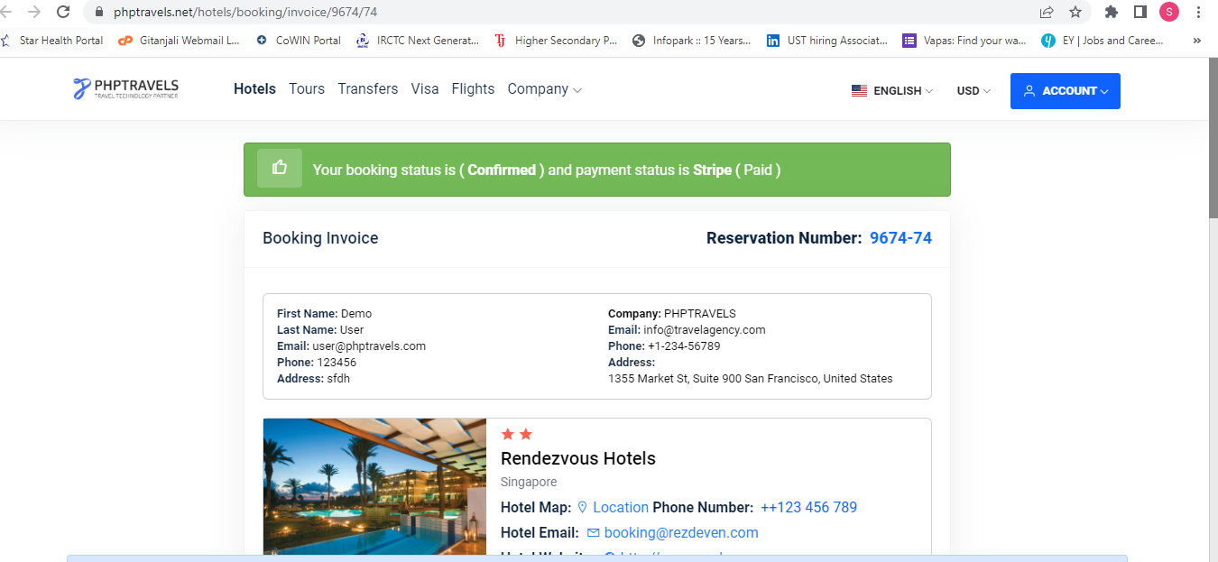

Agent Denomination Conversion

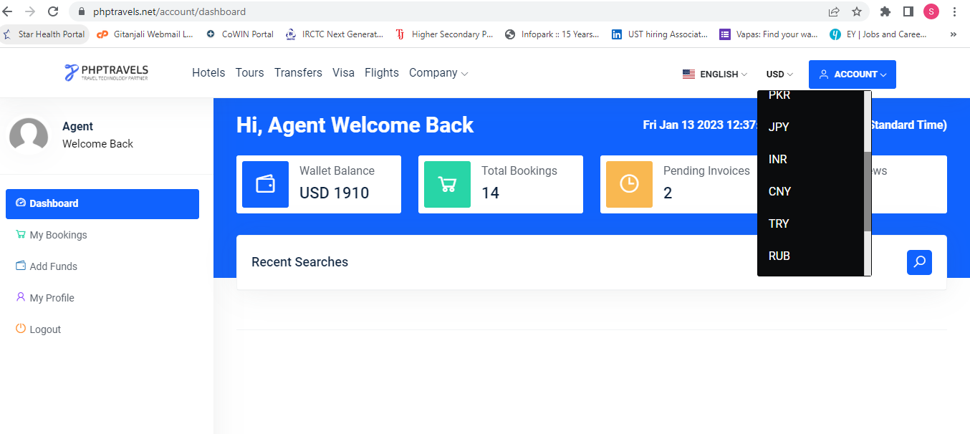

Admin Revenue Breakdown

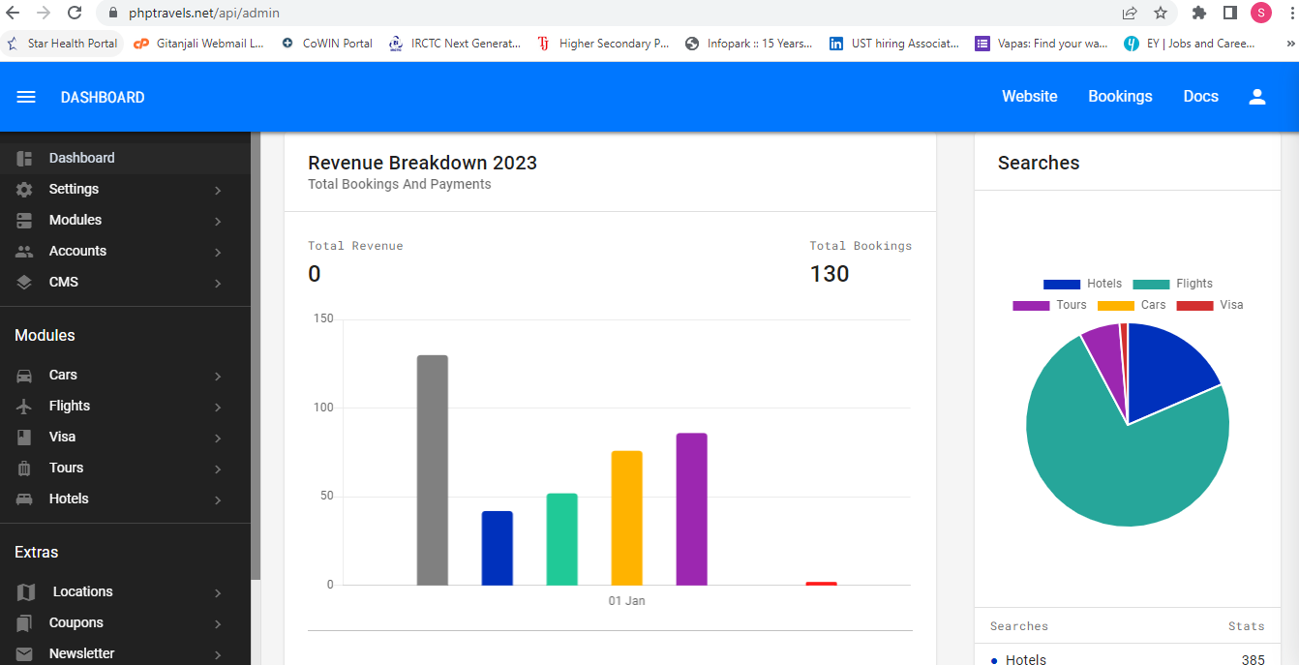

Supplier Dashboard

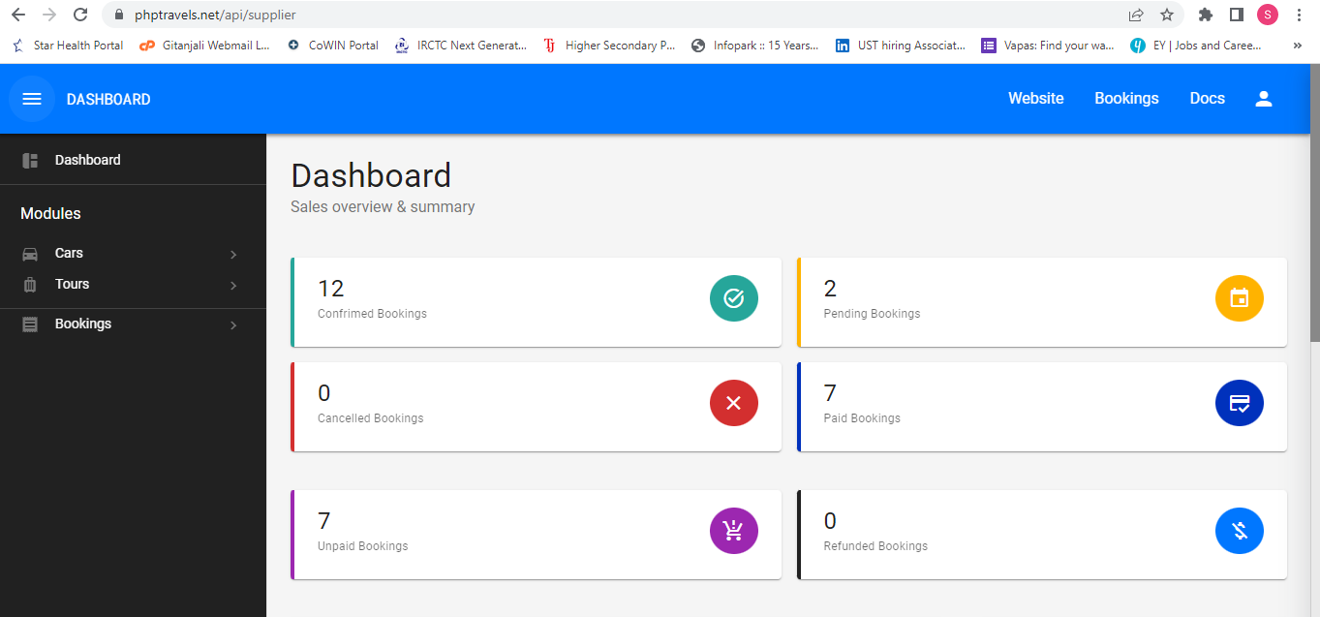

**5.SoftwareTesting**

Software testing is the process of verifying and validating whether a software or application is bug-free, meets the technical requirements as guided by its design and development, and meets the user requirements effectively and efficiently by handling all the exceptional and boundary cases. Testing identifies errors, gaps or missing requirements in contrast to actual requirements. It involves execution of software/system components using manual or automated tools to evaluate one or more properties of interest.

Software Testing can be broadly classified into two types:

* **Manual testing**
* **Automation testing**

### ****Manual Software Testing****

Manual testing is carried out by a tester manually without the use of any kind of automation tool. It can identify visible and hidden defects. It may require great effort and time, but the result will be bug-free software. Testers use test plans, test cases, or test scenarios to test software to ensure the completeness of testing. It also includes exploratory testing, as testers explore the software to identify errors in it.

### Automation Testing of Software

Automation testing involves the use of special automation tools and requires a huge investment of money and resources. Here, testers handle test scripts and return the result automatically. Test suites are recorded by using tools, and these can be played again by the testers as per the requirement. No human intervention is required for automation testing. It increases the test coverage, improves accuracy, and saves time and money when compared to manual testing.

**5.1 Types of testing:**

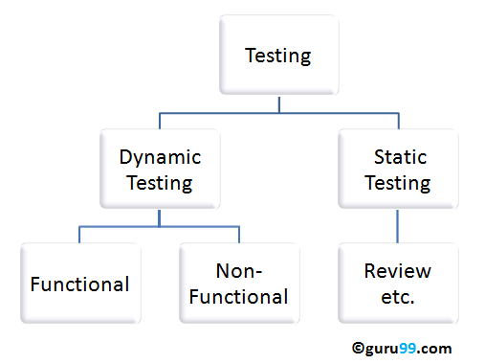

**5.1.1 Static testing**

Static testing is process which checks the application without executing the code. It is a verification process. Some of the essential activities are done under static testing such as business requirement review, design review, code walkthroughs, and the test documentation review. Static testing can be done manually or with the help of tools to improve the quality of the application by finding the error at the early stage of development.

**5.1.2 Dynamic testing**

Dynamic testing is testing, which is done when the code is executed at the run time environment. It is a validation process where functional testing [unit, integration, and system testing] and non-functional testing [user acceptance testing] are performed.

**5.2 Testing of Website**

Website testing is checking your website for potential bugs before its made live and is accessible to general public. It checks for functionality, usability, security, compatibility, performance of the web application or website.

**6.Test Approach**

A test approach defines how testing would be performed, what steps need to be undergone to accomplish a task. In the Test Strategy and Planning phase, we analyze the requirements. It will be a single time activity for the entire program. Whereas in the Execution phase we analyse the requirements, prepare test cases, execute it and make the bug fixes etc. This will be repeated in all cycles. Test cases, test scenarios etc. are used to ensure completeness of testing. Automated Functional testing will be carried out on the various modules.

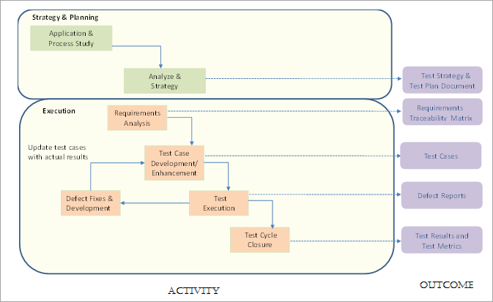

**6.1Tools**

The different automated tools used in the testing of the website are as below:

**6.1.1 Selenium**

Selenium is an open source tool that automates web browsers in different platforms. It is a single interface which allows to write scripts in different programming languages like Java, Python, C# etc. Selenium WebDriver is the most important component of Selenium Tool’s suite.

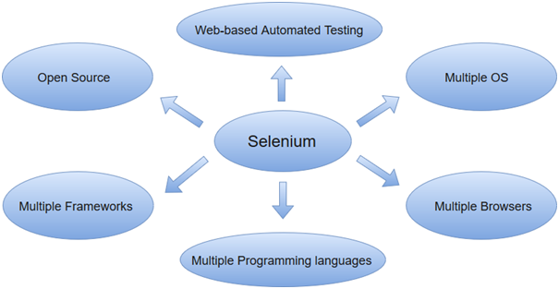

WebDriver has a built-in implementation of Firefox driver (Gecko Driver). For other browsers, you need to plug-in their browser specific drivers to communicate and run the test. Most commonly used WebDriver's include:

* Google Chrome Driver
* Internet Explorer Driver
* Opera Driver
* Safari Driver

**Selenium WebDriver- Architecture**

Selenium WebDriver API provides communication facility between languages and browsers. The following image shows the architectural representation of Selenium WebDriver.

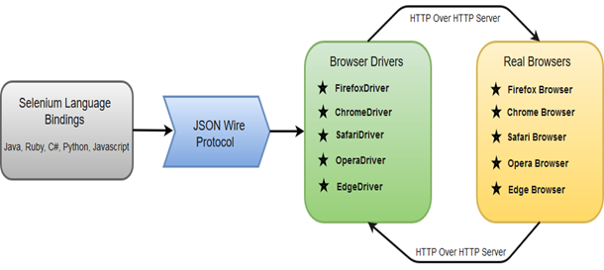

There are four basic components of WebDriver Architecture:

* Selenium Language Bindings
* JSON Wire Protocol
* Browser Drivers
* Real Browsers

### Selenium Language Bindings / Selenium Client Libraries

Selenium developers have built language bindings/Selenium Client Libraries in order to support multiple languages. For instance, if you want to use the browser driver in java, use the java bindings. All the supported language bindings can be downloaded from the official website [(https://www.seleniumhq.org/download/#client-drivers)](https://www.seleniumhq.org/download/#client-drivers) of Selenium.

### JSON Wire Protocol

JSON (JavaScript Object Notation) is an open standard for exchanging data on web. It supports data structures like object and array. So, it is easy to write and read data from JSON. To learn more about JSON, visit <https://www.javatpoint.com/json-tutorial>

JSON Wire Protocol provides a transport mechanism to transfer data between a server and a client. JSON Wire Protocol serves as an industry standard for various REST web services. To learn more about Web Services, visit <https://www.javatpoint.com/web-services-tutorial>

### 6.1.2Browser Drivers

Selenium uses drivers, specific to each browser in order to establish a secure connection with the browser without revealing the internal logic of browser's functionality. The browser driver is also specific to the language used for automation such as Java, C#, etc.

**6.1.3Maven**

Maven is a built automation tool from Apache Software Foundation and is commonly used to handle [Java projects](https://www.simplilearn.com/tutorials/java-tutorial/java-projects-for-beginner). These days it is commonly used to manage project dependencies and the whole lifecycle of any project which can include code generation, compilation , testing, validation, packaging etc. Maven uses the concepts of the project object model (POM) and enables the user to cut down several steps followed in the build process.

Maven simplifies does mainly following tasks.

1. It makes a project easy to build
2. It provides uniform build process (maven project can be shared by all the maven projects)
3. It provides project information (log document, cross referenced sources, mailing list, dependency list, unit test reports etc.)
4. It is easy to migrate for new features of Maven

Apache Maven helps to manage

* Builds
* Documentation
* Reporting
* SCMs
* Releases
* Distribution

**Maven pom.xml**

POM is an acronym for Project Object Model. The pom.xml file contains information of project and configuration information for the maven to build the project such as dependencies, build directory, source directory, test source directory, plugin, goals etc.

Maven reads the pom.xml file, then executes the goal.

**Maven Lifecycle**

There is a lifecycle that every Maven in Selenium build follows.The crucial goals are clean, install, and test.

### Maven Clean

Maven Clean is used to clean the target folder. This is where the previous build’s files, libraries, reports, output files, etc., are saved. The command to execute this is ‘mvn -clean’.

### Maven Install

Maven Install is used to install all the dependencies and create the deployment file. After this, it will run the test.

### Maven Run

Maven Run will simply run the test without creating any deployment file.

**6.1.4 TestNG**

TestNG is an automation testing framework which creates test report in a proper format. It can be easily integrated with Maven, Jenkins etc. Annotations used here are easy to understand. TestNG provides you full control over the test cases and the execution of the test cases.TestNG framework eliminates the limitations of the older framework by providing more powerful and flexible test cases with help of easy annotations, grouping, sequencing and parametrizing.

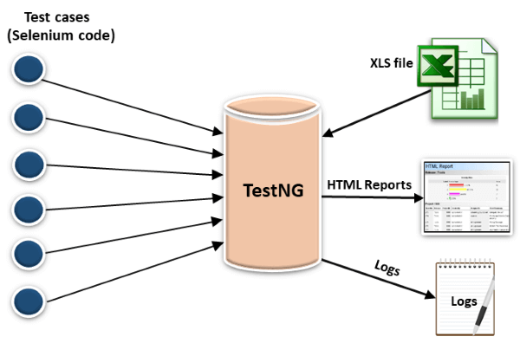

* In TestNG, annotations are easier to understand than Junit.
* It produces the HTML reports for implementation.
* It also generates the Logs.
* In TestNG, there is no constraint available such as @beforeclass and @afterclass which is present in Junit.
* TestNG does not extend any class. TestNG framework allows you to define the test cases where each test case is independent of other test cases.
* Parallel execution of test cases, i.e., running multiple test cases is only possible in the TestNG framework.

**6.1.5 Eclipse**

Eclipse is an IDE(Integrated Development Environment) for developing applications using Java and other languages. We can add plugins to IDE to extend the functionality. It works on major platforms like Windows, Mac OS, Linux etc.

**7.Test Summary**

**7.1Types of testing done on the website.**

**7.1.1Functionality Testing**

It is performed to test the functionalities of each feature on the website. We check the links in webpages are working correctly and make sure that there are no broken links. Forms are tested for scripting checks (If a user does not fill a mandatory field in a form an error message is shown.) Test negative scenarios such that when a user executes an unexpected step, appropriate error message is displayed .Manual and automated testing is performed.

**7.1.2 Usability Testing**

Website is checked for usability features like consistency and visibility of menus, buttons, links across different web pages.

**7.2Outcomes expected**

With this website testing,I try to understand different types of errors, scenarios in which these errors are created, the guidelines which are not met while creating websites.

**7.3 Test Results**

|  |  |
| --- | --- |
| Test cases planned | 92 |
| Test cases executed | 92 |
| Test cases passed | 76 |
| Test cases failed | 16 |

**8.System Configurations**

**8.1Hardware Specification**

OS: Windows 64

Working Internet Connection

**8.2 Software Specification**

JDK with JRE

IDE: Eclipse

Web browser: Chrome,Firefox

Cloud repository: GitHub

Database: Local Storage

Automation Test tools: Selenium with Java,TestNG, Maven

**9.Description of Internship**

The students of ICT Academy of Kerala are given an opportunity to do the TCS iON Remote Internship of 125 hours as part of the Certified Specialist in Software Testing course. Through this internship, students get a chance to explore the practical world under the guidance of industry mentors of TCS iON.

As part of the internship, we have to go through the Customer Front End, Agent Front End, Admin Back End and Supplier Back End modules of the site phptravels.net and perform automated functional testing of the various tasks using Selenium WebDriver API. Various reports namely Test Design, Test Scenario, Test Design have to be created. Defects found need to be captured in Defect Log.

**10.Internship Activities**

* Completed the Pre Assessment Test.
* Watching various videos provided in the welcome kit so that we can adhere to the various guidelines.
* Interacting with friends and mentors regarding the project using Digital discussion board.
* Submission of daily reports to keep an eye on daily activities.
* Checking the events space in the Dashboard to know more about the upcoming events.
* Checking for the industry mentor’s post in Digital Discussion Room.
* Read and understand various project tasks shared in Industry Project.
* Self learning the various concepts using references shared.
* Learned about Selenium WebDriver, test plan, test case, test scenario etc.
* Learned about installation of Java, Eclipse, Browser driver.
* Tried logging into the different modules of phptravels.net with the various credentials shared and clicked on the links to find out the working as part of doing exploratory testing.
* Prepared Test design, Test Scenario, Test case, Defect log documents as part of project deliverables.
* Learned about WebElements and how to locate it.
* Learned about Wait and Action class
* Prepared automation scripts for 4 modules
* Submitted Interim project report 1 and 2.
* Learned about Assertions and Window handles.
* Learned to create project using Maven page object model.
* Captured the video on execution of various automated scripts.
* Shared the test docs(Test design,test scenario,test case,defect log), project report,test summary report ,automation scripts(code),video of running the scripts via GitHub.

**11.Challenges and Opportunities**

TCS iON Remote internship is a great opportunity to gain valuable practical experience with much ease and flexibility. Even though I was facing issues on how to kick start the project, the reference materials and self learning helped me in equipping myself to face the real world problem. Variety of examples in different sites helped to write automation scripts for various modules.

**12. Research and Learnings**

This report has been created as part of the TCS iON Remote Internship RIO- 125.This has been done in order to study the practical aspect of project test life cycle for Functional Testing and implement it in a real life scenario. The reference links provided and self learning through the internet helped me to understand the basics of software testing. Moving forward, in order to achieve my milestones I learned preparing the test documents . Various documents shared helped me in easy installation of softwares. The coding examples in various sites using Selenium with Java helped me to understand the basics of Selenium and hence implement the various functionalities. I was able to understand Page Object Model and Page Factory settings in Selenium by browsing the internet.

**13. Conclusion**

This is an initial learning phase for achieving a bigger goal of applying our theoretical knowledge into a real life scenario. The testing process opened the door of learning through sharing and discussion among members. With the help of internet, I was able to research on the new topics, gain sufficient knowledge and implement it in order to produce the required outcomes.

**14. Link to code and executable file**

https://github.com/sherinkalathil/PHPTRAVELS_SHERINTHOMAS.git

**15.Bibliography**

**15.1. Weblinks**

https://www.guru99.com/test-scenario.html

https://artoftesting.com/test-scenario-examples

https://www.softwaretestinghelp.com/difference-between-test-plan-test-strategy-test-case-test-script-test-scenario-and-test-condition/

https://www.browserstack.com/guide/selenium-webdriver-tutorial

<https://crozdesk.com/software/phptravels>

https://www.softwareadvice.com/travel-agency/phptravels-profile/

https://www.javatpoint.com/selenium-tutorial