Question 1

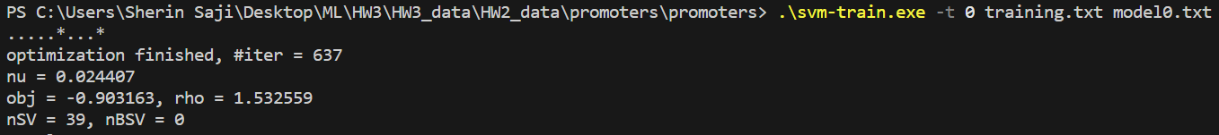

1. For kernel 0, accuracy is 84.375%
2. For kernel 1, accuracy is 81.25%
3. For kernel 2, accuracy is 90.625%
4. For kernel 3, accuracy is 43.75%

Files used for for q1 can be found in HW3\HW3_data\HW2_data\promoters\promoters.

Question 3

This is my final theta value.

In this theta, only position 1,2,3,19 and 20 (1 is the first index) has the five highest magnitudes. So, features x1, x2, x3, x19, x20 are the most important.