**CONTEXT LEVEL DIAGRAM(LEVEL 0)**

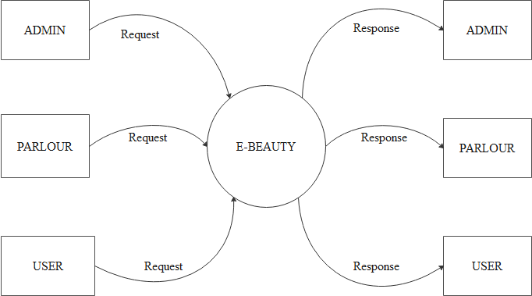

LEVEL 1 DFD FOR ADMIN

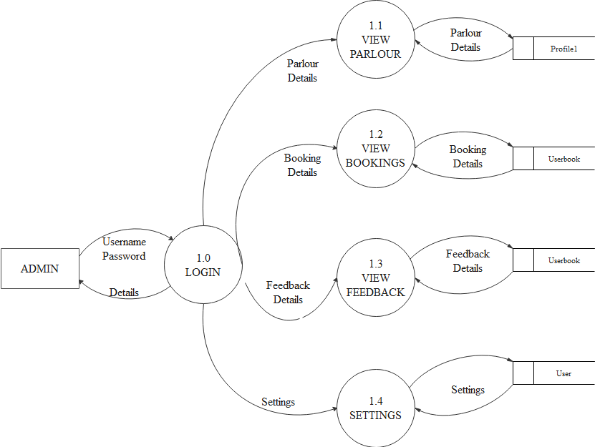

LEVEL 1 DFD FOR PARLOUR

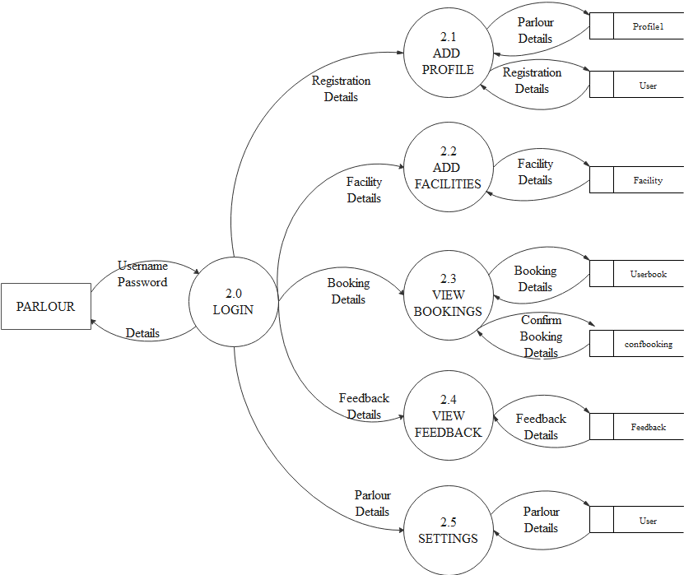

LEVEL 1 DFD FOR USER

