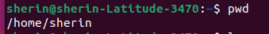

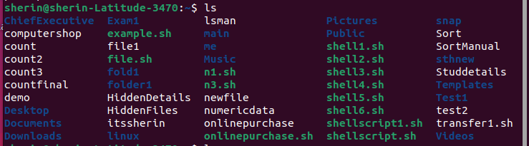
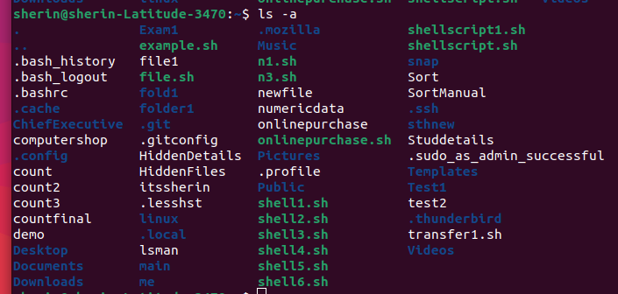

Q2.
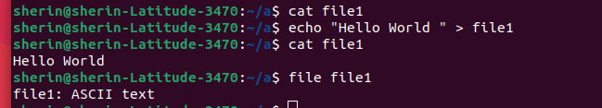

Q3.

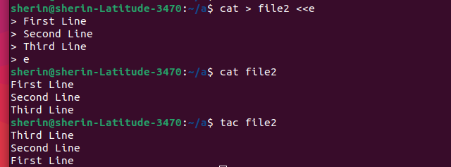

Q4.

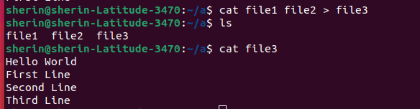

Q5.

Q6.
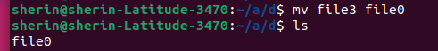

Q7.

Q8.

Output

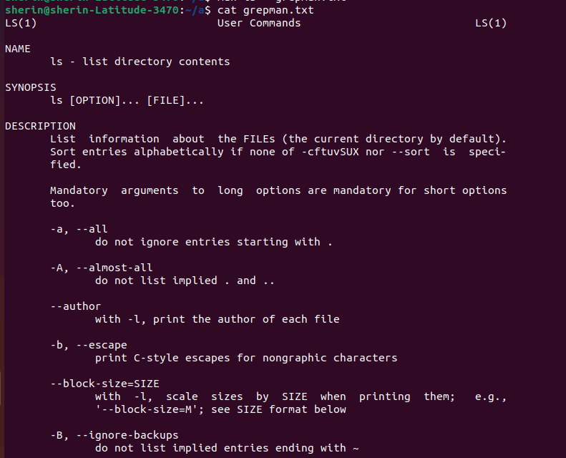

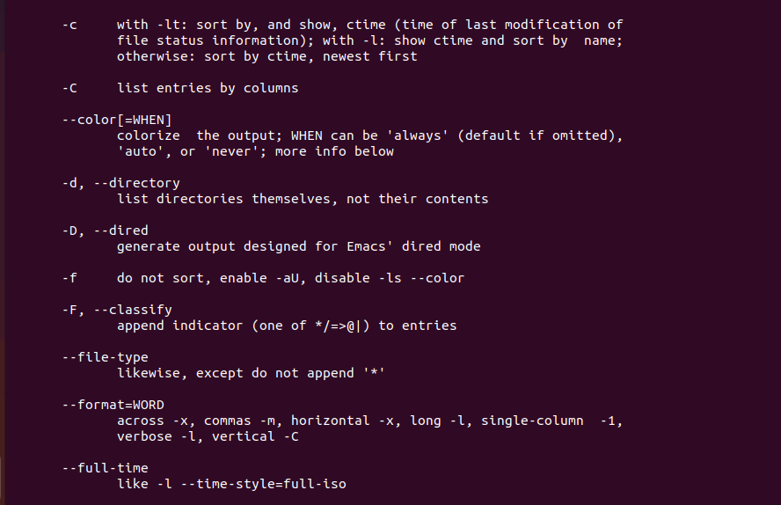
B

Q9.

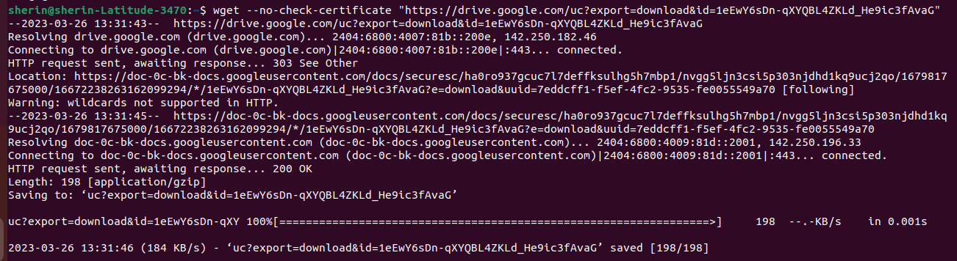
Q10.

Q11.

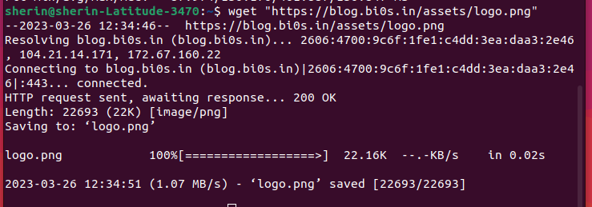

Output:

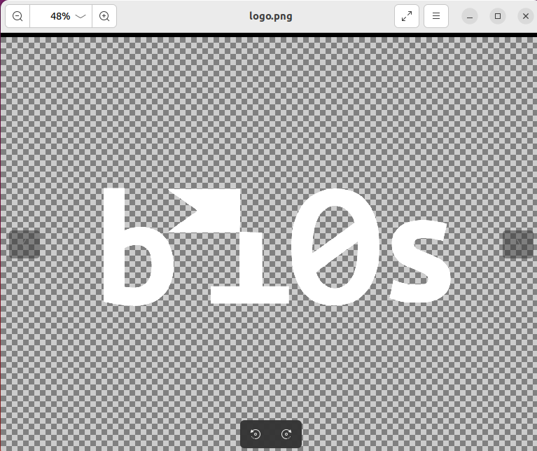

Will download it to the specified location in this case Desktop

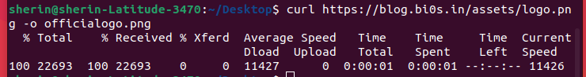

Here the downloaded image is saved as officialogo.png in the Desktop.
I changed the directory to desktop before downloading it to make finding the image easier
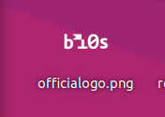

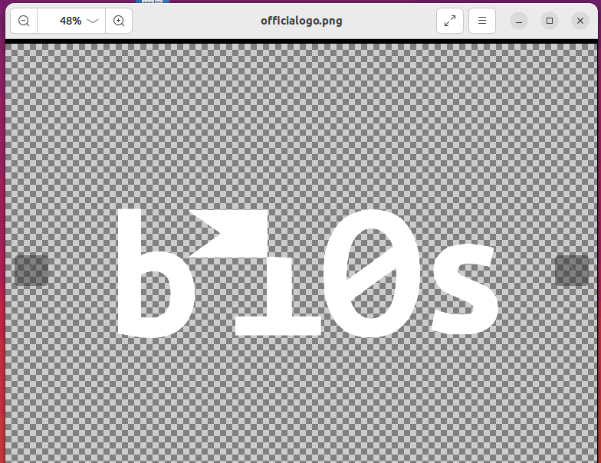

Q12.

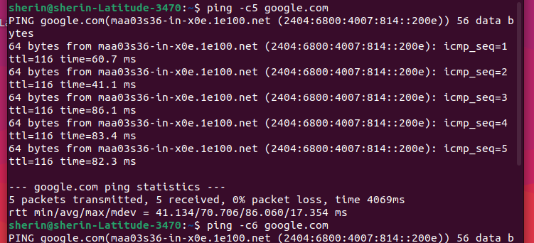

Here the lowest time taken is 41.134 ms

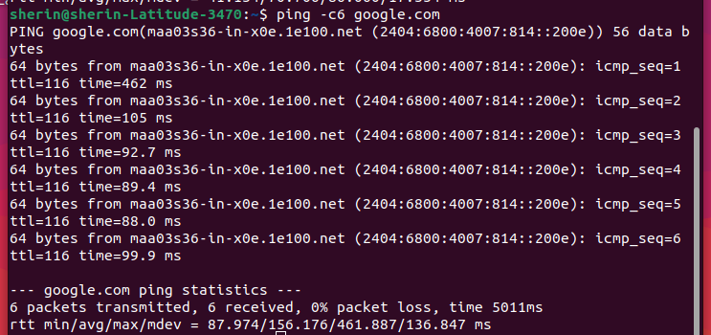
Here the avg time taken is 156.176ms

Q13.

Q14.
N map can be used to check whether the network ur using is safe whether there are any possible hackers around.
USING -nmap .sP network address
U can find who all are using ur network

-sudo nmap -sT -p 80,443 network address
Its a full open scan
U can specify the port nos usually 80 and 443
It will tell you what ports are open. Works under TCP protocol using a 3 way handshake . The first one being a syn the second one from the web server syn ack and finally from the client ack

-sudo nmap -sS 80,443 network address
Its a half open scan , a syn scan
Used in cases when u want to be a bit more secretive since sometimes IDS which is built into firewall can track u down.

Scanning my own machine
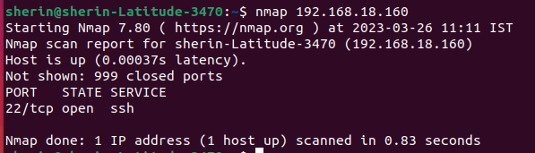
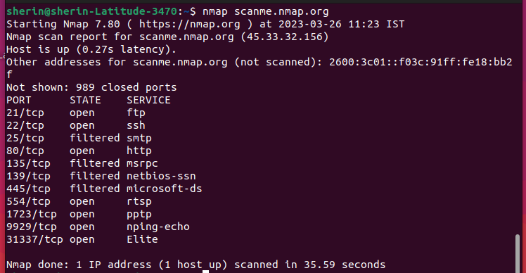

Q15.
Host
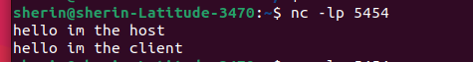

Client
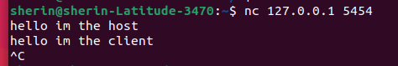

Just to show the contents of the file
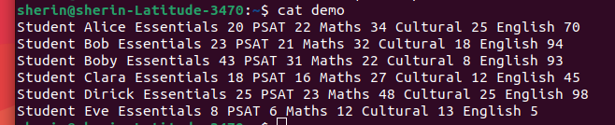

Host/Server

Client

Displaying the contents of new file DEMO

