# LAB#06

## Introduction to

## Loops

### Problems to Solve:

* Which loop system would be better for user input. Justify your answer by creating a program that takes a value and adds it to a variable and prints it repeatedly until the user enters a zero value.

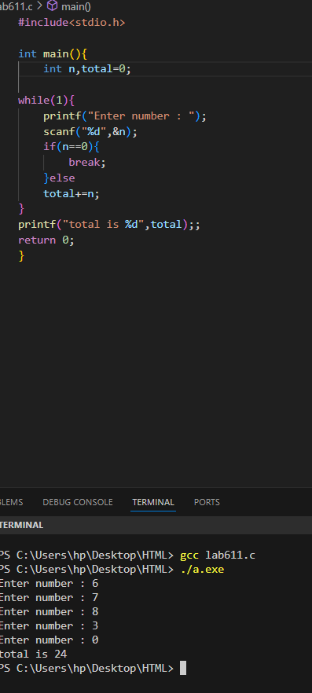

* Write a program to check whether a given number is a multiple digit number or not.

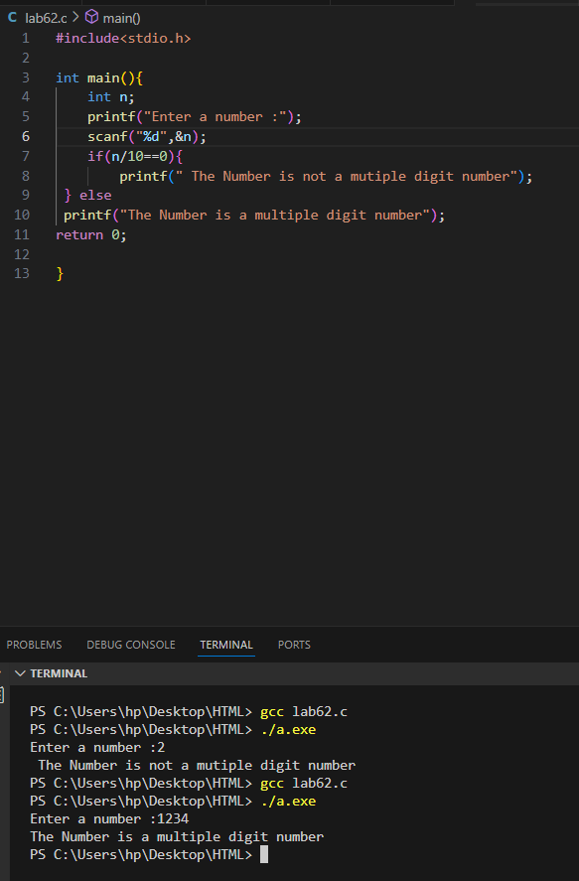

* Using the above program integrate the number if it is a prime or composite number.

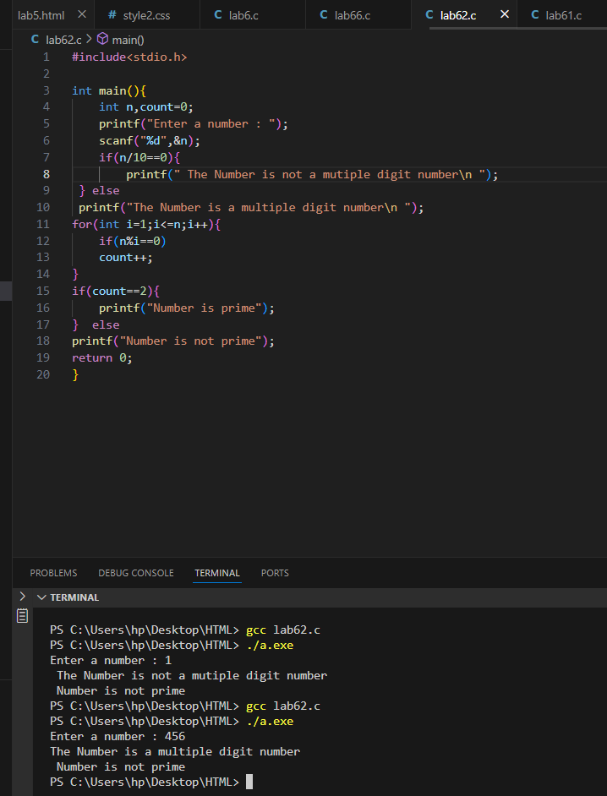

* Write a program to print the following series: 1, 2, 3, 5, 8, 13.

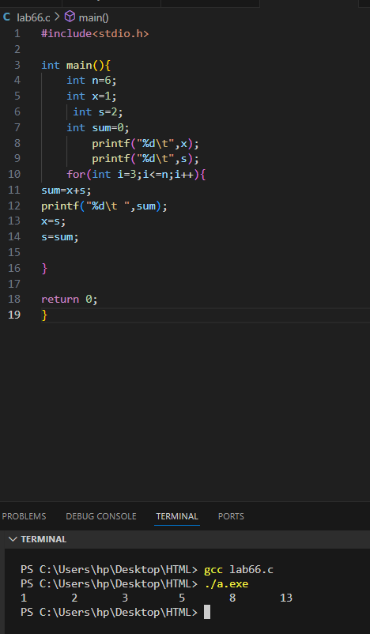

* Using for-loop statement print the following series:65536,32768,10922,2730,546,91,13,0.

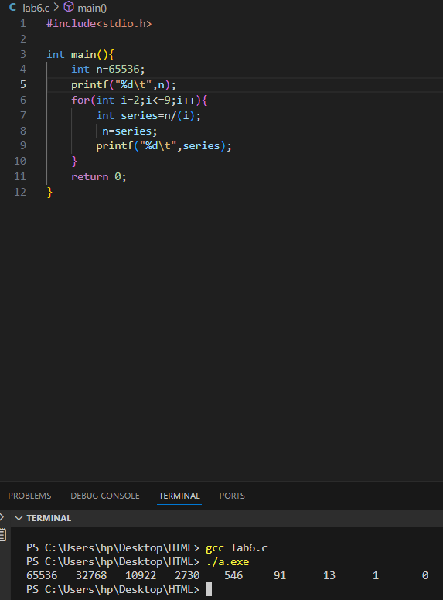

* Using for-loop statement print the following series:1,2,2,4,8,32,256,8192,2097152.

