|  |  |  |  |
| --- | --- | --- | --- |
| Mathematical Methods | | |  |
| Heat Transfer Through a Pin Fin | | | |
| Student Name | ID | Course | |
| Sher Khan |  | Numerical Methods | |
| Heat Transfer Through a Pin FinAbstract | | | |

Numerical determination of the temperature distribution T (x) and fin heat transfer rate q of a cylindrical pin fin is presented. The classical Runge- Kutta 5th -order method and Euler method is used to solve a 2nd -order ODE governing the temperature profile. The shooting method converts the boundary value problem into an initial value problem. Multiple iterations are performed until the solution converges to an adiabatic condition at the fin tip. Numerical results at different parameters are compared to the analytical solution. Parameters such as length, diameter and material of the pin fin are compared and tested with various combinations to check the effect of these parameter on the effectiveness of the pin fin for heat exchange. The complete code was implemented in MATLAB, and graphical outputs are also shown for better understanding.

# Introduction

In many heat transfer applications, it is desirable to increase the surface area that is available for the heat transfer process; this is particularly true when one desires to dissipate heat to a low conductivity medium such as air. Often the fin geometry may be quite complex, and analytical solutions may not be available to describe the heat transfer process. Instead, one needs to resort to various numerical in this module, we will analyse a two-dimensional fin with temperature-independent properties. We will start by formulating the problem as a one-dimensional problem. The fin’s geometry is sufficiently simple so that this problem can be solved analytically. The solution requires, however, the use of special functions of mathematical physics such as heat equations and newton's cooling law. Although we encountered these functions in our mathematics courses. Here MATLAB will come to our aid and help us solve the equations. Unfortunately, many fin problems are not amenable to analytic solution. Hence, we will proceed and solve the same problem numerically and then compare the numerical and analytical solutions. The purpose of this experiment is to help us build confidence in the numerical solutions and compare them with analytical solutions. Subsequently, we will develop a back of the envelope approximate solution, known as an integral solution, and compare it again with the analytic solution to assess how well it works. Finally, we note that the fin analysis is based on the assumption that the temperature is nearly uniform at each cross-section of the fin. In order to evaluate how accurate this approximation is and when it can be used, we will resort to a two-dimensional, finite element solution.

# Literature Survey

Fins are extended surfaces used specifically to enhance the rate of heat transfer between a solid material and an adjoining fluid. [2] Practical applications include radiators in cars, computer CPU heatsinks, and heat exchangers in power plants. [3, 7, 10] In thermal systems design, engineers are primarily interested in knowing the extent to which particular extended surfaces or fin arrangements could improve the heat transfer from a surface to the surrounding fluid. [1] Thus, a major objective is to optimize fin geometry and material so as to augment heat transfer. [6] In order to determine a particular fin’s heat transfer rate q f, it is necessary to obtain the temperature distribution T (x) along the fin. Real-world analysis of fin design is often complex. Investigators frequently adopt idealizing assumptions when analysing extended thermal surfaces. These assumptions are attributed to researchers Murray [9] and Gardner [4] and are as follows:

* the heat flow and temperature distribution throughout the fin are independent of time, i.e. steady-state heat flow
* the fin material is homogeneous and isotropic
* there is no volumetric heat generation q̇ within the fin
* the heat flow to or from the fin surface at any point is directly proportional to the temperature difference between the surface at that point and the surrounding fluid
* the thermal conductivity of the fin k is constant
* the convective transfer coefficient h is the same all over the fin surface
* the surrounding fluid has uniform temperature T ∞
* the temperature at the base of the fin Tb is uniform
* fin thickness t is much smaller than its height l so that temperature gradients normal to the surface are neglected
* Heat transfer through the outermost edge of the fin is negligible compared to which passes through the sides.

Under these highly idealized scenarios it is possible to develop analytical solutions for the temperature distribution and fin heat transfer rate of a wide range of fin configurations, especially when considering the simple fin geometries as in Figure below.

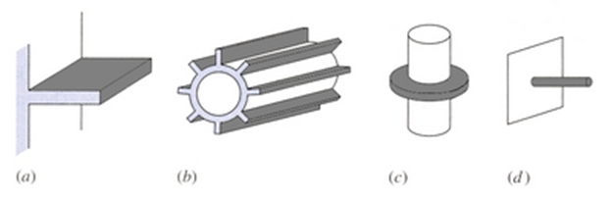

However, often times the equations that arise in engineering problems such as those in heat transfer are too complicated to be solved analytically, and computational techniques must be used to obtain the numerical values needed. [5] Even in cases where numerical techniques are used it is still advantageous to reduce the problem to an idealized case with a known analytical solution. The error between the numerical (approximate) solution and the analytical (exact) solution in the simplified case gives an indication of how much error will be involved in the numerical solution of the more complex scenario that does not have an analytical solution or whose analytical solution is not able to be computed.

# Method

To prove the understanding about both the numerical methods I implemented the code using MATLAB. To establish ground truth, I used analytical technique by following the equation mentioned in (). It helps me in verifying my results obtain from numerical technique. I used MATLAB to compare the both numerical methods. The completed code is shown in Appendix section.

I started by defining the known parameters on the code by following the description in the problem statement of assignment. According to description, the tip of the pin was considered as insulated. Therefore, the rate of change of temperature at the tip of the pin is equal to zero.

Since the Heat equation for pin fin is a second order differential equation, therefore two boundary conditions are required at the start of the fin pin. In this problem the temperature at the base of the pin is known which 50ºC i.e. T (0) = 50, however the rate of change of temperature at the base is unknown.

Since we consider the tip of the fin to be insulated we can say that rate of change of temperature at the tip will be zero. This can be considered as the second boundary condition. I used the shooting technique to estimate the correct values of dt/dx at the base of the pin x=0. The initial guess for the dT/dx was made by considering the step size equal to the length of the pin fin and applying Euler method on Eq().

$\frac{dT}{dx}{}_{x=0}=−L∗f\left(0\right)→\left(2\right)$

The value of the computed dT/dx was updated after every iteration by subtracting the current value of dT/dx by the different of values between the computed dT/dx and ideal value, multiplied by a factor (0.1). I used 200 iterations to finding dT/dx until $\frac{dT}{dx}{}_{x=L}$ becomes almost equal to zero. I did 200 iterations which resulted in pretty good estimate of the initial value of dT/dx.

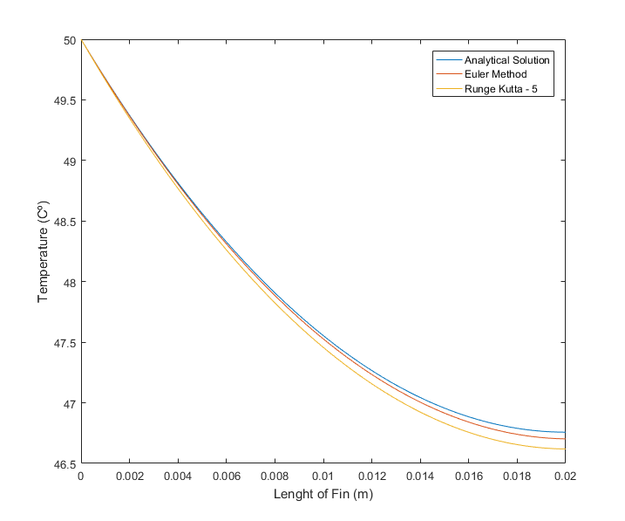Euler method is applied on the heat equations to compute the value of temperature at each step. The process was then repeated for Runge Kutta 5th Order method to compute the temperature at each point. The figure on the right, shows the final output of all three approaches for provided conditions.

The 200 itterations were done for shooting technique and 100 step size was considered for each numerical technique.

# Discussion

To compute the effectiveness of the pin fin on various conditions I changed different parameters and computed the value of effectiveness of the pin fin. To calculate the effectiveness, I used following equation.

$Q_{fin}=−KAc\frac{dT}{dx}$

$Q_{no−fin}=h\left(A_{c}\right)\left(T_{0}−T_{∞}\right)$

$effectiveness=\frac{Q_{fin}}{Q_{no−fin}}→\left(3\right)$

The results for all the results are shown in the results section below.

# Results

I computed the effective by changing parameters for length, diameter and the material. Following graphs shows the outcome for each case.

### **Changing Length**

I tested by changing the length parameters and computed the effectiveness of the fin pin for each case. The length was tested for 1cm, 2cm and 4cm using both numerical approaches, the analytical result is also shown in the figures to compare the computed values with the ideal value.

|  |  |  |
| --- | --- | --- |
|  | **Length** | **Effectiveness** |
| **1** | 1cm | 38.9984 |
| **2** | 2cm | 73.3817 |
| **3** | 4cm | 118.5080 |

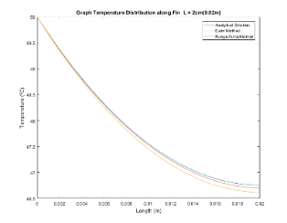 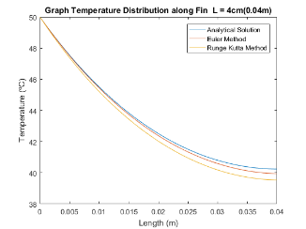 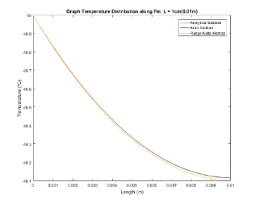

### **Change Pin Diameter**

I tested by changing the diameter parameters and computed the effectiveness of the fin pin for each case. The diameter was tested for 1mm, 2mm and 3cm using both numerical approaches, the analytical result is also shown in the figures to compare the computed values with the ideal value. It was noticed that decreasing the diameter increases the effectiveness.

|  |  |  |
| --- | --- | --- |
|  | **Length** | **Effectiveness** |
| **1** | 1cm | 70.4513 |
| **2** | 2cm | 36.54 |
| **3** | 3cm | 24.67 |

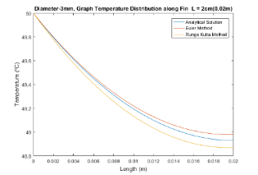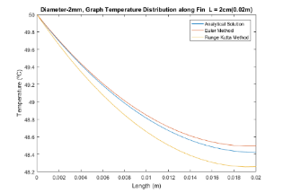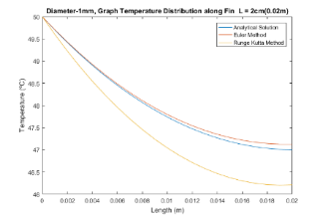

### Change Pin Material

I tested by changing the materials of the parameters and computed the effectiveness of the fin pin for each case. The material was tested for copper, brass and aluminium using both numerical approaches, the analytical result is also shown in the figures to compare the computed values with the ideal value.

|  |  |  |
| --- | --- | --- |
|  | **Length** | **Effectiveness** |
| **1** | Brass | 70.4513 |
| **2** | Aluminium | 73.064 |
| **3** | Copper | 74.1465 |
|  |  |  |

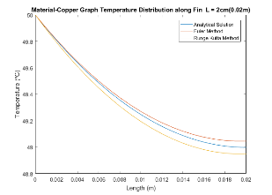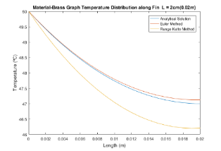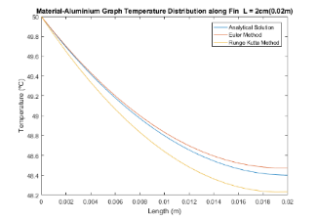

# Conclusion

In this assignment I have used the numerical methods namely Runge Kutta 5th Order and Euler method to solve the heat exchange equation for pin fin. I computed the effectiveness of pin fin by changing different parameters such as material, dimensions and finally the step size. All the code written in MATLAB and source code provide in appendix.

Form the analysis it was found that changing materials for pin fin greatly effects its effectiveness.

# Acknowledgements

I would like thanks my math teacher David Sawtell and my matlab teacher Prabav Nibti for guiding me during the course, without their help I couldn’t have accomplished all this.

# References

1. Incropera, F.P. and Dewitt, D.P., Introduction to Heat Transfer (1996). *John WHey & Sons. New York. NY*.
2. Bergman, T.L. and Incropera, F.P., 2011. *Fundamentals of heat and mass transfer*. John Wiley & Sons.
3. Fraas, A.P., 1960. Design precepts for high-temperature heat exchangers. *Nuclear Science and Engineering*, *8*(1), pp.21-31.
4. Gardner, K.A., 1945. Efficiency of extended surfaces. *Trans. Asme*, *67*(1), pp.621-631.
5. Jaluria, Y., 2011. *Computer Methods for Engineering with MATLAB® Applications*. Taylor & Francis.
6. Laor, K. and Kalman, H., 1996. Performance and optimum dimensions of different cooling fins with a temperature-dependent heat transfer coefficient. *International Journal of Heat and Mass Transfer*, *39*(9), pp.1993-2003.
7. Lieblein, S., 1959. *Analysis of temperature distribution and radiant heat transfer along a rectangular fin of constant thickness* (Vol. 196). National Aeronautics and Space Administration.
8. Butcher, J., 2007. Runge-Kutta methods. *Scholarpedia*, *2*(9), p.3147.
9. Murray, W.M., 1938. Heat transfer through an annular disk or fin of uniform thickness. *ASME J. Appl. Mech*, *5*(2), p. A78.

Vogel, M. and Xu, G., 2005. Low profile heat sink cooling technologies for next generation CPU thermal designs. *Electronic Cooling Online*

# Appendices

Source code

clc**;**

clear all**;**

close all**;**

PI **=** 3.14159**;** % The value of pie

d **=** 1e-3**;** % diameter of Pin Fin

K **=** 120**;** % Conduction co-efficient

Tb **=** 50**;** % Base temperature

Ta **=** 25**;** % Ambient Air temperature

L **=** 2e-2**;** % Length of pin fin

h **=** 20**;** % Convection co-efficient

A **=** PI**\*(**d**/**2**)^**2**;** %Cross sectional area of pin fin

p **=** PI**\***d**;** % Perimeter value

m **=** sqrt**((**h**\***p**)/(**K**\***A**));** % value of m

%%%%%%%%%%%%%%%%%%%%%%%%%%%%%%%%%%

% Analytical solution method %

%%%%%%%%%%%%%%%%%%%%%%%%%%%%%%%%%%

x **=[**0**:**0.0001**:**L**];**

Temp **=** cosh**(**m**\*(**L **-** x**))/**cosh**(**m**\***L**);**

temperature **=** Temp**\*(**Tb **-** Ta**)** **+** Ta**;**

plot**(**x**,(**temperature**));**

%%%%%%%%%%%%%%%%%%%%%%%%%%%%%

% Using Euler method

%%%%%%%%%%%%%%%%%%%%%%%%%%%%%

% 1. Boundary condtions.

% Two Boundary conditions.

% a. T(0) = 100

% b. dT/dx = 0 | (x = L)

n **=** 20**;**

T**(**1**)** **=** Tb**;**

step **=** L**/**n

f**(**1**)** **=** m**^**2 **\*** **(**T**(**1**)** **-** Ta**);**

v**(**1**)** **=** **-**L**\***f**(**1**);** % initial guess... assume that step = length....

% shooting method to guess the value of v(1)

**for** i**=**1**:**200 % loop for calculating the euler method

**for** j**=**1**:**n

v**(**j**+**1**)** **=** v**(**j**)** **+** step **\*** f**(**j**);**

T**(**j**+**1**)** **=** T**(**j**)** **+** step **\*** v**(**j**);**

f**(**j**+**1**)** **=** m**^**2 **\*** **(**T**(**j**+**1**)** **-** Ta**);**

**end**

%adjusting the next value of v(0) based on deviation from ideal value

**if(**abs**(**v**(**n**))** **>** 0.00001**)**

v**(**1**)** **=** v**(**1**)** **-** v**(**n**)\*** 0.1**;**

**end**

**end**

hold

plot**(**0**:**step**:**L**,**T**);**

%%%%%%%%%%%%%%%%%%%%%%%%%%%%%

%%%% RUNGE KUTTA 5th ORDER%%%

%%%%%%%%%%%%%%%%%%%%%%%%%%%%%

%setting up initial values

T**(**1**)** **=** Tb**;**

step **=** L**/**n**;**

F **=** **@(**T**)** m**^**2 **\*** **(**T **-** Ta**);**

F2 **=** **@(**v**)** v**;**

RK_v**(**1**)=** **-**L**\***F**(**T**(**1**));** % initial guess... assume that step = length....

% shooting method to improve the guessed value of v(1)

**for** i**=**1**:**20 % Loop for calculating Runga-Katta 5th order

**for** j**=**1**:**n

k1_v **=** F**(**T**(**j**));**

k2_v **=** F**(**T**(**j**)** **+** **(**1**/**4**)\***k1_v**\***step**);**

k3_v **=** F**(**T**(**j**)** **+** **(**1**/**8**)\***k1_v**\***step **+** **(**1**/**8**)\***k2_v**\***step**);**

k4_v **=** F**(**T**(**j**)** **-** **(**1**/**2**)\***k2_v**\***step **+** k3_v**\***step**);**

k5_v **=** F**(**T**(**j**)** **+** **(**3**/**16**)\***k1_v**\***step **+(**9**/**16**)\***k4_v**\***step**);**

k6_v **=** F**(**T**(**j**)** **-** **(**3**/**7**)\***k1_v**\***step **+** **(**2**/**7**)\***k2_v**\***step **+** **(**12**/**7**)\***k3_v**\***step **-** **(**12**/**7**)\***k4_v**\***step **+** **(**8**/**7**)\***k5_v**\***step**);**

RK_v**(**j**+**1**)** **=** RK_v**(**j**)** **+** 1**/**90**\*(**7**\***k1_v **+** 32**\***k3_v **+** 12**\***k4_v **+** 32**\***k5_v **+** 7**\***k6_v**)\***step**;**

k1_t **=** F2**(**RK_v**(**j**));**

k2_t **=** F2**(**RK_v**(**j**)** **+** **(**1**/**4**)\***k1_t**\***step**);**

k3_t **=** F2**(**RK_v**(**j**)** **+** **(**1**/**8**)\***k1_t**\***step **+** **(**1**/**8**)\***k2_t**\***step**);**

k4_t **=** F2**(**RK_v**(**j**)** **-** **(**1**/**2**)\***k2_t**\***step **+** k3_t**\***step**);**

k5_t **=** F2**(**RK_v**(**j**)** **+** **(**3**/**16**)\***k1_t**\***step **+(**9**/**16**)\***k4_t**\***step**);**

k6_t **=** F2**(**RK_v**(**j**)** **-** **(**3**/**7**)\***k1_t**\***step **+** **(**2**/**7**)\***k2_t**\***step **+** **(**12**/**7**)\***k3_t**\***step **-** **(**12**/**7**)\***k4_t**\***step **+** **(**8**/**7**)\***k5_t**\***step**);**

T**(**j**+**1**)** **=** T**(**j**)** **+** 1**/**90**\*(**7**\***k1_t **+** 32**\***k3_t **+** 12**\***k4_t **+** 32**\***k5_t **+** 7**\***k6_t**)\***step**;**

**end**

%adjusting the next value of v(0) based on deviation from ideal value

**if(**abs**(**RK_v**(**n**))** **>** 0.00001**)**

RK_v**(**1**)** **=** RK_v**(**1**)** **-** RK_v**(**n**)\***0.1**;**

**end**

**end**

%%%%%%%%%%%%%%%%%%%%%%%%%%%%%%%%%%%%%%%%%

% Plotting the solutions %

%%%%%%%%%%%%%%%%%%%%%%%%%%%%%%%%%%%%%%%%%

plot**(**0**:**step**:**L**,**T**);**

xlabel**(**'Length (m)'**)**

ylabel**(**'Temperature (ºC)'**)**

title**(**'Original, Graph Temperature Distribution along Fin L = 2cm(0.02m)'**)**

legend**(**'Analytical Solution'**,**'Euler Method'**,**'Runge Kutta Method'**)**

%%%%%%%%%%%%%%%%%%%%%%%%%%%%%

%%%% FIN EFFICIENCY %%%%%%%%%

%%%%%%%%%%%%%%%%%%%%%%%%%%%%%

Q_fin **=** v**(**1**)\*** **(-**K**\***A**);**

Q_noFin **=** h**\***A**\*(**Tb **-** Ta**);**

Q **=** Q_fin **/**Q_noFin %Final Fin effectiveness.