CURRICULUM VITAE

PERSONAL PARTICULARS
Name: |  |  | Sechidanond Rai |  |  | 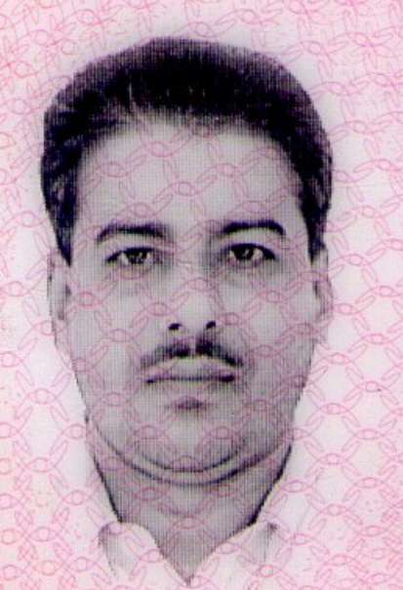  Photo
NRIC/PP No: |  |  | S1841447C
Date of Birth: |  |  | 25/06/1962
Address: |  |  | Block 26, Jalan Berseh, #05-154, S(200026)
Contact Tel. No: |  |  | 96831045 | Driving Licenses: |  | NIL
Race: |  |  | Indian | Religion: |  | Hindustani
Language Spoken: |  |  | English, Malay, Hindi | Nationality: |  | Singaporean
Current Railway Job: |  |  | LTA Thompson East Coast Line Stage 123, Mandai Depot, Galibatu Depot Extension
EDUCATIONAL BACKGROUND
 | Academic/Technical Qualification |  |  |  | Institution |  | Year
1 | Primary PSLE |  |  |  | Pac Xia Primary School |  | 1967-1972
2 | GCE O Level |  |  |  | Whitley Secondary School |  | 1973-1976
SAFETY TRAINING
 | Qualification |  |  |  | Institution |  | Year
1 | Building Construction Supervisors Safety Course |  |  |  | Concord Associates Pte Ltd |  | 2011
2 | Risk Assessment Training |  |  |  | Concord Associates Pte Ltd |  | 2011
3 | First Aid Training & CPR plus AED Training |  |  |  | St John |  | 2012
EMPLOYMENT BACKGROUND
Period |  | Organisation Name |  | Job Title
1984-1993 |  | N-Shaams Pte Ltd |  | Sales Executive

Responsibilities & Scope

Purchasing & Selling

Management of store

Customer Service
Period |  | Organisation Name |  | Job Title
1993-2004 |  | Thakral Pte Ltd |  | Sales Executive

Responsibilities & Scope

Purchasing & Selling

Management of store

Customer Service
Period |  | Organisation Name |  |  | Job Title
2004-2011 |  | Alstom Pte Ltd- Circle Line |  |  | Works Train Station Supervisor (WTSS)

Responsibilities & Scope

Access Control

Train Shunting

Point Throwing

Book In/Out

Pedestrian Access Control

Period Organisation Name Job Title
July 2011- 31st May 2016 Alstom- Downtown Line 1 and 2 Track Access Supervisor
Galibatu, NSLE and Tuas West Extension and Sengkang Depot
(End of Project)
Track Work Controller

J (NNN\
Responsibilities & Scope

Construction of Railway
Oversee Safety
Book In/Out
Pedestrian Access Control
Coordination with SWC and CWC Contractor
Controller Job- Consist Movement
Administration & Control of Workers
Trainer

Period Organisation Name Job Title
2016 – Present CTCI Pte Ltd rack Work Duty Controller
Responsibilities & Scope

Construction of Railway
Oversee Safety
Book In/Out
Pedestrian Access Control
Coordination with SWC and CWC Contractor
Controller Job- Consist Movement
Administration & Control of Workers
Trainer

Job Related Courses Attended

Works Train Station Supervisor Training

Track Access Supervisor Training

Works Train Controller Training

Civil Stations Safety Induction Training

OTHER DETAILS
Reservists: |  |  | Completed | Organisation: |  | SAF
Division / Camp: |  |  | 21st Battalion of Singapore Artillery Camp | Rank: |  | SSG
Pastimes Activities: |  |  | Reading, Football, Hockey
Awards: |  |  | Safety Award – 2018/2019

