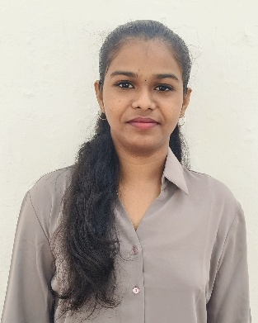  Technical skills  - Ms word  - Ms Excel  - Adobe illustrator  - Adobe Photoshop  - Ms PowerPoint  - Tuka-cad  Soft skills  - Time management  - Team work  - Leadership  - Adoptability  - Problem solving  Courses  - Fashion illustration to adobe illustrator  - Advance in aari work and embroidery  Other skills  - Pattern making  - Fashion illustration  - Embroidery  Languages  - Tamil  - English |  | J.THANIS ANSIL  MBA- APPAREL MANAGEMENT ( Pursuing)  CAREER OBJECTIVE  - To be Passionate about learning new concepts, ideas and techniques. Creative and detail-oriented fashion enthusiast seeking to blend innovative textile design with sustainable fashion trends to create stylish, functional, and eco-friendly products.  EDUCATION  - Pursuing MBA- Apparel Management at Sardar Vallabhbhai Patel International School Of Textiles & Management,  Coimbatore. 2023-2025.  - B.Sc- Costume design and fashion at Vivekananda college of arts and sciences for women,  Thiruchengode.(2021-2024) - 77.58%  - St.Marys Higher Secondary School, Pothakalanvilai. (2018-2021)  HSC - 87%  SSLC - 82%
INTERNSHIP
Syndicate impex – Tiruppur (2023)
- Analyzed overall company performance and gained insights into core departments like Production, Quality Control, and Merchandising.
- Observed and understood garment manufacturing processes, from fabric sourcing to final product delivery.
C-Cube Institute – Erode (2023)
- Designed fashion sketches, technical flats, and garment illustrations using Adobe Illustrator. Assisted in creating mood boards, color palettes, and design concepts for seasonal collections.
- Learned industry standards for spec sheets, sizing, and digital pattern making.
Smart weaving – Coimbatore (2024)
- Learned the principles of air jet loom mechanics. Operated and maintained air jet weaving machines; assisted in warp preparation, fabric quality checks,.
- Monitored loom efficiency, fabric quality, and production output using standard metrics.
Bee- vee impex – Tiruppur (2025)
- Learned principles of label and packaging design, focusing on creating label mockups for apparel products using Adobe Illustrator, coreldraw and Photoshop.
- Collaborated with senior designers to refine aesthetic layouts and improve product presentation.

Contact
- Phone: 9345644806
- Email Address: ansilthanis@gmail.com
- Address: 5/253, Main road, pothakalanvilai,
Thoothukudi -628702.

