囚徒问题实验报告
- 算法说明
import random
from typing import List

def generate_random_boxes(n: int) -> List[int]:
"""生成随机排列的盒子内容"""
numbers = list(range(1, n+1))
random.shuffle(numbers)
return numbers

def strategy_random(boxes: List[int], prisoner_num: int, max_attempts: int) -> bool:
"""随机策略：随机选择盒子"""
attempts = random.sample(range(len(boxes)), max_attempts)
for attempt in attempts:
if boxes[attempt] == prisoner_num:
return True
return False

def strategy_cycle(boxes: List[int], prisoner_num: int, max_attempts: int) -> bool:
"""循环策略：跟随盒子中的数字跳转"""
current_box = prisoner_num - 1 # 转换为0-based索引
for _ in range(max_attempts):
if boxes[current_box] == prisoner_num:
return True
current_box = boxes[current_box] - 1 # 跳转到下一个盒子
return False

def run_simulation(n: int, k: int, strategy) -> bool:
"""运行一次模拟"""
boxes = generate_random_boxes(n)
for prisoner_num in range(1, n+1):
if not strategy(boxes, prisoner_num, k):
return False
return True

def compare_strategies(n: int = 100, k: int = 50, t: int = 10000):
"""比较两种策略的成功率"""
random_success = 0
cycle_success = 0

for _ in range(t):
# 对两种策略使用相同的盒子排列
boxes = generate_random_boxes(n)

# 测试随机策略
random_failed = False
for prisoner_num in range(1, n+1):
if not strategy_random(boxes, prisoner_num, k):
random_failed = True
break
if not random_failed:
random_success += 1

# 测试循环策略
cycle_failed = False
for prisoner_num in range(1, n+1):
if not strategy_cycle(boxes, prisoner_num, k):
cycle_failed = True
break
if not cycle_failed:
cycle_success += 1

print(f"set: {n} prisoners, {k} tries per person, {t} simulation")
print(f"random strategy succeed probability: {random_success/t:.6f} ({random_success}/{t})")
print(f"c: {cycle_success/t:.6f} ({cycle_success}/{t})")

if __name__ == "__main__":
# 默认参数: N=100, K=50, T=10000
compare_strategies(n=100, k=50, t=10000)

- 实验结果
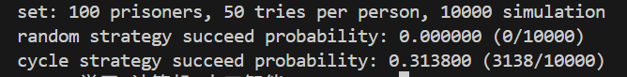
理论计算
对于n=100，k=50：
P_{success}≈1−$\sum_{l=51}^{100}{\frac{1}{l}}$≈1−(ln(100)−ln(50))≈1−ln2≈0.30685
约 30.685% 的成功率，远高于随机策略。

- 优化思路
向量化优化：
- 使用NumPy替代列表和循环
- 并行模拟
- 批量模拟囚犯行为：在策略实现中尽量减少显式的 for 循环，借助布尔数组、索引数组等技巧一次性模拟多个囚犯的行为。

- 图
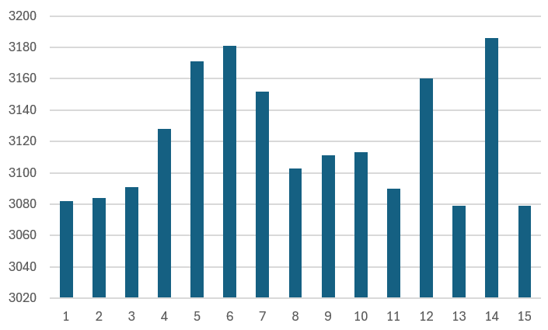
切换参数（n=50, K=25）后输出结果：
