SS Cygni
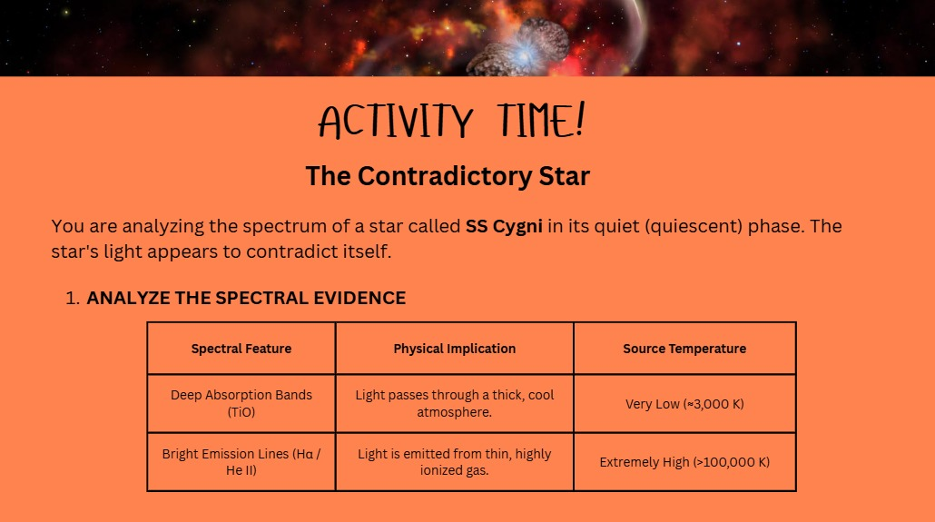

Based on the temperature, and by deducing from HR diagram:
- The deep absorption bands are from a dwarf star. Since the temperature is relatively low, it must be a red dwarf
- The other lines are emitted from a very luminous source. The temperature is a clue, but the main clue is that the light emitted is from highly ionized gas. At the given temperature, gas can get ionized, which means the radiation & pressure releases electrons away. Therefore, it could be a white dwarf, but also a blue giant
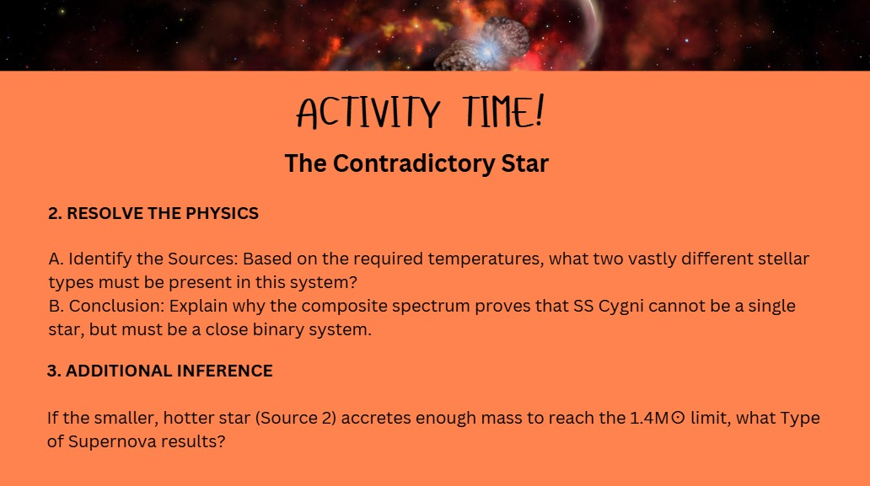
It is clear now that it is a binary system. Since the spectral evidence points out two distinct, separate lines, the two bodies have to be orbiting each other at a very close distance. At one point in time, the deep absorption is detected, and the ionized line is observed at a different time.

One object is definitely a red dwarf, while the other object is either a white dwarf or a blue supergiant.

But based on Point-3 above, it is given that the hotter object is smaller than the other source. So, it is a white dwarf.

If the white dwarf passes the Chandrashekar limit, it explodes in a Type 1a supernova. For a Type 2 supernova, the mass has to be much greater, and not just pass this limit.

