EE-677 Foundation of VLSI CAD
Final Project

Balraj Parmar 14D070001
Sudipto Banerjee 14D070028
Dhruti Shah 14D070002

Project Topic

Expressing a given boolean logical expression in terms of 2-input NAND gates and efficient placement in a 2-dimensional grid.

Project overview

We have taken a Boolean logical expression and converted it to SOP form using PyEDA functionality. The expression obtained is in the form of multiple input AND and OR gates. This expression is then parsed and converted as objects of user defined classes for AND and OR gates. This is then expressed in terms of efficient NAND2 units. i.e. each AND gate and each OR gate is expressed in terms of NAND2 blocks, for the most efficient method, ie one which gives the least delay at the output.

Each 2 input AND gate can be in terms of NAND2 as follows:
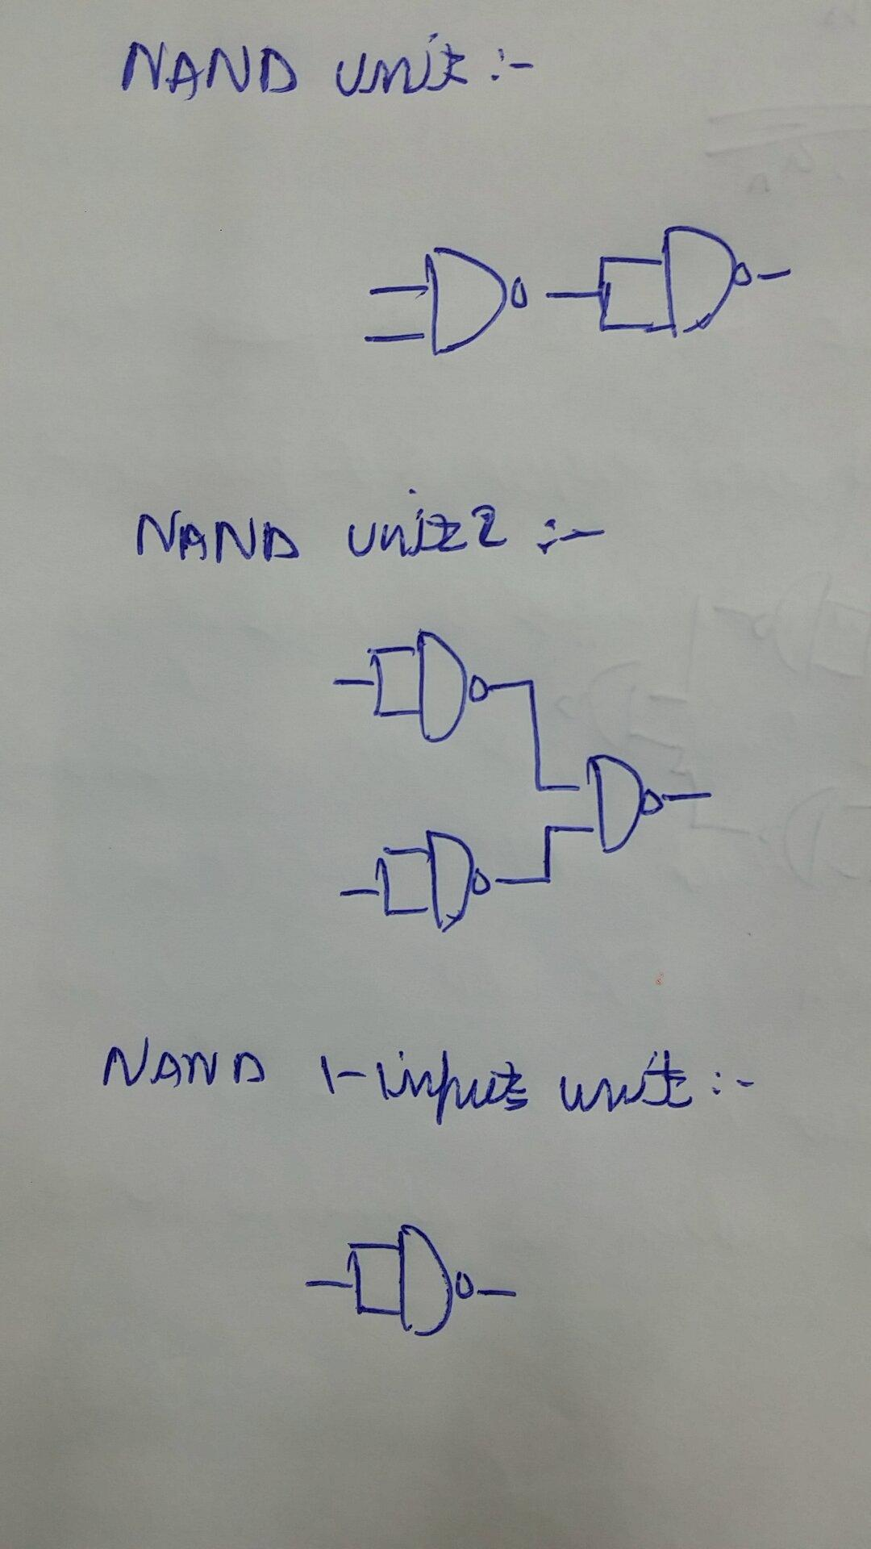

Each 2 input OR gate can be in terms of NAND2 as follows:

After the expression has been expressed in terms of NAND2, the placement problem is addressed.

Efficient placement in a 2-dimensional grid, is done as follows. The user inputs boolean expression string, and restricted positions in a 17 by 17 grid.
The function works on efficient placement in this grid by selecting a valid position. It calculates the cost, and if the cost is less then selects that move. Even if the cost is more, it can probabilistically select that move to avoid getting stuck at a local minima. To find the minimum cost for a particular configuration of gates, Dijstra’s algorithm used. This is iterated a large number of times, to reach at the global minima, and thus find the most efficient placement.

Individual contributions

Given expression in terms of classes and conversion to tree form NAND2 expression - Dhruti

Efficient conversion to NAND2 expression so as to minimize the delay at the output - Sudipto

Placement problem for minimum cost placement in 2-dimensional grid - Balraj

