Name: Tran Dinh Duy

ID: 19020001

**REPORT CHALLENGE 1 ARTIFICIAL INTELLIGENCE**

1. Train the model

* Before training the model, I do normalizing, reshaping the data, and converting class vectors to class metrices

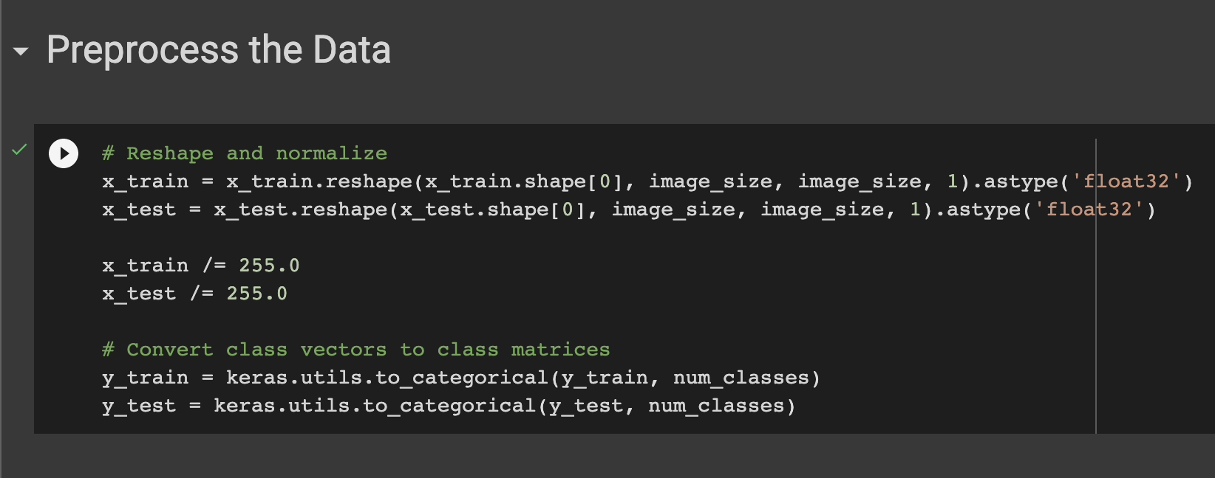

* I choose 10 classes data to train [“tooth”, “key”, “square”, “line”, “circle”, “triangle”, “hat”, “book”, “star”, “pencil”] CNN model deep learning

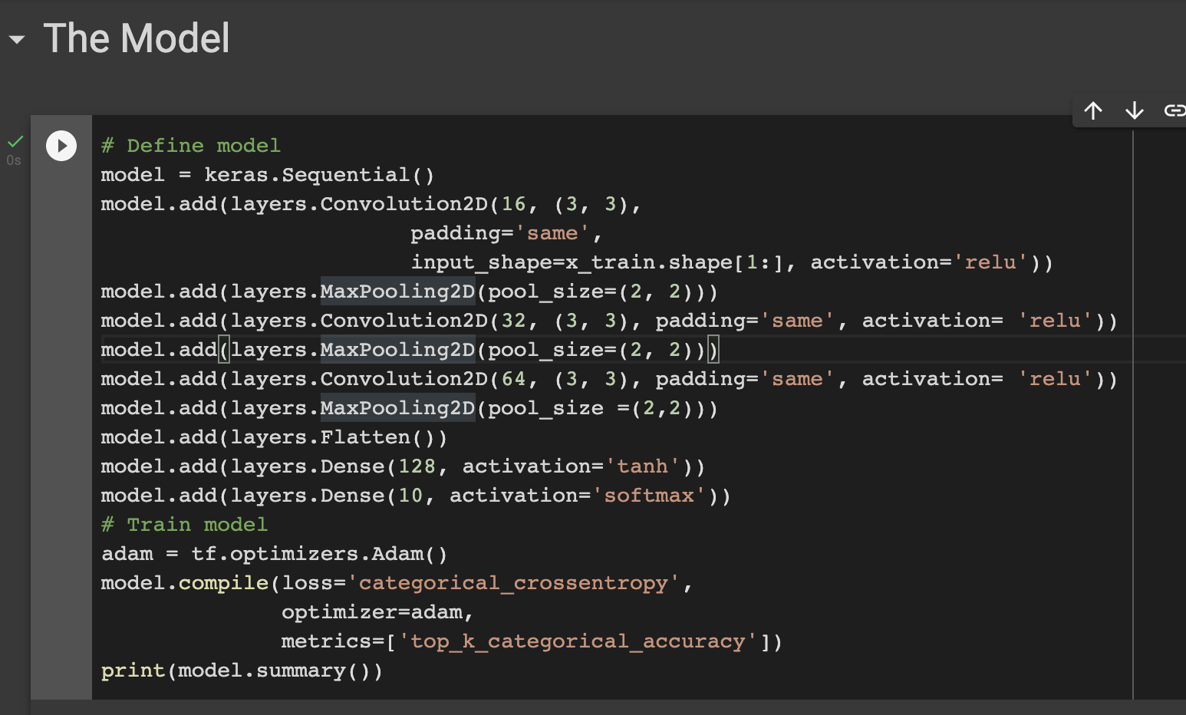

* Explaination about layers:
  + Activattion function: This function will get output from one layer, then filter back output as an input in other layers. Activation function use “relu” (Rectified Linear Unit) as a parameter, which is a non-linear function. “Relu” does not activate all the neurons at one time, it just activates value positive. When a neuron value is less than zero, it just deactivate that neuron, so it save time and complexity for the model and return the values between zero or one.
  + 3 Convolution2D layers: These layers will extract all features of a source image (getting size, color, pixel, etc. of that image).
  + 3 MaxPooling2D layers: These layers will optimize the feature I get from Convolution2D layer. Because the model will not need all the features of the image, It just need the important features, so MaxPooling layer will dimensionalize and focus on the most important elements.
  + Flatten layer: It is a fully connected layer to flatten the features identified in the previous layers into a vector, and predicts probabilities that the image belongs to each one of several possible labels.
* I train the model with fit function in 5 epochs and print out the accuracy of model (98,59%)

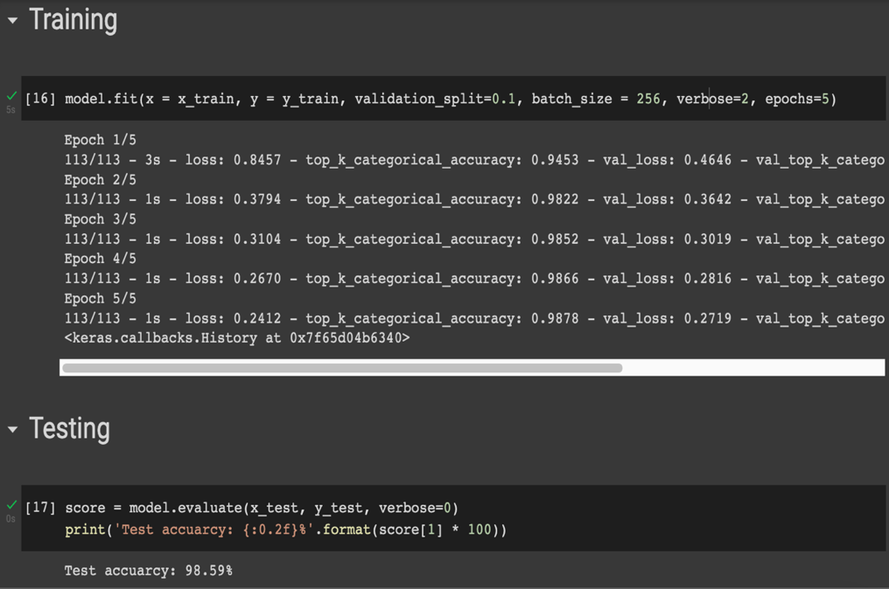

1. Deploy the model

* I use flask framework and HTML 5 to build the website for deploying the model.

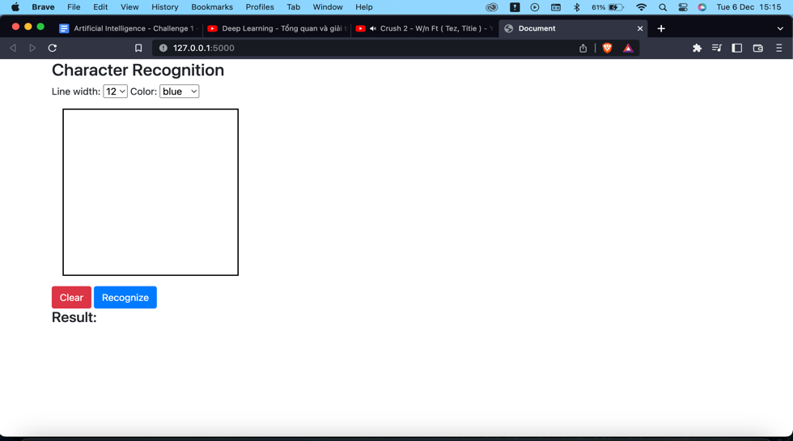

* 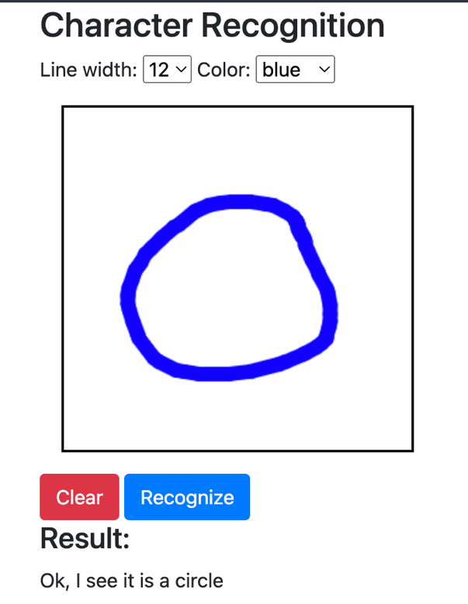After importing the model to website, I make drawing to test the model and click on recognize button to obtain the result

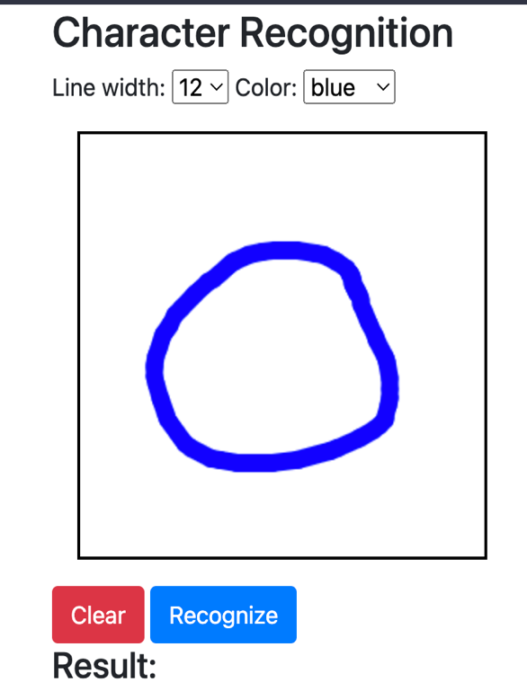

* The code I use for resizing doodle drawing to the required size of 28x28, normalizing array of pixels before passing it as the input of the CNN model predicting doodle

