Canada has always been known as one of the safest countries in the world, yet when I began my university study in Toronto in 2017, I have heard more crime news since then. By the end of 2020, I moved a new apartment which was located near the Toronto policy headquarter, and ever since then, I heard more and more police sirens. At that point, I started wondering if Toronto was safe to live and if the neighborhood I lived in was secure enough. Thus, I started working on this project and trying to learn more about the crime in Toronto by analyzing the data provided by the Toronto police from 2014 to 2019.

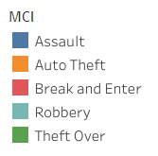The report is divided into three sections. The first section is designed for police divisions in Toronto to understand their performance over time from 2014 to 2019, while the second part is made for civilians to understand their neighborhood of interest. The third part is created for both groups to explore and discover interesting aspect of police divisions and neighborhood.

For this report, Toronto refers to the city of Toronto. The Major Crime Index (MCI) includes five types of crimes: assault, auto theft, break and enter, robbery as well as theft over. These five MCI will be represented by five colors in plots.

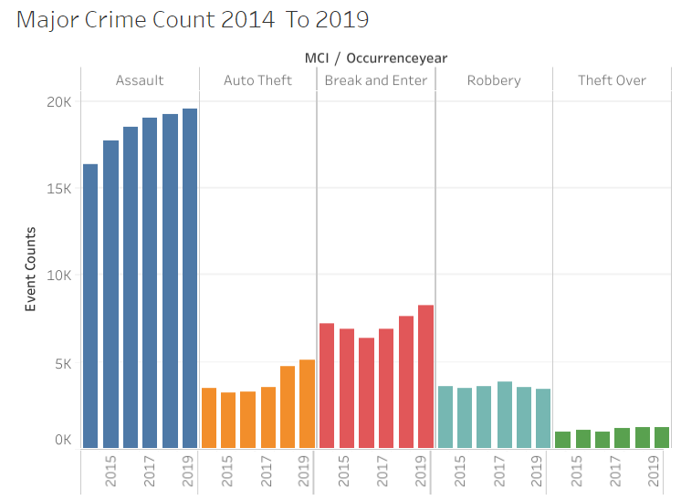Part I

There are 16 police divisions excluding the police headquarter in Toronto. Overall, the number of crime events in each MCI has shown an increasing trend from 2014 to 2019, especially for assault, auto theft, and B&E (break and enter).

In order to understand how the rate of crime changes over time, it may be easier to look at the *% Change In Crime From Previous Year* for each MCI. For instance, in the above case, it is difficult to see the change in amount of crime events involving robbery or theft over from 2014 to 2019, in fact, it is difficult to perceive if they changed at all since the diagram is so small.