Part A.

**Question 1**

**a**

Yes,The observation is that Hive/Tez is always better than Hive/MR. However, how much it is better varies from query to query. It is not a constant because the job assignment and structure differs from query to query. 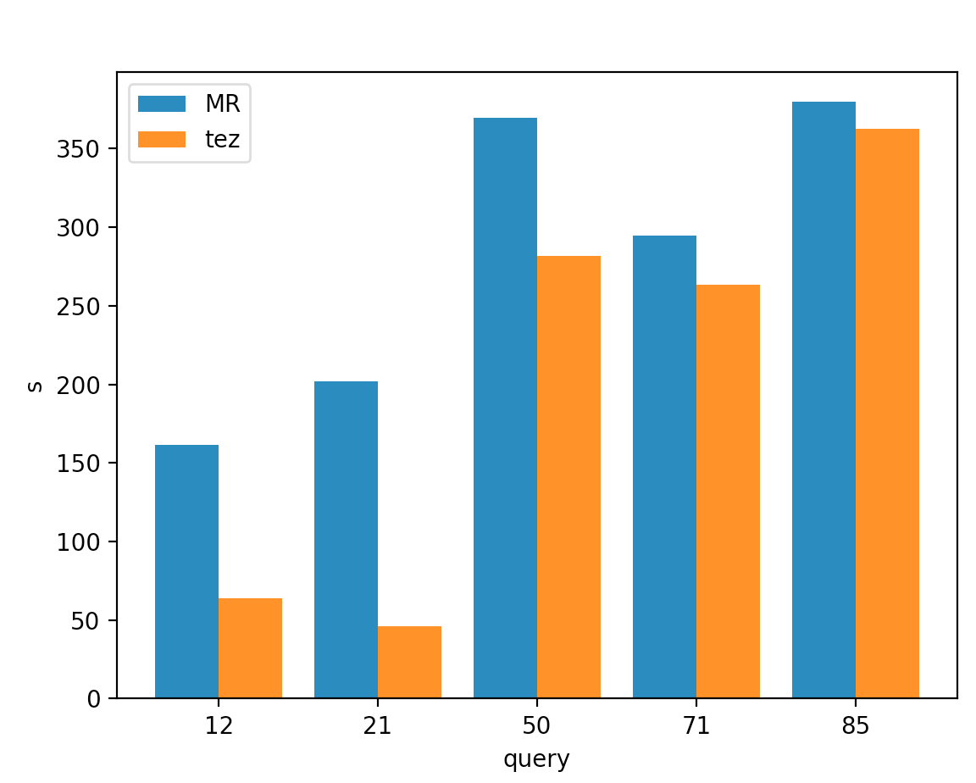

**b**

Please see the plots for total amount of data for each query and the bandwidth for each query below.

Bandwidth: since we can only calculate throughput instead of bandwidth, which is the upper bound of the throughput. The throughput is shown below and it is a approximation of bandwidth.

Observation: TEZ has more writing to the disks. Explanation: Tez uses different strategies of reduce from MR.

Trend: Generally speaking, Tez has a higher disk reading throughput. It can be verified by the DAG of the jobs, Tez has more jobs reading from the disk independently(simultaneously) and thus reach a higher reading throughput.

**Throughput for disks: (MB)**

**disk, query 12**

mr read: 48.95850362496357

tez read: 122.76038139230036

mr write: 14.758073218682364

tez write: 0.9111593139932272

**disk, query 21**

mr read: 7.780409191435345

tez read: 33.11108693286911

mr write: 16.42801463806492

tez write: 0.8436949189424439

**disk, query 50**

mr read: 60.12029497743321

tez read: 78.59067666398163

mr write: 22.773393619639204

tez write: 28.76923022330727

**disk, query 71**

mr read: 144.8298323036187

tez read: 161.93326621711464

mr write: 4.454002308371241

tez write: 143.63922879665685

**disk, query 85**

mr read: 22.47439027923749

tez read: 32.29191693555059

mr write: 13.041562950260907

tez write: 250.79196933344366

**Throughput for net: (bytes)**

**net, query 12**

mr reveived: 13569929.97525474

tez received: 4541608.261419141

mr transmit: 13030853.99676265

tez transmit: 4358742.263697508

**net, query 21**

mr reveived: 17172014.657899696

tez received: 4059002.6765313894

mr transmit: 16483401.584798628

tez transmit: 3921021.4122511153

**net, query 50**

mr reveived: 21947591.65041875

tez received: 18328306.441596966

mr transmit: 21099852.03804311

tez transmit: 17636962.903952677

**net, query 71**

mr reveived: 14354141.642338244

tez received: 10115218.976161078

mr transmit: 13781936.832099939

tez transmit: 9742852.191091271

**net, query 85**

mr reveived: 9750606.596758517

tez received: 15401145.746118419

mr transmit: 9368998.78306084

tez transmit: 14887260.497504205

**Plots for total amount of data:**

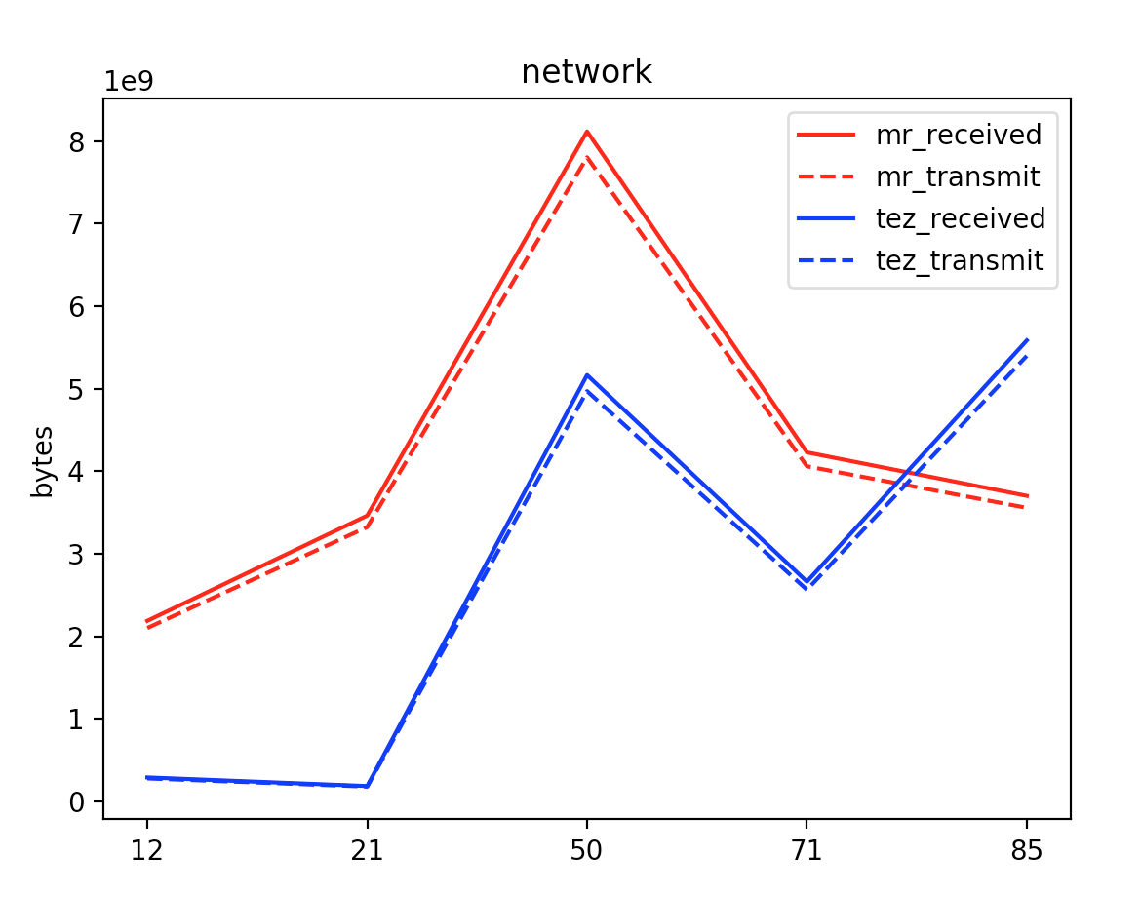

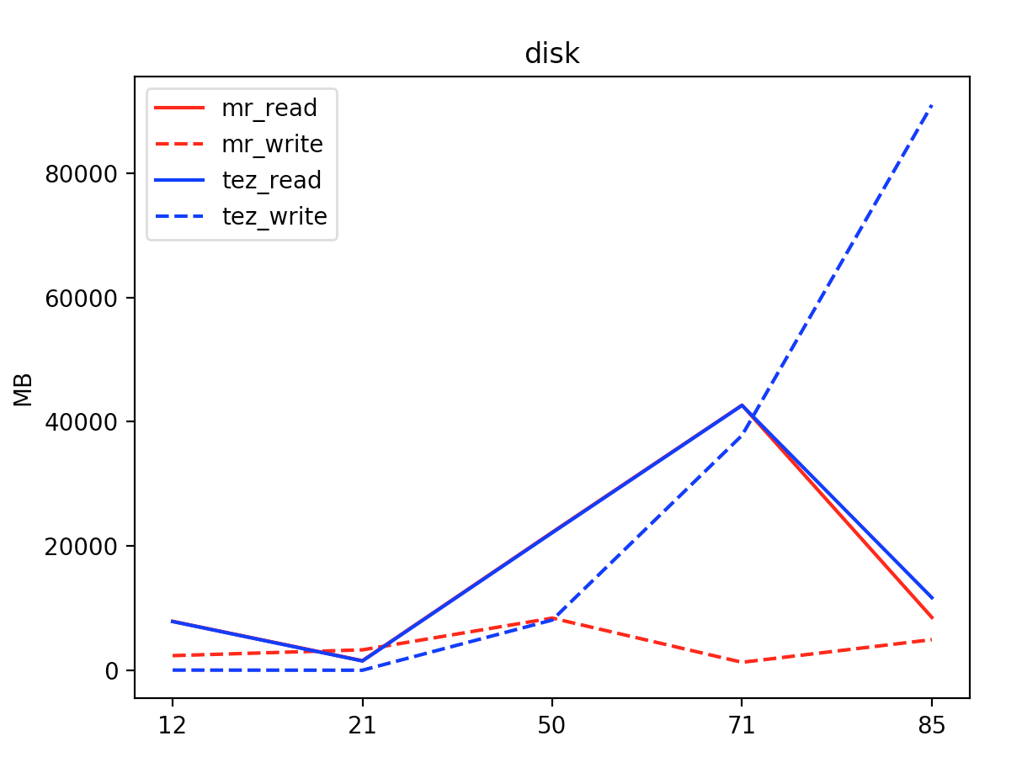

**c**

**For map reduce:**

**Query 12**

total tasks: 42

number of map tasks: 39

number of reduce tasks: 3

ratio of reduce versus map: 0.07692307692307693

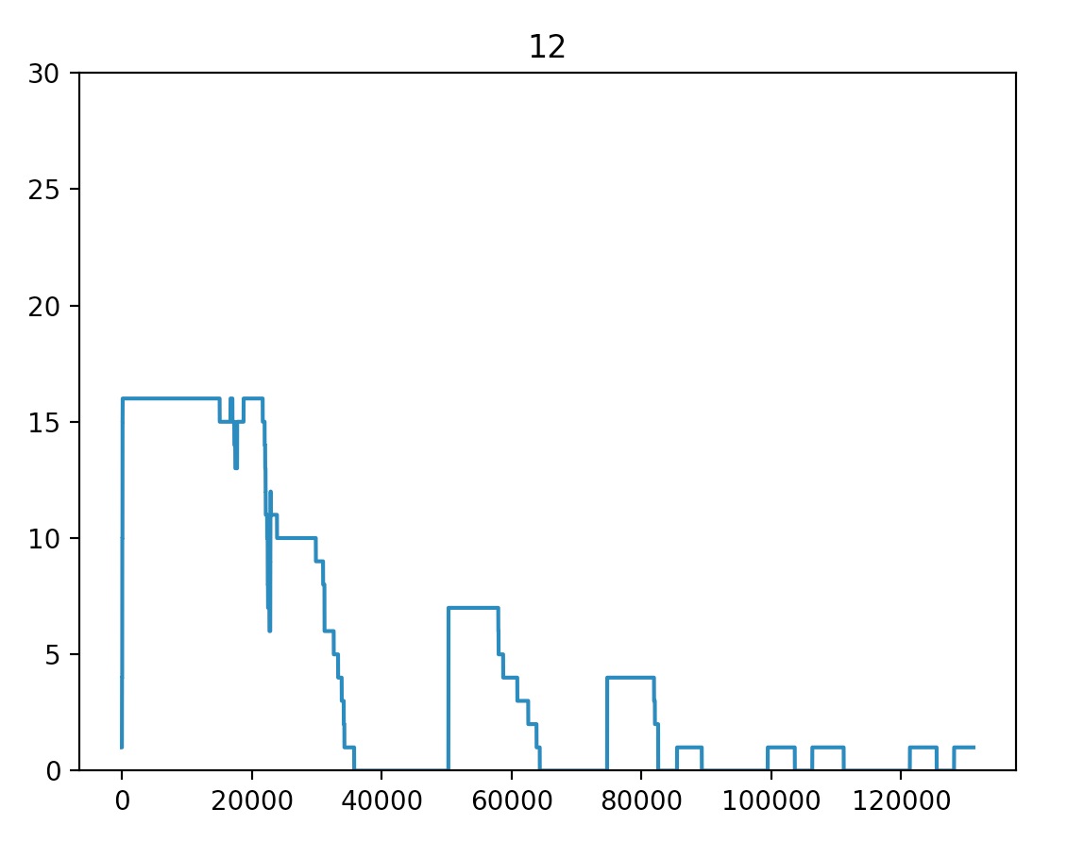

**Query 21**

total tasks: 22

number of map tasks: 20

number of reduce tasks: 2

ratio of reduce versus map: 0.1

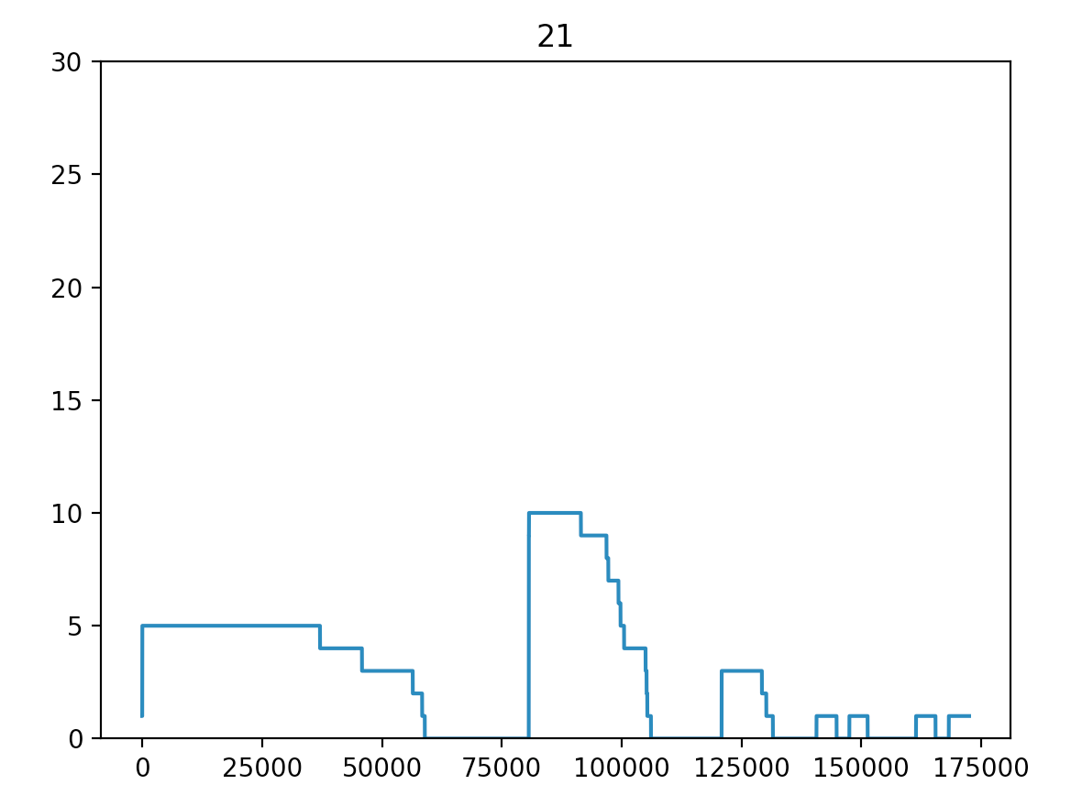

**Query 50**

total tasks: 188

number of map tasks: 99

number of reduce tasks: 89

ratio of reduce versus map: 0.898989898989899

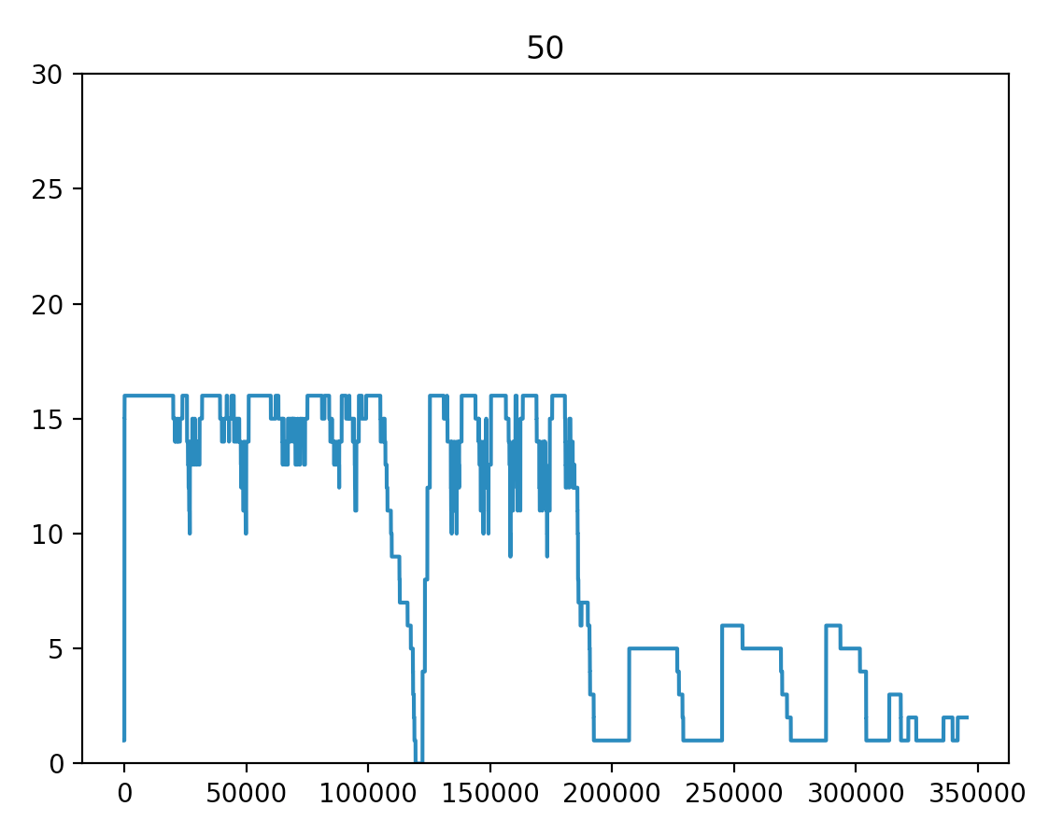

**Query 71**

total tasks: 170

number of map tasks: 168

number of reduce tasks: 2

ratio of reduce versus map: 0.011904761904761904

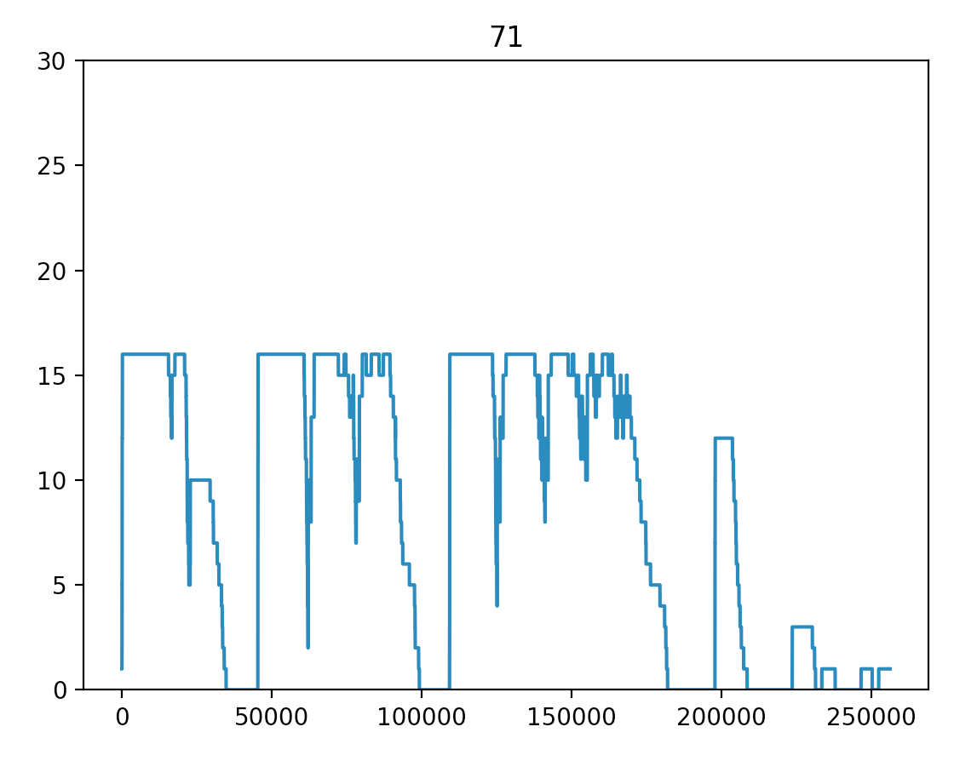

**Query 85**

total tasks: 92

number of map tasks: 52

number of reduce tasks: 40

ratio of reduce versus map: 0.7692307692307693

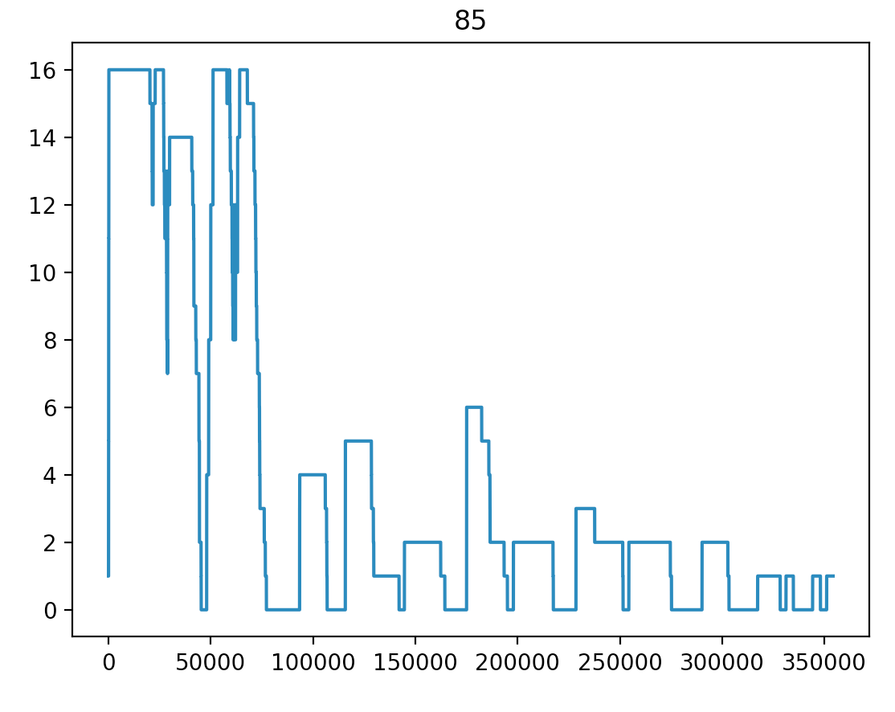

**For Tez:**

**query 12**

total tasks : 55

number of map tasks : 52

number of reduce tasks: 3

ratio of reduce versus map: 0.057692307692307696

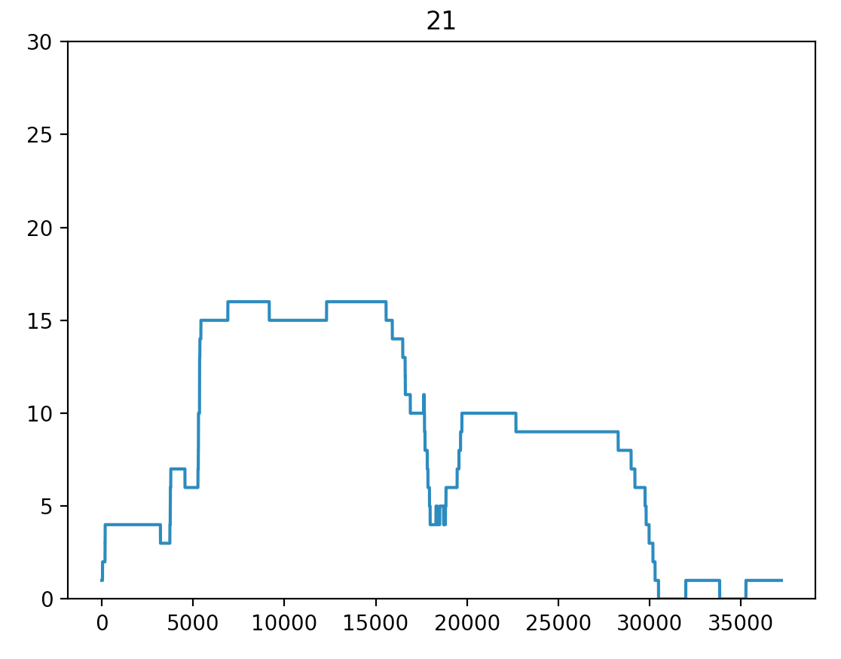

**query 21**

total tasks : 30

number of map tasks : 28

number of reduce tasks: 2

ratio of reduce versus map: 0.07142857142857142

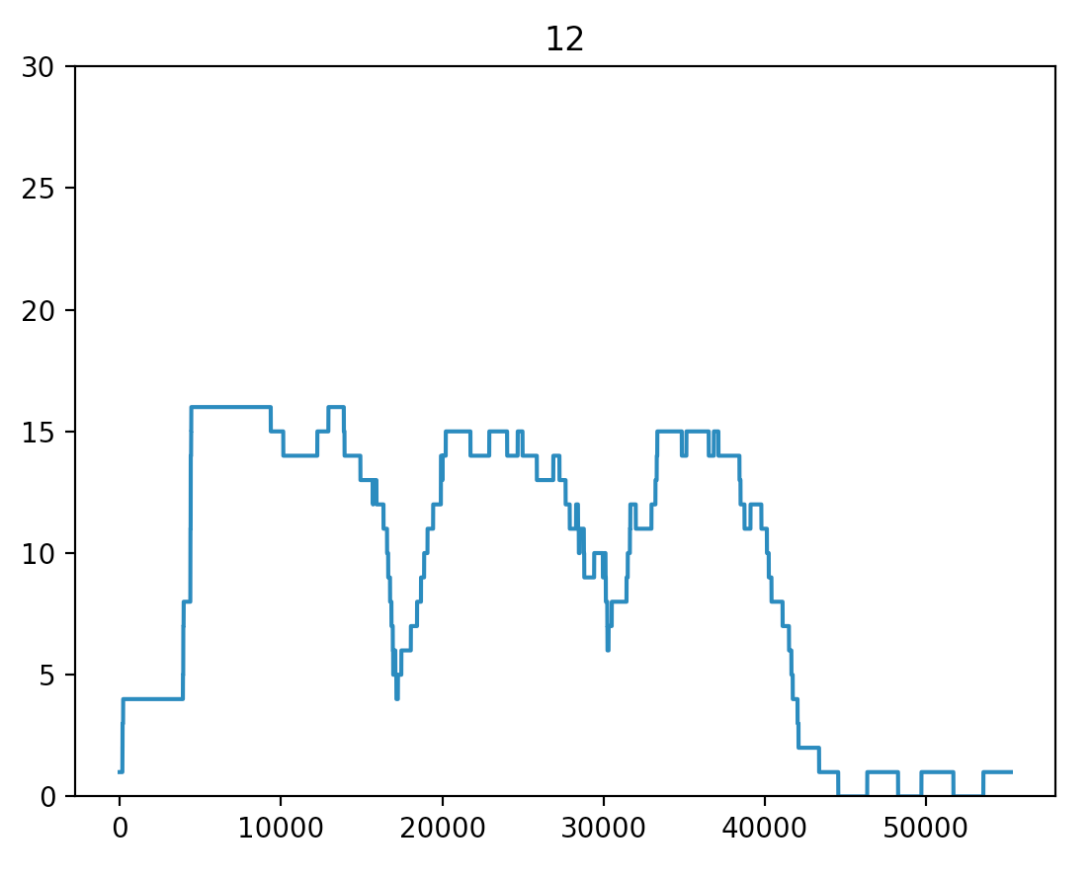

**query 50**

total tasks : 97

number of map tasks : 92

number of reduce tasks: 5

ratio of reduce versus map: 0.05434782608695652

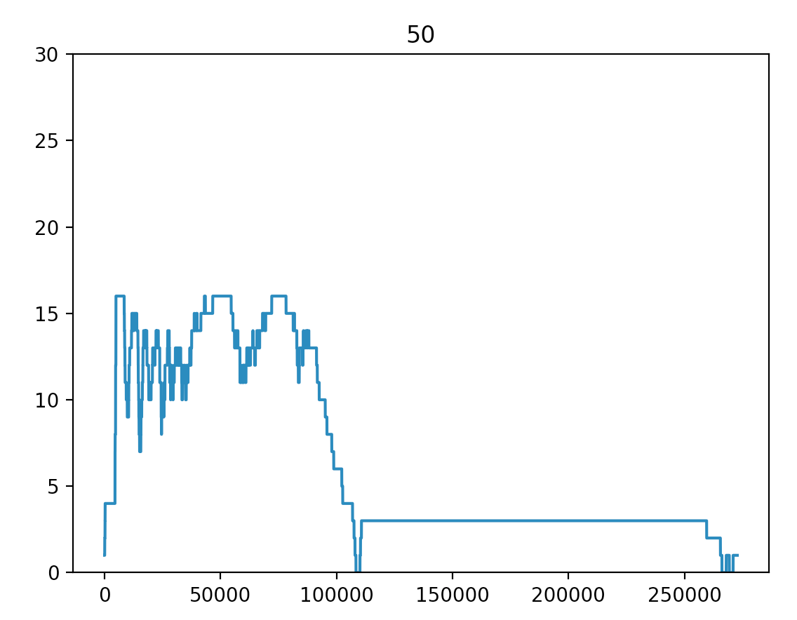

**query 71**

total tasks : 144

number of map tasks : 129

number of reduce tasks: 15

ratio of reduce versus map: 0.11627906976744186

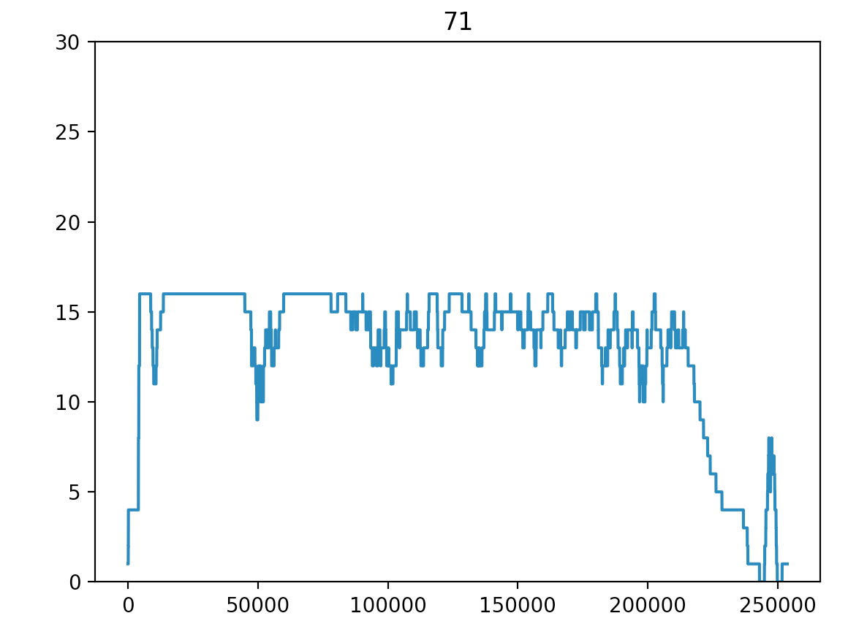

**query 85**

total tasks : 83

number of map tasks : 72

number of reduce tasks: 11

ratio of reduce versus map: 0.1527777777777778

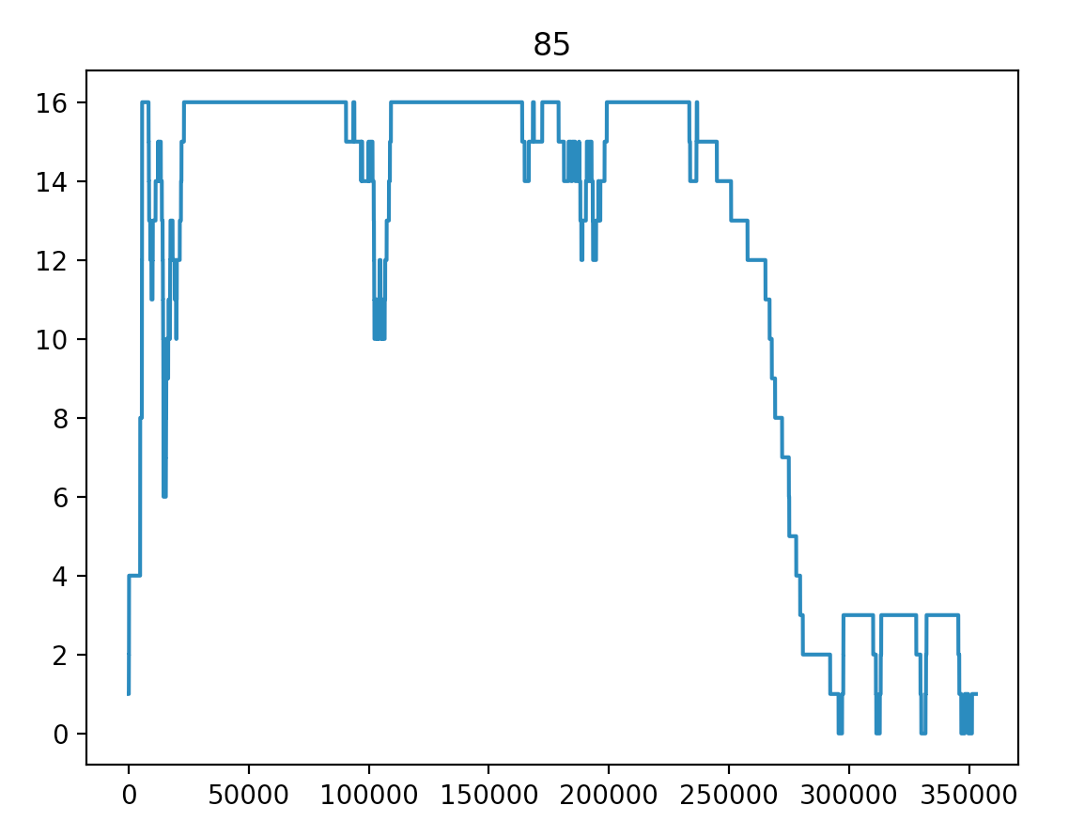

Correlation:

The higher number of total tasks, the higher the overall throughput will be.

The higher number of map tasks, the higher the reading throughput will be, and same story happens to the number of reduce tasks and writing throughput.

**d.**

**MR:**

12:

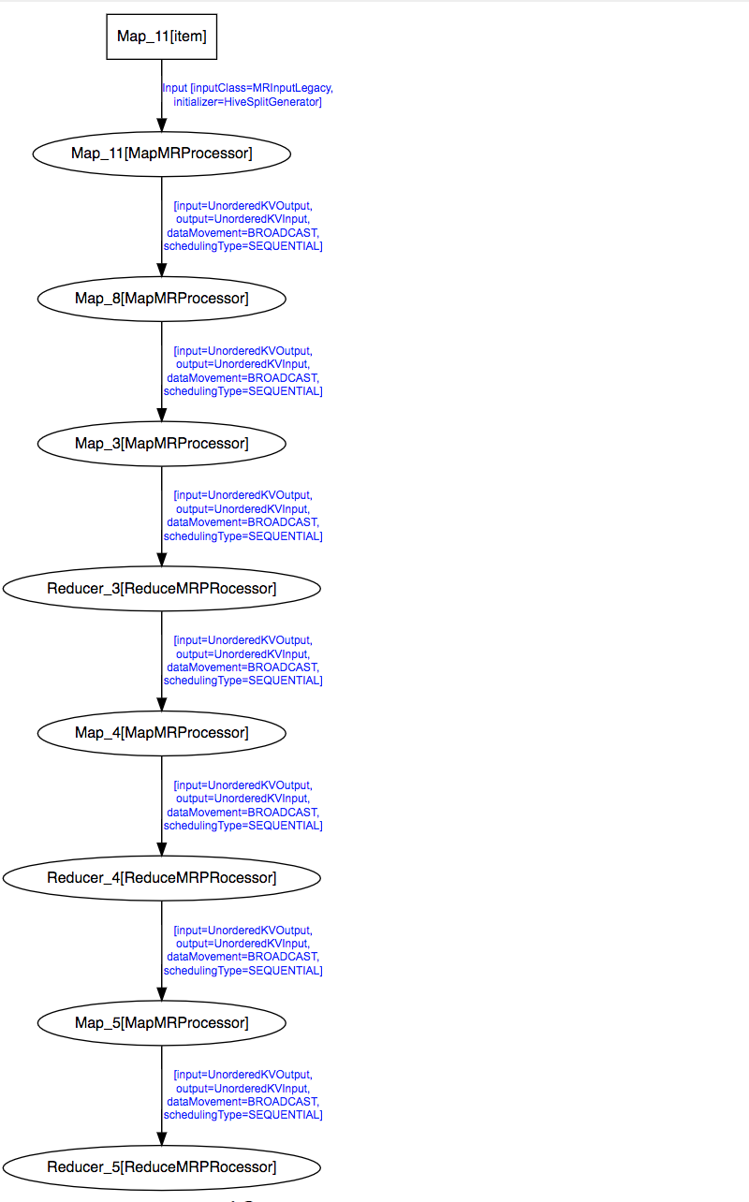

21:

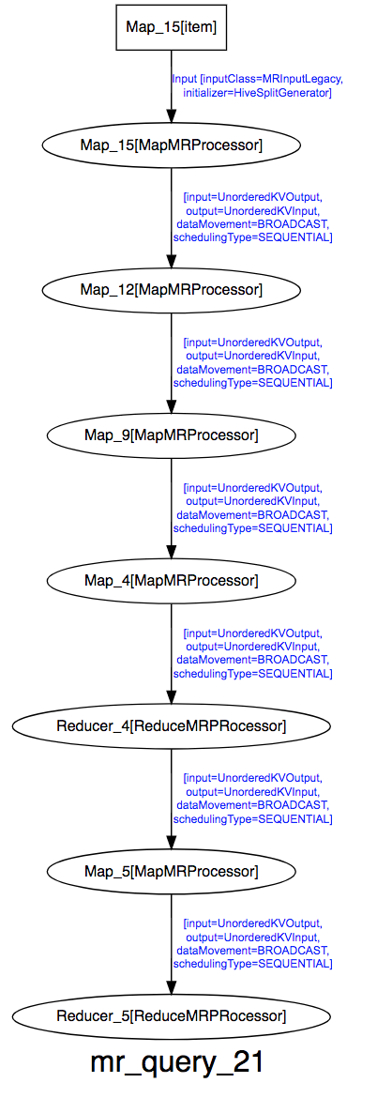

50:

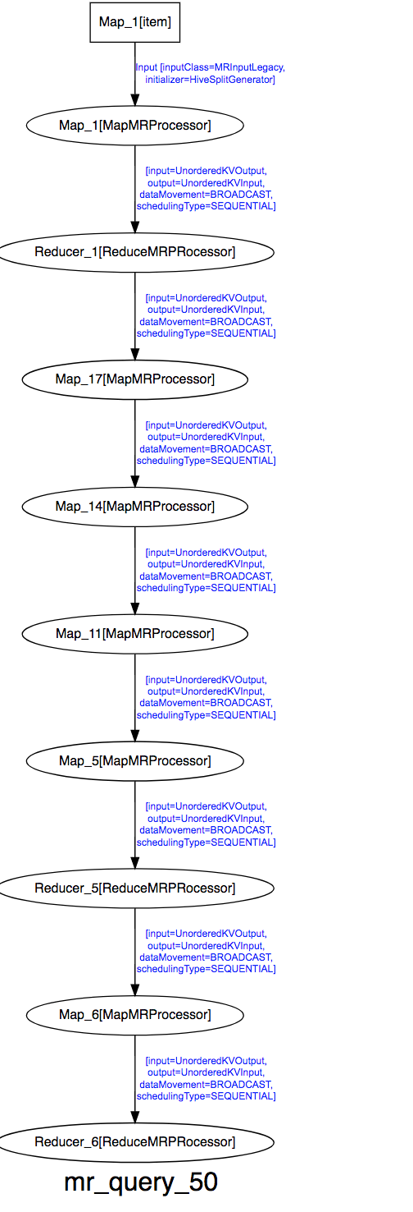

71:

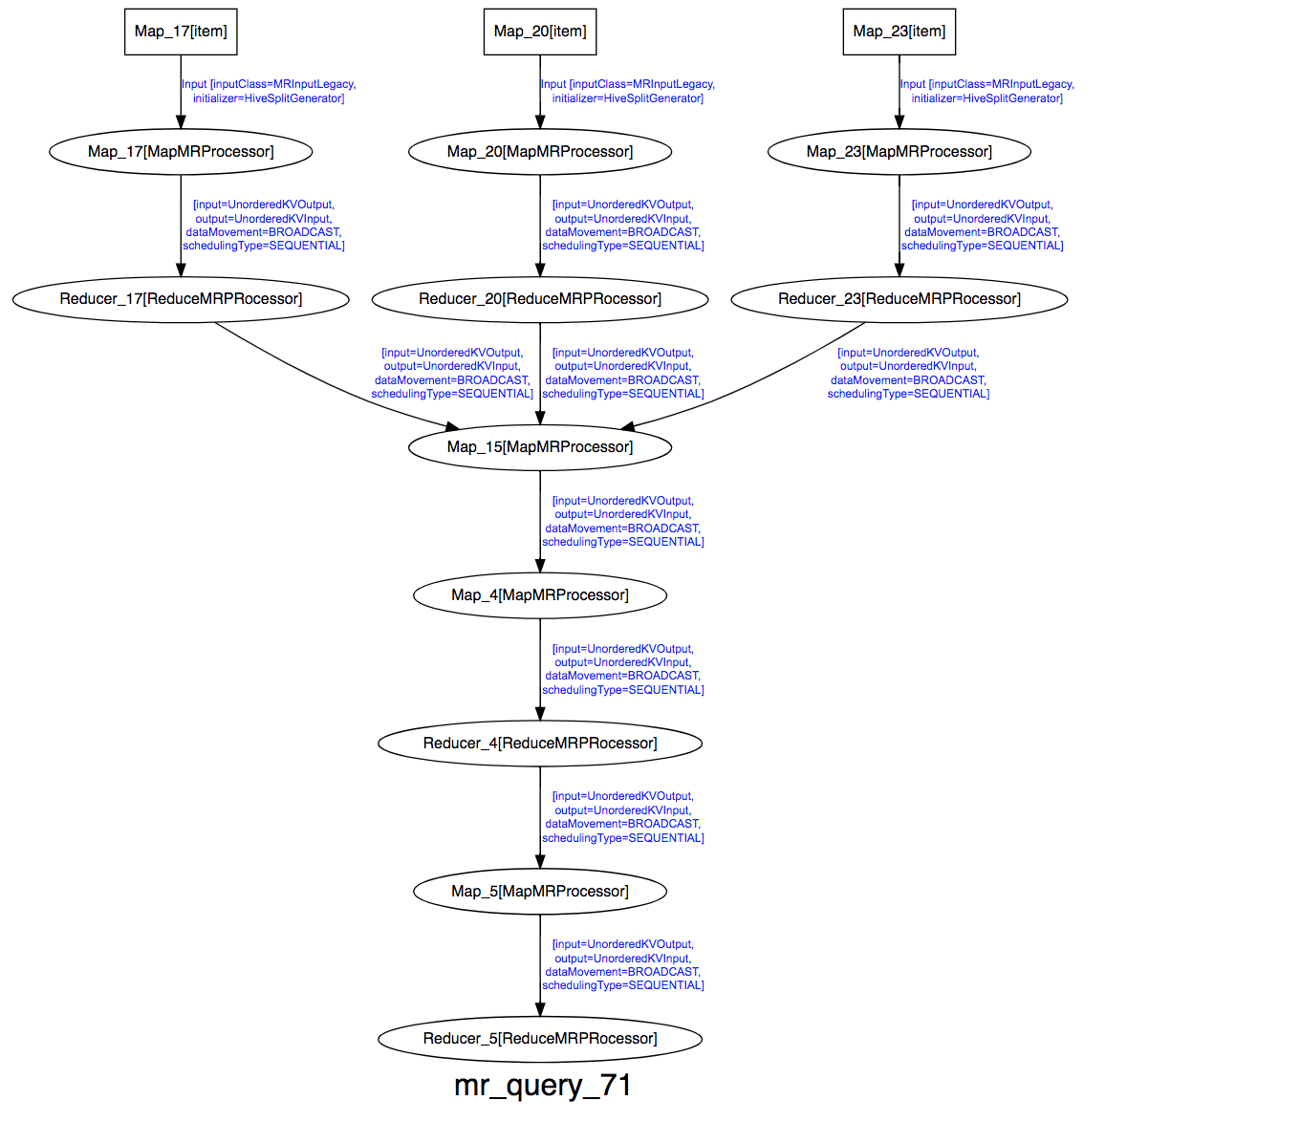

85:

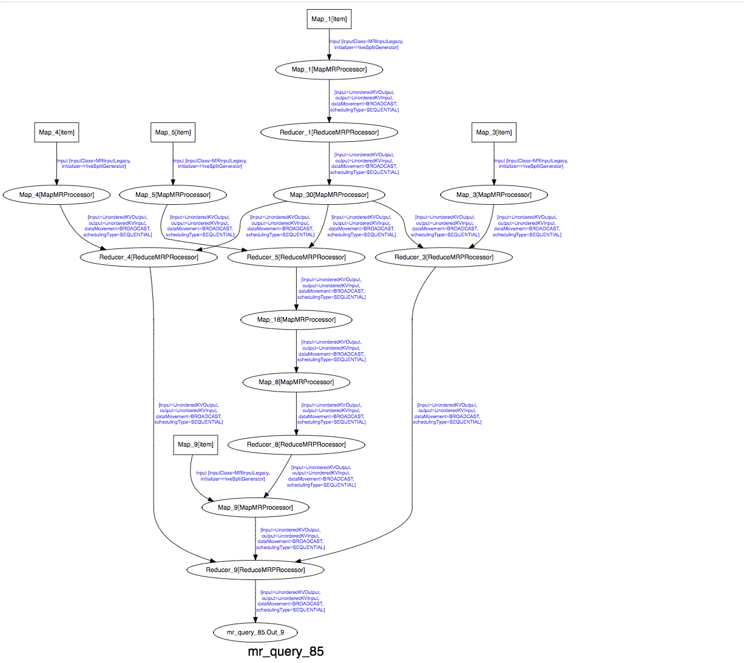

Tez:

12:

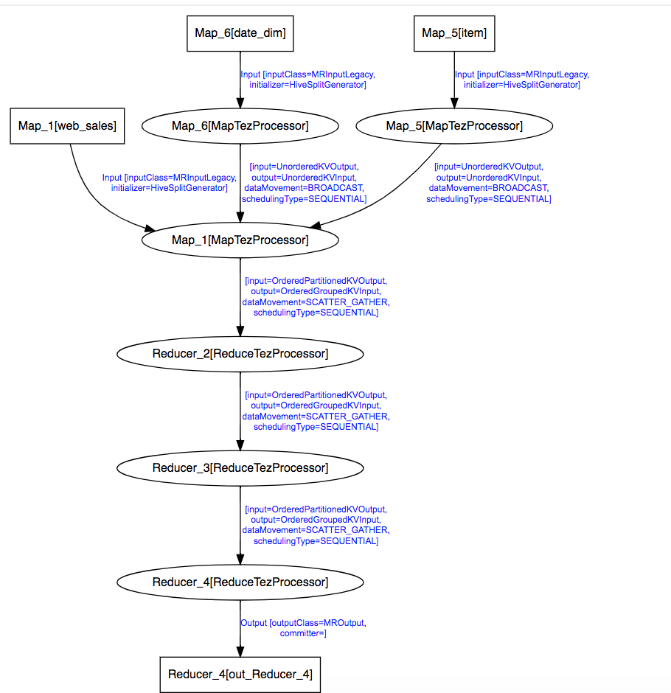

21:

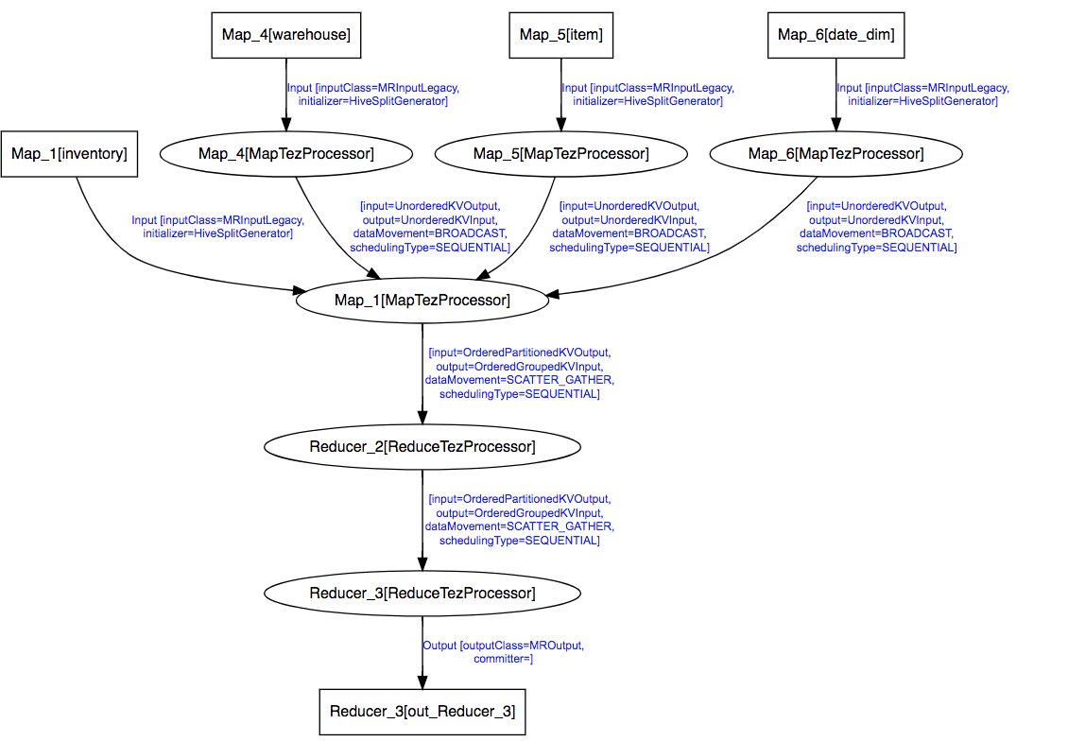

50

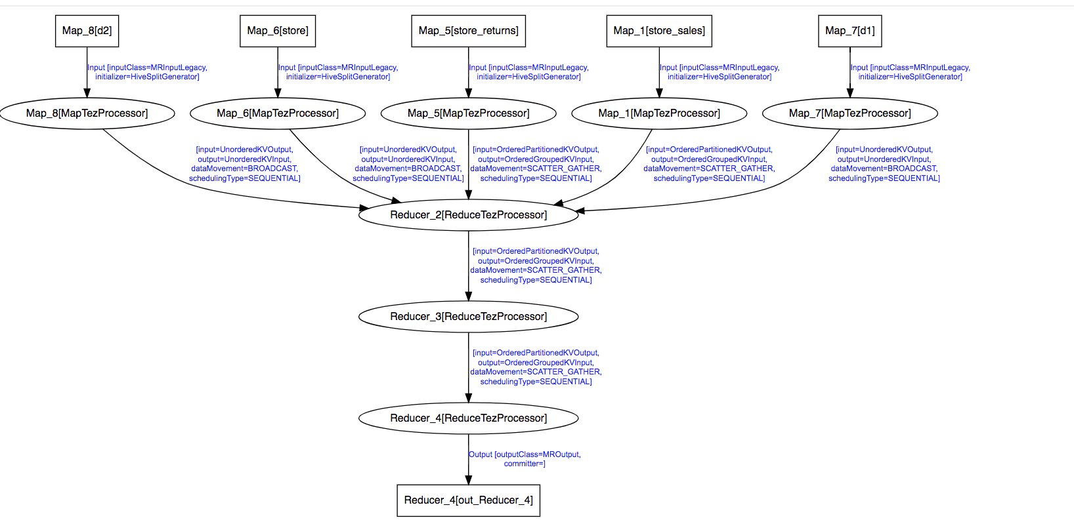

71:

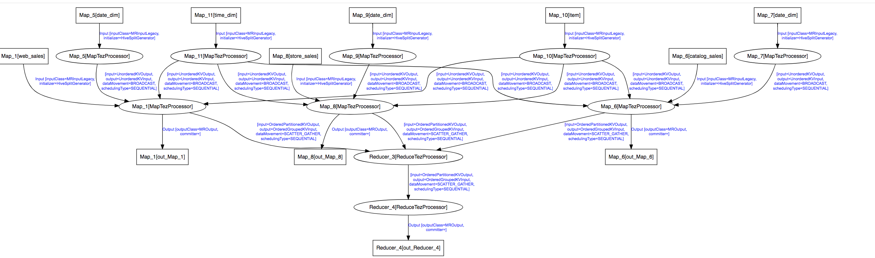

85:

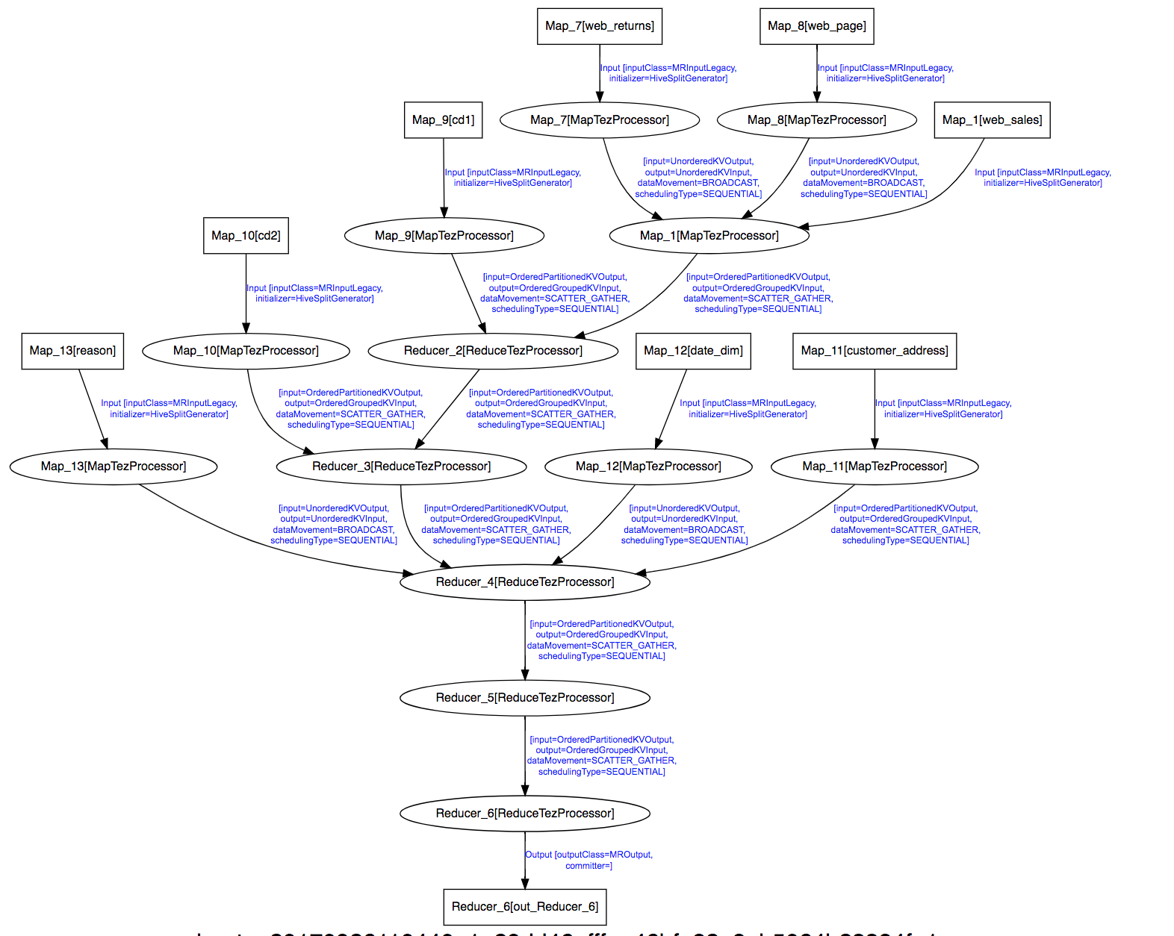

These DAGs are very different.

Yes, the structure can impact the performance. Say we have many independent mapping tasks reading from HDFS simultaneously, then we have a higher reading from disk throughput. If we just have a sequential structure, we can only have a lower throughput because the nest stage depends of the result of the previous one. This can be verified by observing difference of reading throughput of Tez and MR in query 12, query 21 and query 50.

**2.**

**Mapreduce:**

Normal: 296.7 s

25%: 386.5 s

75%: 355.5 s

**Tez:**

Normal: 263.2s

25%: 325.9s

75%: 301.3s

We observed that In both MR and Tez, failing a slave can slow the query. The earlier the slave is failed, the slower it will be.

Firstly, failures happened and it takes time to recover from the failures and re-schedule the particular jobs.

Secondly, some of the jobs can be executed in a parallel way at the first place, however after the data node fails, they can no longer be executed in a parallel style because the only copy of the data on the failed node is in the busy node and it can only be executed after the current job is finished. It explains that the earlier it fails, the slower it will be: the earlier it fails, less jobs can be done in parallel.