**配置文件1：nginx.conf**

# the upstream component nginx needs to connect to

upstream django {

    server unix:/etc/nginx/django/daowang/**Wangdao.sock**; # for a file socket

}

# configuration of the server

server {

    # the port your site will be served on

    listen      80;

    # the domain name it will serve for

    server_name http://114.215.157.15/; # substitute your machine's IP address or FQDN

    charset     utf-8;

    # max upload size

    client_max_body_size 75M;   # adjust to taste

    # Django media

    location /media  {

        alias /etc/nginx/django/daowang/static/media;  # your Django project's media files - amend as required

    }

    location /static {

        alias /etc/nginx/django/daowang/static; # your Django project's static files - amend as required

    }

    location /FingerHire{

        proxy_pass http://127.0.0.1:8080;

    }

    # Finally, send all non-media requests to the Django server.

    location / {

        uwsgi_pass  django;

        include     /etc/nginx/django/daowang/uwsgi_params; # the uwsgi_params file you installed

    }

}

注：1、红色标注的**Wangdao.sock** 为空壳文件，即后缀为.sock的空文件

2、配置文件存放在项目里，便于维护，但是nginx.conf 文件必须在nginx的文件夹sites-enabled添加一个软链接，如下图：命令为：**ln -s /data/www/ts/conf/ts_nginx.conf /etc/nginx/sites-enabled/**

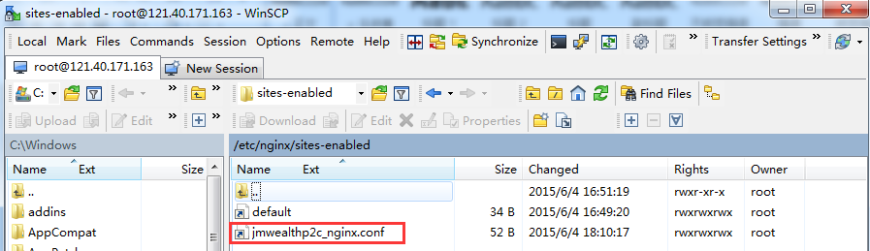

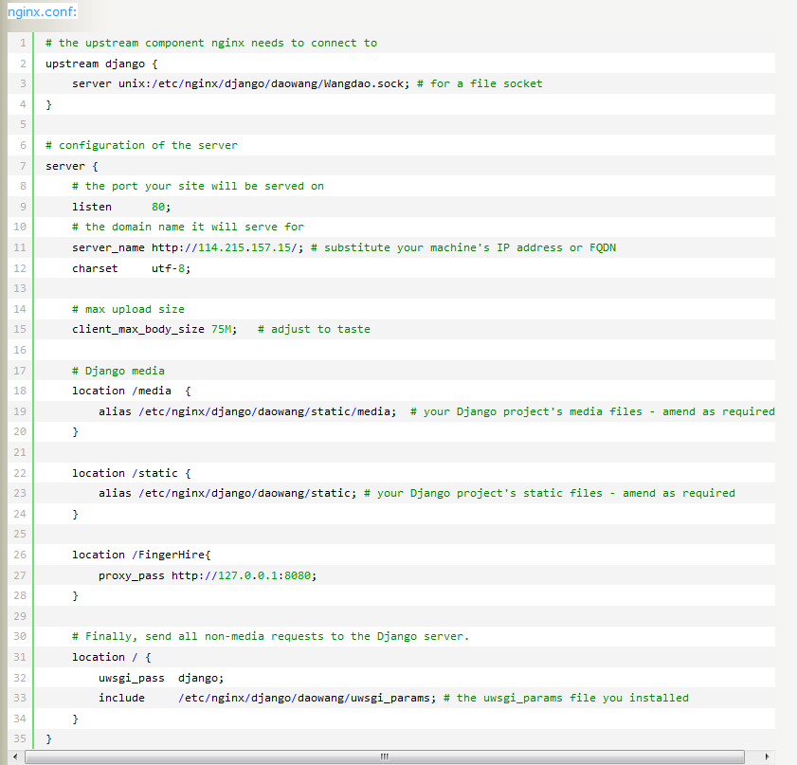

**配置文件2：uwsgi.ini**

[uwsgi]

# Django-related settings

# the base directory (full path)

chdir           = /etc/nginx/django/daowang

# Django's wsgi file

module          = Wangdao.wsgi

# master

master          = true

# maximum number of worker processes

processes       = 32

max-requests    = 1000

# the socket (use the full path to be safe

socket          = /etc/nginx/django/daowang/Wangdao.sock

# ... with appropriate permissions - may be needed

chmod-socket    = 666

#chown-socket    = www-data:www-data

# clear environment on exit

vacuum          = true

daemonize       = /var/log/uwsgi/Wangdao.log

pidfile         = /tmp/project-master.pid

# added 2014-09-17

reload-on-as    = 126

reload-on-rss   = 126

enable-threads  = true

pythonpath      = /etc/nginx/django/daowang

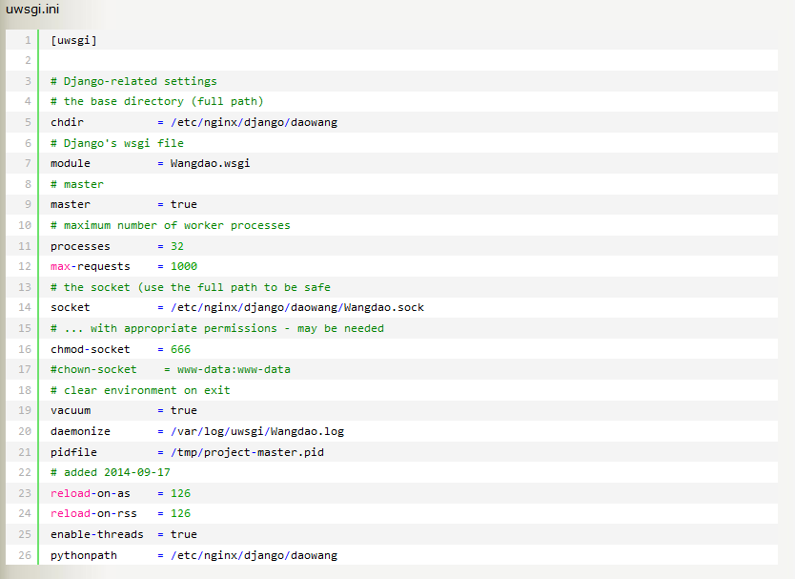

**配置文件3：uwsgi_params**

uwsgi_param QUERY_STRING $query_string;

uwsgi_param REQUEST_METHOD $request_method;

uwsgi_param CONTENT_TYPE $content_type;

uwsgi_param CONTENT_LENGTH $content_length;

uwsgi_param REQUEST_URI $request_uri;

uwsgi_param PATH_INFO $document_uri;

uwsgi_param DOCUMENT_ROOT $document_root;

uwsgi_param SERVER_PROTOCOL $server_protocol;

uwsgi_param HTTPS $https if_not_empty;

uwsgi_param REMOTE_ADDR $remote_addr;

uwsgi_param REMOTE_PORT $remote_port;

uwsgi_param SERVER_PORT $server_port;

uwsgi_param SERVER_NAME $server_name;

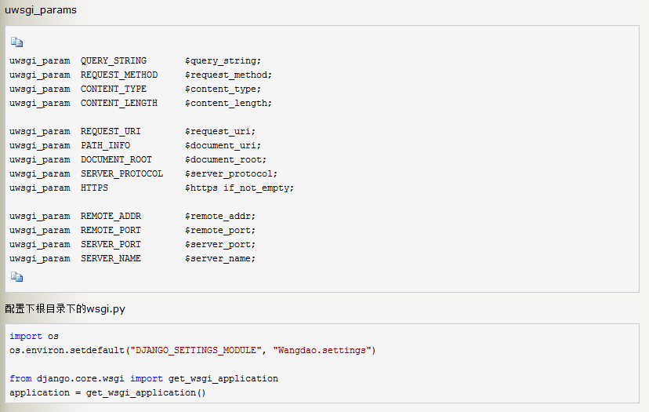

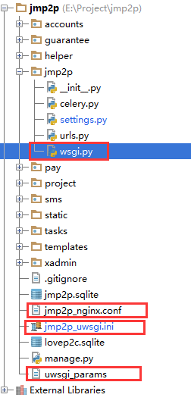

**常用命令：**

1.查看端口占用情况：

netstat -lpnt

2.杀死所有uwsgi进程

killall -9 uwsgi

3.uwsgi启动命令

uwsgi --ini /etc/nginx/django/lovep2c/lovep2c_uwsgi.ini



4.关闭uwsgi命令

uwsgi --stop /tmp/project-master.pid

5.重启uwsgi命令

uwsgi --reload /tmp/project-master.pid

nginx错误日志：

tail /var/log/nginx/error.log

uwsgi日志：

tail /var/log/uwsgi/lovep2c.log

项目错误日志：

tail /etc/nginx/django/debug.log

tail /etc/nginx/django/error.log

参考网址：<https://uwsgi.readthedocs.org/en/latest/tutorials/Django_and_nginx.html>

