**What’s Up?**

**Proposed Level of Achievement**

Project Gemini

**Motivation**

While you are waiting for the bus or in the queue or has some free time to spare, a fun and addictive game can seriously help with killing time. Complicated games, such as RPG, often require lots of time to set ‘Up’ and during the actual game play. For short durations of time, games with simple instructions and game play would be a better choice.

It is hard to overstate how good 2048 is, but considering the fact that we have been playing it for 3 years for now (introduced in 2014), it is time to get your hands on something refreshing and different.

**Aim**

We hope to create a fun mobile game that can be played across all ages, helping them to relax while improving their reaction and reflex.

**User Stories**

* As a teenager, I would like to spend my spare time playing a game that is not too time consuming, yet interesting and challenging. It would be cool to show my friends my quick reflexes too.
* As a parent, sometimes when I wait for my child to be dismissed, I do not know how long I have to wait. Hence I prefer to play short games where I can stop anytime. Maybe my child can play this too, it might be good for his mathematics.
* As an elderly, I would like to train my brain and reflexes through a relaxing yet exciting game.
* As a bored person, I want to get my hands on an enticing game that keeps me constantly excited.

**Game Play**

*What’s Up?*is a quick one-tap game with simple controls that also improves your reflexes and test your multiplication skills. Such a game can also be played across all ages, ranging from primary school students to elderlies, bringing joy to everyone in the family.

Users are to challenge themselves by tapping as many correct tiles as possible during short intervals, making it very addictive and tempt users to play it over and over again.

How to Play

1. Player first chooses which ‘Up’ he would like to play with, for example, 7-‘Up’.
2. When the game begins, the player need to search for the smallest tile in the grid and start tapping the tiles in ascending order. Default starting tile is 1.

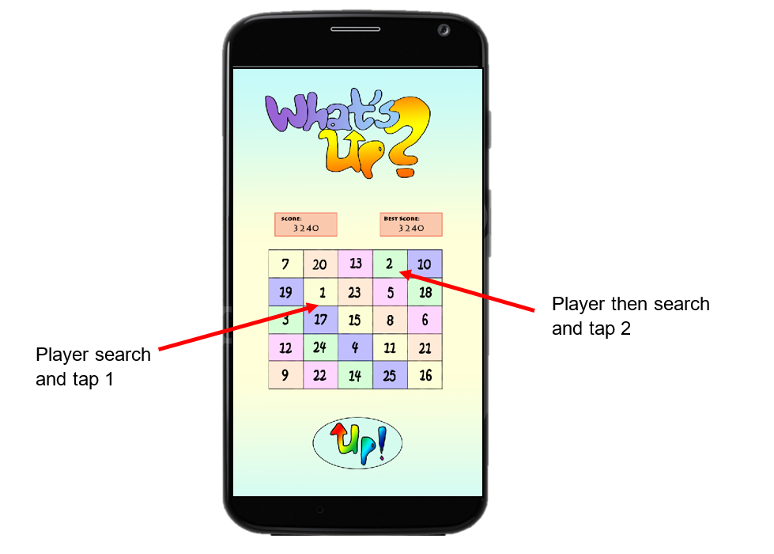

1. If the player press the correct tile, the tile will be replaced by a bigger number down the number line, as shown below. Replacement of tile is in random order so the player cannot predict the position of upcoming numbers.

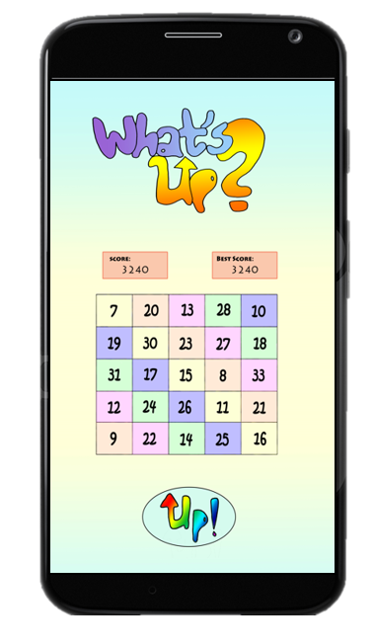

1. When the player encounter a tile that contains the ‘Up’ digit or is a multiple of the ‘Up’ digit, he avoids it by tapping the *Up!* button instead. In a 7-‘Up’ game, user need to avoid tiles such as 7,14,17,21,27,28……Failing to press the *Up!* button will lead to instant Game Over.
2. If the player press the wrong tile, the screen will shake as a warning. Pressing wrong tiles for 3 times will lead to Game Over.
3. Given a time limit of 2 minutes, player will challenge to press as many tiles as possible. Score will be calculated based on the highest number that the player reaches.

**Technology & Tools**

* Android Studios
* libGDX (KIV)

**Proposed Product Features**

Minimum Viable Product

*By Milestone 2:*

* Countdown timer
* Generation of ‘Up’ digit
* Replacement of tiles
* Score tracker
* Background music

Extension

*By Milestone 2:*

* Tracking number of lives, reduces life when number pressed is not in

ascending order

* Difficulty levels
  + Different grid sizes
  + Random rotation of grid during game play to introduce

Uncertainty

*By Milestone 3:*

* Login using Facebook / Sharing scores on social media
* Multiple player mode (against Bot or against other players)
* Highscore Board
* Provide hint to player when player is unable to find the next number after

10 seconds

* Wild Cards
  + Bonus time
  + Extra life
  + Coins (increase points)
  + Stealthier card (when used, the next number in the grid will

be removed by the bot)

* Inventory to store wild cards
  + Wild cards gained in one game can be carried forward to

next game play

**Project Log**

**Ng Xin Ler**

|  |  |  |  |  |
| --- | --- | --- | --- | --- |
|  | Task | Date | Remarks | Hours |
| 1 | Liftoff Day 1 | 8th May |  | 8 |
| 2 | Liftoff Day 2 | 9th May |  | 8 |
| 3 | Learning at Home | 11th May | Studying similar game designs  Learning libGDX | 7 |
| 4 | Consult game developer with prior experience | 18th May | Evaluate feasibility of project  Learning different gaming platforms | 5 |
| 5 | Team Meeting | 19th May | Finalize game design | 6 |
| 6 | Team Meeting | 24th May | Develop algorithms and UI | 8 |
| 7 | Team Meeting | 28th May | Worked on Milestone 1 | 8 |
| Total |  |  |  | 50/140 |

**Wang Zi**

|  |  |  |  |  |
| --- | --- | --- | --- | --- |
|  | Task | Date | Remarks | Hours |
| 1 | Liftoff Day 1 | 8th May |  | 8 |
| 2 | Liftoff Day 2 | 9th May |  | 8 |
| 3 | Learning at Home | 10th May | Study of similar game apps  Identify design pattern for the game  Experimenting with relevant technology | 10 |
| 4 | Team Meeting | 19th May | Finalize game design | 6 |
| 5 | Team Meeting | 24th May | Develop algorithms and UI | 8 |
| 6 | Team Meeting | 28th May | Worked on Milestone 1 | 8 |
| Total |  |  |  | 48/140 |

**Project Poster**

**Project Video**