Manage Program Flow

Multithreading

Threads (System.Threading)

Thread Class
- This class enables you to create new threads, manage their priority, and get their status.
- Thread.Join() is a synchronization method that blocks the calling thread (that is, the thread that calls the Join method) until the thread whose Join method is called has completed.
- Thread.Sleep(0) can be used to signal to Windows that the thread is finished. Instead of waiting for the whole time-slice of the thread to finish, it will immediately switch to another thread.
- Thread.Yield(): Causes the calling thread to yield execution to another thread that is ready to run on the current processor.
  - The operating system selects the thread to yield to.
- Thread.SpinWait(int): Causes a thread to wait the number of times defined by the iterations parameter.
- Thread.Priority:
  - A new thread is assigned a priority of ThreadPriority.Normal.
  - A thread can be assigned any one of the following priority ThreadPriority values:
    - Highest
    - AboveNormal
    - Normal (okay for most scenarios)
    - BelowNormal
    - Lowest (screen saver)
- Thread.IsBackground (true | false [default]):
  - Only when all foreground threads end (i.e. Main) does the application exit.
- Thread Constructors:
  - Has an overload that takes an instance of a ThreadStart delegate with no parameters.
  - Overload takes a ParameterizedThreadStart delegate with a single object parameter.
- To stop a thread, you can use the Thread.Abort method, but this is not recommended.
  - Use a shared variable that both your target and your calling thread can access.
- A thread has its own call stack that stores all the methods that are executed.
  - Local variables are stored on the call stack and are private to the thread.
  - A thread can also have its own data that’s not a local variable.
  - By marking a static field with the ThreadStatic attribute, each thread gets its own copy of a static field.
    - Value types (int, etc.) are set to their default value when this is applied.
    - Cannot be used on static properties.
  - To use local data in a thread and initialize it for each thread, use ThreadLocal<T> class.
    - Has a constructor which takes a delegate to a Func<TResult> method that initializes the value.
    - Can be applied to local / class variables both static and non-static.
- You can use the Thread.CurrentThread | ExecutionContext properties to ask for information about the thread that’s executing (execution context).
  - When a thread is created, the runtime ensures that the initiating thread’s execution context is flowed to the child thread so that it has the same privileges as the parent.
  - This copying cost resources, however. If you don’t need this data, you can disable this behavior by using the ExecutionContext.SuppressFlow static method.

ThreadPool Class
- The reusable threads in the managed thread pool are background threads.
- The thread pool queues a work item that is then picked up by an available thread from the pool.
- The thread pool automatically manages the amount of threads it needs to keep around.
- The pool starts out empty and then creates additional threads as requests come in.
- As long as it can finish an operation before a new one comes in, no new threads have to be created.
- If new threads are no longer in use after some time, the thread pool kills those threads so they no longer use any resources.
- When the thread pool reuses a thread, it does not clear the data in thread local storage or in fields that are marked with the ThreadStatic attribute.
  - Do not rely on state that can potentially be shared between multiple operations.

Signals and Waits

Event Wait Handles
- Event wait handles allow threads to synchronize activities by signaling each other and by waiting on each other's signals.
  - When a wait handle is “signaled”, a waiting thread can proceed (SET => WaitOne returns true).
  - When a wait handle is “un-signaled”, a waiting thread blocks (WaitOne blocks).
- These synchronization events are based on Win32 wait handles and can be divided into two types: those that reset automatically when signaled and those that are reset manually.
- Automatic reset events are usually used to provide exclusive access to a resource for a single thread at a time.
  - A thread requests the resource by calling the WaitOne method.
  - If no other thread is holding the wait handle, the method returns true and the calling thread has control of the resource.
  - If an automatic reset event is signaled when no threads are waiting, it remains signaled until a thread attempts to wait on it.
  - The event releases the thread and immediately resets (“un-signaled”), blocking subsequent threads.
- A manual reset event acts like the gate of a corral.
  - When the event is not signaled, threads that wait on it block, like horses in a corral.
  - When the event is signaled, by calling its Set method, all waiting threads are free to proceed.
  - The event remains signaled until its Reset method is called.
  - This makes the manual reset event an ideal way to hold up threads that need to wait until one thread finishes a task.
- A thread can signal an EventWaitHandle and then block on it, as an atomic operation, by calling the static WaitHandle.SignalAndWait method.
- The Windows operating system allows event wait handles to have names.
  - A named event is system wide. That is, once the named event is created, it is visible to all threads in all processes.
  - Thus, named events can be used to synchronize the activities of processes as well as threads.
  - Event wait handles do not have thread affinity. Any thread can signal an event wait handle.
- WaitHandle.WaitAll(WaitHandle[] h): Waits for all the elements in the specified array to receive a signal.
  - Returns true when every element in waitHandles has received a signal; otherwise the method never returns.

EventWaitHandle
- The EventWaitHandle class allows threads to communicate with each other by signaling.
- Typically, one or more threads block on an EventWaitHandle until an unblocked thread calls the Set method, releasing one or more of the blocked threads.
  - After it is signaled, an event wait handle is reset either manually or automatically.
- The EventWaitHandle class can represent either a local event wait handle (local event) or a named system event wait handle (named event or system event, visible to all processes).
- You create an automatic reset event by specifying EventResetMode.AutoReset when you create the EventWaitHandle object.
  - The EventWaitHandle resets automatically when signaled, after releasing a single waiting thread.
- You create a manual reset event by specifying EventResetMode.ManualReset when you create the EventWaitHandle object.
  - The EventWaitHandle remains signaled until its Reset method is called.
- If the initial state of the event is non-signaled, threads that wait on the event will block.
- Disposable.

AutoResetEvent
- Like a turnstile.
- Can represent only local wait handles, not named system events.
- Resets automatically when signaled, after releasing a single waiting thread.
- Used by Monitor class.
- If the initial state of the event is non-signaled, threads that wait on the event will block.
- A thread waits for a signal by calling WaitOne.
  - If the AutoResetEvent is in the non-signaled state, the thread blocks, waiting for the thread that currently controls the resource to signal that the resource is available by calling Set.
- Calling Set signals AutoResetEvent to release a waiting thread.
  - AutoResetEvent remains signaled until a single waiting thread is released, and then automatically returns to the non-signaled state.
  - If no threads are waiting, the state remains signaled indefinitely.
- If a thread calls WaitOne while the AutoResetEvent is in the signaled state, the thread does not block.
  - The AutoResetEvent releases the thread immediately and returns to the non-signaled state.
- Disposable.

ManualResetEvent
- Like a gate.
- Can represent only local wait handles, not named system events.
- A ManualResetEvent object remains signaled until its Reset method is called.
- Any number of waiting threads, or threads that wait on the event after it has been signaled, can be released while the object's state is signaled.
  - Threads that call WaitOne will block, awaiting the signal.
  - When the controlling thread completes the activity, it calls Set to signal that the waiting threads can proceed.
  - All waiting threads are released.
- If the initial state of the event is non-signaled, threads that wait on the event will block until the Set method is called.
- Disposable.

ManualResetEventSlim
- Use this over the ManualResetEvent class for better performance when wait times are expected to be very short, and when the event does not cross a process boundary.
- Uses busy spinning (tight loop) for a short time while it waits for the event to become signaled.
- When wait times are short, spinning can be much less expensive than waiting by using wait handles.
- However, if the event does not become signaled within a certain period of time, ManualResetEventSlim resorts to a regular event handle wait.
- If the initial state of the event is non-signaled, threads that wait on the event will block until the Set method is called.
- Threads that call Wait() or its overloads will block, awaiting the signal.
- Disposable

Semaphore
- Represents a named (system wide) or local semaphore.
- It is a thin wrapper around the Win32 semaphore object.
- Win32 semaphores are counting semaphores, which can be used to control access to a pool of resources.
- Threads enter the semaphore by calling the WaitOne method, which is inherited from the WaitHandle class.
  - The count on a semaphore is decremented each time a thread enters the semaphore, and incremented when a thread releases the semaphore.
  - When the count is zero, subsequent requests block until other threads release the semaphore.
  - When all threads have released the semaphore, the count is at the maximum value specified when the semaphore was created.
- As threads release the semaphore by calling the Release method, blocked threads are allowed to enter.
- A thread can enter the semaphore multiple times by calling the WaitOne method repeatedly.
  - To release the semaphore, the thread can either call the Release() method the same number of times, or call the Release(Int32) and specify the number of entries to be released.
- Semaphore does not have thread affinity. This means it can be used in scenarios where one thread acquires the semaphore and another releases it.
- Disposable.

SemaphoreSlim
- The SemaphoreSlim class represents a lightweight, fast semaphore that can be used for waiting within a single process when wait times are expected to be very short.
- The SemaphoreSlim class doesn’t support named system semaphores. You can use it as a local semaphore only.
- The SemaphoreSlim class is the recommended semaphore for synchronization within a single app.
- To enter the semaphore, a thread calls one of the Wait overloads. To release the semaphore, it calls one of the Release overloads.
- The semaphore's count is available from the CurrentCount property.
- Disposable.

Monitor
- The TryEnter method allows a thread that is blocked waiting for the resource to give up after a specified interval.
  - It returns a Boolean value indicating success or failure, which can be used to detect and avoid potential deadlocks.
- The Wait method is called by a thread in a critical section.
  - It gives up control of the resource and blocks until the resource is available again.
- The Pulse and PulseAll methods allow a thread that is about to release the lock or to call Wait to put one or more threads into the ready queue, so that they can acquire the lock.
- Monitor has thread affinity. That is, a thread that entered the monitor must exit by calling Exit or Wait.

Mutex
- When two or more threads need to access a shared resource at the same time, the system needs a synchronization mechanism to ensure that only one thread at a time uses the resource.
  - Mutex grants exclusive access to the shared resource to only one thread.
  - If a thread acquires a mutex, the second thread that wants to acquire that mutex is suspended until the first thread releases the mutex.
- The Mutex class uses more system resources than the Monitor class, but it can be marshaled across application domain boundaries, it can be used with multiple waits, and it can be used to synchronize threads in different processes.
- A thread calls the WaitOne method to request ownership.
- The call blocks until the mutex is available, or until the optional timeout interval elapses.
- The state of a mutex is signaled if no thread owns it.
- A thread releases a mutex by calling its ReleaseMutex method.
- Mutexes have thread affinity; that is, the mutex can be released only by the thread that owns it.
- If a thread releases a mutex it does not own, an ApplicationException is thrown in the thread.
- Mutexes are of two types: local mutexes and named system mutexes.
- If you create a Mutex object using a constructor that accepts a name, it is associated with an operating-system object of that name.
  - Named system mutexes are visible throughout the operating system and can be used to synchronize the activities of processes.
  - You can create multiple Mutex objects that represent the same named system mutex, and you can use the OpenExisting method to open an existing named system mutex.
- A local mutex exists only within your process.
  - It can be used by any thread in your process that has a reference to the local Mutex object.
  - Each Mutex object is a separate local mutex.
- Disposable.

SpinLock
- You can use the SpinLock structure when the overhead required by Monitor degrades performance.
- When SpinLock encounters a locked critical section, it simply spins in a loop until the lock becomes available.
- If the lock is held for a very short time, spinning can provide better performance than blocking.
- However, if the lock is held for more than a few tens of cycles, SpinLock performs just as well as Monitor, but will use more CPU cycles and thus can degrade the performance of other threads or processes.
- Because SpinLock is a value type, you must explicitly pass it by reference if you intend the two copies to refer to the same lock.

SpinWait
- A lightweight synchronization structure that you can use to avoid the expensive context switches and kernel transitions that are required for kernel events.
- When a resource is not expected to be held for long periods of time, it can be more efficient for a waiting thread to spin in user mode for a few dozen or a few hundred cycles, and then retry to acquire the resource.
- Designed to be used in conjunction with the types that wrap kernel events such as ManualResetEvent.
- SpinWait can also be used by itself for basic spinning functionality in just one program.

Barrier
- The Barrier class provides a way to cyclically synchronize multiple threads so that they all block at the same point and wait for all other threads to complete.
  - Barriers are useful when the threads are performing multiple phases in loops.
- A barrier is useful when one or more threads require the results of another thread before continuing to the next phase of an algorithm.
- The barrier represents the end of one phase of work.
  - When a participant reaches the barrier, it blocks until all participants have reached the same barrier.
  - After all participants have reached the barrier, you can optionally invoke a post-phase action.
  - This post-phase action can be used to perform actions by a single thread while all other threads are still blocked.
  - After the action has been executed, the participants are all unblocked.
- Deadlocks can occur if one participant fails to reach the barrier.
  - To avoid these deadlocks, use the overloads of the SignalAndWait method to specify a time-out period and a cancellation token.
- Disposable.

ReaderWriterLockSlim
- Enables multiple threads to read a resource concurrently, but requires a thread to wait for an exclusive lock in order to write to the resource.
- ReaderWriterLockSlim allows multiple threads to be in read mode, allows one thread to be in write mode with exclusive ownership of the lock, and allows one thread that has read access to be in upgradeable read mode, from which the thread can upgrade to write mode without having to relinquish its read access to the resource.
- When a thread is in write mode, no other thread can enter the lock in any mode (including reads so no dirty reads).
  - Only one thread can be in upgradeable mode at any time.
  - Any number of threads can be in read mode, and there can be one thread in upgradeable mode while other threads are in read mode.
  - A thread that tries to enter write mode blocks if there is a thread in any of the three modes.
- When the writer is not active, any number of readers can access the resource (for example, by calling the EnterReadLock method).
- When a thread requests exclusive access, (for example, by calling the EnterWriteLock method), subsequent reader requests block until all existing readers have exited the lock, and the writer has entered and exited the lock.
- ReaderWriterLockSlim has managed thread affinity; that is, each Thread object must make its own method calls to enter and exit lock modes.
  - No thread can change the mode of another thread.
- Deprecates the slower/older ReaderWriterLock class.
- Disposable.

CountdownEvent
- Is a synchronization primitive that unblocks its waiting threads after it has been signaled a certain number of times.
- Designed for scenarios in which you would otherwise have to use a ManualResetEvent or ManualResetEventSlim and manually decrement a variable before signaling the event.
- For example, in a fork/join scenario, you can just create a CountdownEvent that has a signal count of 5, and then start five work items on the thread pool and have each work item call Signal when it completes.
  - Each call to Signal decrements the signal count by 1.
  - On the main thread, the call to Wait will block until the signal count is zero.
- Instances can be reused after Wait has returned by calling the Reset method.
- The wait operation can be canceled by using cancellation tokens.
- Its signal count can be incremented after the instance is created.
- Disposable.

Tasks

System.Threading.Tasks.Task Class
- Using Tasks makes sense only if you want to free up the user interface thread or if you want to parallelize your work on multiple processors.
- The Task can tell you if the work is completed and if the operation returns a result, the Task gives you the result.
- Threads from the thread pool are used to execute the Task.
- Calling Task.Wait is equivalent to calling Thread.Join.
- You can use the method WaitAll to wait for multiple Tasks to finish before continuing execution.
- Use the WaitAny method to wait until one of the tasks is finished.
  - To cancel a Task after a time, use an overload of Task.WaitAny that takes a timeout.
  - This does not cancel the running tasks, but specifies that WaitAny should no longer block after the timeout is reached.
  - Returns the array index of the completed task.
- The Task<T> class can be used if a Task should return a value.
  - Attempting to read the Result property on a Task will force the thread that’s trying to read the result to wait/block until the Task is finished before continuing.
- A continuation task can be used if you want another operation to execute as soon as the Task finishes.
  - The ContinueWith method has different overloads that will run when an exception happens, the Task is canceled, or the Task completes successfully.
- Use the WhenAll method to schedule a continuation method after all Tasks have finished.
- A Task can have several child Tasks. The parent Task finishes when all the child tasks are ready.
- A TaskFactory is created with a certain configuration and can then be used to create Tasks with that configuration.
- When passing a parameter to a task from the enclosing method (especially in a loop), use the Task constructor which accepts an Action<object> argument as well as an object parameter.
  - Otherwise, the passed in parameter may not be captured properly by the assigned lambda.
  - 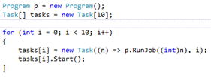
- Exceptions thrown from tasks are wrapped in an AggregateException, which may contain nested AggregateExceptions. Use the Flatten method to remove this nesting as shown below:
- 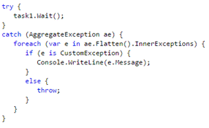

System.Threading.Tasks.Parallel Class
- The Parallel class has static methods For, ForEach, and Invoke that can parallelize work.
  - For / ForEach return a ParallelLoopResult structure which can be used to inspect IsCompleted and LowestBreakIteration properties.
  - The List<T>.ForEach method is not parallel but runs sequentially.
- Increasing performance with parallel processing applies to work that can be executed in parallel.
- For small work sets or for work that has to synchronize access to resources, the Parallel class can hurt performance.
- You can cancel the loop by using the ParallelLoopState object.
  - Break() ensures that all iterations that are currently running will be finished.
  - Stop() just terminates everything.

Cancelling Tasks
- System.Threading.CancellationToken can help you in canceling Tasks, the Parallel class, or PLINQ.
  - Pass a CancellationToken to a Task, which then periodically monitors the token to see whether cancellation is requested.
  - The System.Threading.CancellationTokenSource is used to signal that the Task should cancel itself.
- The operation will end when cancellation is requested with a RanToCompletion state.
  - If you want to signal to outside users that your task has been canceled, throw an OperationCanceledException/TaskCancelledException.
- Instead of catching the exception, you can also add a continuation Task that executes only when the Task is canceled.
  - The cancellation task only runs if the parent task throws an OperationCancelledException/TaskCancelledException or invokes CancellationTokenSource.ThrowIfCancellationRequested().

Async/Await Keywords
- By using asynchronous code, instead of blocking your thread until the I/O operation finishes, you get back a Task object that represents the result of the asynchronous operation.
- By setting a continuation on this Task, you can continue when the I/O is done.
- In the meantime, your thread is available for other work.
- If you are building a client application that needs to stay responsive, you can use await to offload long-running operations to a background task.
- When the I/O operation finishes, the continuation Task is scheduled on the thread pool.
- You use the async keyword to mark a method for asynchronous operations.
  - Signals to the compiler that something asynchronous is going to happen.
  - A method marked with async starts running synchronously on the current thread but it enables the method to be split into multiple pieces (via await).
  - Main cannot be marked async.
- The boundaries of these pieces are marked with the await keyword.
  - The await keyword enables you to write code that looks synchronous but behaves in an asynchronous way.
  - When you use the await keyword, the compiler generates code that will see whether your asynchronous operation is already finished.
  - If it is, your method just continues running synchronously.
  - If it’s not yet completed, the state machine will hook up a continuation method that should run when the Task completes.
  - Your method yields control to the calling thread which is free to do other work.
- When an exception happens in an asynchronous method, you normally expect an AggregateException. However, the generated code helps you unwrap the AggregateException and throws the first of its inner exceptions.
- The SynchronizationContext abstracts the way different applications (ASP.net, WPF, etc.) work and makes sure that you end up on the right thread when you need to update something on the UI or process a web request.
  - The await keyword makes sure that the current SynchronizationContext is saved and restored when the task finishes.
  - When using await inside a WPF application, after your Task finishes, your program continues running on the user interface thread.
  - In an ASP.NET application, the remaining code runs on a thread that has the client’s cultural, principal, and other information set.
  - You can disable the flow of the SynchronizationContext if your continuation code can run on any thread because it doesn’t need to update the UI after it’s finished.
  - By disabling the SynchronizationContext, your code performs better (Task.ConfigureAwait(false)).
- When creating async methods, it’s important to choose a return type of Task or Task<T>.
  - Avoid the void return type except when dealing with asynchronous events.
  - You can never inspect the return type, and you can’t see whether any exceptions were thrown.
- You should never have a method marked async without any await statements.

PLINQ
- Parallel Language-Integrated Query (PLINQ) can be used on objects to potentially turn a sequential query into a parallel one (.AsParallel()).
- Extension methods for using PLINQ are defined in the System.Linq.ParallelEnumerable class.
- Parallel versions of LINQ operators, such as Where, Select, SelectMany, GroupBy, Join, OrderBy, Skip, and Take, can be used.
- The runtime determines whether it makes sense to turn your query into a parallel one.
  - If you want to force PLINQ into a parallel query, you can use the WithExecutionMode method and specify that it should always execute the query in parallel.
    - ParallelExecutionMode.Default
    - ParallelExecutionMode.ForceParallelism
- You can limit the amount of parallelism that is used with the WithDegreeOfParallelism method.
  - You pass that method an integer that represents the number of processors to use.
  - By default, PLINQ uses all processors (up to 64).
- Parallel processing does not guarantee any particular order.
  - If you want to ensure that the results are ordered, you can add the AsOrdered operator.
  - Your query is still processed in parallel, but the results are buffered and sorted.
- You can use AsSequential to stop your query from being processed in parallel.
- You can use the ParallelEnumerable.ForAll operator to iterate over a collection when the iteration can also be done in a parallel way.
  - ParallelEnumerable is returned by a PLINQ query.
  - In contrast to foreach, ForAll does not need all results before it starts executing.
  - ForAll may remove any sort order that is specified.
  - Similar to Parallel.ForEach.
- It can happen that some of the operations in your parallel query throw an exception.
  - .NET handles this by aggregating all exceptions into one AggregateException.
  - This exception exposes a list of all exceptions that have happened during parallel execution.

System.Collections.Concurrent
- .NET offers collection classes that are created specifically for multithreaded code.
- They are thread-safe, which means that they use synchronization to make sure that they can be accessed by multiple threads at the same time.
- A regular collection blows up when being used in a multithreaded scenario because an item might be removed by one thread while the other thread is trying to read it.

BlockingCollection<T> Class
- Removing an item (Take()) from the collection can be blocked until data becomes available.
- You can set a maximum upper limit. If that limit is reached, adding an item blocks the calling thread until there is room.
- Use the CompleteAdding method to signal to the BlockingCollection that no more items will be added.
  - If other threads are waiting for new items, they won’t be blocked anymore.
  - Causes InvalidOperationException to be thrown by current Take().
- By using the GetConsumingEnumerable method, you get an IEnumerable that blocks until it finds a new item.
  - That way, you can use a foreach with your BlockingCollection to enumerate it.
  - Doesn’t throw exception on CompleteAdding.
- The default collection type for BlockingCollection<T> is ConcurrentQueue<T>.
  - A constructor allows the specification of a different collection (stack, etc.).

ConcurrentBag<T> Class
- A ConcurrentBag is just a bag of items.
- It enables duplicates and it has no particular order.
- Important methods are Add, TryTake, and TryPeek.
- TryPeek method is not very useful in a multithreaded environment.
  - It could be that another thread removes the item before you can access it.
- ConcurrentBag also implements IEnumerable<T>, so you can iterate over it.
  - This operation is made thread-safe by making a snapshot of the collection when you start iterating it, so items added to the collection after you started iterating it won’t be visible.

ConcurrentStack<T> Class
- A stack is a last in, first out (LIFO) collection.
- Push is used to add an item to the stack.
- TryPop tries to get an item off the stack.
- You can add and remove multiple items at once by using PushRange and TryPopRange.
- When you enumerate the collection, a snapshot is taken.

ConcurrentQueue<T> Class
- A queue is a first in, first out (FIFO) collection.
- ConcurrentQueue offers the methods Enqueue and TryDequeue to add and remove items from the collection.
- It also has a TryPeek method and it implements IEnumerable by making a snapshot of the data.

ConcurrentDictionary<T> Class
- A ConcurrentDictionary stores key and value pairs in a thread-safe manner.
  - Duplicate keys (case-sensitive) are not allowed.
- You can use methods to add (TryAdd) and remove (TryRemove) items.
- TryUpdate checks to see whether the current value is equal to the existing value before updating it.
- AddOrUpdate makes sure an item is added if it’s not there, and updated to a new value if it is.
  - Returns the new value for the key.
- GetOrAdd gets the current value of an item if it’s available; if not, it adds the new value by using a factory method.
  - Returns the value for the key.

Synchronizing Resources
- Synchronization is the mechanism of ensuring that two threads don’t execute a specific portion of your program at the same time.

Lock Operator
- The lock operator is an abstraction that the compiler translates into a call to System.Threading.Monitor.
- It causes the threads to block while they are waiting for each other (deadlock).
  - You can avoid a deadlock by making sure that locks are requested in the same order.
- Use the lock statement with a reference object that is private to the class.
  - It should be a reference type (avoids boxing).
  - The compiler raises an error when you use a value type for the lock statement.
  - You should avoid locking on this variable.
  - You should not lock on a string.

System.Threading.Interlocked Class
- Making operations atomic is the job of the Interlocked class.
- When using the Interlocked.Increment and Interlocked.Decrement, you create an atomic operation.
- Interlocked supports switching values by using the Exchange method.
  - if (Interlocked.Exchange(ref isInUse, 1) == 0) { }
  - This reads the current value and immediately sets it to the new value in the same operation. It returns the previous value before changing it.
- The CompareExchange method first checks to see whether the expected value is there; if it is, it replaces it with another value.
  - Interlocked.CompareExchange(ref value, newValue, compareTo);

Program Flow

Boolean Expressions (bool)
- OR (||) operator
  - The runtime applies short-circuiting (on true).
- AND (&&) operator
  - The runtime applies short-circuiting (on false).
  - You can also use it to check a variable for null before using it an expression.
- Exclusive OR (^) operator doesn’t apply short-circuiting.
  - Returns true only when exactly one of the operands is true.
Left operand | Right operand | Result
True | True | False
True | False | True
False | True | True
False | False | False

Flow Control Statements
- Variables defined in a code block are accessible only within the block and then go out of scope.
- If/else
  - If (b) { } else if (c) { } else { }
- Null-coalescing operator (??)
  - The operator returns the left value if it’s not null; otherwise, the right operand.
  - string y = x ?? “”;
- Conditional operator (?:)
  - If the expression is true, the first value is returned; otherwise, the second.
  - return p ? 1 : 0;
- Switch statement
  - A switch statement checks the value of its argument and then looks for a matching label.
  - 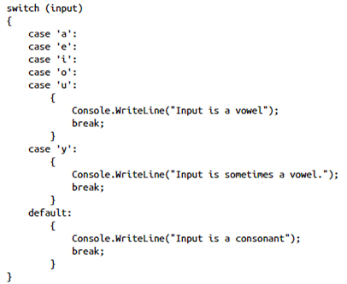
  - A switch can use one or multiple switch-sections that can contain one or more switch labels.
  - A switch expression or case label must be a bool, char, string, integer, enum, or corresponding nullable type.
  - You can add a default label that is used when none of the other labels matches.
  - You need to have a statement such as break or return that explicitly exits the switch statement, or you need to throw an exception (no fall-through).
    - This is required even in the default case.
  - Constant expressions (no variables) can be used in the case statement:
    - 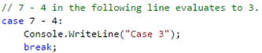
- For loop
  - You can use for(;;) {} as a perfectly legal for loop that would never end.
  - You can use multiple statements in each part of your for loop.
    - for (int x = 0, y = 7; (x < 10) && (y > 0); x++, y--) { }
  - It’s not required to let the loop value increment or decrement with 1 (+=, -=, etc.).
  - You can use the break or return statement when you want to completely exit the loop.
  - You can instruct the for loop to continue to the next item by using the continue statement.
- While / do-while loop
  - A do-while loop executes at least once, even if the expression is false.
  - do { } while (true);
  - You can use the continue and break statements just as with a for loop.
- Foreach loop
  - The foreach loop keeps track of where it is in the collection and protects you against iterating past the end of the collection.
    - foreach (int i in values) { }
  - You can make modifications to the object that the variable points to, but you can’t assign a new value to it (uses Enumerator underneath the hood).

Events and Callbacks

Delegates (function pointer)
- A delegate is a type that defines a method signature.
  - A delegate can only be defined as a class variable (not local).
  - Only instance delegate types are allowed (not static).
  - A delegate can be defined outside of a class.
- You can instantiate a delegate and let it point to another method.
- You can invoke the method through the delegate.
- Use the special delegate keyword to tell the compiler that you are creating a delegate type.
- When a method group is assigned to a delegate type, the delegate is automatically instantiated.
- An instantiated delegate is an object; you can pass it around and give it as an argument to other methods.
- You can combine delegates together (multicasting).
  - You can use the + or += operator to add another method to the invocation list of an existing delegate instance.
    - The same method can be added multiple times (even if pointing to the same reference)
  - You can also remove a method from an invocation list by using the decrement assignment operator (- or -=).
    - When removing, the method must have the same reference.
  - Delegates are executed in the order in which they were added (not guaranteed).
  - When a multicast delegate is assigned to a variable, the return type from the last subscriber invocation is returned.
- Delegates inherit from the System.MulticastDelegate class that in turn inherits from System.Delegate.
  - To find out how many methods a multicast delegate is going to call, you can use the following code:
    - int invocationCount = del.GetInvocationList().Length;
- When you assign a method to a delegate, the method signature does not have to match the delegate exactly (covariance and contravariance).
  - Covariance makes it possible that a method has a return type that is more derived than that defined in the delegate.
    - When invoking delegate, delegate type is returned (base class).
  - Contravariance permits a method that has parameter types that are less derived than those in the delegate type.
    - When invoking delegate, delegate type must be passed in to invocation (derived class).
- .NET has a couple of built-in delegate types that you can use when declaring delegates.
  - The Func<...> types can be found in the System namespace and they represent delegates that return a type and take 0 to 16 parameters.
  - If you want a delegate type that doesn’t return a value, you can use the System.Action types, which take 0 to 16 parameters but don’t return a value.
  - All those types inherit from System.MulticastDelegate so you can add multiple methods to the invocation list.
- When invoking an event chain, the first subscriber to throw an exception will prevent the subsequent subscribers from being invoked.
  - If this is not the behavior you want, you need to manually raise the events and handle any exceptions that occur.
  - You can do this by using the GetInvocationList method that is declared on the System.Delegate base class.
- Unlike lambdas, you must specify parameter types for anonymous methods:
  - Also, the body inside the curly braces must be a valid code statement (always include return if necessary).
- 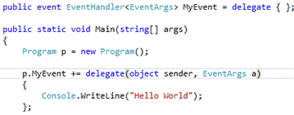

Lambda Expressions
- A lambda expression is a compact, anonymous method (no name).
- Example: Calculate calc = (x, y) => x + y;
- You don’t have to specify a return type explicitly. The compiler infers this automatically.
- If a lambda has only one parameter, you can remove the parentheses around the parameter.
- You can create multiple statement lambdas by adding curly braces around the statements.

Expression Trees
- Expression trees are representations of code in a tree-like data structure.
- An expression tree describes code instead of being the code itself.
- Expression trees are heavily used in LINQ.
  - When using Linq To Entities to query a database, the query is not executed (as is the case in Linq To Objects).
  - Instead, an expression tree describes the query.
  - Later on, this expression tree is translated into SQL that can be sent to the database.
- The System.Linq.Expressions namespace contains all the types you need to create an expression.
  - You have expressions for calling a method and creating a new object or even basic operations such as addition or subtraction.
  - In the example below, the expression is first constructed with a call to Console.Write and Console.WriteLine.
    - After construction, the expression is compiled to an Action (because it doesn’t return anything) and executed.
  - 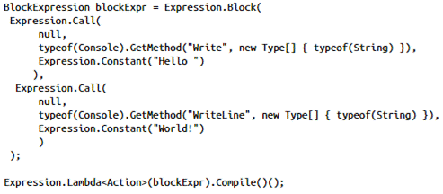
  - Expressions cannot be used to generate code (see CodeDom).

Events
- Publish-subscribe: You can subscribe to an event and then are notified when the publisher of the event raises a new event (establishes loose coupling between components).

Event keyword
- With the event syntax, the compiler protects your field from unwanted access.
  - An event cannot be directly assigned to (i.e. with the = instead of += operator) outside the class in which it is defined (only +=, -= operators are allowed).
- No outside users can raise your event (invoke the delegate). It can be raised only by code that’s part of the class that defined the event (wrapper method).
- Instead of using the Action type for your event (which is allowed), you should use the EventHandler or EventHandler<TEventArgs> built-in delegates (standard convention).
  - EventHandler is declared as the following delegate:
    - public delegate void EventHandler(object sender, EventArgs e);
    - public delegate void EventHandler<TEventArgs>(object sender, TEventArgs e)
  - The sender is by convention the object that raised the event (or null if it comes from a static method).
  - Use EventHandler<T> to specify the type of event arguments you want to use.
- You can use a custom event accessor to customize the addition and removal of event subscribers.
  - A custom event accessor looks a lot like a property with a get and set accessor.
  - Instead of get and set you use add and remove.
  - It’s important to put a lock around adding and removing subscribers to make sure that the operation is thread safe.
  - If you use the regular event syntax, the compiler generates a default accessor for you.
    - This makes it clear that events are not delegates; instead they are a convenient wrapper around delegates.

Exception Handling

Handling Exceptions
- Throwing an exception halts the execution of your application.
  - The runtime starts searching for a location in which you handle the exception.
  - If not found, the exception is unhandled and will terminate the application.
- To handle an exception, use a try/catch statement.
  - Following the try statement, you can add several different catch blocks.
  - A catch block can specify the type of the exception it wants to catch.
  - Because all exceptions in.NET inherit from System.Exception, you can catch every possible exception by catching this base type.
  - The catch blocks should be specified as most-specific to least-specific.
  - When an exception is thrown, the first matching catch block will be executed.
  - If no matching catch block can be found, the exception will fall through
- By using the finally block together with a try or try/catch statement, the finally block will execute whether an exception happens or not.
  - However, in situations such as a power outage, the whole OS will just terminate.
  - Use Environment.FailFast to prevent the finally block from running.
    - This method has two different overloads, one that only takes a string and another one that also takes an exception.
    - When this method is called, the message (and optionally the exception) are written to the Windows event log, and the application is terminated.
  - When the finally block causes an exception, control immediately leaves the finally block and moves to the next outer try block, if any.
- In a catch block, you can use both an exception type and a named identifier (both are optional).
- System.Exception properties:
  - StackTrace: A string that describes all the methods that are currently in execution.
  - InnerException: When a new exception is thrown because another exception happened, the two are linked together with the InnerException property.
  - Message: A message that describes the exception.
  - HelpLink: A URL that points to a help file.
  - HResult: A 32-bit value that describes the severity of an error, the area in which the exception happened and a unique number for the exception.
  - Source: The name of the application that caused the error. If the Source is not explicitly set, the name of the assembly is used.
  - TargetSite: Contains the name of the method that caused the exception. If this data is not available, the property will be null.
  - Data: A dictionary of key/value pairs that you can use to store extra data for your exception.

Throwing Exceptions
- You can then use the special throw keyword to throw the exception.
  - throw new ArgumentNullException("fileName", "Filename is required");
- After this, the runtime will start looking for catch and finally blocks.
- When catching an exception, you can choose to re-throw the exception in three ways:
  - Use the throw keyword without an identifier, which re-throws the exception without modifying the call stack.
  - Use the throw keyword with the original exception, which resets the call stack to the current location in code.
  - Use the throw keyword with a new exception.
    - This also resets the stack trace so set the InnerException to the original exception so that the original stack trace can be inspected.
- Some exceptions are thrown only by the runtime and shouldn’t be used.
  - ArithmeticException: A base class for other exceptions that occur during arithmetic operations.
  - ArrayTypeMismatchException: Thrown when you want to store an incompatible element inside an array.
  - DivideByZeroException: Thrown when you try to divide a value by zero.
  - IndexOutOfRangeException: Thrown when you try to access an array with an index that’s less than zero or greater than the size of the array.
  - InvalidCastException: Thrown when you try to cast an element to an incompatible type.
  - NullReferenceException: Thrown when you try to reference an element that’s null.
  - OutOfMemoryException: Thrown when creating a new object fails because the CLR doesn’t have enough memory available.
  - OverflowException: Thrown when an arithmetic operation overflows in a checked context.
  - StackOverflowException: Thrown when the execution stack is full.
  - TypeInitializationException: Thrown when a static constructor throws an exception that’s goes unhandled.
- Exceptions that you can use:
  - Exception: The base class for all exceptions.
  - ArgumentException: Throw this exception when an argument to your method is invalid.
  - ArgumentNullException: Throw when one of your arguments is null and isn’t allowed.
  - ArgumentOutOfRangeException: Throw when an argument is out of range.
  - FormatException: Throw when an argument does not have a valid format.
  - InvalidOperationException: Throw this exception when a method is called that’s invalid for the object’s current state.
  - NotImplementedException: Method has not been implemented yet.
  - NotSupportedException: Method is invoked that you don’t support.
  - ObjectDisposedException: A user tries to access methods when Dispose has already been called.

Custom Exceptions
- A custom exception should inherit from System.Exception.
- You need to provide at least a parameter-less constructor.
- It’s also a best practice to add a few other constructors: one that takes a string, one that takes both a string and an exception, and one for serialization.
- Use the Exception suffix in naming all your custom exceptions.
- It’s also important to add the Serializable attribute, which makes sure that your exception can be serialized.
- When creating your custom exception, you can decide which extra data you want to store.
  - Exposing this data through properties can help users of your exception inspect what has gone wrong.

Create and use Types
- The C# typing system contains three different categories:
  - Primitive types: int, double, byte, etc.
  - Value types: primitive types, enum, struct
  - Reference types: class, interface, delegate, array
- There are two locations in which a type can be stored in memory: the heap and the stack.
  - The value of a reference type is stored on the heap, and the address to this value is stored on the stack.
  - Although a value type is normally stored on the stack, there are exceptions (for example, a class that contains a value type as one of its fields, a lambda expression that closes over a value type, or a value type that is boxed).
  - The benefit of storing data on the stack is that it’s faster, smaller, and doesn’t need the attention of the garbage collector.
- All objects in C# inherit from System.Object.
  - Value types inherit from System.ValueType (which inherits from System.Object).
  - System.ValueType overrides some of the default functions (such as GetHashCode, Equals, and ToString) to give them a more meaningful implementation for a value type.
- C# is a statically typed language which means that the compiler will check the type of every expression.
- The new dynamic keyword enables you to override the compile-time checking and work with C# as a weakly typed language.
  - In most cases, it functions like it has type object.

Value Types (enum, struct)
- Value types are useful when it comes to small data structures that belong together.
- As a rule of thumb, you can check the following three criteria to determine whether you want to create a value type:
  - The object is small.
  - The object is logically immutable.
  - There are a lot of objects.
- In C#, you cannot directly inherit from System.ValueType.
  - Instead, you can use the struct keyword to create a new value type.

Enumerations (enums)
- An enum is a special kind of value type.
- An enum offers you a way to create a list of possible options as a type.
  - public enum Gender { Male, Female }
- By default, the first element has the value 0, and each successive element is increased by 1, but you can change the starting index and the underlying type.
  - The default underlying type of enumeration elements is int.
  - public enum Days : byte { Sat = 1, Sun = 7, Mon = 13, Tue = 17, Wed, Thu, Fri };
- If you want to compare the enum to the underlying data type value, you have to cast it to that type.
  - if ((byte)day == 1) { }
- Enumerations can be used with a special Flags attribute; you can use one enum to set multiple combinations of values (bitwise or, and, xor - | & ^).
  - 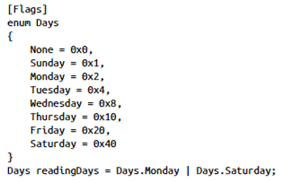
- To implement a Enum with a Count value containing the number of categories in the Enum, add a Count value as the last element and set the value of the first element to -1.

Structures (struct)
- Structs are like classes in that they can have methods, fields, properties, and constructors.
- You cannot declare your own empty constructor for a struct.
- When you declare fields in a struct, the compiler automatically adds an empty constructor that initializes the fields.
  - You cannot have instance field initializers in structs.
    - public int x = 0; // compiler error
- If you define a custom constructor, then properties cannot be initialized in the custom constructor (only the backing fields can).
  - This behavior can be overridden if the custom constructor chains to the default constructor.
- Structs cannot be used in a struct inheritance hierarchy (interfaces are allowed).
- 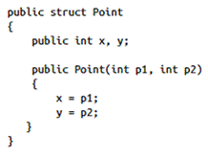
- Passing a struct as a parameter will make a copy of the data.
  - The copy can be changed; the original won’t change with it.

Reference Types

Methods
- Named and optional arguments can be used with methods, indexers, constructors, and delegates.
  - Optional parameters must appear after all required parameters.
  - Named arguments are useful to specify which arguments you want to pass a value.
  - It is legal to mix a named parameter with a positional parameter but the positional parameter must come first.
  - 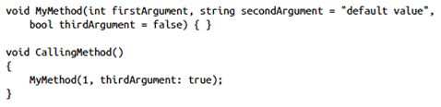
- You create an overload for a method by using the exact same name and return type, but by differing in the arguments you expect.
- If all methods in a class are static, the whole class can be declared static.

Overriding Methods
- When a method in a class is declared as virtual, you can override the method in a derived class.
- You can completely replace the existing functionality or you can add to the behavior of the base class.
  - 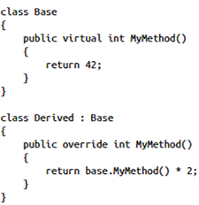
- You can disable inheritance by using the sealed keyword on a class or a method.
  - When used on a class, you can’t derive other classes from it.
  - When used on a method, derived classes can’t override the method.
  - 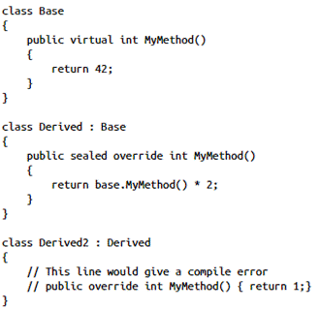

Extension Methods
- Extension methods are static methods with a more convenient syntax.
- Enable you to add new capabilities to an existing type (class, struct, interface).
- You don’t need to make any modifications to the existing type; just bring the extension method into scope and you can call it like a regular instance method.
- Extension methods need to be declared in a non-generic, non-nested, static class.
  - 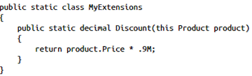
- The special this keyword makes the method an extension method.
- An extension method can also be declared on an interface (such as IEnumerable<T>).
  - With extension methods, you can add methods that will be available on every concrete implementation of the interface.
  - This is similar to defining an Abstract class with concrete methods.

Fields
- Just as with methods, fields can have an access modifier, a type, and a name.
- A field can be marked as readonly, which allows the field to be set only once.
  - You can do this in the constructor or as a part of declaring your variable (or both).
- If the field’s value is set at compile time (inline initialization), you can also mark it as const.
  - That way, the compiler knows for sure that the value will never change and it can perform some optimization.
  - All assignments to the field in your code will result in a compile error.
  - Can be applied both to class fields and local fields.
- Another way to access data in a class is with an indexer, which enables instances of your class or struct to be used like arrays.
  - This is useful when your object contains data that resembles a collection.
  - An indexer property allows your class to be accessed with an index, just like a regular array.
  - 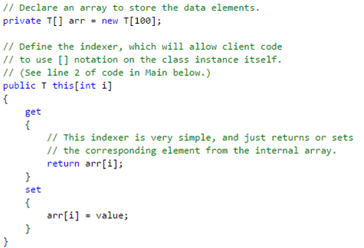
  - Indexers do not have to be indexed by an integer value.
  - Indexers can be overloaded.
  - Indexers can have more than one formal parameter (i.e. a two-dimensional array).
- When you want to store data that’s not specific for an instance, you can make it static.
  - A static field or property is shared with all code that has access to it.

Generics
- A generic type uses a Type parameter instead of hard-coding all the types.
- By using generics, you can avoid the performance penalty for boxing and unboxing.
- Nullables: enables a value type to store null.
- System.Collections.Generic implementations should be used over the non-generic counterparts.
- Generics can be used on structs, classes, interfaces, methods, properties, and delegates.
- A generic type parameter can also be constrained.
  - class ClassA<T> where T: struct { }
    - The type argument must be a value type (enum, struct, int, double, float, etc.)
    - Only Nullable is not allowed.
  - class ClassA <T> where T : class { }
    - The type argument must be a reference type: for example, a class, interface, delegate, or array.
  - class ClassA <T> where T : new(){ }
    - The type must have a public default constructor (includes structs).
  - class ClassA <T> where T : <base class name> { }
    - The type argument must be or derive from the specified base class.
  - class ClassA <T> where T : <interface name> { }
    - The type argument must be or implement the specified interface.
    - Multiple interface constraints can be specified.
    - The constraining interface can also be generic.
  - class Human<T, U> where T : U { }
    - The type argument supplied for T must be or derive from the argument supplied for U.
  - 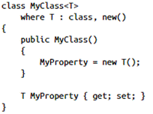
  - Multiple where clauses can be used when there is more than one type parameter.
  - A single where clause must be used for each given generic parameter.
- To specify the default value when working with a generic type parameter, use the special default(T) keyword.
  - T defaultValue = default(T);

Boxing/Unboxing
- When working with value types, sometimes you’ll want to store a value type inside a reference type.
  - 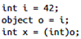
- Boxing is the process of taking a value type, putting it inside a new object on the heap, and storing a reference to it on the stack.
  - Calling GetType always boxes your value type.
  - A value type is boxed when you use it as an interface: IFormattable x = 3;
- Unboxing is the exact opposite: It takes the item from the heap and returns a value type that contains the value from the heap.
  - When boxing and unboxing happen, you need to explicitly cast your object from a reference to a value type.
- There are some performance implications with each box and unbox operation.

Type Conversion
- C# is a statically typed language so you can’t change the type of a variable after it is declared.
- Unless an explicit conversion exists, it’s not possible to convert/cast one item to another.
- The is operator and the as operator can be used to check whether a type can be converted to another type and to do so in a safe way.
  - The is operator returns true or false, depending on whether the conversion is allowed.
    - 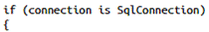
  - The as operator returns the converted value or null if the conversion is not possible.
    - 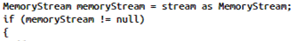
  - Using the as operator is more efficient when you want to use the value afterward.
  - To check whether your type is of a certain type, use the is operator.
  - The is and as operators can also be used on Nullable types.
- The as operator does not perform any conversion on the type.
  - The compiler translates as into: arg1 is arg2 ? (arg2)arg1: null
  - Therefore, implicit/explicit conversions have no relevance here.
- There are several different types of conversions:
  - Implicit conversions
  - Explicit conversions
  - User-defined conversions
  - Conversion with a helper class

Implicit Conversion
- An implicit conversion doesn’t need any special syntax because the compiler knows that the conversion is allowed and that it’s safe to convert.
- A value type such as int can be stored as a double because an int can fit inside a double.
- Another implicit conversion is that from a reference type to one of its base types.
- If an object implements an interface, it can also be implicitly converted to the interface.
  - 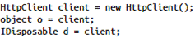

Explicit Conversion (casting)
- The compiler protects you from all implicit conversions that are not safe, such as double to int.
- If you do want to make this conversion, you need to do it explicitly through a cast.
  - 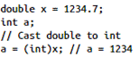
- As with implicit conversion, explicit conversions also exist for reference types.
  - Where you can go implicitly from a derived type to a base type, you need to cast from a base type to a derived type.
  - 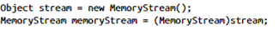

User-Defined Conversion
- When creating your own types, you can add support for both implicit and explicit conversions.
- The implicit and explicit operator should be declared as a public static method on your class.
  - You need to specify the return type (the type you are casting to) and the type you are casting from (an instance of your class).
  - 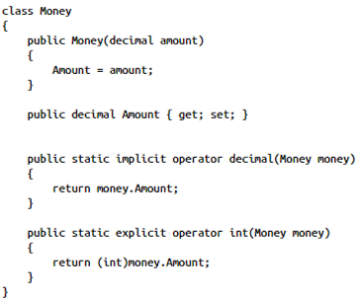
- You can then use an implicit conversion to decimal and an explicit conversion to int.
  - 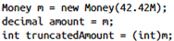
- If an implicit operator is defined the corresponding explicit operator is optional.

Conversion with a Helper Class
- For converting between non-compatible types, you can use System.BitConverter.
- For conversion between compatible types, you can use System.Convert and the Parse or TryParse methods on various types.
  - The supported base types are Boolean, Char, SByte, Byte, Int16, Int32, Int64, UInt16, Uint32, Uint64, Single, Double, Decimal, DateTime, and String.
  - The difference between Parse/TryParse and Convert is that Convert enables null values.
    - It doesn’t throw an ArgumentNullException, but returns the default value for the supplied type
  - 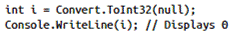
  - 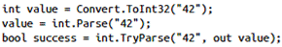
- Use Parse and TryParse when you have a string that you want to convert to a specific data type.
- If your string contains an invalid value, Parse throws a FormatException.
- You use TryParse if you are not sure that the parsing will succeed.
  - You want to handle invalid conversion gracefully w/o an exception.
  - TryParse returns a Boolean value that indicates whether the value could be parsed.
  - The out parameter contains the resulting value when the operation is successful.
  - If the parsing fails, it contains the initial value.
- When parsing numbers, you can supply extra options for the style of the number and the specific culture that you want to use using the System.Globalization.CultureInfo class.

Dates, Times, and Time Zones
- Overview
- Use the TimeZoneInfo class to work with any time zone that is predefined on a system, to create new time zones, and to easily convert dates and times from one time zone to another.
  - The TimeZoneInfo class does not expose a public constructor.
  - As a result, the new keyword cannot be used to create a new TimeZoneInfo object.
  - TimeZoneInfo objects are instantiated either by retrieving information on predefined time zones from the registry or by creating a custom time zone.
- The DateTimeOffset structure combines a date and time value with that time's offset from UTC.
  - A DateTimeOffset value unambiguously identifies a single point in time.
  - DateTimeOffset is more portable from one computer to another than a DateTime.
  - The DateTimeOffset type includes all of the functionality of the DateTime structure along with time zone awareness and should be considered the default date and time type for application development.
  - The DateTimeOffset type supports one implicit type conversion: from a DateTime value to a DateTimeOffset value.
- The TimeSpan structure represents a time interval. Its two typical uses are:
  - Reflecting the time interval between two date and time values. For example, subtracting one DateTime value from another returns a TimeSpan value.
  - Measuring elapsed time. For example, the Stopwatch.Elapsed property returns a TimeSpan value.
- You can use the DateTime.Parse method for parsing a date and a time, which offers several overloads (all return DateTime):
  - Parse(string) uses the current thread culture and the DateTimeStyles.AllowWhiteSpaces.
  - Parse(string, IFormatProvider) uses the specified culture and DateTimeStyles.AllowWhiteSpaces.
  - Parse(string, IFormatProvider, DateTimeStyles) uses culture-specific format information and formatting style.
  - IFormatProvider can be a valid DateTimeFormatInfo, CultureInfo, or null object.
- When parsing a DateTime, you must take into account things such as time zone differences and cultural differences.
  - Only if a DateTime value represents UTC does that value unambiguously identify a single point in time regardless of the system or time zone in which the value is used.
  - The string to be parsed can take any of the following forms:
    - A string with a date and a time component.
      - If no time zone info is specified, the string is parsed as is with no offset.
    - A string with a date but no time component.
      - If the time component is absent, the method assumes 12:00 midnight.
      - If the date component has a two-digit year, it is converted to a year based on the Calendar.TwoDigitYearMax of the current culture's current calendar or the specified culture's current calendar.
    - A string with a time but no date component.
      - The method assumes the current date unless you include DateTimeStyles.NoCurrentDateDefault in the styles parameter, in which case the method assumes January 1, 0001.
    - A string that includes time zone information and conforms to ISO 8601.
      - In the 2 examples, the first string designates UTC, and the second string designates the time in a time zone that's seven hours earlier than UTC:
        - 2008-11-01T19:35:00.0000000Z
        - 2008-11-01T19:35:00.0000000-07:00
    - A string that includes the GMT designator and conforms to the RFC 1123:
      - Sat, 01 Nov 2008 19:35:00 GMT
    - A string that includes the date and time along with time zone offset information:
      - 03/01/2009 05:42:00 -5:00
- Implementing the IFormattable interface is required so that your object can be used by the Convert class.

Dynamic Types
- The dynamic keyword is where you enter the world of weakly typed languages.
- When C# encounters the dynamic keyword, it stops static type checking (for example, checking whether a method exists on a type or if it has certain arguments).
- Using dynamic types won’t generate any compile-time errors, but can generate runtime errors.
- In this example, the type of workSheet is of type dynamic.
  - The statements that use the worksheet variable are evaluated at runtime.
  - All the type checking and necessary conversions take place at runtime.
  - 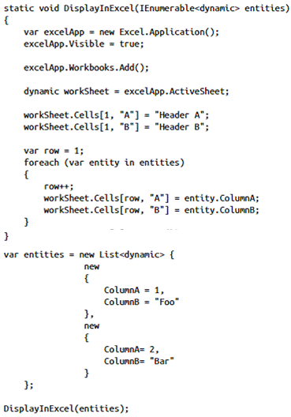

DynamicObject
- When inheriting from DynamicObject, you can override members that enable you to override operations such as getting or setting a member, calling a method, or performing conversions.
- By using DynamicObject, you can create truly dynamic objects and have full control over how they operate at runtime.
  - 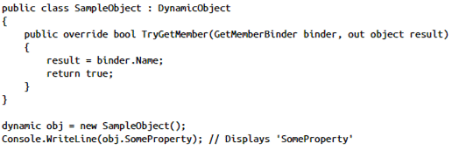

ExpandoObject
- ExpandoObject is a sealed implementation that enables you to get and set properties on a type.
- 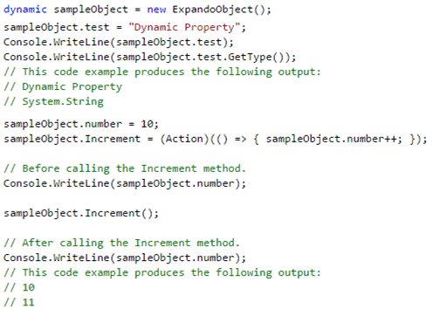

Encapsulation

Access Modifiers
- Access modifiers enable you to restrict access to all types and type members.
- public
  - None; unrestricted access
- internal
  - Limited to the current assembly
  - When you want to expose internal types or type members to another assembly, you can use a special attribute: InternalsVisibleToAttribute.
    - Normally, you include this attribute inside the AssemblyInfo.cs file that’s stored in the Properties folder of your project but it can also be placed at the top of an individual source code file.
    - In this example, the assemblies Friend1a and Friend1b are allowed to access the internal types and members of your assembly.
    - 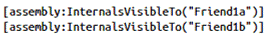
- protected
  - Limited to the containing class and derived classes
- protected internal
  - Access is limited to the current assembly or types derived from the class, even if those types are in another assembly.
- private
  - Limited to the containing type
  - A private member can be accessed only by members within the same type.
  - Instances of the same type can access each other’s private members.
  - A member marked with private is not accessible by derived types.
- Top-level namespace elements (class, struct, enum, interface) can be public and internal (default).
- Allowed access modifiers on nested types:
Members of | Default | Allowed accessibility of the member
enum | public | None
class | private | public, protected, internal, private, protected internal
Interface | Public | None
struct | private | public, internal, private

Properties
- A property looks like a regular field. It has a type, a name, and an access modifier. The difference is that it adds accessors.
  - 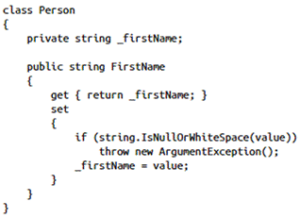
- The get and set accessor can have different access modifiers.
  - You can, for example, have a public get and a private set method.
  - 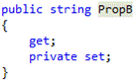
- You can also have properties with only a get or only a set accessor.

Create a Class Hierarchy
- Multiple class inheritance is not supported in C# but multiple interface implementation is.

Interfaces
- An interface contains the public signature of methods, properties, events, and indexers.
- Access modifier is assumed and cannot be specified, even public.
- Implementers must retain the public modifier in their implementation except explicit.
  - 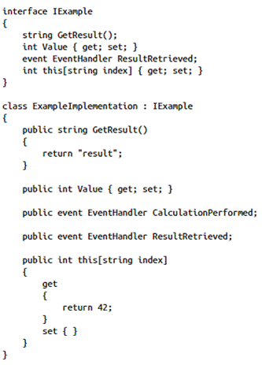
- A type (both a class and a struct) can implement an interface.
- An interface might define a property with only a get accessor while the implementing type also has a set accessor.
- Interfaces can inherit from other interfaces.
  - A class that inherits from one of the derived interfaces has to implement all signatures in the whole hierarchy.
- You can also use generics when defining interfaces.
  - 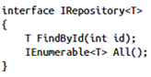

Explicit Interface Implementations
- Explicit interface implementation means that an interface type element can be accessed only when using the interface directly (cast is necessary).
- Explicit interface implementation can be used to hide members of a class to outside users.
- You create an explicit interface implementation by adding the interface name and a period to the implementation.
  - 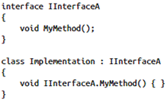
- Explicit interface implementation is necessary when a class implements two interfaces that contain duplicate method signatures but a different implementation is needed for each.
  - When implicitly implementing those two interfaces, only one method exists in the implementation.
  - With explicit interface implementation, both interfaces have their own implementation.
  - 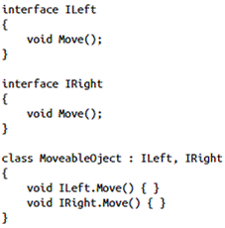
- When two or more interface methods have the exact same signature, you must implement all similar methods except for 1.
  - This last method can be implicitly implemented and the compiler knows by POE which interface it implements.
- Explicit interface implementations cannot have a visibility modifier.

Base Classes
- You can use the base keyword to call the constructor of the base class or when you want to call methods or other members on a base class.
  - 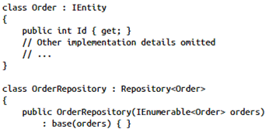
- If a base class doesn’t declare a method as virtual, a derived class can’t override the method.
  - Use the new keyword to hide the member from a base class and prevent polymorphism (can be used on a virtual or non-virtual member).
  - 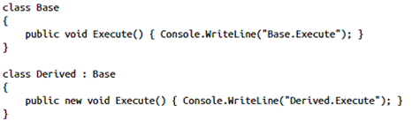
  - If a subclass has the same method signature as a superclass’s virtual or non-virtual method, it effectively functions the same as if the new keyword was used explicitly.
- If you don’t want to allow a base class to be instantiated, you can declare it as an abstract class.
  - You can’t use the new operator on it to create a new instance.
  - An interface never has implementation code.
- An abstract class can have both fully implemented members (including constructors) and abstract members.
  - An abstract method cannot have a body.
  - An abstract class can be defined abstract and not have abstract methods.
  - If a class has an abstract method, then it must be defined abstract.
  - A concrete derived type is required to implement all abstract members.
  - The override keyword is used to implement the abstract method that’s defined in the base class.
    - It can also be used on abstract or virtual methods, properties, indexers, and event accessors to extend or modify the implementation.
    - When overriding properties, either or both get/set methods can be overridden.
    - With event accessors, both add/remove methods must be overridden.
  - 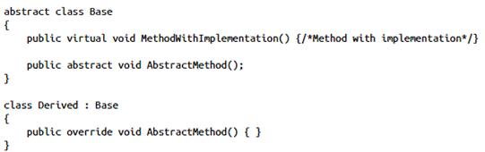
- A sealed class cannot be derived from.
  - All members should have an implementation.
  - Structs are implicitly sealed in C#. It’s never possible to inherit from a struct.

Partial Keyword
- Enables splitting the definition of a class, struct, interface, or method over two or more source files.
- Each source file contains a section of the type or method definition, and all parts are combined when the application is compiled.
- All the parts must use the partial keyword.
- All the parts must be available at compile time to form the final type.
- All the parts must have the same accessibility, such as public, private, and so on.
- If any part is declared abstract, then the whole type is considered abstract.
- If any part is declared sealed, then the whole type is considered sealed.
- If any part declares a base type, then the whole type inherits that class.
- A partial class or struct may contain a partial method.
  - One part of the class contains the signature of the method.
  - A partial method cannot have access modifiers or the virtual, abstract, override, new, sealed, or extern modifiers.
  - An optional implementation may be defined in the same part or another part.
  - If the implementation is not supplied, then the method and all calls to the method are removed at compile time.
  - No compile-time or run-time errors will result if the method is called but not implemented.
  - A partial method declaration consists of two parts: the definition, and the implementation.
    - These may be in separate parts of a partial class, or in the same part.
    - Partial methods are implicitly private, and therefore they cannot be virtual.
    - Partial method declarations must begin with the contextual keyword partial and the method must return void.
  - 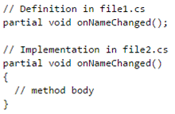

Constructors
- Creating an instance of a class is done with the new operator.
  - Calling new on an object executes that object’s constructor.
- By default, each class has an empty constructor that can be called.
  - Unless the base keyword is explicitly called, the parent class’ default constructor is called when a subclass is instantiated.
- You can also define your own constructors.
  - When doing so, the empty constructor is no longer automatically created.
- Constructors are not inherited.
- Best practices
- A class can also have multiple constructors, which can be chained to each other so you can avoid duplicate code.
  - 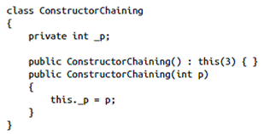
- A static constructor is used to initialize any static data, or to perform a particular action that needs to be performed once only.
  - It is called automatically before the first instance is created or any static members are referenced.
  - 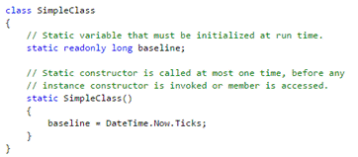

Standard .NET Interfaces

System.IComparable
- The IComparable interface features a single method.
  - int CompareTo(object obj);
- Return values:
  - Less than zero: The current instance precedes the specified object.
  - Zero: Equivalence.
  - Greater than zero: This current instance follows the specified object.
- Generic collections use this interface for internal sorting.
- Use the generic version when possible: IComparable<T>.
- Typically, types that provide an IComparable<T> implementation also implement the IEquatable<T> interface.
  - The IEquatable<T> interface defines the Equals method, which determines the equality of instances of the implementing type.
    - bool Equals(T other)
  - If you implement IComparable<T>, you should overload the op_GreaterThan, op_GreaterThanOrEqual, op_LessThan, and op_LessThanOrEqual operators to return values that are consistent with CompareTo (<, >, <=, >= go together).
- If you implement IEquatable<T>, you should also override the base class implementations of Object.Equals(Object) and GetHashCode so that their behavior is consistent with that of the IEquatable<T>.Equals method.
  - You should also overload the op_Equality and op_Inequality operators (all or nothing).
  - By default, the operator == tests for reference equality by determining whether two references indicate the same object.
    - Therefore, reference types do not have to implement operator == in order to gain this functionality.
    - When a type is immutable, that is, the data that is contained in the instance cannot be changed, overloading operator == to compare value equality instead of reference equality can be useful because, as immutable objects, they can be considered the same as long as they have the same value.
    - It is not a good idea to override operator == in non-immutable types.

System.Collections.IEnumerable
- The IEnumerable/IEnumerable<T> and IEnumerator/IEnumerator<T> interface helps you to implement the iterator pattern.
  - When implementing IEnumerator<T>, IDisposable also needs to be implemented if not using yield implementation.
  - IEnumerator<T> inherits IEnumerator so this interface needs to be implemented but explicitly.
- The IEnumerable interface exposes a GetEnumerator method that returns an IEnumerator.
  - The enumerator has a MoveNext method that returns the next item in the collection.
  - Conceptually, IEnumerable<T> is your table and IEnumerator<T> is a cursor that keeps track of where you are in the table. It can only move to the next row
- The foreach statement in C# is an abstraction over the GetEnumerator and MoveNext methods.
  - 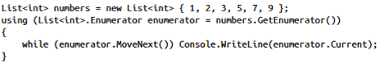
  - Implementing IEnumerable/IEnumerable<T> allows you to use foreach over your custom class.

Yield
- Yield is a special keyword that can be used only in the context of iterators.
- It instructs the compiler to convert this regular code to a state machine.
- The generated code keeps track of where you are in the collection and it implements methods such as MoveNext and Current.
- 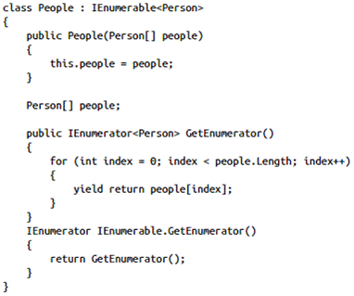
- Yield can be used in a serial statement form:
- 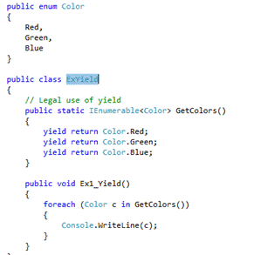

System.IDisposable
- This interface is used to facilitate working with external, unmanaged resources.
- The only method the IDisposable interface has is Dispose() (void return).
- This method is used to free any unmanaged resources.
- Implementing IDisposable with a finalizer (this pattern should be used whenever there is an unmanaged resource to be disposed):
  - The finalizer only calls Dispose passing false for disposing.
  - The extra Dispose method with the Boolean argument checks if it’s being called in an explicit Dispose or if it’s being called from the finalizer:
    - If the finalizer calls Dispose, you only release the unmanaged buffer.
      - The GC will collect any managed objects automatically.
      - Because the order in which the garbage collector collects is unpredictable you can’t reliably call any managed objects.
    - If Dispose is called explicitly, you also dispose managed objects.
  - The explicit Dispose method calls GC.SuppressFinalize(this) to make sure that the object is removed from the finalization list that the garbage collector is keeping track of.
    - The instance has already fully cleaned up after itself.
  - 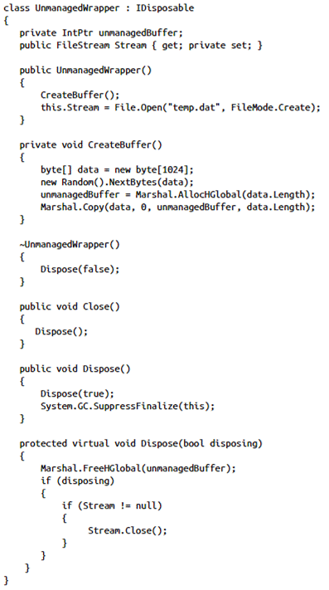
- The difference between implementing IDisposable and a finalizer is that both clean up your object, but a finalizer is called by the garbage collector, and the Dispose method can be called from code.

Reflection
- Reflection is the process of retrieving information about the types, code, assembly, and all other elements stored in your application at runtime.
- Reflection is slower than normally executing static code.
- System.Type is a class in the .NET Framework that you can use to get all kinds of metadata about any given type.
- The System.Reflection namespace defines the elements you need for reflection.
  - 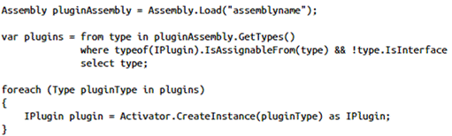
- Reflection can be used to inspect the value of a property or a field.
  - This selects the object’s private integer fields to display them on-screen.
  - You use the BindingFlags enumeration to control how reflection searches for members.
  - 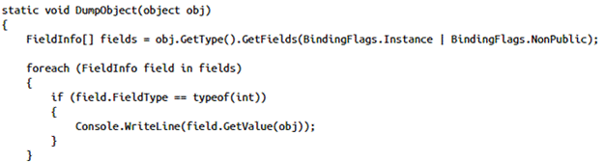
- Reflection can be used to execute a method on a type.
  - You can specify the parameters the method needs, and at runtime .NET will see whether the parameters match and it will execute the method.
  - 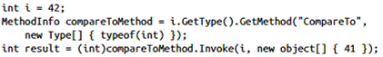
- Reflection can be a really slow process.
  - You can replace reflection with the CodeDom.

Attributes
- Attributes can be added to all kinds of types: assemblies, types, methods, parameters, and properties.
- At runtime, you can query for the existence of an attribute and its settings and then take appropriate action.
- You apply an attribute by placing the attribute name in square brackets ([]) above the declaration that you want the attribute to apply to.
  - When using the attribute, you can skip the Attribute suffix.
  - 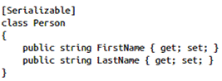
- A type can have as many attributes applied to it as necessary.
  - Some attributes can even be applied multiple times.
  - An attribute can have parameters.
    - Those parameters can be named and optional. The values set to an attribute can later be inspected at runtime.
- An attribute also has a specific target to which it applies.
  - It can be an attribute applied to a whole assembly, a class, a specific method, or even a parameter of a method.
  - Useful when the target of the attribute is not deducible from context.
  - 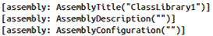
- The System.Attribute class, from which all other attributes inherit, defines some static methods that can be used to see whether an attribute is applied and to get the current instance of an attribute so you can further inspect it.
  - 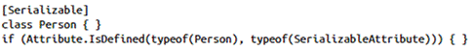
- You can also retrieve the specific instance of an attribute so that you can look at its properties.
  - The GetCustomAttribute and GetCustomAttributes methods have several overloads so you can inspect attributes for an assembly, method, module, or a parameter.
  - 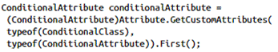
- A custom attribute class has to derive from System.Attribute.
  - When creating your own custom attribute from scratch, you also have to define the targets on which an attribute can be used (methods, parameters, etc.).
  - You can use the AllowMultiple parameter to enable multiple instances of one attribute to a single type.
  - After having declared your custom attribute, you can add properties to it and a constructor to initialize your attribute.
    - Attributes require all properties to be read-write.
    - 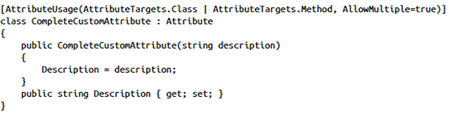

Parameters
- Many attributes have parameters, which can be positional, unnamed, or named.
  - The constructor's parameters are the custom attribute's positional parameters.
  - Any public read-write fields or properties are named parameters.
  - Positional parameters are specified first and cannot be omitted; named parameters are optional and can be specified in any order.
- 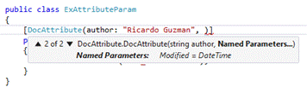
- Positional parameters can be “named” as shown above but this is semantically different from attribute named parameters.
- The types of positional and named parameters for an attribute class are limited to the attribute parameter types, which are:
  - One of the following types: bool, byte, char, double, float, int, long, sbyte, short, string, uint, ulong, ushort.
  - The type object.
  - The type System.Type.
  - An enum type, provided it has public accessibility.
  - Single-dimensional arrays of the above types.

Object Life Cycle

Garbage Collection
- There are two places in memory where the CLR stores items while your code executes.
  - One is the stack; the other is the heap.
- The stack keeps track of what’s executing in your code, and the heap keeps track of your objects.
  - The stack is automatically cleared at the end of a method.
  - The heap is managed by the GC.
- Value types can be stored on both the stack and the heap.
- For an object on the heap, there is always a reference on the stack that points to it.
- The GC works with a mark and compact algorithm.
  - The mark phase checks which items on the heap are still being referenced by a root item.
  - A root can be a static field, a method parameter, a local variable, or a CPU register.
  - If the GC finds a “living” item on the heap, it marks the item.
  - After checking the whole heap, the compact operation starts.
  - The GC then moves all marked/living heap objects close together and frees the memory for all other objects.
- The generation number, or age, of an object is an implementation-defined relative measure of an object's lifespan. The most recently created objects are in generation 0.
- The GC has to make sure that no state is changing while performing all the marking and compacting so all threads are frozen while doing a collect operation.
- The GC starts cleaning up only when there is not enough room on the heap to construct a new object (or when Windows signals that it’s low on memory).
- GC.AddMemoryPressure: Informs the runtime of a large allocation of unmanaged memory that should be taken into account when scheduling garbage collection.
- GC.RemoveMemoryPressure: Informs the runtime that unmanaged memory has been released and no longer needs to be taken into account when scheduling garbage collection.

Unmanaged Resources
- Unmanaged resources can be a network connection, file handle, window handle, and so on.
  - You have to explicitly release those items.
- C# supports the concept of finalization.
  - This mechanism allows a type to clean up prior to garbage collection.
  - Inside the finalizer, you can clean up other resources and make sure that all memory is freed.
  - You can’t be sure when a finalizer is called. It will happen only when the GC determines that your object is ready for being cleaned up.
  - 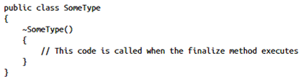
  - The System.Object class provides no implementation for the virtual Finalize method, and the GC does not mark types derived from Object for finalization unless they override the Finalize method.
  - A finalizer increases the life of an object.
    - Because the finalization code also has to run, .NET keeps a reference to the object in a special finalization queue.
    - An additional thread runs all the finalizers at a time deemed appropriate based on the execution context.
    - This delays garbage collection for types that have a finalizer.
- As already mentioned, the finalizer is called only when a garbage collection occurs.
  - You can force this by adding a call to System.GC.Collect.
- When running this piece of code in Release mode, the GC will see that there are no more references to stream, and it will free any memory associated with the Stream-Writer instance.
  - This will run the finalizer, which in turn will release any file handles to the temp.dat file (in debug mode, the compiler will make sure that the reference isn’t garbage collected till the end of the method).
  - The line WaitForPendingFinalizers makes sure that all finalizers have run before the code continues.
  - 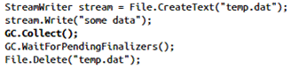
- To offer you the opportunity of explicitly freeing unmanaged resources, C# offers the idea of the IDisposable interface.
  - Dispose will free any unmanaged resources immediately.
  - 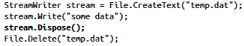
- To make sure that your resources are always cleaned up, you need to wrap all types that implement IDisposable in a try/finally statement.
  - C# has shorthand for this: the using statement.
  - The using statement is translated by the compiler in a try/finally statement that calls Dispose on the object.
  - The using statement can be used only with types that implement IDisposable.
  - 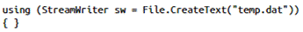
- After disposing an item, you can’t use it any more. Using a disposed item will result in an ObjectDisposedException.

Manipulating Strings
- Best practices

Formatting Strings
- By default, ToString will return the name of your type so overriding it is a good practice.
  - 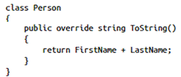
- Providing the correct System.Globalization.CultureInfo is important when formatting values.
  - It contains all the information about how a particular type is displayed in that culture.
- Format strings are strings that describe how an object should display.
  - The .NET Framework uses them for numeric types, dates, times, and enumerations.
  - 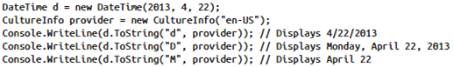
- You can implement custom formatting on your own types by creating a ToString(string) method.
  - Make sure that you are compliant with the standard format strings in .NET.
  - A format string of G should represent a common format for your object (the same as calling ToString()) and a null value for the format string should also display the common format.
  - 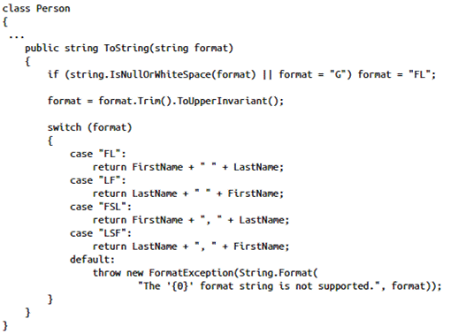
- Format items are processed sequentially from the beginning of the string.
  - Each format item has an index that corresponds to the method's arguments.
- The Format method retrieves the argument and derives its string representation as follows:
  - If the argument is null, the method inserts String.Empty into the result string.
  - If you call the Format(IFormatProvider, String, Object[]) overload and the provider parameter implements the IFormatProvider interface, the argument is passed to the provider object's ICustomFormatter.Format(String, Object, IFormatProvider) method.
    - If the format item includes a formatString argument, it is passed as the first argument to the method.
    - If the ICustomFormatter implementation is able to provide formatting services, it returns the string representation of the argument; otherwise, it returns null and the next step executes.
  - If the argument implements the IFormattable interface, its IFormattable.ToString implementation is called.
  - The argument's parameterless ToString method, which is either overridden or inherited from the Object class, is called.

System.IFormattable
- Classes that require more control over the formatting of strings than Object.ToString provides should implement IFormattable.
- When implementing your own ToString formatting method on a type, you can also choose to accept an IFormatProvider (IFormattable interface).
- Using IFormattable makes sure that you can integrate with.NET when it comes to formatting strings.
  - It is called automatically by the Convert.ToString(Object) and Convert.ToString(Object, IFormatProvider) methods
- You can also support composite formatting.
  - It is called by Console.WriteLine(String, Object), String.Format, and StringBuilder.AppendFormat(String, Object), among others.
  - The ToString method is called for each format item in the method's format string.
    - 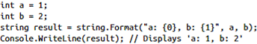
- A class that implements IFormattable must support the "G" (general) format specifier.
  - It can then define the list of format specifiers that it supports.
  - The class must be prepared to handle a format specifier that is null.

System.IFormatProvider
- A format provider returns a formatting object that typically defines the symbols used in converting an object to its string representation.
  - For example, when you convert a number to a currency value, a format provider defines the currency symbol that appears in the result string.
- Providing a custom representation of an object's value requires that you do the following:
  - Define a class that implements the ICustomFormatter interface and its single member, the Format method.
  - Define a class that implements the IFormatProvider interface and its single member, the GetFormat method.
    - The GetFormat method returns an instance of your ICustomFormatter implementation.
    - Often, a single class implements both ICustomFormatter and IFormatProvider.
    - In that case, the class's GetFormat implementation just returns an instance of itself.
  - Pass the IFormatProvider implementation as the provider argument of the String.Format(IFormatProvider, String, Object[]) method or a comparable method.
- The .NET method will then use your custom formatting instead of its own.
- IFormatProvider has one method, object GetFormat(Type formatType), which returns specific formatting information for formatting a type.
- You can implement the IFormatProvider interface and the GetFormat method in classes that provide custom formatting or parsing services.
  - The IFormatProvider implementation is then passed as an argument to any overload of a parsing or formatting method that has a parameter of type IFormatProvider, such as String.Format(IFormatProvider, String, Object[]), Int32.ToString(String, IFormatProvider), or DateTime.Parse(String, IFormatProvider).
- GetFormat is a callback method that formatting and parsing methods invoke to retrieve information about the format of the input string in parsing operations or the format of the output string in formatting operations.
  - In the formatType parameter, the formatting or parsing method passes the type of object it requires to perform its operation.
  - If the IFormatProvider implementation can supply this formatting or parsing object, it returns that object. If not, it returns null.
- .NET includes the following three predefined IFormatProvider implementations to provide culture-specific information that is used in formatting or parsing numerics and dates and times:
  - The NumberFormatInfo class provides information that is used to format numbers, such as the currency, thousands separator, and decimal separator symbols for a particular culture (see Standard Numeric Format Strings and Custom Numeric Format Strings).
  - The DateTimeFormatInfo class provides information that is used to format dates and times, such as the date and time separator symbols for a particular culture or the order and format of a date's year, month, and day components (see Standard Date and Time Format Strings and Custom Date and Time Format Strings).
  - The CultureInfo class represents a particular culture.
    - Its GetFormat method returns a culture-specific NumberFormatInfo or DateTimeFormatInfo object, depending on whether the CultureInfo object is used in a formatting or parsing operation that involves numbers or dates and times.

System.ICustomFomatter
- To perform custom formatting, your provider argument must implement both the IFormatProvider and ICustomFormatter interfaces.
- When this interface is implemented by a reference or value type, the Format method returns a custom-formatted string representation of an object's value.
- When the Format method is passed an IFormatProvider implementation as the provider argument, the Format method calls its IFormatProvider.GetFormat implementation and requests an object of type ICustomFormatter.
  - It then calls the returned ICustomFormatter object's Format method to format each format item in the composite string passed to it.

Securing Strings
- System.Security.SecureString can be used to secure string values.
- SecureString implements IDisposable.
- SecureString automatically encrypts its value.
- SecureString is a mutable string that can be made read-only when necessary.
- SecureString can deal with only individual characters at a time. It’s not possible to pass a string directly to a SecureString.
- To convert the SecureString to a regular string use the Marshal class.

System.String
- The string object contains an array of Char objects internally.
  - You can enumerate a string just as if it were a typical collection.
  - Because a string implements IEnumerable and IEnumerable<Char>, it exposes the GetEnumerator method that you can use to iterate over a string.
  - 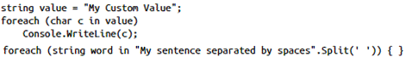
- A string has a Length property that shows the number of Char objects it contains.
- String is a reference type that looks like value type (for example, the equality operators == and != are overloaded to compare on value, not on reference).
- The string keyword is an alias for the .NET Framework’s String.
- A string is immutable, so it cannot be changed after it has been created.
  - Every change to a string will create a new string.
  - This is why all of the String manipulation methods return a new string.
  - It cannot be modified so it is inherently thread-safe.
- When creating two identical string literals in one compilation unit, the compiler ensures that only one string object is created.
  - This is called string interning, which is done only at compile time.
- The String class offers a couple of methods that can help you perform all kinds of search actions. The most common are:
  - IndexOf: returns the zero-based index of the first occurrence of a character or substring within a string. If the value cannot be found, it returns -1.
  - LastIndexOf: same as above but begins searching at the end of a string and moves to the beginning.
    - 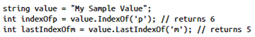
  - StartsWith / EndsWith: see whether a string starts or ends with a certain value, respectively. It returns true or false depending on the result.
    - 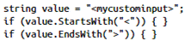
  - SubString: Substring can be used to retrieve a partial string from another string. You can pass a start and a length to Substring.
- One thing to keep in mind is that string methods can be culture sensitive.
  - This is why most of the methods accept an instance of the StringComparison enumeration.

System.Text.StringBuilder
- Instead of creating a new string over and over again, you can use the StringBuilder, which uses a string buffer internally to improve performance.
- StringBuilder.Capacity: Gets or sets the maximum number of characters that can be contained in the memory allocated by the current instance. Always less than MaxCapacity.
- StringBuilder.MaxCapacity: Gets the maximum capacity of this instance.
  - Can be set from constructor only. Otherwise, the maximum capacity is Int32.MaxValue.
  - If the number of characters to be stored in the current instance exceeds this MaxCapacity value, the StringBuilder object does not allocate additional memory, but instead throws an exception.
- The StringBuilder class even enables you to change the value of individual characters inside a string.
- 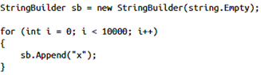
- Consider using the String class under these conditions:
  - When the number of changes that your app will make to a string is small.
  - When you are performing a fixed number of concatenation operations, particularly with string literals. In this case, the compiler might combine the concatenation operations into a single operation.
  - When you have to perform extensive search operations while you are building your string. The StringBuilder class lacks search methods such as IndexOf or StartsWith.
- Consider using the StringBuilder class under these conditions:
  - When you expect your app to make an unknown number of changes to a string at design time.
  - When you expect your app to make a significant number of changes to a string.
- Most of the methods that modify the string in a StringBuilder instance return a reference to that same instance.

System.IO.StringWriter / StringReader
- StringWriter implements a TextWriter for writing information to a string.
  - The information is stored in an underlying StringBuilder, which can also be passed in the constructor.
  - StringWriter enables you to write to a string synchronously or asynchronously (using *Async method versions).
- StringReader implements a TextReader that reads from a specified string.
  - StringReader enables you to read a string synchronously or asynchronously.
  - You can read a character at a time with the Read or the ReadAsync method, a line at a time using the ReadLine or the ReadLineAsync method and an entire string using the ReadToEnd or the ReadToEndAsync method.
- 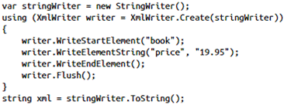
- 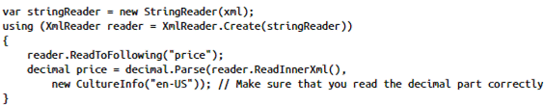

System.Text.RegularExpressions.RegEx
- Regular expressions can be useful when validating user input (such as an e-mail address, ZIP code, or date).
- The methods of the Regex class let you perform the following operations:
  - Determine whether the regular expression pattern occurs in the input text by calling the Regex.IsMatch method.
  - Retrieve one or all occurrences of text that matches the regular expression pattern by calling the Regex.Match or Regex.Matches method.
  - Replace text that matches the regular expression pattern by calling the Regex.Replace method.
- The RegEx class represents an immutable regular expression.
  - When you instantiate a Regex object with a regular expression, that object's regular expression cannot be changed.
  - Using the RegEx static methods enable you to use a regular expression without explicitly creating a Regex object.
  - The Regex class is thread safe.
- You can define a time-out interval for regular expression matches.
  - On timeout, the matching operation throws a RegexMatchTimeoutException exception.
- 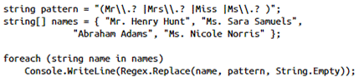

Checked/Unchecked
- The checked keyword is used to explicitly enable overflow checking for integral-type arithmetic operations and conversions.
  - By default, an expression that contains only constant values causes a compiler error if the expression produces a value that is outside the range of the destination type.
  - If the expression contains one or more variables, the compiler does not detect the overflow.
  - Overflow checking can be enabled by compiler options, environment configuration, or use of the checked keyword and will cause overflows to throw an OverflowException.
- The unchecked keyword is used to suppress overflow-checking for integral-type arithmetic operations and conversions.
  - In an unchecked context, if an expression with constants produces a value that is outside the range of the destination type, the overflow is not flagged.

Arrays
- You declare an array by using a special syntax: type[] arrayName.
- When creating an array, you are required to specify the number of items it will contain.
- 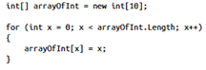
- Arrays are reference types that inherit from the Array class.
- An array implements IEnumerable, so you can use it in a foreach loop.
- An array can also be initialized directly. The compiler then will check the length for you and create an appropriate array.
  - int[] arrayOfInt = { 0, 1, 2, 3, 4, 5, 6, 7, 8, 9 };
- A two-dimensional (or more) array has a certain number of rows and columns.
  - You declare it by using a comma (,) in your array declaration.
  - The number of rows and columns can be different.
  - 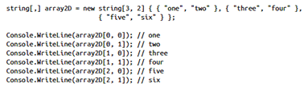
- A jagged array is an array whose elements are arrays.
  - Because arrays are reference types, the values of a jagged array have a default value of null.
  - 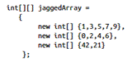
- Passing a reference type (including arrays) by reference enables the called method to replace the object in the calling method to which the reference parameter refers.
  - The storage location of the object is passed to the method as the value of the reference parameter.
  - If you change the value in the storage location of the parameter (to point to a new object), you also change the storage location to which the caller refers.
  - This means you can assign a new reference to the passed in parameter, and this will be reflected in the caller’s stack.
  - See here and here.

Collections
- When you work with objects of one specific type (or base type), use the generic collection.
- It will improve type safety and performance because there is no casting required.
- The non-generic collections can be found in System.Collections, and generic collections can be found in System.Collections.Generic.
- If you use a value type as the type parameter (struct) for a generic collection, you need to make sure that you eliminate all scenarios in which boxing could occur.
  - For example, if your value type does not implement IEquatable<T>, your object needs boxing to call Object.Equals(Object) for checking equality.
  - The same is true for the IComparable<T> interface.
- List and Dictionary types offer random access to all elements.
  - A Dictionary offers faster read features, but it can’t store duplicate keys.
- A Queue and a Stack are used when you want to retrieve items in a specific order.
  - The item is removed when you have retrieved it.
- Set-based collections have special features for comparing collections.
  - They don’t offer random access to individual elements.
- Although List can be used in most situations, it pays to see whether there is a more specialized collection that can make your life easier.
- A basic collection can be implemented by implementing IEnumerable or IEnumerable<T>.
  - That way, you implement the iterator pattern, and your collection can be used in a foreach statement.
- If you need more features, you can look at the interfaces that are implemented by the existing collections in .NET:
  - IList<T>
  - ICollection<T>
  - IDictionary<TKey,TValue>
  - ICollection<TKey,TValue>
  - ISet<T>
- You can also choose to directly inherit from an existing collection.

List<T>
- The List type offers methods for adding and removing items, accessing items by index, and searching and sorting the list.
- The List type makes sure that there is always enough room to store additional items.
  - If necessary, the internal implementation of the List class will increase the size of the array it uses to store its items.
- List<T> can store reference types and it can have a value of null for an item.
- It can store duplicate items.
- 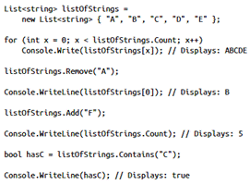

LinkedList<T>
- Represents a doubly linked list.
- Implemented using nodes of type sealed LinkedListNode<T>.
- LinkedList<T> accepts null as a valid Value property for reference types and allows duplicate values.
- If the LinkedList<T> is empty, the First and Last properties contain null.

Dictionary<TKey,TValue>
- Can be used in scenarios in which you want to store items and retrieve them by key, so it doesn’t allow duplicate keys.
- It takes two type parameters: one for the key, and the other for the value.
- The hash value of a key shouldn’t change over time and it can’t be null.
- The value can be null (if it’s a reference type).
- The Dictionary class works with KeyValuePair<TKey,TValue> structures.
- 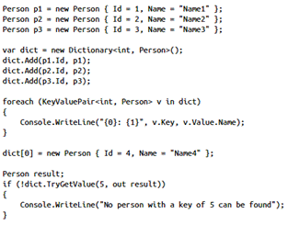
- The Dictionary class has an object initializer syntax as below:
- 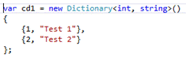

HashSet<T>
- A set is a collection that contains no duplicate elements and has no order.
- The HashSet<T> class is like a Dictionary<TKey, TValue> collection without values.
- HashSet implements the ISet<T> interface:
- 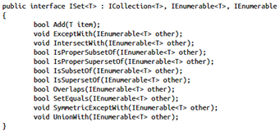

Queue<T>
- It is a so-called first-in, first-out (FIFO) type of collection, just like a checkout line.
- You access elements in the same order you added them.
- By getting an item, you also remove it from the queue.
- The Queue class has three important methods:
  - Enqueue adds an element to the end of the Queue, equivalent to the back of the line.
  - Dequeue removes the oldest element from the Queue (front of the line).
  - Peek returns the oldest element, but doesn’t immediately remove it from the Queue.
    - Throws exception if queue is empty.
- 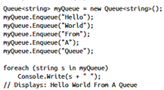
- Foreach does not dequeue the queue (cannot change the enumerator).

Stack<T>
- A Stack is a last-in, first-out (LIFO) collection.
- Items are removed when reading them.
- A Stack has the following three important methods:
  - Push: Add a new item to the Stack.
  - Pop: Get the newest item from the Stack.
  - Peek: Get the newest item without removing it.
    - Throws exception if queue is empty.
- 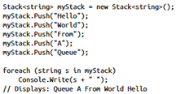
- Foreach does not pop the stack (cannot change the enumerator).

Debug Applications and Implement Security

Validating JSON
- Valid JavaScript Object Notation (JSON) starts with { or [, and ends with } or ].
  - .NET offers the System.Web.Script.Serialization.JavaScriptSerializer that you can use to deserialize a JSON string into an object.
  - It carries significantly less weight compared to XML.
  - JSON is used in asynchronous JavaScript and XML (AJAX) scenarios.
  - All JavaScript engines can parse a JSON string into an object.

Symmetric/Asymmetric Encryption
- A symmetric algorithm uses one single key to encrypt and decrypt the data.
  - You need to pass your original key to the receiver so he can decrypt your data.
  - Symmetric is faster than asymmetric encryption and better for large data sets.
- An asymmetric algorithm uses two different keys that are mathematically related to each other.
  - One key is public and can be read and used by everyone.
  - The other part is private and should never be shared with someone else.
  - When you encrypt something with the public key, it can be decrypted by using the private key, and vice versa.
  - Asymmetric encryption can be very useful for decrypting a small key.
- Example:
  - Alice and Bob both generate their own asymmetric key pair.
  - They send each other their public key and keep their private key secret.
  - They both generate a symmetric key and encrypt it only with the other parties’ public key (so that it can be decrypted by the private key of the other person).
  - They send their own encrypted symmetric key to one another and decrypt the others symmetric key with their own private key.
  - To send a confidential message, they use the symmetric key of the other person and use it to encrypt their message.
  - The receiving person decrypts the message with their own symmetric key.

System.Security.Cryptography

AES (AesManaged)
- Advanced Encryption Standard is a symmetric algorithm
- .NET has a managed implementation of the AES algorithm in the AesManaged class.
- The SymmetricAlgorithm base class has methods for creating an encryptor or a decryptor.
- By using the CryptoStream class, you can encrypt or decrypt a byte sequence.
- This class functions the same way as the RijndaelManaged class but limits blocks to 128 bits and does not allow feedback modes.
- DESCryptoServiceProvider and TripleDESCryptoServiceProvider are older symmetric algorithms.

RSA (RSACryptoServiceProvider)
- RSA is an asymmetric algorithm.

CspParameters
- .NET offers a secure location for storing asymmetric keys in a key container.
- A key container can be specific to a user or to the whole machine.
- You can securely store your asymmetric key without malicious users being able to read it.

ProtectedData
- It provides protection using the user or machine credentials to encrypt or decrypt data.
- The DataProtectionScope enumeration controls by whom the data can be decrypted.
  - CurrentUser: The protected data is associated with the current user. Only threads running under the current user context can unprotect the data.
  - LocalMachine: The protected data is associated with the machine context. Any process running on the computer can unprotect data. This enumeration value is usually used in server-specific applications that run on a server where untrusted users are not allowed access.
- The Protect and Unprotect methods can be used to encrypt and decrypt data such as passwords, keys, and connection strings.

Hashing
- Hashing is the process of taking a large set of data and mapping it to a smaller data set of fixed length.
- Hashing is 1-way and cannot be reversed.
- The GetHashCode method is defined in the base class Object.
  - You can override this method and provide a specific implementation for your type.
  - This method should output an integer code that describes your particular object.
  - As a general guideline, the distribution of hash codes must be as random as possible.
  - Equal items should have equal hash codes.
- How to implement GetHashCode.
- .NET offers a few classes to generate hash values.
  - SHA1Managed
  - SHA256Managed
  - SHA512Managed

Digital Certificate
- A digital certificate authenticates the identity of any object signed by the certificate and helps with protecting the integrity of data.
- One use of digital certificates is to secure Internet communication.
  - HTTPS is used to secure communication between a web server and a client.
  - Digital certificates are used to make sure that the client is talking to the correct web server, not an imposter.
- A digital certificate is part of a Public Key Infrastructure (PKI).
  - A PKI is a system of digital certificates, certificate authorities, and other registration authorities that authenticate and verify the validity of each involved party.
- A Certificate Authority (CA) is a third-party issuer of certificates that is considered trustworthy by all parties.
  - The CA issues certificates, or certs, that contain a public key, a subject to which the certificate is issued, and the details of the CA.
- Example:
  - If Alice sends a message to Bob, she first hashes her message to generate a hash code.
  - Alice then encrypts the hash code with her private key to create a personal signature.
  - Bob receives Alice’s message and signature.
  - He decrypts the signature using Alice’s public key and now he has both the message and the hash code.
  - He can then hash the message and see whether his hash code and the hash code from Alice match.
- X509Certificate2 can be used to sign and verify text.

Manage Assemblies
- Assemblies are completely self-contained; they don’t need to write any information to the registry or some other location.
  - Assemblies contain all the information they need to run in the manifest.
- An assembly is language-neutral. You can write some C# code, compile it to an assembly, and then use the assembly directly from other languages such as Visual Basic.
- An assembly can be versioned, which enables you to have different versions of a specific assembly on one system without causing conflicts.

Assembly Class
- Assembly.Load(string): Loads an assembly given the long form of its name.
- Assembly.LoadFrom(string): Loads an assembly given its file name or path.
- Assembly.ReflectionOnlyLoad(String): Loads an assembly into the reflection-only context, given its display name.
- Assembly.ReflectionOnlyLoadFrom(String): Loads an assembly into the reflection-only context, given its path.

Strong Named Assembly
- A strong-named assembly is signed with a public/private key pair that uniquely identifies the publisher of the assembly and the content of the assembly.
- A strong name consists of the simple text name of the assembly, its version number, culture information, and contains a public key and a digital signature.
- Your unique private key is used to generate the strong name for your assembly.
  - No other assembly can have the exact same strong name.
- You generate a strong-named assembly by using your own private key to sign the assembly.
  - Other users can verify the assembly by using the public key that is distributed with the assembly.
- Steps: Signing an assembly can be done both at the command line and by using Visual Studio.
  - Generate a key pair, which is a file with a .snk extension that contains your public/private key information.
    - From developer prompt: sn -k myKey.snk
    - In Visual Studio, go to Project > Properties and then navigate to the Signing tab.
    - Browse for the key pair generated in step 1 or generate a new key pair.
- A strong-named assembly can reference only other assemblies that are also strongly named.
- You can use a feature called delayed signing.
  - When using delayed signing, you use only the public key to sign an assembly and you delay using the private key until the project is ready for deployment.
- A strongly named assembly does not prove that the assembly comes from the original publisher.
  - It only shows that the person who created the assembly has access to the private key.
  - Authenticode is a technology that uses digital certificates to identify the publisher of an application.
  - You need to buy a certificate online and then use that certificate to sign your application.

GAC
- The GAC is a specialized library for storing assemblies.
- It is machine-wide and it is one of the locations the CLR checks when looking for an assembly.
- One reason to deploy to the GAC is when an assembly is shared by multiple applications.
- Other reasons for installing an assembly into the GAC can be the enhanced security (only users with admin rights can alter the GAC) or the situation where you want to deploy multiple versions of the same assembly.
- To deploy to the GAC, use a tool called the Global Assembly Cache tool (Gacutil.exe).
  - View GAC contents: gacutil –l
  - Install: gacutil –i [assembly path]
  - Uninstall: gacutil –u [assembly name]
- When referencing a shared assembly from your project, you can add a reference to the file located in the GAC or to a local copy of it.
- When Visual Studio detects that there is a GAC version of the DLL you are referencing, it will add a reference to the GAC, not to the local version.
- Assemblies deployed in the global assembly cache must have a strong name.
- GAC folder:
  - .NET 1.0 - NET 3.5: c:\windows\assembly
  - .NET 4.x: c:\windows\Microsoft.NET\assembly

Versioning
- An assembly has a version number.
- Inside the assembly manifest, the assembly records its own version number and the version numbers of all the assemblies that it references.
- Each assembly has a version number that has the following format:
  - {Major Version}.{Minor Version}.{Build Number}.{Revision}
  - The Major Version is manually incremented for each major release.
  - The Minor Version is incremented for minor releases.
  - The Build Number is automatically incremented for each build by the build server.
  - The Revision is used for patches to the production environment.
- There are two version numbers that you need to take into account: the file version number and the .NET assembly version number.
- The AssemblyInfo.cs file contains the following two lines:
  - [assembly: AssemblyVersion("1.0.0.0")]
  - [assembly: AssemblyFileVersion("1.0.0.0")]
- AssemblyFileVersionAttribute is the one that should be incremented with each build.
- AssemblyVersionAttribute should be incremented manually.
  - This should be done when you plan to deploy a specific version to production.
- You can deploy multiple versions of the same assembly to the GAC (side-by-side hosting).
- These configuration files can be used to influence the binding of referenced assemblies.
  - Application configuration files
  - Publisher policy files:
    - You specify that if the CLR looks for a specific assembly, it should bind to the new version.
    - You need to deploy a publisher policy to the GAC so that the CLR can use it when binding assemblies.
  - Machine configuration files
- If you have an assembly deployed privately with your application, the CLR starts looking for it in the current application directory.
  - If it can’t find the assembly, it throws a FileNotFoundException.
  - You can specify extra locations where the CLR should look in the configuration file of the application by using the probing section.
  - 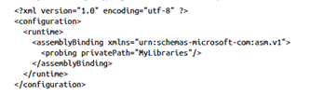
    - The probing option can be used only to point to locations that are relative to the application path.
  - Another option is using the codebase element.
    - A codebase element can specify a location for an assembly that is outside of the application’s directory.
    - These assemblies have to be strongly named if they are not in the current application’s folder.
    - When the assembly is located on another computer, it’s downloaded to a special folder in the GAC.
    - 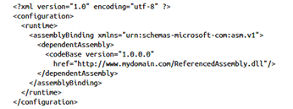
- To redirect an assembly to use a newer version, use the bindingRedirect element:
- 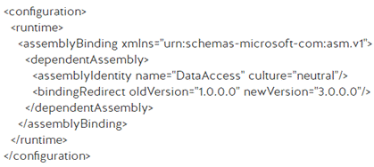
- To require a specific version (or versions) of the .NET runtime to be used, use the supportedRuntime element:
- 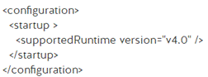
- 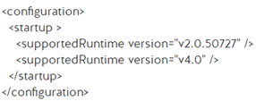

Tools
- Use the assembly linker tool (al.exe) to merge manifest or resource files into a single assembly.
- Use the assembly registration tool (regasm.exe) to register an assembly as a COM object.
- Use the MSIL disassembly tool (ildasm.exe) to access the intermediate language of an assembly.

Debugging

Build Configurations
- In release mode, the compiled code is fully optimized, and no extra information for debugging purposes is created.
  - When deploying to production, use the release configuration for the best performance.
- In debug mode, there is no optimization applied, and additional information is output by the compiler that can be used to debug your application in Visual Studio.

Compiler Directives
- Preprocessor compiler directives are special instructions to the compiler to help in the compilation process.
- #if: Uses current build configuration to branch compiled code output.
  - 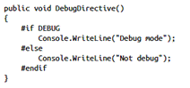
- #define: You can define your own symbols.
  - It’s important that the definition comes before any other code in the file.
  - 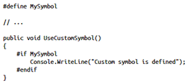
- #undef: can be used to remove the definition of a symbol.
  - The # directive must appear before any statements that are not also directives.
- #warning and #error: can be used to report an error or warning to the compiler
  - #error will cause build to fail.
  - 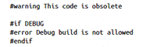
- The #line directive can be used to modify the compiler’s line number and the name of the file.
- If you debug code using the #line hide directive, the debugger skips the hidden parts.
- #pragma warning directive: can be used for disabling and enabling all warnings.
  - 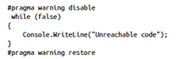
  - You can also target specific warnings:
  - 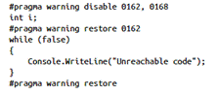
- The ConditionalAttribute can used to include or exclude a certain piece of code depending on the build configuration.
  - Using preprocessor directive:
  - 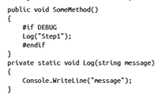
  - Equivalent using the ConditionalAttribute:
  - 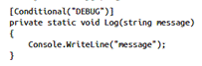
- Use System.Diagnostics.DebuggerDisplayAttribute to display an object (w/o ToString).
  - Literals between curly braces represent expressions/variables.
  - 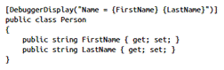

Program Database File
- You have the option of creating an extra file with the extension .pdb, called a program database (PDB) file, which annotates your application’s code with info that is used during debugging.
- Instruct the compiler to create a PDB file with the /debug:full or /debug:pdbonly switches.
  - When you specify the full flag, a PDB file is created, and the specific assembly has debug information.
  - With the pdbonly flag, the generated assembly is not modified, and only the PDB file is generated.
- A .NET PDB file contains two pieces of information:
  - Source file names and their lines
  - Local variable names
- When you load a module, the debugger starts looking for the corresponding PDB file.
  - It looks for a PDB file with the same name that sits in the same directory as the application or library.
  - When it finds a file with a matching name, it compares an internal ID that is created by the compiler. The GUID should match exactly.
  - If you recompile your application, you get a new PDB file that matches your recompiled build exactly.
- When you want to debug an application that’s currently in production, you need the matching PDB file to debug the application.
- When building your own projects, it’s important to set up a Symbol Server for your internal use.
  - TFS has an option to publish all the PDB files from your builds to a shared location, which can then act as a Symbol Server for Visual Studio, enabling you to debug all previous versions of an application without having the source code around.
- When a full-sized PDB file is built by the compiler, it contains two distinct collections of information: private and public symbol data.
  - PDBCopy is a part of the Debugging Tools for Windows in the Windows SDK.
  - This code takes a mysymbols.pdb file and creates a file publicsymbols.pdb file without the private symbol data: pdbcopy mysymbols.pdb publicsymbols.pdb –p

Debug Settings
- Load DLL Exports (under Debug > Options & Settings > General): Scans and imports debug symbols from external files including COM objects. This allows you to debug 3rd-party COM objects.
- Just-In-Time (under Debug > Options & Settings > Just-In-Time): Allows native, managed, or script code to start a debugger even when running outside of Visual Studio.
- Breakpoint Filter (right-click breakpoint): Can restrict the breakpoint to only being set in certain processes, threads, or a specified machine.
- Breakpoint Condition (right-click breakpoint): Provides a Boolean expression which determines if the breakpoint should be hit or not.
- Breakpoint Hit Count (right-click breakpoint): Sets a threshold count (always, equal to, greater than, multiple of) for when the breakpoint is hit.
- When Hit (right-click breakpoint): Prints a configurable message when the breakpoint is hit.

Diagnostics

Logging and Tracing
- Tracing is a way for you to monitor the execution of your application while it’s running.
- Logging is always enabled and is used for error reporting.

System.Diagnostics.Debug
- The Debug class can be used only in a debug build.
  - Can be turned off via #undef DEBUG
- This is because the ConditionalAttribute with a value of DEBUG is applied to the Debug class.
- You can use it for basic logging and executing assertions on your code.
- 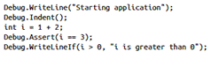
- If the Debug.Assert statement fails, you get a message box showing the current stack trace of the application.
  - This message box asks you to retry, abort, or ignore the assertion failure.

System.Diagnostics.TraceSource
- You must enable tracing to use a trace listener.
  - #define TRACE
  - #undef TRACE
- You can pass a parameter of type TraceEventType to the trace methods.
  - You use this to specify the severity of the event that is happening.
  - This is used by the TraceSource to determine which information should be output.
- The second argument to the trace methods is the event ID number.
  - It does not have a predefined meaning but is just a way to group events together.
- The third parameter is a string that contains the message that should be traced.
- 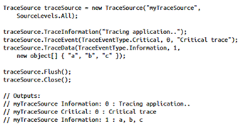
- You can use several different options for the TraceEventType enum:
  - Critical: It should be used sparingly and only for very serious and irrecoverable errors.
  - Error: Indicates that something is wrong in the application. It should typically be used to flag a problem that has been handled or recovered from.
  - Warning: Indicates something unusual has occurred that is worth investigating further.
  - Information: Indicates that the process is executing correctly, but there is some interesting information to include in the tracing output file.
  - Verbose: This should be used for information that is not indicating anything wrong with the application and is likely to appear in vast quantities.
  - Stop, Start, Suspend, Resume, Transfer: These event types are not indications of severity, but mark the trace event as relating to the logical flow of the application.
- Both the Debug and TraceSource classes have a Listeners property.
  - This property holds a collection of TraceListeners, which process the information from the Write, Fail, and Trace methods.
- Out of the box, both the Debug and the TraceSource class use an instance of the DefaultTraceListener class.
  - The DefaultTraceListener writes to the Output window and shows the message box when assertion fails.
  - If you don’t want the DefaultTraceListener to be active, you need to clear the current listeners collection. You can add as many listeners as you want.
  - You can define your own trace listeners by inheriting from the TraceListener base class and specifying your own implementation for the trace methods.
- List of the available listeners:
  - ConsoleTraceListener: Standard output or error stream
  - DelimitedListTraceListener: TextWriter
  - EventLogTraceListener: EventLog
  - EventSchemaTraceListener: XML-encoded, schema-compliant log file
  - TextWriterTraceListener: TextWriter
  - XmlWriterTraceListener: XML-encoded data to a TextWriter or stream.
- You can also use a configuration file to configuring the listeners:
  - 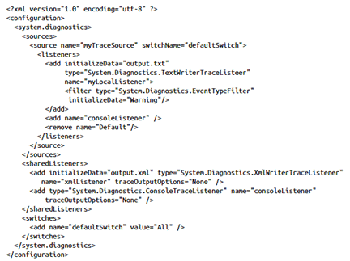
  - In this case, you configure a trace source named myTraceSource to use two listeners: one to a file and the other to the console.
  - The console listener is defined as a shared listener so that you can use it for multiple trace sources.
  - The configuration file also defines a switch, which is used by a trace source to determine whether it should do something with a trace message it receives.
    - This way, you can determine which trace messages you want to see.
  - When you have multiple listeners for one single trace source, you can use filters to determine which trace events are actually processed by the listener.

System.Diagnostics.EventLog
- Writes events to the Windows Event Log.
- You need to run with an account that has the appropriate permissions to create event logs.
- When running it from Visual Studio, you have to run Visual Studio as an administrator.
- By getting an EventLogEntry from the Entries property of the EventLog, you can also read programmatically from the event log.
- The EventLog also gives you the option to subscribe to changes in the event log. It exposes a special EntryWritten event that you can subscribe to for changes.

Profiling
- Profiling is the process of determining how your application uses certain resources.

System.Diagnostics.Stopwatch
- A simple way of measuring the execution time of some code.
- The StopWatch class has a Start, Stop, and Reset method.
- You can get the elapsed time in milliseconds, in ticks, or formatted as a time.

Performance Wizard
- When using the profiler, the easiest way is to use the Performance Wizard.
- You can find this wizard in the Analyze/Performance and Diagnostics menu in Visual Studio.
- When profiling your applications, you have four options:
  - CPU sampling: This is the most lightweight option.
    - You use it for an initial search for your performance problems.
  - Instrumentation: This method injects code into your compiled file that captures timing information for each function that is called.
    - You can find I/O problems or you can closely examine a particular method.
  - .NET memory allocation: This method interrupts your program each time it allocates a new object or when the object is GC’d to give you an idea of how memory is being used.
  - Resource contention data: This method can be used in multithreaded applications to investigate waits and queues.

System.Diagnostics.PerformanceCounter
- Allows you to read the values of the performance counters from code.
- All performance counters are part of a category, and within that category they have a unique name.
- To access performance counters, your application has to run under full trust, or the account that it’s running under should be an admin or be a part of the Performance Monitor Users group.
- All performance counters implement IDisposable because they access unmanaged resources.
- Some types that can be useful are the following:
  - NumberOfItems32/NumberOfItems64: These types can be used for counting the number of operations or items.
    - NumberOfItems64 uses a larger field to accommodate for larger values.
  - RateOfCountsPerSecond32/RateOfCountsPerSecond64: These types can be used to calculate the amount per second of an item or operation.
  - AverageTimer32: Calculates the average time to perform a process or process an item.
  - ElapsedTime: A difference timer that shows the total time between when the component or process started and the time when this value is calculated.

Data Access

I/O

Files (System.IO)
- The DriveInfo class allows you to access the drives on your computer.
  - It has several properties to access information such as the name of the drive, size, and available free space.
- To work with directories, you can use the DirectoryInfo object or the static Directory class.
  - When executing only a single operation against your file system, it can be more efficient to use the static Directory class.
  - When you want to execute multiple operations against a folder, DirectoryInfo is a better choice.
  - You can use both classes to create a new folder.
  - When you create a new folder, you have read and write rights to the folder.
  - If you don’t have sufficient permissions to create a new directory, a UnauthorizedAccessException will be thrown.
  - Trying to remove a folder (Directory/DirectoryInfo Delete) that doesn’t exist throws DirectoryNotFoundException.
  - Use the Exists method on the static Directory class or the Exists property on the DirectoryInfo object to determine whether a folder exists.
  - The Directory and DirectoryInfo classes both have a GetDirectories method for retrieving all subdirectories of a given directory.
    - This returns an array of DirectoryInfo objects.
    - Specify a search pattern (*, +) and an enumeration of type SearchOption to automatically search only the top folder or all subfolders.
  - When working with a huge directory tree, it can be more efficient to use EnumerateDirectories instead of GetDirectories.
    - When using EnumerateDirectories, you can start enumerating the collection before it’s been completely retrieved.
  - Use MoveTo on DirectoryInfo or Move on Directory classes when you want to move an existing directory to a new location.
  - The static Directory.GetFiles(string path) function returns an array of strings, whereas the DirectoryInfo.GetFiles() returns an array of FileInfo objects.
- Access to folders can be arranged by using the DirectorySecurity class from the System.Security.AccessControl namespace.
- You can use both a static File class and a FileInfo object to access files.
  - Move files by using the File.Move(string source, string destination) or FileInfo.MoveTo(string destination).
  - Moving a file deletes the original if the move is successful. If that’s not what you want, you can also use Copy and CopyTo.
- The static class Path that has the static Combine method that has a number of overloads that accept multiple string parameters.
  - The Path class offers some other helpful methods: GetDirectoryName, GetExtension, GetFileName, and GetPathRoot.
  - You can use GetRandomFileName to create a random file or directory name.
  - GetTempPath returns the location of the current user’s temporary folder, and GetTempFileName creates a temporary file that you can then use to store some data in.

Streams
- The Stream class is an abstraction of a sequence of bytes.
- A stream has three fundamental operations:
  - Reading: you get a series of bytes.
    - You can then translate those into some meaningful data such as text or deserialize them to an object.
  - Writing: you translate an object into a series of bytes and then send it off to the stream.
    - It can then be sent across the network or persisted to a file on some other storage medium, such as a hard disk.
  - Seeking: you can query for the current position of a cursor and move it around.
- FileStream supports the methods for reading and writing bytes in files, and for setting the current position by executing a seek operation.
- When writing to a FileStream, you can use the synchronous method Write, which expects a byte array.
  - A simple File object does not store text directly.
  - A Stream works with bytes, so you need to convert your text into bytes.

Encoding/Decoding
- The process of converting characters into bytes (and vice-versa) is called encoding and decoding.
- A char, which is the most basic character type, is equivalent to a single Unicode character taking 2 bytes in memory.
  - A string is simply a sequence of chars.
- System.Text.Encoding is the class that helps you convert between bytes and strings.
- .NET offers several encoding standards that you can use.
  - UTF-8 is one that suffices for general purpose use (1 byte per char).
  - It can represent all Unicode characters and it is used as the default encoding in .NET.
  - Other encodings are ASCII, BigEndianUnicode, Unicode, and UTF32.
- The File class also supports a CreateText method that creates a file with UTF-8 encoding for you.
  - CreateText returns a StreamWriter, a class that inherits from TextWriter and enables you to directly write characters to a Stream with a particular encoding.
- To read data from a file, you can use a FileStream object, reading the bytes, and converting them back to a string with the correct encoding.
- If you know that you are parsing a text file, you can use a StreamReader to read a text file.
  - The StreamReader uses a default UTF-8 encoding and returns the bytes as a string.

Chaining Streams (Decorator)
- To compress data use a GZipStream, which takes another Stream object in its constructor.
  - The second Stream is used as the input or output for the compression algorithm.
  - By giving it a FileStream object, you can easily compress some data (such as another file) and store it to disk.
  - You can also use a MemoryStream as the input or output for a GZipStream.
  - You can find the GZipStream in the System.IO.Compression namespace.
- The BufferedStream takes another Stream in its constructor.
  - The BufferedStream helps you with checking to determine whether it’s possible to read or write larger chunks of data at once.
  - 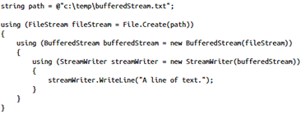

Stream Types
- StreamReader: Implements a TextReader (can read a sequential series of characters) that reads characters from a byte stream in a particular encoding.
  - If an encoding is not provided, UTF-8 is used by default.
  - StreamWriter is the inverse.
- The BinaryReader class provides methods that simplify reading primitive data types from a stream.
  - The class includes read methods that support different data types.
  - When you create a new instance of the BinaryReader class, you provide the stream to read from, and optionally specify the type of encoding and whether to leave the stream open after disposing the BinaryReader object.
  - If you do not specify an encoding type, UTF-8 is used.
  - BinaryWriter is the inverse.

Network Streams
- WebRequest and WebResponse are abstract classes that enable communicating over a network.
- Specific implementations define the protocol to use for communication.
  - Use HttpWebRequest and HttpWebResponse when using the HTTP protocol.

Asynchronous I/O
- I/O is one area that benefits greatly from the new support for async/await.
- Many of the I/O methods have an async equivalent that returns Task or Task<T>.
- The static File class does not support real asynchronous I/O.
  - If you call asynchronous methods, it fakes this by using another thread from the thread pool to work with the file.
- For real async I/O, use the FileStream object and pass a true value for the useAsync parameter.
- Whenever.NET offers an async equivalent of a synchronous method, it is best to use it. It creates a better user experience and a more scalable application.
- Make sure to run I/O operations in parallel when possible:
  - With the code below, each web request starts when the previous one is finished.
  - The thread won’t be blocked while running these requests, but the amount of time the async method takes is the sum of the three web requests.
  - 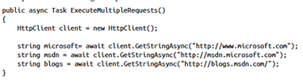
  - If instead you would execute those requests in parallel, you would only have to wait as long as the longest request takes (the other two will already be finished).
  - You can do this by using the static method Task.WhenAll as shown below. All three operations run parallel, which can save you a lot of time.
  - 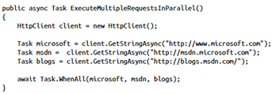
- Whenever possible, determine whether an operation is taking a long time and is not CPU-bound. If true or likely to be true, running it asynchronously is a good idea.

Database Connectivity
- You can find various types of data-related classes in the System.Data.dll.
- The data access code in.NET is under the umbrella of ADO.NET, which consists of two conceptual parts: connected and disconnected data.
- When using the connected parts of ADO.NET, you explicitly connect to a database and use that as the underlying data store.
- You execute queries by using SQL to create, read, update, and delete data.
  - Those queries are used by the ADO.NET infrastructure and forwarded to the database.
  - When working in the connected fashion, you use Connection objects, Command objects, and DataReader objects.
- In the disconnected world, you work with DataSets and DataTables that mimic the structure of a database in memory.
  - Use them to work with offline data and later sync them to a database.
  - A DataSet that is created after executing a query against a connected database can then be manipulated in memory, and the changes can be sent back to the data store by using a DataAdapter.
- A .NET data provider is used for connecting to a database, executing commands, and working the resulting data.
  - The data providers provide a thin layer that integrates with a specific database, so you can create programs that can work with different types of databases without having to change any code.

Connecting
- A connection is established by using a connection string, which contains all the information that .NET needs to know: the type of database, the location of the database, and how to authenticate against the database.
- Connections all inherit from the DbConnection base class.
- The SqlConnection can be used to establish a connection to a Microsoft SQL Server database.
- DbConnection class implements IDisposable.
- When you need to build a connection string dynamically, you can use one of the several DbConnectionStringBuilder classes.
  - You can use OracleConnectionStringBuilder to build a connection string for an Oracle database and SqlConnectionStringBuilder for a Microsoft SQL Server database.
- Depending on the type of application, you use the app.config or web.config file to store all kinds of configuration settings for an application, including connection strings.
  - If you want to use the connection string in your application, you can use the ConfigurationManager.ConnectionStrings property from the System.Configuration.dll.
  - You can access connection strings both by index and by name.
- ADO.NET applies connection pooling, which is enabled by default.

Reading
- A SQL query can be executed by using a SqlCommand object.
- A SqlCommand can return a SqlDataReader that keeps track of where you are in the result set.
  - It gives you access to each row and the columns it contains.
  - You can access the columns of a resulting row both by index and by name.
  - A SqlDataReader is a forward-only stream of rows.
  - The SqlDataReader offers a couple of methods that can map the value of a column to the corresponding CLR type.
    - For example, you can call methods like GetInt32(int index), GetGuid(int index), GetString(int index), and so on.
- When executing a query, you can also batch multiple SQL statements together.
  - The SqlDataReader returned contains multiple result sets.
  - You can advance to the next result set by calling NextResult or NextResultAsync on your SqlDataReader object.
- Use the ExecuteReader or ExecuteReaderAsync to execute a relational query.
- Use the ExecuteXMLReader or ExecuteXMLReaderAsync to execute a relational query which returns an XML result set (XML AUTO). Returns an XmlReader.

Updating
- You can update by using a command object and the ExecuteNonQuery or ExecuteNonQueryAsync methods.
- Instead of getting back a reader with the resulting rows, you get an integer value back that shows how many rows are affected by your last query.
- By checking the result you can determine if the correct amount of rows was affected.
- If you execute a stored procedure or chain multiple SQL statements together you will only get the number of records affected by the last query, not across all queries in your procedure.

Parameterizing
- Parameterizing prevents SQL injection and can lead to more performant execution plans.
- Instead of manually building the correct SQL query, use parameterized SQL statements.
- Parameterized queries can be used when running select, update, insert, and delete queries.
- Besides being much more secure, they also offer better performance.
- Because the database gets a more generic query, it can more easily find a precompiled execution plan to execute your query.
- Use the SqlParameter class to control the direction of parameters in a SqlCommand.Parameters SqlParameterCollection.
  - SqlParameter.Direction: ParameterDirection enum:
    - Input (default): The parameter is an input parameter.
    - InputOutput: The parameter is capable of both input and output.
    - Output: The parameter is an output parameter.
    - ReturnValue: The parameter represents a return value from an operation such as a stored procedure, built-in function, or user-defined function.

Transactions
- When working with transactions, it’s easiest to use the TransactionScope class.
- TransactionScope offers an easy way to work with transactions without requiring you to interact with the transaction itself.
- If an exception occurs inside the TransactionScope, the whole transaction is rolled back.
- If nothing goes wrong, you use TransactionScope.Complete to complete the transaction.
- It’s important to use the TransactionScope inside a using statement so that it is automatically disposed of when it’s no longer necessary.
- A TransactionScope can also be constructed by passing a TransactionScopeOption enum to it.
- A TransactionScope can be constructed with three options:
  - Required (default): Join the ambient transaction or create a new one if it doesn’t exist. If there is an ambient transaction, it controls when the transaction is completed.
  - RequiresNew: Start a new transaction.
  - Suppress: Don’t take part in any transaction.
- When using TransactionScope, .NET automatically manages the transaction for you.
  - If your transaction uses nested connections, multiple databases, or multiple resource types, your transaction is promoted to a distributed transaction.
  - The promotion to a distributed transaction can have a huge performance hit.
  - Try to avoid distributed transactions. If you need them, .NET manages it for you.

Consuming XML
- An XML document consists of several elements.
- XML is case-sensitive.
- First, there is an optional line that specifies you are looking at XML (prolog).
  - It tells something about the encoding that is used and can contain other metadata.
- After the prolog comes the content.
  - There should be a single root element that contains the rest of the information.
  - This creates a hierarchical tree that defines the relationship between all elements.
- The System.Xml namespace helps you parse XML by providing classes that can be used to parse, create, and edit XML files—both in memory and on disk.
  - XmlReader: A fast way of reading an XML file. You can move forward only through the file, and nothing is cached.
  - XmlWriter: A fast way to create an XML file. Just as with the XmlReader, it’s forward only and non-cached.
  - XmlDocument: Represents an in-memory XML document. It supports navigating and editing a document.
  - XPathNavigator: Helps with navigating through an XML document to find specific information.

XMLReader
- System.Xml.XmlReader provides forward-only, read-only access to XML data in a document or stream.
- The XmlReader class offers the fastest option of working with XML data.
- It is an abstract base class that is inherited by classes such as XmlTextReader, XmlNodeReader, and XmlValidatingReader.
- You create a new instance of XmlReader by using the static Create method.
  - You can pass this method an instance of XmlReaderSettings to configure how the XML should be parsed.
  - You can choose to skip data from your XML file such as white space and comments, or start at a particular position.
- The XmlReader treats the XML like a hierarchy of nodes.

XMLWriter
- When you want to create an XML file you can use the XmlWriter class.
- This class is created by using the static Create method and it can be configured by using an instance of the XmlWriterSettings class.
- The XmlWriter class is aware of the hierarchical structure of XML.
- You need to make sure that you write both the start and the end tag of each element.
- You can choose to add attributes or to add elements that have a string value as their content.

XMLDocument
- The System.Xml.XmlDocument can be used to load XML.
- The Schemas property can be used to add XSD schemas for validation.
- When you work with relatively small documents, and performance is not as important, you can use the XmlDocument class.
- It enables you to edit XML files, and it represents the XML in a hierarchical way in memory, and enables you to easily navigate the document and edit elements in place.
- After you finish editing the document, you can save it back to a file or stream.
- An XmlDocument uses a set of XmlNode objects to represent the various elements comprising the document.
- XmlDocument inherits from XmlNode and adds specific capabilities for loading and saving documents.
- XmlNode helps you with reading content and attributes, and gives you methods for adding child nodes so that you can easily structure your document.

XPathNavigator
- XmlDocument implements IXPathNavigable so you can retrieve an XPathNavigator object from it.
- The XPathNavigator offers an easy way to navigate through an XML document.
- You can use methods similar to those in an XmlDocument to move from one node to another, or you can use an XPath query.
- This enables you to select elements or attributes with certain values, similar to the way SQL selects data in a database.

XElement
- You use the class XElement for creating your own XML.
- You can use the Add method to construct an XML hierarchy or you can use the XElement constructor that takes an array of objects that form the content.
- 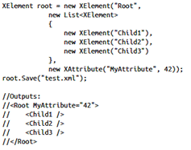

LINQ
- LINQ is entirely based on extension methods.

Implicitly Typed Variables
- When using implicit typing, the compiler infers the type of variable for you and then strongly types your variable to that type.
- Implicitly typed variables can be used only for local variables.
- You can use implicit typing by using the var keyword.
- Implicit typing can be used to avoid repetition when declaring long typed variables.

Object Initialization Syntax
- The new object initialization syntax enables you to combine creating a new object and setting its properties in one statement.
- 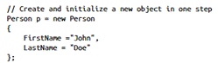
- The same syntax can be used when creating collections.
- 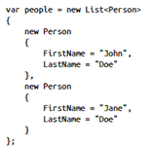
- When working with anonymous types, this is required.
- By using the object initialization syntax, you define the properties that an anonymous type has.

Anonymous Types
- When you create anonymous types, you use both object initializers and implicit typing.
- An anonymous type is a type that is shaped at compile time without having a formal class definition.
- The compiler creates a type and gives a default implementation by overriding the virtual members of System.Object.
- Create an anonymous type by using the var keyword as the type and by using the new operator without specifying a type.
- Anonymous types are used in LINQ when you create a projection.
- This means that you select certain properties from a query and form a specific type for it.
- 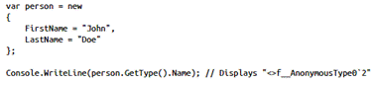
- When projecting an anonymous type in a LINQ query, explicitly naming each column in the type is optional:
  - 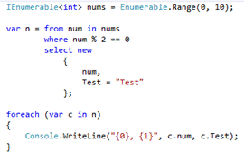
  - However, if a specific class is named, then the members must be named explicitly.

LINQ Queries
- The compiler translates the query syntax into a set of method calls.
- The LINQ operators are extension methods on IEnumerable<T>.
- Some query operations, such as Count, Max, Min, or Avg, have no equivalent query expression clause and must therefore be expressed as a method call.
- You can also mix the two approaches.
- The compiler always transforms your query syntax into method syntax.
- The queries do not actually execute until you iterate over the query variable in a foreach statement.
- To evaluate a query and store its results without executing a foreach loop, just call one of the following methods on the query variable:
  - ToList<TSource>
  - ToArray<TSource>
  - ToDictionary
  - ToLookup
- LINQ to Entities or LINQ to SQL queries won’t be sent to the database until the result is enumerated.
  - That means that executing a query multiple times hits the database multiple times.
  - It is better to save the results of a query in a local variable and use that variable when working with the data.

Standard Query Operators
- LINQ Samples
- A LINQ provider maps your query to a specific data store, such as LINQ to XML, LINQ to Entities, or LINQ to Objects.
- The optional where, join, orderby, from, let clauses may be used zero times or multiple times in a query body.
- Every LINQ provider is encouraged to implement the standard query operators: All, Any, Average, Cast, Count, Distinct, GroupBy, Join, Max, Min, OrderBy, OrderByDescending, Select, SelectMany, Skip, SkipWhile, Sum, Take, Take-While, ThenBy, ThenByDescending, and Where.
- 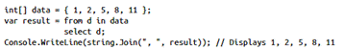
- In a LINQ query, the from clause comes first in order to introduce the data source and the range variable.
- You use multiple from statements to combine the data.
- 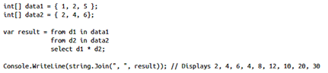
  - Use additional from clauses when each element in the source sequence is itself a collection or contains a collection.
  - For example, to query the City objects in each Country:
  - 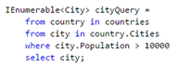
- Additional range variables can be introduced by a let clause.
  - Expressions, even method calls can be used as the let clause.
  - 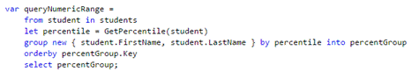
- By adding a where statement, you can create a filter.
  - You can use the familiar C# logical && and || operators to apply as many filter expressions as necessary in the where clause.
- 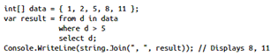
- You can use orderby to sort your data in ascending or descending order.
  - The orderby clause will cause the elements in the returned sequence to be sorted according to the default comparer for the type being sorted.
    - If you specify multiple orderby clauses, only the last is evaluated so use commas to specify multiple sort orders.
  - Secondary sort orders can be specified (ThenBy in query syntax).
- 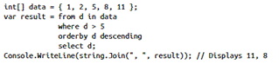
- 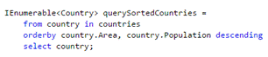
- There is no query syntax for the Average method, which is why you need to use the method syntax.
  - var avg = orders.Average(o => o.OrderLines.Count);
- When using projection, you select another type or an anonymous type as the result of your query.
  - You project your results into it to focus only on the properties you really need.
- The group clause enables you to group your results based on a key that you specify.
  - When you end a query with a group clause, your results take the form of a list of lists.
  - Each element in the list is an object that has a Key member and a list of elements that are grouped under that key.
  - When you iterate over a query that produces a sequence of groups, you must use a nested foreach loop.
    - The outer loop iterates over each group, and the inner loop iterates over each group's members.
  - If you must refer to the results of a group operation, you can use the into keyword to create an identifier that can be queried further.
  - 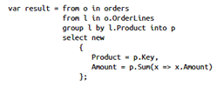
  - A projection can be used in the group clause.
  - 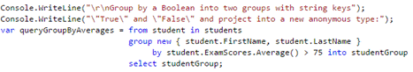
  - Compound grouping:
  - 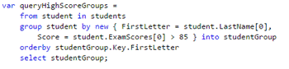
- Join can be used to combine data from two or more sources.
  - When using the join operator, you have to specify the property that needs to be equal.
  - You can use an anonymous type to combine properties from each set of associated elements into a new type for the output sequence.
  - 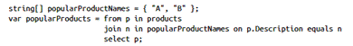
  - 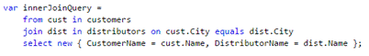
  - You can use a projection to implement a composite key join.
  - 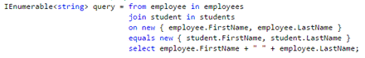
  - 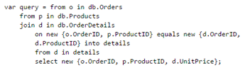
  - Any number of join operations can be appended to each other to perform a multiple join.
    - Each join clause in C# correlates a specified data source with the results of the previous join.
  - 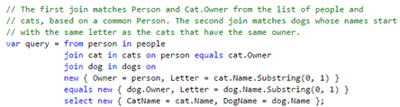
- A left outer join is a join in which each element of the first collection is returned, regardless of whether it has any correlated elements in the second collection.
- A cross join can be implemented using multiple from clauses.
  - 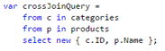
- Select() produces one result value for every source value.
  - The overall result is therefore a collection that has the same number of elements as the source collection.
  - In contrast, SelectMany() produces a single overall result that contains concatenated sub-collections from each source value.
  - The transform function that is passed as an argument to SelectMany() must return an enumerable sequence of values for each source value.
  - These enumerable sequences are then concatenated by SelectMany() to create one large sequence.
- To implement paging, you can use the Skip and Take operators.
  - There is no query syntax for them, so you need to use the methods.
  - 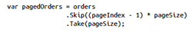
- To force immediate execution of any query and cache its results, you can call the ToList<TSource> or ToArray<TSource> methods.
- A query clause may itself contain a query expression, which is sometimes referred to as a subquery.
  - 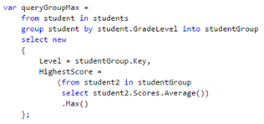
- A LINQ query can be returned from a method as the return value or as an out parameter.
  - The ref keyword causes an argument to be passed by reference, not by value.
  - To use a ref parameter, both the method definition and the calling method must explicitly use the ref keyword (same for out).
- 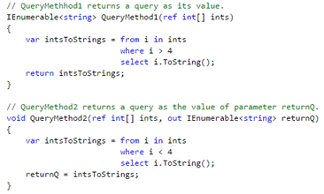
- If a source collection is null or contains an element whose value is null, and your query does not handle null values, a NullReferenceException will be thrown when you execute the query.
  - 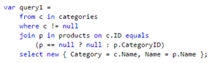

Serialization
- Serialization is the process of transforming an object or object graph that you have in-memory into a stream of bytes or text.
- Deserialization is the opposite. You take some bytes or text and transform them into an object.
- You use serialization when you need to exchange data with another application.
- This exchange can be done over a network or when you store data into a database or file.
- Methods are not serialized.
  - When you deserialize an object, you need access to the original class definition or you will end up with an object that only stores data.
- .NET offers classes to help with serializing your object that can be found in the System.Runtime.Serialization and System.Xml.Serialization namespaces.
  - These classes can help you with serializing and deserializing an object, but also with configuring your own objects so they can be serialized.
- The .NET Framework offers three serialization mechanisms that you can use by default:
  - XmlSerializer
  - DataContractSerializer
  - BinaryFormatter

XMLSerializer
- The XmlSerializer doesn’t have the highest performance; it also doesn’t maintain the object references you have and it can’t work with private fields.
- When working with the XmlSerializer, it’s important that you mark your types with the [Serializable] attribute, part of the SerializableAttribute class.
  - This informs.NET that your type should be serializable.
  - It will check your object and all the objects it references to make sure that it can serialize the whole graph or throw an exception at runtime.
- You can configure how the XmlSerializer serializes your type by using attributes.
  - XmlIgnore: Don’t serialize
  - XmlAttribute: serialize the class member as an XML attribute.
  - XmlElement: (default) serialize the public field or property as XML element.
  - XmlArray: serialize a particular class member as an array of XML elements.
  - XmlArrayItem
  - XmlInclude: Allows the XmlSerializer to recognize a type when it serializes or deserializes an object.
    - When applying the XmlIncludeAttribute, specify the Type of the derived class.
    - When the XmlSerializer serializes objects that include both the base and the derived class, it can then recognize both object types.
    - Only valid on classs, struct, method, or interface declarations.

XMLAttributeOverrides
- Allows you to override property, field, and class attributes when you use the XmlSerializer to serialize or deserialize an object.
- Overriding serialization in this way has two uses: first, you can control and augment the serialization of objects found in a DLL--even if you do not have access to the source; second, you can create one set of serializable classes, but serialize the objects in multiple ways.
- For example, instead of serializing members of a class instance as XML elements, you can serialize them as XML attributes, resulting in a more efficient document to transport.

Binary Serialization
- By using a binary format, you get a smaller result.
- You can also serialize data that is not suitable for an XML format such as an image.
- You need to mark an item with the SerializableAttribute and then you use instance of the binary serializer to serialize an object or an object graph to a Stream.
- The important namespaces are System.Runtime.Serialization and System.Runtime.Serialization.Formatters.Binary.
- One thing that’s different compared with XML serialization is that private fields are serialized by default.
- Another thing is that during deserialization, no constructors are executed. You have to take this into account when working with binary serialization.
- You can prevent fields from being serialized by using the by using the [NonSerialized] attribute.
- You can use the OptionalFieldAttribute to make sure that the binary serializer knows that a field is added in a later version and that earlier serialized objects won’t contain this field.
- You can influence the serialization and deserialization process in four specific phases, namely when starting and finishing an action, by using the following four attributes:
  - OnDeserializedAttribute: When applied to a method, specifies that the method is called immediately after deserialization of an object in an object graph.
  - OnDeserializingAttribute: When applied to a method, specifies that the method is called during deserialization of an object in an object graph.
  - OnSerializedAttribute: When applied to a method, specifies that the method is called after serialization of an object in an object graph.
  - OnSerializingAttribute: When applied to a method, specifies that the method is during serialization of an object in an object graph.
- Everyone who has permissions to deserialize the file can access your sensitive data.
  - If you have a sensitive class, you should implement the ISerializable interface.
  - When implementing this interface, you have control over which values are serialized.
  - You could choose to not serialize sensitive data or possibly encrypt prior to serialization.
- Implementing ISerializable consists of two important parts.
  - The first is the GetObjectData method.
    - This method is called when your object is serialized.
    - It should add the values that you want to serialize as key/value pairs to the SerializationInfo object that’s passed to the method.
    - One thing that’s important is that you should mark this method with a System.Security.Permissions.SecurityPermission attribute so that it is allowed to execute serialization and deserialization code.
  - The other important step is adding a special protected constructor that takes a SerializationInfo and StreamingContext.
    - This constructor is called during deserialization, and you use it to retrieve the values and initialize your object.

JavaScriptSerializer
- You can use the class when you want to work with JavaScript Object Notation (JSON) in managed code.
- In the System.Web.Script.Serialization namespace.

DataContract
- Another type of serialization is used when you use WCF.
- When your types are used in WCF, they are serialized so they can be sent to other applications.
- The Data Contract serializer is used by WCF to serialize your objects to XML or JSON.
- You use DataContractAttribute instead of SerializableAttribute.
  - If you omit both the DataContract and DataMember attribute, your public members are serialized.
  - With the DataContract attribute applied, you have to specify which members you want to serialize by using the DataMember attribute on them.
- As with binary serialization, you can use OnDeserializedAttribute, OnDeserializingAttribute, OnSerializedAttribute, and OnSerializingAttribute to configure the four phases of the serialization and deserialization process.

DataContractSerializer
- You can use the DataContractSerializer from the System.Runtime.Serialization namespace in the same way you used the XmlSerializer and BinarySerializer.
- The DataContractSerializer is used to serialize and deserialize data sent in WCF messages.
- Apply the DataContractAttribute attribute to classes, and the DataMemberAttribute attribute to class members to specify properties and fields that are serialized.
- You need to specify a Stream object that has the input or output when serializing or deserializing an object.
  - It is recommended that you use the XmlDictionaryReader and XmlDictionaryWriter classes to read and write, because both are optimized to work with the DataContractSerializer.
- 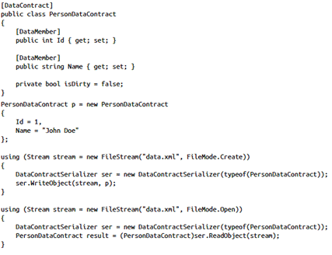

DataContractJsonSerializer
- When you want to execute JSON serialization manually, you can use the DataContractJsonSerializer.
- 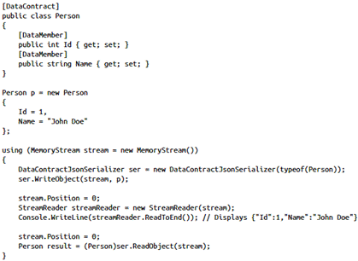

IDataContractSurrogate
- Some scenarios where a surrogate may be used is when a data contract has not been specified for the type, fields and properties are not marked with the DataMemberAttribute attribute or users wish to dynamically create schema variations.
- A surrogate works by mapping one type (the "original" type) to another type (the "surrogated" type).
- The IDataContractSurrogate allows you to override serialization specified by the DataContract and DataMember attributes.

