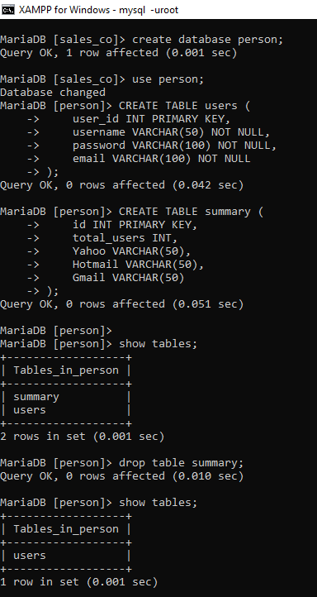

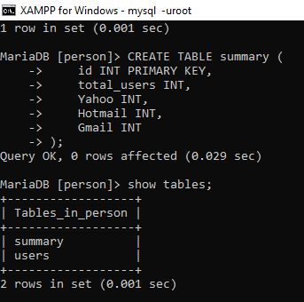

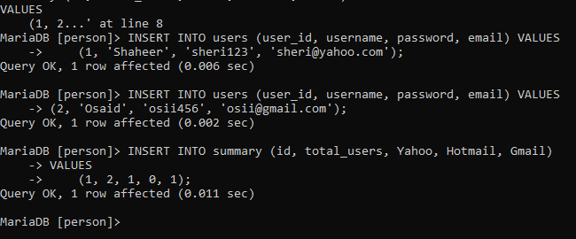

write a procedure that take id,total_user,Yahoo,Hotmail,Gmail values as an input and insert the data into the table summary

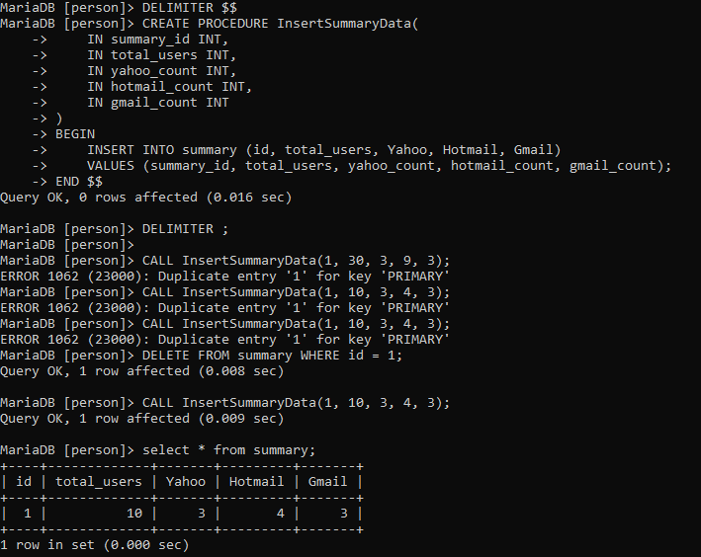

write a procedure that take user_id,username,password,email values as an input and insert the data into the table users

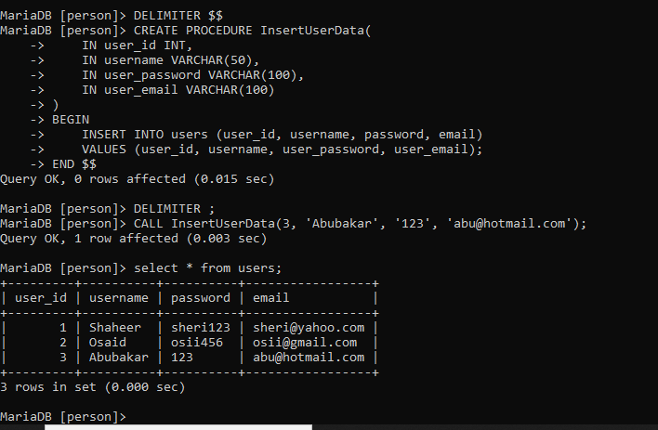

write a procedure that output the average value of yahoo

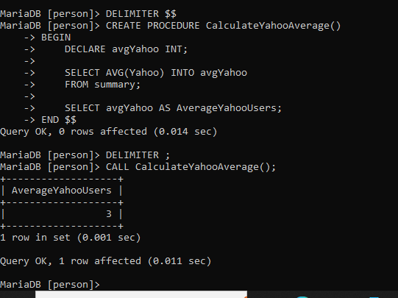

write a procedure that output the min value of gmail

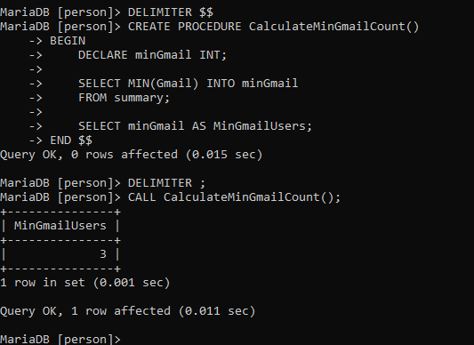

write a procedure that output the max value of hotmail

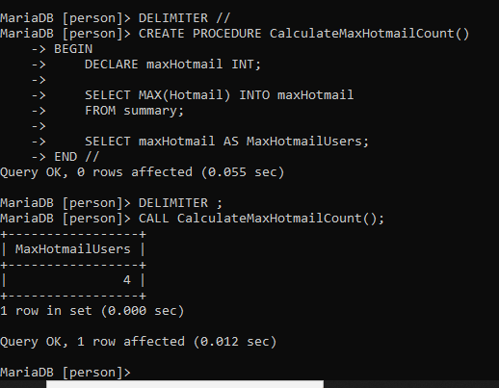

Write a procedure that increment the total user by 1 when yahoo value is less then equal to Hotmail

