Bayesian hierarchical regression

models of viral properties

Summary
Each viral property, e.g. IFN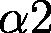 IC or Env/RT ratios, was modeled using a Bayesian hierarchical model. The model is based on a linear regression estimating the differences between donor plasma viruses and viruses from donor genital fluid or recipient plasma viruses along with the effects of HIV subtype and IFN- and IFN-selection. Unlike a normal linear regression, this model allows accounting for 1) nested measurements within transmission pairs, 2) multiple transmissions from a single donor, 3) heteroscedasticity among virus populations, 4) censored data where we only know that a measurement is less than a given value.
These hierarchical models are based on the assumption that observations within a single patient-fluid-treatment are independent and identically normally distributed with mean and variance drawn from common population-level distributions. Estimates of the population-level distributions can then be used to infer broader patterns in the data.

Methods
Data was first transformed as follows:

Variable | Transformation
Env/RT | log
Infectivity | log
Replicative capacity | log
IFN IC | log
IFN IC | log
IFN Vres | logit
IFN Vres | logit
p24 release | logit

The observation from each viral isolate was then modeled as a normal distribution 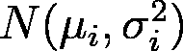 with mean 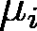:
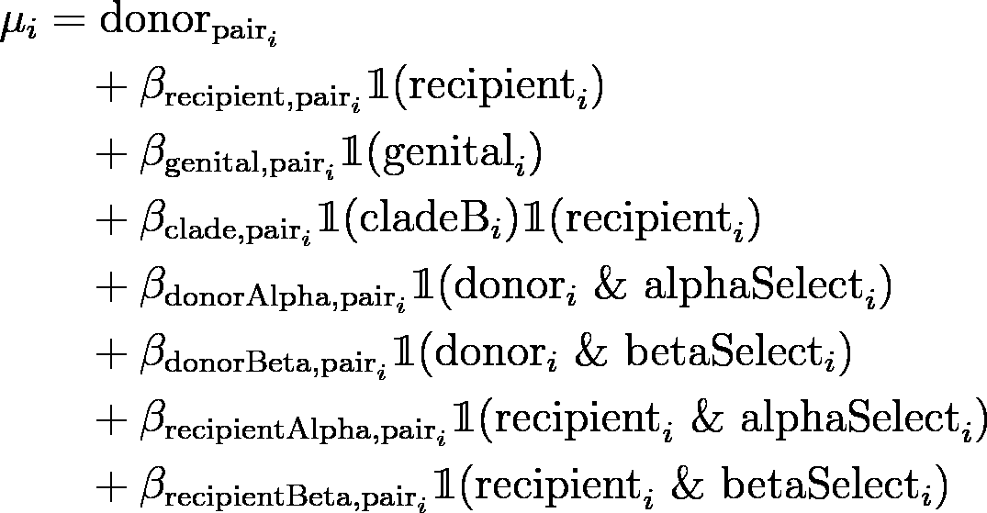
and variance 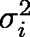:
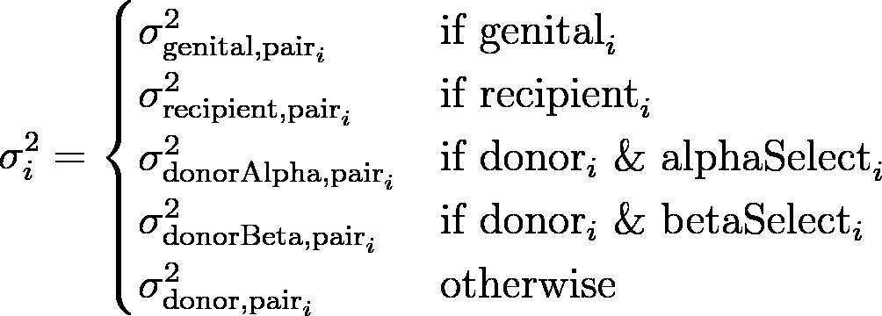
where pair indicates the pair identity of the 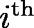 observation, 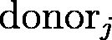 is the estimated mean of untreated donor plasma viral isolates from pair and 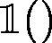 is an indicator function that is 1 if True and 0 if False. The various are coefficients modeling the change expected for viruses in recipients, in donor genital samples, in recipients from HIV clade B and the effects of IFN- or IFN-selection on donor or recipient viruses. So for example, a donor plasma virus from pair 2 would have mean 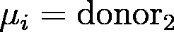 and an IFN-selected recipient virus from pair 3 (which happened to be clade B) would have mean:
For a trio where one donor transmitted viruses to two separate recipients, recipient parameters were estimated independently for each recipient.
In Autologous and Bnaber IC, observations less than or equal to 20 were censored at 20 (the maximum amount of plasma tolerated by the cells). To model this, the probability of these observations was considered to be:
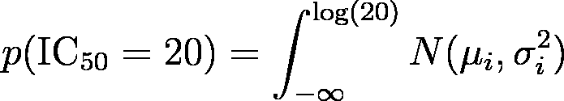
Vres measurements were calculated as the amount of p24 released under maximum IFN dose divided by the released p24 without IFN as measured by ELISA. The limit of detection on these measurement was 0.1 so concentrations 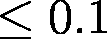 were measured as 0.1. To account for this, the probability of these observations was considered to be:
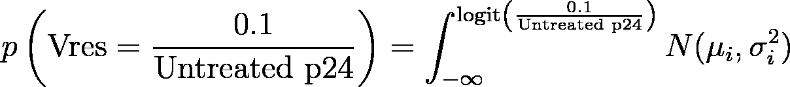
The coefficients for each pair come from population-level normal hyperpriors:
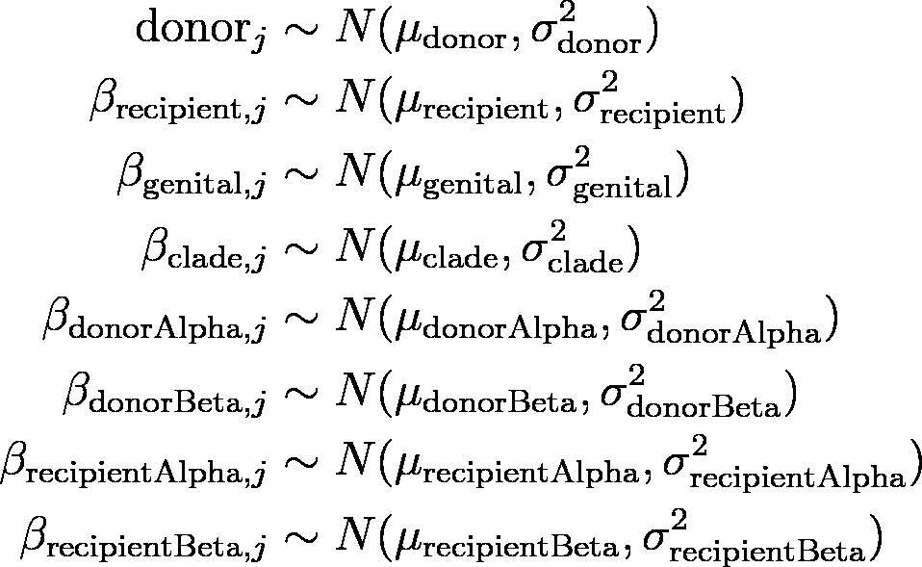
and coefficients from population-level normal hyperpriors:
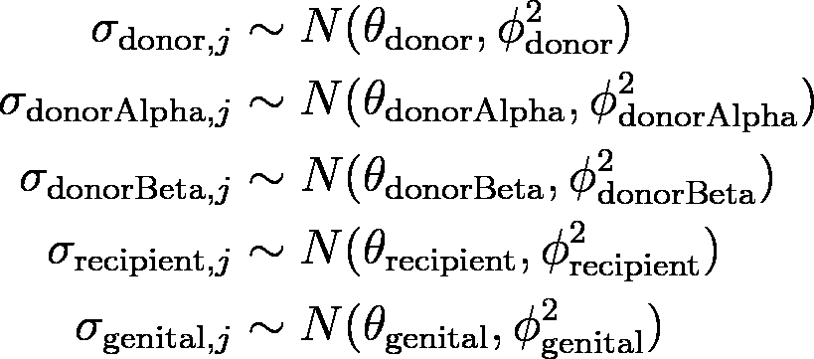
The effect hyperparameters 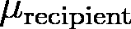, 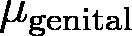, 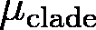, 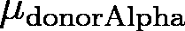, 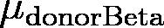, 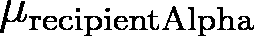 and 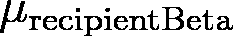 were all given a flat prior probability. The variance parameters , 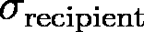, 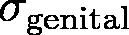, , 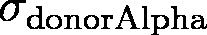, , 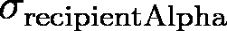, , 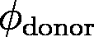, 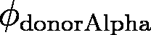, 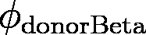, 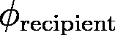, 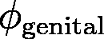, 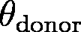, 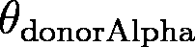, 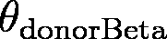,  and 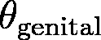 were given a prior of Gamma(1,2) reflecting prior knowledge that the standard deviation in these assays was unlikely to be greater than several logs.
Plots and statistics are based on the estimated posterior probabilities of the population-level effects , , , , , and .
Markov Chain Monte Carlo sampling of the posterior probability distributions of the models was implemented in Stan using the R package rstan and run in 50 chains with each having a 50,000 iteration burnin and 50,000 iterations of sampling every 25 iteration. Code is available at:
https://github.com/sherrillmix/hivPair/blob/master/bayesIC50.R.

2 Simple comparison
As an example of a comparison of the Bayesian estimates with a simpler analysis, we can look at the estimated change in IFN IC between untreated donor plasma viruses and IFN-selected donor plasma viruses (Figure 3). We observed 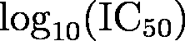 in both untreated and IFN-selection viral isolates for 3 donors with averages:

Donor | Untreated | IFN-selected | Difference
CH148 | -4.269 | -2.831 | 1.438
CH492 | -4.203 | -2.717 | 1.487
CH596 | -4.162 | -2.820 | 1.343

The simplest estimate would be to take the average, 1.423, and the standard deviation, 0.0733, of the three differences and estimate the 95% confidence interval on the mean as:
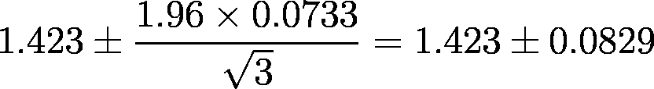
Or equivalently an estimate that IFN-selected donor viruses have an IC 26.5 (95% confidence interval: 21.9–32.0) higher than untreated isolates.
From the Bayesian model, we obtained estimates of 20.7 (95% credible interval: 11.0–36.2) higher IC. So the Bayesian model is being more conservative with wider intervals in its estimation due to incorporating uncertainty in our estimates of untreated and IFN-selected IC for each donor.

