**Problem Statement:**

**Inconvenient Parking facilities**

**Abstract**

We were supposed to find a solution for problem for insufficient parking space at M.G Road but instead we will be creating a generic solution for the given definition hence to able to solve similar issues at a larger scale. This application will help users find, navigate and book a parking slot in their nearest parking facilities, With our application The user will be able to pre-book a slot in advance hence solving the issue of finding and discovering that no parking slots are available. This will also help users if they are in an unknown area where they are unaware of such facilities.

**Literature Review:**

There are some already existing services that provide functionalities similar to us Although they just provide the location of the nearby parking facilities and not booking of slot. Apart from this the following issues were application specific:-

**AMC Smart Parking App**:Data on the app didn't match thereal- time availability.

**ParkingRhino**:This application has geographical limitations i.e.

It is just available for Bengaluru.

**GetMyParking**:Available only for "events" that take place inDELHI only. It was also asking the user for how much time the user wanted to park their vehicle.

**PparkE**:This Service didn't allow user any access to the serviceswithout payment.

**Approach to Solve Problem:**

We will be creating an Android Application that will find and locate nearby parking facilities.

Owner of a parking facility will be asked to upload a map or drawing (Blue Print) of the their parking structure

Our application will use that drawing or blue print to provide a Graphical user interface to user which they can view and interact with to find and select their preferable parking slot.

**EXPECTED** **RESULT**

Features of the system

* Profiles
* Booking system
* Payment
* Cancel and lock slots
* Navigation (nearest parking lots with details)
* Search area wise
* Pro Version (later version )

Modules

1. Login

Login module will provide the ability to register the user with the system and enter the dashboard according to its roles. This module will also include session and cookies which will help the user throughout.

1. Logout

Logout module will make the user be able shuffle through multiple accounts if he wished to.

1. Profile

From this module the user will be able to edit his details which will be useful for booking and maintaining.

1. View Digital version of blue print

This module will make it possible for the user to view the digital version of the parking slot he chooses in 2 dimension.

**OWNER DASHBOARD**

1. Upload file

The owner of the parking lot after getting the permission from the admin will be able to upload the file (blueprint in .cad extension) and related documents of the parking space and details about the charges according to time.

1. Add attendant module

The owner will add the attendant and his details at the time of adding the parking lot .

**ATTENDANT DASHBOARD**

1. Block slot

He can block a slot in case if the slot is taken by a walk in user or if the slot is not in a usable condition.

1. Lock slot

The attendant will lock the slot when the user who booked the slot comes.

1. Notification

The attendant will receive a notification from the system when any user books a slot.

1. Free Slot

If the user does not reach within 15 minutes of the booking, the attendant will cancel the slot and make it free for others to book.

1. Accept payment

Attendant will accept the payment from the user according to his summary. And select “payment done “option and then free slot.

**USER DASHBOARD**

1. Navigation

This module will allow the users to navigate through the nearest parking lots from their current location and see their details as well as their digital map which will allow them to know if the lots have free space or not.

1. Search

This will allow the user to search for free parking lots in a particular area if they wish to.

1. Book Slot

The user will be able to book his desired slot before reaching his destination so that he can save time and directly go there and park.

1. Payment

The user will have two options for payment, when the session is ended. Either make a payment through paytm or pay cash to the

Attendant .

**Project Design**

Use Case Diagrams

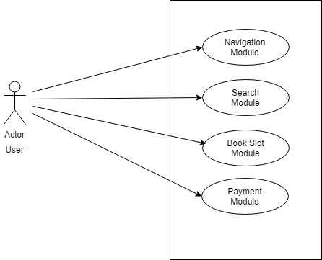

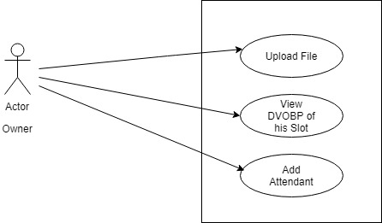

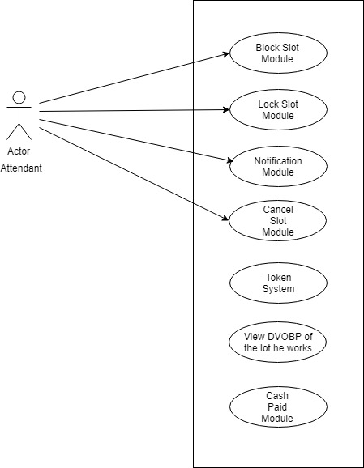

Data Dictionary

Database: - ParkingBay

**ROLE**

|  |  |  |  |
| --- | --- | --- | --- |
| **Field** | **Datatype** | **SIZE** | **CONSTRAINTS** |
| RoleId | NUMBER | 1 | PRIMARY KEY |
| RoleName | VARCHAR2 | 15 | NOT NULL |

**LOGIN**

|  |  |  |  |
| --- | --- | --- | --- |
| **Field** | **Datatype** | **SIZE** | **CONSTRAINTS** |
| RegId | NUMBER | 10 | PRIMARY KEY |
| EmailId | VARCHAR2 | 50 | NOT NULL |
| PassWord | VARCHAR2 | 20 | NOT NULL |
| RoleId | NUMBER | 1 | FOREIGN KEY |

**USER**

|  |  |  |  |
| --- | --- | --- | --- |
| **Field** | **Datatype** | **SIZE** | **CONSTRAINTS** |
| RegId | NUMBER | 10 | FOREIGN KEY |
| UserName | VARCHAR | 20 | NOT NULL |
| Address | VARCHAR | 50 | NOT NULL |
| VehicleID | NUMBER | 2 | FOREIGN KEY |

**Vehicle**

|  |  |  |  |
| --- | --- | --- | --- |
| **Field** | **Datatype** | **SIZE** | **CONSTRAINTS** |
| VehicleId | NUMBER | 5 | PRIMARY KEY |
| VehicleType | VARCHAR | 5 | NOT NULL |
| NumberPlate | VARCHAR | 5 | NOT NULL , UNIQUE |

**ParkingLot**

|  |  |  |  |
| --- | --- | --- | --- |
| **Field** | **Datatype** | **SIZE** | **CONSTRAINTS** |
| LotId | NUMBER | 10 | PRIMARY KEY |
| Area | VARCHAR | 20 | NOT NULL |
| Address | VARCHAR2 | 50 | NOT NULL |
| BikeSlots | NUMBER | 20 |  |
| CarSlots | NUMBER | 20 |  |
| PricePerHour | NUMBER | 2 |  |
| isFree | BOOLEAN | 1 | NOT NULL |
| AttendantId | NUMBER | 10 | FOREIGN KEY |

**Attendant**

|  |  |  |  |
| --- | --- | --- | --- |
| **Field** | **Datatype** | **SIZE** | **CONSTRAINTS** |
| AttendantId | NUMBER | 10 | PRIMARY KEY |
| Name | VARCHAR | 20 | NOT NULL |
| ContactNumber | NUMBER | 10 | NOT NULL,UNIQUE |

**Owner**

|  |  |  |  |
| --- | --- | --- | --- |
| **Field** | **Datatype** | **SIZE** | **CONSTRAINTS** |
| OwnerId | NUMBER | 10 | NOT NULL |
| Lotid | NUMBER | 10 | FOREIGN KEY |
| Name | VARCHAR2 | 20 | NOTNULL |
| AttendantId | NUMBER | 10 | FOREIGN KEY |
| FileName | VARCHAR2 | 10 | NOT NULL |

**Parking**

|  |  |  |  |
| --- | --- | --- | --- |
| **Field** | **Datatype** | **SIZE** | **CONSTRAINTS** |
| RegId | NUMBER | 10 | FOREIGN KEY |
| SlotId | NUMBER | 10 | FOREIGN KEY |
| ArrivalTime | NUMBER | 3 |  |
| DepartureTime | NUMBER | 3 |  |

**Slot**

|  |  |  |  |
| --- | --- | --- | --- |
| **Field** | **Datatype** | **SIZE** | **CONSTRAINTS** |
| SlotId | NUMBER | 10 | PRIMARY KEY |
| LotId | NUMBER | 10 | FOREIGN KEY |
| SlotType | VARCHAR2 | 10 | NOT NULL |
| IsBooked | BOOLEAN | 1 | NOT NULL |

Data Flow Diagrams

Level 0 DFD:

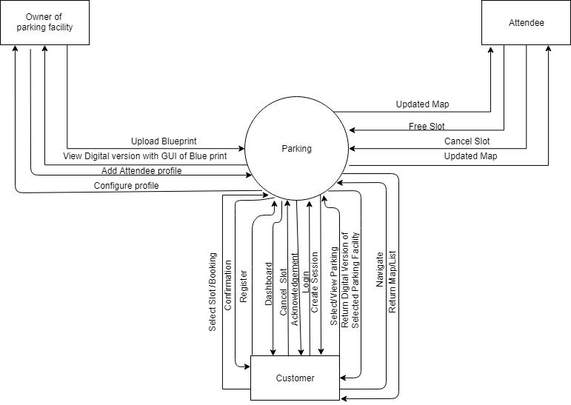

Level 1.1 DFD:

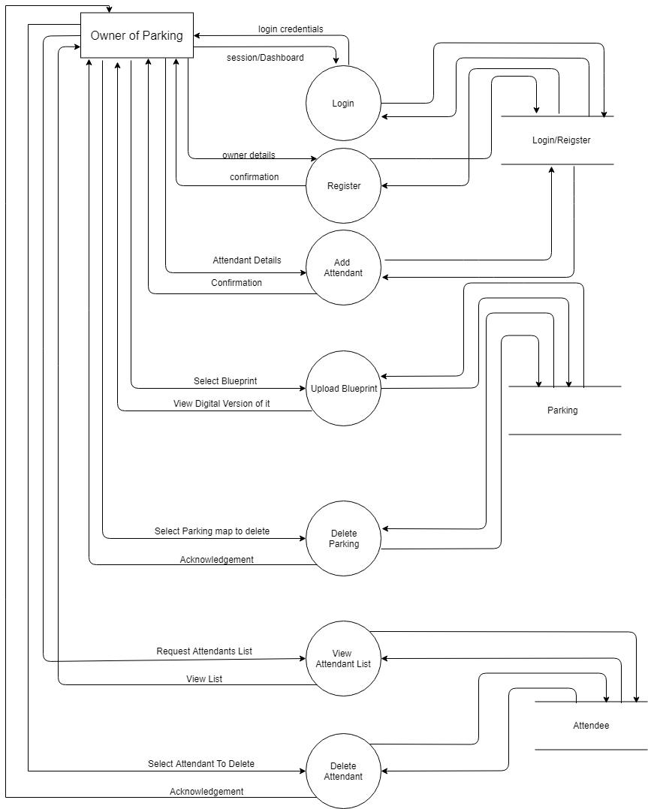

Level 1.2 DFD:

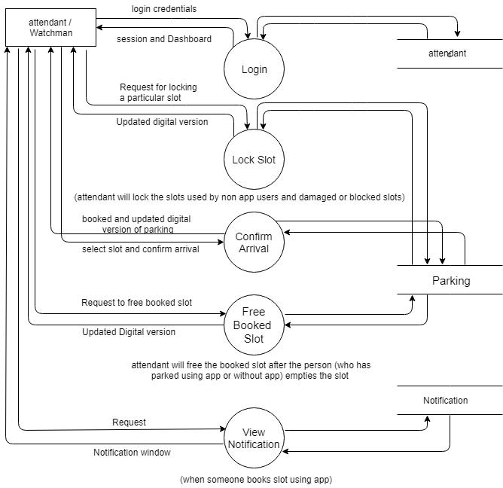

Level 1.3 DFD:

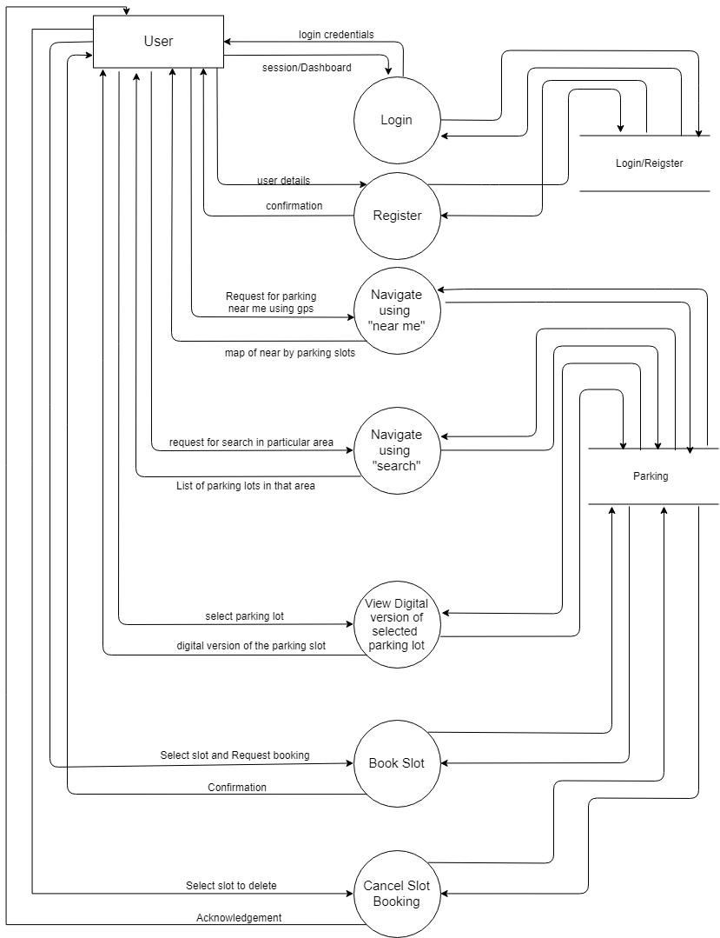

Entity Relationship Diagrams

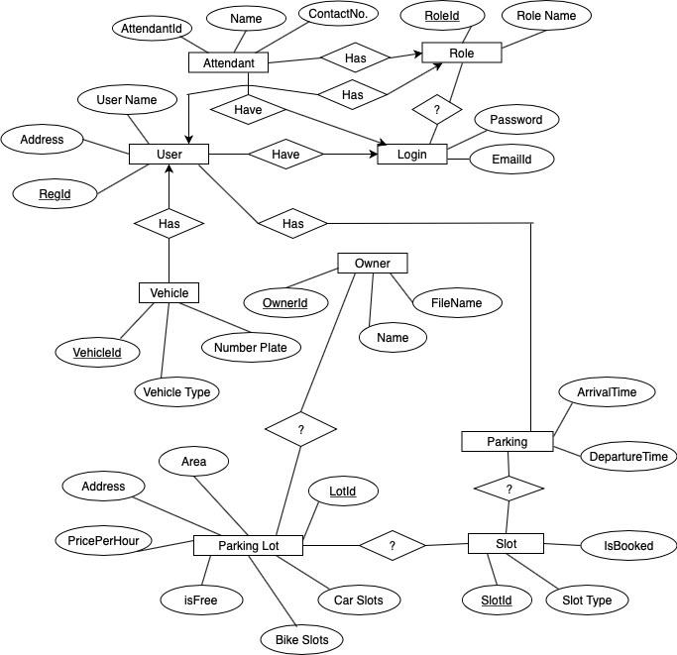

**Tools and Technologies to be used:**

**For App Development:**

Android Studio

Firebase (DB)

Java/Kotlin

**For Admin Panel:**

HTML,

CSS

JS

jQuery,

php

MySql

**For Image Processing:**

OpenCV Library

**Design of the system with Screenshots**

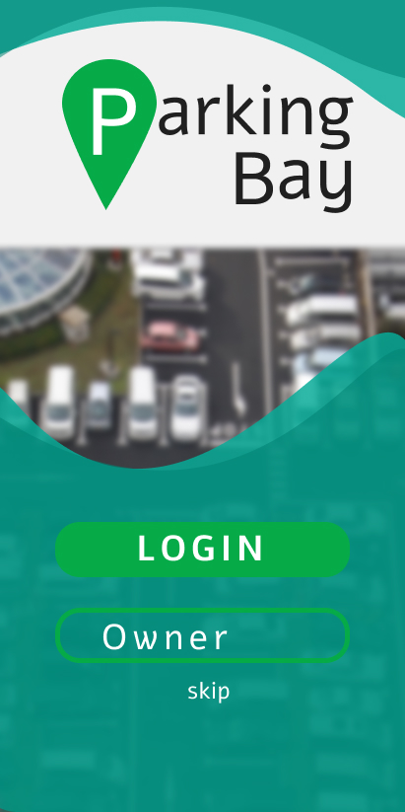 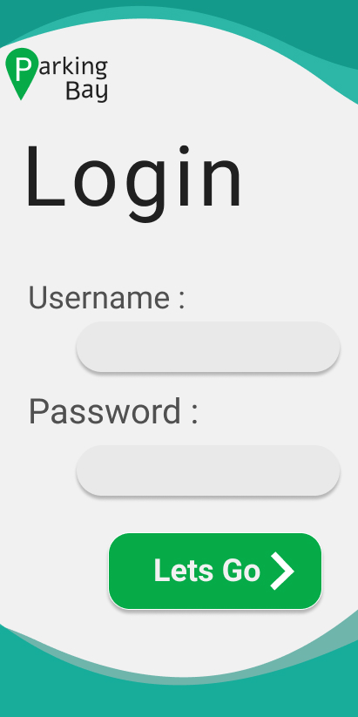

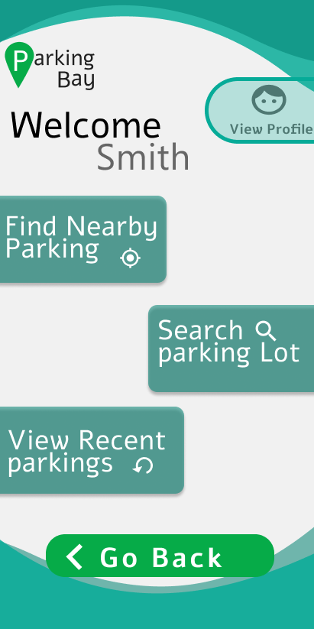 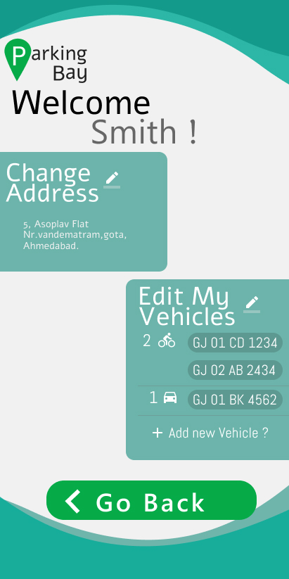

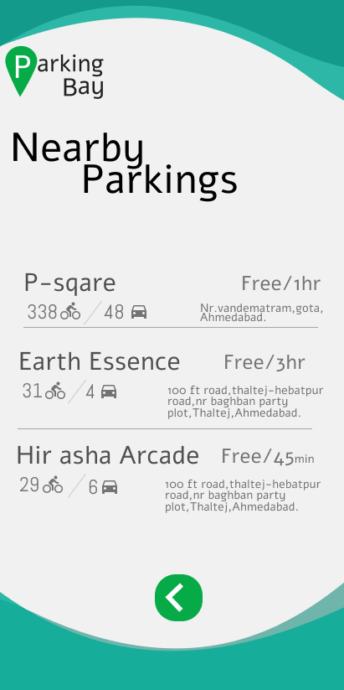 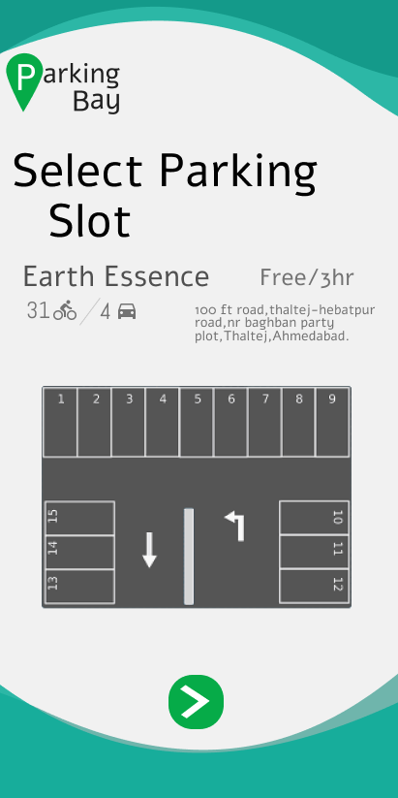

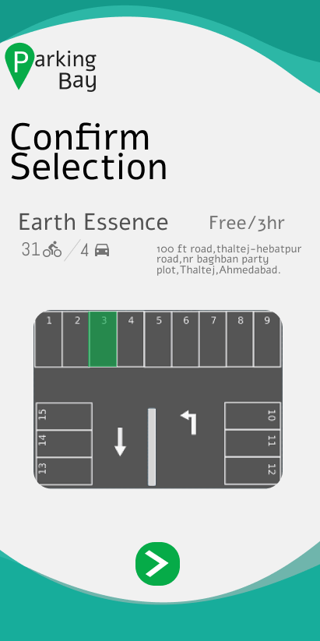 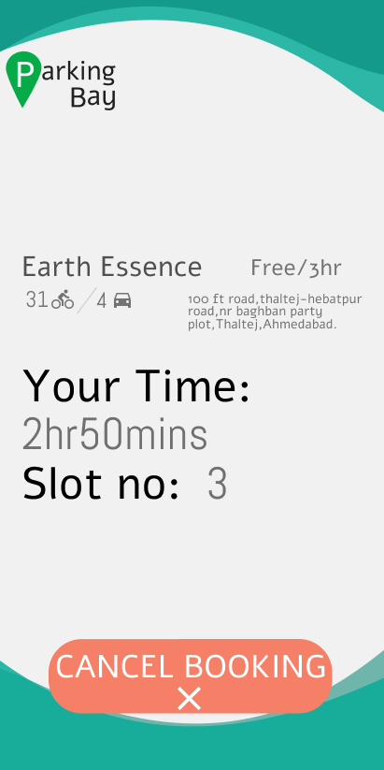

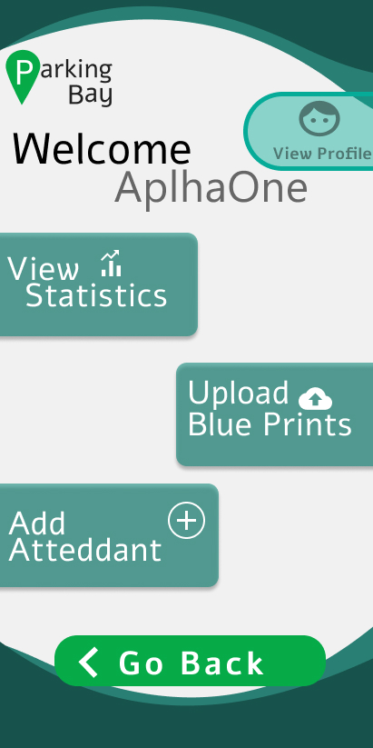 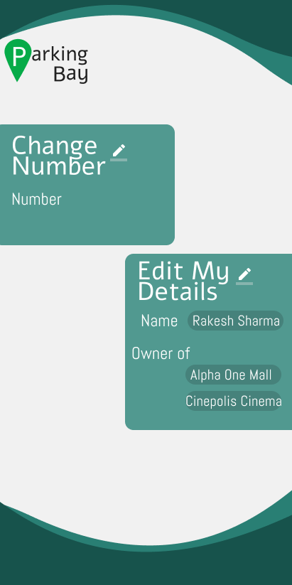

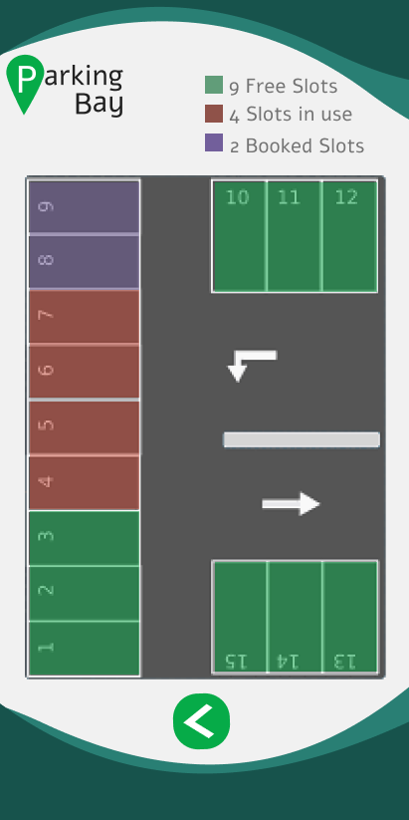 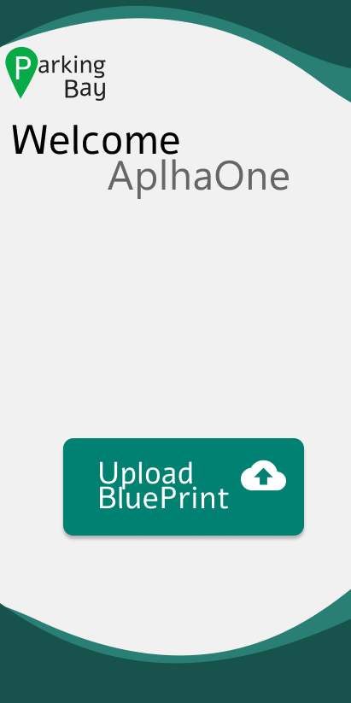

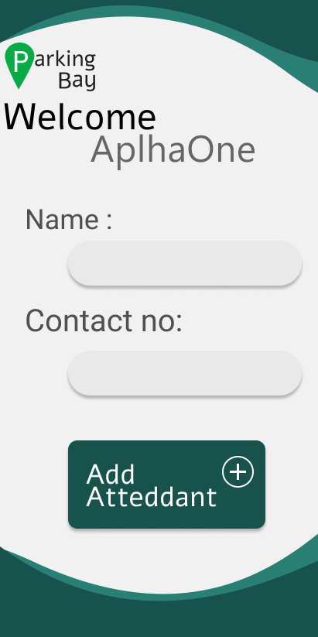 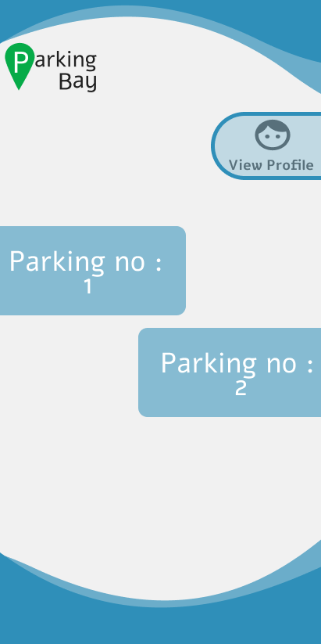

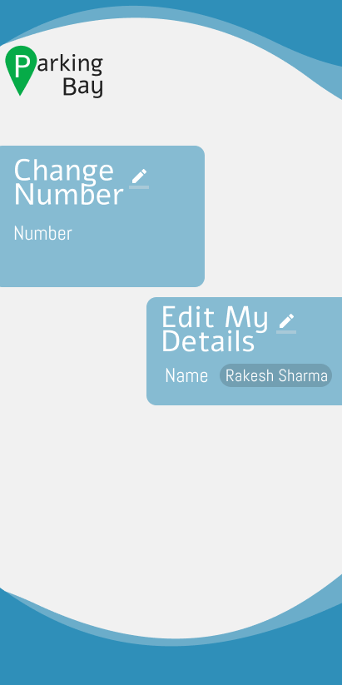 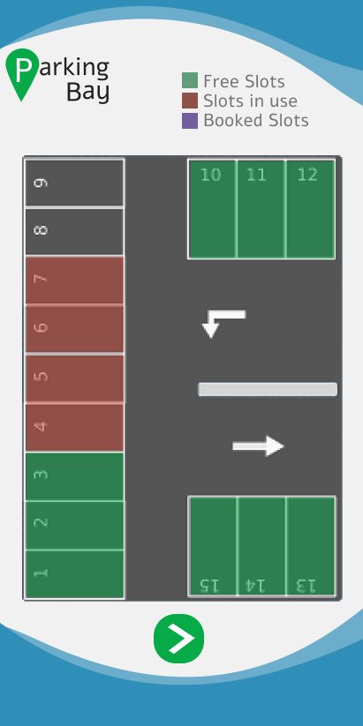

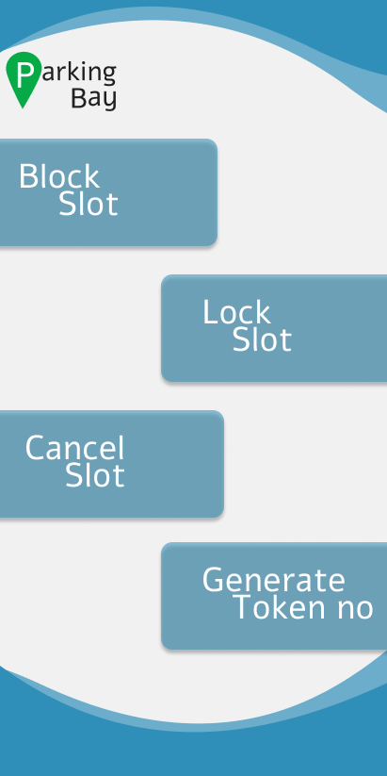

**Challenges/Risk in implementation:**

**>**Parking lots where no Attendant is available, we will be providingour own Attendant in such exception.

**>**To create a digital version of the Blue print Uploaded by the ownerof parking, we will be using image processing using openCV for that purpose.

**>**Learning new technologies for implementation was challenging tous.

**>**Providing such service without monetization.

**Possible outcomes:**

To help user find and locate nearby Parking Facilities and solve issues regarding unavailability of parking

Admin independent functionalities as user and owner of the parking will provide major Data.

**Future Scope**

* The payment gateway using paytm and bank api is kept as the feature in the next iteration of the software.
* Also we are planning to launch a pro version of the application which will be paid. The added functionality is in the current version the slot can be booked only 15 minutes prior to when the user arrives. After that if the user does not come he slot is cancelled. (this is kept to save the slot from being kept empty for too much time due to pre booking)
* The pro version will allow the user to book the slot anytime before his arrival, there will be no time limit for arrival.
* Also we have planned to deal with the owner of parking slots during events and make it compulsory for the event viewers to use the app and thus increase users.

**Work Done till Date:**

We have surveyed several existing systems and found issues and faults in them which we will be trying to overcome. We have finished with the documentation stage and the prototype designing. Database has been designed and the algorithms and technology used to convert blueprint to a digitally operable version have been seen into.

Also the future scope which is the pro version of the application and its features have been discussed and planned to implement in the next iteration of the application. Also the website required to manage the application and connect with the database has been designed and coded.

We will now be starting with the coding of the dynamic designing and the application coding along with the database interaction.