**Assignment no: 3**

Submitted To: Ma’am Sadaf Tanvir

Submitted By: Shaher Bano

Roll no: 7396

Course Title: Mobile Application Development

Course Code: CS-375

**Department of Computing**

Program: Software Engineering

**ABASYN UNIVERSITY**

**ISLAMABAD CAMPUS**

**Bid no 1:**

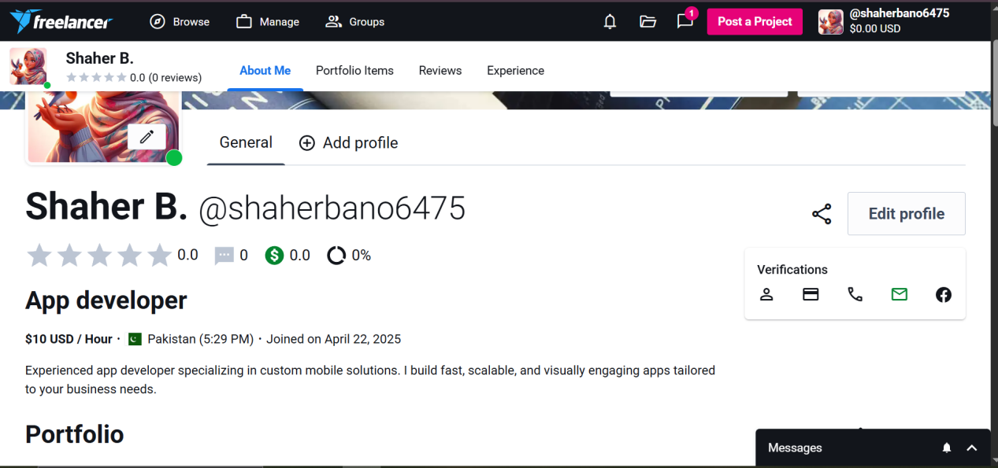

**Bid no 2:**



**Bid no 3:**

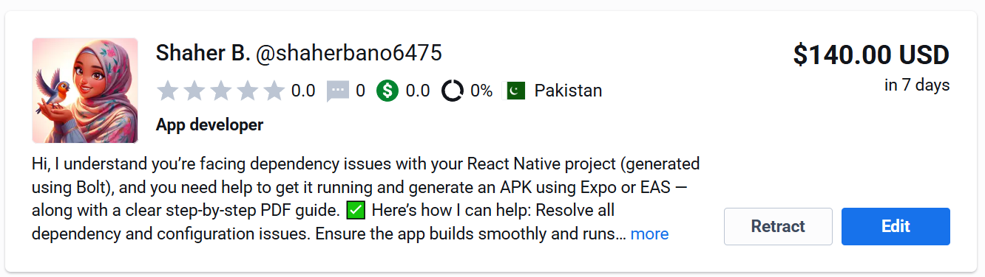

**Bid no 4:**



**Bid no 5:**



**Bid no 6:**

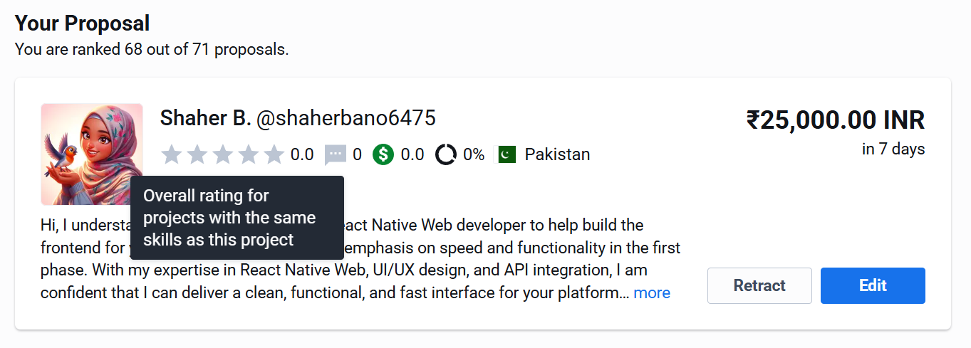

**Bid no 7:**

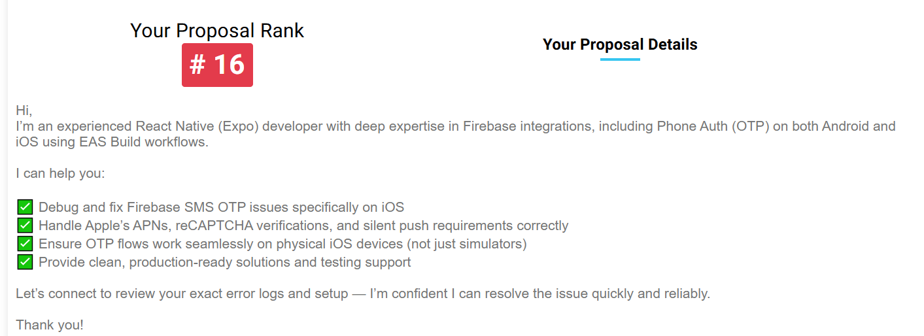

**Bid no 8:**

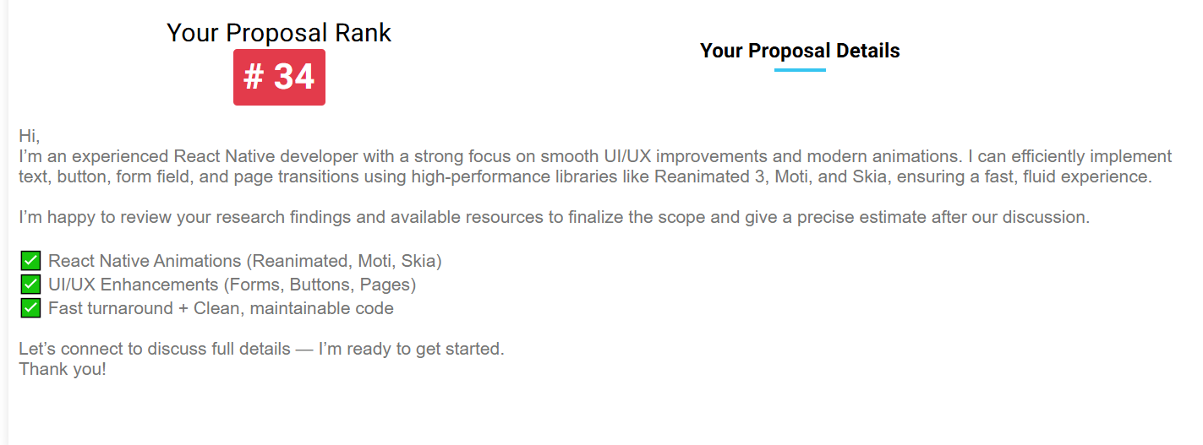

**Bid no 9:**

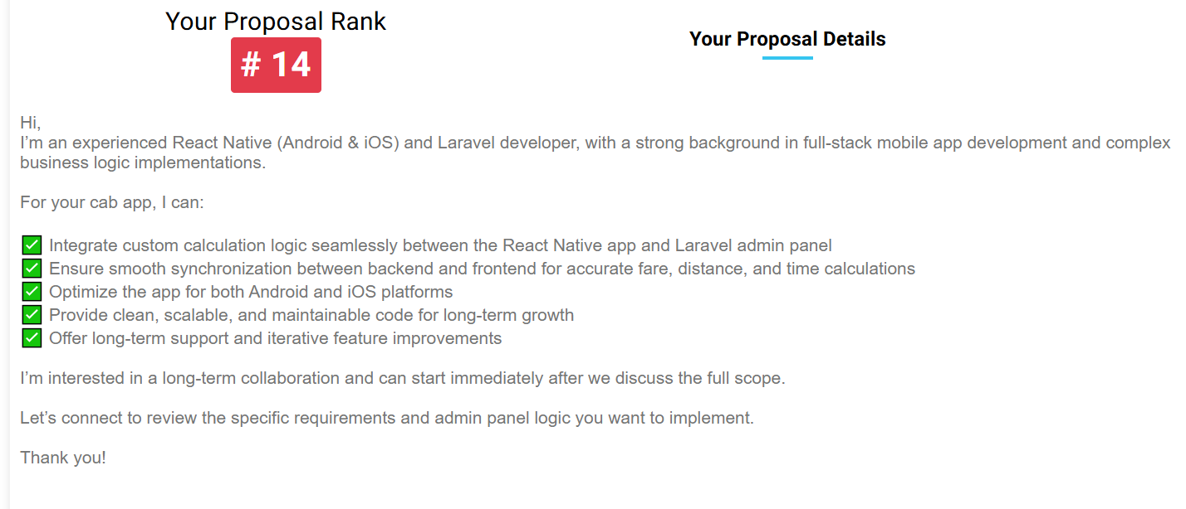

**Bid no 10:**

