|  |  |
| --- | --- |
| SUMAIYA SHAREEN | 7817 |
| SAFIA NASEEM | 7901 |
| SHERBANO | 7396 |

COURSE: OPERATING SYSTEM

Assignment 3:

Memory Management Simulation

Total Marks: 10 CLOs Covered: CLO-3

Tasks:

• Implement memory management techniques such as paging, segmentation,

and virtual memory.

• Simulate various memory allocation strategies, including First Fit, Best Fit,

and Worst Fit.

• Develop a virtual memory management system that simulates page faults and

implements page replacement algorithms like FIFO (First In, First Out),

LRU (Least Recently Used), and OPT (Optimal).

• Allow memory to be dynamically allocated as processes are created and terminated,

and handle situations where processes may have to wait for memory allocation.

• Include memory fragmentation and optimize memory usage for the processes in the

system.

CODE:

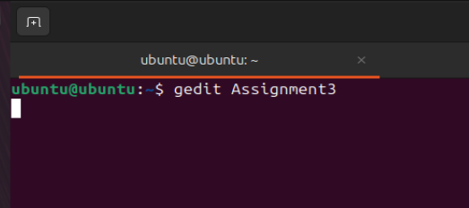

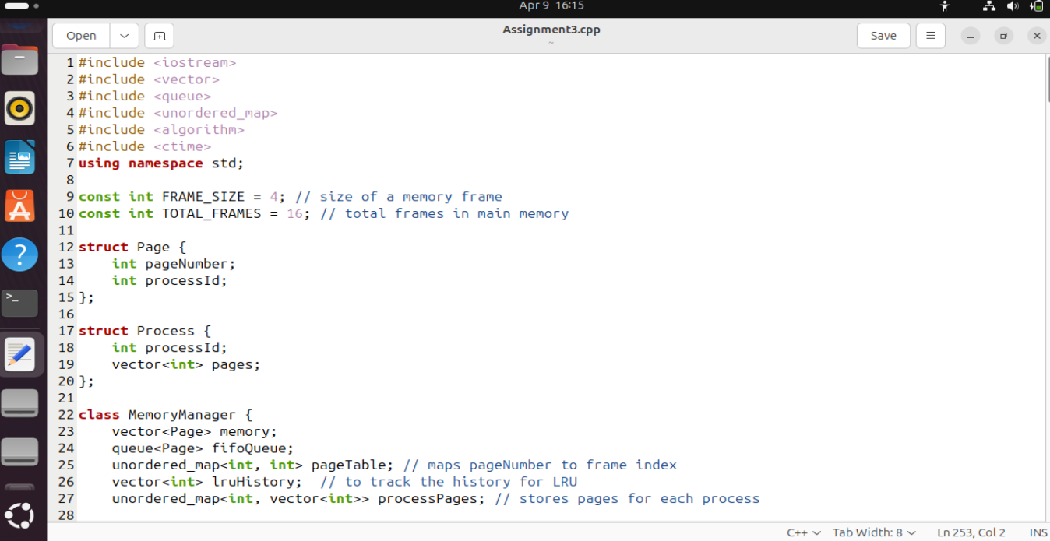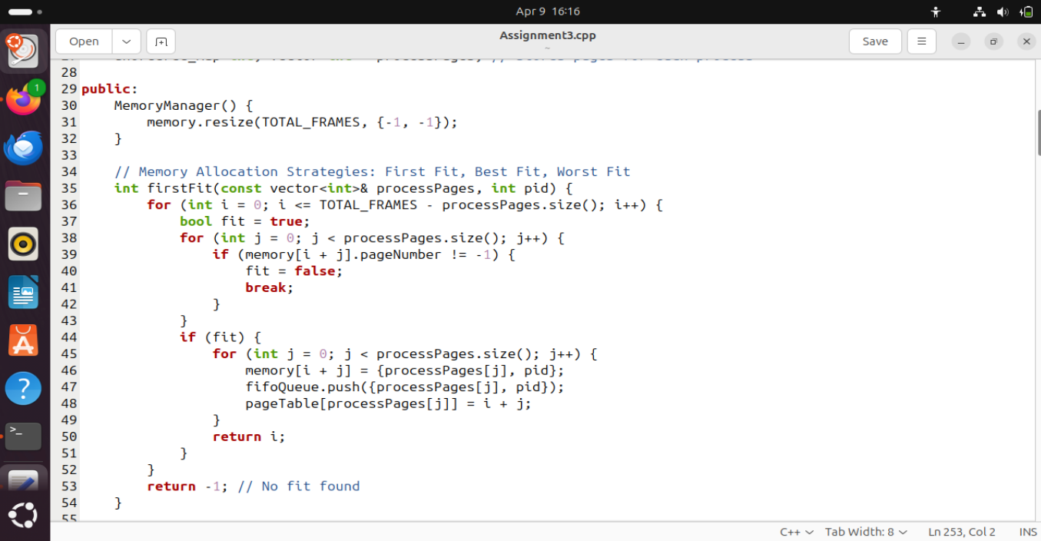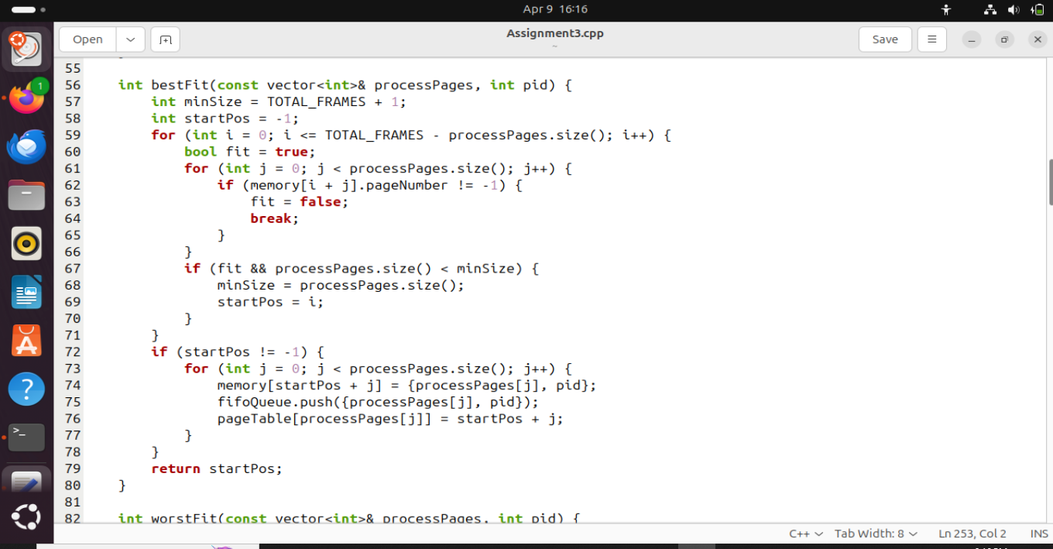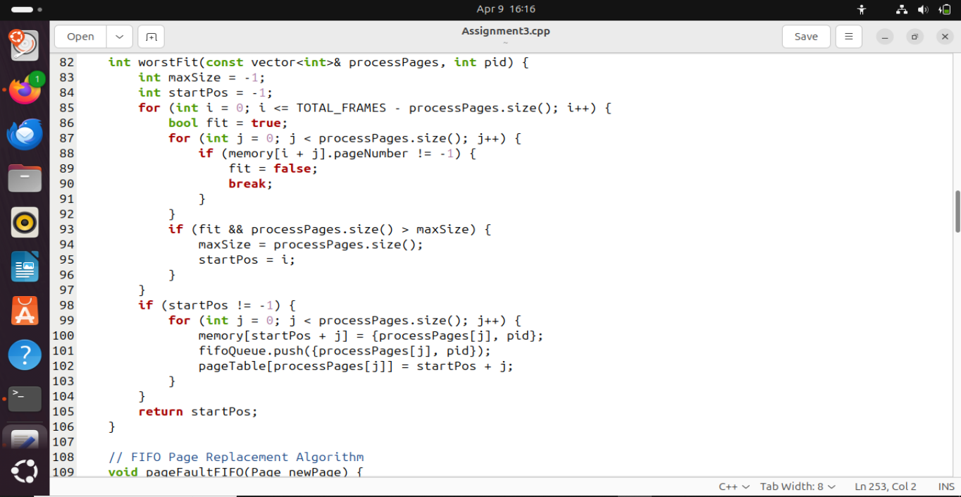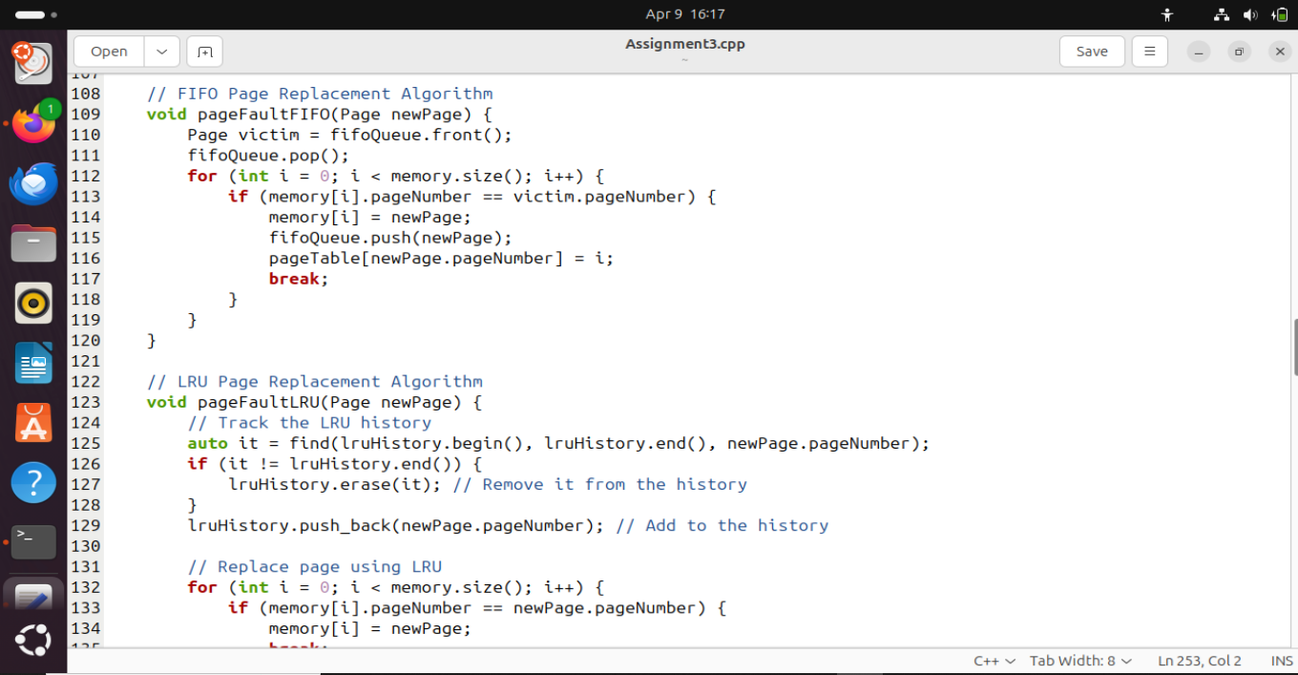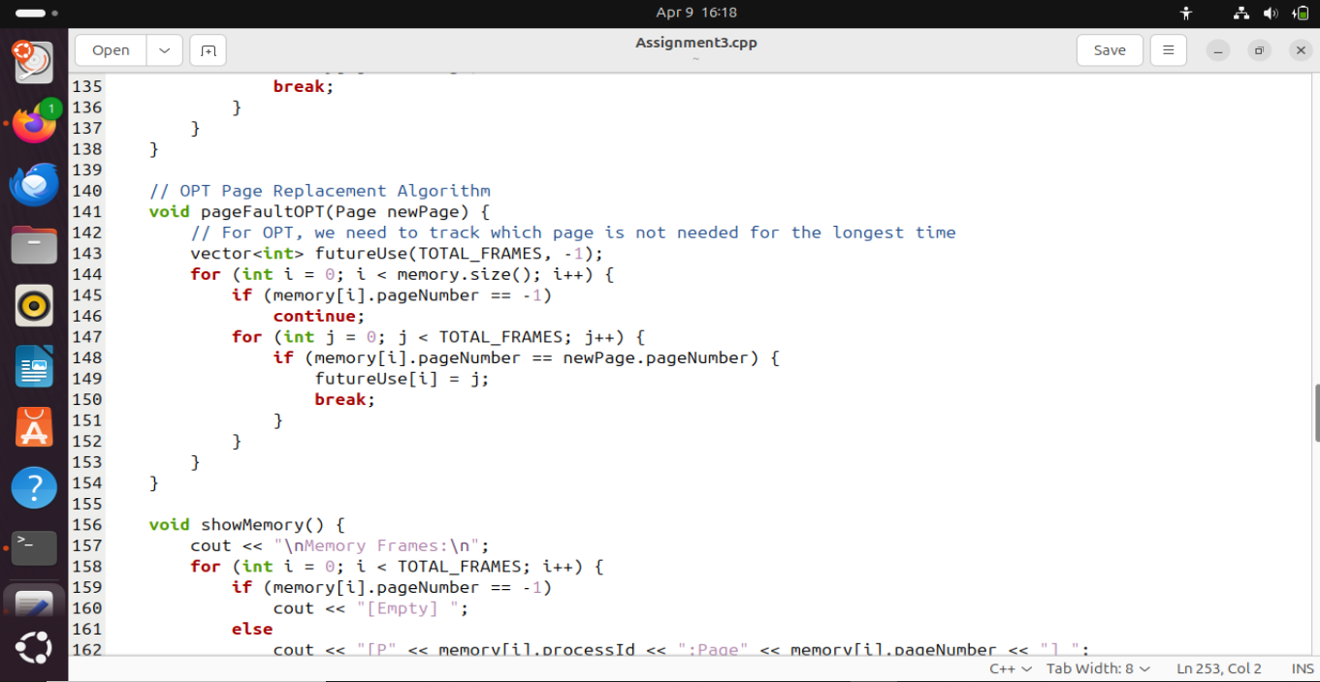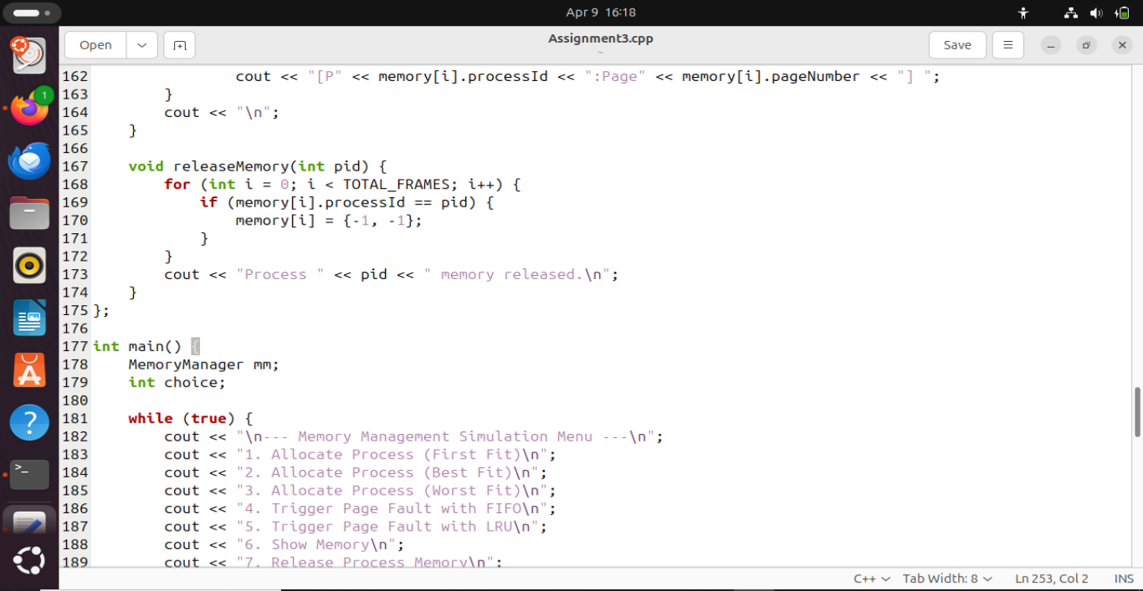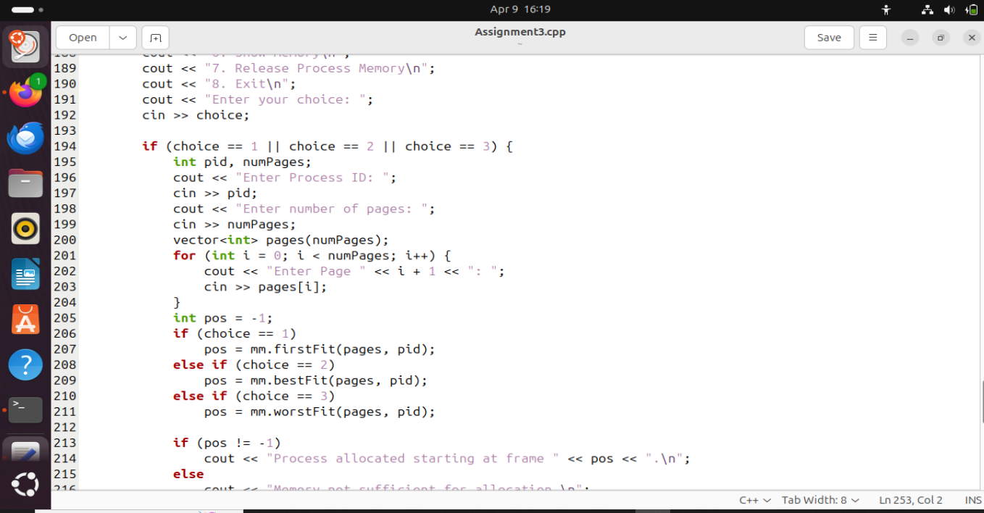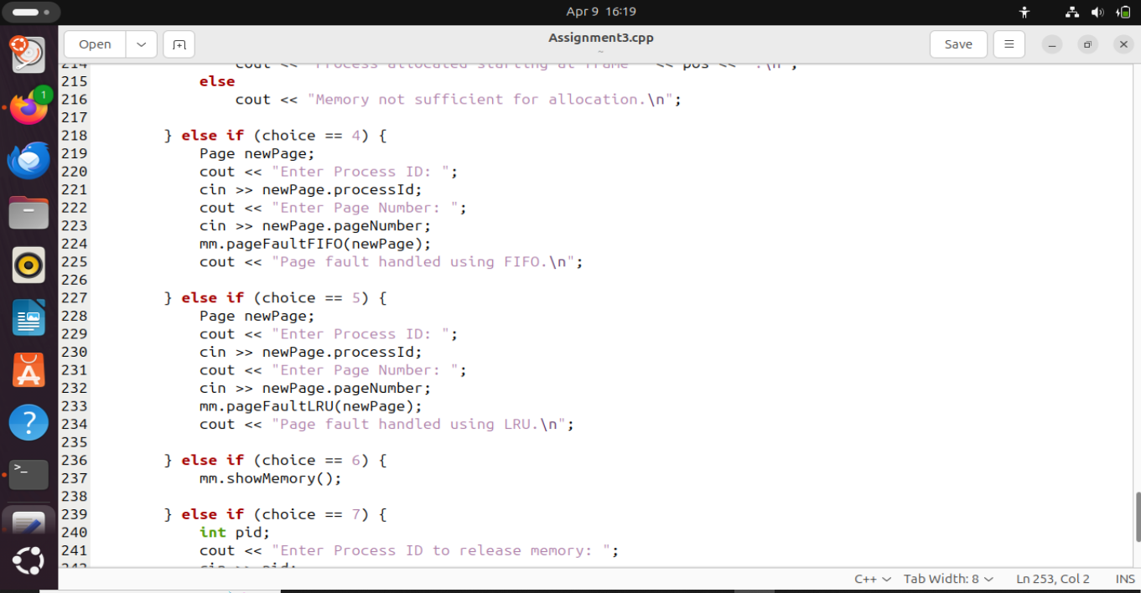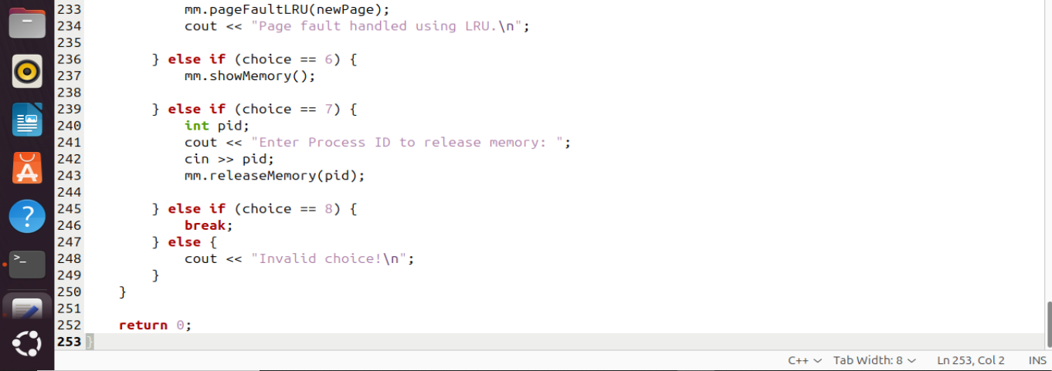

OUTPUT:

