**Assignment no: 4**

Submitted To: Ma’am Sadaf Tanvir

Submitted By: Shaher Bano

Roll no: 7396

Course Title: Mobile Application Development

Course Code: CS-375

**Department of Computing**

Program: Software Engineering

**ABASYN UNIVERSITY**

**ISLAMABAD CAMPUS**

**Bid no 11:**

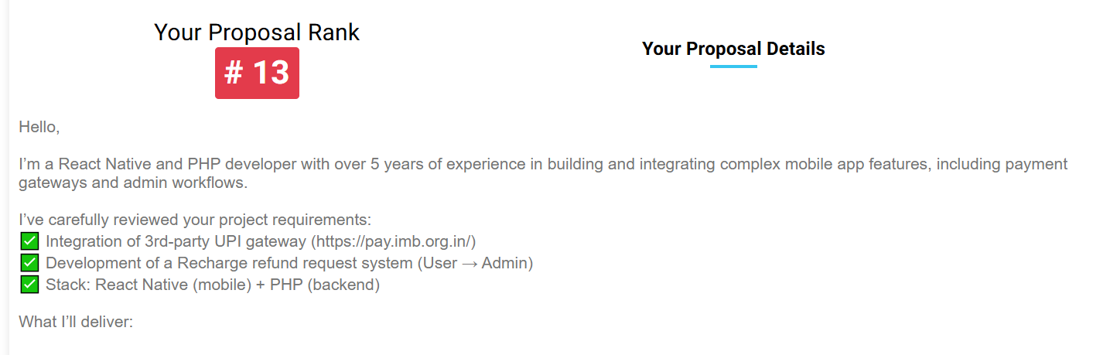

**Bid no 12:**

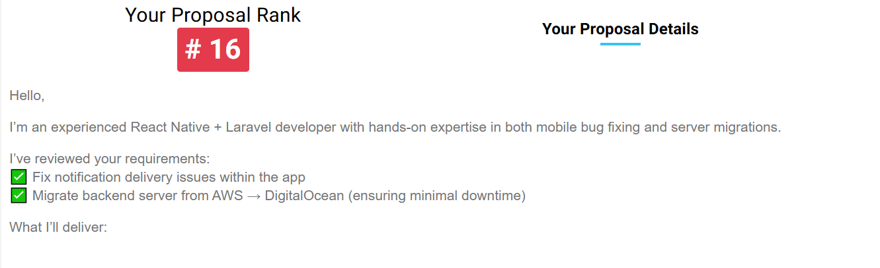

**Bid no 13:**

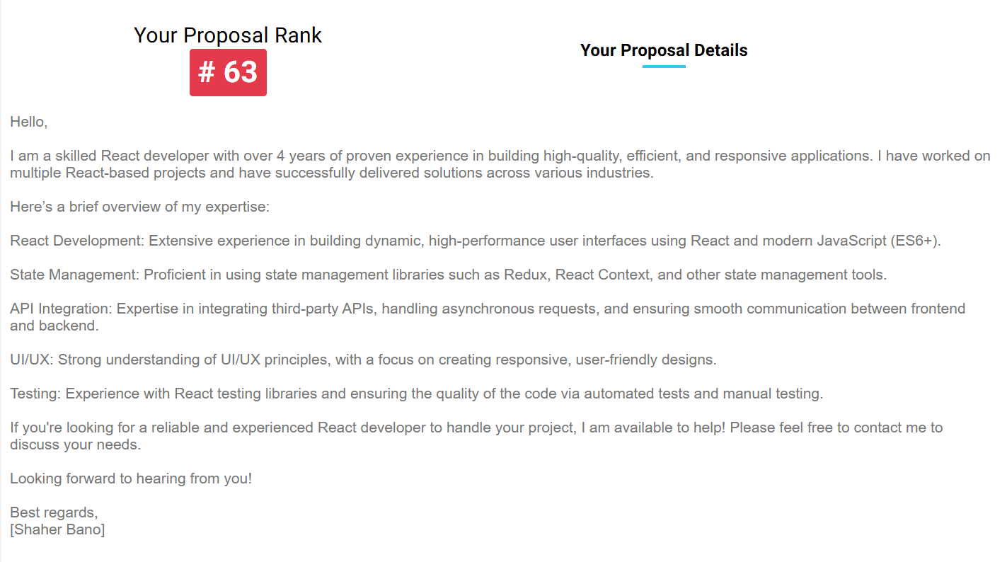

**Bid no 14:**

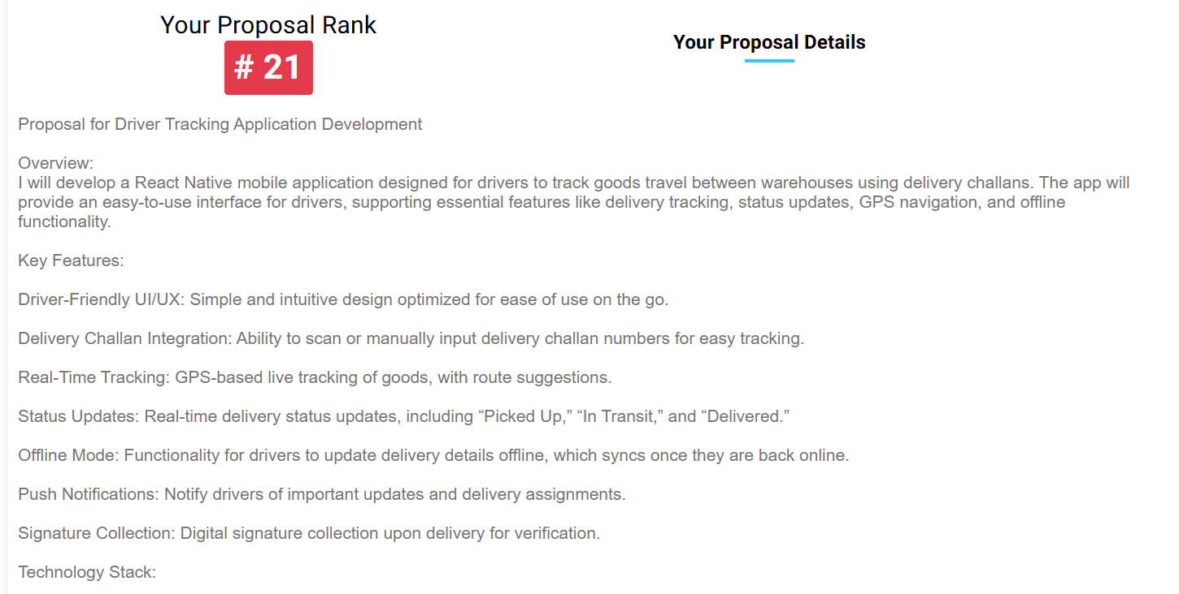

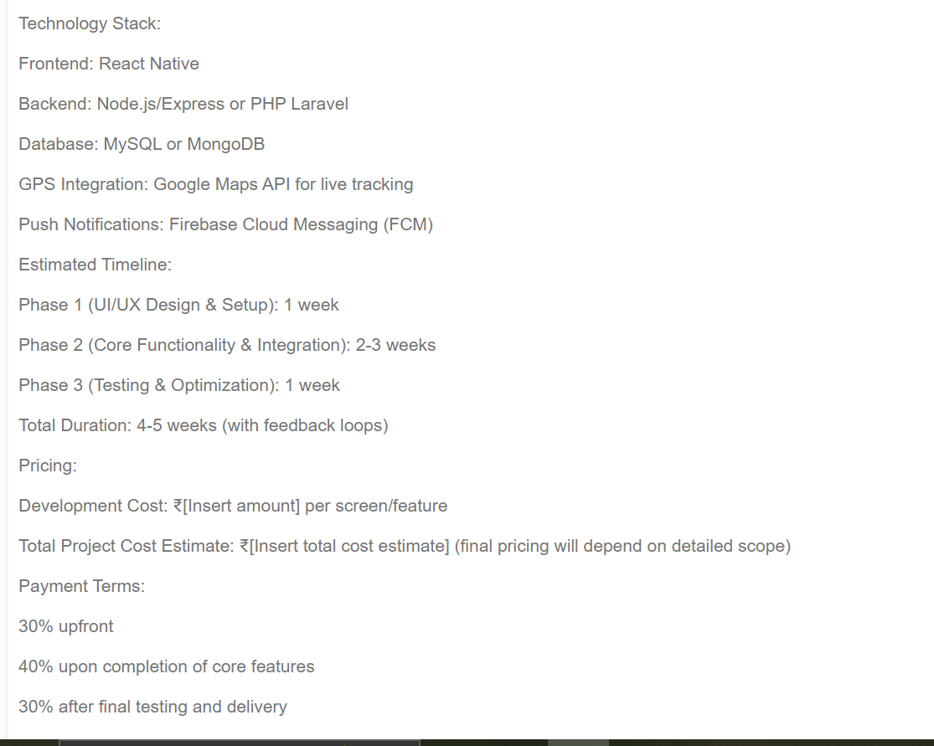

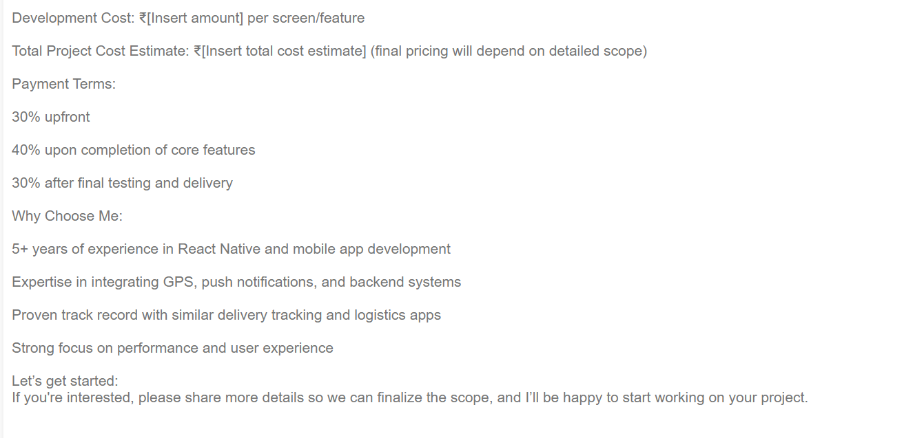

**Bid no 15:**

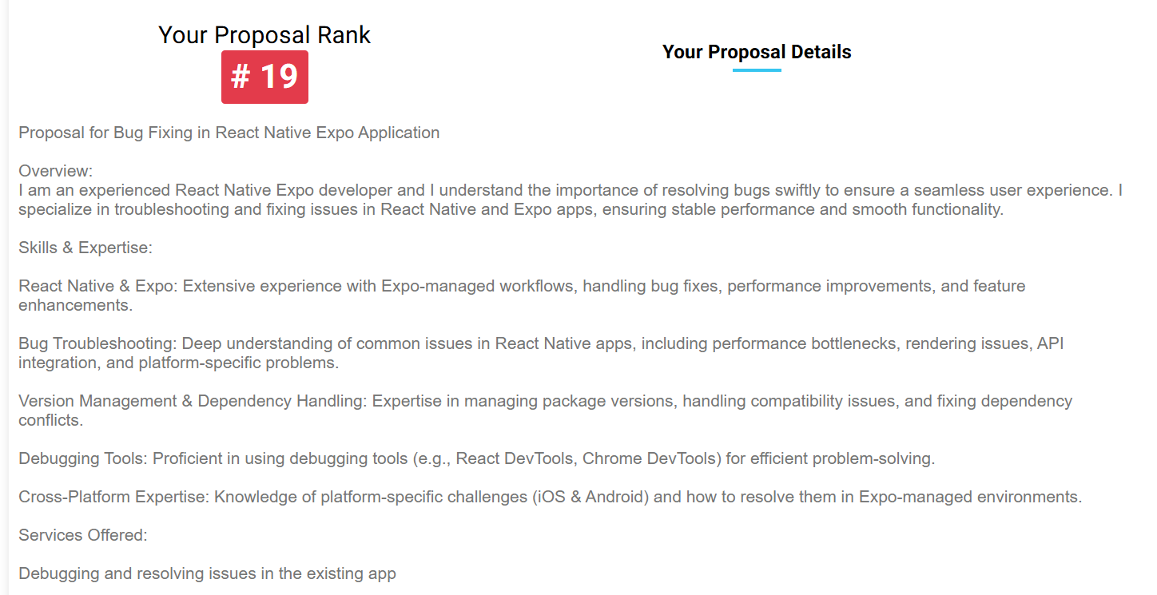

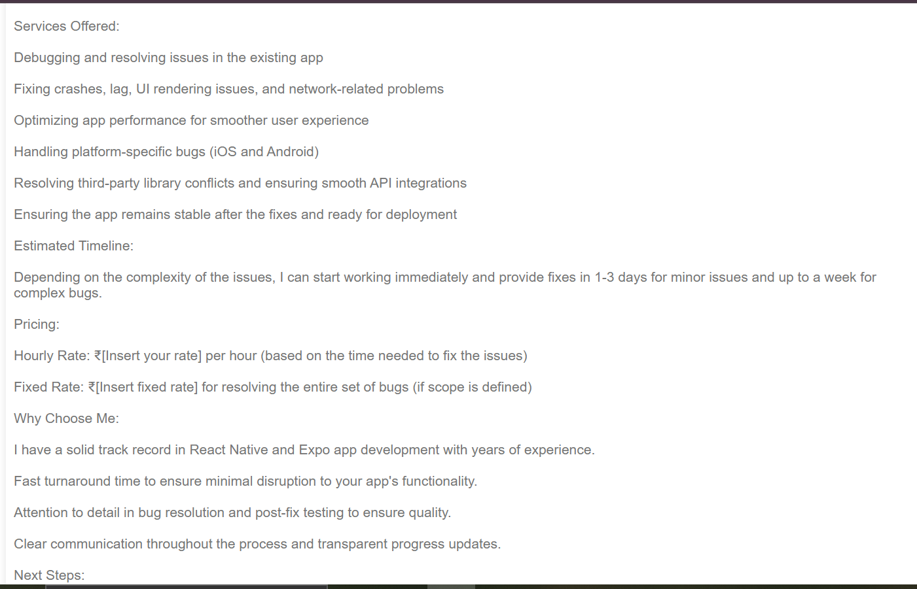



**Bid no 16:**

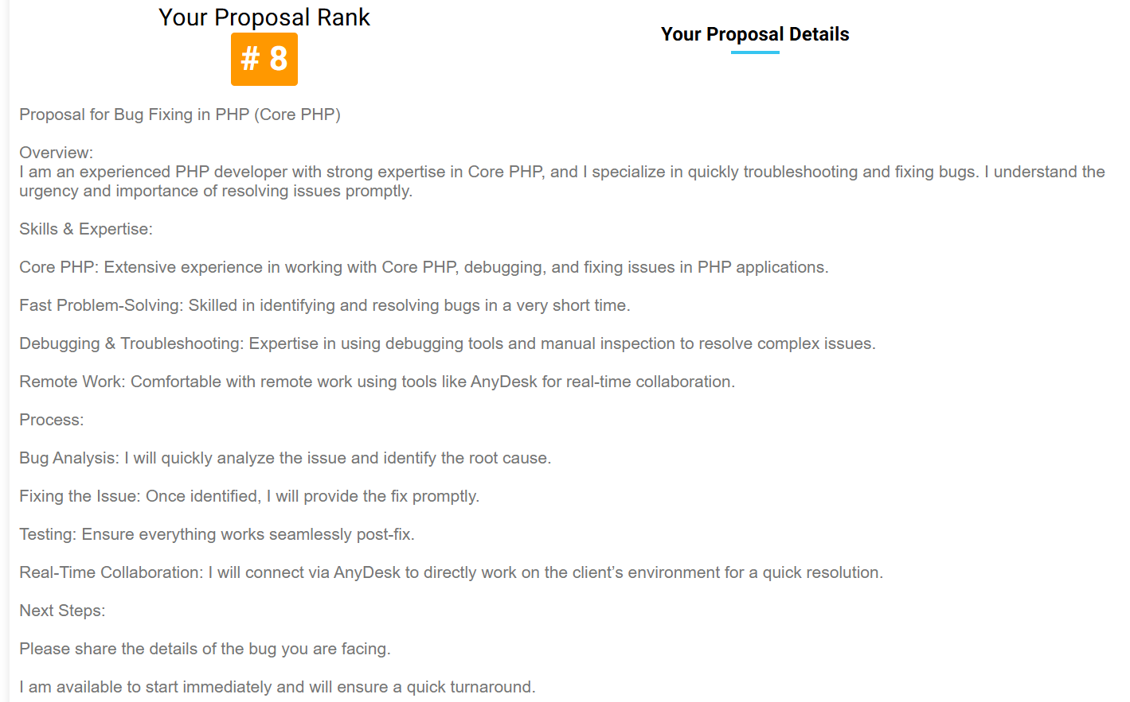

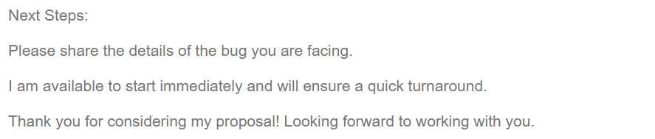

**Bid no 17:**

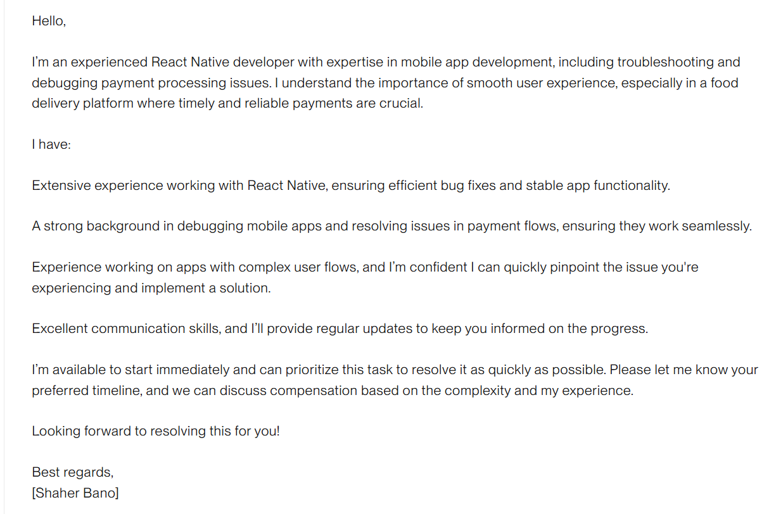

**Bid no 18:**



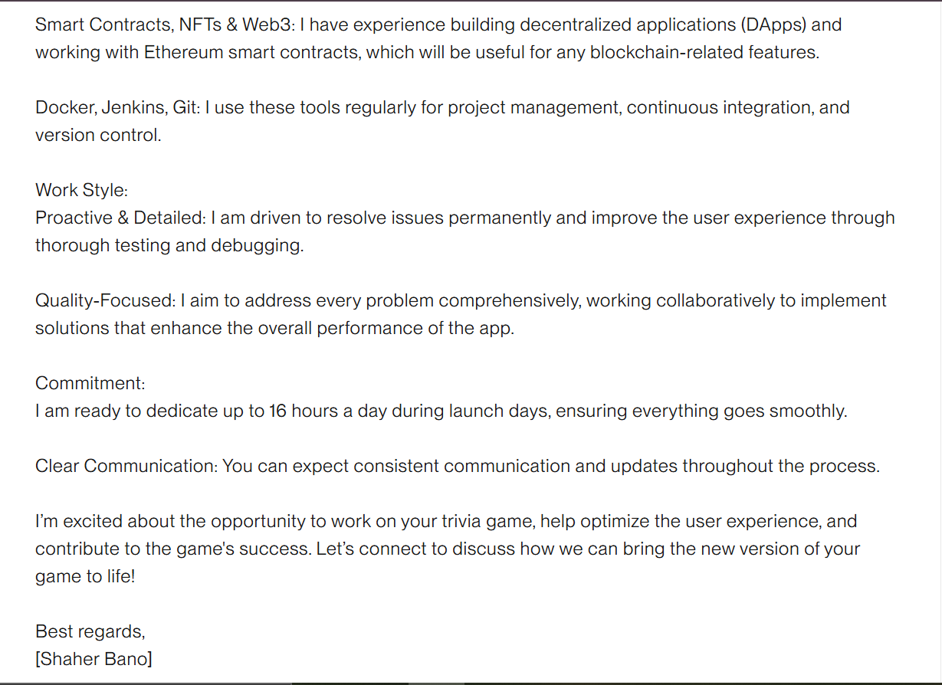

**Bid no 19:**

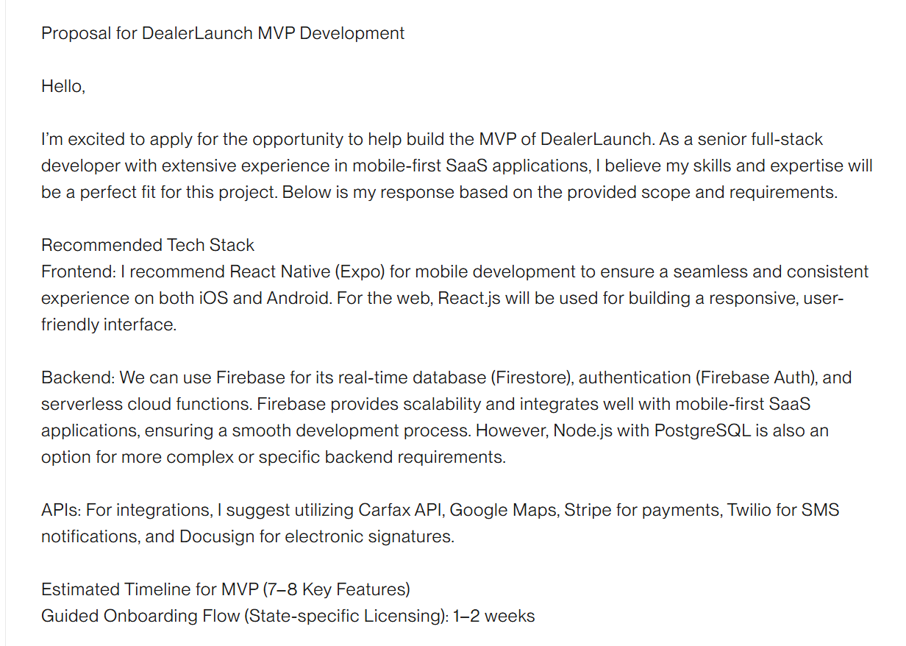

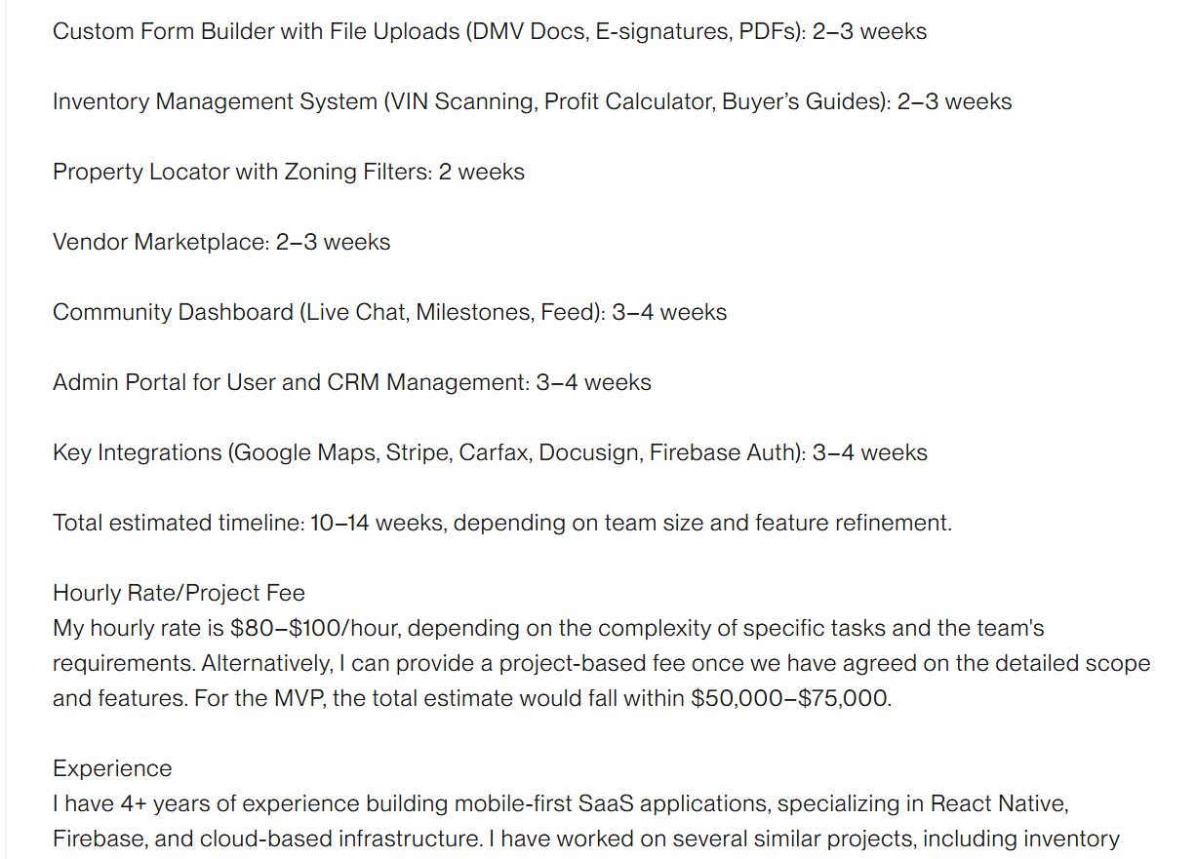

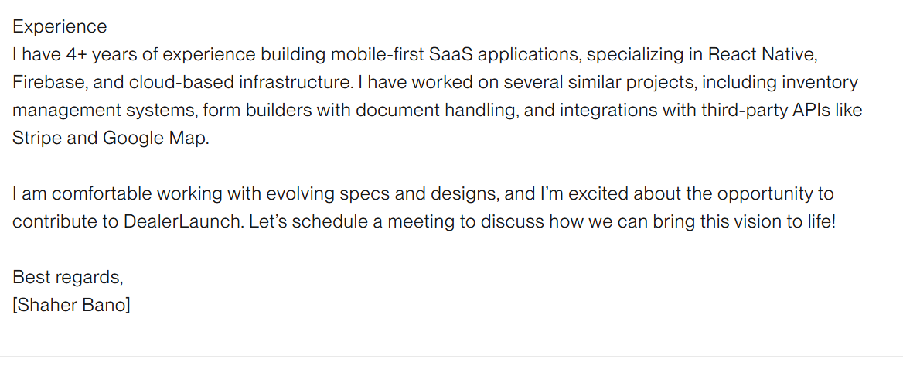

**Bid no 20:**

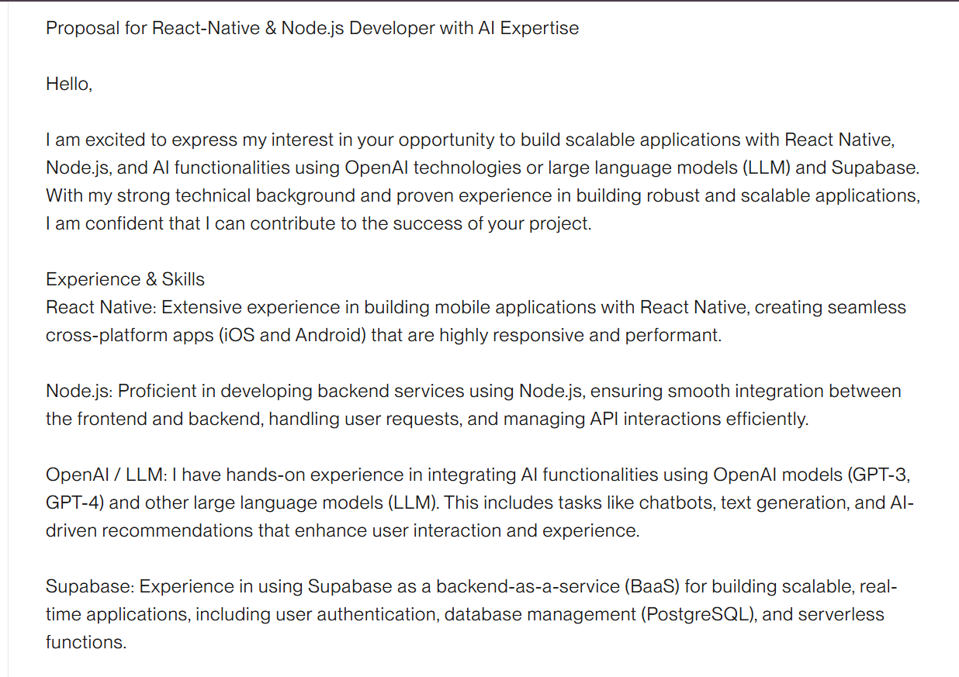

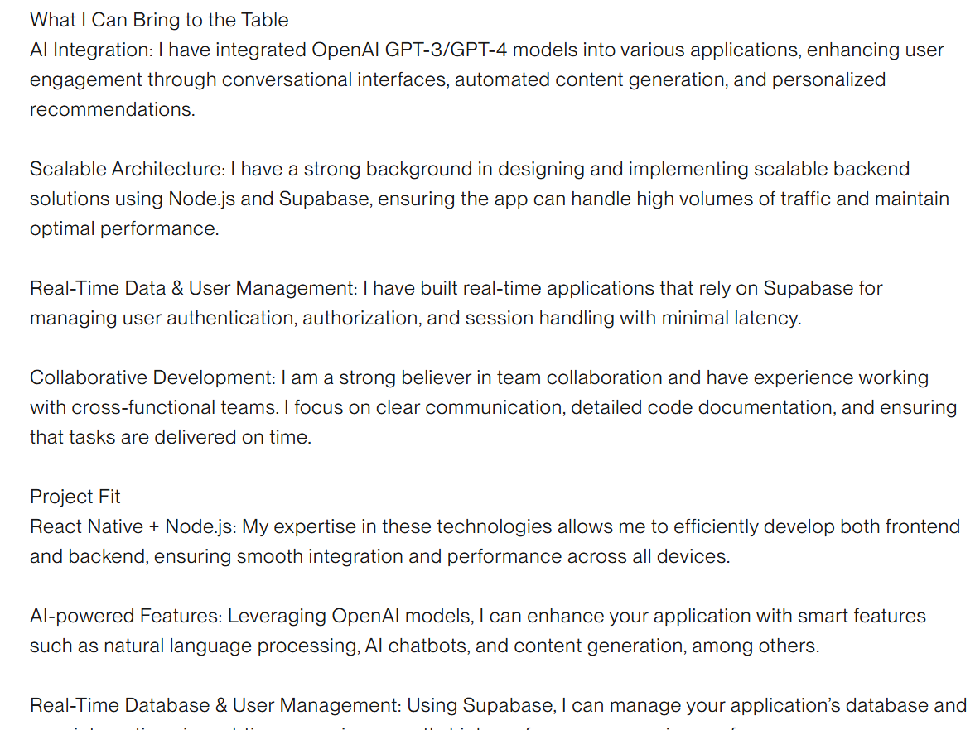

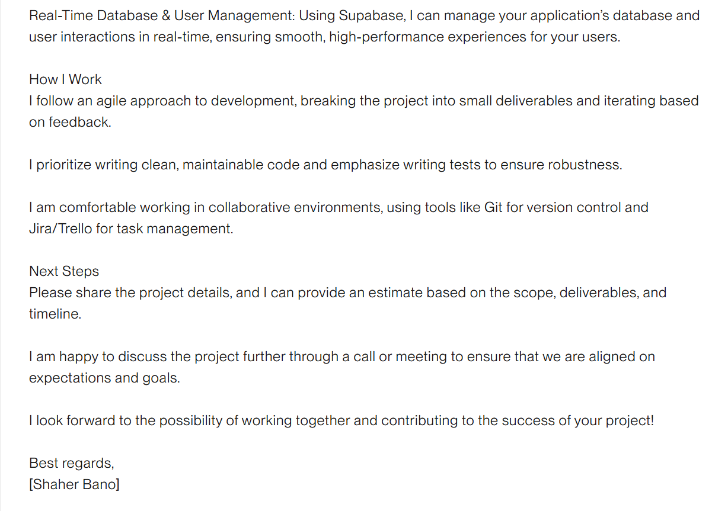

**Bid no 21:**

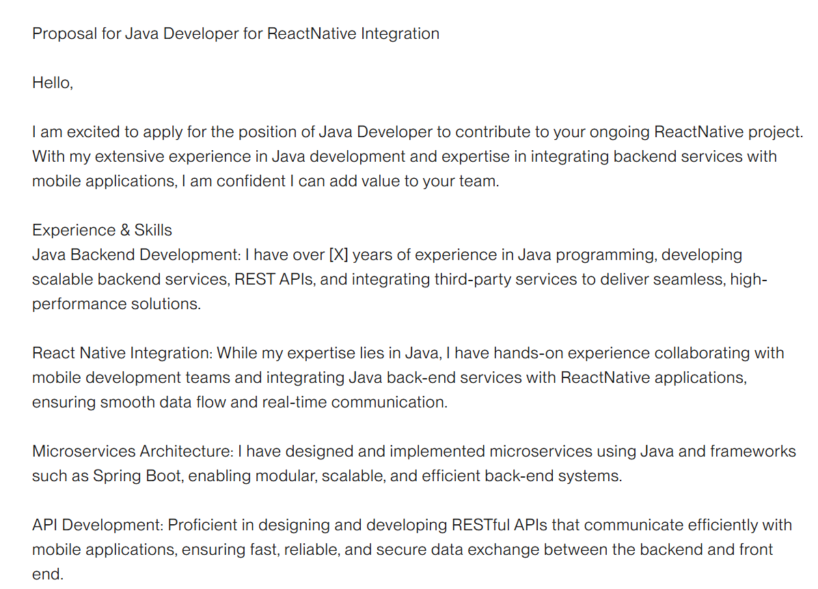

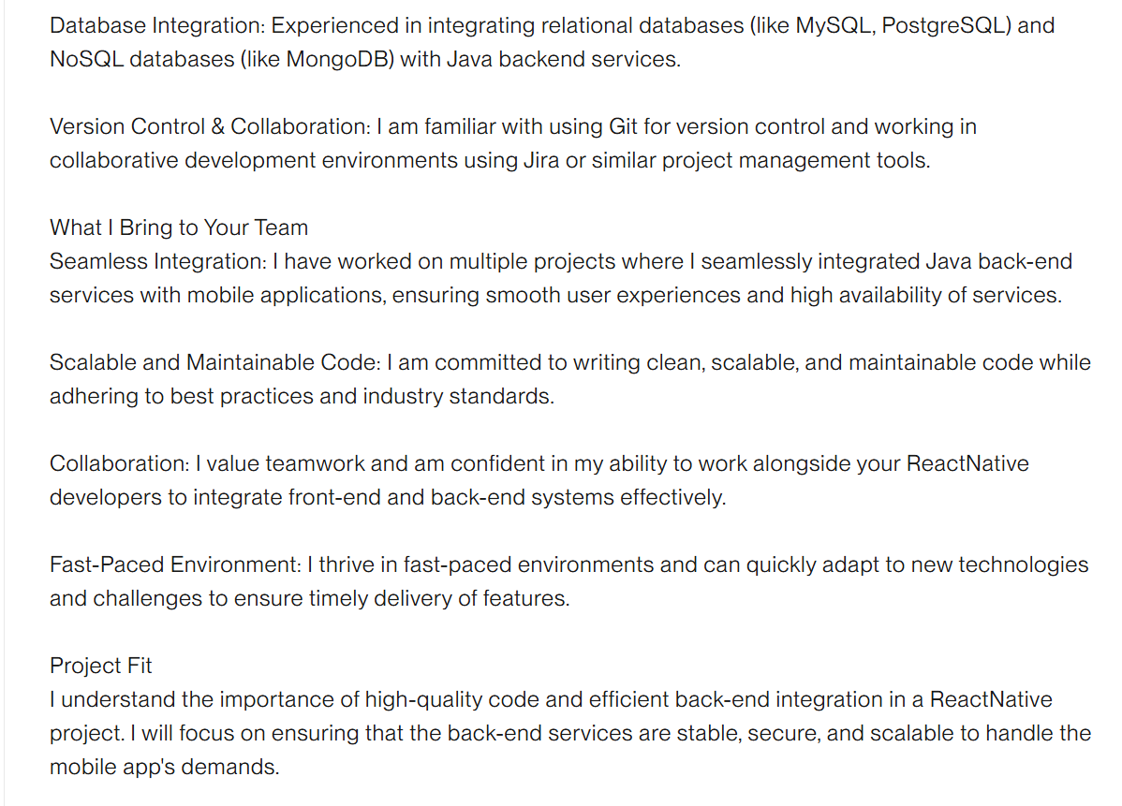

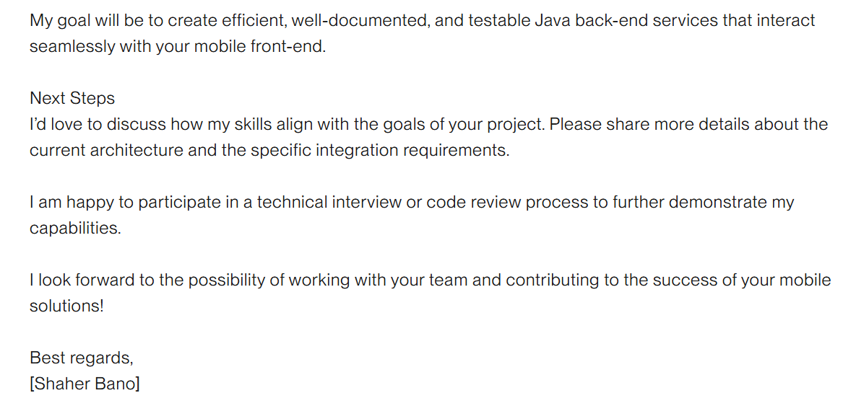

**Bid no 22:**

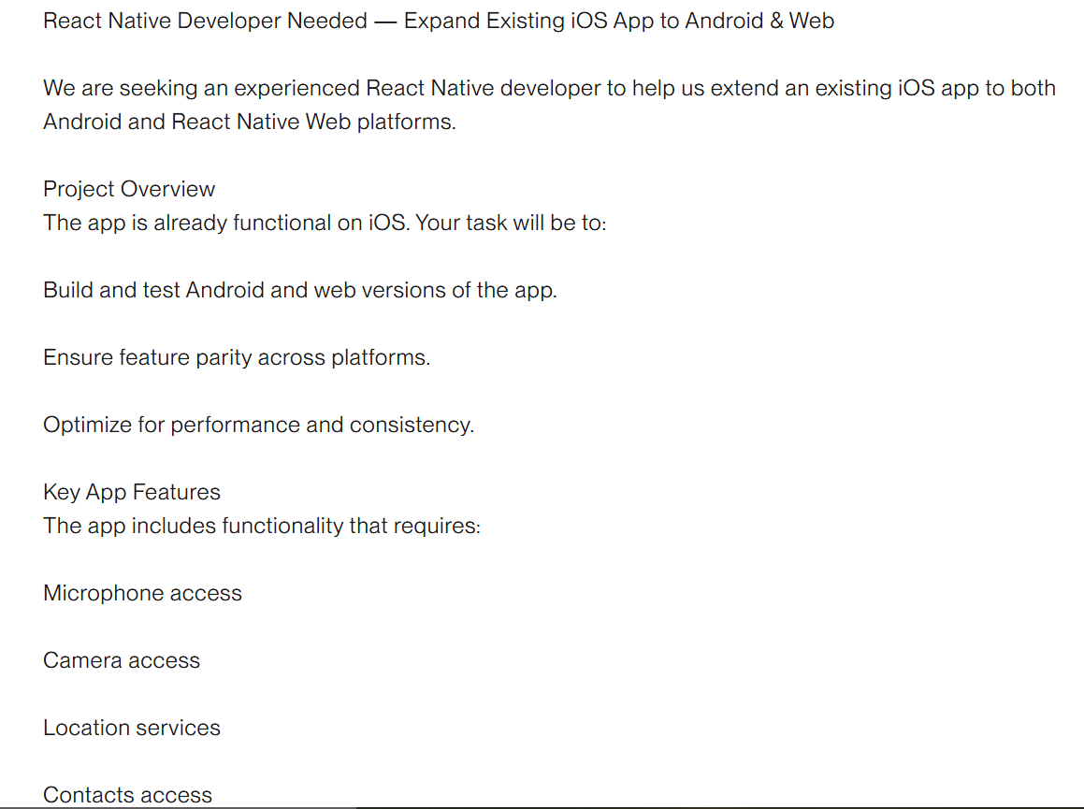

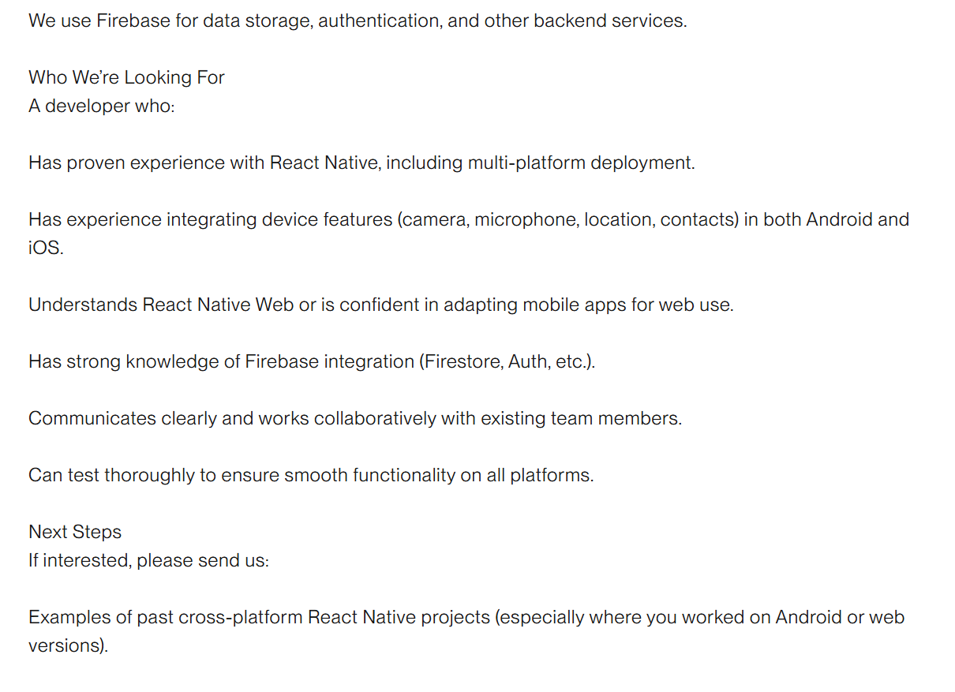

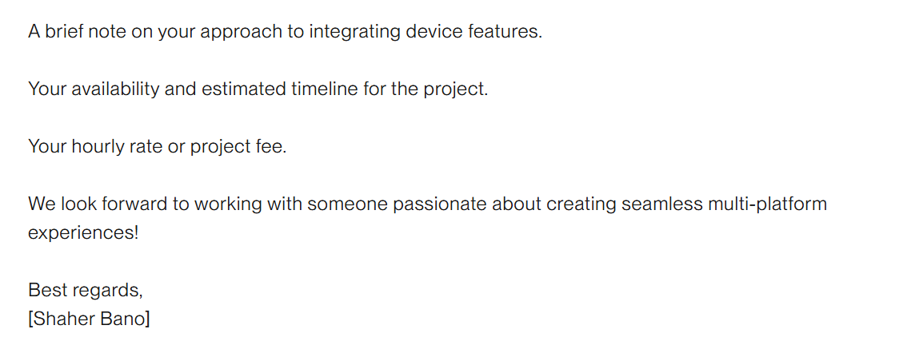

**Bid no 23:**



**Bid no 24:**





**Bid no 25:**





