USER MANUAL.
Color Mulsh Theme
Version 1.0.
By Shaheryar Afzal / Fulcrum Creative.
sherryafzal@gmail.com
http://www.fulcrum-creative.com/

786.

Hi! Welcome and thank you for buying and supporting this theme. Once I get around to it, I’ll be creating more themes such as this one, and continue development for the current theme you seemed to have purchased! Again, thank you for buying me beer and a coffee.

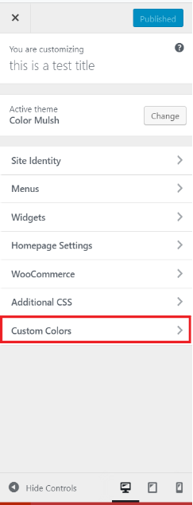Lets get started:

This theme works almost like all other themes. It’s got the same regular options as most themes on the internet, like Site Identity, menus, widgets, homepage settings etc, as conforms to the standard means of use as per all the other themes on the internet. I won’t go into detail of the general options available here, but I will discuss and outline the “unique” features of this Theme.

In order to use this theme, and it might need a little configuring, you’re going to have to go to the Customize page, of your newly acquired Wordpress Theme.
At the very bottom is an option: Custom Colors. Click that to customize this theme with different colors, etc.

Here, you see many different options, as depicted in the screen shot below.
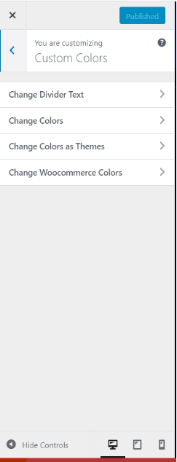
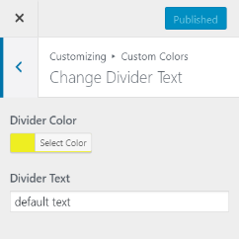
Change Divider Text.
This allows you to change the divider section of the front-page, the bottom divider right above footer section of the page.

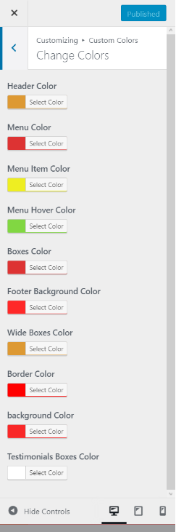
Change Colors
As you see here, this section will allow you to change the colors of the different elements of the theme. You can see it reflect in the preview, of whatever element you’re trying to change.

If, for example, you would like to change the color of the header, the menu color, hover color, etc. you would do such a thing here, in this section.
Again, this will reflect in the preview window so you can see what you’re doing.

NOTE: if you want to use custom colors, you have to change the setting under the title “CHANGE COLORS AS THEMES” to custom, for this to work.

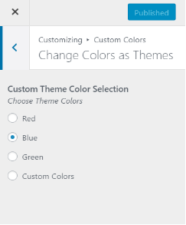Change Colors as Themes:

In this section, you get to choose the color you want your theme to reflect.
The Options presented currently are Red/Blue/Green and Custom Colors.

These colors are are pre-set. It’ll give you an idea as to how you can change your theme colors to a different shade, based on a whim or your changing mood.
NOTE: for custom colors as defined in the previous section to work, you’re going to have to select “custom Colors” here from this menu. Go back to the “Custom Colors” menu and define your custom colors.

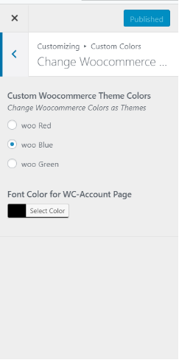Change Woocommerce Colors:
For this to work, you’re going to need Woocommerce. Download woocommerce for your wordpress theme.
Changing the options presented here are going to change the colors of Woocommerce, and you also have the option of changing the font color woocommerce is presenting itself in.
This will let you adjust woocommerce to the theme colors that you’re defining in the previous sections.

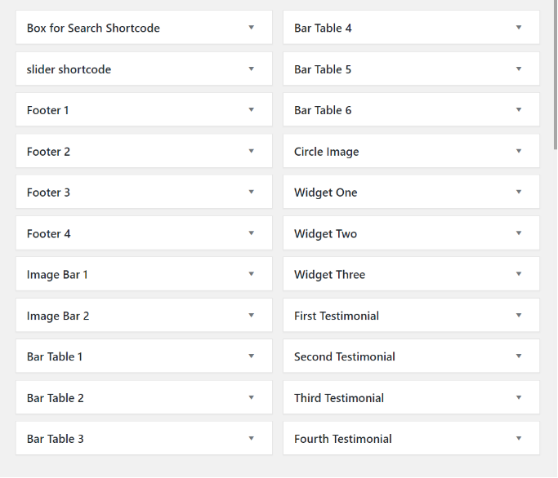
Definitions of the WIDGETS.
In Total, there are Twenty-two widgets sections.
They are depicted in the following image.

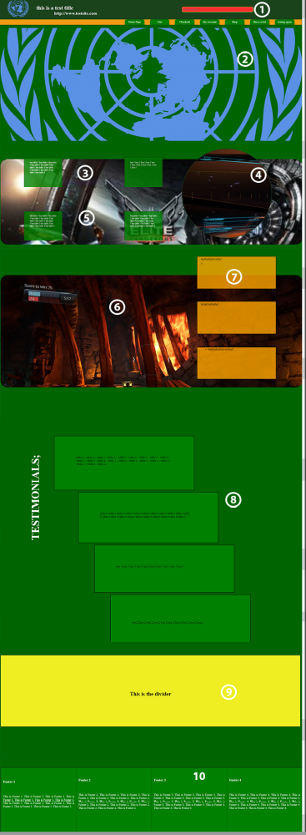

- BOX for Search short code
Adding a search widget into this section will add a search box into the top right corner of the theme, in the HEADER section.

- Slider Short Code
This will add a slider of your choosing to the main page itself.

- Bar Table 1, 2, 3, 4, 5, 6.
These are the boxes that appear right underneath the slider of the page.
You can fill them with text or images, depending on preference.

- CIRCLE Image.
This is the image that you see on the right of the boxes right after the slider. The recommended image setting varies, and should be set to whatever makes the image appear perfectly.

5/6. Image bar 1, and image bar 2.
This section is for the images that appear on the front page of the theme.
They can be background images, or whatever you would like depending on your preferences of configuration.

7. Widget One, Two and Three
These are the boxes you see near the bottom of the page. Over the Image Bar – 2.

8. First Testimonial, second, third and fourth.
Boxes for Testimonials.
If you want to set a testomial section in the theme, you may. it depends on what you would want to set your theme as.

9. divider Text.
This is the Divider text, you can change this in the “customize” menu of your wordpress theme.

10. Footer 1, 2, 3 and 4.

This is the footer section.
You can put a footer into this theme by filling out this section with text widgets, or even images.
Depending on preferences.

This manual should help you configure the theme just right.
If in the case of when you need support,
Please visit
http://www.fulcrum-creative.com/
or email me directly,
sherryafzal@gmail.com

